RFQ Specification
Budget Code | PJ-NA-430-147
Project Name | T-Levels Wave 5 Bicton
Location | Bicton
Contact Details | Mark Wright  Deputy Head of Estates  Cornwall College Camborne, Trevenson Road, Pool, Redruth, Cornwall, TR15 3RD  What3words: ///fiction.pines.streamers  +44 (0) 1209 616341 (Ext. 3341)  +44 (0) 7971 993401
Project Description | Light touch refurbishment of Rooms L8, L9 and L10, Learning Resources, Hayter Hames Building.
Product/Service Specifications: | - Replacement ceiling grid and tiles in all three rooms.  - Replacement LED lighting in all three rooms.  - Replacement three compartment trunking in all rooms.  - New DDA Regs compliant sockets and data outlets to be fitted.  - Repainting of all walls in all three rooms.  - Repainting of all skirting boards in all three rooms.  - New floor covering in all three rooms. Please refer to the product specification document for more details.  - Servicing of all windows and fire doors.  - All electrical circuits to be tested and certified.  - All data circuits to be tested and certified.  - All fire door remedials to be certified.  - Please refer to the product specification document (Product Specifications – Bicton L8 L9 & L10) for product details and paint finishes.
Access for Viewing | 10.30am to 12.30pm Thursday 4th January 2024, Bicton College, East Budleigh, Budleigh Salterton EX9 7BY
Quote submission deadline | 12.00pm Friday 12th January 2024
Completion Date | Sunday 18th February 2024
Pre-Construction Documentation | Please see Drawing Bicton “LRC Rooms L8 L9 & L10-A3” and the following photos:  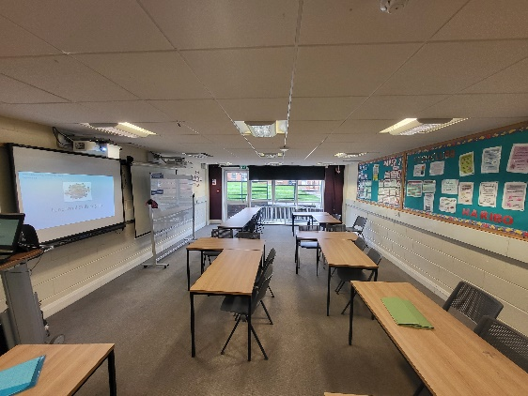  L8 door intumescent L9 room photo  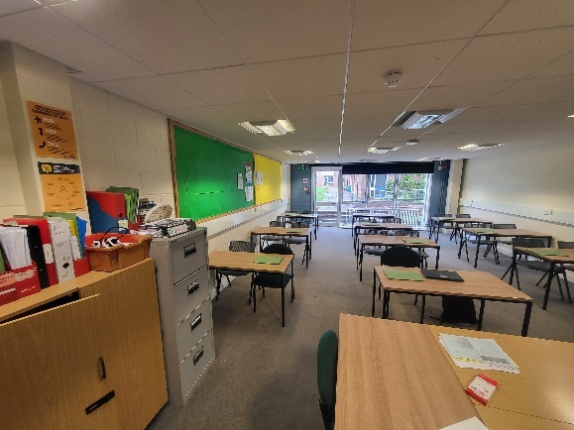  L9 door intumescent L10 room photo    L10 door intumescent

Please complete and return along with any supporting information:
Company Information:

Please provide your company name, address, and contact information.

What is your company's legal structure (e.g., LLC, corporation)?

Pricing Information:

What is the total cost for the products/services, including any taxes, fees, or additional charges?

Are there any volume discounts or special pricing options available?

Delivery and Lead Times:

Please suggest possible dates for delivery of the products/services.

Can you provide information on your standard lead times and any expedited options?

Quality and Warranty:

What quality control measures are in place for your products/services?

What is the warranty or guarantee offered for your products/services?

Safety

Please indicate if any special permits are required for Hazardous works. (Hot works, Confined Spaces, Working at Height, Working with Hazardous Chemicals etc)

An authorised set of RAMS will be required before work commences.

General Conditions of Workmanship and Statutory Compliance
If you are appointed to carry out work at the College, you will be required to comply with our expectations of workmanship and statutory compliance. Where the Specification of Works is performance-driven, as opposed to being prescribed, the contractor should ensure that all works comply with the relevant Building Regulations, Approved Code of Practice and other statutory and mandatory rules and procedures.
Please get in touch with the Estates Project Manager for clarifications on this document or the Specification of Works.
Hours of Work
- The contractor shall carry out all works during regular working hours (Monday to Friday 0800 to 1700hrs) unless other times are requested and agreed by the College.

Waste
- All waste arising from works shall be disposed of safely and following relevant regulations. Copies of all Waste Transfer Notes must be provided to the client.
Protection of Areas
- All areas, fixtures, and fittings are to be fully protected during the works, and operations are to be carried out with full consideration to the users/ occupants of the buildings.

Workmanship and Supervision
The contractor will undertake to provide the following:
- Operatives with enhanced CRB clearance or details for safeguarding risk assessment to be conducted. (See attached Safeguarding Appendix – Safe Working Practice)
- Provide operatives with the necessary skills and training to complete tasks safely
- Work will be carried out correctly and professionally.
- Evidence of operatives' competence and training.
- Supervisory staff will be qualified and have the adequate technical knowledge to instruct and supervise operatives competently.
- Work areas must be kept clean and tidy ready for occupation, clear of all dust and debris, surplus materials, plant and equipment.

Health and Safety
- All escape routes must remain clear and unobstructed and comply fully with all statutory and mandatory regulations. The contractor shall take all necessary measures and precautions to prevent the risk of fire when carrying out work (the College operates a Permit to Work for Hot Works) which the local Site Services Office will issue
- The contractor will be responsible for providing and maintaining safe access routes (if appropriate) around the work area unless otherwise stated in the Specification of the work supplied by the Project Manager
- The contractor will ensure that all personnel employed are familiar with the Health & Safety procedures associated with the sites and associated buildings, installations and equipment
- Plant and equipment items must be maintained safely whilst being worked on
- Operatives are supplied with and required to wear appropriate Personal Protective Equipment
- Where appropriate, the contractor will be required to produce a formal method statement detailing procedures to eliminate, reduce or control the hazard such that the risk of harm has been reduced to acceptable levels.
All risk assessment and method statements must be submitted to the Project Manager for prior agreement and approval.
- The College operates a No Smoking policy within its buildings, and the contractor must ensure that their operative(s) comply with this policy. Smoking is only permitted in the designated areas, and cigarette waste must be extinguished and disposed of in the appropriate bins.
- The College has a strict Asbestos Policy. Contractors must check the register before any work is commenced.

Insurance
- The contractor will be responsible for providing the College with the correct levels of insurance required. Please note the levels of Public Liability insurance that are needed below (please ensure you provide your current Public Liability Insurance certificate and not just Employers' Liability)
Public Liability Insurance | Level of work
£1,000,000 | £10,000
£3,000,000 | £100,000
£5,000,000 | No limit

Statutory Requirements and Regulations
- The contractor, whilst undertaking all the works, shall comply with all the relevant statutory and mandatory instructions and regulations, including but not limited to:
  - Health & Safety at Work Act 1974
  - Electricity at Work Act 1989
  - Current Edition of the IET Regulations: BS7671
  - Noise at Work Regulations 2005
  - Manual Handling Operations Regulations 1992
  - Personal Protective Equipment at Work Regulations 2002
  - COSHH Regulations 2002
  - Provision and Use of Work Equipment Regulations 1998
  - Workplace (Health, Safety & Welfare) Regulations 1992
  - Control of Asbestos Regulations 2006
  - RIDDOR 1995
  - Gas Safety (Installation & Use) Regulations 1998
  - The Regulatory Reform (Fire Safety) Order 2005
  - Wildlife and Countryside Act (1981) (as amended)
  - Conservation of Habitats and Species Regulations (2017) (as amended).

Safeguarding Appendix – Safe Working Practices

Please note, whilst this guidance relates specifically to working with students who are young people (under the age of 18) or vulnerable adults, the vast majority of what follows should be observed in your dealings with all students.

Underpinning Principles
- The welfare of the young person of a vulnerable adult is paramount.
- You have a responsibility to safeguard and promote the welfare of young people and vulnerable adults. Failure to do so may be regarded as neglect.
- You shall always be seen to work openly and transparently.
- You shall always apply the same professional standards regardless of culture, disability, gender, language, race, religious belief and/or sexual identity.

Professional Judgement
This guidance cannot provide a complete checklist of what is, or is not, appropriate behaviour in all circumstances. There may be occasions or circumstances where you feel that you have to make decisions or actions in the best interest of the young person or vulnerable adult which contravene this guidance or where no specific guidance exists. If so:
- You shall always consider whether your actions are warranted, proportionate, safe, and applied equitably.
- You shall always record your judgements and share them with your manager.
Confidentiality
As part of your role, you may be given or have access to highly sensitive or private information about a young person or vulnerable adult. This information should be kept confidential at all times and only shared when it is in the interests of the young person or vulnerable adult to do so.
Accordingly:
- You must not use this information to intimidate, humiliate or embarrass the young person or vulnerable adult concerned.
- If you receive a disclosure of a safeguarding nature, you should not promise to keep the information confidential (see Safeguarding Policy).
- Where possible, seek the consent of the young person or vulnerable adult before passing on confidential information.
- If you are in doubt about whether confidence should be passed on, seek guidance from a Senior Tutor, Safeguarding Officer or your manager.
Power and Position of Trust
By virtue of your role at the College, you will be viewed as occupying a position of trust in relation to students, particularly young people and vulnerable adults. This cannot be a relationship between equals, and you have a responsibility to ensure that this unequal balance of power is not used for personal advantage or gratification.
Accordingly:
- You shall not use your position to intimidate, bully, humiliate, threaten, coerce or undermine young people or vulnerable adults.
- You must not use your status to form or promote relationships that are of a sexual nature or which may become so.
Propriety and Behaviour
All adults working with young people and vulnerable adults have a responsibility to maintain public confidence in their ability to safeguard the welfare and best interests of young people and vulnerable adults. It is therefore expected that they will adopt high standards of personal conduct. Suppose actions in their personal life come under scrutiny from local communities, the media or public authorities. In that case, this may compromise their position in the workplace or indicate unsuitability to work with young people or vulnerable adults. For example; Where misuse of drugs or alcohol or acts of violence are concerned).
Accordingly:
- You shall understand and be aware that you should use judgement and integrity about behaviours in places other than just your work setting.
- You shall not behave in a manner that would lead any reasonable person to question your suitability for working with young people or vulnerable adults.
Dress and Appearance
Dress and appearance are matters of personal choice and self-expression. However, it is important to dress in ways appropriate to the role and tasks that are undertaken. Those who dress in a manner that could be considered inappropriate could render themselves vulnerable to criticisms or allegations.
Accordingly:
- You shall not wear clothing that is likely to be viewed as offensive, revealing, or sexually provocative.
- You shall not wear clothing that is likely to distract, cause embarrassment or give rise to misunderstanding.
- You shall not wear clothing that has overtly political or otherwise contentious slogans.
Personal Living Space
No young person or vulnerable adult should be invited into the home of a staff member unless the reason for this has been firmly established with a senior manager and the parent/carer.
Accordingly:
- You shall be vigilant in maintaining your privacy and avoid placing yourself in a vulnerable situation.

Gifts, Rewards and Favouritism
Giving gifts or rewards to young people or vulnerable adults should always fall under the College's arrangements for supporting positive behaviour or recognising particular achievements. Methods and criteria for selection should always be transparent and subject to scrutiny. Care should also be taken to ensure that you do not accept any gift that might be construed as a bribe by others or lead the giver to expect preferential treatment.
Accordingly:
- In general, you shall only give gifts to an individual young person or vulnerable adult as part of an agreed reward system.
- You shall try to ensure that all selection processes concerning young people and vulnerable adults are fair and, wherever practical, involve other staff members.
Infatuations
Occasionally a young person or vulnerable adult may develop an infatuation with an adult who works with them. Such infatuations need to be dealt with sensitively but carry a high risk of misinterpretation of words or actions.
Accordingly:
- You shall report to your manager any indications (verbal, written or physical) that suggest that a young person or vulnerable adult has developed an infatuation with you or another member of staff.
- You shall always acknowledge and maintain professional boundaries.

Communication with young people and vulnerable adults
Communication with young people and vulnerable adults should occur within clear and explicit professional boundaries. This includes the wider use of mobile phones, text messaging, e-mails, digital cameras, webcams and social networking sites.
Accordingly:
- You shall not give your personal contact details, including your mobile phone number, to a young person or vulnerable adult unless the need to do so is appropriate to your professional role and has been discussed with your manager.
- You shall only use College equipment (including mobile phones) to communicate with young people and vulnerable adults and only for professional reasons.
- You shall not use internet-based social networking sites to send personal messages to a young person or vulnerable adult.
Social Contact
Adults who work with young people and vulnerable adults should not seek to have social contact with them or their families unless there is a clear professional justification for this. Where this may be the case, staff should maintain appropriate personal and professional boundaries. This also applies to social contact made through interests outside of work or your own family or personal networks.
Accordingly:
- You shall have no secret social contact with young people or vulnerable adults.
- You shall consider the appropriateness of any social contact and ensure that any planned social contact is discussed with your manager.
Sexual Contact
Intimate or sexual relationships between staff and young people or vulnerable adults will be regarded as a grave breach of trust. Any sexual activity between a member of staff and a young person or vulnerable adult may be considered a criminal offence and will always be a matter of disciplinary action. Allowing or encouraging a relationship to develop in a way that might lead to a sexual relationship is also unacceptable. Sexual activity does not just involve physical contact, including penetrative and non-penetrative acts. It may also include causing young people or vulnerable adults to engage in or watch sexual activity or produce pornographic material.
Accordingly:
- You must not have sexual relationships with a young person or vulnerable adult.
- You shall not have any form of communication with a young person which could be interpreted as sexually suggestive or provocative, i.e. verbal comments, letters, notes, e-mails, texts, phone calls or physical contact.
- You shall not make sexual remarks to or about a young person or vulnerable adult.
- You shall not discuss your sexual relationships with or in the presence of young people or vulnerable adults.
Physical Contact and Intervention
In general, staff should avoid physical contact with young people or vulnerable adults unless such contact is clearly linked to a professional role and within parameters of established and agreed protocols, e.g. sports activities or medical procedures. If physical contact is required, it should never be secretive and should occur in a safe and open environment. In the context of challenging behaviour on the part of a young person or vulnerable adult, physical intervention should only be used in exceptional circumstances, if it is necessary to prevent personal injury to the young person, vulnerable adult or others, and be proportionate.
Accordingly:
- You shall not touch a young person or vulnerable adult in a way that may be considered indecent.
- You shall understand that physical contact in some circumstances can be easily misinterpreted.
- You shall always try to defuse situations before they escalate.
- You shall report as soon as possible after the event any incident where physical intervention has been used.

Outcome(s):
Please note, if a member of teaching staff, student or business support staff believe that any action of a contractor is contrary to the above guideline, the contractor or individual will face necessary disciplinary action, ranging, but not limited to, an (in)formal discussion to dismissal from site. This action can be taken by either the Corporate Estates managing staff, Site Services Supervisor or any other senior staff member.

