

www.gov.uk/naturalengland
Request for Quotation – 13/07/2023

Allonby Bay candidate HPMA acoustic survey:
Feature Extent and Seabed Character Assessment

Contact Details and Timeline
Sarah Meek will be your contact for any questions linked to the content of the quote pack or the process. Please submit any questions by email and note that, unless commercially sensitive, both the question and the response will be circulated to all tenderers.

Action | Date
Date of issue of RFQ | 13/07/2023
Deadline for clarifications questions | 27/07/2023
Deadline for receipt of Quotation | 07/08/2023
Intended date of Contract Award | 21/08/2023
Intended Contract Start Date | 21/08/2023
Intended Delivery Date / Contract Duration | 01/03/2024

Glossary
Unless the context otherwise requires the following words and expressions used within this Request for Quotation shall have the following meanings (to be interpreted in the singular or plural as the context requires):

“Authority” | Means the Department for Environment, Food and Rural Affairs acting as part of Natural England
“RFQ” | Means this Request for Quotation and all related documents published by the Authority and made available to suppliers
“Contract” | Means the contract to be entered into by the Authority and the successful supplier.

Conditions applying to the RFQ
You should examine your response to the RFQ and related documents ensuring it is complete prior to submitting your completed quotation.

Your quotation must contain sufficient information to enable the Authority to evaluate it fairly and effectively. You should ensure that you have prepared your quotation fully and accurately and that prices quoted are arithmetically correct for the units stated.

The supplier by submitting a quotation is deemed to accept the terms and conditions in the RFQ. Failure to comply with the instructions set out in the RTQ may result in the supplier’s exclusion from this procurement.

Acceptance of Quotations
By issuing this RFQ the Authority does not bind itself to accept any quotation and reserves the right not to award a contract to any supplier who submits a quotation.

Costs
The Authority will not reimburse you for any costs and expenses which you incur preparing and submitting your quotation, even if the Authority amends or terminates the procurement process.
Please note total approved budget for the work is £100,000

To ensure we have capacity to mitigate and manage any potential risks, quotes over £100,000 will still be considered as the total budget available for this contract is £150,000.

Mandatory Requirements
The RFQ includes mandatory requirements and, if you do not comply with them, your quotation will not be evaluated.

Clarifications
The Authority reserves the right to discuss, confidentially, any aspect of your quotation with you prior to any award of Contract to clarify matters.

Amendments
The Authority may amend the RFQ at any time prior to the deadline for receipt. If it amends the RFQ the Authority will notify you in writing and may extend the deadline for receipt in order to give you a reasonable time in which to take the amendment into account.

Conditions of Contract
The terms and conditions: will be included in any contract awarded as a result of this RFQ process. The Authority will not accept any material changes to these terms and conditions proposed by a supplier.

Specification
The Authority is Natural England. The Authority’s priorities are to secure a healthy natural environment; a sustainable, low-carbon economy; a thriving farming sector and a sustainable, healthy and secure food supply. Further information about the Authority can be found at: Natural England

Introduction
This survey will contribute to evidence gathering in year one of the Highly Protected Marine Areas (HPMAs) pilot project.
HPMAs are areas of the sea that allow for the protection and full recovery of marine ecosystems. By designating areas of sea with high levels of protection, HPMAs will allow nature to fully recover to a more natural state, allowing the ecosystem to thrive. They prohibit extractive, destructive and depositional uses, allowing only non-damaging levels of other activities to the extent permitted by international law. HPMAs will protect all species and habitats and associated ecosystem processes within the site boundary, including the seabed and water column. This means gathering comprehensive evidence of the effectiveness of the HPMA in delivering biodiversity recovery will be critical.
The ecological monitoring of this Defra-funded programme will be led by Natural England and JNCC. Natural England’s marine remit includes biodiversity extending from the intertidal zone out to 12 nautical miles. Natural England will therefore gather baseline data and continue to monitor the inshore HPMA site Allonby Bay throughout the pilot project.

Please note total approved budget for the work is £100,000 to £150,000 to ensure we have capacity to mitigate and manage any potential risk from adverse weather.

1.1 Survey Area

Allonby Bay candidate HPMA covers 27.6 km² of the southern region at the mouth of the Solway Firth (Figure 1). The boundary follows the Mean High Water line along the shore from the western most building of Bank End Farm, Maryport to Christ Church south of Allonby and then extends seaward to approximately 5.6 km off the shore at its maximum width. The site has a maximum depth of 6.6m at lowest chart datum (Figure 2). The area is located within the 12 nm territorial sea limit of the Irish Sea region. It overlaps with Allonby Bay MCZ and the Solway Firth SPA and there is a very small overlap with the Solway Firth SAC and Upper Solway Flats and Marshes SSSI along the northeastern boundary.

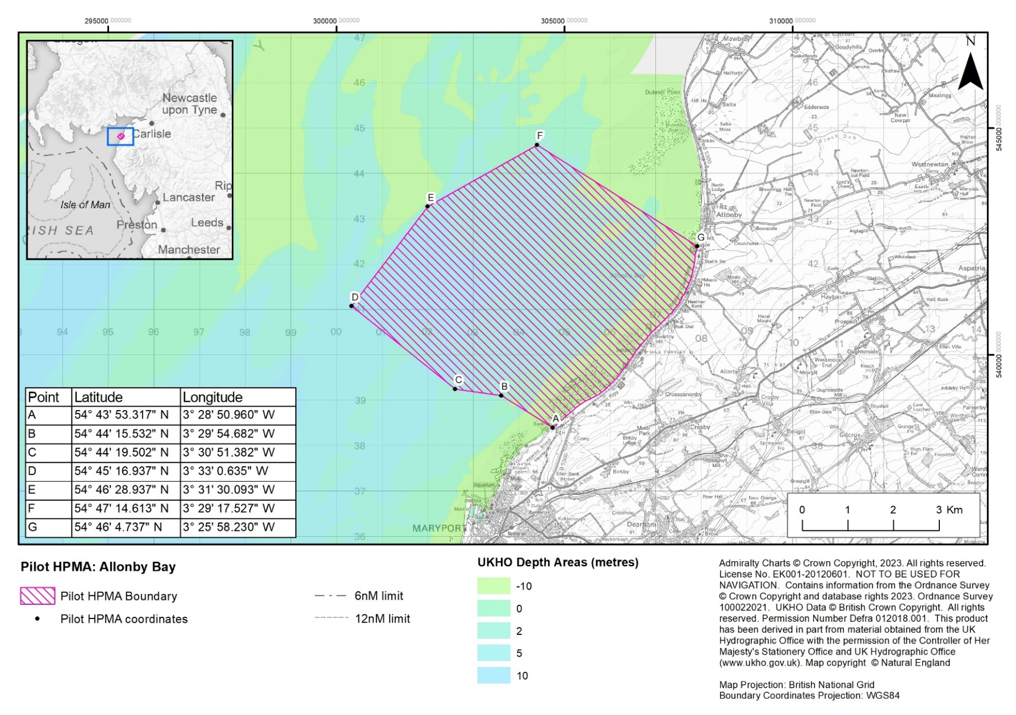
Figure 1. Candidate HPMA Allonby Bay proposed boundary and coordinates.

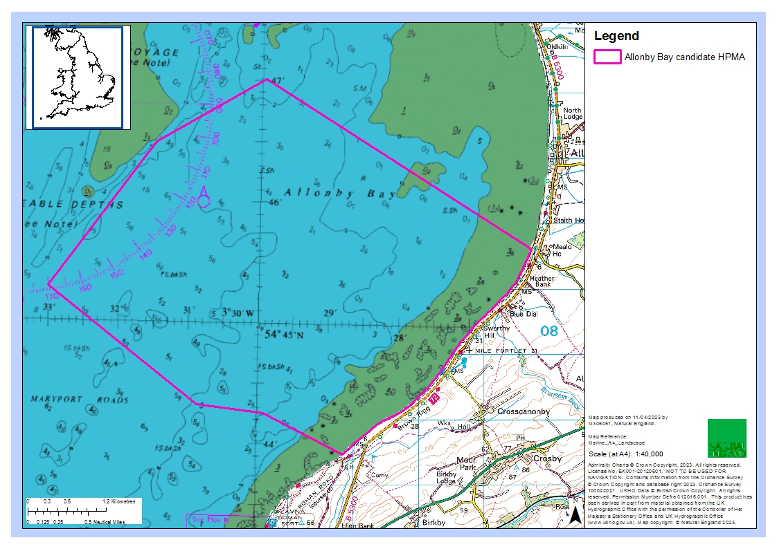
Figure 2. Candidate HPMA Allonby Bay chart datum.
Allonby Bay consists of a mix of habitats, characteristic of an environment that is subject to dramatic currents and tides. The seabed consists of a range of rocky habitats and sediment dominated habitats, including mudflats, sandbanks, reefs, peat and clay exposures, and biogenic reefs (Figure 3).

The nutrient-rich sediments, dense mussel beds and intertidal rocky habitats in this area attract large densities of shore birds including species such as curlew and oystercatcher. The biodiverse subtidal habitats here provide a food source for fish species, such as flat fish and nursery areas for other species such as bass, cod and herring. In turn, these fish species attract diving, foraging seabirds including guillemots, gannets and razorbills. There is also one of the best examples of honeycomb Sabellaria alveolata reefs in the UK within the site, creating a complex sediment network of tubes attached to rock creating vital habitat for crustacea and molluscs.

Previously recorded habitats in the Allonby Bay MCZ include:
- Moderate energy littoral rock
- Low energy littoral rock
- Features of littoral rock (rockpools/ ephemeral algae)
- Littoral sand and muddy sand
- Littoral biogenic reefs
- Features of littoral sediment (ephemeral algae)
- High energy infralittoral rock
- Moderate energy infralittoral rock
- Moderate energy circalittoral rock
- Sublittoral coarse sediment
- Sublittoral sand
- Sublittoral mud
- Sublittoral mixed sediments
- Sublittoral biogenic reefs

A designation order covering a HPMA will set out the protected feature and the conservation objectives applicable within the HPMA site boundary. The protected feature is: “The marine ecosystem, habitats and species of flora and fauna, abiotic elements, and their supporting ecosystem function and processes, including the seabed, water column and sea surface, within the site boundary.” The proposed conservation objective for all pilot HPMAs, including Allonby Bay is: “To achieve full natural recovery of the structure and functions, features, qualities and composition of characteristic biological communities present within HPMAs and prevent further degradation and damage to the marine ecosystem subject to natural change.”

Natural England and JNCC advise within an HPMA:
- The ecosystem is allowed to fully recover in the absence of damaging activities such that:
  - The ecosystem structure consists of a diverse range of benthic and pelagic communities, habitats and species, including biotic and abiotic components of the ecosystem. These fulfil a variety of functional roles, including supporting key life cycle stages and/or behaviours of marine species.
  - The physical, biological and chemical ecosystem processes and functions proceed unhindered, so that the site realises its full ecological potential to deliver goods and services, including habitats and species considered important to the long-term storage of carbon, and habitats and species important for flood and erosion protection.
  - The ecosystem is resilient to change and stressors.

- Any ecosystem changes brought about by the process of removing anthropogenic pressures should be considered in the context of a naturally recovering ecosystem.
- The HPMA supports our understanding of how marine ecosystems change and recover in the absence of impacting activities

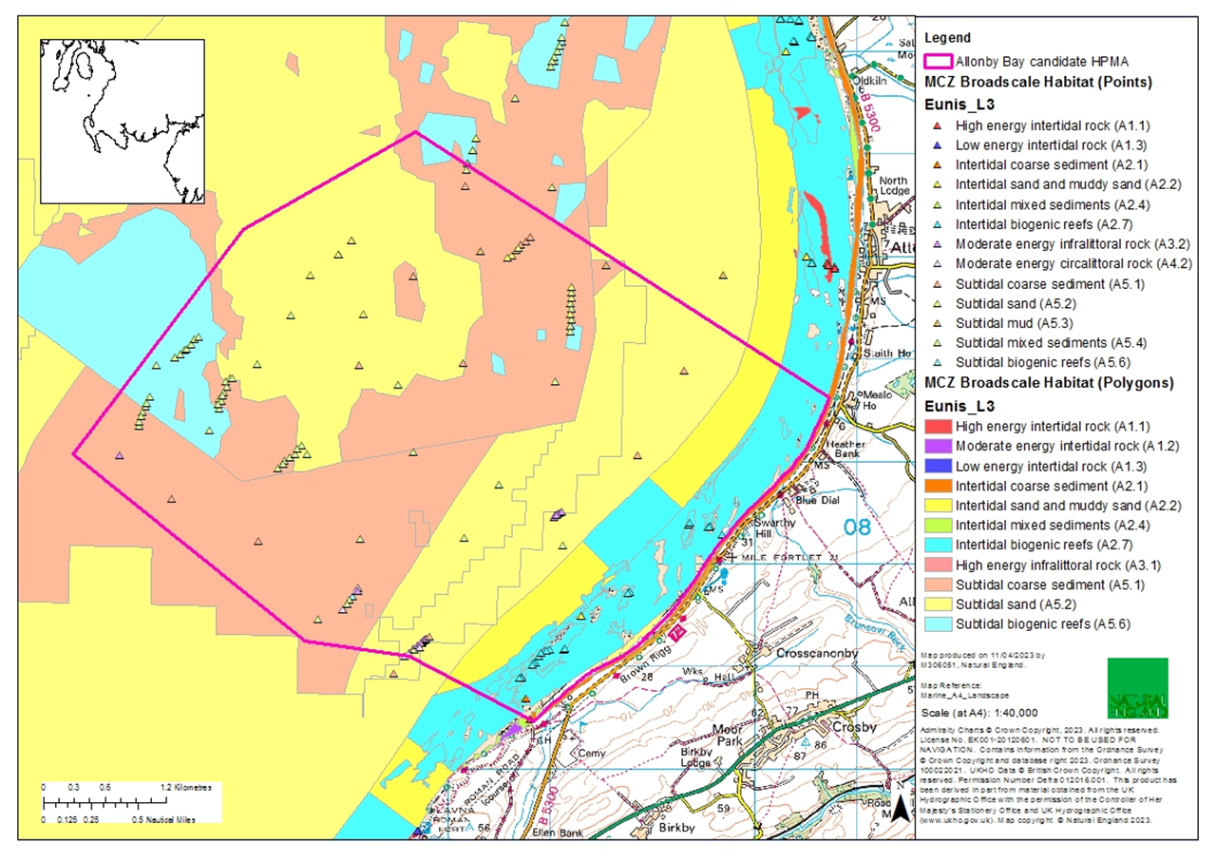
Figure 3. Current map of the broadscale habitats in Allonby Bay with the candidate HPMA boundary.
1.2 Previous Surveys

Previous bathymetry and backscatter data were collected in Allonby Bay in 2009 by Admiralty CHP (Figure 4 and Figure 5). Defra commissioned a number of surveys to provide supplementary information as part of the MCZ designation process. The Environment Agency carried out habitat characterisation surveys (grab sampling and drop camera) in February and March 2012 for Allonby Bay MCZ (Godsell & Fraser, 2013) (Figure 6 and Figure 7).
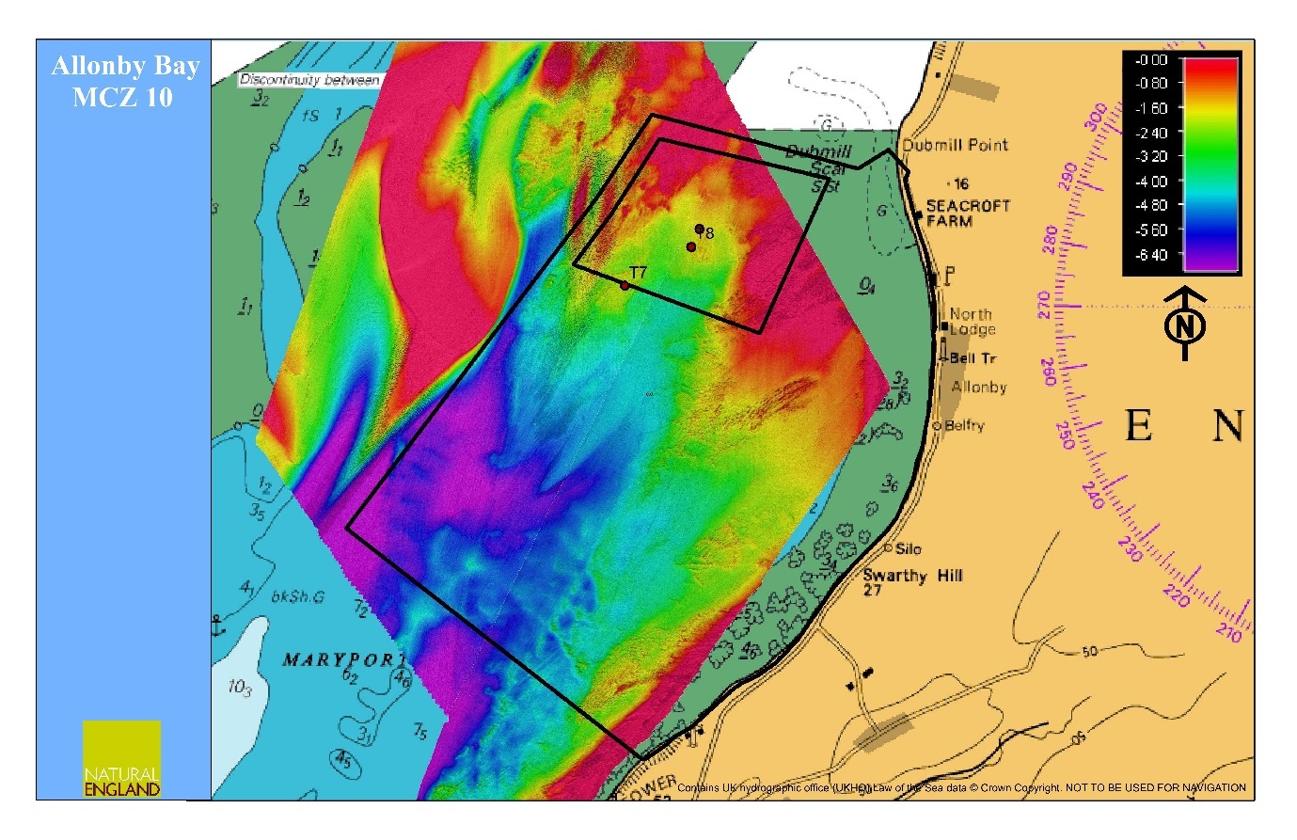
Figure 4. Bathymetry for Allonby Bay MCZ (Admiralty CHP, 2009)
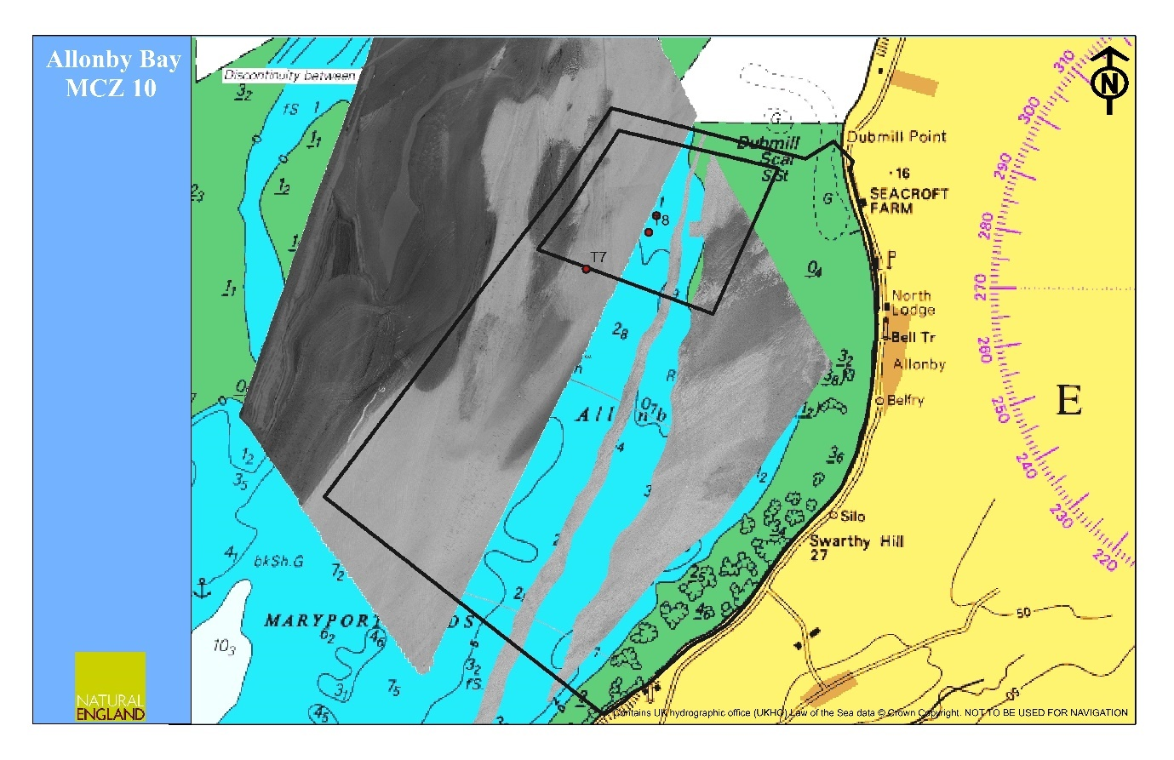
Figure 5. Incomplete backscatter for Allonby Bay MCZ (Admiralty CHP, 2009)

Figure 6. Benthic habitat characterisation for Allonby Bay MCZ using drop camera data (EA, 2013)

Figure 7. Broad Scale Habitat (BSH) descriptions based on a modified Folk seabed sediment classification system recorded during the Allonby Bay rMCZ survey (EA, 2013)

Aims & Objectives

Natural England is commissioning acoustic survey work in summer 2023 to better understand the extent and distribution of subtidal broad-scale habitats in Allonby Bay candidate HPMA.
Natural England will let a separate tender for further ecological survey work to ground-truth (DDV/grab sampling) the habitat map produced from this project.

The key aim of this project is to:
- Collect multibeam echosounder data to create benthic habitat maps in Allonby Bay candidate HPMA, at 100 % seabed coverage.

Due to the very shallow nature of the site, it is expected that the successful contractor will undertake a multibeam echo sounder survey, rather than use side scan sonar. Multibeam reflectivity should be adjusted for habitat discrimination, and backscatter should be collected which will be used to define different sedimentary broad scale habitats and identify any areas of subtidal reef and Sabellaria.
Using acoustic survey techniques, the objective of this project is to improve our knowledge and understanding of the extent and distribution of subtidal broad scale habitats in Allonby Bay candidate HPMA.

Environmental indicators have been identified to measure change and assess recovery over time in HPMAs. Biotic and abiotic attributes are set out for each indicator and consider a whole-site management approach (Annex 1).

Primary indicators to monitor in this survey:
- Benthic habitats (extent and distribution)

Technical and survey requirements
3.1 Vessel

The vessel needs to be large enough that it represents a stable platform which minimises motion however it must be manoeuvrable and of sufficiently small draft that it can operate in very shallow open coast environments.

3.2 Multibeam

  - The multibeam survey should meet at least IHO order 1a requirements.
  - The multibeam or swath sonar should utilise a very wide swath width due to the shallow water environment.
  - The environment may represent a challenging underwater environment with regard to multibeam data acquisition. These challenges will be related to the high levels of suspended sediment and material in the water column, high tidal flows (creating cavitation) and mobile or fluid seabed sediments. The sonar settings are best defined by the surveyor in the field but we would request that angular filters are constantly monitored and if necessary adjusted to ensure the best balance of seabed coverage and data quality. The reporting should include the detailed settings used throughout the survey to ensure repeatability which could be included in an annex.
  - The angular offsets and latency (if required) of the multibeam will need to calibrated at or close to the survey site prior to survey commencement through a patch test. The results of this test should be presented in the reporting
  - The salinity profile of Allonby Bay cHPMA may be variable depending on rainfall and state of tide, with the potential for well-defined transient pycnoclines. It is essential that full depth sound velocity profiles are taken at regular intervals throughout the survey and applied to the relevant periods of survey. The frequency at which sound velocity profiles are taken will depend on the conditions at the time and location of survey. The reporting should outline how many/when velocity profiles are taken and additionally it should present a typical sound profile.
  - The survey will be undertaken in summer, ideally in June or July to reduce exposure to westerly winds. High quality motion compensation may be required to both prevent artefact in the data and to extend the potential weather windows. Motion compensation is required for heave, pitch, roll and yaw. The reporting will need to outline what motion reference equipment was used and present the results of the dimensional control survey used to obtain the sensor offsets.

3.3 Horizontal and Vertical Control

  - Horizontal datum should be UTM 30 N
  - The tidal range in the survey is moderate to high, as a consequence accurate and regular tidal correction will be vital to prevent significant artefact and produce an accurate representation of bathymetry. The reporting should outline what method of tidal correction is chosen i.e. tide gauge or RTK GPS positioning, what the accuracy of the tidal correction is and how frequently the tidal correction was updated.
  - The report should outline what vertical datum i.e. local chart datum is used and what parameters were used to undertake any datum shift i.e. the separation value between chart datum and ordnance datum.
  - The horizontal accuracy should be 2m or less when collecting multibeam data to ensure positional accuracy, lack of artefact and high resolution in areas of overlapping data. This is also essential to achieve IHO order 1a standard.

3.4 Finalisation of survey design
Natural England will obtain permission from seabed owners, Port Authorities, or leaseholders for survey work as necessary.

- Before the survey is carried out the contractor will discuss any pre-survey work with the project lead, including checking information about the site and identifying sources of relevant information.
- Finalise the sampling strategy in conjunction with the project lead after the contract is awarded but before survey is started.

3.5 Health and safety requirements

All risk assessments for contracts need to be seen and signed off by the project leads (ideally when presented with then project plan), as part of the contract management process.

Downtime
The works must be undertaken in summer when there is a low risk of exposure from westerly winds and swells. There may be some downtime incurred due to poor weather thus the tender must outline what proportion of downtime they predict throughout the course of the survey. This percentage downtime figure should be used to provide a lump sum costing which covers this risk and acts as an insurance against further unpredicted downtime. Natural England will not pay for downtime resulting from mechanical failure or personnel issues.

Natural England requires that the contract be assigned through an all-inclusive single price agreed at the outset of the project. The final quoted price should incorporate contingencies any potential risks or weather downtime likely to incur further costs after the contract has been awarded.

Please note that to ensure we have capacity to mitigate and manage any potential risks, potential bidders are asked to ensure to include these potential risks in the breakdown of costs under item 11 in Annex 1B as a separate item if they see this being utilised.

Please note that the total approved budget for the work is £100,000 to £150,000.

Survey outputs
This contract shall be managed on behalf of the Authority by Sarah Meek

  - Reporting requirements

The successful contractor should produce a report outlining

- The detailed survey methodology used,
- A timeline of events and actions
- Any difficulties encountered
- A brief discussion and interpretation of the data i.e. obvious features, areas of similar sediment type, areas of sediment change, identification of seabed features.

Draft reports should be provided in electronic MS Office Word *.DOCX format for comment. A template and guidance exists for writing Natural England commissioned reports and will be sent to the contractor upon award of the tender. All reports should retain a clear suggested citation stating that it is a ‘Report to Natural England.’

  - Data requirements
Appropriate survey level metadata should be supplied in a format acceptable for the corresponding MEDIN Data Archive Centre (DAC). All interpreted products following data analysis should accompany the draft report; these will include:
- All GIS datasets need to be provided in ESRI ArcGIS format compatible with ArcGIS version 10.2 and have attached metadata.
- As specified in the MESH DEF, data files must be provided as ESRI Shapefiles using geographic coordinates (lat/long) and the WGS84 datum. If the datasets supplied are in other projections, transformation using the appropriate petroleum (EPSG) transformation should be carried out as part of the data formatting procedure.
- If not included in the GIS data layers listed above all sampling locations and links to data obtained should also be included as a single GI layer.

Natural England are a member of the UK Centre For Seabed Mapping and also endorses the MEDIN initiative. Any data gathered/derived as part of this project must be submitted to Natural England in MEDIN data standards through Data Archive Centres (DACs) with metadata meeting the MEDIN metadata discovery standard (MEDIN discovery metadata standard). A MEDIN compliant metadata XML file must be provided for each survey.

All the cleaned and processed bathymetric data should be gridded (1 metre bins) and presented to Natural England as a .xyz file.

A large-scale 3D digital terrain model (DTM) of Allonby Bay cHPMA should be created by gridding the data to (1 m) and interpolating the bathymetry. The interpolation technique and parameters used should be selected by the contractor to best display the bathymetric features of the data. The DTM should be used to create a colour filled contour image, using the most appropriate contour spacing, colours and lighting effects which best display the features of the area. The colour coded contour image (with key) should be presented to Natural England in a georeferenced file format capable of being displayed in the GIS software ESRI© ArcGIS 10.2 and Fledermaus v7.2

The backscatter data should be optimised to allow for clear visual interpretation and mosaiced. The final image should be presented to Natural England in a georeferenced file format capable of being displayed in the GIS software ESRI© ArcGIS 10.2 and Fledermaus v7.2. Due to the large size of the survey area the backscatter data should be divided into subsections which will allow a reasonable level resolution of the imagery when plotted on a chart.

High resolution screen grabs of any physical interest feature displayed by the backscatter imagery e.g. trawl marks, stony areas, possible reef, or areas of sediment change, should be presented in a supplementary document giving a brief caption on the image’s location and the feature it shows.

All data products and electronic files must be appropriately named so they sufficiently describe the contents and are not purely a numerical value. All products should be named appropriately so that they can be clearly linked to the report/project.

The NE Project Officer will raise purchase orders to cover the cost of the services and will issue to the awarded supplier following contract award. Upon completion of the survey, the first of two staged payments for this contract will be released. Final payment will be issued upon completion of the final report.

Indicative Timeline for Project Delivery

Event | Date
Successful contract awarded | 21st August 2023
Finalise sampling design | 31st August 2023
Produce final project plan | 1st September 2023
Survey to be completed by | 30th September 2023
Submission of brief field/survey report by | 1st November 2023
Draft final report and associated products to be provided by | 15th January 2024
Final report, biotope maps and output to be delivered | 12th February 2024

Any delays to this timetable should be discussed with the Natural England Project Officer and delays not outside the control of the contractor will be penalised.

7 Other

In support of this contract NE will provide the winning supplier with:

- Project support from dedicated Project Officer
- Opportunity to feedback and discuss progress and the project
- Supporting GIS datasets (if required) under licence for use in this contract:
  - Base map data from Ordnance Survey
  - Aerial photography from Next Perspectives
  - S-57 vector data from the UK Hydrographic Office (in ArcGIS format)*
  - Raster charts from Oceanwise*
*(Not to be used for Navigation)

Please see the following site for information on how to obtain access to the GI datasets listed above: https://www.gov.uk/how-to-access-natural-englands-maps-and-data

- Additional reports to help with the analysis and report, such as those listed in Section 1.2

The intellectual property rights and copyright for all products (including photographs) will lie with Natural England. All data will be made available by Natural England under the Open Government Licence at the end of the project via www.data.gov.uk and the MEDIN Data Archiving Centres.

8 References

Davies, J., Baxter, J., Bradley, M., Connor, D., Khan, J., Murray, E., Sanderson, W., Turnbull, C. & Vincent, M., (2001). Marine Monitoring Handbook, 405 pp, ISBN 1 85716 550 0. Available online at: http://jncc.defra.gov.uk/page-2430

Godsell, N. & Fraser, M. (2013). Allonby Bay rMCZ Survey Report. Environment Agency. Project Code: C5784A

JNCC (2004). Common Standards Monitoring Guidance for Marine, Version August 2004, ISSN 1743-8160. Available online at: http://jncc.defra.gov.uk/page-2236

9 Contract Award Criteria
We will award this contract in line with the most economically advantageous tender (MEAT) as set out in the following award criteria:

Criteria | Weighting | Scores
Cost | 50% | Ranked in cost order
Proposed schedule of work and availability/capacity (Q1) | 25% | Using scoring criteria set out below
Proposed survey design methodology - Quality of proposal based on the survey design meeting the requirements of the new proposal, number of samples, statistical rigour and power of the design. (Q2) | 10% | Using scoring criteria set out below
Successful collaboration with contractors who will be delivering Drop Down Video and Grab survey (Q3) | 10% | Using scoring criteria set out below
The ability of the sampling strategy to be replicated in future years or for other applications (Q4) | 5% | Using scoring criteria set out below

For a score of 100: Excellent - Response is completely relevant and excellent overall. The response is comprehensive, unambiguous and demonstrates a best-in-class thorough understanding of the requirement and provides details of how the requirement will be met in full.
For a score of 70: Good - Response is relevant and good. The response demonstrates a good understanding and provides details on how the requirements will be fulfilled.
For a score of 50: Acceptable - Response is relevant and acceptable. The response provides sufficient evidence to fulfil basic requirements.
For a score of 20: Poor - Response is partially relevant and/or poor. The response addresses some elements of the requirements but contains insufficient / limited detail or explanation to demonstrate how the requirement will be fulfilled.
For a score of 0: Unacceptable - Nil or inadequate response. The response fails to demonstrate an ability to meet the requirement.

9.1 Disclosure

All Central Government Departments, their Executive Agencies and Non Departmental Public Bodies are subject to control and reporting within Government. In particular, they report to the Cabinet Office and HM Treasury for all expenditure. Further the Cabinet Office has a cross-Government role delivering overall Government policy on public procurement, including ensuring value for money and related aspects of good procurement practice.

For these purposes, the Authority may disclose within Government any details contained in your quotation. The information will not be disclosed outside Government during the procurement.

In addition, the Authority is subject to the Freedom of Information Act 2000 and the Environmental Information Regulations 2004, which provide a public right of access to information held by public bodies. In accordance with these two statutes, the Authority may be required to disclose information contained in your quotation to any person who submits a request for information pursuant to those statutes.

By submitting a quotation you consent to these terms as part of the procurement.

9.2 Disclaimers
Whilst the information in this RFQ and any supporting information referred to herein or provided to you by the Authority have been prepared in good faith the Authority does not warrant that this information is comprehensive or that it has been independently verified.

The Authority does not:

- make any representation or warranty (express or implied) as to the accuracy, reasonableness or completeness of the RFQ;

- accept any liability for the information contained in the RFQ or for the fairness, accuracy or completeness of that information; or

- accept any liability for any loss or damage (other than in respect of fraudulent misrepresentation or any other liability which cannot lawfully be excluded) arising as a result of reliance on such information or any subsequent communication.

Any supplier considering entering into contractual relationships with the Authority following receipt of the RFQ should make its own investigations and independent assessment of the Authority and its requirements for the goods and/or services and should seek its own professional financial and legal advice.

Protection of Personal Data

In order to comply with the General Data Protection Regulations 2018 the contractor must agree to the following:

- You must only process any personal data in strict accordance with instructions from the Authority
- You must ensure that all the personal data that we disclose to you or you collect on our behalf under this agreement are kept confidential.
- You must take reasonable steps to ensure the reliability of employees who have access to personal data.
- Only employees who may be required to assist in meeting the obligations under this agreement may have access to the personal data.
- Any disclosure of personal data must be made in confidence and extend only so far as that which is specifically necessary for the purposes of this agreement.
- You must ensure that there are appropriate security measures in place to safeguard against any unauthorised access or unlawful processing or accidental loss, destruction or damage or disclosure of the personal data.
- On termination of this agreement, for whatever reason, the personal data must be returned to us promptly and safely, together with all copies in your possession or control.

General Data Protection Regulations 2018
For the purposes of the Regulations the Authority is the data processor.

The personal information that we have asked you provide on individuals (data subjects) that will be working for you on this contract will be used in compiling the tender list and in assessing your offer. If you are unsuccessful the information will be held and destroyed within two years of the award of contracts. If you are awarded a contract it will be retained for the duration of the contract and destroyed within seven years of the contract’s expiry.

We may monitor the performance of the individuals during the execution of the contract, and the results of our monitoring, together with the information that you have provided, will be used in determining what work is allocated under the contract, and in any renewal of the contract or in the award of future contracts of a similar nature. The information will not be disclosed to anyone outside the Authority without the consent of the data subject, unless the Authority is required by law to make such disclosures.
Annex I: Evaluation questions
These are indicators identified as monitoring areas from which we will assess the success of HPMA designation. These are provided for context of the work only.
EQ 1: To what extent has the designation and management of HPMAs achieved recovery in the designated areas
EQ 1.1: How has the marine environment in the HPMA and the species it supports changed since designation?
EQ 1.2: How do these changes represent a trajectory towards ‘recovery’ and achieving specific conservation objectives?
EQ 1.3: How has HPMA designation and management affected the ability of marine assets to deliver ecosystem services?
EQ 1.4 How has HPMA designation and management affected the ability of marine assets to deliver ecosystem services that were selection criteria for HPMAs?

Linked Factor | Indicators of Change
Benthic, biodiversity, abundance and function inside/outside the HPMA | Extent, diversity and distribution of habitats important for conservation and ecosystem services have changed eg sea grass beds, reef, blue mussel beds, intertidal rock, maerl beds, reefs, shallow subtidal sediment, shelf subtidal sediment, subtidal rock Including 'Essential Fish Habitat' - ie habitat supporting key life stages of commercial fish species and flagship and rare species
Benthic, biodiversity, abundance and function inside/outside the HPMA | Changes in the structure of habitats e.g. shoot density of seagrass
Benthic, biodiversity, abundance and function inside/outside the HPMA (Commercial) | Extent and distribution of biogenic reef or supporting habitat
Blue Carbon | Extent and distribution of (% cover) blue carbon habitats
Benthic, biodiversity, abundance and function inside/outside the HPMA | Extent and distribution of habitats with a role waste remediation eg seagrass, saltmarsh reef (kelp),

Appendix 1A: Technical Questions
Quotes will be evaluated for both technical and commercial merit using the evaluation criteria below to determine which quote is the most economically advantageous submission.
Ref: Allonby Bay cHPMA Acoustic Survey
Project: Allonby Bay HPMA monitoring

Technical Questions – 50%

- 1. Please supply a proposed schedule of work, stating the timescales you will be able to execute and deliver the products specified in this RFQ.
- Use Section 6 - Timeline information as a guide to provide indicative project delivery dates.
- In any event the survey MUST be completed by the end of October 2023.

Your response should include:
- A statement on your availability and capacity to mobilise a survey team
- Your methodology to deal with adverse weather to ensure data quality
- Commentary on key risks eg availability of staff, equipment

Page Limit: 5 pages - 12-point Arial Font
Question Weighting - 25%
2. Detail your proposed survey design methodology, and in particular highlight any differences from that suggested in our requirements (this RFQ).

Page Limit: 3 pages - 12-point Arial Font
Question Weighting - 10%

    - Provide a summary of what measures you would put in place to ensure successful collaboration with contractors who will be delivering Drop Down Video and Grab survey information for this site.

Page Limit: 2 pages - 12-point Arial Font
Question Weighting - 10%
    - Provide a summary of how the sampling strategy can be replicated in future years or for other applications

Page Limit: 2 pages - 12-point Arial Font
Question Weighting - 5%
Appendix 1B: Costings

Ref: Allonby Bay cHPMA Acoustic Survey
Project: Allonby Bay HPMA monitoring

Commercial Questions 50%
Please create new lines where necessary.

Costs
ITEM | SPECIFICATION TITLE | Staff to deliver work | No. of days | UNIT PRICE (ex. VAT) £ | TOTAL PRICE  (ex. VAT) £
1 | Project set up/design and review
2 | Pre survey planning and design
3 | Initial project meetings
4 | Equipment requirements and duration
5 | Field work
6 | Data analysis and mapping (if required)
7 | GIS data to electronic format
8 | Travel and subsistence
9 | Customer support/contract management
10 | Please detail any assumptions made during pricing
11 | Other – please detail, including contingency planning for weather downtime/equipment failure etc.  Provide a separate costing using the headings provided in this table for any additional elements/effort that may be required to incorporate WER methodologies.
 | TOTAL COST

SUBMITTED BY:
Contractor name
Address
Email
Telephone

https://medin.org.uk/data-standards

