

BIDDER TRAINING

UK SHARED BUSINESS SERVICES EMPTORIS TRAINING MODULE

- SCOPE OF TRAINING

The scope of this training module will include

  - Logging on the system
  - Committing to respond to a requirement
  - Reviewing RFx attachments
  - Reviewing RFx messages
  - Answering questionnaires
  - Receiving clarifications
  - Submitting your bid
  - Downloading your response

- LOGGING ONTO THE SYSTEM

It is assumed that the Bidder has a Login to Emptoris. If you do not have a login please use ‘Bidder logging in – first time’ for guidance on how to obtain a login and change your password.

Bidders who are invited into a sourcing exercise will receive an email similar to this:

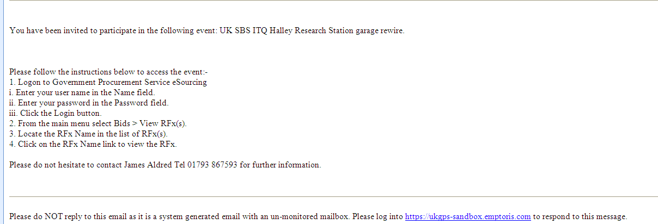
Here are your login instructions and
contact at UK SBS
Login
URL

Bidders will now need to login to the system.

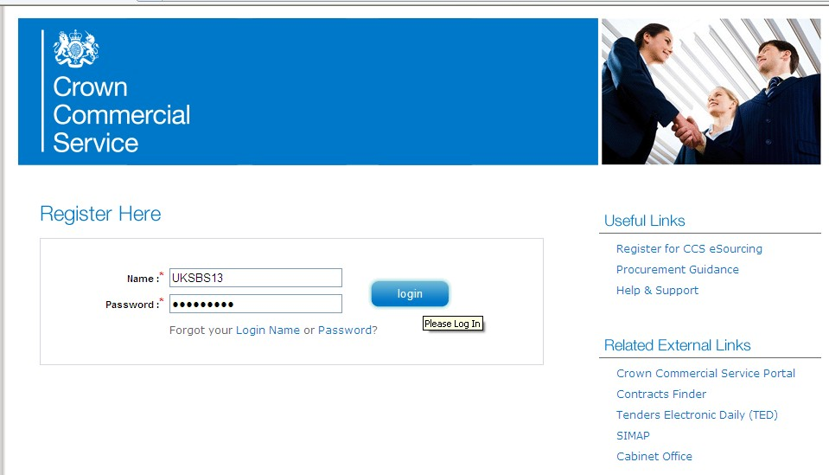

Bidders will now need to review the system usage terms for the e-sourcing suite. Access to the system will only occur if you agree to the system usage terms:
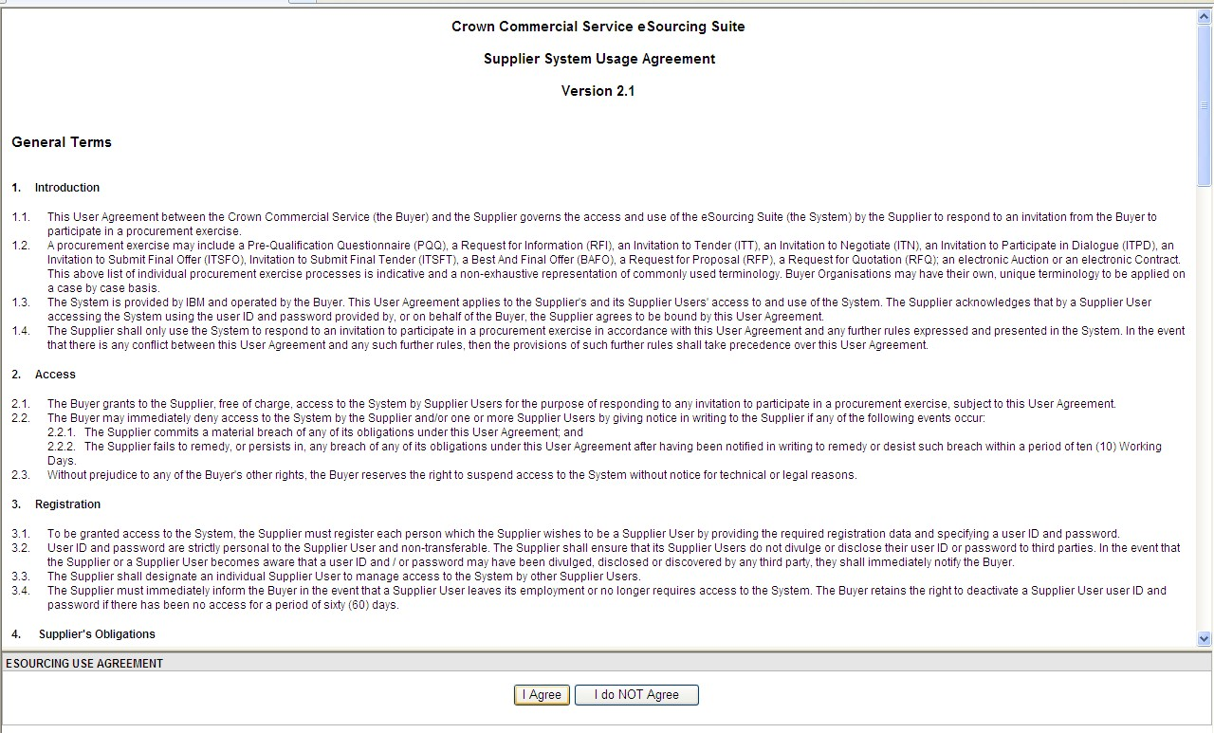

- COMMITING TO RESPOND TO A REQUIREMENT

Bidders will have access to all the sourcing activities they have been invited to and can click on ‘view/respond to RFx’ to confirm their interest.

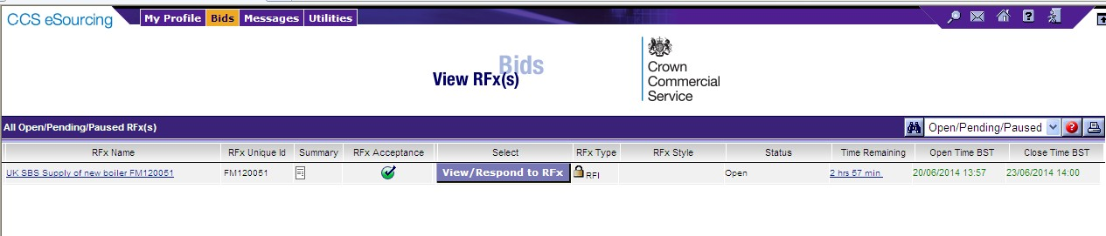

Bidders can elect to ‘Accept’ or ‘Decline’ to Bid from here:

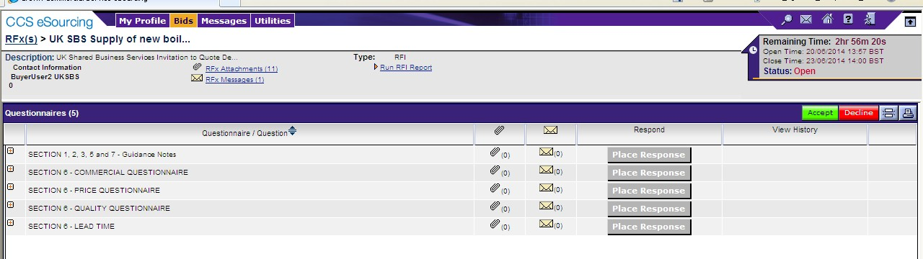

- REVIEWING RFx ATTACHMENTS

Bidders will now face a page similar to this. Locations of key areas to consider are attached. The + icons indicate the questionnaire can be expanded to reveal the questions below.
Place response is clicked on to place a response against a questionnaire. RFx attachments and RFx message are available to view.

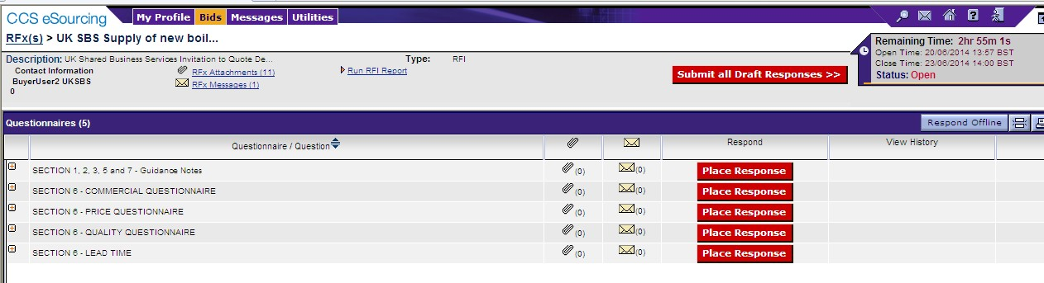

It is STRONGLY recommended that prior to commencing with completion of the questionnaire responses Bidders review all of the RFx attachment so they have a clear understanding of the requirement, evaluation model, price schedule, contract terms, and any associated attachments to questions.

Generally attachments to questions will have a naming convention at the start of the attachment name (e.g. AW5.2 Price Schedule) to help Bidders associate the attachment with the relevant clarification.

Bidders should also be aware that clarification answers to the bid documents will be posted to RFx attachments on a regular basis. Please regularly check for updates. Note typically the latest set of clarifications will be uploaded and the previous version deleted from the system.

To view attachments:

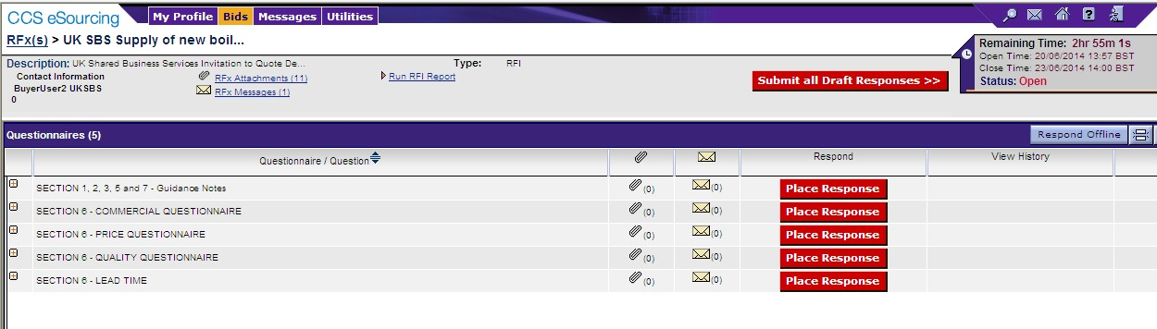
Click here to view
attachments

Bidders will see a screen like this:

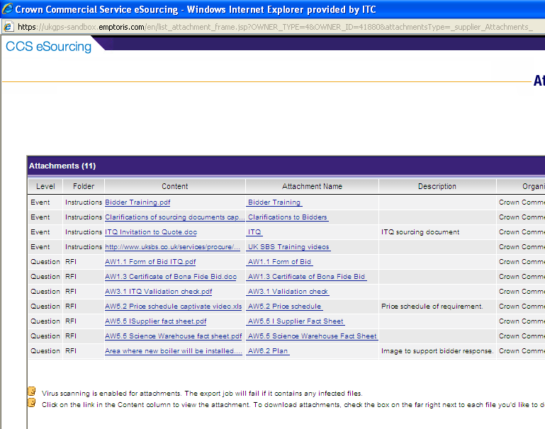
Click on content link to download
training videos and notes and attachments to RFx

They can access the specific attachment by clicking on one of the ‘Content’ hyperlinks.

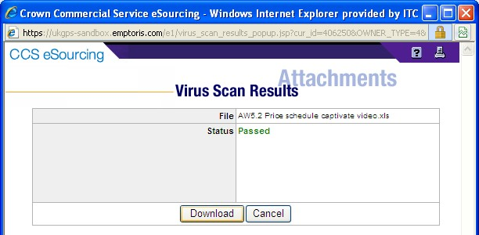

REVIEWING RFx MESSAGES

Bidders can access RFx messages by clicking on the area below:

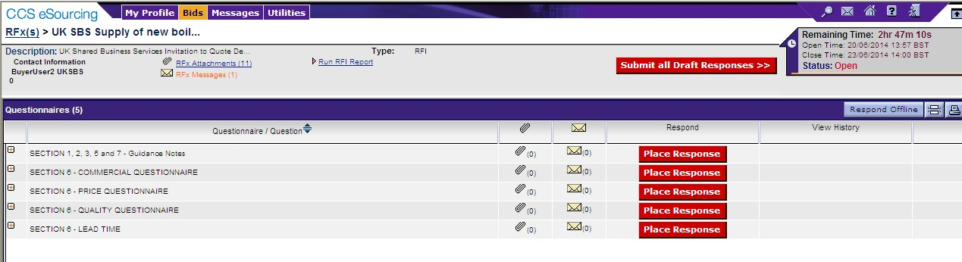

All received messages are in the ‘Received messages’ folder. All messages sent are in the ‘Sent messages’ folder.
All standard system related messages are in the ‘Broadcast messages’ folder.

It is STRONGLY recommended that Bidders review RFx messages before commencing with responding to the questionnaires.

Later in the training we will advise how to contact the UK SBS Category Manager for your procurement if you need to raise any clarifications or have any questions.

ANSWERING QUESTIONNAIRES

In order to answer a questionnaire Bidders need to click on the ‘place response’ button.

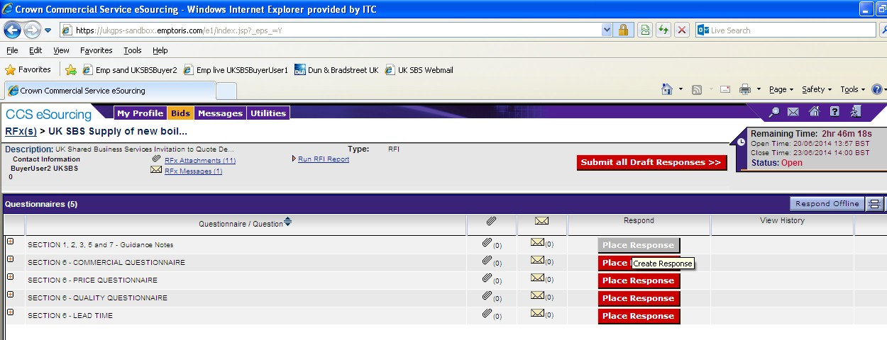

They will then face a screen with questions:

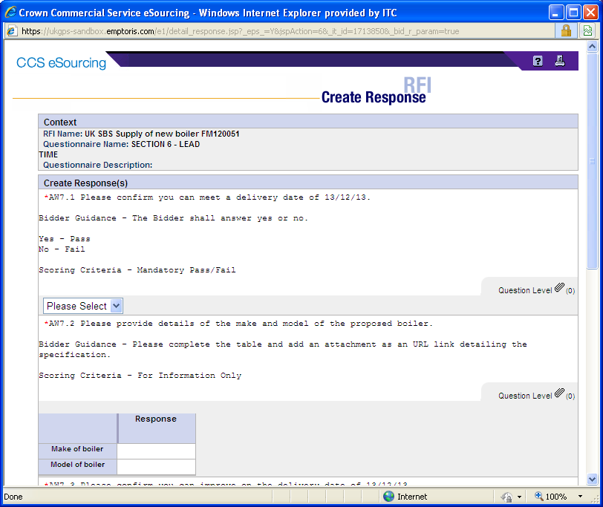

Typically the questions will detail:

  - The question number – these are NOT sequential so do not think there are questions missing.
  - The question detail
  - Bidder guidance – This usually advises if attachments are permissible, word count details, guidance to help with the bid response and any specific information about the evaluation model proposed. Where a question is pass or fail typically Bidders will see the criteria for a pass or a fail.
  - Scoring criteria – This indicates if the question is pass / fail, scoring (and the maximum score available) or for information only.

ALL REQUIRED (*) QUESTIONS WILL NEED TO HAVE SOME TEXT ENTERED IN ORDER TO SAVE YOUR ANSWERS.

Click on the various drop down boxes and complete the various text boxes to reply.

Where an attachment is permissible click on the question level icon and you will see a pop up screen like this. Click on ‘add’ to add an attachment and then go to the bottom of the page and ‘save’. After saving the question level icon will show the number of attachments uploaded against the specific question.

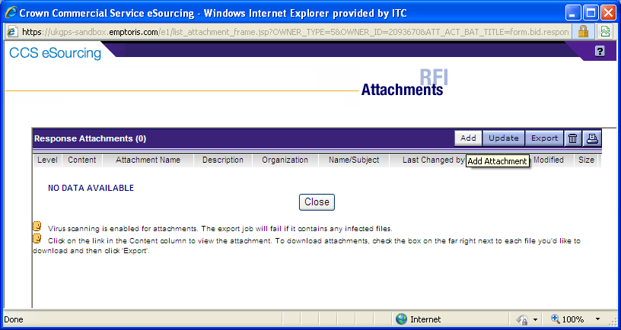

Bidders can add an attachment by clicking on browse and finding their file on their local PC or shared drive. They can change the name presented to UK SBS. It is STRONGLY recommended the Name commences with the question reference (e.g. AW5.2) to ensure we can effectively cross refer answers.

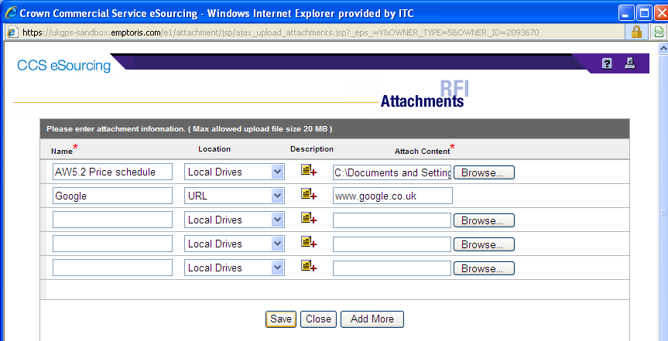

When you have completed a questionnaire and added all the relevant attachments you MUST click on the ‘save’ button.

After saving the question level icon will show the number of attachments uploaded against each specific question. Bidders must check their attachments have been correctly uploaded and embedded in the questionnaire response.

You will then see a message which says ‘changes saved successfully’ at the top of the page.

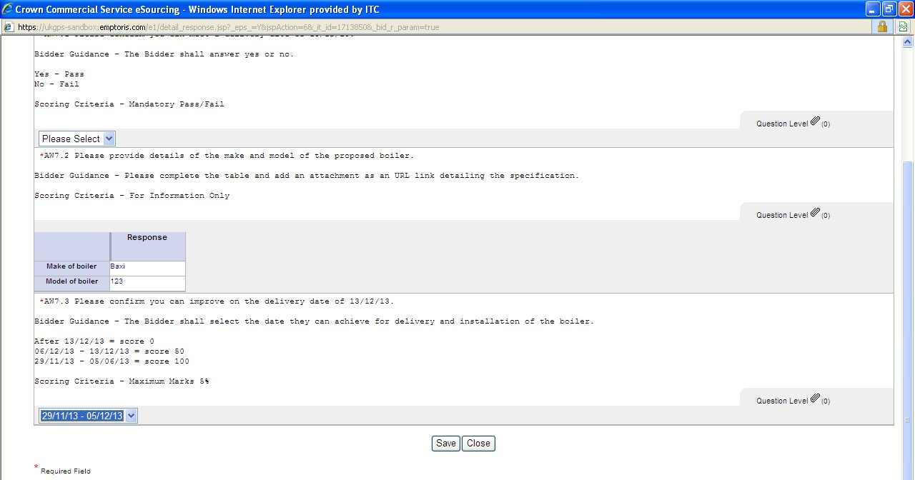

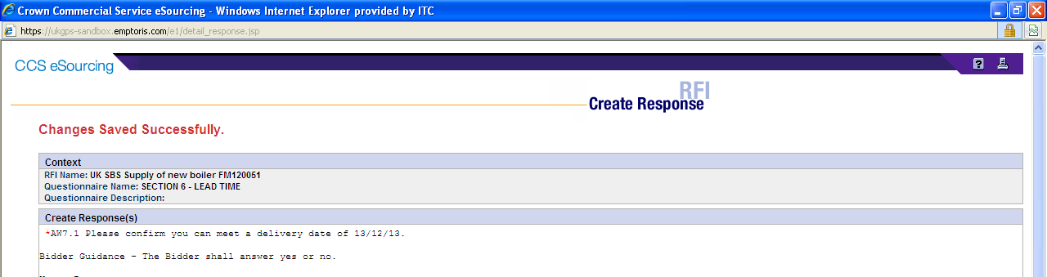

If Bidders do not fill in the entire form you will receive a message which says:

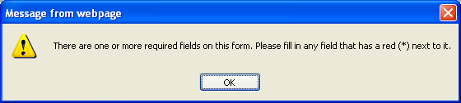

Bidders should find the missing field and provide an answer otherwise all the answers will not be saved.

When complete save and close the questionnaire.

On the questionnaires page you will see the ‘Respond’ field has now gone green, but answers can still be modified until you submit the draft responses.

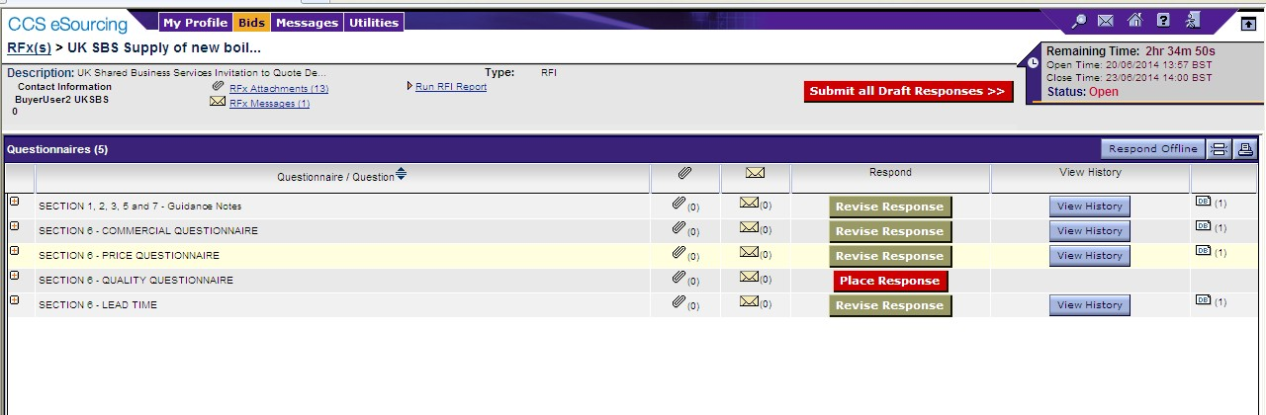

Once all questionnaires are completed you can submit them.

RAISING CLARIFICATIONS

Clarifications can be raised easily in two ways, irrespective of the approach taken it is
crucial that Bidders cross reference their clarification to the relevant question number. Clarification at questionnaire level.
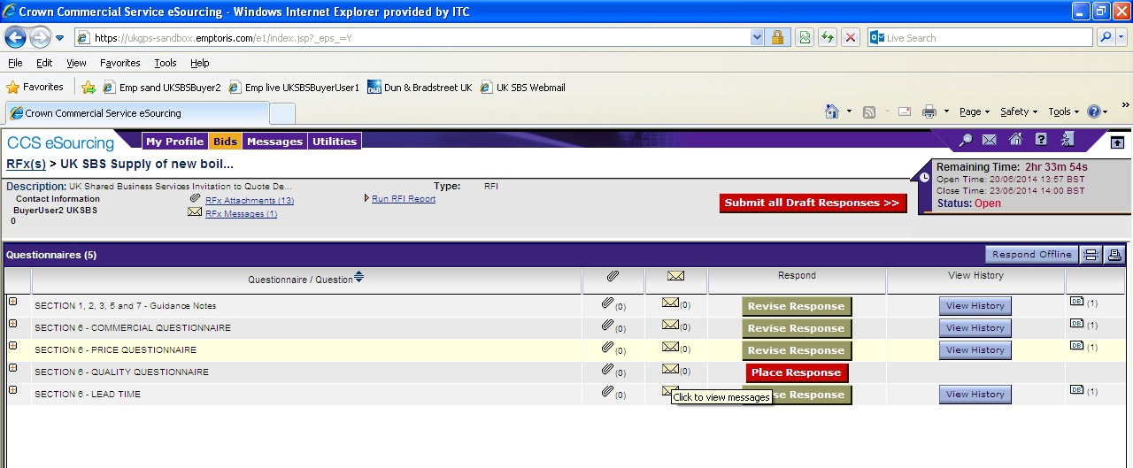
Click on relevant
envelope

You will always see a screen like this with messages in (questionnaire messages), your messages (sent messages) and system messages (broadcast message).

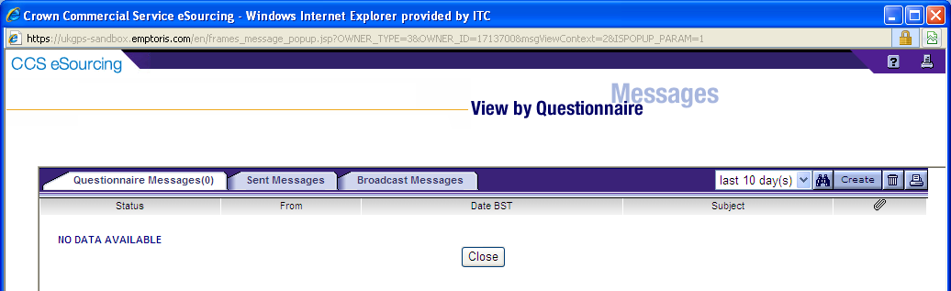

To raise a clarification click on ‘Create’

You will now be able to upload your message and any attachments.

Always send to ‘All hosts’.

Remember to cross reference to the question number and to ‘send’ the document.

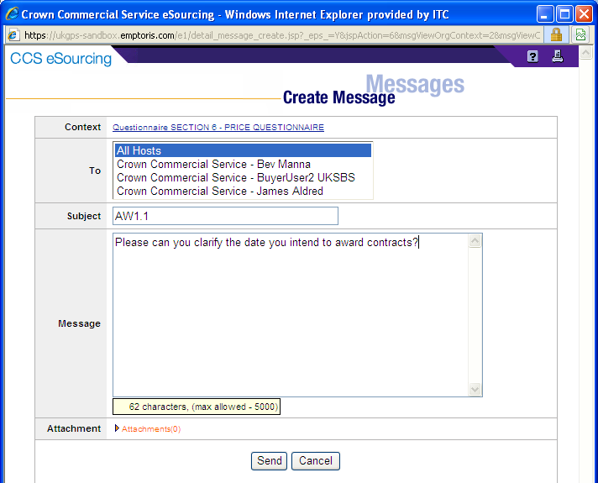
Link to ‘All hosts’
Add question no from
the questionnaire

Bidders can view the question in the sent messages.

They can also filter against all questions, last 30 days, 10 days or last day

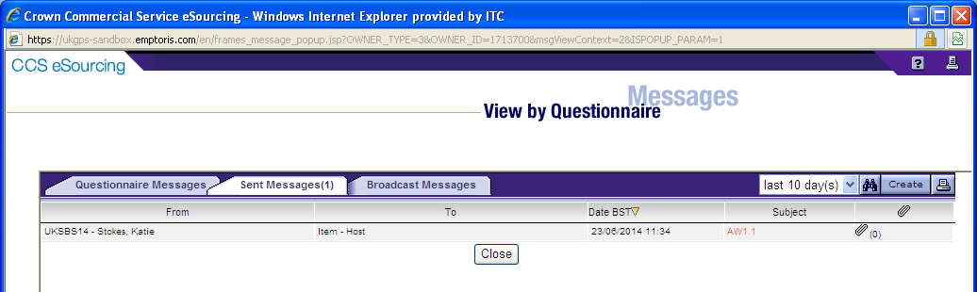

Alternatively Bidders can raise clarifications through RFx messages:

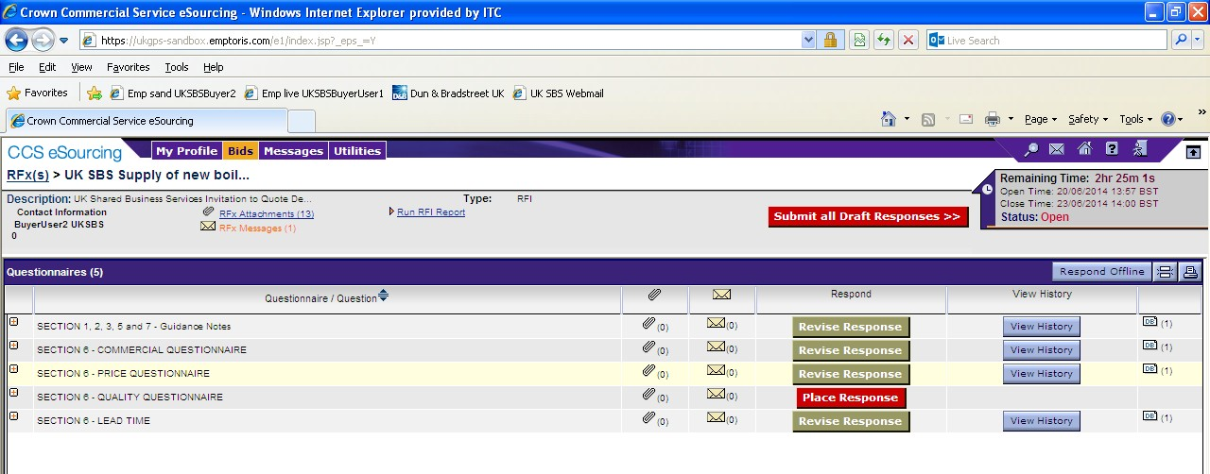
RFx messages

In RFx messages the process is similar to the questionnaire clarifications. Click on ‘create’ to send a new message.
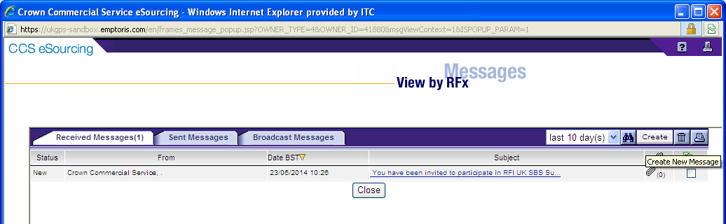

Bidders can upload their clarifications, remembering to send to ‘All hosts’ and including the question number (if relevant) in the subject.

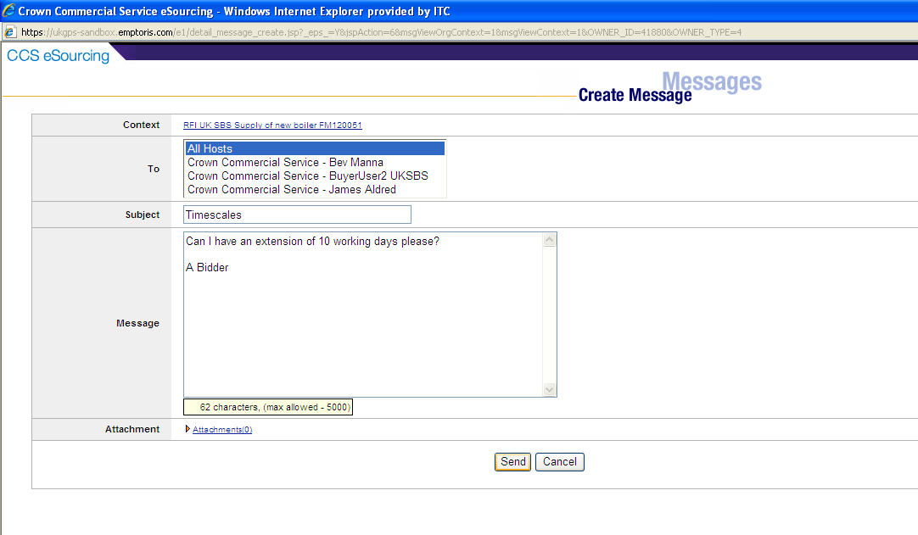In this example it is a general clarification and not associated to a specific question. Remember Bidders can add attachments and must always ‘send’ the clarification.

The clarification can now be viewed in the sent messages folder.

Note the previous clarification raised at questionnaire level is also available to view. The filtering of messages against 1, 10, 30 days or all is still available in this view.
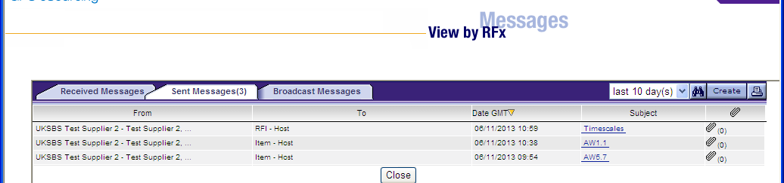

RECEIVING CLARIFICATIONS
Regularly check the RFX attachments folder for clarifications to the procurement. There maybe associated messages also in RFx messages to review.

Note it is the Bidders responsibility to check for clarifications.

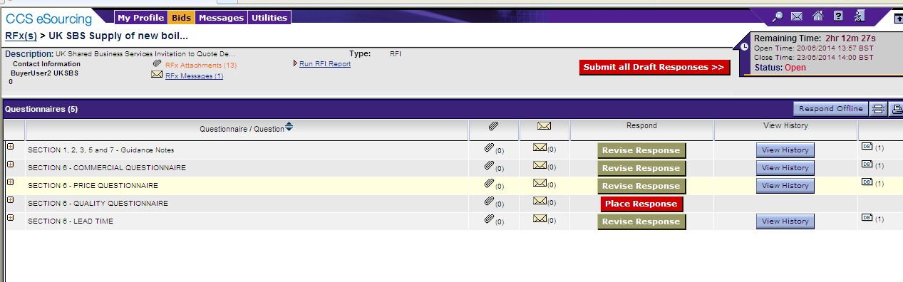

Clarifications will generally be given a document name ‘Clarifications’. Generally only the latest set of clarifications will be uploaded.

Simply click on the content for the relevant file to download it.

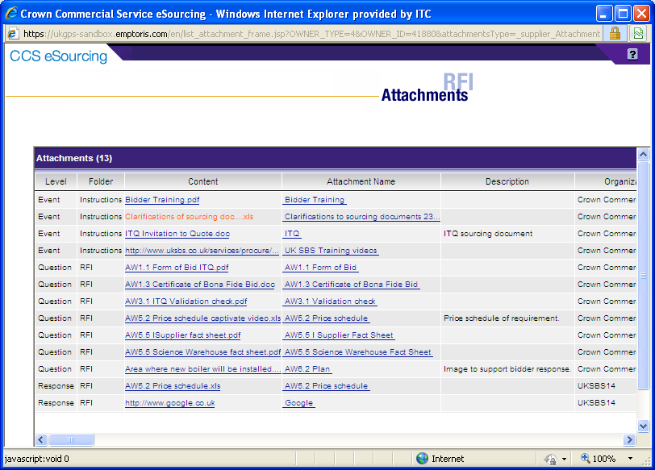

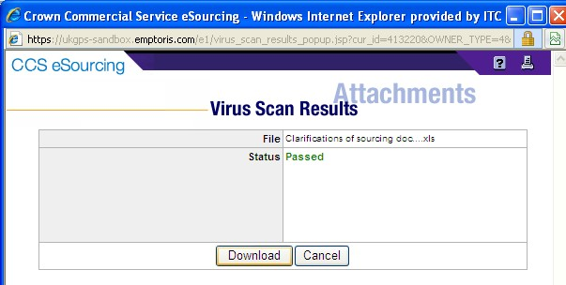

Bidders should see a document like this now, detailing all the clarifications received. This document is available to all Bidders at all times, irrespective of when they requested access to the procurement:

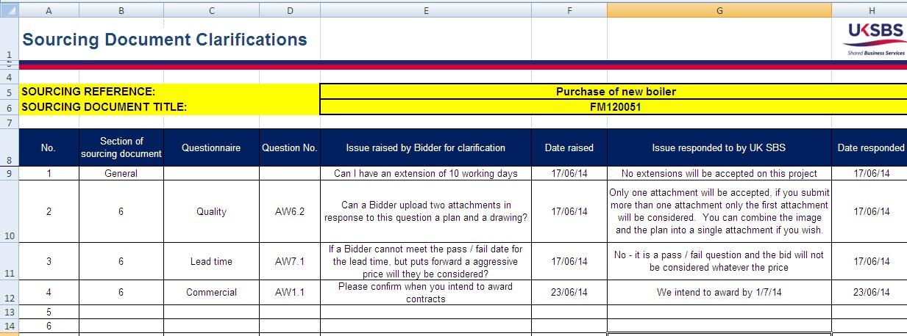

SUBMITTING YOUR BID

Once you have answered all required (*) questions and uploaded all your attachments you can submit your draft response.

If you fail to submit all draft responses before the closing date your bid cannot be received and considered.

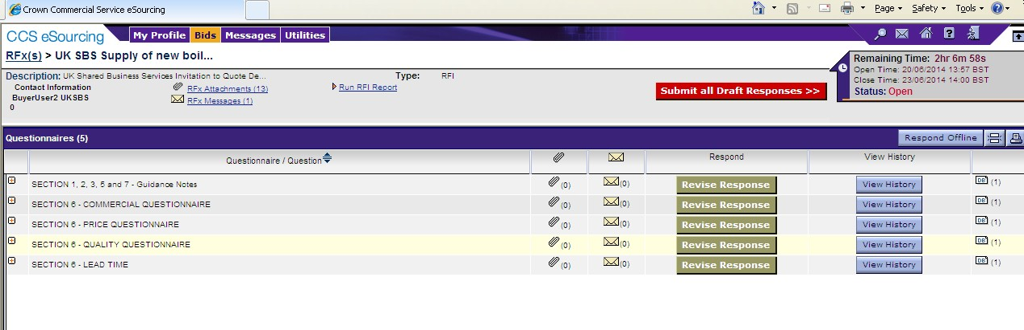
Bidders MUST click on
‘Submit all Draft Responses’
All required questionnaire
responses must be completed and shaded

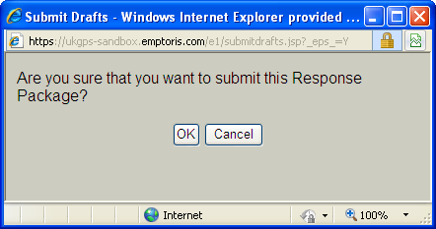

Questionnaire responses can be updated at any time up to the closing date; however each time you update the questionnaire responses YOU MUST RESUBMIT YOUR RESPONSE.

DOWNLOADING YOUR RESPONSE

You can download your text responses to the questionnaire by simply clicking on ‘Respond offline’:

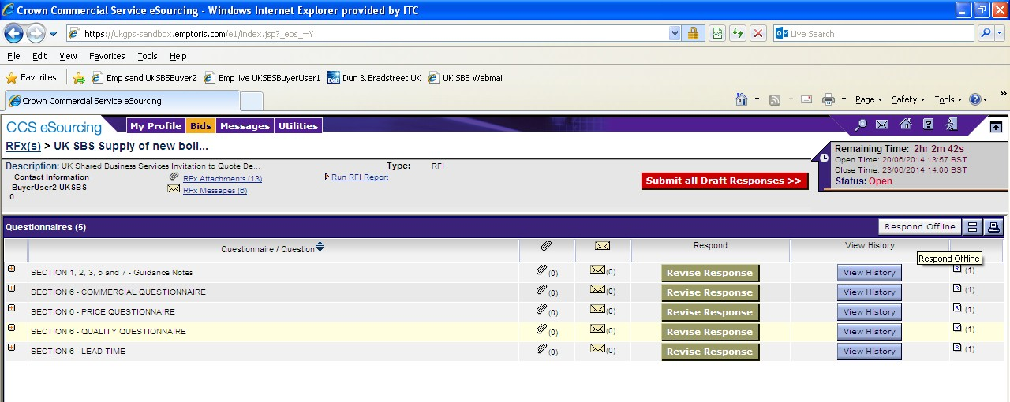

Then click on ‘download offline bidding template’ and OK

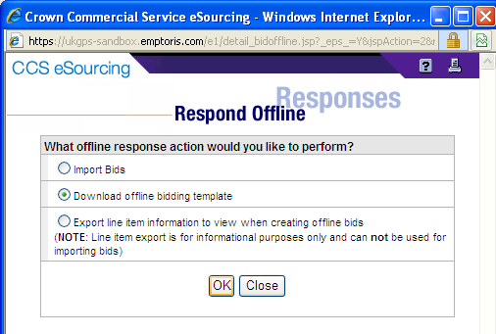

Note it is not permitted for Bidders to use this functionality to import bids.

And export in your required format:

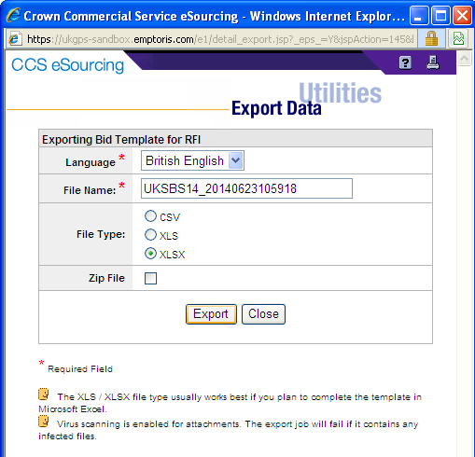

From here you will see the Data Manager, refresh the page after a few seconds and you should be able to click through to your report. Repeat this process if the Data Manager is showing ‘pending’ or ‘running’ status.

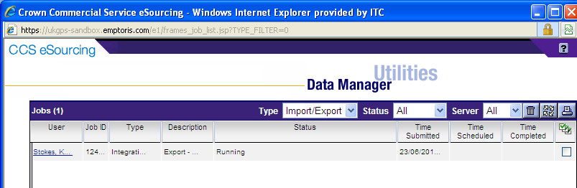
Refresh

Once complete you can download the report.

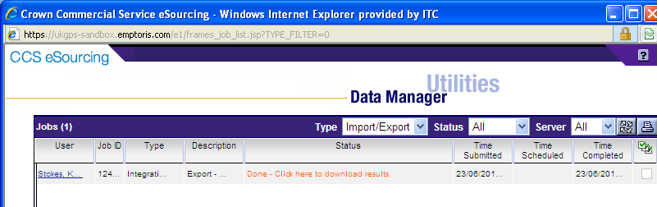

Bidders should now be able to open a document which provides their text and table based responses as below. Note the report has three tabs.

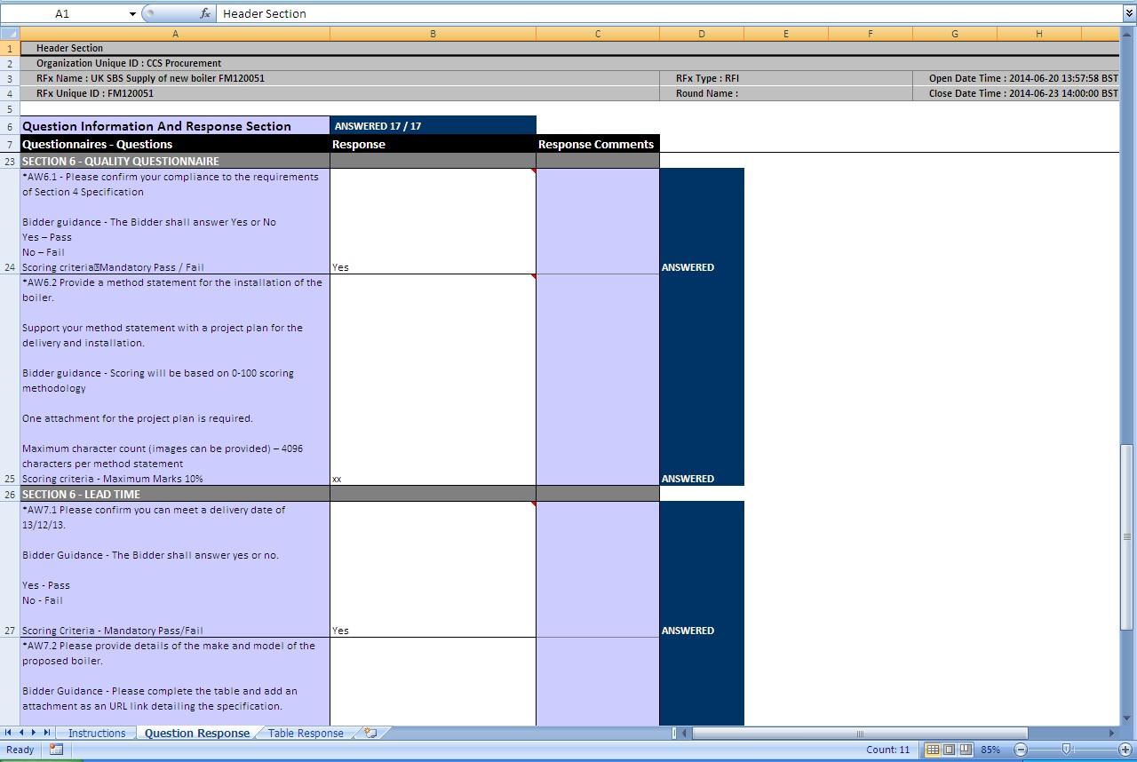

The slides contained within this presentation were created using the Emptoris e sourcing suite and Internet Explorer 8.

UK Shared Business Services Ltd. makes no guarantees that the functionality available in these screen shots will be fully replicated in the live Emptoris e sourcing suite, nor if using an alternative web browser to IE8.

Any Bidder using these training materials should do so at their own risk and UK Shared Business Services Ltd does not make any commitment to their accuracy.

In using these training materials the Bidder commits that UK Shared Business Services Ltd shall be in no way liable should the Bidder be unable to complete any or all of their Bid or Response submission.

