A New College for Cheshire

Tender Documentation
Tender Number: SWCC_WEB_15517
Creation of a New Website and Provision of on-going Technical Support for South and West Cheshire Colleges

(both Colleges formally merged and became one entity on 31 March 2017)
- Terms of Reference
  - South and West Cheshire Colleges (The College) have a requirement to create a new website that will go live on 1 September 2017.
  - The College intends that the successful agency would take over a 12-month hosting and a support contract with a minimum of 7 hours’ support per month.
  - These documents detail the requirements of the College, and clearly state the nature of the required response.
- Tender Submission
  - There should be no reference on the envelope to your company. Tenders must be submitted by hard copy. Tenders submitted by email or fax will not be considered and will result in exclusion from this tender exercise. As a formal tender, suppliers are requested to return submissions by post with original copies in a plain envelope to:
Tender Submission
Andrew Hubert
Finance Department
West Cheshire College
Off Sutton Way
Ellesmere Port
CH65 7BF
All original copies are to be clearly marked as SWCC_WEB_15517
The submission is required to arrive by post no later than 5:00pm on 23 May 2017
Any submissions after that time will be excluded.
  - Clarification of specifications for this document and the website can only be sought from:

Paul Jones
Associate Marketing Director
Ellesmere Port Campus
West Cheshire College
Off Sutton Way
Ellesmere Port
CH65 7BF
p.jones@west-cheshire.ac.uk
Tel: 01244 656418

Nicola Moore
Marketing Manager
Crewe Campus
South Cheshire College
Dane Bank Avenue
Crewe
CW2 8AB
nicola.moore@scc.ac.uk
Tel: 01270 654639

  - Please indicate clearly as part of your submission a contact person and phone number should the College require clarification. The nominated person will be the person reached by letter / email or phone in accordance with the timeline of the tender process; this can be completed in section 8.
- Background
  - South Cheshire College and West Cheshire College formally merged on 31 March 2017. As a result of the merger there is a requirement to create a new website that combines the content relevant to both Colleges.
  - The new College will have wide range of courses, facilities and information which will need to be communicated via the website. The College’s campuses boast industry-relevant, modern facilities with real work environments. The College strives to ensure that students leave College with the skills, qualifications and work experience they need to progress into further study or employment or an Apprenticeship.

  - The College’s primary products/activities include:
- Full time courses (16-18 and 19+ students)
- Part-time courses
- Higher Education courses
- A Levels
- Professional courses
- Apprenticeships
- Working with employers
- Work-based learning
- International students
- Commercial activities

- Website Requirements
  - Functionality
The successful agency should incorporate the following features using up-to-date devices and solution to ensure the website is using the latest developments. The new site should feature the following:
- Back end system – CMS system should be proposed and reasons for application choice justified
- Homepage advertising banners
- Tawkto online help or alternative system built in to the structure of the site
- Integrated email system to automatically send out emails and capture and validate email addresses
- Advanced course search facility via dynamic link to the College’s ‘Compass Pro-solution’ MIS system
- Facility for prospective students to complete an application form and submit electronically. This needs the capability to import straight into ProSolution
- Facility to create account to create and submit applications
- News section with historical news releases
- College Events
- Student Case studies and increased use of videos
- Microsites or other facility to display College services and commercial activities
- Prospectus download section
- Feedback and Enquiry forms
- Apply in 30 seconds feature
- ability to interface with social media platforms
- Maximise SEO potential

We would expect the successful agency to propose additional features or functionality with an accompanying rationale that would add value to the website.

  - Website Objectives
The website must be intuitive to use and recognise potential future developments so that these can be integrated as the College moves forward. Some of the key factors to inform the development would be:
- A website that is accessible, intuitive and easy to navigate
- Increase traffic and course applications by using relevant and useful content
- Increase traffic and course applications by making the site more visually appealing
- Reduce time spent managing and updating content
- Be the first point of contact for the College that effectively depicts our positioning
- Increase enquiries by creating a user-friendly interactive design and incorporating features described in section 4.1
- Enhance our global reach by developing our international appeal and compatibility

  - Creative brief
Both organisations currently have live websites and the requirement is to replace these two sites with one new site. Creatively, a new brand is currently being created for the College and it is envisaged that this will be available towards the end of June use as part of the website development.
The College’s Marketing, PR & Communications Team will support with imagery, copy and take an active part in populating the new website landing pages and sub-pages with content.

  - CMS features
The website must have an advanced content management system (CMS), secured with a complex password protected access. Administrators must have the ability to create user accounts with different privileges to access various components of the website.
The CMS should have a sophisticated yet intuitive visual interface allowing the administrator to change site structure and contents easily. The administrator should be able to perform such tasks as:
- Creation, modification and deletion of new menu items, pages and sections
- Change the structure and therefore navigation of site by moving pages of sections
- Input and editing of text according to pre-determined styles
- Add and remove advertising banners
- Add and remove links by modifying text properties using inbuilt editor
- Uploading attachments – word, excel, PDFs
- Monitoring of web usage through access to log files or other web metrics (via Google analytics)
- Be capable of enabling different levels of access to different users
- Uploading and positing of images, MP3 files, video
- Rotating banner on a selected site page
- Audit trail of Administrator activity

- Evaluation Criteria

The tenders submitted will be evaluated on the criteria detailed in section 9.
  - The programme for the project is tight and the project must be completed by the date set out in section 8. Contractors tendering will be required to demonstrate that they have the resources and capability to meet the deadlines contained within the schedule and a preliminary programme must be submitted with the tender.
  - Suppliers must ensure that the overall cost for all required elements of the tender are clearly identified, including VAT.
- Preliminaries
  - Description of the project
The project comprises of three distinct elements:
- The creation of a new College website for the merged College. The website must be fully accessible across existing and any anticipated future devices likely to use the site
- 12-month hosting agreement
- A 12-month support contract with a minimum of 7 hours support per calendar month for future development, continuous improvement and adaptation to the ever changing digital landscape
  - Project Particulars
The employer of this project is South Cheshire College.

  - Management of the project
    - Communication
First line of communication with the College is with Paul Jones or Nicola Moore and the successful organisation will appoint one single point of contact. Either party who are named may, when necessary, appoint another person to act as point of contact.
    - Your co-ordination
You will provide the College with preliminary project plans during this tender period to include planned timeline, suggested service level agreement (SLA), and project milestones for the creation of the new website.
You will provide the College with capability assurances and a suggested SLA for on-going support.
    - Capacity
Please provide assurances of capacity and evidence of capability including two references in your return submission with contact details.
  - Programme and Progress Monitoring

Programme

Immediately, when requested and before starting work, a detailed and approved master project programme is to be supplied, which must include:
- Weekly progress reports
- Planning with contingency elements built in accounting for unplanned project slippage

Monitoring progress and delays
- Monitoring progress: The College expects that the key account representatives at the College and at the successful organisation have a weekly ‘keep in touch’ phone-calls and fortnightly meetings to discuss progress which will include key stakeholders at both organisations
- Project slippage: If any circumstances arise which may affect the progress of the project, you are to submit proposals or take other action as appropriate to minimize any delay and to recover any lost time.
    - A pre-contract start meeting will be held prior to commencement to ensure that the deadlines and requirements of the project can be adhered to and met, and capability is demonstrated and supported by evidence.
    - Completion of the project.
Completion of the project is required by 1 September 2017. Website Support is to initiate on 1 September.
  - Quality Standards
  - Updates
The College expects, as a minimum
- Verbal keep in touch updates - weekly
- Project monitoring meetings - fortnightly
- All project plans and meetings are to happen in an agreed acceptable format to both parties
    - Quality of products
The College expects, as a minimum:
  - 99% Uptime agreement – with regular reports to the College
  - Out of hours support agreement – the College expects out-of-hours contacts (i.e. bank holidays)
  - Speed of site – on-going testing and identification of issues, with notification to the College and assurances / SLAs for speed of the site
  - Assurances and evidence of security measures to protect our students’ personal data
  - W3C-A and Disability Discrimination Act 2005 Compliance
  - A website compatible with MS Internet Explorer, Microsoft Edge, Chrome, Safari, Firefox and Opera
- The website must be fully responsive and accessible through PC, Apple Mac and mobile devices (Windows, IOS and Android)

- Specifications for tender consideration
5.1 Additional costs
All costings need to be clearly identified within the areas as detailed in Section 10.
5.2 Project Element A – Creation of a New Website
In your tender response, the College expects:
- A detailed project plan and the overarching approach taken in creating the new website and initial creative concepts for website design, layout and navigation
- A description and demonstration of the CMS and how this interfaces with the website and external systems/databases. The approach taken for course search, display and subsequent application
- A description of process and supporting documentation for website administrators
- Timescales for project milestones through to final commissioning
- Details of website enhancements not covered in this tender document
5.3 Project Element B – Hosting
In your tender response, the College expect to see evidence of hosting capability and evidence that you can adhere to the minimum requirements set out, including up-time.
5.4 Project Element C – Support Contract
In your tender response, the College expect to see evidence of expertise with being able to provide on-going support of the site in terms of design, capability and function.

All elements, including design, content, code, databases and CMS will be the property of South Cheshire College who will need to own the copyright for the site and its content.

- Schedule
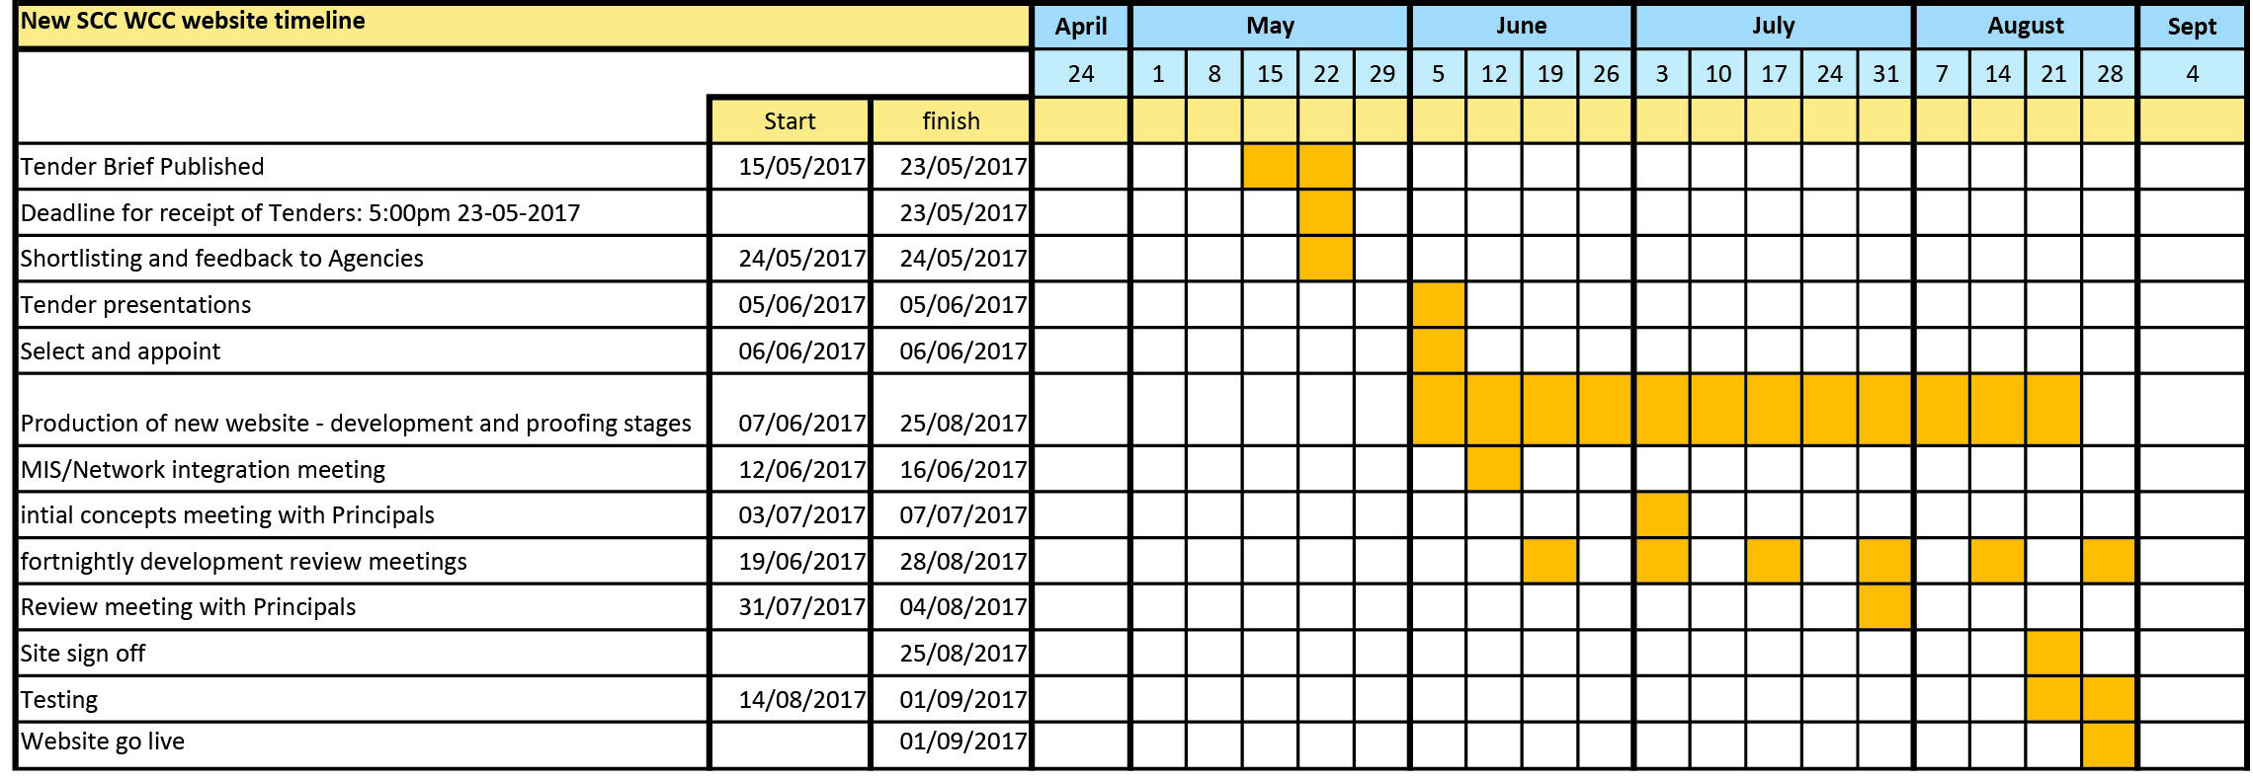

- Evaluation Criteria
  - The table below is a summary of requirements that tenderers will be assessed on, either from reply documentation, within the pitch meeting or both.
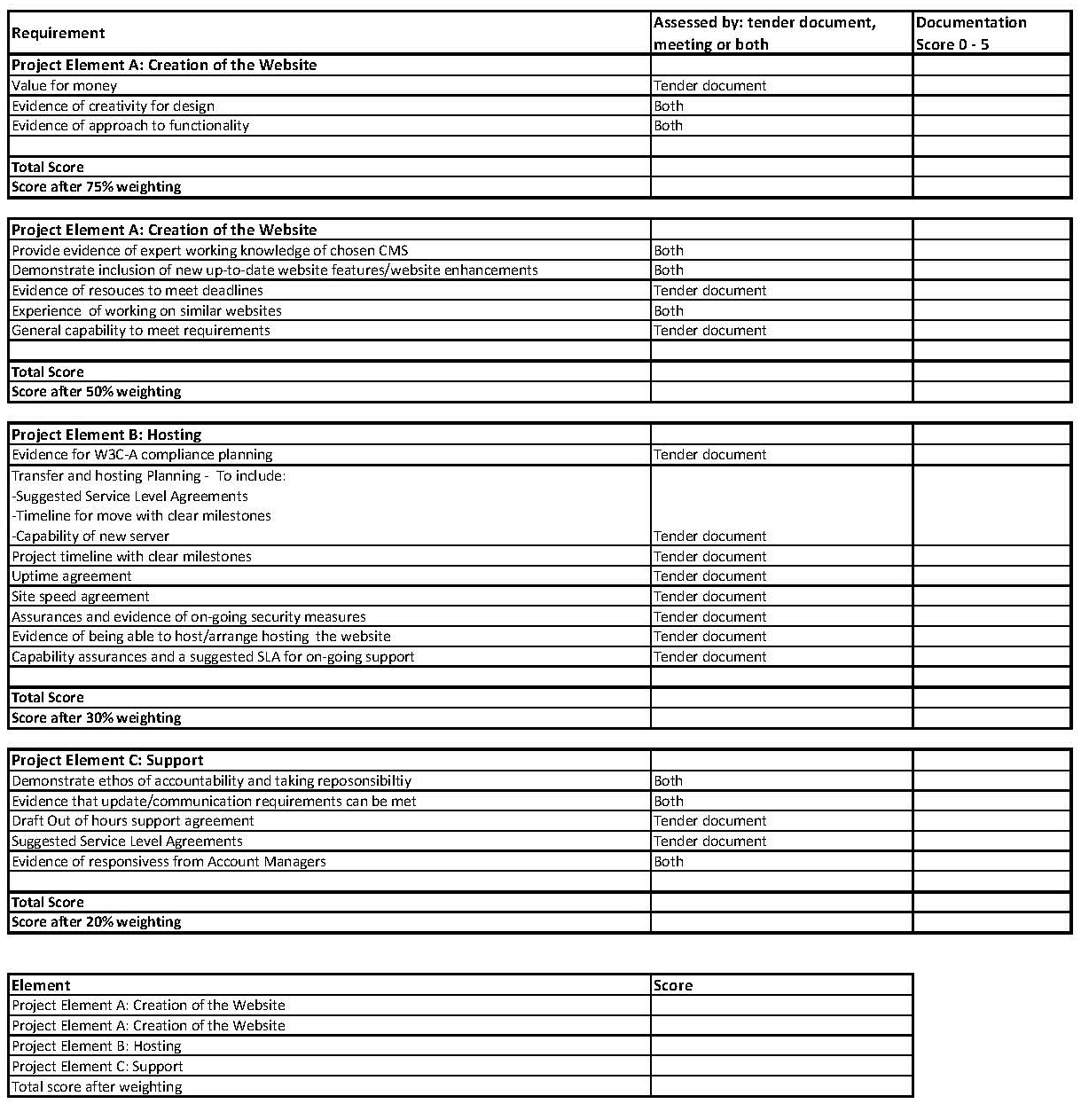
- Tender reply cover sheet

All replies must have this sheet attached

Contact details
Company name: Click here to enter text.
Contact name: Click here to enter text.
Email: Click here to enter text.
Address: Click here to enter text.
Telephone: Click here to enter text.

Cost outline

Please list all items exclusive of Value Added Tax and include it separately onto the line titled VAT.

Item | £ | p
Redesign of website to make it accessible and responsive
Hosting of website for 12-months
Support Contract for 12-months
VAT
TOTAL

Opened Date: Processed: Decision: I / D

