Draft tender for replacement pavilion at Wickham Recreation Ground, Wickham, Hampshire: DOCUMENT 1

Wickham & Knowle Parish Council Invitation to Tender – Wickham Recreation Ground New Pavilion

- Project Overview
Wickham & Knowle Parish Council in Hampshire is pleased to invite suitably qualified and experienced companies to submit tenders on a design and build basis for the construction of a new sports pavilion at the Recreation Ground in Wickham.

This project intends to replace an existing pavilion at the location that is no longer fit for purpose. The building should be such that it is modular in design, prefabricated in whole or in part and delivered to site for erection and fitting out (the option to prefabricate and fit out before delivery would also be considered).

Design should be in keeping with a village location and constructed most probably from wood, but other materials would be considered so long as the solution matched the rural criterion.

Please note: the council has a significant amount of finance already available to deliver this project, but some additional funding may be needed in the event that solutions supplied by bidders warrant extra expenditure. The Council has the ability to apply for additional grant funding if necessary.

- Key Dates
Tenders to be submitted by email to the Clerk no later than 12.00pm | June 3rd, 2024
Tenders to be opened by the Clerk in the presence of at least one member of the Parish Council | On or after June 3rd, 2024
Due diligence to be completed | By or on June 17th, 2024
Parish Council to resolve which bid is successful | On or after June 25th, 2024
All bidders notified of resolution by email | On or after June 25th, 2024
Work to begin | No later than one month after planning approval

- Council Priorities and Evaluation Method
The Parish Council’s priorities are in the table below, with the weighting which will be applied to each score when considered by the Council.

No | Priority | Weighting Applied (%)
1 | Approach to and methodology for: planning and construction, aftercare methods, and site specific conditions and limitations | 20
2 | Value for money | 20
3 | Highly experienced Contractor with excellent record and communication plans | 20
4 | Health and Safety and risk management | 15
5 | Planning, construction and finish design and quality | 15
6 | Sustainable approach | 10

- Qualification Criteria for Tenderers
In addition to the priorities identified above, the successful Contractor will be required to have the following:
- Proven experience in delivering sports pavilions or similar structures with evidence of successful completion
- Compliance with all safety, quality, legal and regulatory standards
- Appropriate insurance
- Financial stability and capability in terms of staff and machinery to undertake the project
- Ability to assist with community consultation if required
- Excellent references
- Provision of all relevant information as detailed in Document 2: Tender Information and Quotation Form.

- Site details
Wickham Recreation Ground, Wickham, PO14 5DE, Hampshire

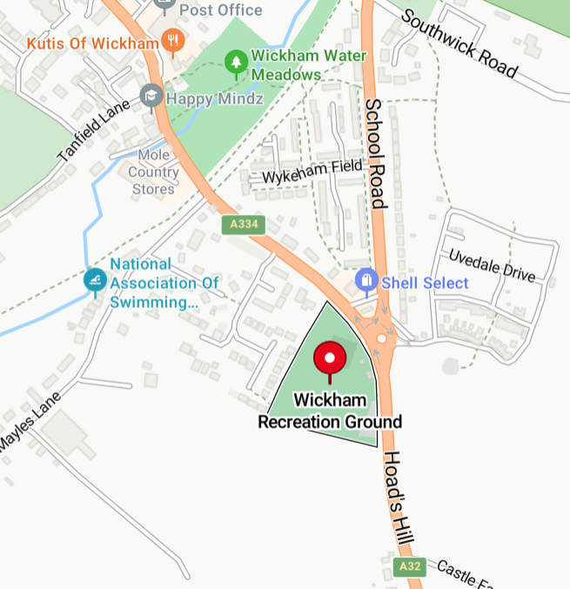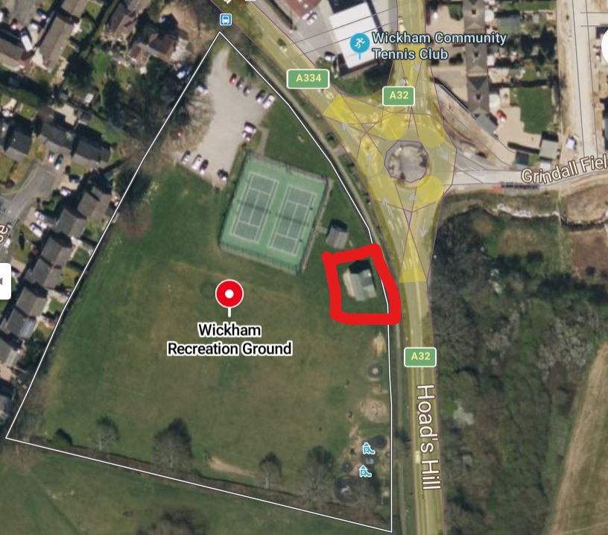

Access to the site is via the entrance to the Recreation Ground

- Scope of Works
The scope is:
- Detailed planning of project
- Clearing and preparation of the site
- Necessary groundworks
- Finish to a high standard, leaving access and work area safe and tidy.

The above is to be supplemented with:
- Compliance with safety standards and regulations, and robust risk management
- Communication with the Parish Council
- Sustainability measures.

- Duration
Tenderers should state their expected critical dates in the information submitted, as detailed in document 2: Tender Information and Quotation Form.

- Payment
Payment will be made upon satisfactory completion of the stage or project and receipt of an itemised invoice. Payment will be made by bank transfer or cheque. The Parish Council prefers the following payment schedule:
- On completion of 50% of the Works - 40% of the Contract Price;
- On completion of the Works - 58% of the Contract Price; and
- On completion of an independent inspection report following Completion of the Works – 2%.

VAT is to be clearly shown on any invoice, with the company’s VAT registration number.
Wickham and Knowle Parish Council reserves the right to deduct appropriate costs for any substandard work or neglect by the provider.

- Assumptions and Constraints
The land is mostly level with a small fall from south to north. The Parish Council has not undertaken any surveys of the site. The land is not registered as contaminated. The Council gives no warranty as to contamination or the condition of the land. The successful Contractor will need to manage the work on the site as it is found.
The Contractor will be considerate to all neighbours of the site, and residents who may be interested in the development.
The Parish Council understands that planning permission is required, therefore the submissions and final design must fall within permitted development regulations.

- Anti-bribery and corruption
Wickham and Knowle Parish Council conducts itself in an honest, professional and ethical manner. It is an offence to bribe, or attempt to bribe, a public official and for such an official to accept a bribe. It is unacceptable for anyone connected with the Council, tendering or contracting for services to:
- Give, promise or offer a payment, gift or hospitality with the expectation or hope that any advantage will be received, or to reward any business advantage already given.
- Threaten or retaliate against anyone who has refused to commit a bribery offence or who has raised concerns about bribery.
- Engage in any activity that might be classed as bribery or which breaches the terms of the Bribery Act 2010.

- Insurance
All tenderers must provide evidence of sufficient insurance for this project, and ensure it is maintained for the entirety of the contract period. Requirements and details of what to submit are in Document 2: Tender Information and Quotation Form.

- Health and safety
Health and safety is a key priority. The successful Contractor will be expected to have robust policies and procedures and to abide by all relevant legislation and regulations. Information required as part of tendering is detailed in Document 2: Tender Information and Quotation Form

- How to Tender
The tender has three parts as follows:
Document 2 Tender Information and Quotation Form
Document 3 Draft Contract

Tenderers should ensure they understand the tender documents, visit the site and then submit the completed Information and Quotation Form and all requested documents by email by the closing date
.
The Parish Council reserves the right to ask any further questions about any information (whether supplied or not) by the Tenderer, and to undertake a criminal record check for relevant convictions for any Contractor or relevant persons if desired.

- Notes to Tenderers
Tenderers are required to confirm their understanding of the tender documents. Tenderers are strongly advised to visit the site before submitting their tender.
The Council is under no obligation to accept the lowest priced tender, nor indeed any tender. The final design will be agreed with the successful tenderer.
The information provided herein is not necessarily to any scale or indicative of the final outcome.

Prospective Contractors must not contact Councillors or staff to encourage or support their tender outside of the prescribed tender process. Certain behaviour in this regard is criminal.

No fixing or adjusting of prices must be attempted or entered into, or any attempt at bribery made.
No expense incurred by any person submitting a tender will be reimbursed.
Tenders which are received after the closing time will not be considered.
If any clarification of the tender documents or process is required, these should be addressed to the Parish Clerk using the contact details supplied, in good time before the closing date. The Parish Council will not accept any liability in the case of any questions not answered.

All details submitted by Companies will remain confidential except for information that we are required to release (if obligated or requested to do so) under data protection legislation including the Freedom of Information Act.

Amounts paid to Contractors, and certain other details, will or may be made public as part of the Parish Council’s transparency obligations.

The Parish Council’s main policies including Financial Regulations are on its website for the information of Tenderers.

Please do not include any information that has not been requested. Any questions should be asked before the closing date: do not enclose questions with your tender. Mark your email or sealed envelope clearly with TENDER ENCLOSED, for the attention of the Parish Clerk, using the details below.

Please mark all correspondence for the attention of the Parish Clerk.  Wickhama and Knowle Parish Council Knowle Village Hall Street  Knowle Avenue  Fareham  PO17 5LG | Telephone:  Mobile:  Email: clerk@wickhamparishcouncil.org  Website: https://wickhamparishcouncil.org

