LITTER PICKING SPECIFICATION Ref GMG/2

Note
This specification must be read in conjunction with the Contract Procedure Rules.

Contract requirements

Location 1: Lion Green

- Litter Picking and bin emptying - varies with season, see (a) & (b) below.

  - Beginning March to end October
4 Days a week: Monday, Wednesday, Friday & Saturday

  - November to end February
2 Days a week: Monday & Friday

- To carry out litter picking from the Lion Green green spaces including the children’s play area and at the school entrance and on the footpath running from the Esso Garage to the school.

- To remove litter and discarded rubbish from the stream running between Lion Green and Weysprings.

- Bag up waste and remove to commercial waste disposal.

- Empty all litter bins on Lion Green (both sides) and remove to commercial waste disposal.

Map 1: Lion Green, Weyhill, Haslemere

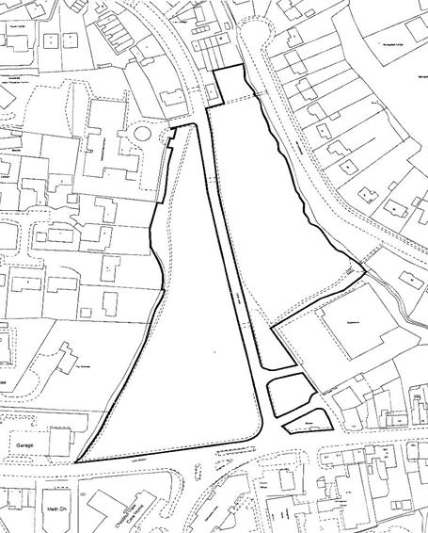

Location 2: Town Meadow

- Litter Picking and bin emptying - varies with season, see (a) & (b) below.

  - Beginning March to end October
4 Days a week: Monday, Wednesday, Friday & Saturday

  - November to end February
2 Days a week: Monday & Friday

- To carry out litter picking from the Town Meadow green spaces including the children’s play area and the path to the Fire Station.

- To remove litter and discarded rubbish from the stream running along the path to the Fire Station.

- Bag up waste and remove to commercial waste disposal.

- Empty all four litter bins on Town Meadow twice a week and remove to commercial waste disposal.

Map 2: Town Meadow

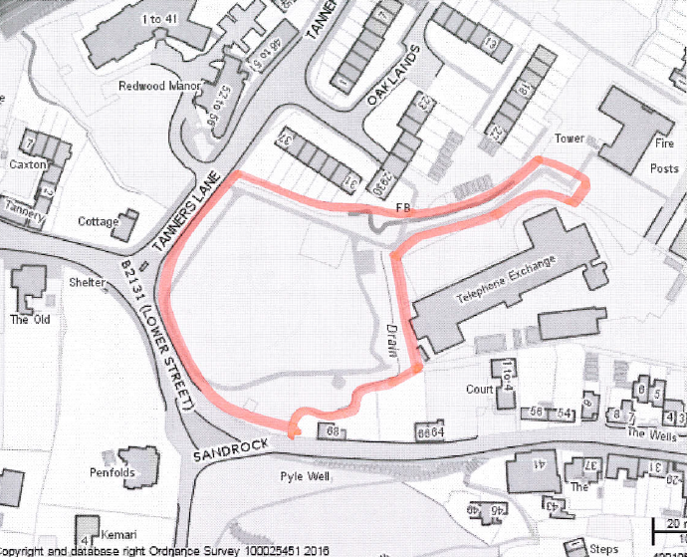

Location 3: St Christopher’s Green

- Empty two litter bins on St Christopher’s Green once a week and remove to commercial waste disposal.

Map 3: St Christopher’s Green

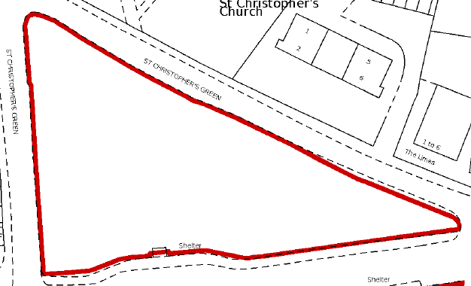

Location 4 : Grovers Garden

- Empty litter bin in Grovers Garden once a week and remove to commercial waste disposal.

Map 4: Grovers Garden

