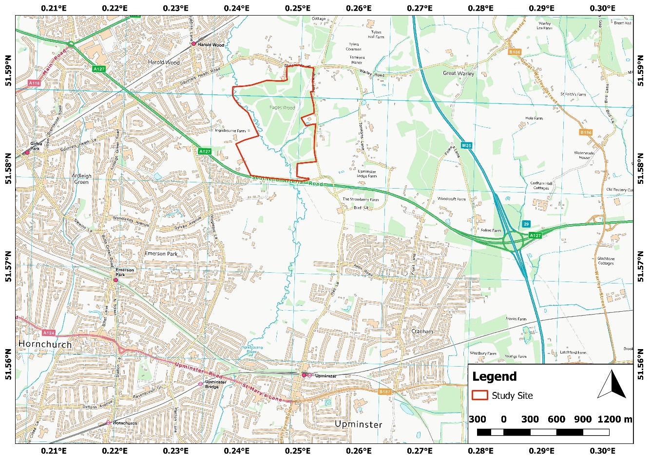
Crown copyright and database right 2019 Ordnance Survey 100021242.

