RM6187 Framework Schedule 6 (Order Form and Call-Off Schedules)

Order Form

CALL-OFF REFERENCE: 708942453

THE BUYER: Defence Infrastructure Organisation

BUYER ADDRESS DIO Enabling Services, Room 1202-1221, Kentigern House , 65 Brown Street, Glasgow, G2 8EX

THE SUPPLIER: KPMG LLP
SUPPLIER ADDRESS: 15 Canada Square, London, E14 5GL
REGISTRATION NUMBER: OC301540
DUNS NUMBER: 423916167
SID4GOV ID: N/A

Applicable framework contract
This Order Form is for the provision of the Call-Off Deliverables and dated 17 October 2023.
It’s issued under the Framework Contract with the reference number RM6187 for the provision of JSP 850: Infrastructure Policy and Standards Support 2023-2026

CALL-OFF LOT(S): Lot 2: Strategy & Policy

Call-off incorporated terms
The following documents are incorporated into this Call-Off Contract.
Where schedules are missing, those schedules are not part of the agreement and can not be used. If the documents conflict, the following order of precedence applies:

- This Order Form includes the Call-Off Special Terms and Call-Off Special Schedules.
- Joint Schedule 1(Definitions and Interpretation) RM6187
- The following Schedules in equal order of precedence:

Joint Schedules for RM6187 Management Consultancy Framework Three
  - Joint Schedule 1 (Definitions)
  - Joint Schedule 2 (Variation Form)
  - Joint Schedule 3 (Insurance Requirements)
  - Joint Schedule 4 (Commercially Sensitive Information)
  - Joint Schedule 6 (Key Subcontractors)
  - Joint Schedule 7 (Financial Difficulties)
  - Joint Schedule 9 (Minimum Standards of Reliability)
  - Joint Schedule 10 (Rectification Plan)
  - Joint Schedule 11 (Processing Data)

Call-Off Schedules
  - Call-Off Schedule 1 (Transparency Reports)
  - Call-Off Schedule 3 (Continuous Improvement)
  - Call-Off Schedule 5 (Pricing Details)
  - Call-Off Schedule 7 (Key Supplier Staff)
  - Call-Off Schedule 8 (Business Continuity and Disaster Recovery)
  - Call-Off Schedule 9 (Security)
  - Call-Off Schedule 10 (Exit Management)
  - Call-Off Schedule 13 (Implementation Plan and Testing)
  - Call-Off Schedule 14 (Service Levels)
  - Call-Off Schedule 15 (Call-Off Contract Management)
  - Call-Off Schedule 16 (Benchmarking)
  - Call-Off Schedule 17 (MOD Terms)
  - Call-Off Schedule 18 (Background Checks)
  - Call-Off Schedule 20 (Call-Off Specification)

- CCS Core Terms
- Joint Schedule 5 (Corporate Social Responsibility)
- Call-Off Schedule 4 (Call-Off Tender) as long as any parts of the Call-Off Tender that offer a better commercial position for the Buyer (as decided by the Buyer) take precedence over the documents above.

Supplier terms are not part of the Call-Off Contract. That includes any terms written on the back of, added to this Order Form, or presented at the time of delivery.

Call-off special terms

Where there is a discrepancy between a Defence Condition (DEFCON) and a CCS
term, the DEFCON will be used.

These are available through https://www.gov.uk/guidance/knowledge-in-defence-kid

The following (DEFCONS) are incorporated into this Call-Off Contract:

• DEFCON 5J (Edn 18/11/16) - Unique Identifiers
• DEFCON 76 (Edn 11/22) - Contractors Personnel at Government Establishments
• DEFCON 501 (Edn 10/21) - Definitions and Interpretations
• DEFCON 503 (Edn 06/22) - Formal Amendments to Contract
• DEFCON 513 (Edn 04/22) – Value Added Tax and Other Taxes
• DEFCON 514 (Edn 08/15) - Material Breach
• DEFCON 515 (Edn 06/21) - Bankruptcy and Insolvency
• DEFCON 516 (Edn 04/12) - Equality
• DEFCON 522 (Edn 11/21) - Payment and Recovery of Sums Due
• DEFCON 530 (Edn12/14) – Dispute Resolution (English Law)
• DEFCON 531 (Edn 09/21) - Disclosure of Information
• DEFCON 534 (Edn 06/21) - Subcontracting and Prompt Payment
• DEFCON 537 (Edn 12/21) - Rights of Third Parties
• DEFCON 538 (Edn 06/02) - Severability
• DEFCON 539 (Edn 01/22) – Transparency
• DEFCON 540 (Edn 05/23) – Conflicts of Interest
• DEFCON 550 (Edn 02/14) - Child Labour and Employment Law
• DEFCON 566 (Edn 10/20) - Change of Control of Contractor
• DEFCON 602B (Edn 12/06) - Quality Assurance (Without Deliverable Quality Plan)
• DEFCON 642 (Edn 07/21) - Progress Meetings
• DEFCON 649 (Edn 12/21) - Vesting
• DEFCON 656A (Edn 08/16) - Termination for Convenience – (Contracts Under £5M)
• DEFCON 658 (Edn 10/22) - Cyber (Cyber Risk Profile for the contract – in
accordance with the Guidance).
• DEFCON 659a (Edn 09/21) - Security Measures
• DEFCON 660 (Edn 12/15) - Official-Sensitive Security Requirements
• DEFCON 670 (Edn 02/17) - Tax Compliance
• DEFCON 703 (Edn 06/21) - Intellectual Property Rights – Vesting in the Authority

Call-off start date: 19 October 2023

Call-off expiry date: 31 March 2026

Call-off initial period: 31 October 2024
Call Off Contract Value: Limit of Liability of £2,880,000.00 exclusive of vat t

Call-off deliverables:

As per Schedule 20 – Attachment 3 Schedule of Requirements

Security

Short form security requirements apply

And

Security Policy – as per DEFCONs listed above and in Call Off Schedule 17.

Maximum liability
The limitation of liability for this Call-Off Contract is stated in Clause 11.2 of the Core Terms.

The Estimated Year 1 Charges used to calculate liability in the first contract year are:

For Year One £649,950.00 exclusive of vat.

Call-off charges

Staff Grade | Day Rate (£)
Partner | Redacted
Managing Consultancy / Director | Redacted
Principal Consultant / Associate Director | Redacted
Senior Consultant / Engagement Manager / Project Lead | Redacted
Consultant | Redacted
Analyst / Junior Consultant | Redacted

All changes to the Charges must use procedures that are equivalent to those in Paragraphs 4, 5 and 6 (if used) in Framework Schedule 3 (Framework Prices)

The Charges will not be impacted by any change to the Framework Prices. The Charges can only be changed by agreement in writing between the Buyer and the Supplier because of:

- Specific Change in Law
- Benchmarking using Call-Off Schedule 16 (Benchmarking)

‘

Reimbursable expenses
Recoverable as stated in Framework Schedule 3 (Framework Prices) paragraph 4.

Payment method
CP&F MOD Exostar

Buyer’s invoice address:

Redacted

Email: Redacted

FINANCIAL TRANSPARENCY OBJECTIVES
The Financial Transparency Objectives apply to this Call-Off Contract.

Buyer’s authorised representative

Redacted

Email: Redacted

Buyer’s security policy

Security Policy – as per DEFCONs listed above. Please see links to Protecting Government Assets and Management of Environment Protection in Defence

Security policy framework: protecting government assets - GOV.UK (www.gov.uk)

Management of environmental protection in defence (JSP 418) - GOV.UK (www.gov.uk)

All Suppliers staff engaged on this Contract must be cleared to BPSS level.

Supplier’s authorised representative
Redacted
DIO Senior Commercial Manager
Room 1202-1221
Kentigern House
Glasgow
G2 8EX

Email: Redacted

Supplier’s contract manager

[insert name]
[insert role]
[insert email address]
[insert address]

Progress report frequency

Progress Meetings monthly on the first Monday of each month, per Project with the ISA Team.

Key staff

Redacted

Key subcontractor(s)

Redacted

Commercially sensitive information
Not applicable

Service credits
Not applicable

Additional insurances
Not applicable

Guarantee
Not applicable

Buyer’s environmental and social value policy

Defence Infrastructure Organisation estate and sustainable development - GOV.UK (www.gov.uk) (https://www.gov.uk/government/publications/jsp-418-mod-corporate-environmental-protection-manual )

Procurement Policy Note 06/20 – taking account of social value in the award of central government contracts - GOV.UK (www.gov.uk) Social value commitment
The Supplier agrees, in providing the Deliverables and performing its obligations under the Call-Off Contract, that it will comply with the social value commitments in Call-Off Schedule 4 (Call-Off Tender) and replicated below:

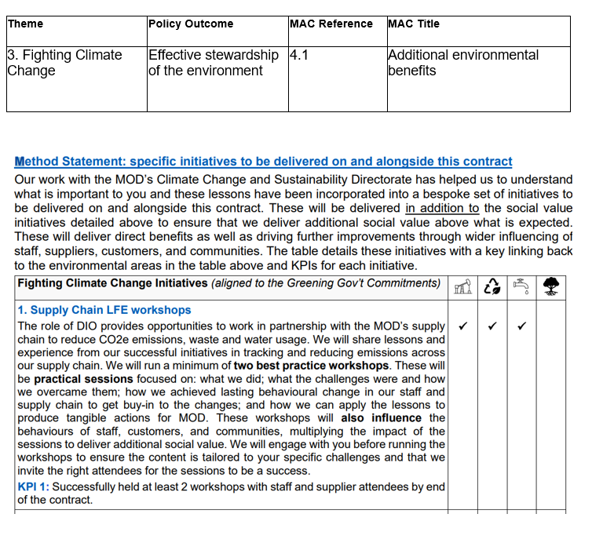
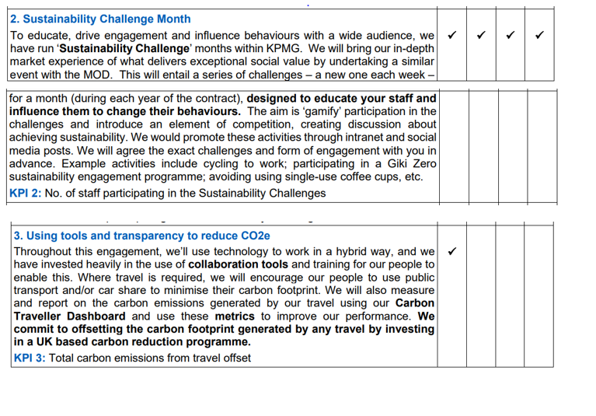

Formation of call off contract
By signing and returning this Call-Off Order Form the Supplier agrees to enter a Call-Off Contract with the Buyer to provide the Services in accordance with the Call-Off Order Form and the Call-Off Terms.
The Parties hereby acknowledge and agree that they have read the Call-Off Order Form and the Call-Off Terms and by signing below agree to be bound by this Call-Off Contract.
For and on behalf of the Supplier:

Signature:

Name: Stephen Armour

Role: DIO Senior Commercial Manager

Date:18 October 2023

For and on behalf of the Buyer:

Signature:

Name:

Role:

Date:

