National Army Museum
2018 Special Forces Exhibition:
Marketing Campaign Brief

July 2017

Contents Page

1. Introduction 3
2. The National Army Museum 4
3. British Special Forces temporary exhibition 6
4. Audiences 7
5. Scope of services 9
6. Budget 11
7. Programme 12
8. Tender process 13
Appendices 16

1. Introduction

The National Army Museum is looking to appoint a creative marketing, media and design agency(ies) to create, produce and deliver the campaign for the a charging temporary exhibition, due to open mid-March 2018.

The exhibition, Special Forces – Out of the Shadows**, will be the Museum’s first charging temporary exhibition since opening on 30/3/2017 following a £23.75 million project that has seen the wholesale transformation of the Museum – building, galleries, facilities and public services, as well as the creation of a new brand. We therefore see this temporary exhibition as vital in extending the Museum’s appeal following its initial year as an open museum.

For this reason, the Museum has worked to identify an exhibition that it believes has the potential to maintain public interest in and visits to the Museum, and help generate income.

Due to the breadth of activity needed, we are looking to partner with a (number of) agency(ies) to allow us to build on the work done to create the exhibition itself in order to create a visually exciting and appealing campaign that reflects our new brand, raises the profile of the exhibition (and therefore the National Army Museum) and encourages visitors from across all key audience groups.

This document explains the project and requirements in more detail. We expect to work closely with the chosen company(ies) to develop and deliver a campaign for the exhibition in a creative and impactful way that is relevant and accessible to our audiences.

If you are interested in tendering for this challenging project, this document provides the following information:

- Background on the National Army Museum
- More information about the project
- Scope of services
- Budget
- Programme
- Project Team
- Tender Process

** final title of exhibition currently undergoing testing

2. The National Army Museum

2.1 A new Museum

In spring 2017, a newly transformed and contemporary national museum opened in London after a three-year closure.
Our vision is bold. We use our rich historical and developing contemporary collections to foster people’s awareness, understanding and knowledge of the British Army, its soldiers and legacy. And through this exploration, encourage debate about an institution that is little understood but is intrinsically part of our democratic society and enables us to live with the freedoms we enjoy everyday.
Integral to the new Museum is our new brand – a brand that seeks to actively engage people in the narrative of why we have an army and its impacts on society, citizens and those who serve.

A key purpose of the new brand is to help broaden the appeal of the Museum to wider audiences. To this end, targets are ambitious: the visitor numbers forecast for the opening year is 320-342,000 in the first year, a 49% increase from the 2013-14 pre-closure numbers; commercial income is forecast to increase by around 200% and there is a need to drive and sustain footfall that will also convert into visitor spend in the new café, shop and Play Base as well as generate commercial events activity.

Since opening, initial reactons and feedback from visitors has been broadly positive, with many embracing the modern design and the thematic and engaging nature of the galleries. However, as anticipated, not all feedback has been entriely positive. Some previous visitors have been less happy with the bright open and airy spaces, the thematic approach and the obvious appeal of of the Museum to families and children.
The Museum is very conscious of the need to deliver an offer that appeals to a broad spectrum of audiences – young and older, exisiting (pre-closure) and new.
The Museum’s developing public programme is central to this strategy on an ongoing basis, as are its temporary exhibitions. This exhibition is seen as vital in sustaining and growing both traditional and new visitors after the first year of opening.

2.2 A new brand
As part of the transformed Museum, we launched a wholly new brand into the sector, a brand that seeks to stretch the role of the Museum to one of civic participation.

We very much see our new Museum and culture as the means by through which we will spark conversations with local, national and international audiences and foster participation in our narrative.
Having consulted widely in the planning and formation of the new Museum, we are well aware that our subject matter can be challenging. But we believe in our purpose, vision and mission and have developed a clear sense not only of our role as the custodians of Britain’s army history, but also of the utility of the Museum and our role in helping people engage with an institution that can be little understood but works in our service every day.
At the same time we are a Museum whose story is both historic and of the moment. Not a day goes by without it being in the press or on television. This is a very unique and special position and one that we want to maximise to grow wider public engagement with our work.
Our new brand model was developed in 2014-15 and has guided the development of the Museum. It has been tested extensively with audience focus groups and we believe it provides a strong foundation on which to deliver this transformational change and engage new audiences.

Comprehending and being able to reflect an understanding of our Museum’s new brand will be vital to successfully realising a modern, relevant and engaging campaign about Britain’s Special Forces – parts of the armed forces whose work often takes place in secret and can be regarded with suspicion but which is vital to Britain’s security and people’s safety.

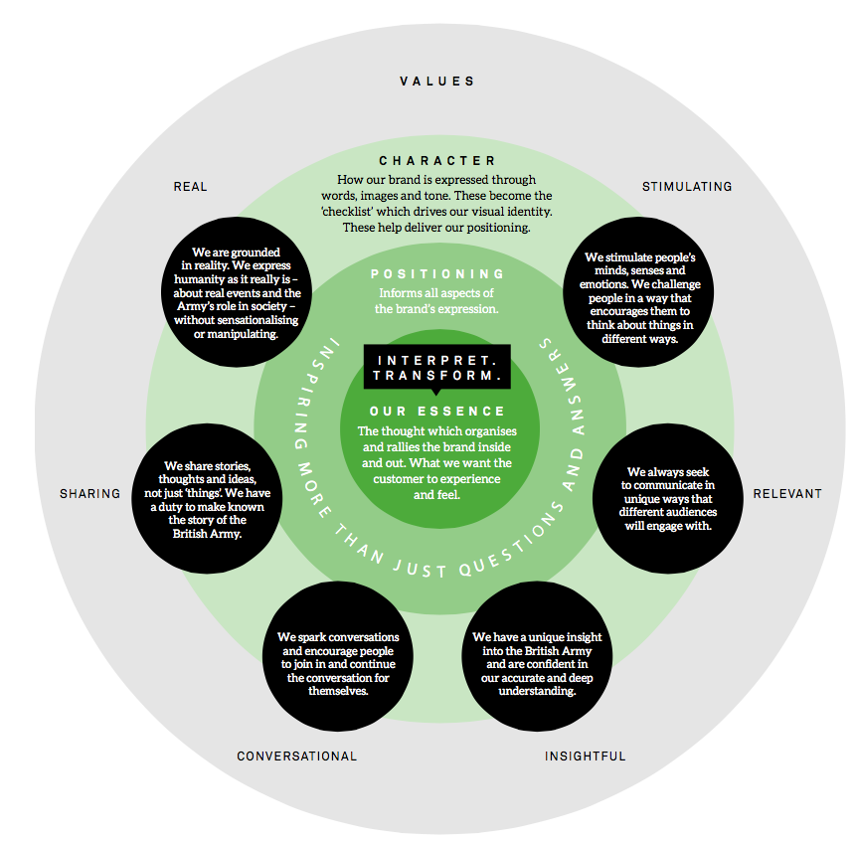
Figure 1: National Army Museum Brand Model

3. British Special Forces temporary exhibition

3.1 The background

The National Army Museum’s theme for 2018-19 is “Security”. This will compare perceptions of threat – from cyber security and terrrorism, to overseas instability, climate change and natural disasters – with the realities facing Britain and examine whether the British Army is the best security soloution. We want to encourage a public discussion about this question.

3.2 The exhibition

Set in this context, the Special Forces temporary exhibition aims to uncover the secret world of the Special Forces, exploring what makes them special, whether they actually keep us safe and the ethics and controversy surrounding their actions.

Both populist and challenging, the exhibition has potential to appeal to a wide range of audiences, from Experts, Empathisers, Self Developers and Learning Families, using a rich selection of interactive elements and objects.

Further information about the Museum’s audience segmentation model is provided later in this document.

3.3 Exhibition aims

To maintain focus throughout the development and operation of the exhibition, the following aims have been devised for the exhibition:

- To sustain and increase awareness of the Museum in its second year of operation
- To raise the profile of the Museum in the London Museum’s sector, enhancing brand sentiment and awareness
- To drive visitors (footfall) to the Museum in its second year of operation
- To help deliver the museum’s audience development strategy
- To generate income through ticket sales and secondary income streams
- To increase membership.

3.4 Exhibition content

The exhibition is split into 7 key areas:

i. What are Special Forces?
- What makes them special and what are they intended to do?
- Do Special Forces make us more secure?

ii. Making the cut
- What does it take to become a member of the Special Forces?
- How are Special Forces soldiers selected?

iii. Training and skills
- What training do the Special Forces soldiers undertake?
- What skills do they develop and training do they undertake? (Physical & Mental)

iv. Operations
- Surveillance & reconaissance
- Counter Terrorism

v. Special Forces in popular culture
- How are the Special Forces represented in the media and popular culture?

vi. Why the secrets?
- Secrecy and sources
- Consequnces and accountability

vii. Your reaction
The exhibition will close with a thought and opinion installation the purpose of which is to stimulate further responses and continue the discussion stimulated by the exhibition. There are also opportunites to extend the discussion to Epilogue (a display located within the central Atrium space of the Msueum) and online, taking the exhibition beyond the walls of the Museum and linking to the associated public programme and social media.

3.5 Public programme

A creative public programme will be devised to run in parallel with the exhibition. This will be designed to appeal to Experts, Self Developers, Empathisers and Learning Families. The National Army Museum is working with partners to create a varied public offer of free and charging events. It expected that this will include security experts and advisors and ex special forces personnel.

3.7 Duration

The exhibition aims to open on 17th March 2018 (in time for Easter 2018) and run until early November (past the October half-term 2018). The campaign will run from early 2018 with a launch campaign and will be supported at a lower level throughout the duration of the exhibition.

4. Audiences

4.1 National Army Museum’s audiences

The Museum has undertaken an extensive programme of audience research and consultation to better understand its current and potential audiences. Integral to the transformation and success of the Museum is the transformation of its audiences.

In 2011, as part of the development of the Building for the Future project, the Museum developed an audience segmentation model based on visitors’ main motivations and needs. This breaks the Museum’s audiences into the following seven segments that have informed the redesign of the Museum and its public programmes.

Segment | % of core audience | Description | Broad needs
Sightseers | 6% | First time visitors making a general visit. Mainly tourists wanting to ‘do’ the Museum | Ease of access, comfort, orientation, good facilities, engaging exhibitions
Days Out | 3% | Repeat visitors wanting to enjoy a social visit, possibly with friends or relatives
Self Developers | 14% | Non-specialists wanting to informally improve general knowledge | Journey of discovery, layered information, finding out new things
Experts | 16% | Academics, students, people with specialist knowledge wanting to deepen knowledge. | High quality access to collection, detailed interpretation, access to expert staff and resources
Empathisers | 18% | Have a personal connection to subject, wanting to engage with collection emotionally and spiritually | Engaging exhibitions, strong narratives and personal stories, able to search databases for personal relevance
Kids’ First | 4% | Mixed age groups, wanting fun and social trip for children and whole family | Ease of access, child friendly facilities and activities, services for all ages, engaging exhibitions, accessible interpretation
Learning Families | 39% | Mixed age groups, wanting an educational trip for children | As above: but better able to direct visit than Kids Firsts
Figure 2: NAM’s audience segmentation model

  - Special Forces exhibition audience priorities

Visitation to the temporary exhibition has been estimated at low, medium and high levels. The table below demonstrates how these numbers translate as both a % conversion and a ratio of the Museum’s forecast visitor numbers for the 2018-19 year.

 | Low | Mid | High
As a % of Total Annual Visitors | 13.24% | 18.53% | 23.82%
Expressed as a ratio | 1:8 | 1:5 | 1:4
Figure 3: Proposed conversation and ratio of visitor numbers to the temporary exhibition

Based on the audience profile, Figure 4 shows the potential visitor numbers by audience type. The Museum’s Business Sustainability Plan (2013) suggests that prior to closure the Museum has a 10% repeat visitor profile and this has been applied to the visitor projections.

The high level conversion rate has been applied to the key audiences for the exhibition (Learning Families, Experts, Empathisers and Self Developers) with the low level applied to Kids’ First and Sightseers. Conversion from formal learning visitors has not been included.

In addition, based on information provided by a comparable museum in London, we have applied a 30% membership take up on the exhibition. Members have been excluded from the Sightseers and formal learning numbers.

Audience | Visitors less Repeats @10% | Conversion to SF Exhibition | Free Membership Visits | Total Paid Visitors
Learning Families | 9810 | 2337 | 701 | 1636
Kids’ First | 11700 | 1549 | 465 | 1084
Experts | 34200 | 8148 | 2444 | 5703
Empathisers | 45900 | 10935 | 3281 | 7655
Self Developers | 43200 | 10292 | 3088 | 7204
Sightseers | 31950 | 4229 | 0 | 4229
Formal Learning | 20250 | 0 | 0 | 0
Totals | 197010 | 37489 | 9978 | 27511
Figure 4: Forecast visitor numbers to Special Forces temporary exhibition

5. Scope of services

5.1 Overview

The National Army Museum wishes to appoint an agency(ies) to design, develop, and deliver a campaign (through launch and beyond) to raise the profile of the Special Forces exhibition in order to drive both traditional visitors and new visitors to this exciting temporary exhibition.

This project is divided into 3 strands of work:

5.1.1 Strand 1 – develop the concept creative for a launch campaign to run across multiple platforms: (eg outdoor, digital, social, print).

The campaign should:
- Engage with our priority audience groups
- Include creative marketing concepts incorporating, but not limited to, outdoor, online, video and digital for use online and via social media
- Reflect the visual language of the exhibition design and overall “look and feel”
- Reflect our brand values and positioning for the museum as a whole
- Incorporate clear calls to action to drive visitors and pre-booking via the website
- Include a strong digital element.

5.1.2 Strand 2 – production and artwork to deliver the individual elements from the agreed creative concept across all channels, supporting the agreed media plan.

The activity should include:
- Detailed design and artwork for all deliverable elements (for example including but not limited to: print/digital OOH ads, flyer, ticket, digitial banners/assets, video and social content)
- Creation of social advertising and video content to support organic and paid for posts.

5.1.3 Strand 3 – develop and negotiate (buy) a multi-channel media plan that covers the launch period activity and through the remaining 8 months of the exhibition run, providing reach, impact (across audiences) and return on investment.

The campaign should include:
- An integrated plan to targets our priority audience groups
- Methodolgy to support media selection and audience profiling criteria
- Ongoing tracking and reporting across the campaing to maximise results and report to stakeholders.

Agencies are invited to apply for individual strands or for all three. Where an agency is pitching for only 1or 2 of these strands, they must advise on who they would advise we work with for the outstanding elements and how this may practically be achievable.

5.2 Copyright

It must be noted by the designer that all rights (including ownership and copyright) in any reports, documents, specifications, instructions, plans, drawings, patents, models or designs whether in writing or on magnetic or other media:

- Provided to or made available to the Designer by the Museum shall remain vested in the Museum

- Prepared by or for the Designer (or any sub-contractors employed or contracted by the Designer) for use, or intended use, in relation to this project will be assigned to and shall vest in the National Army Museum absolutely.

The Designer should therefore allow for such vesting in rights to be included within the fee bid.

6. Budget

The available (total) budget for this project is £100k net (billable over 2017/18 and 2018/19 financial years) and should include fees. It cannot be exceeded. All costs for individual elements detailed in the response must be fully disclosed along with all calculations.

Quoted fees must include all elements as identified in the Scope of services and refer to the appropriate strand(s). These should also include the following:

- Professional fees

- Development costs

- Travel and expenses

- Accommodation

- Disbursements

- Visuals

- An estimate of any contingency

- All third party fees

- Report, printing and presentation costs

- All other expenses and costs required in the delivery of the project.

- The fees should indicate if they include or exclude VAT.

7. Programme

The programme for the project is as follows:

Activity | Deadline
Issue of Tender | 07th August 2017
Tender Return | 29th August (12 noon)
Notify successful applicants | *Early September
Tender Interviews, London | *Early September
Tender decision and appointment | *15th September
Briefing | *25th September
Concept design and sign off | *27th October
Production and design | *November 29th
Print and delivery | *December 22nd
Media planning and sign off | *November – December 15th
Launch campaign | *From January 2018

*THESE DATES ARE FOR GUIDANCE ONLY

8. Tender process

8.1 Tender requirements

Tenders should comprise 1 x hard copies and 1 x electronic on memory stick of all tender content as outlined below:

a. Response to Brief
Response to the brief should be an expression of interest and should demonstrate:
- Identification of which strand(s) of work are being bid for.
- An understanding of the Museum and how this exhibition works within that offering and the challenges of the project
- An outline work plan identifying key dates of all elements and sign off points
- Identification of team members, including sub-contractors if relevant
- Name and contact details of three clients with whom the agency has worked with recently who could be approached for references before confirmation of appointment.
- Fee proposals: the fee is to be a fixed lump sum for the agency(ies) in the provision of the relevant project strands as outlined in the Scope of Services.
- Submissions will be shortlisted and those selected will be briefed and asked to submit a creative proposal after which an appointment wil be made to the successful applicant(s).
- Those selected to submit a proposal for strand 1 will receive a pitch fee of £1000.

b. Insurance
Please provide copies of up-to-date insurance – the Museum requires Public Liability minimum of £1 million, Employers Liability of £1 million and Professional Indemnity Insurance to the value of £1 million.

c. Financial
Please provide a copy of the company’s published accounts for the last three years.

d. All company documentation as requested below:

- The Completed Form of Tender (Appendix A);
- Certificate of Bona-Fide Tender (Appendix B);
- Both forms (Appendix A & B) should be signed by the Tenderer or, in the case of a Company by the Secretary or other authorised person.
- Any other information that is required to clarify the tender.

8.2 Tender return

Tenders must be submitted no later than 12 noon on 29th August 2017 in a plain envelope labelled only with the address below and clearly marked “2018 Temporary Exhibition Marketing & Communications tender”. No other marks or wording (including pre-paid franked stamps) which might indicate the identity of the sender shall appear on the envelope containing the tender.

The tender should be submitted to:

Mr John Foster
National Army Museum
Royal Hospital Road Chelsea
London
SW3 4HT

Tenders can also be returned via email at the above date and time to: jfoster@nam.ac.uk.

The subject of the email should state “2018 Temporary Exhibition Marketing & Communications tender”.

Any electronic tenders received before this date will be rejected.

Tenders are to remain open for acceptance for a period of 60 days.

8.3 Tendering costs

The Museum will not be responsible for or pay for any costs or expenses that are incurred by any tendering consultant in preparing and submitting their tender.

8.4 Contract award criteria

The tender board will comprise of the following representatives of National Army Museum:

- Head of Marketing & Communications (Public Programmes)
- Marketing Manager (Public Programmes)
- Marketing Advisor to the Council (External Consultant)
- Head of Learning and Participation (Public Programmes)

Tenders will be assessed on the following criteria:

- Response to brief 50%
- Relevant Qaulifications & Experience 25%
- Fee 25%.

Each proposal will be given a score. A proposal considered to be unsuitable shall be rejected at this stage if it does not respond to important aspects of the brief. National Army Museum shall notify unsuccessful tenderers of the rejection of their proposal after completing the selection process.

Tenders will be awarded on the absolute discretion of the Board of National Army Museum, in accordance with internal policies and statutory regulations. The museum is not required to accept the lowest priced tender.

The decision will be final and binding, no correspondence will be entered into.

8.8 Enquiries

Any enquiries arising from this Invitation to Tender must be submitted in writing via email to:

Linda Stranks, Head of Marketing & Communications, National Army Museum
Email: lstranks@nam.ac.uk

Matt White, Marketing Manager, National Army Museum
Email: mwhite@nam.ac.uk

Enquiries should be submitted between 31 July 2017 and 18 August 2017. Enquiries will be answered within three working days and may be shared with all tenderers expressing an interest in the project.

Appendices

Appendix A: Form Of Tender

Appendix B: Certificate Of Bona-Fide Tender

Appendix C: Visual Identity Guidelines

Appendix A – Form of Tender

Tender for: ‘Marketing campaign for the 2018 Temporary Exhibition’ for the National Army Museum

To: The Council and Director General of the National Army Museum

Sirs,

I/We the undersigned, having examined the enclosed tender documents and Appendices, do hereby offer to execute and complete in accordance with the said documents the works described therein:

For the sum as listed in the attached document:

Tenderer Reference:

I/We hereby affirm our agreement to enter into a contract with the Council of the National Army Museum for the due performance of the Works in the form described by the above said documents.

I/We have completed the Certificate of Bona-Fide Tender included in this document.

I/We understand that the Trustees are not bound to accept the lowest or any tender which may be received nor or responsible for any cost incurred in the preparation of any tender.

I/We declare that this offer is to remain open for acceptance for a period of 60 days from the date fixed for the receipt of tenders.

Signed: ____________________________________________________

In the capacity of

Duly authorised to sign the tender on behalf of:

Date:

Appendix B – Certificate of Bona-Fide tender

Tender for: ‘Marketing campaign for the 2018 Temporary Exhibition’ for the National Army Museum

I/We certify that this is a bona-fide tender and that I/we have not fixed or adjusted the amount thereof by or under in accordance with any agreement or arrangement with any other person.

I/We also certify that I/We have not done and I/We undertake that I/we will not do at any time any of the following acts:

- Communicate to a person other than the person calling for these tenders the amount or approximate amount of the proposed tender except where the disclosure, in confidence, of such amount(s) was necessary to obtain insurance premium quotations required for the preparation of the tender.

- Enter into any agreement or arrangement with any other person that he shall refrain from tendering or as to the amount of any tender to be submitted;

- Offer or pay or give or agree to pay or give any sum of money or valuable consideration directly or indirectly to any person for doing or having done or causing or have caused to be done in relation to any other tender or proposed tender for the said work any act or thing of the sort described above.

In this certificate the word “person” includes any person and any body, association, corporate or un-incorporated; and “any agreement” includes such transaction, formal or informal, and whether legally binding or not.

Signed: ____________________________________________________

In the capacity of

Duly authorised to sign the tender on behalf of:

Date:

