12th August 2019
Dear Sirs,
Western Sussex Hospitals NHS Foundation Fire Compartmentation works
Expressions of Interest
Authority's reference number: FT/1385/MQP
Western Sussex Hospitals NHS Foundation Trust is seeking expressions of interest in this project from suitably qualified providers. If you are interested and believe you have the capability to deliver the works in line with the documentation provided please confirm your interest and contact details to the undersigned by 12 noon on Friday 2nd September 2019 together with the following information:
- Please provide relevant experience details of fire compartmentation contracts including the date and location of all NHS and Health projects where you have rectified breaches of fire compartmentation across the two priority levels as detailed in the preamble and within the attached spreadsheet.

- We have provided a written scope of works at this stage [2019 - 2020 Remedial actions P1 and P2]. We also have photographic evidence provided by LWF to support each breach, copies of which can be provided on request.

- Please can you indicate if you wish to conduct your own survey of our hospital sites and indicate the duration you will require for this survey if applicable.

- In your response please also indicate your estimated required duration in weeks for producing a proposal and submitting it to the Trust.

Yours faithfully,
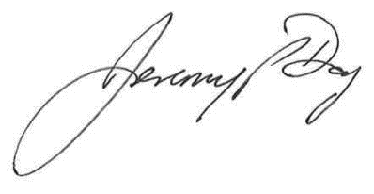
Jeremy Day
Divisional Procurement Lead – Estates & Facilities

Email: Jeremy.day@wsht.nhs.uk
For and on behalf of
Western Sussex Hospitals NHS Foundation Trust

