**Multi-Use Artificial Grass Sports Pitch for Community Use**

**Outline Design Brief**

**Project Details:**

Site location – Fairways Sports Complex, The Fairways Sherburn In Elmet, LS25 6, North Yorkshire.

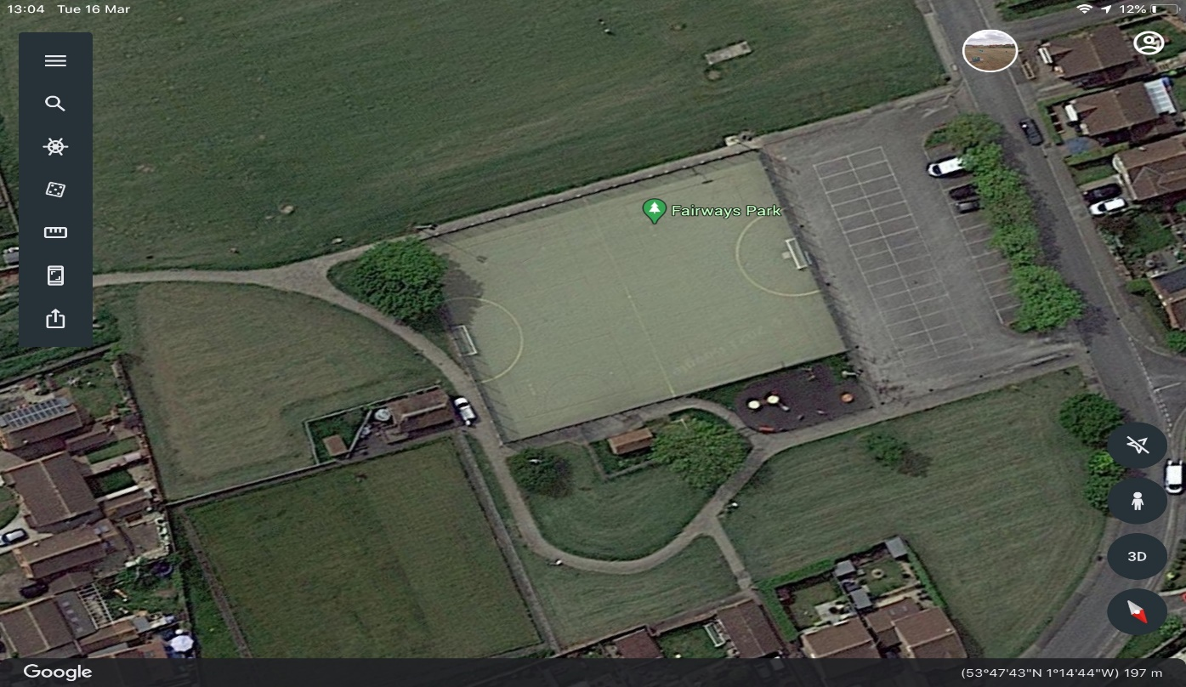

**Employer:**

Sherburn In Elmet Parish Council – Eversley Park Centre, Sherburn In Elmet LS25 6BA – Email [clerk@sherburninelmet-pc.gov.uk](mailto:clerk@sherburninelmet-pc.gov.uk) Tel 01977 681024

**Site info:**

The site includes an AGP multi-sports pitch approx. 48mtrs X 36mtrs, including a small changing building with welfare facilities, perimeter fencing and floodlighting, small play area, bowling green and ancillary facilities.

**Description of works:**

1. Lift and dispose of existing sand filled needlepoint Artificial Grass Pitch.
2. Clean and remove all debris from existing tarmac surface, to include any remedial repairs found (this to be agreed prior to any work starting)
3. Prepare existing tarmac surface for laying insitu shock pad (optional) and new sand dressed/filled artificial grass pitch, to include tapering tarmac edges to provide a flush fit (if required). Pitch area dimensions are approx. 48mtrs X 36mtrs.
4. Fit and secure appropriate insitu shock pad (optional) and artificial sand dressed/filled grass pitch for multi sports use, to include small-sided football, Netball and Tennis.
5. Line mark artificial grass pitch for 1 x small-sided football pitch, 2x Netball courts, 2x tennis courts. Line marking should not protrude or damage the carpet in any way.
6. Provide and brush in new sand, this will be undertaken until all the sand has been brushed into the surface to provide a good playing area.

**General conditions and form of contract:**

1. A contract of works will be submitted to the employer as per the description of works above, taking advice from the contractor on any new designs for multi-sports artificial grass pitches, these will be related to the provision of a shock pad and carpet.
2. The contractor will provide a tender document outlining all works to be undertaken, appropriate shock pad (optional) sand dressed/filled artificial grass pitch suitable for the named multi sports.

**Contract:**

The contractor shall agree to enter into a formal contract and will provide a tender that is incorporated in such a formal contract, executed under deed by the employer, their tender together with the employers written acceptance will constitute a formal contract between the parties.

**Design and construction responsibilities:**

The contractor shall assume responsibility for the preparation of the design, and for the construction of the whole project, as detailed in the employer’s description of works. The final design and construction will be decided by the employer, considering any new artificial grass pitch and shock pad products, which maybe more suited to multi-use sports use and all ongoing maintenance.

**Conditions for tendering:**

The employer does not bind itself to accept any design or tender, and all contractors tendering for the above work should be suitably experienced in the development of artificial grass pitches. All tenders are at the cost of the contractor and will be open for acceptance for a period of 12 weeks after the due date for submission. The contractor should note that a pre-meeting will be requested by the employer to discuss various options for the work, artificial grass pitch products, construction methods, construction programme and management structure to be used to control and progress the work to the timeline agreed.

The price for the whole works will be agreed before work commences, however it is understood by the employer that there may be some additional remedial works to be undertaken once the existing artificial grass pitch is lifted, although this will be limited to a set contingency and maybe sub-contracted out, dependant on price, this is to be agreed before the contract is awarded.

**Site access & welfare:**

There is full access to the pitch through a large carpark and through lockable double gates, there is no restrictions to access. Onsite welfare services will be provided, so no additional costs should be added for this provision.

**Inspection of site:**

It is recommended that the contractor visits the site before submitting a tender for the works, arrangements will be made to meet the employer on site.

**Method Statement:**

The contractor shall provide, prior to the contract, a statement describing their proposed general and detailed arrangements and methods for carry out the works. The tender document should also indicate any areas of work to be sub-contracted and detail the company to be employed.

The method statement should include details of how all stages of the works will be executed and all health and safety requirements. Any equipment and/or materials left on site will be secured and covered by the contractor’s insurances, no responsibility for damage of loss of equipment or materials will be held by the employer or site owner.

The contractor will be responsible for the removal of all waste from the site.

**Summary:**

This outline tender brief is provided to allow a tender document to be prepared by the contractor for the removal of an existing sand filled needle punch artificial grass pitch, preparation of existing tarmac surface, provide and fitting of a sand dressed/filled artificial grass pitch and shock pad (optional) any questions should be directed to the employer.