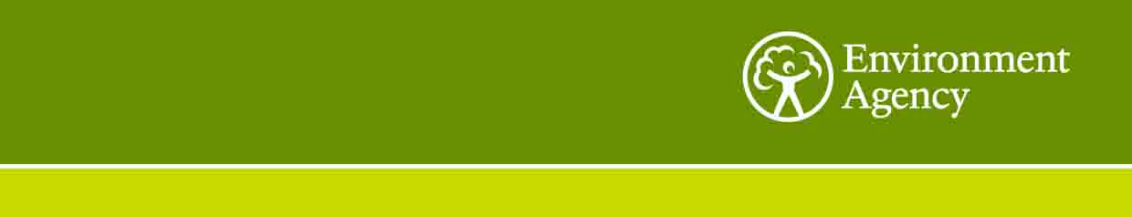

Ref: NL161103

# Date: 18/11/16

Dear Sirs

**Contract: NLS161103 – Structural Supports for Exhaust Ducting at NLS Starcross Laboratory**

You are invited to submit a quotation for the above in accordance with the enclosed Specification (Section 1), Pricing Schedule (Section 2) and Conditions of Contract for Goods .

This contract is for the supply and installation of a support frameworks at our NLS Starcross Laboratory, Staplake Mount, Starcross, Devon, EX6 8FD

Please complete Section 2 Pricing Schedule and in addition provide the following information:

1. Details if how you will undertake these works including the materials used and the corrosion prevention method.
2. Details of the delivery and installation timescales.

A site visit is to inspect the existing frameworks is essential and can be arranged by contacting Mr Toby Crimmins by email or phone;

email – toby.crimmins@environment-agency.gov.uk

Tel: 02030 250 0097

**Please return all the information requested by email to andy.fegan@environment-agency.gov.uk**

**Responses must be received by 4pm on … December 16th 2016.**

If you have any queries or require further information, please contact Andy Fegan.

Yours faithfully



Andy Fegan

NLS Contract Development Manager

Staplake Mount, Starcross

Exeter EX6 8FD

E-mail: andy.fegan@environment-agency.gov.uk

Telephone: 02030 250 009

Fax: 01626 892701

enc.