JAGGAER Commercial System
Supplier Guidance

Contents
1. Introduction 3
2. How to register as a supplier 4
2.1 How to access the Supplier Registration page 4
2.2 Registration Data 5
3. Logging into Jaggaer and responding to the ITT 7
3.1 Log into Jaggaer 7
3.2 Navigating to the ITT 9
3.3 Expressing an interest in responding to the ITT 10
3.4 Creating a response to the ITT 11
3.5 Editing a submitted response 14
4. Raising a Clarification 16
4.1 Using the Jaggaer Messaging Tool 16
5. How to access Documents 18
5.1 Accessing ITT documentation 18
6. Uploading Files in Jaggaer (Important notes on Files sizes and restrictions 19
7. Howto add additional users and user permissions to your Jaggaer account. 19
8. How to request support from Jaggaer 22

Introduction

This document will take the user through the steps required to register as a supplier.

How to register as a supplier

How to access the Supplier Registration page

Navigate to the Jaggaer log in page

Click the ‘Click here to register!’ button
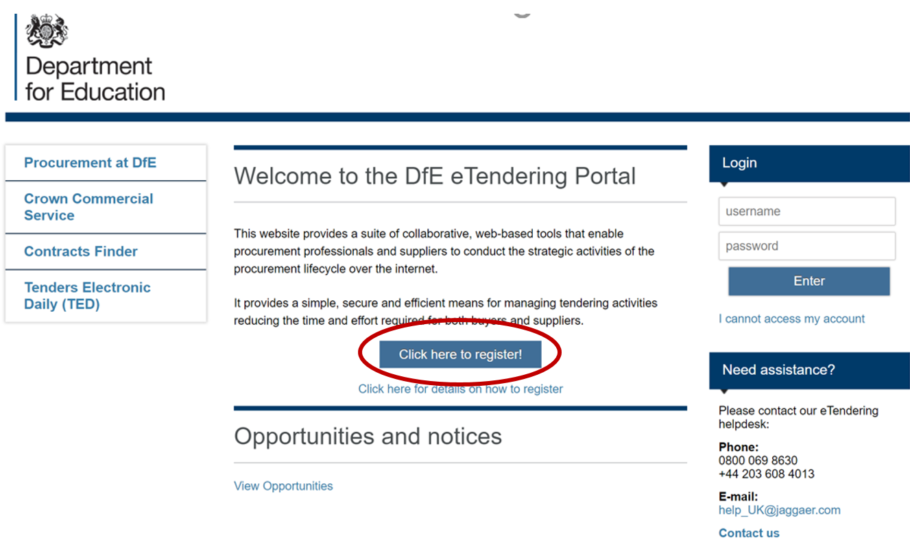

Registration Data

To register as a supplier on Jaggaer it is necessary to complete the information in the three tabs shown below:

‘Registration data’, ‘Basic Profile Forms’, ‘My Category Selection’

Registration Data tab.

The mandatory fields should be completed for ‘Organisational Details’ and ‘User Details’. Once satisfied with your answers click the ‘Save’ button.
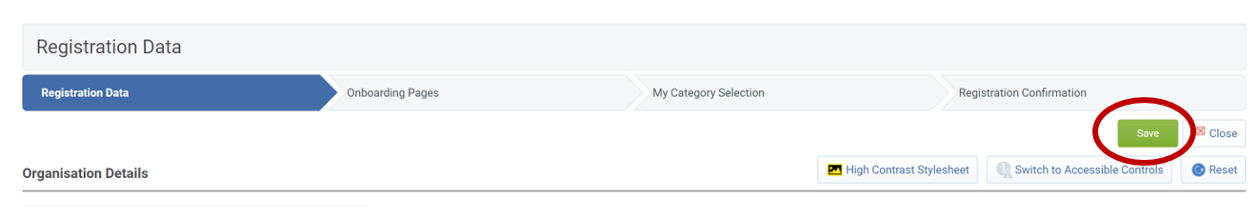
If any mandatory fields have been missed there will be a pop-up message stating the error. Revisit the answers and check for blank answers in the form, then click save when completed.

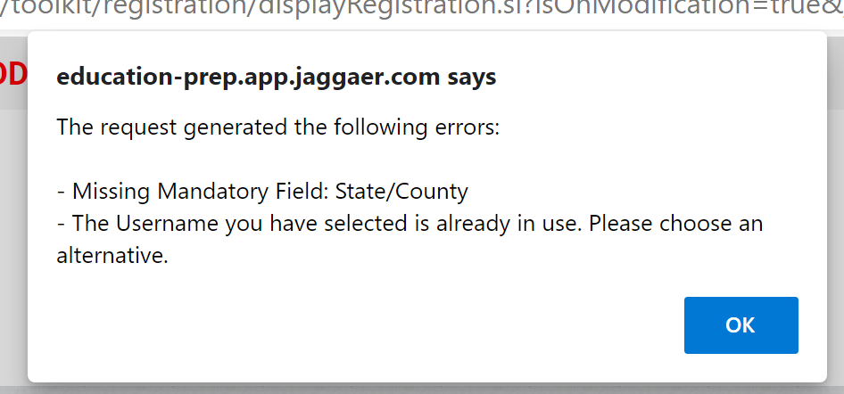

Onboarding Pages.

There are 3 mandatory questions to answer in the ‘Basic Profile Forms’. Once complete click the ‘Save & Continue’ button.
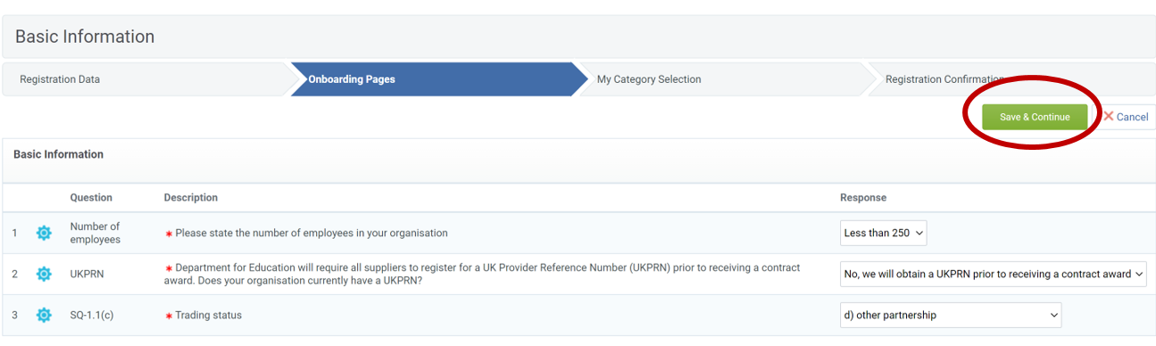

My Category Selection.

Select the categories that apply to your procurement and then click ‘Confirm’.
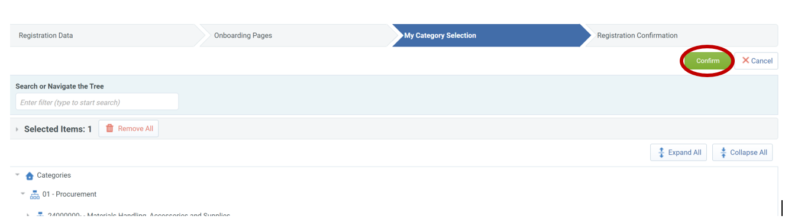

Registration Complete.

Once all the information is complete, the final tab is ‘Registration Confirmation’. You will receive an email with your username and password, which you can use to log into Jaggaer.

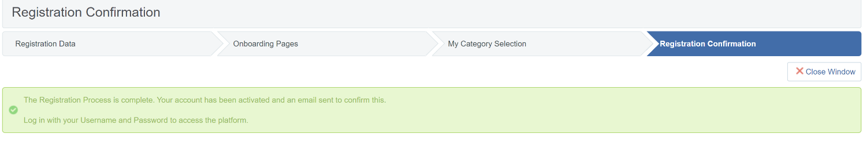

Logging into Jaggaer and responding to the ITT

Log into Jaggaer

Navigate to the Jaggaer log in page.

Enter your login details which were provided in an automated email when you have registered.

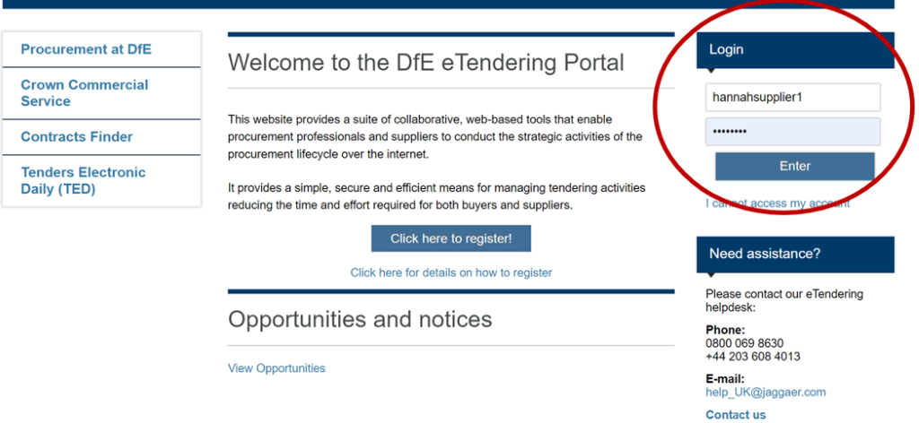

Read and Accept the User Agreement.

Click ‘I agree’ or ‘I do not agree’, then click ‘Next’.

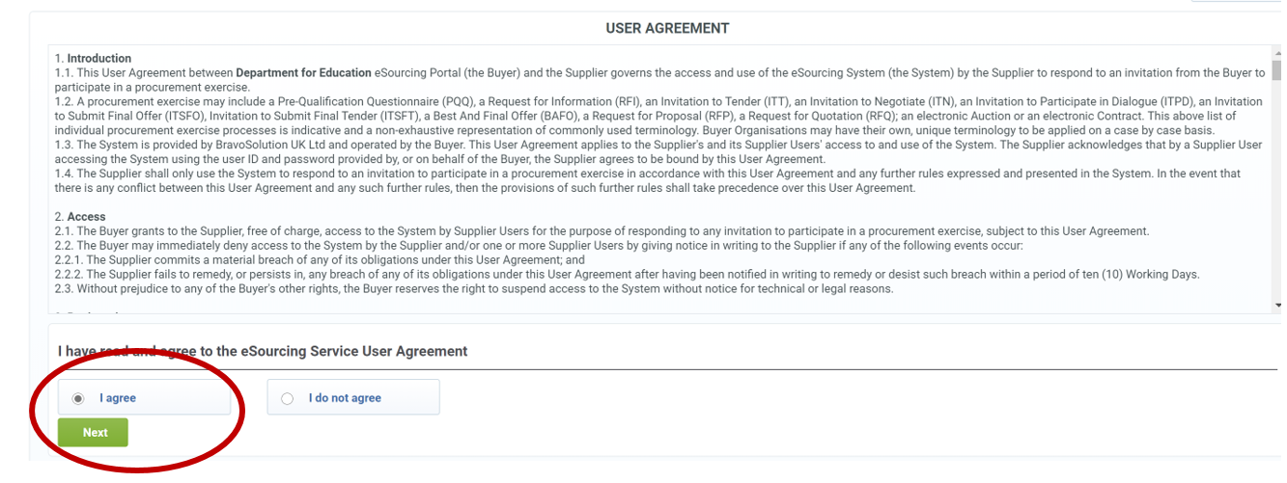

You will be asked to create a new password for your account.

Enter the password you wish to chose twice and click ‘Submit’.

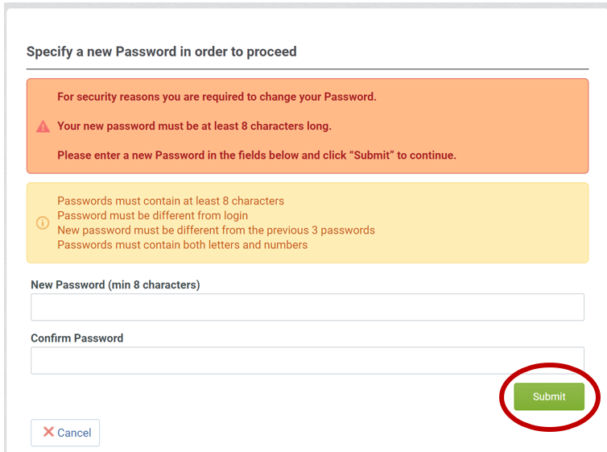

Navigating to the ITT

Click on ‘ITT’s Open to All Suppliers’ or, if you know have already registered your interest, ‘My ITTs’ in the left-hand menu

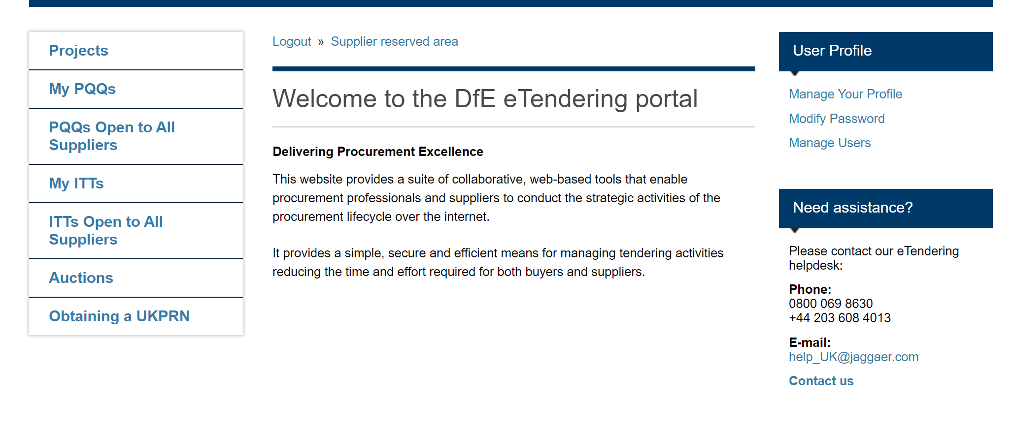

Select the relevant ITT title.

You can see in the field ‘Time Limit for Expressing Interest’ how much time you have to respond.

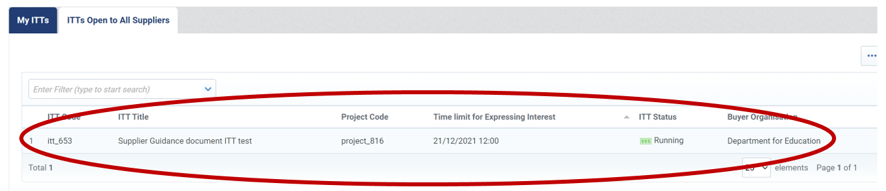

Expressing an interest in responding to the ITT

If the ITT is of interest to you, click ‘Express Interest’.

There is also the option to ‘Decide Later’.

You will see the following pop-up box, if you wish to proceed with completing the form then click ‘OK’.
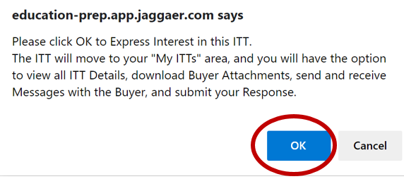

You will then see the following pop-up providing information on what to do next.

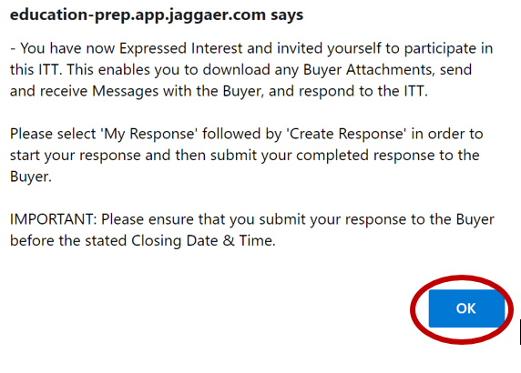

Creating a response to the ITT

Click the tab ‘ITT Details’, then ‘My Response’.

If there are attachments to the ITT you can download these from the ‘Buyer Attachments Tab’.

Click on the ‘Create Response’ button.

If you change your mind and no longer wish to respond, click ‘Decline to Respond’.

You will see the following pop-up message confirming you have started to create a response and giving some instructions on how to proceed.

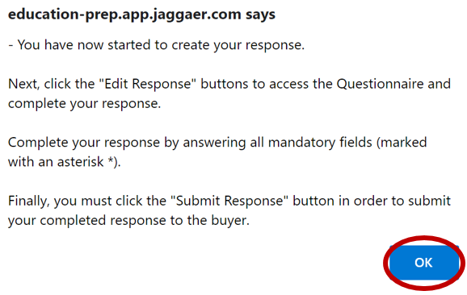

Click ‘Edit Response’ to begin the process of completing the questionnaire.
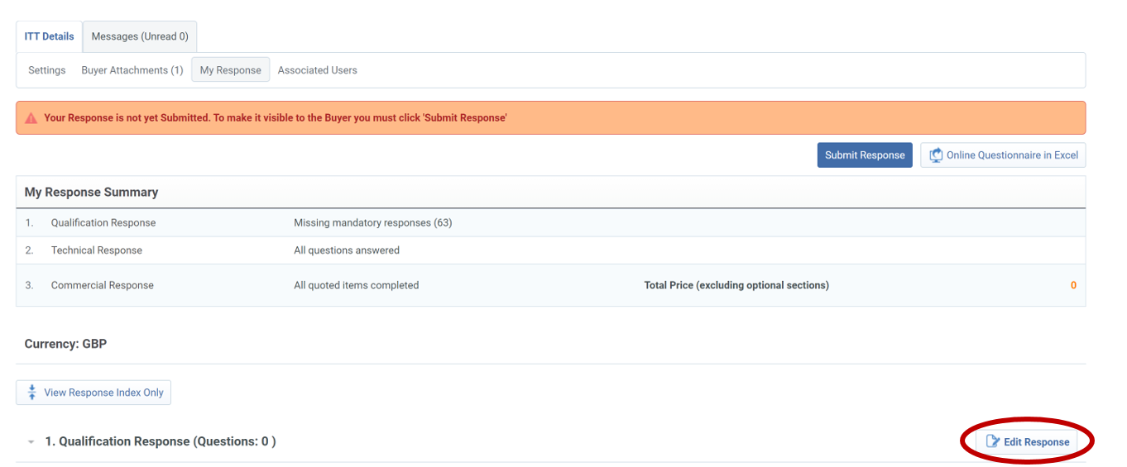

At any point you may click ‘Save Changes’ prior to submitting your response.

You will see the pop up below confirming the changes are saved but that you still need to submit your response.
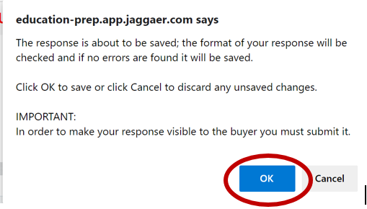

3.4 Submitting the Response
Once you are satisfied with your answers you need to submit your response

Click ‘Save and Exit Response’.
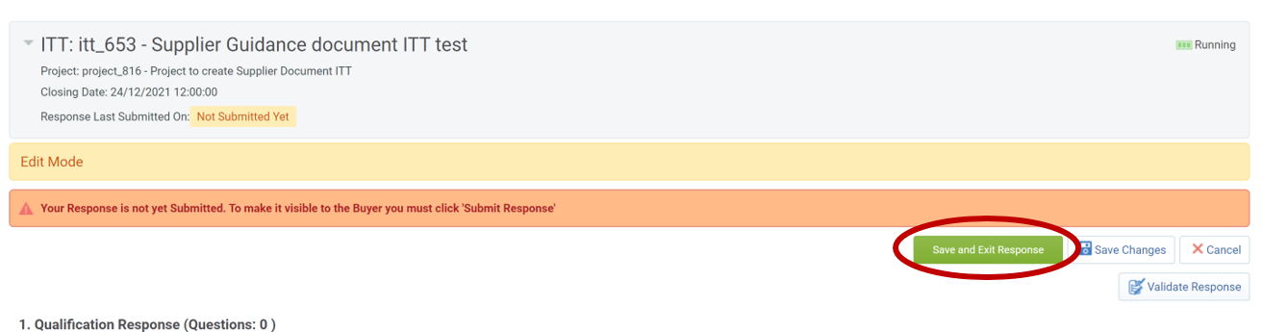

Click ‘Submit Response’.

PLEASE NOTE: You must ‘Submit Changes’ for your response to be considered

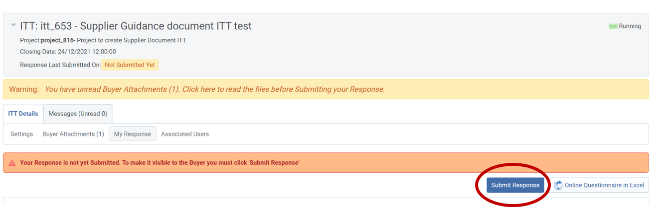

You will see the following confirmation pop-up message that you have successfully submitted your response.
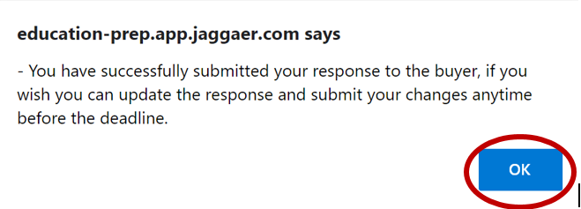

Editing a submitted response

Navigate to ‘My Responses’. Click ‘Edit Response’.
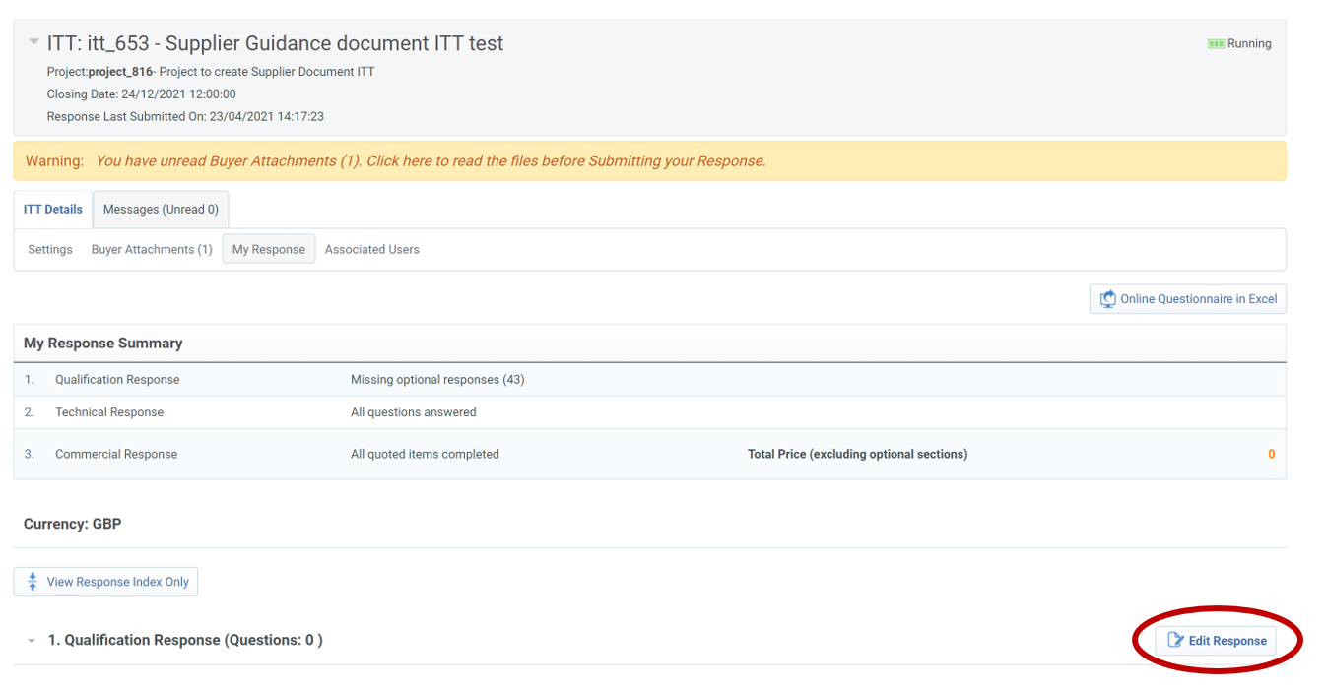

When you have edited your response click ‘Keep Changes’.

You can also click ‘Discard Changes’ at this point and revert to your previous answers.

Clicking ‘Validate Response’ will check that all fields have been completed.
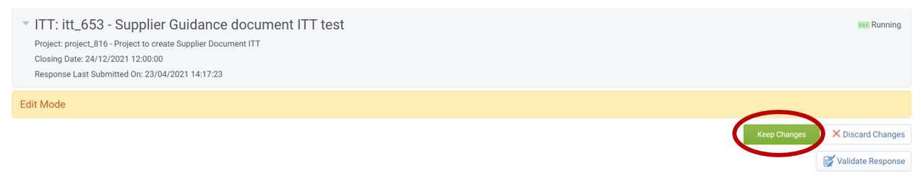

Make sure you click ‘Submit Changes’. If you don’t, your existing response will remain in place.
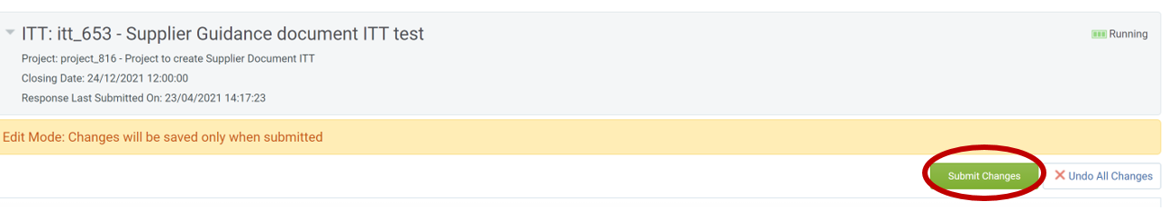

A pop-up message confirming successful submission will be shown.

You can repeat the process of editing your response until the Time Limit for Expressing Interest has passed.
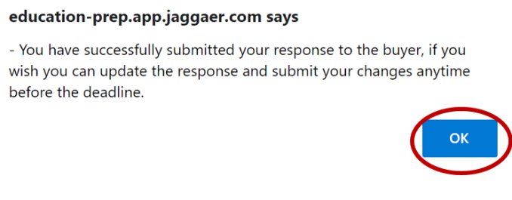

Please note that if a file is over 50MB it will need to be zipped when uploading

Raising a Clarification

Using the Jaggaer Messaging Tool

When responding to an ITT in Jaggaer it is vital that there is a clear and auditable chain of communication. The messaging feature enables you to send messages directly to the owner of the ITT and receive communication directly back in the tool

When in the ITT, navigate to ‘Messages’ tab.

Creating a message.

Click on Create Message.

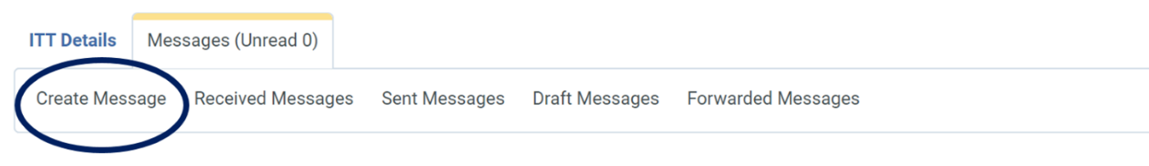
Add a relevant subject, enter message and click ‘send message’ button.

If you are not ready to send you message you can click ‘Save as draft’ and the message will be found in the ‘Draft Messages’ tab.

You can also upload an attachment using the ‘Attachments button’.
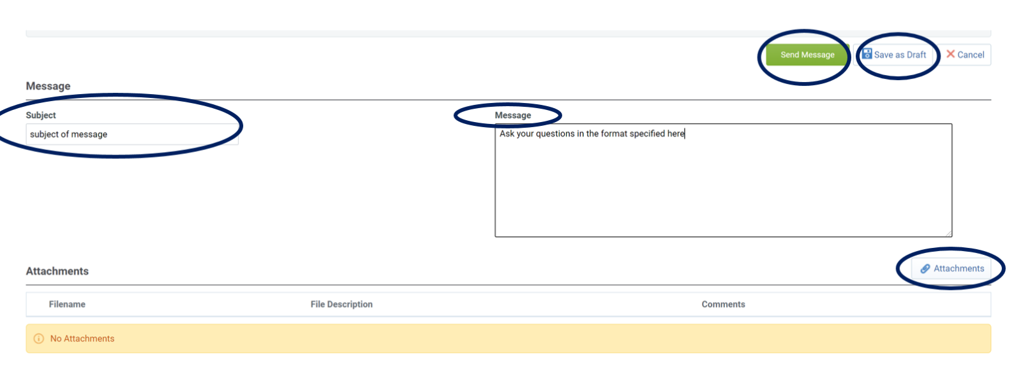

Received messages.

When your message has been replied to you will received an email notification and the response will be shown in the ‘Received’ messages tab.

Click on the message to open. You can then reply to this message as necessary.

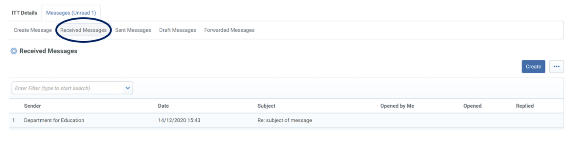

How to access Documents

Accessing ITT documentation

There may be documents within the ITT questions to download or there maybe documents in the ‘Buyer Attachments’ tab. The process to download is the same.

Navigate to the section where the attachment you wish to download is stored.

In the example below you can see there is 1 attachment in the ‘Buyer Attachments’ tab – if you click this link it will take you to view the attachments.

There is the option to ‘Mass Download’ if there were more documents to view.

When you click on the document Jaggaer gives you a ‘download’ option button.

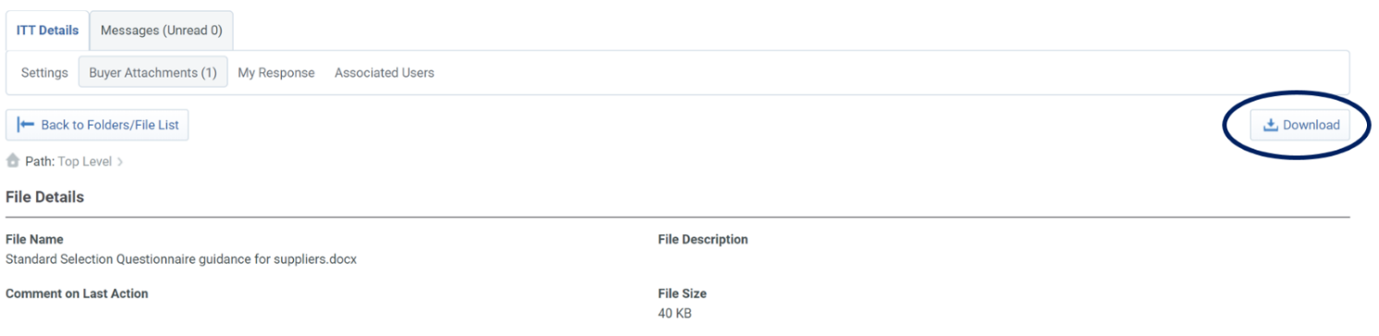

Uploading Files in Jaggaer (Important notes on Files sizes and restrictions)

Please note that when responding to the ITT Jaggaer will only store one attachment per question. If you upload a second file, only one file can be stored, any subsequent uploads will over write any previously uploaded documents

Any file over 50MB in size will need to be zipped prior to being uploaded.

How to add additional users and user permissions to your Jaggaer account.

These instructions show how to add multiple additional users to a single Jaggaer account. You will need to review and set the user permissions for each user you add, this will include the ability to access and create bid responses.
Please note: when responding to bidding opportunities only a single bid response per Jaggaer account is permitted.

Log in and select ‘Manage Users’.

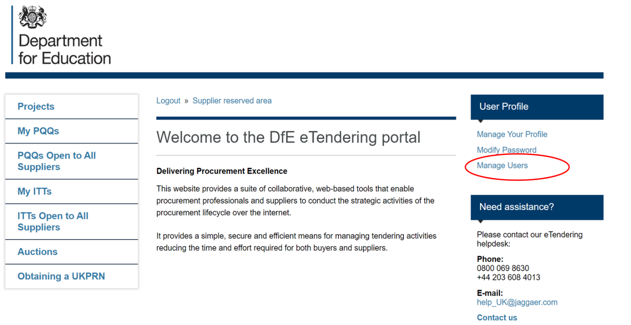

Select ‘Create’.
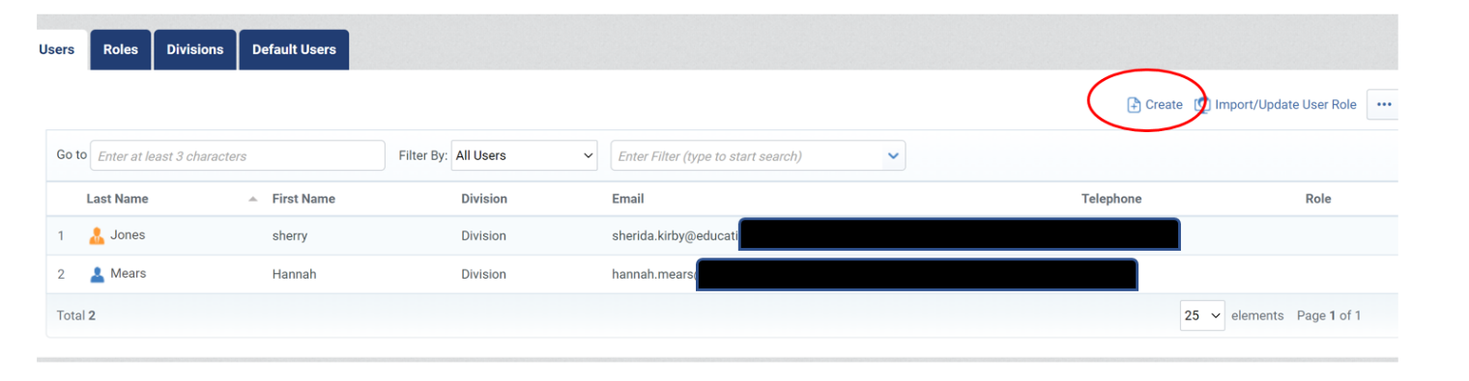

Enter the details of the new user and click ‘Save’. An email containing the new users’ log in information will be sent.

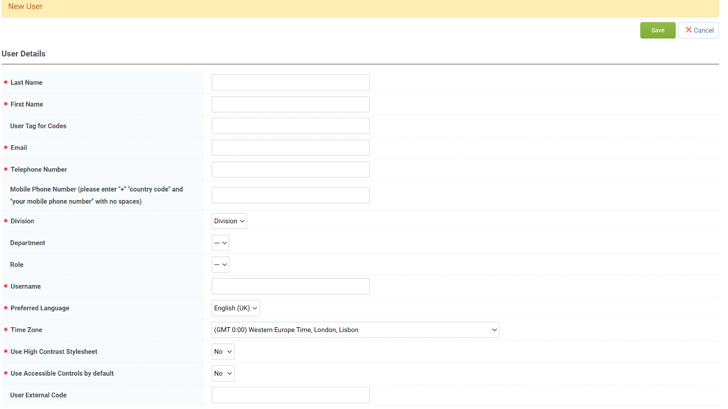

Select ‘View User Rights’.
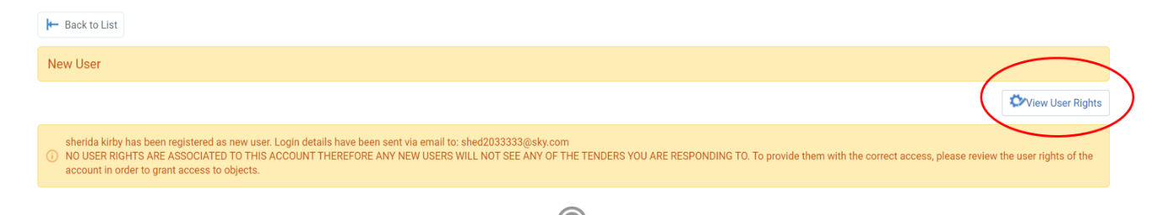

Select ‘Edit…’ at the top of each section (e.g. ‘Edit SSq/ITT Rights’), to assign the user with permissions as required. An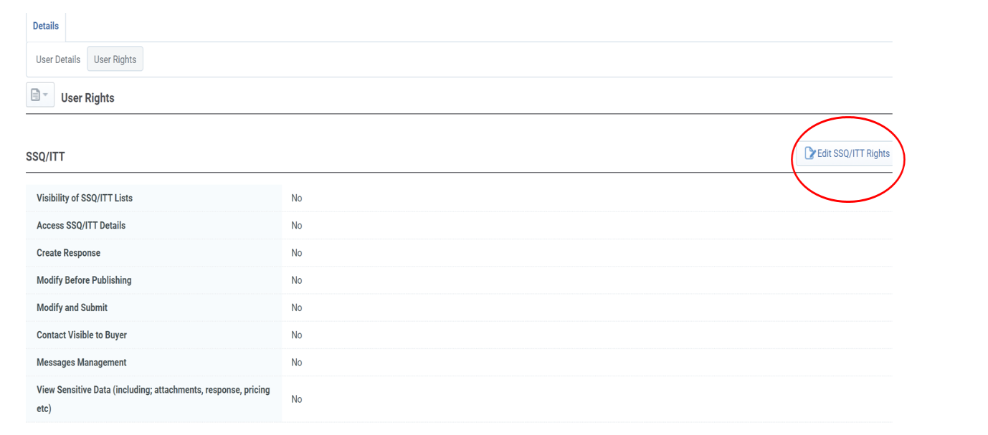

How to request support from Jaggaer

If you need assistance whilst replying to the ITT or when registering as a supplier you can contact the Jaggaer helpdesk directly using the following details (found on the Jaggaer Homepage).
