Request for Quotation

Selsey Bill & the Hounds MCZ – Drop Down Camera & Grab Surveys
29/06/2023

Request for Quotation
Selsey Bill & the Hounds MCZ – Drop Down Camera & Grab Surveys
You are invited to submit a quotation for the requirement described in the specification, Section 2.
Please confirm by email, receipt of these documents and whether you intend to submit a quote or not.
Your response should be returned to the following email address by:
Email: Danni.Barratt@naturalengland.org.uk
Date: 12/07/2023
Time: 17:00
Ensure you include the name of the quotation and ‘Final Submission’ in the subject field to make it clear that it is your response.
Contact Details and Timetable
Paula Daglish will be your contact for any questions linked to the content of the quote or the process. Please submit any clarification questions via email and note that, unless commercially sensitive, both the question and the response will be circulated to all tenderers.
Action | Date
Date of issue of RFQ | 29/06/2023
Deadline for clarifications questions | 12/07/2023
Deadline for receipt of Quotation | 12/07/2023 at 17:00
Intended date of Contract Award | 17/07/2023
Intended Contract Start Date | 24/07/2023
Intended Delivery Date / Contract Duration | 31/12/2023

Section 1: General Information
Glossary
Unless the context otherwise requires, the following words and expressions used within this Request for Quotation shall have the following meanings (to be interpreted in the singular or plural as the context requires):
“Authority” | Means the Department for Environment, Food and Rural Affairs acting as part of Natural England who is the Contracting Authority.
“Contract” | means the contract to be entered into by the Authority and the successful supplier.
“Response” | means the information submitted by a supplier in response to the RFQ.
“RFQ” | means this Request for Quotation and all related documents published by the Authority and made available to suppliers.

Conditions applying to the RFQ
You should examine your Response and related documents ensuring it is complete and in accordance with the stated instructions prior to submission.
Your Response must contain sufficient information to enable the Authority to evaluate it fairly and effectively. You should ensure that you have prepared your Response fully and accurately and that prices quoted are arithmetically correct for the units stated.
By submitting a Response, you, the supplier, are deemed to accept the terms and conditions provided in the RFQ. Confirmation of this is required in Annex 2.
Failure to comply with the instructions set out in the RFQ may result in the supplier’s exclusion from this quotation process.
Acceptance of Quotations
By issuing this RFQ the Authority does not bind itself to accept any quotation and reserves the right not to award a contract to any supplier who submits a quotation.
Costs
The Authority will not reimburse you for any costs and expenses which you incur preparing and submitting your quotation, even if the Authority amends or terminates the procurement process.
Self-Declaration and Mandatory Requirements
The RFQ includes a self-declaration response (Annex 1) which covers basic information about the supplier, as well as any grounds for exclusion. If you do not comply with them, your quotation will not be evaluated.
Any mandatory requirements will be set out in Section 2, Specification of Requirements and, if you do not comply with them, your quotation will not be evaluated.
Clarifications
Any request for clarification regarding the RFQ and supporting documentation must be submitted via email no later than the deadline for clarifications set out in the Timetable. The Authority shall be under no obligation to respond to queries raised after the clarification deadline.
The Authority will respond to all reasonable clarifications as soon as possible but cannot guarantee a minimum response time. The Authority will publish all clarifications and its responses to all suppliers via email unless deemed commercially sensitive.
If a supplier believes that a request for clarification is commercially sensitive, it should clearly state this when submitting the clarification request. However, if the Authority considers either that:
the clarification and response are not commercially sensitive; and
all suppliers may benefit from its disclosure,

then the Authority will notify the supplier (via email), and the supplier will have an opportunity to withdraw the request for clarification by sending a further message requesting the withdrawal of the clarification request. If not withdrawn by the supplier within 2 working days of the Authority’s notification, the Authority may publish the clarification request and its response to all suppliers and the Authority shall not be liable to the supplier for any consequences of such publication.
The Authority reserves the right to seek clarification of any aspect of a quotation and/or provide additional information during the evaluation phase to carry out a fair evaluation. Where the Authority seeks clarification on any aspect of the quotation, the supplier must respond within the timeframe requested by the Authority.
Amendments
The Authority may amend the RFQ at any time prior to the deadline for receipt. If it amends the RFQ the Authority will notify you via email.
Suppliers may modify their quotation prior to the deadline for Responses. No Responses may be modified after the deadline for Responses.
Suppliers may withdraw their quotations at any time by submitting a notice via the email to the named contact.
Conditions of Contract
The Authority’s standard condensed terms and conditions of contract to be provided as part of the RFQ will be included in any contract awarded as a result of this quotation process. The Authority will not accept any changes to these terms and conditions proposed by a supplier.
Suppliers should note that the quotation provided by the successful bidder will form part of the Contract.
Prices
Prices must be submitted in £ sterling, inclusive of VAT.
Disclosure
All Central Government Departments, their Executive Agencies and Non Departmental Public Bodies are subject to control and reporting within Government. In particular, they report to the Cabinet Office and HM Treasury for all expenditure. Further the Cabinet Office has a cross-Government role delivering overall Government policy on public procurement, including ensuring value for money and related aspects of good procurement practice. For these purposes, the Authority may disclose within Government any details contained in your quotation. The information will not be disclosed outside Government during the procurement.
In addition, the Authority is subject to the Freedom of Information Act 2000 and the Environmental Information Regulations 2004, which provide a public right of access to information held by public bodies. In accordance with these two statutes, the Authority may be required to disclose information contained in your quotation to any person who submits a request for information pursuant to those statutes.
Further to the Government’s transparency agenda, all UK Government organisations must advertise on Contract Finder in accordance with the following publication thresholds:
Central Contracting Authority’s: £12,000
Sub Central Contracting Authority’s and NHS Trusts: £30,000
For the purpose of this RFQ the Authority is classified as a Central Contracting Authority with a publication threshold of £12,000 inclusive of VAT.
If this opportunity is advertised via Contracts Finder, we are obliged to publish details of the awarded contract including who has won the contract, the contract value, and indicate whether the winning supplier is a small and medium-sized enterprise (“SMEs”) or voluntary organisation or charity. A copy of the contract must also be published with confidential information redacted.
By submitting a Response, you consent to these terms as part of the procurement.
Disclaimers
Whilst the information in this RFQ and any supporting information referred to herein or provided to you by the Authority have been prepared in good faith the Authority does not warrant that this information is comprehensive or that it has been independently verified.
The Authority does not:
make any representation or warranty (express or implied) as to the accuracy, reasonableness or completeness of the RFQ;
accept any liability for the information contained in the RFQ or for the fairness, accuracy or completeness of that information; or
accept any liability for any loss or damage (other than in respect of fraudulent misrepresentation or any other liability which cannot lawfully be excluded) arising as a result of reliance on such information or any subsequent communication.
Any supplier considering entering into contractual relationships with the Authority following receipt of the RFQ should make its own investigations and independent assessment of the Authority and its requirements for the goods and/or services and should seek its own professional financial and legal advice.
Protection of Personal Data
In order to comply with the General Data Protection Regulations 2018 the supplier must agree to the following:
You must only process any personal data in strict accordance with instructions from the Authority.
You must ensure that all the personal data that we disclose to you or you collect on our behalf under this agreement are kept confidential.
You must take reasonable steps to ensure the reliability of employees who have access to personal data.
Only employees who may be required to assist in meeting the obligations under this agreement may have access to the personal data.
Any disclosure of personal data must be made in confidence and extend only so far as that which is specifically necessary for the purposes of this agreement.
You must ensure that there are appropriate security measures in place to safeguard against any unauthorised access or unlawful processing or accidental loss, destruction or damage or disclosure of the personal data.
On termination of this agreement, for whatever reason, the personal data must be returned to us promptly and safely, together with all copies in your possession or control.

General Data Protection Regulations 2018
For the purposes of the Regulations the Authority is the data processor.
The personal information that we have asked you provide on individuals (data subjects) that will be working for you on this contract will be used in compiling the tender list and in assessing your offer. If you are unsuccessful the information will be held and destroyed within two years of the award of contracts. If you are awarded a contract, it will be retained for the duration of the contract and destroyed within seven years of the contract’s expiry.
We may monitor the performance of the individuals during the execution of the contract, and the results of our monitoring, together with the information that you have provided, will be used in determining what work is allocated under the contract, and in any renewal of the contract or in the award of future contracts of a similar nature. The information will not be disclosed to anyone outside the Authority without the consent of the data subject, unless the Authority is required by law to make such disclosures.
Equality, Diversity & Inclusion (EDI)
The Client is striving to create a diverse and inclusive working environment where every individual has equality of opportunity to progress and to apply their unique insights to making the UK a great place for living. The Service Provider is expected to respect this commitment in all dealings with Natural England staff and service users.
Suppliers are expected to;
support Defra group to achieve its Public Sector Equality Duty as defined by the Equality Act 2010, and to support delivery of Defra group’s Equality & Diversity Strategy.
meet the standards set out in the Government’s Supplier Code of Conduct
work with Defra group to ensure equality, diversity and inclusion impacts are addressed (positive and negative) in the goods, services and works we procure, barriers are removed and opportunities realised.
Sustainable Procurement
Addressing global sustainability impacts and realising additional community benefits within commercial activity is core to Defra group’s approach, working with its supply chain is key to achieving sustainable outcomes. In addition to supporting Defra group to meet its outcomes we look to understand and reduce negative sustainability impacts associated with our commercial activity and realise benefits.
The Client encourages its suppliers to share these values, work to address negative impacts and realise opportunities, measure performance and success.
Suppliers are expected to have an understanding of the Sustainable Development Goals, the interconnections between them and the relevance to the Goods, Services and works procured on the Client’s behalf
Conflicts of Interest
The concept of a conflict of interest includes but is not limited to any situation where an Involved Person or Relevant Body has directly or indirectly, a financial, economic or other personal interest which might be perceived to compromise their impartiality and independence in the context of the procurement procedure and/or affect the integrity of the contract award.
We expect suppliers to mitigate appropriately against any real or perceived conflict of interest through their work with government. A supplier with a position of influence gained through a contract should not use that position to unfairly disadvantage any other supplier or reduce the potential for future competition
Where the supplier is aware of any circumstances giving rise to a conflict of interest or has any indication that a conflict of interest exists or may arise you should inform the Authority of this as soon as possible (whether before or after they have submitted a quotation). Tenderers should remain alert to the possibility of conflicts of interest arising at all stages of the procurement and should update the Authority if any new circumstances or information arises, or there are any changes to information already provided to the Authority. Failure to do so, and/or to properly manage any conflicts of interest may result in a quotation being rejected.
Provided that it has been carried out in an open, fair and transparent manner, routine pre-market engagement carried out by the Authority should not represent a conflict of interest for the supplier.

Section 2: The Invitation

Specification of Requirements
The Authority is Natural England. The Authority’s priorities are to secure a healthy natural environment; a sustainable, low-carbon economy; a thriving farming sector and a sustainable, healthy, and secure food supply.

Specification

Introduction
The Selsey Bill & the Hounds Marine Conservation Zone (MCZ) was designated in 2019 under the third tranche of MCZ designations to complete the Marine Protected Areas network in Secretary of State waters. The site is located along the coast of the eastern English Channel and covers an area of 1564.85 ha. The MCZ lies along the Manhood Peninsular between Chichester Harbour in the west and Pagham Harbour in the east and extends seaward to encapsulate the offshore rocky outcrops that make up ‘the Hounds’ (Figure 1).
Figure 1: Boundary map for Selsey Bill & the Hounds Marine Conservation Zone (MCZ).
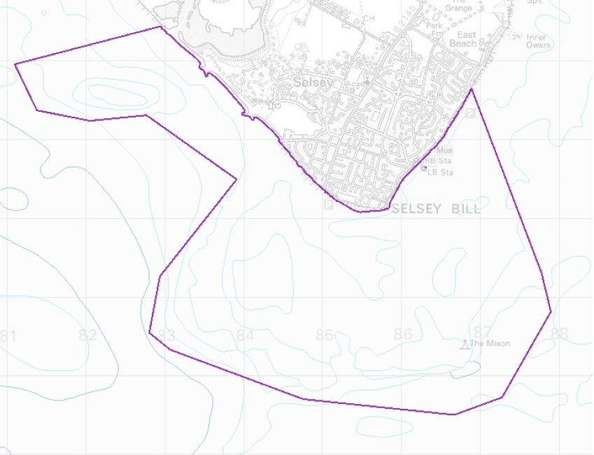
Coordinates of the entire MCZ can be found here.
There are several legislative and policy drivers which underpin the need to monitor, assess and report upon habitats and species within the marine environment. Marine monitoring activity in Natural England therefore takes place in the context of the wider UK approach under the UK Marine Monitoring and Assessment Strategy. The overarching monitoring strategy describes two main functions of monitoring:
- To identify state and changes in state for an ecological component of biodiversity, and identify whether changes are due to natural change or as a result of anthropogenic activities,
- Information provided through this contract will inform the need for management measures; and to identify if management measures already in place are effective in meeting their objectives.
Following a prioritization process Selsey Bill & the Hounds MCZ has been selected for a survey which will contribute to evidence gathering to support condition assessment for the MCZ.
The seabed within the MCZ mainly consists of moderate or low energy infralittoral rock, subtidal sand, and subtidal mixed sediments, however, the site also captures one of the best-known examples of peat and clay exposures on the southeast coast. The eastern regions of the MCZ are generally characterized by mixed sediments and subtidal sand.
Selsey Bill is well known for its high biodiversity and species richness, attributed to the variety of habitats present and unusual seabed topography. In the southeast of the site is the Mixon Hole, characterised by a drowned river gorge kept open by strong tidal currents, and boasts a dramatic 20 meter drop in the seafloor exposing clay cliffs capped with limestone and supporting a rich diversity of habitats and species. The rocky exposures along the site that make up ‘the Hounds’ are dominated by dense red algae and mixed animal turf, while the underlying clay provides habitat for mobile species such as edible crabs and spider crabs.
The MCZ hosts the following qualifying habitat features of conservation interest which are the subject of the monitoring program:
- Bracklesham Bay geological feature
- High Energy Infralittoral Rock
- Moderate Energy Infralittoral Rock
- Low Energy Infralittoral Rock
- Moderate Energy Circalittoral Rock
- Peat & Clay Exposures
- Subtidal Mixed Sediments
- Subtidal Sand
Full site details are available on the NE designated sites webpage here.

Aims and Objectives
The monitoring surveys should meet five objectives, these are:
Objective 1: Acquire and analyse sediment grab samples to provide high quality biological and sediment granulometry data of suitable resolution to allow temporal and spatial variability in the sediment broad scale habitat (BSH) extent, distribution and community structure to be determined.
Objective 2: Acquire high quality video/image data sufficient to verify the extent and distribution of subtidal rock habitats, and determine the main characterising species present within such habitats so that spatial and temporal comparisons can be made, as far as possible, with previous data collected using diving methods; and
Objective 3: Identify and map all subtidal communities identified using grab and drop-down video (DDV) methods to the highest possible EUNIS level and compare, where possible, to previous habitat maps of the site in order highlight any significant changes.
Objective 4: Identify and record the abundance and location of Invasive Non-Native Species (INNS) wherever encountered during surveys.
Objective 5: Derive, where possible, any changes in condition of the subtidal sedimentary and rock habitats and the communities they support and form part of an ongoing time-series of data.

Previous surveys
Previous surveys undertaken within Selsey Bill and the Hounds MCZ are listed in Appendix 1 and the report from the Environment Agency 2014 survey is provided with the tender documents. An additional package from the Marine Evidence database of this survey information can be provided upon request to the successful contractor. Figure 2 shows existing mapped locations of subtidal features within the MCZ.
In 2014, the Environment Agency undertook a verification survey of the site to determine the presence of subtidal features. Up to 22 sample stations were identified for this survey. The survey report is provided as a separate document.
Figure 2: Selsey Bill & the Hounds MCZ Feature Map
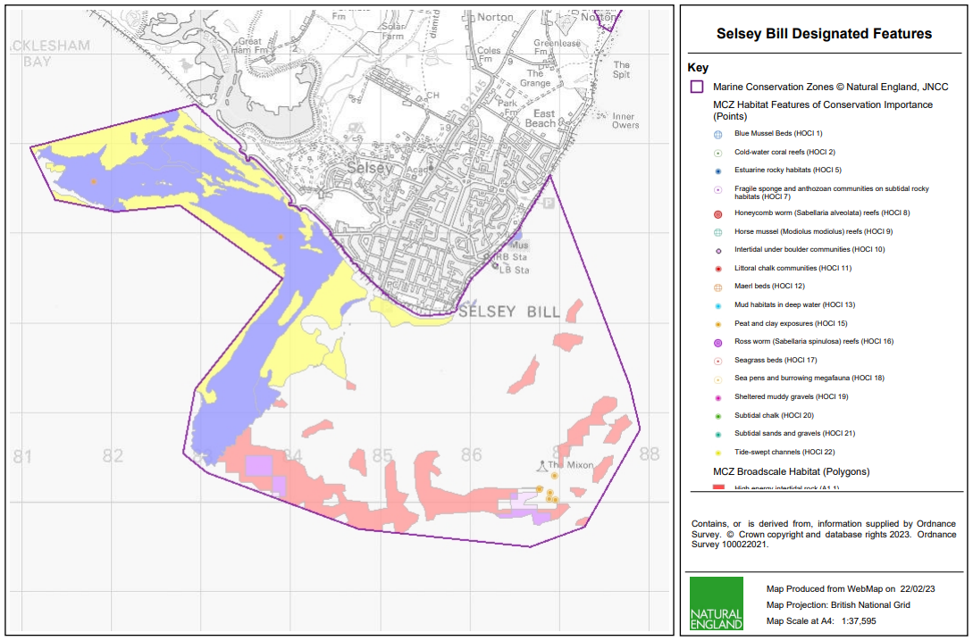
Further information on features available from: Selsey Bill and the Hounds MCZ feature maps (publishing.service.gov.uk)

Figure 3: Environment Agency habitat verification survey plan.
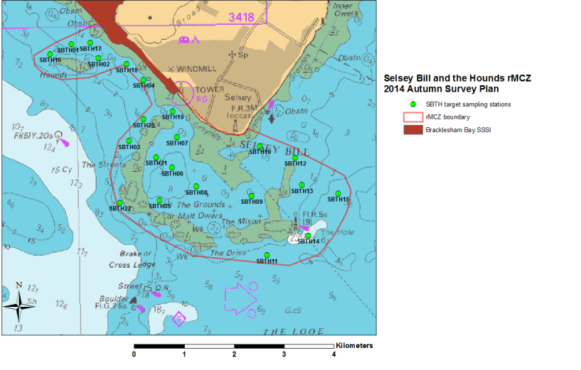

Data and Sample Collection
1.3.1 Sample Collection Methodology
Day grab sampling (surface sampling area of 0.1m2) for biotic and abiotic analysis should be undertaken according to the relevant guidelines1,2 as will deployment of the video / stills camera (including stills camera mounted on video frame)3,4. Any proposed deviation from the guidance should be highlighted and reasons provided. Where appropriate, the contractor should also suggest their own specialist techniques, to help contribute to the on-going research and development in this field.
A sampling plan should be identified that covers the original stations (where successful samples were obtained) from the EA survey and any previous surveys and additional stations suggested to ensure wide-spread coverage using a triangular grid pattern. Costings for a fixed number of stations should be identified within the plan but the specific locations of these may be altered and confirmed by the successful contractor and Natural England at the start up meeting.
1.3.2 General Positioning
During surveys the position of the specified vessel and any sampling gear deployed should be resolved using differential GPS to a minimum accuracy of ±10 m. Positioning systems shall be installed, calibrated and operated in accordance with manufacturers’ instructions in order to supply sufficient accurate positioning information to control the survey. Its use will follow the guidelines published by the UKOOA Surveying and Positioning Committee (1994), in particular the recommendations on quality monitoring and acceptance criteria.
Prior to deployment, receiver tests and calibrations will be carried out at a point with known coordinates, to verify the normal operation of the receiver. Data relating to these checks will be available on the vessel. Full back-up of all operational equipment will be made.
Data from the positioning, orientation, measurement and computational systems shall be checked or self-checked in such a way that coordinates of the vessel datum points are provided correctly and are demonstrated to be correct. All calibration corrections, adjustments, offsets and changes to positioning data shall be recorded and displayed during the execution of the survey.
Annotation relating to any set of co-ordinates shall indicate the location being positioned, the system utilised for positioning and the nature of adjustments applied during computation. Data generated by positioning equipment should be rectified using the appropriate projection, datum and spheroid for the region of the works.
1.3.3 Sample Processing
All macrofauna sample processing (including biomass determination) should be undertaken in accordance with the latest NMBAQCS guidelines5 and associated quality assurance methods, as should all Particle Size Analysis (PSA)6. In line with the EA survey of 2014, a 1.0 mm sieve will be used for processing the macrofauna samples.
The abundance and biomass data matrices should be in provided in the template format. An additional column to include the species directory code for each species in the taxon list should be provided, and the taxa list should be ordered by major taxonomic group.
Species nomenclature should be the accepted name as per the most recent update of the World Register of Marine Species.
Metadata, compliant with MEDIN/ISO standards will accompany all data and samples delivered that describe the methods of acquisition, equipment settings and configuration, date/times, onboard/post-acquisition processing undertaken and relevant charts and figures describing the location of survey operations.
All survey data should be supplied in a format as agreed by MEDIN to expedite archiving within the MEDIN Data Archive Centres (DACs). This may require completion of metadata spreadsheet templates for onward supply to the DACs.

Reporting
2.1 Progress Reports
Progress reports will be provided to Natural England during the field survey – the frequency of which will be determined at the start up meeting.
2.2 Cruise Report
A cruise report will be produced within one month after the completion of the survey.
2.3 Final Report
A final report will be produced. The report should include an updated broadscale habitat map and reported as follows:
Executive Summary
1. Introduction
1.1 Site Description
1.2 Survey Aims/Objectives
2. Methods (Fully detailed)
2.1 Sampling Strategy
2.2 Access
2.3 Survey Dates
2.4 Survey Team
2.5 Grab Sampling Protocol
2.6 DDV/Camera Sampling Protocol
3 Results
3.1 Sublittoral Sediments (inc. Fauna, Biomass and PSA inc. assignment of a habitat type at each station to the highest EUNIS classification possible)
3.1.1 Spatial community analysis
3.1.2 Comparison with historical data
3.2 Sublittoral Rock
3.2.1 Spatial community analysis
3.2.2 Comparison with historical
3.3 Habitats/Species of Conservation Importance
3.4 INNS
3.5 Evidence of Anthropogenic Impacts
4. Discussion
4.1 Review of Methods (inc. power analysis)
5. Conclusion
References
Annexes

3. Deliverables, delivery format, and timescales
Survey work under the contract should be scheduled to be completed by the end of September 2023 where possible however, potential contractors should provide contingency dates should the planned survey be affected e.g. by weather downtime. Completion of this Plan of Action will include the following deliverables:
- Survey work suitable to meet the overarching aims and objectives.
- Provision of detailed ‘standard operating protocols’ for the work undertaken to ensure that these can be repeated as required in the future.
- Progress Reports
- Final report addressing each of the 5 main objectives listed above. An evaluation of the methods should also be carried out and include techniques such as species accumulation plots which could be used to determine how well the sampling carried out represented the communities present. Power analysis should also be carried out on the univariate statistics to inform future sampling design.
- Appropriate GIS outputs, Marine Recorder files, MEDIN compliant metadata including a confidence assessment of the data outputs. The GIS files will contain all of the data relating to extent and distribution of subtidal sediment habitat types (to the highest EUNIS classification possible), reef sub-features, species and habitats of conservation importance, reef indicator species, INNS and anthropogenic influences.
- Catalogue of image data – file names must conform to the format ‘relevant species/taxon name and video/still file name’ (Hitchin et al 2015).
- Media catalogue.
- Benthic Sampling Spreadsheets.
- Cruise Report.
- Provision of all raw data inc. benthic taxa, abundance, biomass data and PSA data.
Milestone/ Deliverable | Completion Date | Lead
Draft Survey Plan including sampling design | Complete (suggested plan provided) | NE
Final Survey Plan | TBC in collaboration | NE
Video (.avi) data  Digital stills (.jpeg) data  Media catalogue  Video/Benthic Sampling Spreadsheet | TBA | Contractor
Cruise Report | 1 month after completion of survey | Contractor
Taxonomic reference collection | After completion of processed samples – specific timing tbc | Contractor
Final report and data deliverables to NE | TBC | Contractor

Natural England would expect to discuss and review timelines with the successful contractor in the start-up meeting and throughout the duration of the contract. Any delays to this timetable should be discussed with the Natural England Project Officer and delays not outside the control of the contractor will be penalised.

4. Methods
4.1 Pre-survey deskwork
Before the survey is carried out the contractor will discuss any pre-survey work with the Nominated Officer, including:
(a) Clarification of roles, responsibilities, and expectations
(b) Acquisition and checking of sources of relevant information and gathering of local advice in preparation of a project plan
(c) Review existing information provided by Natural England or any datasets known to the contractor.
(d) Ways of working and close collaboration with NE in developing project plan, particularly taking account of previous work, and finalising survey design and methodologies.
(e) Ensure that up to date charts are used to position sample sites away from cables, pipelines, or any other coastal infrastructure. Should any coastal infrastructure exist within an area to be sampled then a buffer should be used to ensure that sampling activity does not cause damage, and this should be clearly displayed within the survey plan. Should coastal infrastructure be found during fieldwork then any sample sites should be relocated, and the Nominated Officer informed
(f) Consider weather constraints and ensure there is expected to be a suitable weather window for data gathering to sufficient standards as required by the project.
4.2 Site access
The Nominated Officer should be contacted prior to commencement of any fieldwork.
Contractors should allow for the inclusion of Natural England staff on surveys wherever feasible. The Nominated Officer will liaise with the contractor regarding the availability of Natural England staff to join the survey, where available.
Contractors must ensure that vessels or equipment do not contact the seabed. Where contact with the seabed is necessary, a MCZ assessment would require approval to cover the activity.
4.3 Invasive Non-Native Species
Invasive Non-Native Species (INNS) are considered to be one of the top five pressures directly driving biodiversity loss globally. Prevention is the key focus, particularly in marine environments. The contractor shall be aware of and work in accordance with standard good practice biosecurity measures to avoid spread of INNS:
- Equipment, clothes, and boots should be clean before carrying out any work on site
- When on or near water it is important that equipment is drained after use and as far as possible dried
- Boats to be used in survey work should have their hulls cleaned on a regular basis. Best practice guidelines should be followed as outlined by The Green Blue
INNS species previously recorded in this region and/or to particularly look out for during this survey. See GB non-native species secretariat.
The contractor must report any records of INNS observed on site on Marine Recorder and to the Natural England project officer as part of the survey report. Any species currently listed as ‘alert’ species should be flagged immediately to the GB Non-Native Species Secretariat http://www.nonnativespecies.org/alerts/index.cfm. More information and guidance including ID guides can be found at www.nonnativespecies.org and the Marine Aliens Project.
4.4 H & S Requirements
All risk assessments need to be seen and signed off by the Nominated Officer (ideally when presented with then project plan), as part of the contract management process. Risk assessments need to be provided by the contractor. Surveys will be done out of season, risks around reduced daylight and poor weather etc. need to be highlighted.
4.5 Weather downtime & contingency
Survey windows should be allocated in accordance with the best tides available. Contractors will be expected to check weather regularly (daily) prior to agreed survey windows. If contractors have 48 hours' notice of impending poor weather, then they will be expected to make alternative arrangements for the duration of the poor weather and reschedule survey work to be completed at a later date. If contractors have not yet mobilised, then Natural England does not expect to be charged for any weather downtime. It is the responsibility of the contractor to contact Natural England in the event that impending poor weather is putting the survey at risk.
Natural England does not envisage paying for downtime or contingency time for intertidal contracts, but in the event of unforeseeable weather events, a maximum of 1 day may be paid.
In the event of uncertainty or other unforeseen events that impact upon the ability of the contractor to undertake the survey, the Natural England Nominated Officer should be contacted immediately.
5. Outputs – Products and Timescales
This contract shall be managed on behalf of the Authority by Paula Daglish.
The project outputs will follow the objectives set out in this tender (Section 3) and refer to available guidance for writing Natural England Technical publications.
Suppliers are to fill in the costing template below in application for the RFQ.
5.1 Reporting and analysis
Draft reports should be provided in electronic MS Office Word *.DOCX format for comment. A template and guidance exist for writing Natural England commissioned reports and will be sent to the contractor upon award of the tender. All reports should retain a clear suggested citation stating that it is a ‘Report to Natural England’.
Data must be interpreted, analysed and presented in light of the overarching hypotheses stated above. Contractors should pay particular consideration to the data and GIS required formats for information compatibility (including MEDIN metadata standards and Marine Recorder provision if applicable).
All interpreted products following data analysis should accompany the draft report; these will include:
- All GIS datasets need to be provided in ESRI ArcGIS format compatible with ArcGIS 10.2 and have attached metadata.
- The GUI provided by Natural England for each survey will be used, and as much information as possible (e.g. survey name, originally assigned feature/habitat name etc.) from the original dataset, as well as any documentation provided (where available) should be included in the resulting datasets to maintain a useful audit trail. As specified in the MESH DEF, data files must be provided as ESRI Shapefiles or as a feature class data within a geodatabase using the WGS1984 geographic coordinate system and (lat/long coordinates. If not included in the GIS data layers listed above all sampling locations, vessels tracks, and links to data obtained should also be included as a single GI layer.
- Copies of the original data spreadsheets or databases are to be provided in the appropriate Microsoft Office format
- Stills photographs (if taken) to be provided in their raw format on CD/DVD or USB compliant external hard drives.
All sample data (e.g. grab sample analyses, video/still photography analyses, PSA analysis and biotope lists, biological taxon data), if taken, need to be entered into Marine Recorder NBN data and an exported snapshot file of the data should be provided for QA. Natural England will provide licence keys for Marine Recorder. Natural England will supply a ‘Marine Recorder guidance for contractors’ document to successful contractors.
The contractor must report any records of Invasive and Non-Native Species observed on site on Marine Recorder and to the Natural England project officer as part of the survey report. Any species currently listed as ‘alert’ species should be flagged immediately to the GB Non-Native Species Secretariat Species alerts. More information and guidance including ID guides can be found at GB non-native species secretariat.
Copies of the original data spreadsheets or databases are to be provided in the appropriate Microsoft Office format.
All data products and electronic files must be appropriately named so they sufficiently describe the contents and are not purely a numerical value. All products should be named appropriately so that they can be clearly linked to the report/project.
Any species lists submitted will be compliant with current taxonomic names and synonyms (e.g. Marine Species of the British Isles and Adjacent Seas (MSBIAS), World Register of Marine Species (WoRMS))
Video and still camera filenames must include the recording start date and time. Position data must be included within the overlay information.
We will raise purchase orders to cover the cost of the services and will issue to the awarded supplier following contract award. Upon completion, the first payment will be made, and the final payment on completion of deliverables.
6. Other
In support of this contract NE will provide the winning supplier with:
- Project support from dedicated Nominated Officer
- Opportunity to feedback and discuss progress and the project
- Supporting GIS datasets (if required) under licence for use in this contract:
- Base map data from Ordnance Survey
- Aerial photography from Next Perspectives
- S-57 vector data from the UK Hydrographic Office (in ArcGIS format) *
- Raster charts from Oceanwise (Not to be used for Navigation)
- Additional reports to help with the analysis and report, such as those listed in Section
Please see the following site for information on how to acquire GI information https://www.gov.uk/how-to-access-natural-englands-maps-and-data
The intellectual property rights and copyright for all products (including photographs) will lie with Natural England. Natural England aims to make all data available under the Open Government Licence at the end of the project via www.data.gov.uk and the MEDIN Data Archiving Centres.
Payment
The Authority will raise purchase orders to cover the cost of the services and will issue to the awarded supplier following contract award.
The Authority’s preference is for all invoices to be sent electronically, quoting a valid Purchase Order number. An invoicing schedule will be agreed at the start up meeting.
It is anticipated that this contract will be awarded for a period of 5 months to end no later than 31/12/2023 . Prices will remain fixed for the duration of the contract award period. We may at our sole discretion extend this contract to include related or further work. Any extension shall be agreed in writing in advance of any work commencing and may be subject to further competition.
Evaluation Methodology
We will award this contract in line with the most economically advantageous tender (MEAT) as set out in the following award criteria:
Criteria | Weighting | Scores
Cost | 40% | Ranked in cost order
Availability/ capacity |  | Pass/fail
Quality of proposal based on the survey design meeting the requirements of the new proposal, number of samples, statistical rigour, and power of the design. | 30% | Using scoring criteria set out below
Relevant expertise and skills of team | 20% | Using scoring criteria set out below
Quality Assurance measures | 10 % | Using scoring criteria set out below

Evaluation criteria
Evaluation weightings are 60% technical and 40% commercial, the winning tenderer will be the highest scoring combined score.

Award Criteria | Weighting (%) | Evaluation Topic & Weighting | Sub-Criteria | Weighted Question
Technical | 60% | Service / Product Proposal | Methodology | 3 Questions (30% of technical score availability)  Q1.1 (Pass/Fail)  Q1.2  Q1.3 (Pass/Fail)
Technical | 60% | Service / Product Proposal | Key personnel | 1 Question  Q2 (20% of technical score available)
Technical | 60% | Service / Product Proposal | Quality Assurance measures | 1 Question  Q3.1 (30% of technical score available)
Technical | 60% | Service / Product Proposal | Management of sustainability and social value | (10% of technical score available)
Technical | 60% | Service / Product Proposal | Health & Safety | (10% of technical score available)
Commercial | 40% | Whole life cost of the proposed Contract | Commercial Model | 1 Question  Q4 (40% of commercial score available)

Technical (60%)
Technical evaluations will be based on responses to specific questions covering key criteria which are outlined below. Sco res for questions will be based on the following:
Description | Score | Definition
Very good | 100 | Addresses all the Authority’s requirements with all the relevant supporting information set out in the RFQ. There are no weaknesses and therefore the tender response gives the Authority complete confidence that all the requirements will be met to a high standard.
Good | 70 | Addresses all the Authority’s requirements with all the relevant supporting information set out in the RFQ. The response contains minor weaknesses and therefore the tender response gives the Authority confidence that all the requirements will be met to a good standard.
Moderate | 50 | Addresses most of the requirements with most of the relevant supporting information set out in the RFQ. The response contains moderate weaknesses and therefore the tender response gives the Authority confidence that most of the requirements will be met to a suitable standard.
Weak | 20 | Substantially addresses the requirements but not all and provides supporting information that is of limited or no relevance or a methodology containing significant weaknesses and therefore raises concerns for the Authority that the requirements may not all be met.
Unacceptable | 0 | No response or provides a response that gives the Authority no confidence that the requirement will be met.

Technical evaluation is assessed using the evaluation topics and sub-criteria stated in the Evaluation Criteria section above.
Separate submissions for each technical question should be provided and will be evaluated in isolation. Tenderers should provide answers that meet the criteria of each technical question.
Methodology | Detailed Evaluation Criteria
Q1.1 Provide a statement on your availability & capacity to mobilise a survey vessel / team.
Q1.2 Report proposal including data analysis and survey report
Q1.3 Please supply a proposed schedule of work, stating the timescales you will be able to execute and deliver the product specified above. If applying for more than one ‘Lot’, please consider all Lots together if relevant. See Section 4.1 Timeline for project delivery.

Key Personnel | Detailed Evaluation Criteria
Q2.1 Provide CVs for the survey team. C.V.s should demonstrate appropriate skills for subtidal survey work – 20 %

Quality Assurance Measures | Detailed Evaluation Criteria
Q3.1 Provide a summary of your survey design methodology – 30 %

Commercial (40%)
The Contract is to be awarded as a fixed price which will be paid according to the completion of the deliverables stated in the Specification of Requirements.
Suppliers are required to submit a total cost to provide the deliverables stated in the Specification of Requirements. In addition to this the Commercial Response template must be completed to provide a breakdown of the whole life costs against each objective used in the delivery of this requirement.
Calculation Method
The method for calculating the weighted scores is as follows:
Commercial
Score = (Lowest Quotation Price / Supplier’s Quotation Price) x 40% (Maximum available marks)
Technical
Score = (Bidder’s Total Technical Score / Highest Technical Score) x 60% (Maximum available marks)
The total score (weighted) (TWS) is then calculated by adding the total weighted commercial score (WC) to the total weighted technical score (WT): WC + WT = TWS.
Information to be returned
Please note, the following information requested must be provided. Incomplete tender submissions may be discounted.
Please complete and return the following information:
completed Commercial Response template
separate response submission for each technical question (in accordance with the response instructions)
completed Mandatory Requirements (Annex 1)
completed Acceptance of Terms and Conditions (Annex 2)

Award
Once the evaluation of the Response(s) is complete all suppliers will be notified of the outcome via email.
The successful supplier will be issued the contract, incorporating their Response, for signature. The Authority will then counter sign. On receipt of the signed contract the Authority will issue a purchase order.

Annex 1 Mandatory Requirements
Part 1 Potential Supplier Information
Please answer the following self-declaration questions in full and include this Annex in your quotation response.
Part 1.1 Potential Supplier Information:
Question no. | Question | Response
1.1(a) | Full name of the potential supplier submitting the information
1.1(b) | Registered office address (if applicable)
1.1(c) | Company registration number (if applicable)
1.1(d) | Charity registration number (if applicable)
1.1(e) | Head office DUNS number (if applicable)
1.1(f) | Registered VAT number
1.1(g) | Are you a Small, Medium or Micro Enterprise (SME)? | (Yes / No)
Note: See EU definition of SME https://ec.europa.eu/growth/smes/business-friendly-environment/sme-definition_en
Part 1.2 Contact details and declaration
By submitting a quotation to this RFQ I declare that to the best of my knowledge the answers submitted and information contained in this document are correct and accurate.
I declare that, upon request and without delay you will provide the certificates or documentary evidence referred to in this document.
I understand that the information will be used in the selection process to assess my organisation’s suitability to be invited to participate further in this procurement.
I understand that the authority may reject this submission in its entirety if there is a failure to answer all the relevant questions fully, or if false/misleading information or content is provided in any section.
I am aware of the consequences of serious misrepresentation.

Question no. | Question | Response
1.2(a) | Contact name
1.2(b) | Name of organisation
1.2(c) | Role in organisation
1.2(d) | Phone number
1.2(e) | E-mail address
1.2(f) | Postal address
1.2(g) | Signature (electronic is acceptable)
1.2(h) | Date

Part 2 Exclusion Grounds
Part 2.1 Grounds for mandatory exclusion
Question no. | Question | Response
2.1(a) | Please indicate if, within the past five years you, your organisation or any other person who has powers of representation, decision or control in the organisation been convicted anywhere in the world of any of the offences within the summary below.
 | Participation in a criminal organisation. | (Yes / No)  If yes please provide details at 2.1 (b)
 | Corruption. | ((Yes / No)  If yes please provide details at 2.1 (b)
 | Fraud. | (Yes / No)  If yes please provide details at 2.1 (b)
 | Terrorist offences or offences linked to terrorist activities | (Yes / No)  If yes please provide details at 2.1 (b)
 | Money laundering or terrorist financing | (Yes / No)  If yes please provide details at 2.1 (b)
 | Child labour and other forms of trafficking in human beings | (Yes / No)  If yes please provide details at 2.1 (b)
2.1(b) | If you have answered yes to question 2.1(a), please provide further details.  Date of conviction, specify which of the grounds listed the conviction was for, and the reasons for conviction.  Identity of who has been convicted  If the relevant documentation is available electronically please provide the web address, issuing authority, precise reference of the documents.
2.1 (c) | If you have answered Yes to any of the points above have measures been taken to demonstrate the reliability of the organisation despite the existence of a relevant ground for exclusion? (i.e. Self-Cleaning) | (Yes / No)
2.1(d) | Has it been established, for your organisation by a judicial or administrative decision having final and binding effect in accordance with the legal provisions of any part of the United Kingdom or the legal provisions of the country in which the organisation is established (if outside the UK), that the organisation is in breach of obligations related to the payment of tax or social security contributions? | (Yes / No)
2.1(e) | If you have answered yes to question 2.3(a), please provide further details. Please also confirm you have paid or have entered into a binding arrangement with a view to paying, the outstanding sum including where applicable any accrued interest and/or fines.

Part 2.2 Grounds for discretionary exclusion
Question no. | Question | Response
2.2(a) | The detailed grounds for discretionary exclusion of an organisation are set out on this webpage, which should be referred to before completing these questions.  Please indicate if, within the past three years, anywhere in the world any of the following situations have applied to you, your organisation or any other person who has powers of representation, decision or control in the organisation
2.2(b) | Breach of environmental obligations? | (Yes / No)  If yes please provide details at 2.2 (f)
2.2(c) | Breach of social obligations? | (Yes / No)  If yes please provide details at 2.2 (f)
2.2(d) | Breach of labour law obligations? | (Yes / No)  If yes please provide details at 2.2 (f)
2.2(e) | Shown significant or persistent deficiencies in the performance of a substantive requirement under a prior public contract, a prior contract with a contracting entity, or a prior concession contract, which led to early termination of that prior contract, damages or other comparable sanctions? | (Yes / No)  If yes please provide details at 2.2 (f)
2.2 (f) | If you have answered Yes to any of the above, explain what measures been taken to demonstrate the reliability of the organisation despite the existence of a relevant ground for exclusion? (Self Cleaning)

Annex 2 Acceptance of Terms and Conditions
I/We accept in full the terms and conditions appended to this Request for Quote document.
Company ____________________________________________________
Signature ____________________________________________________
Print Name ____________________________________________________
Position ____________________________________________________
Date ____________________________________________________

Appendix 1: Previous Surveys
Survey Name | Feature Common Name | Feature Code | Dataset Year
2019 Seasearch Survey Chichester to Worthing, Sussex | Moderate energy infralittoral rock | A3.2 | 2019
2019 Seasearch Survey Chichester to Worthing, Sussex | Moderate energy circalittoral rock | A4.2 | 2019
2019 Seasearch Survey Chichester to Worthing, Sussex | Subtidal mixed sediments | A5.4 | 2019
2019 Seasearch Survey Chichester to Worthing, Sussex | Peat and clay exposures | HOCI_15 | 2019
2018 Seasearch Survey in Selsey Bill and The Hounds and rMCZ, Sussex | Moderate energy infralittoral rock | A3.2 | 2018
 | Moderate energy circalittoral rock | A4.2 | 2018
 | Peat and clay exposures | HOCI_15 | 2018
2017 Seasearch Survey in Selsey Bill and The Hounds and rMCZ, Sussex | Moderate energy infralittoral rock | A3.2 | 2017
 | Moderate energy circalittoral rock | A4.2 | 2017
 | Subtidal mixed sediments | A5.4 | 2017
 | Peat and clay exposures | HOCI_15 | 2017
2016 Sussex Seasearch Chichester to Eastbourne | High energy infralittoral rock | A3.1 | 2016
2016 Sussex Seasearch Chichester to Eastbourne | Moderate energy infralittoral rock | A3.2 | 2016
2016 Sussex Seasearch Chichester to Eastbourne | Subtidal mixed sediments | A5.4 | 2016
2015 Sussex Seasearch Chichester to Eastbourne | Moderate energy circalittoral rock | A4.2 | 2015
2015 Sussex Seasearch Chichester to Eastbourne | Peat and clay exposures | HOCI_15 | 2015
2014 Sussex Seasearch Chichester to Eastbourne | Low energy infralittoral rock | A3.3 | 2014
2014 EA Selsey Bill and the Hounds MCZ Grab Survey | Subtidal sand | A5.2 | 2014
2014 EA Selsey Bill and the Hounds MCZ Grab Survey | Subtidal mixed sediments | A5.4 | 2014
2014 CCO SCOPAC Eastern Solent HI1437 TR65 Seabed Mapping | Low energy infralittoral rock | A3.3 | 2014
2014 CCO SCOPAC Eastern Solent HI1437 TR65 Seabed Mapping | Subtidal sand | A5.2 | 2014
2013 Sussex Seasearch Chichester to Rye Bay | High energy infralittoral rock | A3.1 | 2013
2013 Sussex Seasearch Chichester to Rye Bay | Moderate energy infralittoral rock | A3.2 | 2013
2013 Sussex Seasearch Chichester to Rye Bay | Moderate energy circalittoral rock | A4.2 | 2013
2013 Sussex Seasearch Chichester to Rye Bay | Subtidal mixed sediments | A5.4 | 2013
2013 Sussex Seasearch Chichester to Rye Bay | Peat and clay exposures | HOCI_15 | 2013
2013 CCO H1313 TR 64 Hove to Selsey Seabed Mapping | Low energy infralittoral rock | A3.3 | 2013
2013 CCO H1313 TR 64 Hove to Selsey Seabed Mapping | Subtidal sand | A5.2 | 2013
2012 Seasearch Survey of Selsey Bill and the Hounds rMCZ and rRA, Sussex | Moderate energy infralittoral rock | A3.2 | 2012
 | Moderate energy circalittoral rock | A4.2 | 2012
 | Subtidal sand | A5.2 | 2012
 | Subtidal mixed sediments | A5.4 | 2012
 | Peat and clay exposures | HOCI_15 | 2012
2011 Sussex Seasearch Chichester to Newhaven | Subtidal mixed sediments | A5.4 | 2011
2010 Sussex Seasearch Bracklesham Bay to Newhaven | Moderate energy infralittoral rock | A3.2 | 2010
2010 Sussex Seasearch Bracklesham Bay to Newhaven | Moderate energy circalittoral rock | A4.2 | 2010
2010 Sussex Seasearch Bracklesham Bay to Newhaven | Subtidal mixed sediments | A5.4 | 2010
2010 Sussex Seasearch Bracklesham Bay to Newhaven | Peat and clay exposures | HOCI_15 | 2010
2009 Sussex Seasearch Chichester to Eastbourne | Moderate energy infralittoral rock | A3.2 | 2009
2009 Sussex Seasearch Chichester to Eastbourne | Moderate energy circalittoral rock | A4.2 | 2009
2009 Sussex Seasearch Chichester to Eastbourne | Subtidal mixed sediments | A5.4 | 2009
2006 Sussex Seasearch: Chichester Harbour to Rye Bay | Moderate energy circalittoral rock | A4.2 | 2006
2006 Sussex Seasearch: Chichester Harbour to Rye Bay | Peat and clay exposures | HOCI_15 | 2006
1998 Sussex Seasearch: Chichester Harbour to Rye Bay sublittoral survey | Moderate energy circalittoral rock | A4.2 | 1998
 | Subtidal mixed sediments | A5.4 | 1998
1997 Sussex Seasearch: Chichester Harbour to Rye Bay sublittoral survey | High energy infralittoral rock | A3.1 | 1997
 | Moderate energy infralittoral rock | A3.2 | 1997
 | Low energy infralittoral rock | A3.3 | 1997
 | Moderate energy circalittoral rock | A4.2 | 1997
 | Subtidal sand | A5.2 | 1997
 | Subtidal mixed sediments | A5.4 | 1997
 | Peat and clay exposures | HOCI_15 | 1997
1996 Sussex Seasearch: Chichester to Rye Bay sublittoral survey | Moderate energy circalittoral rock | A4.2 | 1996
 | Subtidal sand | A5.2 | 1996
 | Peat and clay exposures | HOCI_15 | 1996
1995 Sussex Seasearch: Brighton to Beachy Head sublittoral survey | Moderate energy infralittoral rock | A3.2 | 1995
 | Moderate energy circalittoral rock | A4.2 | 1995
 | Peat and clay exposures | HOCI_15 | 1995
1994 Sussex Seasearch: Chichester Harbour to Pevensey Bay sublittoral survey | Moderate energy infralittoral rock | A3.2 | 1994
 | Subtidal sand | A5.2 | 1994
1993 Sussex Seasearch: Chichester Harbour to Littlehampton sublittoral survey | Moderate energy infralittoral rock | A3.2 | 1993
 | Moderate energy circalittoral rock | A4.2 | 1993
 | Subtidal sand | A5.2 | 1993
 | Subtidal mixed sediments | A5.4 | 1993
 | Peat and clay exposures | HOCI_15 | 1993
1992 Sussex Seasearch: Chichester to Littlehampton sublittoral survey | Moderate energy circalittoral rock | A4.2 | 1992

Appendix 2 Quotation Presentation
Please provide quotation by line items for example
Item | Unit Cost | Survey Cost
Grab sampling unit cost
Video transect unit cost
Still photography unit cost
Survey mobilisation cost
Demob cost
Weather contingency cost
Vessel / equipment hire (if required)
Manpower costs
Estimated fuel cost
Grab sample analysis unit cost
Still and video analysis cost
Reporting

Appendix 3 Sample Log Sheet
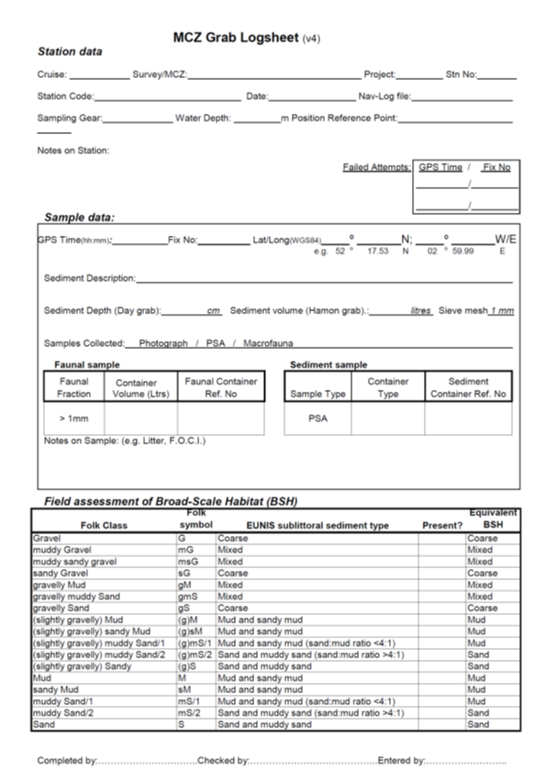

References
Davies, J., Baxter, J., Bradley, M., Connor, D., Khan, J., Murray, E., Sanderson, W., Turnbull, C. & Vincent, M., (2001), Marine Monitoring Handbook, 405 pp, ISBN 1 85716 550 0. Available online at: http://jncc.defra.gov.uk/page-2430
DEFRA (2019) Marine Conservation Zones: Selsey Bill and the Hounds - GOV.UK (www.gov.uk)
Environment Agency (2007) Sediment sampling in water for chemical and particle size analyses. Operational Instruction 10_01 (internal document). Environment Agency, Bristol, UK.
Environment Agency (2016) Selsey Bill and the Hounds rMCZ 2014 Survey Report, Environment Agency, Peterborough, UK.
Green, S. et al. (2015) Cromer Shoal Chalk Beds rMCZ Post-survey Site Report. Contract Reference: MB0120. Report Number: 34. http://randd.defra.gov.uk/Document.aspx?Document=12825_Cromer_Shoal_Chalk_Beds_rMCZ_SummarySiteReport_v5.pdf [accessed 24/5/19]
JNCC (2004), Common Standards Monitoring Guidance for Marine, Version August 2004, ISSN 1743-8160. Available online at: http://jncc.defra.gov.uk/page-2236
MESH (Not Piblished) MESH: ‘Recommended operating guidelines (ROG) for underwater video and photographic imaging techniques (https://www.emodnet-seabedhabitats.eu/media/1656/gmhm3_video_rog.pdf)
NE (2018) Cromer Shoal Chalk Bed MCZ SACO. Updated 16th March 2018. https://designatedsites.naturalengland.org.uk/Marine/SupAdvice.aspx?SiteCode=UKMCZ0031&SiteName=cromer&SiteNameDisplay=Cromer+Shoal+Chalk+Beds+MCZ&countyCode=&responsiblePerson=&SeaArea=&IFCAArea [accessed 21/05/19]
NE (2019) Designated Sites View – Cromer shoal Chalk Beds MCZ: Management Measures https://designatedsites.naturalengland.org.uk/SiteMMO.aspx?SiteCode=UKMCZ0031&SiteName=cromer&countyCode=&responsiblePerson=&SeaArea=&IFCAArea= [accessed 24/05/2019]
NMBAQCS (2010) National Marine Biological Analytical Quality Control Scheme (NMBAQCS). Guidelines for processing marine macrobenthic invertebrate samples: a Processing Requirements Protocol http://www.nmbaqcs.org/media/1175/nmbaqc-inv-prp-v10-june2010.pdf
NMBAQCS (2015) National Marine Biological Analytical Quality Control Scheme (NMBAQCS). Epibiota Remote Monitoring from Digital
Imagery: Operational Guidelines. http://www.nmbaqcs.org/media/1591/epibiota_operational_guidelines_final.pdf
NMBAQCS (2016) National Marine Biological Analytical Quality Control Scheme NMBAQCS Best Practice Guidance Particle Size Analysis (PSA) for Supporting Biological Analysis. http://www.nmbaqcs.org/media/1255/psa-guidance_update18012016.pdf
Ware, S.J. & Kenny, A.J. (2011) Guidelines for the Conduct of Benthic Studies at Marine Aggregate Extraction Sites (2nd Edition). Marine Aggregate Levy Sustainability Fund, 80 pp.

SUBMITTED BY:
Contractor name
Address
Email
Telephone
Fax

