The Leys (Shaftesbury Avenue)
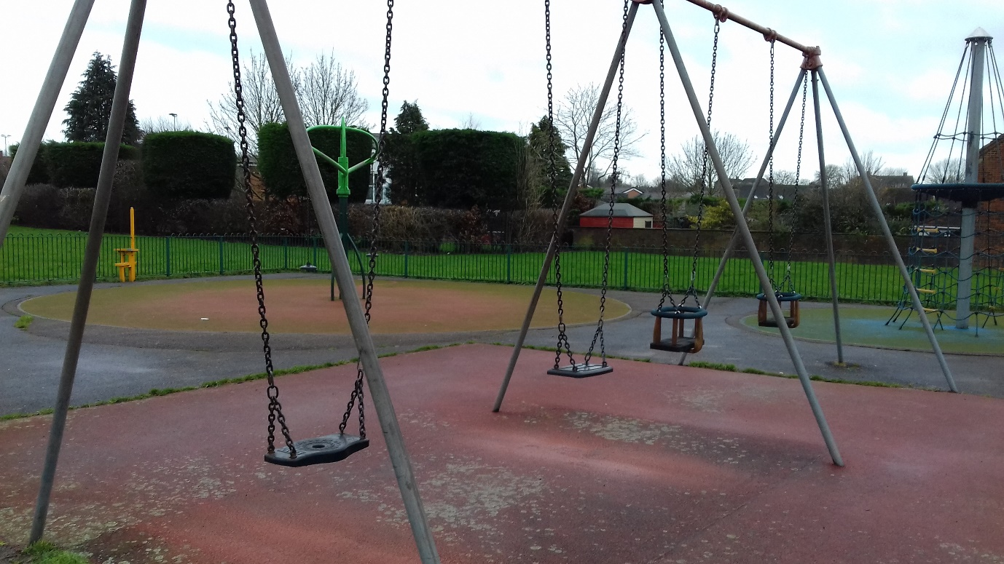
Swing frames – paint top bars, replace wetpour
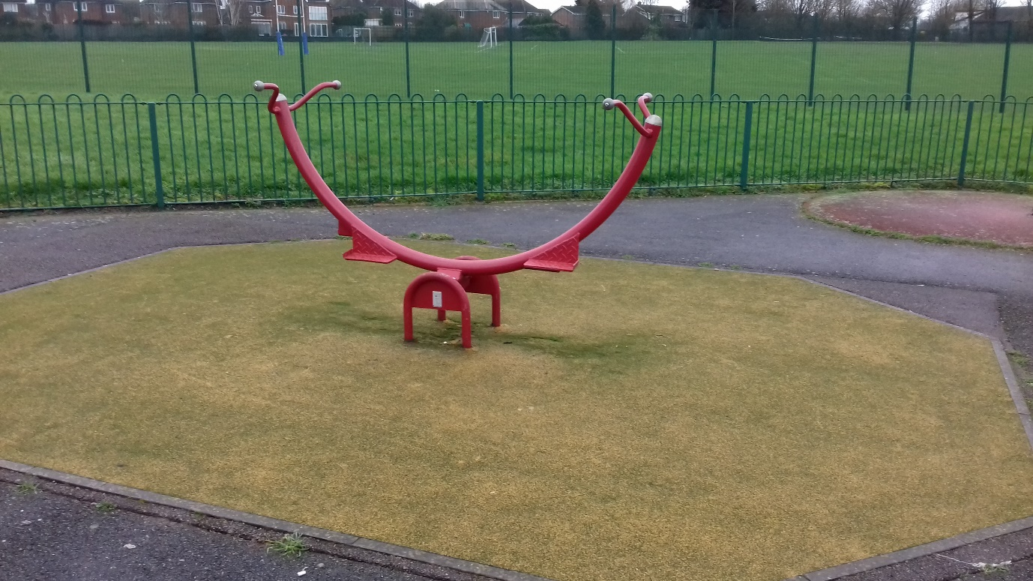
See-saw – replace wetpour
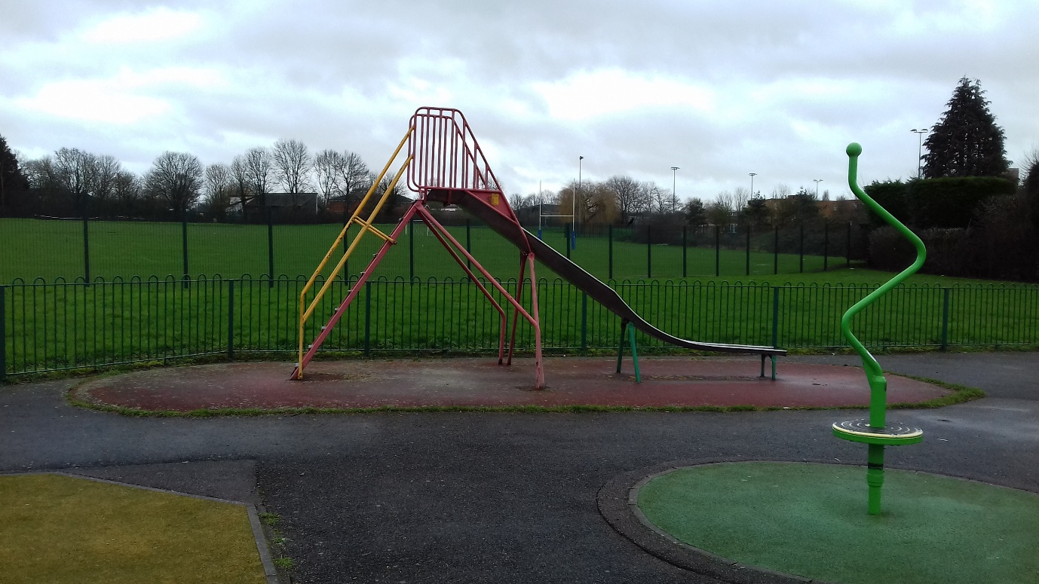
Slide – paint frame, replace wetpour
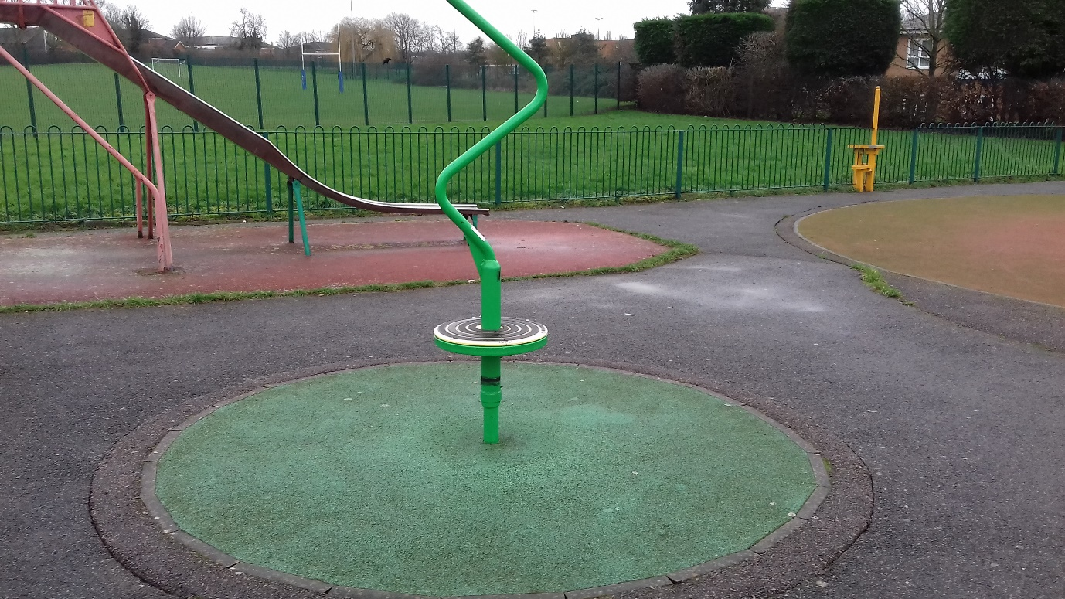
Spinner – replace wetpour
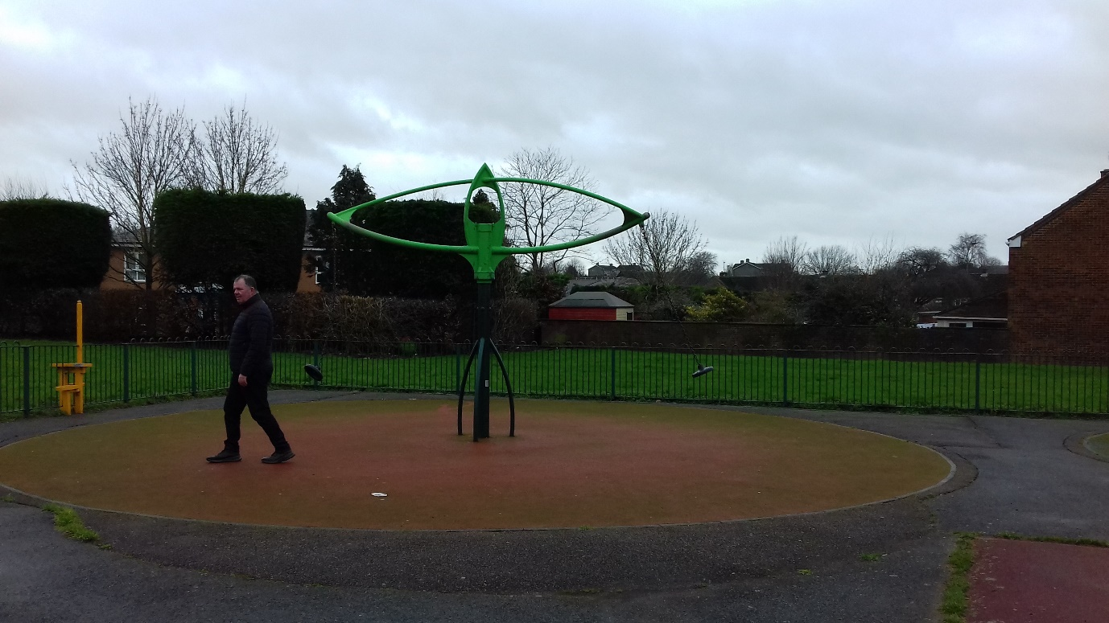
Replace wetpour
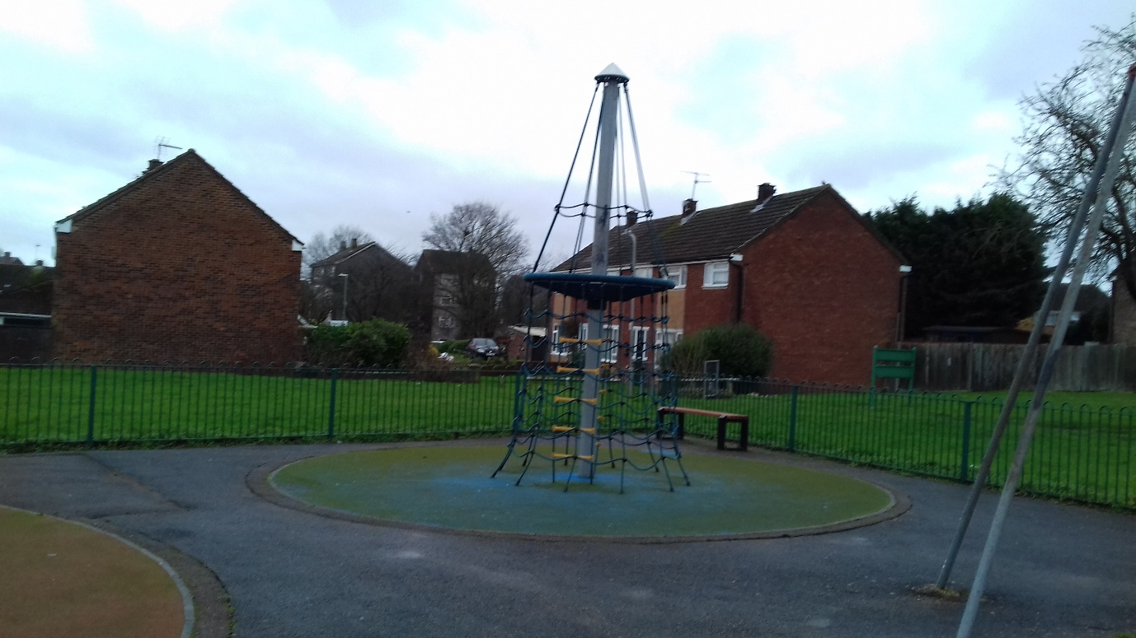

Replace wetpour

