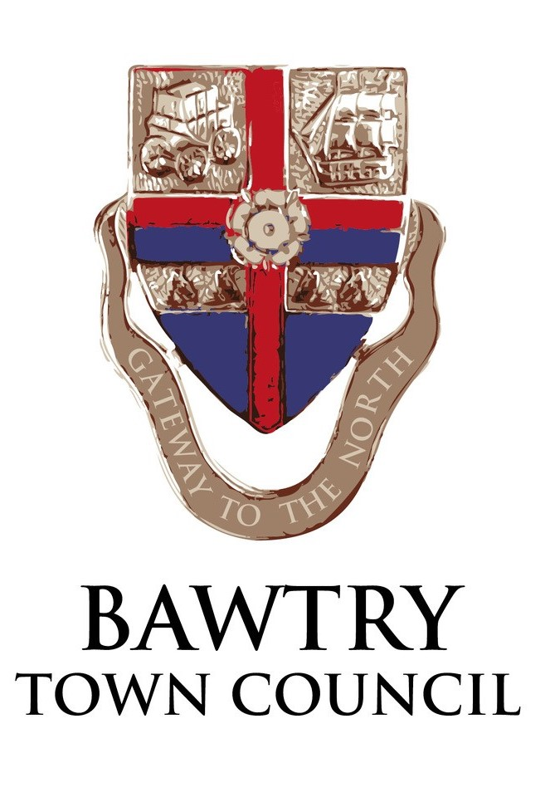
PROVISION OF ELECTRIC VEHICLE CHARGING UNITS MARKET HILL, BAWTRY
INVITATION TO TENDER
1. Invitations to tender are invited in respect of the provision of electric vehicle charging units in Bawtry. An inspection of the site is required prior to tendering.

2. Proposed commencement dates should be provided in the tender.

3. Tenders should be submitted to the Town Clerk no later than 12.00 noon on Friday 16th December 2022

4. Tenders received after 12.00 noon on Friday 16th December 2022 may not be considered.

5. Tenders should be submitted as an attachment via email to bawtrytowncouncil@gmail.com or in an envelope marked “EVCI Contract”, to:

Mrs Angela Harrison, Clerk to the Council
Bawtry Town Council
The Old Coach House
The Yews, Firbeck
Worksop S81 8JW

Tenders will not be “opened” until after the 16th December.

6. Any enquiries about the tender process or contractual requirements should be made to Angela Harrison who can be contacted on 07494 893954 or email: bawtrytowncouncil@gmail.com .

6. The Council shall not be bound to accept the lowest, or any, tender, and the award of contract shall be based on a combination of price and product.

7. The contract documents include an Invitation to Tender, Specification and the Tender Document.

9. The tenders will likely be considered at a meeting of the Town Council in January 2023.

