Agenda for PETREL Invitation To Tender (ITT) Briefing Day – Held at Warminster
Date: 12th March 2018

Serial | Session | Speaker | Timing
1. | Arrival |  | 9.30-10.00
2. | Project Overview | Ben Jackson | 10.00-11.00
3. | Technical Overview | Major Warren Allison | 10.00-11.00
4. | DSTL Coverage Definitions and Assessment | Dr. Robert Fryer | 10.00-11.00
5. | Questions | PETREL project team | 10.00-11.00
6. | Sizing and fitting of GFE demonstration | Major Warren Allison | 11.00-13.00
7. | Questions and Dispersal | PETREL project team | 13.00-14.00

Invitees |  | Industry
Maj Warren Allison | Army/DE&S | Blücher GmbH
Ben Jackson | DE&S | Level Peaks Associates
Dr Jon Russell | DSTL | Source Tactical Gear
Dr Robert Fryer | DSTL | Cooneen Group
Kimberley Strickland | DSTL | Point Blank Enterprises Inc
Helen Jefferies | DE&S | ADS Inc
Emily Wolfe | DE&S
Apologies
WO2 Gary Gass | Army (ITDU)
Callum Partridge | DE&S
Barbara Clarke | DE&S

Land Warfare Centre Directions:
Address:
Soldier Reference Centre
Land Warfare Centre
Infantry Trials & Development Unit (ITDU)
Imber Road
Warminster
Wiltshire
BA12 0DY

Approach from the north (M4): follow the A350 through Westbury. At the traffic lights turn left - signposted 'all military units'. As the road bends sharply to the right, take the left hand turn (effectively straight on). Cross one mini-roundabout. At the end of the road, turn left onto Imber road

Approach from the east (A303): follow the signs on the A36 for Warminster. At the first roundabout take the last exit (B3414). Follow this road into the residential area of Warminster. Take the right hand turn into Imber Road just before the petrol station on the left

Approach from the south and west: join the A36 bypass and enter Warminster by one of the routes described above
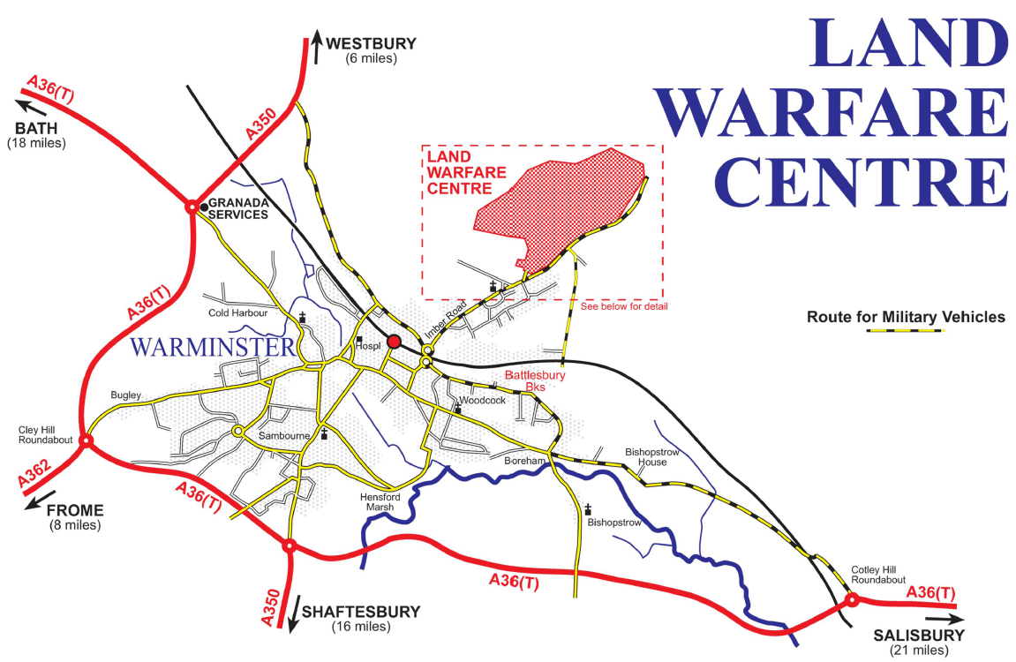

WATERLOO LINES - VISITOR NOTIFICATION

All visitors are to be escorted at all times, unless this form is countersigned by an SO2 or above.
Forms for ESCORTED visitors are to be e-mailed to [WarminsterGar-MPGS-GateSpvr] or may be faxed to ext 2746.
Forms for UNESCORTED visitors are to be manually countersigned and to be faxed to ext 2746, or delivered.

HOST/SPONSOR DETAILS
Host/Sponsor Name | Bldg/Room | Dept/Branch | Tel Ext | Date Of Visit
WO2 Gass | 60 | ITDU | 2114 | 12/03/18
VISITORS’ DETAILS
Title | Surname | Forename | ID  Type | Company/ Unit | ETA | Date & ETD | Vehicle details

Host’s Signature (Electronic):  Date: |  |  |  |  |  | The visitor(s) named on this form may be granted unescorted access to Waterloo Lines  Countersignature (Manuscript) by SO2 or higher  Name and Appointment: Date:
 | FOR MAIN GATE USE ONLY |  |  | Received on: |  | Processed by: | Date:

