Notification of Supplier Day and Request for Expressions of Interest
RSSB research project T1132 Development of Supplementary Freight Container Gauges
RSSB, on behalf of the rail industry, are seeking to assess the technical and economic feasibility of possible options, before developing supplementary container gauges

Purpose
This notification is to attend a supplier day on 15 August 2018 and/or provide information through Expression of Interest (EoI).
The supplier day will offer more detail on the background to the research proposal and suppliers will be given the opportunity to ask questions to establish a greater understanding of the project and support the direction of the research.
The EoI enables interested parties to put forward their capability and also provide any thinking that could support the development of the scope. To feed into the process, EoIs will need to be received by COP 13 Aug 2018.

Background
A decline in freight traffic and a shift from the traditional market composition necessitates changes in the rail freight industry to maintain competitiveness with other transport modes. W7, W8, W9 (including W9Plus), W10 (including W10A) & W12 are the standard gauges used for container/wagon combinations, however some of these do not align with some common container/wagon combinations used within the industry e.g. international and domestic intermodal. Consequently, many emerging opportunities need to be authorised annually by Network Rail, which is often time-consuming, impacting rail’s competitiveness with other modes of transport.
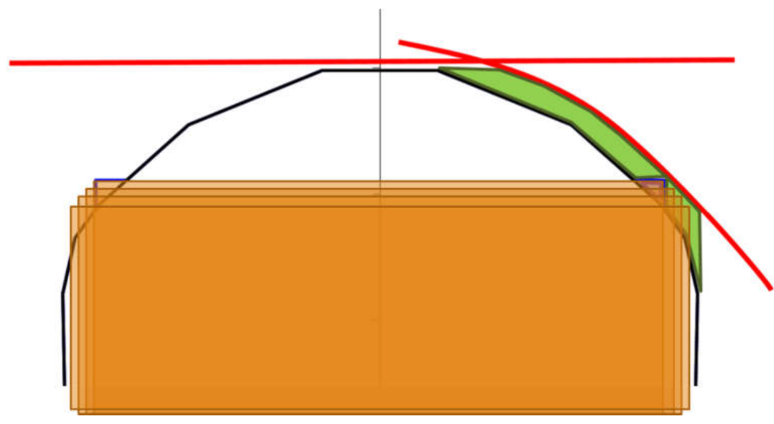
As illustrated below, the development of a set of ‘supplementary’ container gauges could allow more wagon types and container sizes to be carried on existing cleared routes without costly infrastructure work, opening up more opportunities for rail to exploit.
Figure 1: The green space is clearance between the infrastructure and gauge profiles. Therefore, container gauges could be made narrower and taller or wider and shorter without requiring infrastructure work
The proposed project will assess the technical and economic feasibility of possible options, before developing suitable supplementary container gauges for inclusion in the revised gauging standards (GE/RT8073). In turn, the outputs from this project should allow the freight community to respond to changing market demands, enhancing its competitiveness against other modes of transport.

Scope of work
The envisaged scope of work can be summarised as:
The evaluation of the appropriateness of the container gauges
An evaluation of the possible container gauge options that are feasible to implement and demonstrate a significant financial benefit to the industry will determine the appropriate container gauges to develop. It is expected the work will include, but is not limited to:
- An economic assessment of the current and potential demand from high-growth areas (e.g. short-sea and domestic swap body market). The assessment of each supplementary gauge should estimate costs, benefits, and give a consideration of estimated implementation timeframes.
- A technical feasibility study, including
  - A comparison between the proposed supplementary container gauge(s) and existing gauge(s).
  - A consideration of infrastructure on the routes that the existing standard gauge is cleared for.
  - An assessment of the Load Unit/Wagon combinations, and a consideration of the lifespan of assets.

The development of the optimised ‘supplementary’ gauge profiles
It is expected that this work will build upon the findings from the evaluation process in order to specify the beneficial supplementary container gauges. This should include, but is not limited to:
- Defining an appropriate criteria for the optimisation of the refined gauges.
- Defining the tallest practical container top corner to fit the above rail level (ARL) set in GE/RT8073 and/or to fit under the Overhead Line Equipment on electrified routes.
- Modelling the supplementary container gauges in the RSSB J Table spreadsheet to determine the sizes of Load Units available
- Confirming the viability through modelling the container gauges on the routes that the existing standard gauge is cleared for. In order to ensure the viability of the container gauges, it is anticipated that there will be a large number of structures that would need to be cleared. Therefore, it is likely that some iteration of the defined container gauges would be required at this stage. – Exploring optimal trade-off between being able to transport the most amount of container combinations and maximising the route capability.
- Proposing the text for inclusion in GE/RT8073.

Delivery particulars
Outputs from the research project are expected to be included in a revised version of GE/RT8073, therefore it is imperative that the timeframes are aligned. To support this, the expected date of release of ITT is Late August 2018, with tenders to be received by Late September 2018. The expected date of project completion is September 2019.
The indicative budget for this project is £120k and the suitability of the budget will be assessed during supplier engagement day.

Supplier Day
We welcome suppliers’ thoughts on developing objectives of the project to contribute to achieving a successful outcome.
While there is expected to be some discussion of the approach to be taken in delivery of the objectives, the tender is expected to be left open for the supplier to define the approach to meeting those objectives.
During the supplier day, we aim to discuss the timeframes and refine the scope further. We would like suppliers to consider:
- Given the changing market composition, is the freight community on the right path, and what are your initial thoughts on the benefits of this proposed project?
- Who are the key stakeholders that should be engaged through the project to enable successful outcomes?
- What key sources of information will be required? Where are there likely to be barriers in gaining access to this information?
- Considering the proposed project schedule, what structure of the project would best support a successful and timely outcome?
- What are the key skillsets needed for each of the key project activities?
- What are the key objectives of the work that should be included in the specification?
- Is the proposed budget suitable for the delivery of the work proposed?

Expressions of interest
We also welcome suppliers to provide a short summary of their capabilities and experience in this subject area to help us deliver a successful project. Taking into account the envisaged scope of work, we would be pleased to receive a summary response (Max 4 pages) by 13 Aug 2018 setting out your capabilities related to the project.
Based on experience of similar projects, we would welcome any additional thoughts based on the questions outlined for the supplier day to support the development of the project (no page limit).

Next steps
Please contact Shareditt@rssb.co.uk if you wish to attend the supplier day, or to submit an expression of interest.

The new gauge could be narrower and taller, shorter and wider, or recommend utilising both.

