Requirement for Privacy Screens – e-Passport Gates upgrade at Border Force ports

Background:

As part of the e-Passport Gate upgrade at ports Digital Passenger Services (DPS) have been advised by Home Office Security that some form of privacy screening for the testing phase of the eGates is required. The screens are required in the arrivals hall eGates area (airside location) for a period of 3 weeks whilst testing of the eGates is carried out.

The screens are required for dual purpose deployment:
- to create partitioning to enable privacy between the engineers and the travelling public/passengers whilst security testing is carried out on the eGates
- to comply with social distancing to protect the travelling public/passengers and the engineers working on the eGates.

The following UK airports and Juxtaposed locations are where the screens will be required:

Birmingham, Bristol, Brussels Gare du Midi train station, Cardiff, East Midlands, Edinburgh East, Edinburgh West, Gatwick North, Gatwick South, Glasgow, Heathrow Terminal 2, Heathrow Terminal 3, Heathrow Terminal 4, Heathrow Terminal 5, London City, Luton, Manchester Terminal 1, Manchester Terminal 2, Manchester Terminal 3, Newcastle, Paris Gare du Nord train station and Stansted.

Mandatory requirements:

Border Force/DPS need to procure 16 x sets of screens to accommodate measurements for a bank of 5 eGates and 5 x sets of screens to accommodate measurements for a bank of 10 eGates. Therefore, the screens must be adaptable/flexible to measurements of 5 and 10 eGates at some sites.

The eGate upgrade will be carried out in banks of 5 and 10. For a set of:

- 5 eGates the area the screens must cover 5245mm length x 1800mm height - 16 sets required
- 10 eGates the screens must cover 10245mm length x 1800mm height - 5 sets required

Both of these screen dimensions must be able to accommodate a 1.2 metre depth between the eGates and the screens for the engineers to safely manoeuvre around the eGates. For all sets of screens (5 and 10 gates measurements) two screens approx. 1672mm x 834mm will be required to be attached to the existing eGates glass panel without the use of drilling and leave the glass in its original state. These should be easy to remove by the user.

Dimensions of screens:

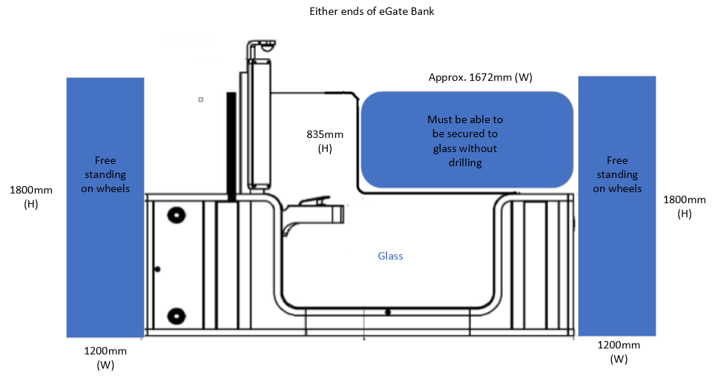

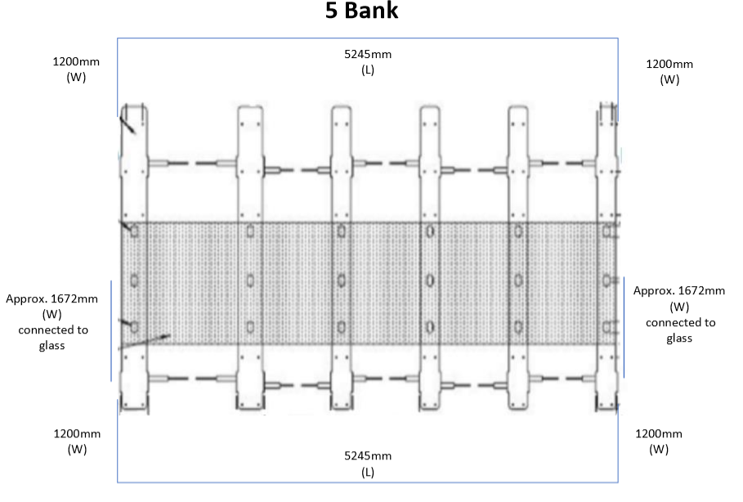

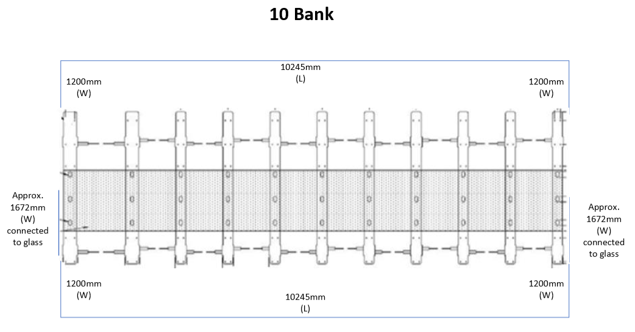

The glass panel is approximately 10mm in thickness. The screens should therefore allow a robust fitting onto the screens to avoid any H&S hazards but at the same time easily removeable by the user without any damage to the glass.

The screens will be in situ for approximately 3 weeks. They will be a temporary fixture and remain in BF accommodation after its use. Due to the nature of the usage the floor standing screens (not attached to glass) must be on wheels to allow easy and free movement between the eGates, equally they must have stabilising feet with castor wheels.

The successful bidder must be able to deliver and assemble the screens to airside and or secure locations listed above, supported by DPS/BF project team. This also includes Brussels and Paris train stations.

The screens must have the ability to print bespoke BF disruption signage. Suppliers must therefore provide their graphic requirements and timescales of production in order for BF to provide the correct graphic requirements in sufficient time. Please note: the earliest date the screens are required is 22nd March 2021 and others will be required incrementally throughout 2021.

The supplier must be able to deliver within specified timescales to the specified airside and/or secure locations from receipt of purchase order by the successful bidder to delivery of the items to the BF delivery addresses. Full delivery addresses will be provided at the same time the order is placed. Suppliers must be able to carry out a site visit if required in order to ascertain the correct specifications of the screens required.

The successful bidder must have the necessary documentation to enable airside delivery and provide full names, date of birth and photo ID for temporary airside passes to be issued.

All screens must be delivered with a written User Guide in English giving clear, concise and comprehensive instructions on how to assemble and dissemble the screens.

Please provide the following in your response:

The full, detailed specification on how the product meets the requirements outlined above, including the following General Details/Information:

- Measurements listed above must be available
- Screens must be adaptable/flexible to the measurements provided
- Clear printed bespoke BF signage on the screens
- Ability to deliver to all UK airport airside locations
- Ability to deliver to Europe to Brussels and Paris train stations secure areas.
- Delivery lead-in time from receipt of Purchase Order.
- The cost of 1 x screen to cover a bank of 5 x e-gates delivered to a UK location
- The cost of 1 x screen to cover a bank of 10 x e-gates delivered to a UK location
- The cost of 1 x screen to cover a bank of 5 x e-gates delivered to Paris or Brussels.

If at this time, you are unable to quote for supply of Privacy Screens to Paris and Brussels locations, we may still consider your bid if no one supplier can submit a compliant bid for all locations.

Information for bidders:

All received bids must be compliant with the above mandatory requirements and will be evaluated on the combined firm cost of 1 x set of screens to cover a bank of 5 x e-gates to a UK location, 1 x set of screens to cover a bank of 10 x e-gates to a UK location and 1 x set of screens to cover a bank of 5 x e-gates to a Paris and/or Brussels, including delivery, any set up costs and any on-site training required and/or `User Guides’. The bidder offering the lowest price with a compliant tender will be awarded the contract.

Only if no compliant bids are received to supply to all locations (including Paris and/or Brussels), then the evaluation will be altered to the combined firm cost of 1 x set of screens to cover a bank of 5 x e-gates to a UK location and 1 x set of screens to cover a bank of 10 x e-gates to a UK location, including delivery, any set up costs and any on-site training required and/or `User Guides’. The bidder offering the lowest price with a compliant tender for UK locations only will be awarded the contract.

(Ideally 1 x single screen of 10245mm that covers the bank of 10 gates is required. However, if that is not possible, we can consider quotes for 2 x single walls, but for evaluation purposes we would need to compare that to the cost 1 x screen to cover a bank of 10 x e-gates.)

The Goods contract expected duration for which prices must be firm is from Monday 22nd March 2021 until 31st March 2022 inclusive. No guarantee can be given of any minimum number of orders that will be placed with the successful bidder. There is a possibility that several more sets of screens to cover either a bank of 5 x e-gates or a bank of 10 x e-gates may be required, but again not guarantee can be given that this additional requirement will materialise.

Once the contract for the purchase of the Privacy Screens are signed by both sides, all orders for goods will be placed by Home Office Purchase Order quoting relevant contract reference.

Any questions, queries or clarifications regarding this tender should be submitted to Paul.Tooke@homeoffice.gov.uk by 11.59 hours on Tuesday 16th February 2021 at the latest.

All written submissions should be submitted to Paul.Tooke@homeoffice.gov.uk by 11.59 hours on Thursday 18th February 2021 at the latest.

Please note any agreement signed with your Company will be subject to the Standard UK Government Short Form Terms and Conditions for Goods and Services (attached for reference).

