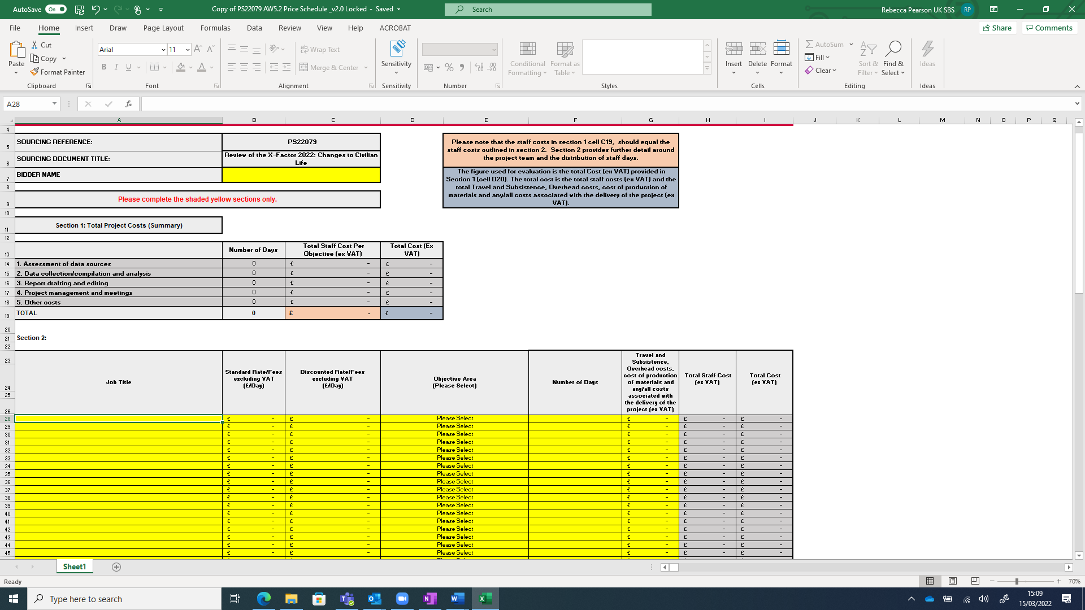

Figure 1 Albiddingl documentation including Excel pricing schedule to be found in Delta platform