

**Guildford and Waverley CCG –**

**Adult Community Health Services**

**Statement of Intent for bidders**

**(7 January 2016)**

**1. Introduction**

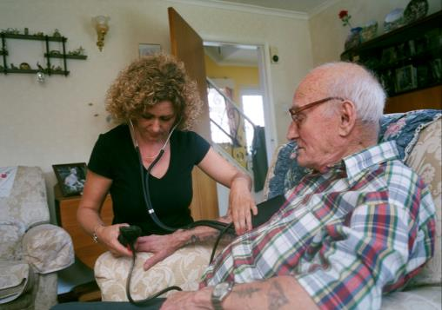

This statement has been drafted to support bidders in understanding Guildford and Waverley’s vision and intention regarding the procurement and subsequent delivery of adult’s community health services. Surreys CCGs, Surrey County Council Public Health and NHE England are jointly commissioning a range of community health services.

The purpose of this document is to provide potential bidders the following:

* Our vision and expectations
* Services in scope
* Outcome measurement
* Key local service relationships
* Key strategic documents

These intentions outline the Guildford and Waverley CCGs vision for a model of integrated services (see Appendix 1: My care, My Choice Operating Model) for working age adult general community health services and older adult general and mental health services to be implemented from 2017. It forms part of the Guildford and Waverley CCG’s wider programme to support out of hospital care for older people. Whilst the needs of working age adults and older adults are the subject of the procurement, this model of care is based upon the needs of older adults for 2 reasons:

* Older adults account for high volume use of community health services
* Older adults are more likely to have complex needs so we wish to procure services that understand that management of complexity is the norm rather than the exception

The vision has been developed through engagement with key stakeholders including:

* CCG clinical leads
* NHS providers of primary care, community, acute and mental health services
* Social care
* Third sector advocates and providers
* Patient/people who use these services, representatives and carers

**High level organising principles for the integrated care model**

The main principle for the Guildford and Waverley CCGs integrated model is ‘get it right first time’ to ensure timely access to the right service at the right time. Further principles include:

Holistic care to meet the general and mental health needs of older adults

* Coordinated assessment, care planning and service delivery
* The system of care and support for this cohort of patients sits within a wider context of up-stream prevention and early intervention

As a starting point for discussion with bidders – and ultimately the new provider – we have established a model of care that highlights the areas of interventions that we believe can make a significant improvement on the quality of care and secure better outcomes for people who use health and care services. Partnership working is central to our vision and in particular we wish to secure a provider that:

* Has an organisational culture where staff work alongside primary care to share responsibility for patient outcomes;
* The voluntary sector is woven into care pathways.

Whole system joint working is integral to this model of care. We believe that true integration is about a way of working rather than about organisational structures. The Guildford and Waverley CCG believe that integrated community services for the local population includes:

* Alignment of strategic planning across the NHS and the local authority that spans upstream information and advice to the general population through to downstream sub-acute services
* Whole system commissioning requiring the alignment of resources and commissioning intentions
* Seamless delivery of services across health and care domains provided by public, third and/or private providers

**2. Our vision**

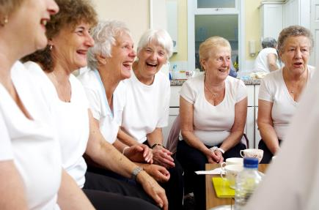

The vision from our Surrey Health and wellbeing strategy is to:

*“Through mutual trust, strong leadership and shared values will improve the health and wellbeing of Surrey people”*

We will achieve this through:

* Innovative, quality driven, cost effective and sustainable health and social care is in place;
* People keep as healthy and independent as possible in their own homes with choice and control over their lives, health and social care support;
* We support and encourage delivery of integrated primary care, community health and social care services at scale and pace.

We will commission high quality, patient and carer centred services that are compassionate, responsive, needs-led, and effective; and provide good value for money in order to meet the needs of the adult population and collaboratively work towards achieving the strategic aims of the health and social care economy.

The CCG supports providers to develop co-created strategic programme plans that set out the shared and co-owned vision of the future of health and social care in Guildford and Waverley. We will continue to work in partnership with patients, their carers’, providers and other partners to deliver a high quality and cost effective health and social care system to the people of Guildford and Waverley, empowering them to lead healthy and independent lives.

We are looking for a system leader who can help us deliver this vision and associated improvements in health outcomes requires us all to work together as one system with the following shared principles:

* Improving quality and safety;
* Delivering integration and collaboration;
* Delivering service Innovation;
* Increasing the focus on early intervention;
* Wrapping services around the patient;
* Safeguarding the vulnerable;
* Achieving value for money;
* Ensuring full citizen engagement;

We know that whole system service transformation is required and appreciate the need to drive widespread, transformational change across our health and social care system to deliver a step change in the quality of services and improvements in the experience for patients. We expect the providers of the services we commission to respond proactively and constructively to the changes we are seeking to make building on good partnership work to date.

The CCGs’ key priorities for the next five years to enable us to deliver our vision are as follows:

* Placing a greater emphasis on prevention and putting patients in control of their own care planning
* Moving away from disease specific services to the commissioning of person centred care
* Implementation of new models of care which support better integration, and which expand and strengthen primary and out of hospital care
* Development of new payments mechanisms which incentivise the delivery of outcome focused care and which support the future sustainability of the local system
* Development of urgent and emergency care networks which ensure patients get the right care at the right time in the right place.
* Better use of technology and innovation to achieve improved outcomes and efficiencies
* Achieving parity of esteem for people with mental health problems and learning disabilities

As part of our transformational change we intend to continue to develop, implement and extend the scope of the whole system health and care service development across at least the following pathways, some of which will require a community delivery element:

|  |  |
| --- | --- |
| * Frail older people; * Diabetes whole system pathway; * Stroke services; * Mental health; * Cancer; * Long term conditions self-management; * Urology; | * Orthopaedic; * Respiratory; * Cardiology; * Ophthalmology; * CAMHS; * Paediatric; * Maternity; * Gynaecological. |

In taking forward our priorities, we will continue to adopt the commissioning principles set out in the local commissioning intentions:

* Ensure service provision and commissioning changes are transparent and developed in partnership with the public and stakeholders
* Prevent ill-health in areas with high levels of deprivation
* Provide patients with the skills and knowledge to ‘self-care’ where clinically appropriate
* Improve patient experience and outcomes
* Shift service provision from hospitals, to timely and proactive care in the community
* Ensure patients requiring urgent or elective care have their needs met in the right place, by the person, as quickly as possible
* Provide responsive services that improve patient flow in and out of hospital; reducing the need for unplanned admissions and, if admission is required, reducing lengths of stay and supporting effective discharge home

The main principle for the Guildford and Waverley CCGs integrated model is ‘get it right first time’ to ensure timely access to the right service at the right time. Further principles include:

* Holistic care to meet the general and mental health needs of older adults
* Coordinated assessment, care planning and service delivery
* The system of care and support for this cohort of patients sits within a wider context of up-stream prevention and early intervention

This service specification is for general community services provided to working age and older adults and for mental health services for older adults.

The integrated model of care has been developed specifically to focus on the needs of frail older people who require support to enable them to cope at home. Those persons are characterised as having:

* health and care needs associated with ageing
* co-morbidities, including organic and functional mental health needs
* high level dependencies for activities of daily living
* at risk of admission to long term care or acute hospital
* older adults requiring mental health assessment and services
* working age adults requiring community health services

**3. Services in scope**

The successful bidder will work through a collaborative partnership to provide a wide range of adult community health services

**Community Health Services In Scope (still to be confirmed):**

1. District Nursing
2. Specialist Nursing (TVN, Parkinson’s, Heart Failure)
3. Phlebotomy
4. Rapid Response Service (including In-reach Teams incl. OPAL In-reach Nurse)
5. Specialist Community Rehabilitation Teams (Adult SLT, Care Co-ordination)
6. Community Heart Failure Service
7. Occupational therapy
8. Physiotherapy
9. Speech and Language Therapy
10. Out of hours nursing
11. Community Hospitals – Milford and Haslemere (including X-ray)
12. Haslemere MIU
13. Diagnostic Assessment and Treatment – Milford and Farnham
14. Lymphoedema Service
15. Respiratory

Please note that discussions are currently underway to understand whether it will be possible to include specifics acute and primary care health services. A confirmed list will be made available to bidders at the start of the tender process.

**4. The Integrated Model of Care**

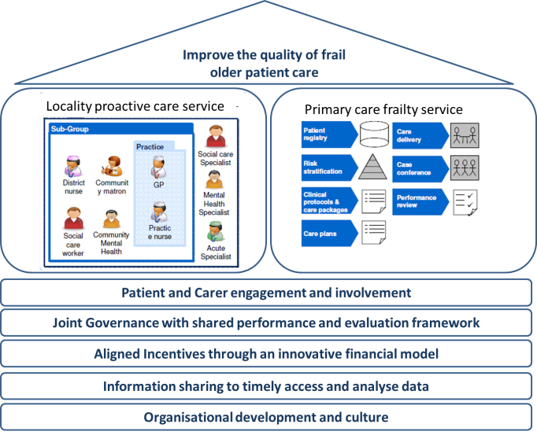The vision for Guildford and Waverley CCG integrated care is a whole system model of care. It reaches from upstream information and advice/support services through to sub-acute care in the community and the front door of the acute hospital as well as facilitated early or timely discharge from acute in-patient care.

We emphasize these levels of care as a guide to bidders.

We have identified opportunities for significant improvement to managed care and improved pathways through a focus on these levels of care.

**Level 1:** Information and advice for those who are able to manage their own needs

**Level 2:** Prevention and early intervention services for people at risk of deteriorating physical and mental health, Activities of Daily Living and who have multiple or complex needs

**Level 3:** Community coordinated assessment, care planning and service provision

**Level 4:** Intermediate services for people with deteriorating functional skills and abilities; in need of rehabilitation, recovery or reablement; at risk of admission to a care home

**Level 5:** Sub-acute care for people who are acutely ill and at risk of admission to hospital

A number of underpinning enablers are necessary to make the integrated model of care work effectively:

**Enabler 1:** single points of referral

**Enabler 2**: single assessment process/common assessment framework

**Enabler 3**: integrated information – sharing IT

**Enabler 4:** workforce development and skill set

The wide span of the services reflects the complex needs of frail elderly and the consequent interdependencies across health and social care. The integrated model of care will dovetail with the End of Life Care services.

Guildford and Waverley CCG has commenced the piloting of a Level 3: Community coordinated assessment, care planning and service provision through the East Waverley Locality Proactive Care Team.

**5. Principles**

**Patient Experience:**

* Patient centred working ethos and services
* Patient experiences services without borders
* Right time right place right person services
* Build upon local system strengths in a „makes sense‟ economic and effective way

**System Development:**

* Multi-disciplinary thinking, acting, development, accountability
* Dynamic culture of enquiry, learning, innovation, development
* Integrated & collaborative approach between all providers (statutory, private non statutory)
* Mutual accountability and responsibility for multi-disciplinary team work and service
* Integrated network of care including voluntary statutory and private providers

**Strengthening Local Services:**

* Solutions built around each of the CCGs differences
* Enhancing existing community and primary care service strengths
* Increased responsiveness and improved access to assessment, re-ablement, diagnostics and treatment
* Expanded portfolio of community and primary care based diagnostics, therapies and services

**Change of Dynamic with secondary care:**

* Decreasing dependency on secondary care assessment, in-patient and out-patient services
* Strengthened links with secondary care assessment and advice services /expertise

**6. Access and Choice:**

* A **‘No wrong door’** approach must be adopted – no referral for a patient will be turned away from advice and direction to support will be given;
* Patients must receive quality, timely and appropriate interventions;
* Services must deliver positive outcomes for patients, their carers and families;
* Services should promote prevention, early identification and early intervention; to avoid costly packages of care across the health and social care economies.

To ensure equity of access to adult community health services there should be:

* timely and equitable access, based on an agreed set of service criteria and key performance indicators, for patients;
* clear protocols and care plans in place to facilitate/support access to hospital care when necessary for patients who have complex care needs; pathways and robust communication should be in place between the acute, community, mental health and primary care services for patients who may require urgent or unscheduled care. Frail vulnerable patients in the community should have ‘trusted’ care plans
* Appropriate skill mix and staffing levels that reflect national and local best practice and current and projected future needs should be established and maintained to deliver the service effectively;
* Partnership working with other health and care services commissioned by NHS England and Surrey County Council;
* Clinics in accessible locations and a range of home/community based services;
* Audits and on-going service reviews in order to inform service developments;

**7. Outcomes**

The programme would be expected to deliver the following **outcomes:**

* Improvement in patient experience measures as care provided with services organised around the patient
* Increased health and functioning of frail older people living in the community
* Community services to be based around localities and practices
* A reduction in avoidable emergency admissions, re-admissions and extended stays in acute hospitals (including delayed transfers of care)
* A service around patients identified as frail that has an MDT coordinator function
* Effective MDT working with attendance at practice MDT meetings of community matron, district nurse, therapists, community psychiatric nurses
* An increase in the percentage of frail older people cared for “out of hospital” and improvement in quality of these services
* A reduction in the number of Emergency Bed Days in the over 65s & over 85s
* Better partnership working between different parts of the health and social care system and other partners
* The above delivered within the identified budget
* Reduction in delayed discharge from acute provider
* Reduction in delayed transfer of care to other providers
* Early holistic assessment for frail older people in the Emergency Department and for those admitted, to be under the care of the Department of Medicine for the Elderly
* Reduced length of stay
* All patients must have equitable access to services, giving them the best possible health outcomes.
* Appropriate Health and Social Care summaries and plans accessible at point of admission to all staff engaged in care and discharge summary and plan shared with community and primary care staff at discharge.
* Positive feedback from practices
* Rapid and coordinated community response for frail older people with a deterioration in their health to give them a choice of staying in the community if it is appropriate to so, including access to intermediate care beds
* A fully integrated service for patients with long term conditions that supports primary care referral by timely assessments and development of management plan for each patient and where appropriate early referral back to primary care

**8. Key documents**

**Nationally associated policy documents:**

* [NHS and Social Care Act (2011)](https://www.gov.uk/government/publications/health-and-social-care-bill-2011-combined-impact-assessments)
* [Chief Medical Officer's Annual Report on State of Public Health](https://www.gov.uk/government/news/chief-medical-officer-publishes-annual-report-on-state-of-the-publics-health) (2014)
* [Public Services (Social Value) Act 2012](https://www.gov.uk/government/publications/public-services-social-value-act-2012-1-year-on)
* [Five Year Forward View](http://www.england.nhs.uk/wp-content/uploads/2014/10/5yfv-web.pdf)
* [Forward View into action: Planning for 2015/16 guidance](http://www.england.nhs.uk/ourwork/forward-view/)

**Key local Documents:**

* Integrated Care Partnership ‘My Care, My Choice’ Operating Model
* [Joint Strategic Needs Assessment Surrey](http://www.surreyi.gov.uk/GroupPage.aspx?GroupID=36&cookieCheck=true&JScript=1)
* Health Profile for Guildford and Waverley

**Guildford and Waverley Demographics:**

* <http://www.surreyi.gov.uk/ProfileBrowser.aspx?by=area&rt=52&rid=297256>

Further information can be found on the Guildford and Waverley’s website: <http://www.guildfordandwaverleyccg.nhs.uk>