SOFT MARKET TESTING REQUEST FOR INFORMATION
Get into Teaching Information Service
Section 1 – Introduction
  - This Information Pack and Request for Information (RFI) has been issued by the Department for Education (DfE) with a Prior Information Notice (PIN) advertised in the OJEU ahead of any competitive procurement. The PIN gives outline detail of soft market testing activity and a future procurement for the provision of the Get into Teaching Information Service (the Service). This soft market testing activity is being carried out under the provisions of regulation 40 of the Public Contracts Regulations 2015 (‘PCR’).

  - This RFI is in preparation for a competitive procurement to provide a contact centre and advisory service to support recruitment to Initial Teacher Training candidates and returning teachers throughout England. DfE is seeking to stimulate the interest of organisations who would consider operating the Service and consider a fresh approach as to how the Service may be commissioned.

  - The purpose and aims of this soft market testing exercise are to:
    - Seek opinion from the potential suppliers to assist in finalising our procurement strategy.
    - Share our outline for the Service and what DfE would expect from potential suppliers.
    - Outline indicative timescales for the procurement, transition and implementation of the Services.
    - Receive responses from potential suppliers of the Service on the impacts that differing potential or proposed service design options may have and on potential commercial arrangements
    - Gauge the level of interest in the tender to provide the service

  - Neither this document nor any of the associated engagement activities comprise any part of any procurement exercise and participation does not imply any intention or commitment by DfE. No information provided in the response to the RFI will be used in any evaluation of any subsequent competitive procurement exercise.

Engagement Event Webinar - 14 December 2017
  - Potential suppliers that are interested in this planned opportunity are invited to attend a Market Engagement Webinar on 14 December 2017. This will provide greater detail about the proposed scope of service including further detail of DfE’s vision for the Service, the proposed conceptual design, design constraints and potential areas for innovation.

  - Reservations to attend the Engagement Event Webinar should be made through our event page:
https://www.eventbrite.co.uk/e/get-into-teaching-information-service-market-engagement-webinar-tickets-40145553431

Individual supplier surgeries (8 – 19 January 2018 - Manchester)
  - We will be offering individual surgeries to interested parties to discuss the opportunity further. The sessions shall be recorded and conducted on the same basis and will only deal with matters concerning the RFI. Details of how information that respondents provide will be treated is covered later in this document.

  - The individual surgeries will be held between 8 and 19 January 2018 at DfE’s Piccadilly Gate office, Manchester, M1 2WD. Hourly slots are available from 10.30am – 2.30pm daily. To arrange an appointment, please book through Bravo by 3 January 2018. Surgeries will be allocated on a first come, first served basis.
Submitting the RFI
  - Information about our plans for the procurement are set out in Section 2 of this document. Potential suppliers are invited to respond to questions set out in Section 3.

  - All responses to the RFI must uploaded to the DfE Bravo e-tendering portal; no later than 3 January 2018. DfE are unable to commit to reviewing RFI documents uploaded after this deadline.

  - The RFI return must be clear and concise. Respondents should submit only such information as is necessary to respond effectively to this RFI. Respondents are advised that:
- where documents are embedded within other documents, respondents
must upload separate copies of the embedded documents;
- the RFI return must be in English;
- each RFI return must be headed with the name of the responding organisation; and,
- there is no obligation to answer all these questions in the response.

  - All queries about the RFI process should be submitted via the secure online message board within the Bravo e-tendering portal.

Indicative timetable for the RFI process.
  - The timeframe for this RFI process is set out in the table below.

Issue of the RFI document | 4 December 2017
Engagement Event Webinar | 14 December 2017
Latest date for submission of the RFI | 3 January 2018
Review of RFI submissions | 3 – 5 January 2018
Individual surgery sessions | 8 – 19 January 2018

  - Please note that DfE reserves the right to amend this timetable. Any amendments to the timetable will be communicated through the Bravo portal.

Terms of Engagement
  - In responding to this RFI, respondents do so on the conditions set out below.

  - This RFI process does not bind DfE to enter into any formal obligation or commitment to future business with any supplier. All costs and expenses incurred by or on behalf of respondents in respect of this RFI, including preparing and submitting the RFI response are wholly the responsibility of the respondent. DfE accept no liability for these costs, including costs which may arise out of, or result from, any variation or amendment of this RFI process. DfE may withdraw this RFI at any time without incurring any liability.

  - This document is provided for information and discussion purposes only and does not represent an offer capable of legal acceptance. This document is not intended to be exhaustive and DfE reserve the right to add to or amend the document, as more information becomes known. The information contained herein is the property of DfE and whilst every effort is made to ensure the accuracy of such information, it is supplied without liability for errors or omissions.

  - All information from respondents will be collated and assessed by the DfE to enable officers to produce any necessary reports and recommendations. Individual responses will not be shared with other organisations, however information and views submitted by respondents may be disclosed in an anonymised form as part of or ancillary to this or later market engagement, and will be shared within DfE and with any advisors and third parties to support the DfE’s commercial and public decision making process. If respondents consider that any particular information provided within their response is commercially sensitive, this should be clearly identified in the response. In such cases the DfE will take a view as to whether such information can be considered further, and reserve the right to discount any such information from its assessment.

Confidentiality

  - The information contained in this document and any communications connected to this soft market testing procedure are confidential and only for the recipients’ knowledge. As such, no information included in this document or any communication connected to it may be disclosed to any other party without the written consent of the DfE.

- Outline requirement for the planned procurement.

Background
  - Successful, high quality teacher recruitment is critical for the country’s educational needs. The Department for Education (DfE) determines how many teachers need training through its Teacher Supply Model (TSM). Approximately 30,000 new teacher trainees need recruiting every year. In recent years, the target has not been achieved and acute teacher recruitment shortages have occurred in some subjects and areas of the country. The target number of teachers is expected to grow in the coming years.

  - The DfE runs a comprehensive programme of initiatives to bolster teacher recruitment, including marketing campaigns to encourage graduates, those with equivalent qualification, those considering changing career or those considering returning to teaching to act to pursue a career in teaching. These marketing campaigns are designed to inform, interest and stimulate action.

  - DfE uses the following channels to support the marketing campaigns to maximise the number of potential candidates that are recruited to the teaching profession:

    - The Get into Teaching website - which, in addition to acting as an information source, enables candidates to register their interest in teaching so that they can receive additional support.

    - The Get into Teaching Information Service (which is the focus of this planned procurement) - which comprises:
- A contact centre - where over the phone and via chat, potential candidates can access advice and guidance from an agent and, register to the Get into Teaching website on an assisted digital basis. The contact centre makes outbound calls to potential candidates that have registered interest in teaching via the Get into Teaching website. This is to support and encourage them to apply to teach a priority recruitment subject and to validate their eligibility for one-to-one support from a dedicated advisor. For eligible registrants that accept support from an advisor, their next step is to start working with the dedicated advisor on a one-to-one basis.
- Registrant Advice Service – this is delivered by a team of advisors, whose role is to act as both an inspiring champion of teaching and a practical, pragmatic advisor on applying successfully to teacher training courses or to return to the profession. There are currently three elements to this service to support different groups of potential candidates – these are currently referred to as Early Education Advisors, Premier Plus Advisors and Return to Teaching Advisors.
- Additionally, the contact centre is used to address queries from potential candidates on social media. Phone, email and SMS are also used as communication channels for outbound marketing campaigns.

Scope of the planned procurement
  - The scope of the planned procurement is to secure a new contract for the Get into Teaching Information Service as outlined above. DfE is seeking to use the soft market testing to explore options around the issues set out below.

Operational design for the service

  - For the exiting contact centre services, the key characteristic constraining the operational design is to have staff dedicated solely to the services in small teams, with no “bureau” type working, for example with other clients of the supplier. For the Registrant Advice Service, the key characteristic is to have a geographically distributed, constant number of full-time staff of ex-teachers or persons with equivalent qualifications largely working from home, using mobile and home phones, text and email to deliver service. In both these areas, we are considering alternative operational designs and are seeking responses through the RFI process on the most appropriate methods for the operational design of the service.

Technology for the contact centre CRM solution.

  - In order to have greater control over the strategically important data on potential candidates and align to good marketing practices, DfE plans to use an industry standard Customer Relationship Management (CRM) package to help run the service and to enable the successful bidder to optimize conversion. DfE is currently reviewing its future requirements for the CRM solution and contact centre technology that will need to integrate with this.

Transfer of Undertakings (Protection of Employment) TUPE

  - The DfE anticipates that the TUPE may apply to either or both of the existing contact centre services and Registrant Advice Services. Agents providing contact centre services are located in a single location. The Registrant Advice Service is provided by geographically distributed staff who deliver service from home via the phone or occasionally face-to-face. At any one time, these Advisors may be supporting a large number of Advised Registrants.

Marketing services.

  - Get into Teaching exists to stimulate interest in teaching among qualified members of the public and convert this interest into teachers, particularly in priority subject areas. The intent of the Marketing Services is to ensure the Get into Teaching Information Service is proactive in using the best techniques to improve engagement in its target segments and reducing inappropriate drop outs of registrants from the target journey. This is a potential source of continual innovation and improvement to maximise value from the contract.

Flexibility to support new or adjust to changed requirements

  - We are considering awarding a contract of a minimum of five years with the option of extending up a further two-year period.

  - DfE anticipates that changes in scope may be required, for example for the service to be expanded to meet emerging government priorities, be it a small outbound campaign or a longer term inbound helpdesk. DfE is considering how best to support the delivery of these requirements flexibly.

Volumetric data for interactions with potential candidates.

  - The current call centre’s volumetric data for interactions with potential candidates from October 2016 to September 2017 are set out in the table below. There is significant monthly seasonality with January as the busiest month. Therefore, the service requires less resource (monthly cost) at various times of the year. Monday is the busiest day of the week. Further volumetric data will be provided at the Engagement Event Webinar on 14 December 2017.

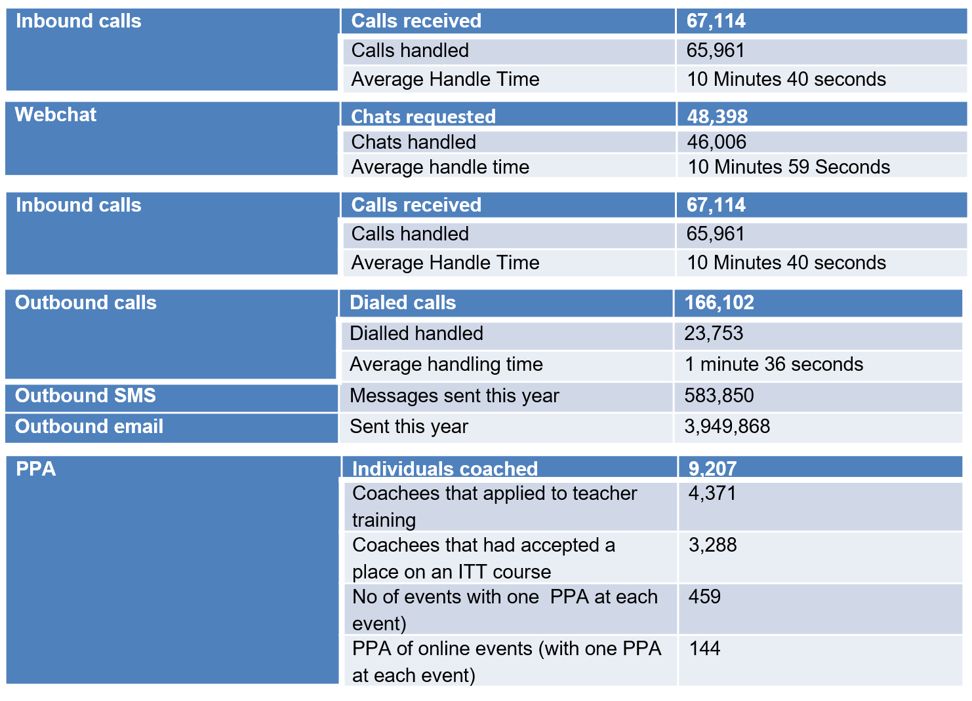

Pricing arrangements for the service and the commercial model

  - The present commercial model provides a stable monthly cost for the service that is primarily based on fixed staffing structure. DfE is considering a more volume drive commercial model and introducing controls on cost drivers such as average handling time and utilization. It is also considering opportunities to adopt industry best practice arrangements such as incentivising performance and gainshare.

  - Include SLA’s attached to operational performance and the achievement of outcomes, which result in service credits and incentives; including but not limited to, Advised Registrants who secure a place on a teaching course or return to the profession.

  - The potential gainshare arrangement that we are considering would be to generate innovation and continuous improvement to operational efficiency such as by reducing the average handling time while protecting service quality.

Outline Timescales

  - It is anticipated (subject to approval of the outline business case) that the invitation to tender will be issued in early spring 2018.

  - It is anticipated (subject to approval of the full business case) that the provider will have three months to transition and implement the service.

  - It is anticipated that the Service will be ready for use on 1 October 2018.

- Section 3 – Questionnaire

  - We would be grateful if you could answer the following questions. Your response will assist the DfE in developing our approach further and the formation of the associated tender documents thereafter.

  - This is not an invitation to bid, this is solely a RFI and no direct business will be awarded as a result of completing this RFI. Responding to this document does not advantage or disadvantage any supplier in a future procurement process. No supplier selection or supplier preference is implied.

  - It is not essential that you complete all questions if your organisation is not able, or does not wish, to do so.

3.4 Completed questionnaires should be returned via Bravo by midnight on 3rd January 2018:
https://education.bravosolution.co.uk/web/login.shtml

- Which aspects of the proposed opportunity appeal to your organisation and why?

- Paragraph 2.5 in section 2 of this document sets out the current operational design of the service. Do you consider that an alternative operational design to that currently employed might be beneficial to the delivery of the service?

- Are there any other key areas which you consider may benefit from an alternative approach?

- What do you consider would be the main challenges / barriers to delivering this service?

- What are the critical factors that you will consider when sizing the requirement and determining price? How would you provide price stability over a five year period? Are there any pricing risks which should be retained by the DfE (e.g. indexation)?

- DfE is considering adopting a pricing structure based on cost per productive minute. What are the benefits and or risks if any with this approach?

- The DfE intends to include in the contract a number of service levels to manage performance. These may action incentive payments for outstanding performance and service credits where there is poor performance. Does your organisation have any concerns or advice around how this is implemented?

- A gainshare arrangement may be used to incentivise efficiency. One area that DfE is considering is around attaching them to average handling times for interactions with potential candidates (while ensuring key performance indicators are met). Does your organisation have any or concerns or advice around this?

- DfE is currently reviewing its future requirements for the CRM solution. What are the main technical interfaces / issues required to be taken into consideration by the DfE to ensure integration with a DfE provided CRM system?

- Implementation. We are proposing a minimum 12 week period to transition and implement the new service. Can you please confirm that this is a realistic timeframe and set out any risks that you are concerned about? (N.B the supplier will not be required to develop the CRM solution).

- What are the major risks for you in the opportunity?

12. You are invited to provide additional information and comments which you consider the DfE would find useful to formulate its future strategy.

Thank you for completing this questionnaire.

