Draycot Close in Draycot Foliat approximate location.

51.497484, -1.737384

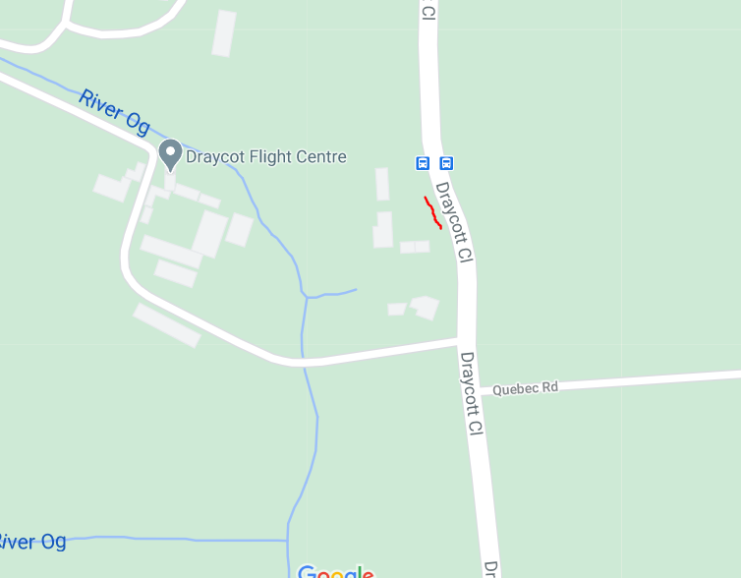

Windmill Piece in Chiseldon approximate location.

51.517888, -1.727565

