Bid Pack For Call Off Competition
Attachment 2 – How To Bid Including Evaluation Criteria
Contract Reference: Project 29170 – Language Services for Interreg funded Project PACCo
Contents

1. How To Make Your Bid 2
2. How The Questionnaires Are Structured: 2
3. Award Criteria 10
4. Marking Scheme 12
5. Technical Evaluation 13
6. Commercial Evaluation 14
7. Final Decision to Award 16
8. Further Information 17

How To Make Your Bid

Your bid must be made by the organisation that will be responsible for providing the deliverables if your bid is successful.

Remember to:

Accept or Decline this Bid Pack. If you decline please send an email stating your reasons for declining this tender to PACColanguagebids@environment-agency.gov.uk and quote reference PACCoITTNov20 .

Enter your bid via email to: PACColanguagebids@environment-agency.gov.uk and quote reference PACCoITTNov20 .

Make sure you answer every question within the word count permitted.

Each question must be answered in its own right. You must not answer any of the questions by cross referencing other questions or other materials e.g. reports located on your website.

Submit your bid in good time and before the bid submission deadline.

Check for messages via email throughout the competition.

If you are unsure, ask questions before the Clarification Questions Deadline.

Please create a separate document for each questionnaire to attach to your final submission email in Word.

How The Questionnaires Are Structured:

A summary of all the questions in the technical questionnaire, along with the marking scheme, and weightings for each question is set out below:

QUESTIONNAIRE 1 – QUALIFICATION - KEY PARTICIPATION REQUIREMENTS

QUESTIONNAIRE 2 – QUALIFICATION - CONFLICTS OF INTEREST

QUESTIONNAIRE 3 – QUALIFICATION - INFORMATION ONLY

QUESTIONNAIRE 4 - TECHNICAL EVALUATION

QUESTIONNAIRE 5 - COMMERCIAL EVALUATION

QUESTIONNAIRE 1 – QUALIFICATION - KEY PARTICIPATION REQUIREMENTS
Response Guidance
The following questions are ‘Pass/Fail’ questions. If Potential Bidders are unwilling or unable to answer “Yes”, their submission will be deemed non-compliant and shall be rejected. Potential Bidders should confirm their answer by selecting the appropriate option from the drop down menu.
Question Number | Question | Your Response
1.1 | Do you accept the competition rules as described in Attachment 1 – About the Procurement? | Yes/No
1.2 | Have you read, understood and accepted the Bid Pack and all associated attachments, specifically Attachment 3 - Statement of Requirement? | Yes/No
1.3 | Do you agree, without caveats or limitations, that in the event that you are successful, Attachment 5 - Terms and Conditions will govern the provision of this contract? | Yes/No
1.4 | - Can you confirm that all interpreters and translators who will be delivering the service have the right to work in the UK and hold a National Insurance Number? Can you confirm you hold the following information on record for all interpreters and translators and are able to provide a copy of documentation upon request?  RIGHT TO WORK IN THE UK: a document confirming a candidate's right to work in the UK  ADDRESS: A copy of correspondence, not older than 6 months, from one of the following sources:  - a bank / building society  - an official government body, e.g. HMRC, local council  a utility company | Yes/No
1.5 | As evidence of practice, can you confirm that all interpreters and translators who will be delivering the service have proof of active membership with one of the following professional organisations:  - NRPSI (National Register of Public Service Interpreters)  - CIOL (Chartered Institute of Linguists) as a Member (MCIL) or as a Fellow (FCIL)  - ITI (Institute of Interpreters and Translators)  - APCI (Association of Police and Court Interpreters)  - AIIC (International Association of Conference Interpreters)  - Alternatively, (a) letter(s) of endorsement issued by a translation agency or another type of organisation within the last 12 months is acceptable. The endorsements will need to confirm at least 400 hours of interpreting experience. | Yes/No
1.6 | Can you confirm that all interpreters and translators who will be delivering the service have provided you with proof of one of the following for each language combination?  - DPSI (Diploma in Public Service Interpreting)  - Dip Trans (Diploma in Translating)  - DPI (Diploma in Police Interpreting)  - MET Test (The Metropolitan Police Test)  - a Degree or Diploma in translation or interpreting from a UK or an overseas university | Yes/No

QUESTIONNAIRE 2 – QUALIFICATION - CONFLICTS OF INTEREST
Response Guidance

Question 2.1 is a ‘Yes/No’ question and will dictate whether or not question 2.2 needs to be answered.

Question 2.2 is a Pass / Fail question. Potential Bidders are required to provide details of how the identified conflict will be mitigated.

The Contracting Authority will review the mitigation in line with the perceived conflict of interest, to determine what level of risk this poses to them. Therefore, if Potential Bidders cannot or are unwilling to suitably demonstrate that they have suitable safeguards to mitigate any risk then their Bid will be deemed non-compliant and will be rejected.
Question Number | Question | Your Response
2.1 | Please confirm whether you have any potential, actual or perceived conflicts of interest that may by relevant to this requirement. | Yes/No
2.2 | We require that any potential, actual or perceived conflicts of interest in respect of this Bid Pack are identified in writing and that companies outline what safeguards would be put in place to mitigate the risk of actual or perceived conflicts arising during the delivery of these services. | Text Box

QUESTIONNAIRE 3 – QUALIFICATION - INFORMATION ONLY
Response Guidance

The following questions are for information only and do not form part of the evaluation. Information provided in response to these questions may be used in preparation of any Contract Award and any omissions may delay completion of this procurement.
Question Number | Question | Your Response
3.1 | Please provide details of where the Award Outcome should be directed. Your response must include their;  - Full Name  - Role/Title  - Registered Address  - Email Address | Text Box
3.2 | Please provide details of any sub-contractors you propose to use in order to meet your obligations should you be awarded a Contract. Your response must include their;  - Trading Name(s)  - Registered Address(ees) and contact details  - Goods/Services to be provided | Text Box

QUESTIONNAIRE 4 - TECHNICAL EVALUATION WEIGHTING 60%
Response Guidance
Potential Bidders MUST answer ALL the following questions. The method of response; page limit on attachments and evaluation criteria is set per question.
Unless otherwise specified, you must upload your response as an Attachment.
Attachments may be submitted in Microsoft Word, Excel. PDF format and must be in Arial font size 11. Page limits include the use of headers footers and diagrams. Attach ONLY those attachments we have asked for – any other supporting evidence, certificates for example, will be requested separately by us.
No individual response will be considered beyond the 500 word count.
Scoring criteria are provided below this table.
No costings should be included in responses to this Questionnaire.
Question Number | Question | Maximum 500 words per response | Minimum Acceptable Score | Maximum Available Score | Weighting out of 100
4.1 | Can you describe your subcontractors’ (interpreters and translators) experience of working on:  - Complex cross-border European-funded projects (if so, please indicate which Programme).  - Working with partnerships and understanding the roles and linkages between partners. |  | 20 | 100 | 20%
4.2 | Can you describe your subcontractors’ (interpreters and translators) experience of working on:  - Coastal and estuarine management, including tides, wetlands and flood defences.  - Climate change and adaptation. |  | 20 | 100 | 20%
4.3 | Can you describe your subcontractors’ (interpreters and translators) experience of working on:  - Socioeconomics, particularly the links between people and environment. |  | 20 | 100 | 20%
4.4 | Can you describe your subcontractors’ (interpreters and translators) experience of working on:  Construction projects, particularly with an environmental component. |  | 20 | 100 | 20%
4.5 | Can you describe how your organisation has adapted to using video/remote interpreting under Covid where face to face interpreting would previously have been used?  You may want to include: What platforms do you employ to successfully deliver this interpreting? How do you ensure high quality consecutive and simultaneous interpreting provision? |  | 20 | 100 | 20%
Total |  |  |  |  | 100%

QUESTIONNAIRE 5 – COMMERCIAL EVALUATION WEIGHTING 40%
Response Guidance
Potential Bidders must enter costs by uploading the relevant Attachment 4 - Price Schedule, at the question level via email.
Prices should be submitted in pounds Sterling inclusive of any expenses but exclusive of VAT.
Potential Bidders will be scored in accordance with the marking scheme at Section 2.
Question Number | Question | Your Response | Minimum Acceptable Score | Maximum Available Score | Weighting out of 100
7.1 | Please attach the completed Price Schedule to your email response. In so doing, you are also confirming that prices offered are inclusive of any expenses, exclusive of VAT and firm for the period following the Deadline for Submission as stated in the Attachment 1 – About the Procurement. | Yes/No  Attachment | 20 | 100 | 100

Award Criteria

The award stage consists of a technical evaluation and a commercial evaluation.

The award of the resultant contract will be on the basis of the ‘Most Economically Advantageous Tender’ (MEAT).

The weighting for the technical evaluation is 60%; and, the commercial evaluation is 40%.

Award process - What you need to do

Answer the questions in section 2 above via email.

Complete the Attachment 4 – Price Schedule.

You must attach your completed Price Schedule via email

What we will do
Compliance Check
First, we will complete a mandatory evaluation to make sure that you have answered all questions and have completed the Attachment 4 - Price Schedule in line with our instructions. All bids passing the mandatory evaluation will be progressed to the Technical Evaluation.
Technical Evaluation
We will give your responses to the Technical questionnaires to the Contracting Authority’s evaluation panel. Each evaluator will independently assess your responses to the technical questions using the response guidance and the evaluation criteria.
They will give a score and a reason for their score for each question they are assessing. The evaluators will communicate the scores and reasons into via email to the consensus evaluator.
If the evaluation panel wishes to clarify any areas of your bid, bid clarification questions will be issued via email on an individual basis.
Consensus
Once the evaluators have independently assessed your answers to the questions we will arrange for the evaluators to meet. A mediator will facilitate the discussion.
At this meeting, the evaluators will discuss the technical responses and review their scores and reasons for that score. The discussion will continue until they reach a consensus regarding the score, and reason for that score, for each question.
These final scores will be used to calculate your technical score.
If the evaluation panel wishes to clarify any areas of your bid, bid clarification questions will be issued via email on an individual basis.
TECHNICAL Threshold
If you have not met the minimum acceptable score for each question, you will be excluded from the competition. We will tell you that you have been excluded from the procurement and why at award stage.
If this is a 2 stage evaluation, we will advise you at the point in which stage 2 invitations are sent.
Evaluate COMMERCIAL
We will then evaluate your commercial response and calculate your score using the evaluation criteria specified.
If we wish to clarify any areas of your bid, bid clarification questions will be issued via the email on an individual basis.
Final Score
Your technical score will be added to your commercial score, to create your final score.
Award
Award will be made to the successful bidder, subject to contract.
We will notify successful and unsuccessful bidders providing feedback.
In some cases we may include a standstill period of up to 10 days, in which case the successful bidders will be issued an Intention to Award letter with all suppliers notified of the intended outcome.

Marking Scheme

The evaluation criteria set out below will be used during the Technical Evaluation:
Mark | Comment
100 | Exceptional - the response is significantly above the Authority’s requirements and provides a high degree of confidence that the supplier can deliver to an exceptionally high standard.
70 | Exceed requirements - the response exceeds the Authority’s requirements and provides confidence that the supplier can deliver a high standard.
50 | Meets requirements - the response meets all the Authority’s requirements and provides confidence that the supplier can deliver to the required standard.
20 | Below requirements - the response partially meets the Authority’s requirements but has weakness that does give the Authority limited confidence that the supplier will be able to deliver to the required standard.
0 | Unacceptable - the response fails to meet the Authority’s requirements. The  response includes errors, weaknesses, inconsistencies, omissions or general risks. The tender provides the Authority with little or no confidence that the supplier can deliver to the required standard.

Technical Evaluation

Questionnaires Q1 and Q2 are mandatory question(s) and will be evaluated PASS / FAIL. If you fail any of these questions, you will be excluded from the competition. We will tell you that your bid has been excluded.

When the consensus meeting has taken place and the final score for each question has been agreed by the evaluators, your final score for each question will be multiplied by that question’s weighting to calculate your weighted score for that question.

Each weighted score for each question will then be added together to calculate your technical score.

Please see table A below for an example of how your technical score will be calculated.

Table A – EXAMPLE ONLY
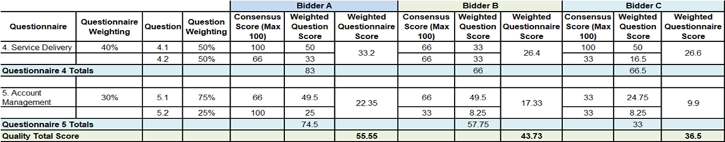

Commercial Evaluation

This section contains information on how to complete Attachment 4 - Price Schedule and the commercial evaluation process.

How to complete your Attachment 4 – Price Schedule

Read and understand the instructions in the Attachment 4 - Price Schedule, and in this section before submitting your prices.

Your prices should compare with the technical aspect of your offer.

Your prices must be sustainable and inclusive of all costs for example your operating costs and profit.

Your prices are to exclude VAT.

Pricing is to be inclusive of all expenses.

The currency is British pounds sterling, up to two decimal places.

The percentages submitted shall be up to two decimal places.

Pricing will be based on:

Remote / video interpreting per minute;

Minimum 2 hour face to face interpreting

Translation per 1,000 words in source language

Minimum translation charge for less than 1,000 words

Rounded to the nearest £10.

Zero bids will not be allowed.

We will investigate where we consider your bid to be abnormally low and your submission may be rejected

The prices submitted shall not exceed the overarching commercial agreement rates.

You must download and complete the Attachment 4 – Price Schedule. Further detail may be provided within the Attachment 4 – Price Schedule.

When you have completed your Attachment 4 - Price Schedule, you must upload this via email at question Q5. If you do not upload your Attachment 4 – Price Schedule your bid may be rejected from this competition.

Do not alter, amend or change the format or layout of the Attachment 4 – Price Schedule.

Commercial Evaluation Process

This is how we will evaluate your pricing:

We will check you have completed the Attachment 4 – Price Schedule as instructed.

Failure to complete the Attachment 4 - Price Schedule as instructed may result in your bid being deemed non-compliant and it may be rejected from this competition.

The commercial evaluation will be undertaken separately to the technical evaluation process.

The Potential Bidder with the lowest total price for each pricing table will be awarded the maximum score available for that pricing table.

All other Potential Bidders will get a price score relative to the lowest total price.

The calculation we will use to evaluate your total price per element, is as follows:
Price Score = Lowest total price * maximum score available Potential Bidder’s total price

Please see table B below for an example of how your Price score will be calculated.

Table B – EXAMPLE ONLY
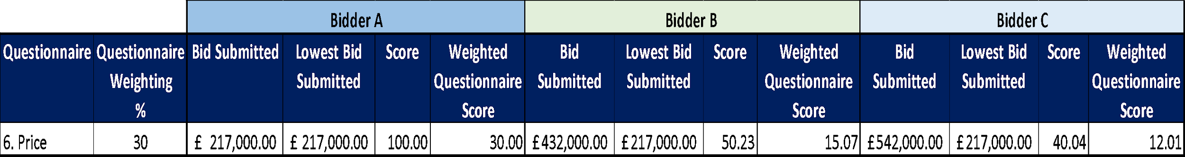

The total score for each pricing table will be added together and the potential bidder with the highest total score will be awarded the maximum available commercial score.

All other bidders will get a score relative to the total highest score.

The calculation we will use to evaluate the total commercial score is as follows:
Commercial Score = Potential Bidders Total Score * maximum score available
Highest Total Score

Where we consider any of the total price(s) you have submitted to be abnormally low will ask you to explain the price(s) you have submitted (as required in regulation 69 of the Public Contracts Regulations 2015).

Final Decision to Award

We will add your technical score to your commercial score to calculate your final score.

Please see table C below for an example of how your technical score and Price score will be added together to identify your final score.

Where the Final Score achieved by multiple Bidders ranks them in equal position and all such Bidders have achieved the Minimum Pass Mark or higher in all questions, the Bidder with the highest score for the pricing schedule, will be deemed the winner and awarded the Contract.
Table C – EXAMPLE ONLY:
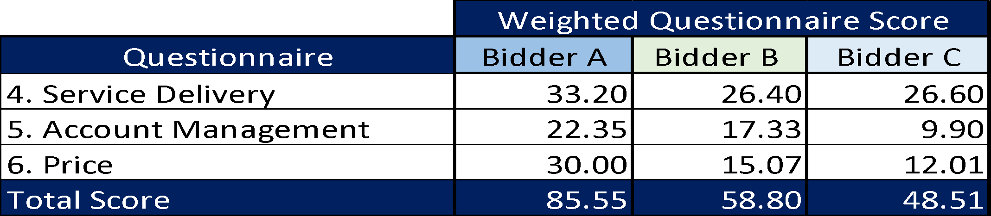

The bidder with the highest final score will be awarded the contract. However, if this is a 2 Stage Evaluation the final scores up to this point will act as a gateway to Stage 2 as outlined in “What we will do”.

Further Information
  - We will tell you if you have been successful or unsuccessful via email.
  - We will send Intention to Award letters to all Potential Bidders. At this stage, a Standstill Period of ten (10) calendar days will start, the term Standstill Period is set out in Regulation 87(2) of the Regulations. During this time, you can ask questions that relate to our decision to award.
  - Following the standstill period, and if there are no challenges to our decision, successful bidders will be formally awarded a contract.

