**Invitation to Tender for Support and Maintenance for the Electricity Distribution Network Model: Q&A**

**Tender Reference Number: 1583/08/2018**

Date: 22nd August 2018

1. Do you anticipate the support being provided locally or could it be provided remotely, e.g. using conference calls and screen sharing etc.?

We believe the support can be provided remotely via conference (video) calls and screen sharing. We would expect to have at least one meeting in person e.g. for a training session with BEIS analysts.

1. Do you suspect that an overseas supplier would be at a material disadvantage and if so why?

We do not believe an overseas supplier would be at a significant material disadvantage but the supplier must consider the cost of travel for any face-to-face meetings and any currency exchange rates as the contract will be in £GBP and all costs in the tender must be quoted in £GBP.

1. Could a supplier with predominantly international modelling experience, but with familiarity of the UK context, form a credible offer? What would be required in this case?”

If the tender can compete with other bids and exhibits the supplier is familiar with the UK system, they can form a credible offer. There are no special requirements and international bids are welcome.

1. Could you provide a working version of the model populated with realistic test data?

A working version of the model cannot be provided at this stage but a small sample of the code can be provided (see question 6). Further information on the inputs of the models come from the legacy Smart Grid Forum Workstream 3 and Workstream 7.

1. Functional and non-functional requirements of the model, if they are documented. Failing that, a structured list of all input data and all output data, and a description of representative examples of use cases.

The main inputs into the power flow model include general inputs, such as technology profiles, GW deployments and the regional distribution of technologies and underlying demand in each region, and separately the representative distribution networks, branch and busbar connections and a list of contingencies (i.e. outages). The model outputs the thermal headroom and voltage headroom and legroom, which go into the Investment model to output:

* Costs incurred in each year (including gross capital and operational costs)
* Cumulative costs in each year (including gross capital and operational costs)
* Costs by solution, region, network level, gross capex, gross opex, model topology
* Capacity added
* Number of deployments of each solution and associated technical factors such as lengths of circuits, number of transformers, etc.
* Other costs such as disruption cost and whole system cost/benefit.

1. As noted on page 11 of the tender 1583/08/2018, we would like to ask for examples of the code.

Table 1 Snapshot from data exchange file

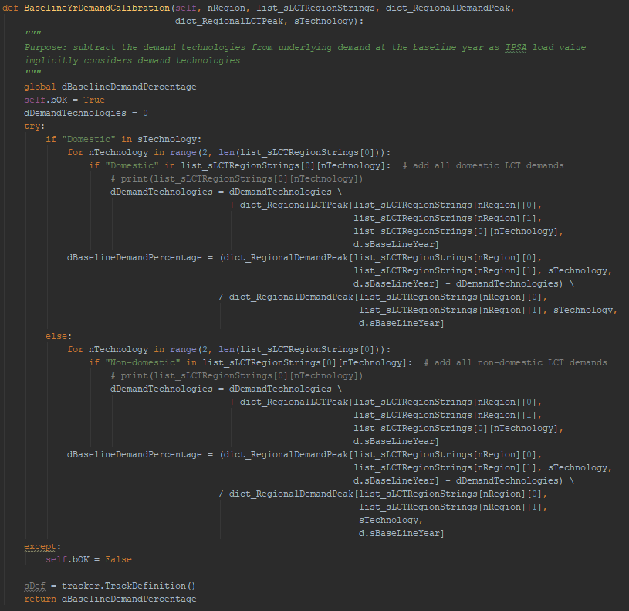

Table ‑2 Snapshot from Scripted IPSA

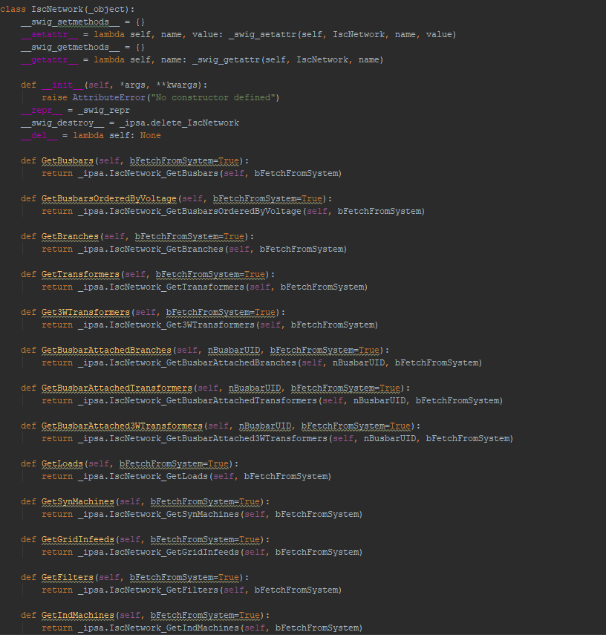

1. Please provide the design documents, or samples of the design documents, for the code.

SAMPLE:

“The User Interface (UI) calls a set of top layer Python modules which read all the required input data from the UI and the respective csv files and undertake a data validity check. Once the input data is deemed to be fit for the study, either the power flow model (PFM) is initiated or the investment model (IM) based on the user selection in the UI. The PFM and the IM are separate sets of Python modules which are tied together by the top layer Python modules.

The outputs obtained from the PFM are exported to a set of csv files and are placed in the IM input data folder. Before the IM is executed, a second set of data check is performed on all the inputs coming from the PFM. A final data sanity check is performed on the outputs from the IM before these are processed and passed on to an output excel workbook.”

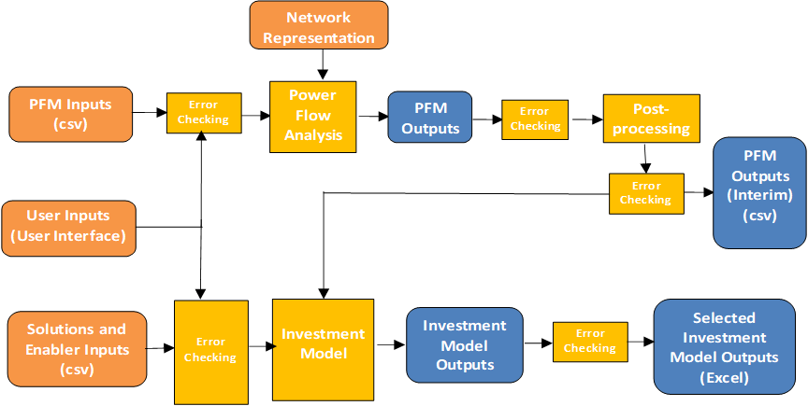

1. Please provide the DNM user guides. If these are not available, please give an indication of size (e.g. number of words, number of pages) for each guide.

The model user guide is around 100 pages long, with approximately 24,000 words (including appendixes, glossaries, etc.).

1. Who owns the IP for the original model(s)?

TNEI Services Ltd.

1. What are the programming languages used in the model?

Python and VBA

1. What versions of the programming languages are used? (e.g. Excel 2013)

Python version 2.7.15 (32-bit version) and Microsoft Excel (version 2007 or 2016).

1. What IDEs or commercial packages have been used to develop and run the model? (e.g. IPSA2, PowerFactory DIgSILENT, Python 3, Microsoft Visual Studio for C#)

IPSA version 2.7.1, Scripted IPSA version 2.7.1 (32-bit version), Excel (version 2007 or 2016), Python version 2.7.15 (32-bit version).

Python packages include: pip, Pandas, CSV, Shutil, Numpy, Pulp, Win32com.client and Inspect.

1. Are there any ancillary programs that are required to operate the model(s)? (e.g. database server, webserver, etc.)

No.

1. What version control system is used for the model(s)?

The user fills in a version control log in the model interface and output template.

1. What operating system/version is required for the model(s) to run?

Windows, we are currently using Windows 7.

1. How large are the codes for each of the languages (e.g. approximate number of electrical nodes for power flow models, number of lines and number of functions for the programming languages, number of variables used for the inputs in Excel)?

Power Flow Model’s Network Size

The tool uses 4 separate network models:

Model 1: 638 nodes, 641 branches

Model 2: 641 nodes, 536 branches

Model 3: 969 nodes, 770 branches

Model 4: 1402 nodes, 1683 branches

Programming languages

Python: 74 modules with 500 lines in each on an average

VBA: 250 lines of code, 33 variables

1. How much hard drive space do the models/inputs occupy? (If possible, please break this down for each model/language/input).

Each model folder is around 540MB.

1. What unit tests are run for the models?

Testing has followed [BEIS Modelling Quality Assurance tools and guidance](https://www.gov.uk/government/collections/quality-assurance-tools-and-guidance-in-decc).

1. What level of verification has been performed on the model(s)?

Testing has followed [BEIS Modelling Quality Assurance tools and guidance](https://www.gov.uk/government/collections/quality-assurance-tools-and-guidance-in-decc).

1. Will these unit tests and verification tests be provided alongside the model?

All relevant information that is necessary to provide maintenance and support will be shared with the successful bidder.

1. What system is used for tracking and monitoring issues currently? How many issues are tracked (historically)? Is this available in the event of successful bid?

Currently an Excel-based tracker is used to report issues and record solutions. All relevant information that is necessary to provide maintenance and support will be shared with the successful bidder.

1. What system is used for the assumptions log? How many assumptions are currently on this list?

The Assumptions log follows [BEIS Modelling Quality Assurance tools and guidance](https://www.gov.uk/government/collections/quality-assurance-tools-and-guidance-in-decc). It currently holds around 70 assumptions.

1. How many input scenarios are in existence currently? Do these need to be maintained to ensure backwards compatibility?

BEIS establishes and maintains input scenarios.

1. How many output templates are in existence currently? Do these need to be maintained to ensure backwards compatibility?

One output template, which needs to be maintained.

1. How many user enquiries/issues/feature requests/priority improvements/days of training have been requested in the past 5 years, for each of the categories Major/Minor/Not approved? (A yearly breakdown would be very useful if this is available).

N/A - The model has just come in-house and this contract will be the first of its kind for this specific model.

1. Who judges where issues lie between the boundaries of Type III and Type IV enquiries?

BEIS Analysts will consult with the successful bidder to determine where issues lie and will accordingly make the final decision.

1. Are all users on exactly the same hardware and software versions (both OS and programs that run the software)? If not, what is the range of hardware and software versions that must be catered for?

All users are currently using machines with Windows 7 and software versions as mentioned in the response to Question 10.

1. What is the expected method of transferring models on to BEIS systems? (e.g. email model upgrades over the internet, file transfer to BEIS server, cloud storage, encrypted CD/hard drive?)

Information and models should be exchanged via SharePoint.

1. Is there any requirement to use cloud-based storage either now, or in the future of the contract?

Yes, this might be something to consider in the future.

1. What is the maximum security / governmental data classification required?

Official Sensitive

1. Any pre-existing IP owned by the contractor and used while meeting this contract will be freely available. Will this be for use exclusively by BEIS, or will BEIS pass this on to any 3rd parties?

Please see BEIS’s Terms and Conditions for this project.

1. Details of the intellectual property rights that the department has secured to permit the contractor to access, reverse-engineer and/or modify any proprietary components of the model, including IPSA2.

Please see BEIS’s Terms and Conditions for the original project contract published here: <https://www.contractsfinder.service.gov.uk/Notice/Attachment/99fe67a7-93f7-451f-93ad-3cd0c3393937>

1. What is the procedure for reconciling disputes for categories, or agreeing on a fair expected time requirement for developing new features?

If disputes cannot be resolved at project management level, they will be escalated to more senior staff.

1. What is the expected turnaround time for the BEIS expert user to decide on converting an enquiry to resolution?

This will depend on the nature of the enquiry.

1. Will BEIS cover any, or part, of the costs for the time taken to familiarise ourselves with the model?

BEIS will not be held liable for recovery of costs from unsuccessful bids if a contract is not awarded. All costs will be borne by the bidding organisations. The bidder’s model familiarisation time should form part of the supplier’s bid and budget.

1. Is there an expected type of contract? (e.g. fixed price, Time-and-materials (day rate) etc.)

BEIS expects the supplier to provide day-rates as part of their bid. The upper-limit over the whole contract period is £50,000 which must be considered when submitting a bid.

1. Is there a maximum bound on the number of days support that can be requested? If this is more than 50 days, will the contract be extended on a day-rate basis, or will the contractor be expected to do this for the original price?

The maximum bound is up to the contractor to decide according to the day-rates offered but must be kept within the original budget of £50,000 across the whole contract period.

1. What office hours are required for support? (e.g. 9-5 weekdays only? 24/7?)

Weekdays only.

1. Are the quarterly invoices in arrears or forward projected for the quarter ahead?

Arrears.

1. What detail level of summary is required for invoicing? For example, is it acceptable to for the contractor to put in a single line item, or is a detailed breakdown of time spent & equivalent costs per week, expenses, remaining budget, number of issues resolved required?

The detailed breakdown of what was changed in the model (including the number of issues resolved and the time/days spent on each issue) should be included in the issues log. The invoice would be produced in line with the information included in the issues log, subject to the prices and time allocated for solving issues as agreed beforehand.

Creating a log to cover costs per week, expenses incurred and remaining budget according to work completed is welcome.