RM6187 Framework Schedule 6 (Order Form and Call-Off Schedules)

Order Form

CALL-OFF REFERENCE: C384874

THE BUYER: Secretary of State for Health & Social Care Acting as Part of The Crown
BUYER ADDRESS 39 Victoria Street, Westminster, London, SW1H
0EU

THE SUPPLIER: Grant Thornton UK Advisory & Tax LLP

SUPPLIER ADDRESS: 8 Finsbury Circus, London, EC2M 7EA
DUNS NUMBER: 233668709

Applicable framework contract
This Order Form is for the provision of the Call-Off Deliverables and dated 21/08/2025 It’s issued under the Framework Contract with the reference number RM6187 for the provision of expert knowledge and input to the DHSC annual report and infographics

CALL-OFF LOT(S):
Not applicable

Call-off incorporated terms
The following documents are incorporated into this Call-Off Contract.
Where schedules are missing, those schedules are not part of the agreement and can not be used. If the documents conflict, the following order of precedence applies:

- This Order Form includes the Call-Off Special Terms and Call-Off Special Schedules.
- Joint Schedule 1(Definitions and Interpretation) RM6187

- The following Schedules in equal order of precedence:

Joint Schedules for RM6187 Management Consultancy Framework Three
  - Joint Schedule 1 (Definitions) -
  - Joint Schedule 2 (Variation Form)
  - Joint Schedule 3 (Insurance Requirements)
  - Joint Schedule 4 (Commercially Sensitive Information)
  - Joint Schedule 10 (Rectification Plan)
  - Joint Schedule 11 (Processing Data)

Call-Off Schedules
  - Call-Off Schedule 5 (Pricing Details) - Optional
  - Call-Off Schedule 9 (Security)
- CCS Core Terms
- Joint Schedule 5 (Corporate Social Responsibility) - Mandatory
- Call-Off Schedule 4 (Call-Off Tender) as long as any parts of the Call-Off Tender that offer a better commercial position for the Buyer (as decided by the Buyer) take precedence over the documents above.

Supplier terms are not part of the Call-Off Contract. That includes any terms written on the back of, added to this Order Form, or presented at the time of delivery.

Call-off special terms

The following Special Terms are incorporated into this Call-Off Contract:
Special Term 1 - The Buyer is only liable to reimburse the Supplier for any expense or any disbursement which is
- specified in this Contract or
- which the Buyer has Approved prior to the Supplier incurring that expense or that disbursement. The Supplier may not invoice the Buyer for any other expenses or any other disbursements

Call-off start date: 21/08/2025

Call-off expiry date: 20/09/2025

Call-off initial period: 1month

Call-off deliverables:

Expert input based on the Supplier’s knowledge of best practice to suggest areas from the narrative in the Annual Report and Accounts of the Buyer, in particular the Performance Report and Governance Statement, which lend

themselves to visual representation using infographics
- Authorship of 5-10 infographics to be included in the narrative, in a print-ready format, but that the Buyer can edit if required in case of late changes close to publication of the ARA. The Buyer will seek to re-use the infographics in future years where relevant.

All to be delivered by 9th September 2025.

Security

Short form security requirements apply

Maximum liability
The limitation of liability for this Call-Off Contract is stated in Clause 11.2 of the Core Terms.

The Estimated Year 1 Charges used to calculate liability in the first contract year are:
£10,000.00 ex VAT

Call-off charges
£10,000.00 (ex VAT)

All changes to the Charges must use procedures that are equivalent to those in Paragraphs 4, 5 and 6 (if used) in Framework Schedule 3 (Framework Prices)
The Charges will not be impacted by any change to the Framework Prices. The Charges can only be changed by agreement in writing between the Buyer and the Supplier because of:
- Specific Change in Law
- Benchmarking using Call-Off Schedule 16 (Benchmarking)

Reimbursable expenses
None

Payment method
Payment made via BACs within 30 days of receipt of valid invoice

Buyer’s invoice address
AccountsPayable@dhsc.gov.uk

FINANCIAL TRANSPARENCY OBJECTIVES
The Financial Transparency Objectives do not apply to this Call-Off Contract.

Buyer’s authorised representative
Sophie Garrod
Section Head – DHSC Annual Report Sophie.Garrod@dhsc.gov.uk

Supplier’s authorised representative Peter Saunders
Managing Director
peter.g.saunders@uk.gt.com
Grant Thornton UK Advisory and Tax LLP, 8 Finsbury Circus, London, EC2M
7EA

Supplier’s contract manager
nick.caley@uk.gt.com
Principal Consultant
Nick Caley

Progress report frequency
Not applicable

Progress meeting frequency
Not applicable

Key staff
emma.j.murray@uk.gt.com
Associate Director
Emma Murray

Key subcontractor(s)
Not applicable

Commercially sensitive information
Not applicable

Service credits
Not applicable

Additional insurances
Not applicable

Guarantee
Not applicable

Social value commitment
The Supplier agrees, in providing the Deliverables and performing its obligations under the Call-Off Contract, that it will comply with the social value commitments in Call-Off Schedule 4 (Call-Off Tender)]

Formation of call off contract

By signing and returning this Call-Off Order Form the Supplier agrees to enter a Call- Off Contract with the Buyer to provide the Services in accordance with the Call-Off Order Form and the Call-Off Terms.
The Parties hereby acknowledge and agree that they have read the Call-Off Order Form and the Call-Off Terms and by signing below agree to be bound by this Call-Off Contract.
For and on behalf of the Supplier: Supplier Signature:
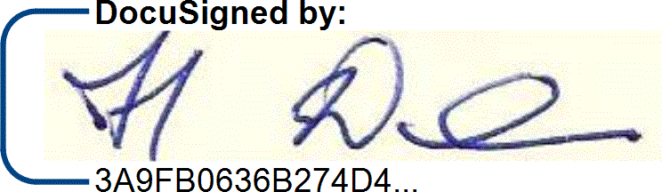

Full Name: Howard Davis
Name:
Role:

Job Title/Role:
Date:
Date Signed:
Director 21/08/2025

For and on behalf of the Buyer: Buyer Signature:

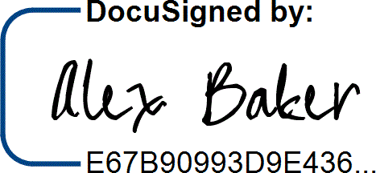

Full Name:
Name:
Role:
Job Title/Role:
Date:
Date Signed:
Alex Baker Commercial Lead 21/08/25

