Structure review support
Appendix 1: Specification

Introduction
    - The Single Source Regulations Office or SSRO is an executive non-departmental public body, sponsored by the Ministry of Defence (MOD). We play a key role in the regulation of single source, or non-competitive defence contracts.
    - When undertaking our statutory functions, we aim to ensure that good value for money is obtained in government expenditure on qualifying defence contracts, and that persons who are parties to qualifying defence contracts are paid a fair and reasonable price under those contracts.
    - The Defence Reform Act 2014 (‘the Act’) created a regulatory framework for single source defence contracts. The framework came fully into force in December 2014, following Parliamentary approval of the Single Source Contract Regulations 2014. The framework places controls on the prices of qualifying contracts and requires greater transparency on the part of defence contractors. The SSRO is at the heart of the regulatory framework, supporting its operation.
    - Additional general information about the SSRO, can be found on our website: http://www.gov.uk/government/organisations/single-source-regulations-office

The Service Specification
    - The SSRO’s Framework agreed with the Ministry of Defence (MOD) requires that the SSRO pay bill, and annual award increases be constrained by a public sector ‘Pay Remit’, overseen and approved in our case by MOD and MOD Ministers. The pay bill excludes payments to non-executive Board Members, which are subject to rates set by the MOD.
Background
    - Under its current policy, staff salaries are agreed on a ‘spot rate’, within existing salary bands, through negotiation with successful candidates. The SSRO has introduced a range of ‘pay bands’, with the band and associated salaries within that band reflecting the role weighting assessed against other, similar roles. Role weights have only been formally tested independently in four cases, which resulted in roles being moved to the next higher pay band for two individuals. The organisation’s current pay bands are as follows:
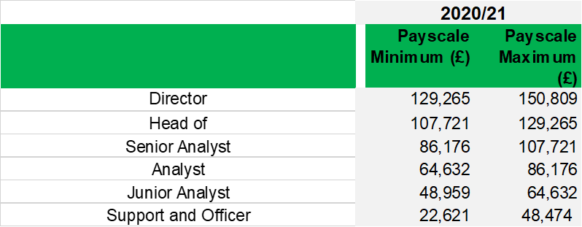

    - The number of employees within each of these bands are as follows:
Band | Number of Employees
Director | 4
Head of | 6
Senior Analyst | 7
Analyst | 6
Junior Analyst | 7
Support and Officer | 8

    - As a result of the current approach to agreeing salaries there may be inconsistencies with grades and roles.
    - On inception, the SSRO set pay levels at rates to attract employees from target markets in the private and regulatory sector, above comparable levels in other public bodies. Currently staff members are drawn from (last job before joining the SSRO) the following sectors:
Previous employers’ sector | Number
Civil Service | 3
Defence Industry | 0
Other Regulators | 6
Other public sector | 20
Other private sector | 9

    - Historically, pay awards are applied at the same percentage equally to all staff. The pay system allows for the SSRO to make variable awards as long as the overall pay remit limit is not exceeded.
    - In line with government policy, there is no system of automatic progression linked to time served. Currently, salaries can be increased solely to reflect changes in job weight, either temporarily with an allowance or permanently if the change is ongoing.
    - The SSRO operates three Performance Related Pay (PRP) systems: one for the chief executive; one for directors and senior managers; and one for junior managers and staff.
    - In addition to pay rewards, the SSRO offers several other benefits, including:
      - an Oyster card or equivalent discount from an annual rail season ticket, up to zone 6;
      - employer enhancement of statutory rates of maternity, paternity, shared parental and adoption pay; and
      - access to the Civil Service Pension Scheme.
    - Turnover levels at the SSRO since its inception are as set out in the table below. The absence of long-term career paths within a small organisation may change this position over time.
Leavers Since 2015 | 18

Service requirements
    - The organisation is looking for expert advice on job grades / banding and remuneration, to include all of the following deliverables:
- review all job descriptions and propose a consistent format and structure that allows the SSRO to update job descriptions and easily compare roles and transparently links to a grading and remuneration methodology. This must be capable of future review and update as managers and staff refresh job descriptions.
- provide a grading and remuneration methodology that links skills, experience and qualifications (as set out in the above structured job descriptions) to remuneration and reward. This must support and be capable of accommodating career progression paths, including the ability to move between grades based on an objective assessment of skills and qualifications.
- provide an objective assessment of all existing salaries based on a comprehensive and objective analysis of market data on similar relevant roles both in the private and public sector in geographically relevant locations. This should be supplemented with advice on how to lawfully, fairly and equitably address anomalous remuneration levels.
    - These deliverables should be provided in written reports to the SSRO.
    - The supplier will be expected to approach the work by relying on paper-based analysis and only engaging with members of staff where necessary and by agreement.
    - The delivery of the service is expected to commence promptly on appointment. The work must be concluded by 14 July 2021.

Programme of planned activities
    - The organisation has recently appointed a Chief Operating Officer which has merged two directorates: Legal and Policy and Economics and Regulations. The Chief Operating Officer is currently reviewing his requirements and his resources. You will be provided with a copy of the proposals and consultation document along with staff responses. This material should be considered when finalising the deliverables above.
Service approach / management
    - The supplier will need to act with the utmost confidentiality. Issue of pay and structure are very emotive, and information is only to be shared with express permission of either the Interim Director of Corporate Resources, Chief Operating Officer or the Chief Executive. No information is to be shared with any other internal or external party, unless required by law.
    - Only those consultants who are nominated in the tender as the key personnel are to conduct the work, save with the prior agreement of the SSRO.

