Specification for: CCC indicators to track progress in developing Greenhouse Gas Removal options

Tender Reference Number: SS/0117

Specification of Requirements

Invitation to Tender for - CCC indicators to track progress in developing Greenhouse Gas Removal options
Tender Reference Number: SS/0117
Deadline for Tender Responses: 1pm 17TH February 2017

Contents

1. Preamble 4
2. Background 4
The CCC indicator framework 4
Motivation for greenhouse gas removal (GGR) measures 5
Adding new GGR indicators 6
3. Aims and objectives 8
4 Methodology 9
5 Outputs Required 11
6 Ownership and Publication 11
7 Quality Assurance 11
8 Timetable 12
9 Working Arrangements 12
10 Skills and Experience 12
11 Consortium Bids 12
12 Budget 13
13 Evaluation of Tenders 13

Scoring Method 14
Structure of Tenders 14
Evaluation for Interviews 15
Feedback 15

Preamble
The Committee on Climate Change (CCC) was set up as part of the UK Climate Change Act. The CCC is an independent body tasked with advising Government on climate change issues, particularly the setting of carbon budgets and the monitoring of progress towards meeting those budgets and the 2050 target (to reduce UK emissions of greenhouse gases at least 80% below 1990 levels by 2050). CCC’s past reports are available here: http://www.theccc.org.uk/reports/.

Background

The CCC indicator framework
The CCC monitors progress towards meeting carbon budgets and the 2050 target using an indicator framework, first set out in our October 2009 Progress Report to Parliament. This framework contains future trajectories for a range of measureable quantities linked to UK emissions:
- Headline indicators (greenhouse gas emissions, emissions intensity and energy demand);
- Implementation indicators for specific measures (e.g. additional low-carbon power generation capacity, purchases of electric cars, roll-out of loft insulation);
- Forward indicators to measure progress in advance of implementation (e.g. power generation investments at planning and construction stages);
- Policy milestones for an appropriate framework enabling future implementation of measures (e.g. legislation of new efficiency targets for cars).
The full set of current indicators across the main sources of emissions is available in technical annexes here: https://www.theccc.org.uk/publication/meeting-carbon-budgets-2016-progress-report-to-parliament/.
Our indicators follow our current best projection of the technologies and behaviours required to cost-effectively meet carbon budgets and the 2050 target. However, there is uncertainty over the rates at which technologies will develop, their future costs, and how people will change their behaviour. Analysis of the required changes is also more developed in some areas than others. This means some sectors and measures have more detailed indicator sets than others. It also means indicators are not prescriptive (carbon budgets could be met by underperforming in some indicators, while outperforming others) nor exhaustive.
We are currently updating our indicators in advance of our 2017 Progress Report, to reflect:
- Updated CCC scenarios (available at https://www.theccc.org.uk/publication/the-fifth-carbon-budget-the-next-step-towards-a-low-carbon-economy/) which informed the level of the fifth carbon budget, legislated by Parliament last July.
- Our October report on UK Climate Action following the Paris Agreement (available at https://www.theccc.org.uk/publication/uk-action-following-paris/). A key additional conclusion was the need for a Government strategy to develop options for removing greenhouse gases from the air.

Motivation for greenhouse gas removal (GGR) measures
Greenhouse Gas Removal (GGR) measures actively remove CO₂ and other greenhouse gases from the air. The recent CCC report on UK climate action following the Paris Agreement highlighted that net emissions need to eventually reach zero in order to stabilise global temperature. Given some emission sources will continue for the foreseeable future (especially from aviation, agriculture and parts of industry) GGRs will be necessary to reach net zero emissions. The CCC scenarios to meet the 2050 target already include some GGR measures – afforestation, biomass with carbon capture and storage (BECCS) and use of wood in construction together contribute a reduction in emissions of around 50 MtCO₂e/yr in a central case.

The CCC report cited a range of possible GGR measures (Table 1) with estimated costs, technology readiness and potential to remove CO₂. Some are already well understood, but many are at an early stage of development with uncertain costs, effectiveness, feasibility and wider impacts.

Table 1: Indicative range of GGR measures, including estimates of global potential to remove CO₂ and cost per tonne of CO₂.
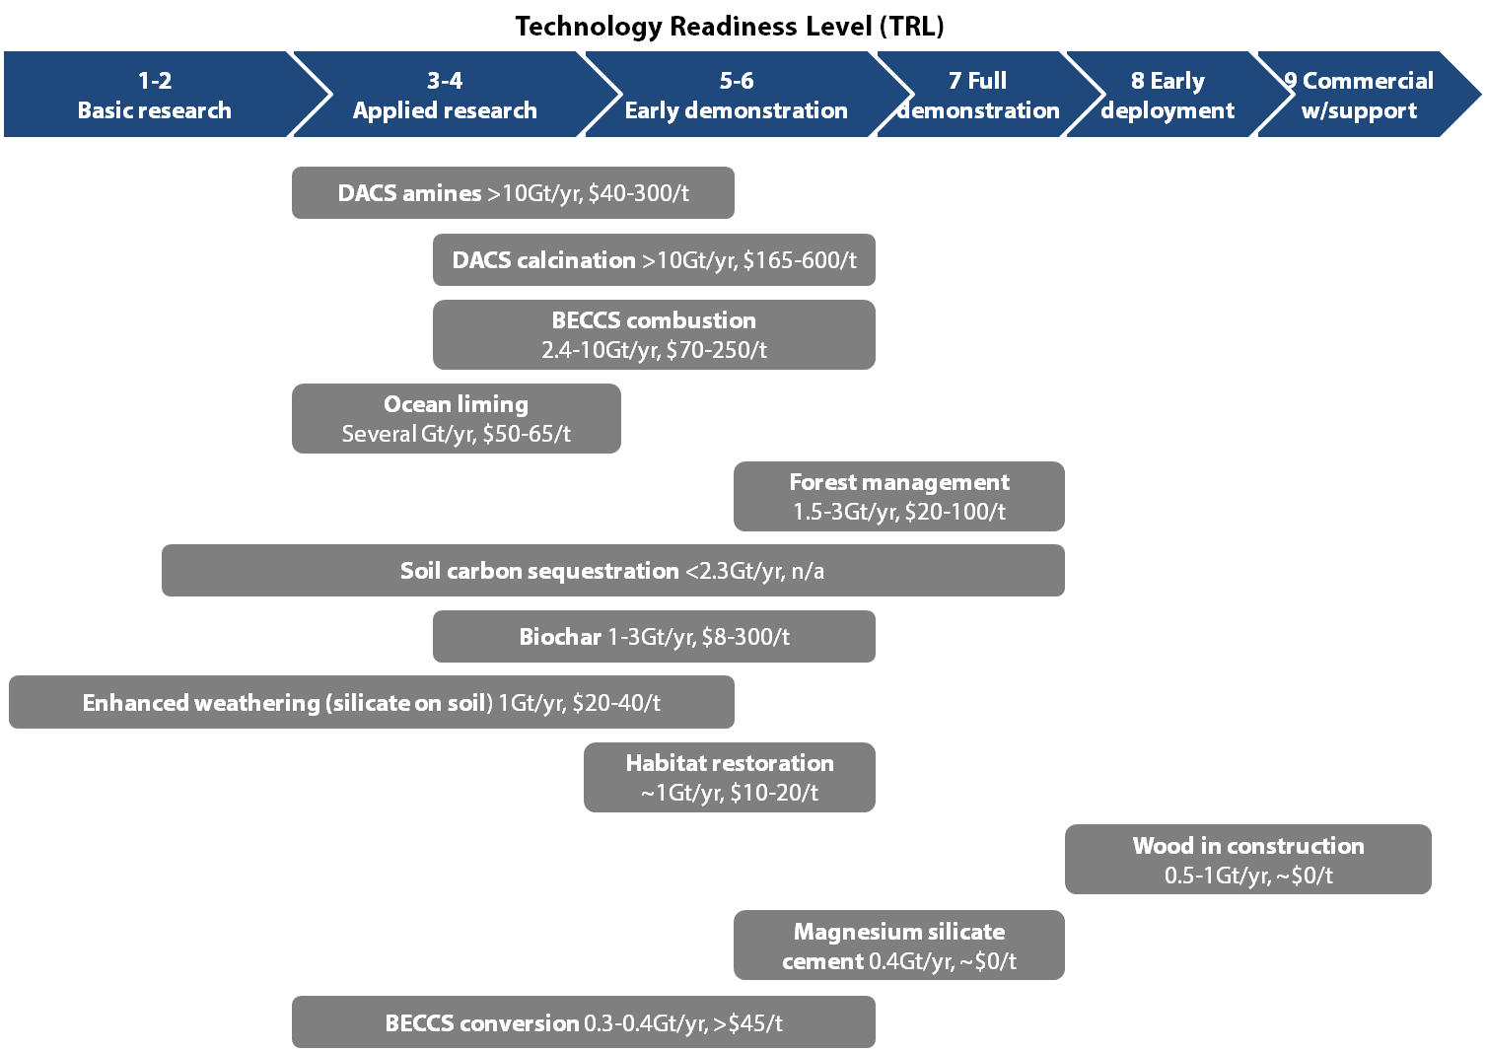
Source: CCC (2016) UK climate action following the Paris Agreement, adapted from McLaren (2012) A comparative global assessment of potential negative emissions technologies. DACS = direct air capture and storage; BECCS = bioenergy with carbon capture and storage
Our conclusion was that the UK should develop a strategy for sustainable GGR deployment at scale by 2050. Development should start now given that new technologies typically take 30-40 years from invention to mass deployment. Such a strategy should include the following high-level elements:
- Support for research, development and demonstration. Research will help clarify whether options deliver genuine long-term greenhouse gas removal and address technical, environmental and social challenges. Examples include improving measurement of land carbon, assessing impacts over the lifecycle of bioenergy crops and biochar, and testing of direct air capture processes.
- Support for deployment. Targeted deployment provides the opportunity to bring down costs and further understand impacts for options that are technically more mature. Support can be in the form of removal of barriers as well as incentives. Examples for deployment include carbon capture and storage infrastructure, sustainable bioenergy crops, afforestation and wood in construction.
- Integration into policy and accounting frameworks. Greenhouse gas removal by suitably effective, permanent sinks should count equally with reduction of emissions. The lack of a long-term policy commitment to rewarding removals is a key barrier to development. Schemes such as the EU Emissions Trading System (ETS) and the Common Agricultural Policy (CAP) could be structured to provide economic incentives but currently are not.
- Integration into a global strategy that pools international resources (given greenhouse gas removals are of global benefit), fosters good governance and reflects the fact that different removal technologies may be best deployed in different locations.

Adding new GGR indicators
The current CCC indicator framework does not cover GGR development in the UK. It does however contain indicators for forest management (one GGR option), set out in Table 2. It also contains indicators for Carbon Capture and Storage (CCS), an important enabler for some GGR options, although these are due to be updated in separate work by the CCC following cancellation of the previous CCS competition around which they were based (Table 3).
Table 2: Current CCC indicators for forest management
Headline
CO₂ sequestered | 2.4 MtCO₂/year by 2030
Implementation
UK woodland planting | • At least 15,000 hectares/year between 2015 and 2030  • Development of agro-forestry schemes
Policy milestones
Development and implementation of a woodland creation programme | Government ambition for England of average rate of 5,000ha/year by 2060
Agro-forestry | Develop a policy framework to increase peatland restoration
Include upland and lowland peat emissions in the LULUCF inventory | By 2018
Develop a policy framework to increase peatland restoration | By 2017

Table 3: Current CCC indicators for Carbon Capture and Storage (CCS)
 | Budget 2 (2013-17) | Budget 3 (2018-22) | Budget 4 (2023-27)
Headline
Generation (TWh) | 0 | 5 | 5
Implementation
Demonstrations operational |  | First plant in 2018, subsequent plant in 2019
First new full CCS plants supported via the post-demonstration mechanism |  | First plant operational
Forward
Planning and authorisation approval, land acquisition, and storage site testing completed, construction commences | 2015-2016 for first demonstrations
Policy milestones
Launch Commercialisation Program
Front-End Engineering and Design (FEED) studies for competition contenders initiated | FEED studies start in 2014
FEED studies for competition contenders completed | FEED studies complete in 2015
Final Investment Decision for Demonstration projects | For both preferred bidders by the end of 2015
Quantification of saline aquifer CO₂ storage potential | By 2015
Review of technology (including cost reduction and commercialisation strategy), strategic plan for infrastructure development and decision on framework for future support | By 2016
The CCC would like to track national progress in developing a GGR strategy in line with its recommendations. We are therefore looking to adjust existing indicators (for forestry, and potentially others) where necessary in order to account for the need to develop GGR options, and to set new indicators for important aspects of GGR development.
The optimal mix of GGR measures is not yet clear, as it depends on developments in their technical performance, cost and acceptability which are subject to considerable uncertainty. Therefore the CCC does not regard it as currently sensible to set specific targets for deployment of specific GGR options to 2032. Instead, indicators should reflect the aim for Government to ensure that the range of GGR options is able to participate fully in the UK’s climate strategy, according to their cost, compliance with other regulations and ability to sequester greenhouse gases reliably.

Aims and objectives
The aim of this project is to develop a set of indicators for the CCC to track near-term UK progress in developing GGR options. The indicators should:
- Break down the CCC’s recommendation for a UK strategy including four elements (support for research, support for deployment, integration into policy and accounting, and integration into a global strategy) into a set of milestones and actions.
- Be consistent with the goal of having UK GGR deployment at scale (of the order of 100 MtCO₂e/yr) by 2050.
- Be quantified where possible (e.g. necessary timescales for closing knowledge gaps or building infrastructure, magnitude of budget for research & development).
- Identify specific policy milestones and actions for the next five years (to 2022) and any key steps beyond that to 2032 (the timescale of legislated carbon budgets).

Methodology
In this section we set out an approach which we envisage would meet our project aim:
Task 1: Characterise the current state of GGR options capable of reducing emissions in the UK.
Consultants should consider all of the options listed in the CCC’s report (Table 1) and if they see any other options as important for inclusion they should highlight these in the bid. Consultants may group some options together, but this should be explained in the bid where intended.
For each option (or group) consultants should review the current state of development, including:
- Estimates of technological readiness, cost and UK potential to remove greenhouse gases. Some are provided in the CCC’s report, but the literature should be checked for more recent information and estimates should be provided for any additional options. Specific gaps in understanding should be identified that need to be resolved within an effective strategy.
- Existing initiatives for research, development and demonstration (in the UK and internationally).
- Existing accounting methods for measuring, monitoring and verifying GHG removals.
- Existing policies and markets which provide an incentive for removals by that method, or could be adapted to do so.
Task 2: Identify the barriers which currently limit deployment of each option.
Based on the review above, consultants should identify and describe the missing conditions which prevent the identification and deployment of cost-effective GGR measures at scale in the UK. We expect that there will be four key barriers to participation to consider, in particular gaps in:
- The understanding of the performance of each measure, in terms of their ability to remove greenhouse gases reliably and securely, their costs and their wider impacts.
- The existence of funding and incentives for each measure (e.g. commercial markets, emissions trading schemes, direct regulations).
- The existence of an agreed method for monitoring and verifying removals by GGR options. UK emissions are monitored primarily via the National Atmospheric Emissions Inventory. This is based on a combination of emissions factors and activity estimates, in turn based on international guidance from the Intergovernmental Panel on Climate Change. Some GGR measures are already covered by current inventory practices, while some may require new guidance and monitoring methods to be developed.
- The potential for wider risks from deployment which could be relevant to decision making (e.g. on air quality, biodiversity, use of infrastructure).
Task 3: Develop a timetable of actions and policy milestones to address these barriers, in order to track progress.
Where barriers are identified, consultants should identify the set of decisions and actions required to address them. Actions may include basic research; adjusting regulations; technology development and price discovery; development of enabling infrastructure and supply chains; public engagement, etc.
Consultants should then organise these decisions and actions into a timetable. This could be done by considering the likely timescales required for each option to reach mass deployment (either by bottom-up assessment or comparison with similar existing activities) consistent with total UK GGR removals of order 100 MtCO₂e/yr, and then scheduling the necessary decisions and actions in time to make this possible by 2050.
Working from this timetable, consultants should develop a set of indicators for GGR development to facilitate monitoring of progress:
- Where relevant indicators already exist (e.g. forestry) these should be checked against requirements for GGR development and modifications proposed as necessary. Note that, since the CCS indicators are actively being redeveloped, we do not expect consultants to propose modifications to these. However, we would expect consultants to take a view on when specific major milestones would need to be met, e.g. when a functioning CCS infrastructure would need to be operating in the UK.
- Where indicators do not exist, new ones should be proposed (e.g. on the development of a national strategy for GGR options, on key near-term requirements for research and development, on deployment, on integration into policy and accounting frameworks, and on international collaboration).
It is not currently known what the cost-effective mix of GGR options to deploy in the UK will be, nor the total scale of removals they could reach. Therefore the aim is not to define a set of implementation indicators for every individual technology to 2050 (unless they are already specified in CCC scenarios). Rather the indicators should focus on policy milestones and actions over the next five years. Where consultants judge that specific steps are sufficiently clear over the longer timescale of carbon budgets (i.e. out to 2032) indicators for these should be proposed too.
Given the range of potential GGR options and the limited scope of this project, where necessary the greatest focus should be given to technologies with the greatest long-term potential as well as actions and policies that incentivise the widest range of options.
The indicators should be consistent with the CCC’s wider indicator framework, i.e. headline, implementation, forward and policy milestones. We expect that most, if not all, of the indicators relevant for the next five years will be policy milestones. They should also follow good practice in being specific, measurable, realistic and time-bound.
Any final decisions on revisions to the CCC indicator framework will of course be made by the Committee, accounting for results from this project.
All tasks: stakeholder engagement
Consultants should consider how best to engage with the expert community across tasks 1-3 to ensure the relevant expertise is feeding into the project and to secure wider buy-in to project conclusions. We propose that consultants arrange one or two expert roundtable meetings focussed around key policy frameworks (e.g. regarding innovation, the EU ETS or CAP). Members of the steering group (see Section 10) will be available to provide analytical input.

Outputs Required
The key deliverables for this project will be agreed at the project meeting but include a summary report, slides, supporting spreadsheets and minutes from project meetings.

Ownership and Publication
The key deliverables will be handed over to the CCC, who may choose to publish these as supporting evidence on its website. Any spreadsheets should be open access and unrestricted, to enable full quality assurance of results and assumptions.

Quality Assurance
This project must comply with the CCC – Quality Assurance of Evidence and Analysis guidance and bidders must set out their approach to quality assurance in their response to this ITT.
All research tasks and modelling must be quality assured and documented. Contractors should:
- Include a quality assurance (QA) plan that they will apply to all of the research tasks and modelling,
- Specify who will be responsible for quality assurance and ensure that this is done by individuals who were not directly involved in the research, analysis or model development,
- Provide QA log to demonstrate the QA undertaken, including who undertook the QA and the scope, type and level of QA that has been undertaken (e.g. a log entry only stating ‘the data was checked’ will not be sufficient) .
- Include in their tender an assessment of risks and challenges to delivering the project on schedule and on budget, and a plan to manage them.
Sign-off for the quality assurance must be done by someone of sufficient seniority within the contractor organisation to be able take responsibility for the work done. Acceptance of the work by the CCC will take this into consideration. The CCC reserves the right to refuse to sign off outputs which do not meet the required standard specified in this invitation to tender.
The successful bidder will be responsible for any work supplied by sub-contractors and should therefore provide assurance that all work in the contract is undertaken in accordance with the quality assurance expectation agreed at the beginning of the project.
For primary research, contractors should be willing to facilitate CCC research staff to attend interviews or listen in to telephone surveys as part of the quality assurance process.

Timetable
We envisage the following timetable:
17 Feb 2017 | Deadline for proposals
22 Feb | Interviews; consultants appointed
w/c 27 Feb | Inception meeting
End March | Draft report
Mid-March | Interim meeting
Mid-April | Final report

Working Arrangements
The successful contractor will be expected to identify one named point of contract through whom all enquiries can be filtered. A CCC project manager will be assigned to the project and will be the central point of contact.
The project will have a steering group, composed of CCC staff and a small number of wider stakeholders, e.g. representatives from BEIS. The steering group will be present at the inception and interim meeting, and any workshops.

Skills and Experience
CCC would like you to demonstrate that you have the experience and capabilities to undertake the project. Your tender response should include a summary of each proposed team members experience and capabilities.
Contractors should propose named members of the project team, and include the tasks and responsibilities of each team member. This should be clearly linked to the work programme, indicating the grade/ seniority of staff and number of days allocated to specific tasks.
Contractors should identify the individual(s) who will be responsible for managing the project.

Consortium Bids
In the case of a consortium tender, only one submission covering all of the partners is required but consortia are advised to make clear the proposed role that each partner will play in performing the contract as per the requirements of the technical specification. We expect the bidder to indicate who in the consortium will be the lead contact for this project, and the organisation and governance associated with the consortia.
Contractors must provide details as to how they will manage any sub-contractors and what percentage of the tendered activity (in terms of monetary value) will be sub-contracted.
If a consortium is not proposing to form a corporate entity, full details of alternative proposed arrangements should be provided. However, please note CCC reserves the right to require a successful consortium to form a single legal entity in accordance with Regulation 28 of the Public Contracts Regulations 2006.
CCC recognises that arrangements in relation to consortia may (within limits) be subject to future change. Potential Providers should therefore respond in the light of the arrangements as currently envisaged. Potential Providers are reminded that any future proposed change in relation to consortia must be notified to CCC so that it can make a further assessment by applying the selection criteria to the new information provided.

Budget
The budget for this project is up to £50,000 excluding VAT.
Contractors should provide a full and detailed breakdown of costs (including options where appropriate). This should include staff (and day rate) allocated to specific tasks.
Cost will be a criterion against which bids which will be assessed.
Payments will be linked to delivery of key milestones. The indicative milestones and phasing of payments can be adjusted and agreed with the contractor and Project Manager. Please advise in your tender response how this breakdown reflects your usual payment processes.
In submitting full tenders, contractors confirm in writing that the price offered will be held for a minimum of 60 calendar days from the date of submission. Any payment conditions applicable to the prime contractor must also be replicated with sub-contractors.
The Committee aims to pay all correctly submitted invoices as soon as possible with a target of 10 days from the date of receipt and within 30 days at the latest in line with standard terms and conditions of contract.

Evaluation of Tenders
Contractors are invited to submit full tenders of no more than 20 pages, excluding declarations and other supplementary documentation. Tenders will be evaluated by at least three CCC staff.
CCC will select the bidder that scores highest against the criteria and weighting listed below, see the ITT for further information.

EVALUATION CRITERIA AND SCORING METHODOLOGY
Criterion | Description | Weighting
1 | RELEVANT EXPERIENCE / DEMONSTRATION OF CABABILITY | 20%
2 | MANAGING YOUR RELATIONSHIP WITH THE CCC | 10%
3 | QUALITY ASSURING THE SERVICES YOU PROVIDE | 10%
4 | PROJECT TEAM – SKILLS AND KNOWLEDGE | 25%
5 | METHOD, ABILITY AND TECHNICAL CAPACITY | 25%
6 | UNDERSTANDING OF REQUIREMENTS | 10%
 |  | 100%

Scoring Method
Tenders will be scored against each of the criteria above, according to the extent to which they meet the requirements of the tender. The meaning of each score is outlined in the table below.
The total score will be calculated by applying the weighting set against each criterion, outlined above; the maximum number of marks possible will be 100. Should any contractor score 1 in any of the criteria, they will be excluded from the tender competition.
Score | Description
1 | Not Satisfactory: Proposal contains significant shortcomings and does not meet the required standard
2 | Partially Satisfactory: Proposal partially meets the required standard, with one or more moderate weaknesses or gaps
3 | Satisfactory: Proposal mostly meets the required standard, with one or more minor weaknesses or gaps.
4 | Good: Proposal meets the required standard, with moderate levels of assurance
5 | Excellent: Proposal fully meets the required standard with high levels of assurance

Structure of Tenders
Contractors are strongly advised to structure their tender submissions to cover each of the criteria above and supply a price schedule specifying the daily rates (ex-VAT) you will charge for each level of your staff.

Evaluation for Interviews
CCC reserves the right to award the contract based on applicants’ written evaluation only if one candidate emerges from the evaluation stage as significantly stronger than the others.
Should interviews go ahead, CCC will shortlist the top three suppliers with the highest marks from the written proposals. Interviews are provisionally expected to be held on 22 February. If this date changes, CCC will notify applicants.
The areas to be covered in the interview, and markings allocated to each topic area will be sent to the shortlisted supplier prior to interview.
Further details of interviews will be sent to successful applicants on selection.

Feedback
Feedback is offered for unsuccessful bids.

naei.defra.gov.uk/
2006 IPCC Guidelines for National Greenhouse Gas Inventories, http://www.ipcc-nggip.iges.or.jp/

