CALL OFF SCHEDULE 12: VARIATION FORM

No. of Call Off Order Form being varied:
Contract Reference: CCCC18A42
Variation Form No:
CCCC18A42-1
BETWEEN:
Cabinet Office ("the Customer")
and
PricewaterhouseCoopers LLP ("the Supplier")

- This Call Off Contract is varied as follows:
  - An uplift in value of an additional £450,000.00 (excluding VAT) on top of the original £900,000.00 (excluding VAT) bringing the total Contract value to £1,350,000.00 (excluding VAT).
  - This variation shall be deemed to have commenced on December 3rd 2018 (the Commencement Date)
  - Updates to the 'Services' and ‘Project Plan’ as outlined below;
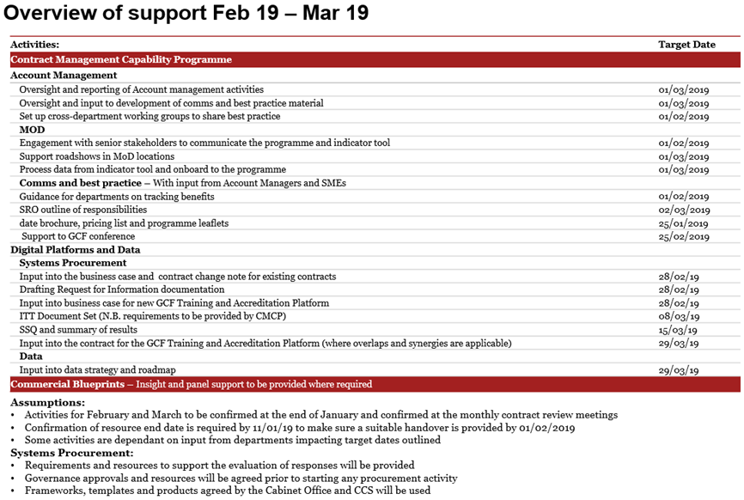
REDACTED
- Words and expressions in this Variation shall have the meanings given to them in this Call Off Contract.
- This Call Off Contract, including any previous Variations, shall remain effective and unaltered except as amended by this Variation.

- 12/08/2013
Signed by an authorised signatory for and on behalf of the Customer
Signature | REDACTED
Date | 05/03/2019
Name (in Capitals) | REDACTED
Address | REDACTED

Signed by an authorised signatory to sign for and on behalf of the Supplier
Signature | REDACTED
Date | 06/03/2019
Name (in Capitals) | REDACTED
Address | REDACTED

