Framework Schedule 2 (Framework Tender)
Supplier Framework Tender response

Response to Question 4.1: Mobilisation

Confidential between PA, IMPOWER, Council for Disabled Children, Olive Academies and DfE © PA Knowledge Limited 1

Mobilisation
Award Question Criteria 4.1 Weighting 20%
Maximum wordcount is 1500 words. Any words in excess of this amount will be redacted and not scored. Words within requested attachments WILL NOT count towards the wordcount stated above.
Our capability – we will mobilise quickly
Our consortium, Outcomes First, will mobilise quickly because we bring:
- The breadth and depth of SEND/AP expertise you require from day one. Our proven track record of managing national programmes and delivering high impact frontline change in SEND/AP (Figure 1) will support successful mobilisation by helping you anticipate risks and problem solve ahead of ‘go live’.

2. Unrivalled sector relationships and credibility that enables us to engage immediately and positively across the stakeholder spectrum, including parents and carers. We have worked with every Integrated Care Board and 70+ local authorities directly in addition to the relationships we have built through our support to national programmes.
3. A team with personal experience of the sector and its challenges and the passion and commitment to hit the ground running and make this work.
Response to Question 4.1: Mobilisation
Confidential between PA, IMPOWER, Council for Disabled Children, Olive Academies and DfE © PA Knowledge Limited 2

Our plan (Attachment 1) will enable the programme to mobilise rapidly and effectively by:
- • Investing in pre-mobilisation activities
- • Providing clarity on our expectations of DfE & LAs
- • Being prepared for the unique risks the programme faces and equipped with appropriate mitigations
Pre-mobilisation
We know that the Department has already begun to mobilise, and so have we.
We have proactively consulted LA Directors of Children’s Services/Inclusion, Parent Carer Forum (PCF) Chairs and national health system leaders on the potential opportunities and challenges and tested practical solutions. The top three risks we identified are:
1. Bandwidth – many local authorities reported feeling at their limits in terms of change effort – with some finding it hard to envisage how they can create bandwidth for the Programme. Similarly, PCF Chairs flagged capacity issues which could preclude their ability to facilitate meaningful co-production.
2. Inspection – concerns that inspections, some expected imminently, would ‘take out’ the system for an extended period.
3. Messaging – there were questions around how local areas could positively message the links with other programmes, such as Delivering Better Value and Safety Valve, to bring stakeholders along.

We have outlined the pre-mobilisation actions for the Department to consider in our attached plan. Whilst many of these are underway, we have highlighted them due to their importance in maximising traction and reducing the risk of delay. These include:
- • Confirming reforms for implementation and their readiness to commence delivery
- • Completing REP selection and ensuring clarity of roles and responsibilities with all participating LAs
- • Ensuring availability for key mobilisation events (DfE Implementation Unit and Delivery Partner Orientation and REP launches)

Mobilisation – including our requirements of DfE as the customer and Local Authorities
The key mobilisation activities take place over the first six weeks of Phase 1 and are shown in detail in the attached plan, including requirements of DfE for signoffs and meeting availability. The three priorities of mobilisation are:
1. Orientation - shared ambition and understanding between the Department and Delivery Partner.
Response to Question 4.1: Mobilisation
Confidential between PA, IMPOWER, Council for Disabled Children, Olive Academies and DfE © PA Knowledge Limited 3

2. Preparation – getting ready to drive Phase 1 at pace: preparing for REP kick off and Phase 1 delivery.
3. Launch – activating the programme with impetus and energy.

To achieve this, mobilisation is broken into four ‘sprints.’
Sprint 1 comprises four day-long sessions between us and the DfE over two weeks to ensure alignment and establish the foundations for the programme. The purposes of these sessions are below, with agendas shown in Figure 3.
1. Launching the programme plan
2. Establishing ways of working
3. Focusing on the reforms
4. Planning the ‘next 50 days’

All sessions will be collaborative throughout, and we anticipate leading delivery of sessions 1, 2 and 4, with DfE driving session 3. Each session we will validate the decisions and actions agreed and the agenda and further preparation inputs required for the following session.
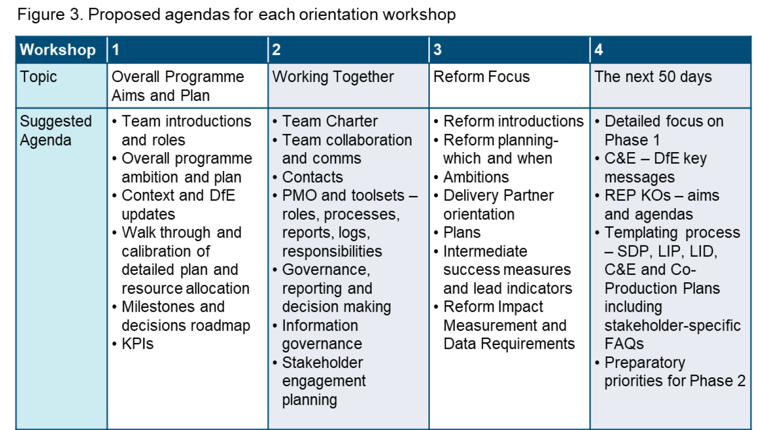
Response to Question 4.1: Mobilisation
Confidential between PA, IMPOWER, Council for Disabled Children, Olive Academies and DfE © PA Knowledge Limited 4

Our requirements of DfE in Sprint 1 are attendance of the Implementation Unit (IU) team at the four sessions, including co-delivery of session three and review and sign off the detailed plan, decisions roadmap, PMO tools and processes, KPIs and action plans.
The key outputs of Sprint 2 are a series of templates and REP guidance that provides the balance of resources to enable rapid progress while allowing for local refinement. These include:
- • Strategic Delivery Plans
- • Local Area Inclusion Plans
- • REP support needs assessments
- • REP Governance Terms of Reference

In Sprint 2, the DfE and Lead LAs will be required to input to and review all templates, with the DfE also required to provide approval.
Sprint 3 will provide Communication and Engagement and Co-Production Plan templates, tools, and guidance to equip REPs for the early communications needed to ensure effective co-production. DfE will be required to review and sign off the key messages and planning and templates and tools developed, while LA drop in sessions will provide opportunities to contribute to template development.
Sprint 4 will activate the programme through LA drop in sessions to ‘meet the delivery partner’ followed by individual REP kick offs. These sessions will further solidify relationships, create a collective understanding of the programme, and agree ways of working. REP participation is vital to the success of these sessions and the DfE will be required to notify them in advance and reiterate this importance. Response to Question 4.1: Mobilisation
Confidential between PA, IMPOWER, Council for Disabled Children, Olive Academies and DfE © PA Knowledge Limited 5

Our comprehensive and robust approach to managing risks
We will accelerate the process of identification of risks and mitigations by bringing a hypothesis based on our previous experience and then running a Capture, Assess and Manage process to confirm and refine.
We will use a single register to capture risks of all types, including reputational, timeliness and quality. Risks recorded will be assessed and monitored by an agreed risk owner and reported regularly to the Programme Working and Delivery Groups to agree actions and any required escalations. Assessment of the risk will reflect on its likelihood and impact to inform the appropriate response. Risks will be managed in one of five ways: Take, Terminate, Transfer, Treat or Tolerate (Figure 5).
Below we have set out the most pertinent risks to mobilisation and our mitigations.
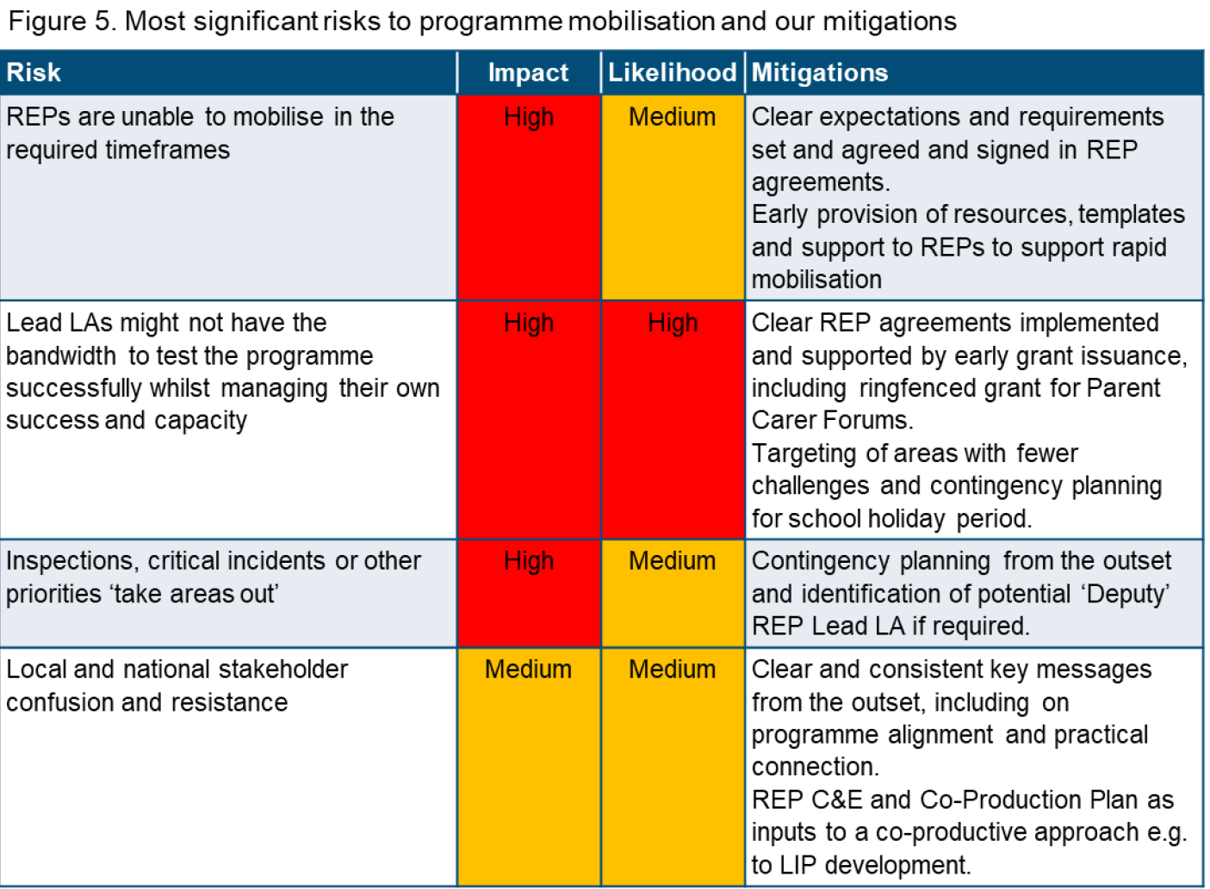
Our thorough approach to quality assurance and testing
We will co-produce an initial Quality Improvement Plan with you during mobilisation, reviewing quarterly. This outlines how we assure quality at Programme and Practice levels embedding a culture of continuous improvement through a Plan, Do, Review, Act model. These continuous improvement activities will explore opportunities for technology and automation, process.

Response to Question 4.1: Mobilisation
Confidential between PA, IMPOWER, Council for Disabled Children, Olive Academies and DfE © PA Knowledge Limited 6

enhancements, application of data and insights and are underpinned by our appropriate ISO quality accreditations.
We understand the threshold of ‘what works' and how to codify evidence-based learning. We have developed the ‘What Works in SEND’ website and the Effective Practice Evidence Framework meaning we have a calibrated framework for successful testing of reforms from the outset. We will incorporate a Rapid Cycle Evaluation (RCE) approach to support our feedback to DfE on the impact of the reforms. RCE is characterised by rapid testing and analysis, rigour, and flexibility. The approach incorporates review of interim data throughout the programme and enables real-time feedback to both DfE and the REPs on what is working and why. For instance, this approach would enable us to correlate emerging outcomes against different approaches to ordinarily available provision thus enabling DfE to ensure that the National Standards reflect evidence of best practice in the system.
Our approach to managing change has stakeholders at its heart
The SEND & AP system is complex. To achieve a change in behaviours requires a recognition that the motivations of such a complex and diverse set of stakeholders varies enormously requiring different methods. We will bring a hypothesis of what such a strategy would look like to refine with you.
EDGEWORK™ is a tried and tested theory of change which recognises this complexity and is aligned to the Department’s ‘test and refine’ approach. We will use the edgework approach to create a positive message for stakeholders, provide the energy and incentive to change, rapidly scale up where methods work well and drive resilience and sustainability so that this is not a one-off exercise.

Response to Question 4.1: Mobilisation
Confidential between PA, IMPOWER, Council for Disabled Children, Olive Academies and DfE © PA Knowledge Limited 7

We have incorporated this edgework approach (in which our people are trained and are expert practitioners) into our overall plan. For example, beginning with Reframing Ambition and facilitating a shared ambition in Phase 1, Unlocking People’s Participation through embedding co-production, and Driving System Performance in applying primed performance and agreeing measures of success.
Our approach to migrating data and information
Like us, the incumbent suppliers across related programmes (e.g., Delivering Better Value and Safety Valve) are motivated by making impactful change in the sector. Therefore, where data/information sharing helps, there will be a collective willingness to collaborate. For example, aggregating and sharing data across programmes would provide a more holistic view of themes and challenges, benefitting all who share. Where these opportunities exist, we will use the migration approach set out in Figure 8.
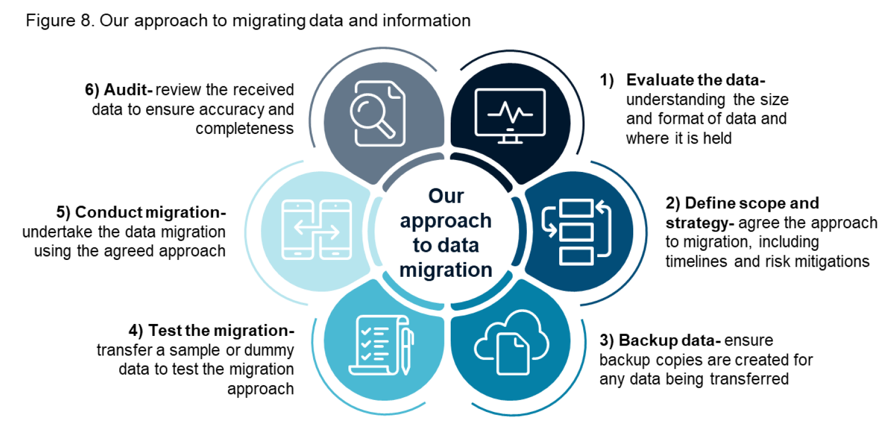
We know that mobilisation can make or break change programmes. We will accelerate mobilisation by taking a hypothesis-based approach; bringing pre-formed plans, strategies and risk assessments created by a senior team and informed by our experience in shaping SENDAP policy formulation. This means we need only to refine these during mobilisation rather than building from scratch.
Key
DfE activity
DfE and DP joint activity
DP activity
DfE sign off
X
Sprint 1-Programme Team Orientation
Milestone
X
Fortnightly Progress Reports
Fortnightly RAID Logs
Monthly / Quarterly Report
GB1
GB2
SEND/AP/HN Programme Board
National SEND/AP Improvement Board
GB3
CP Sub Programme Board
GB4
Local Implementation Unit
GB5
Delivery Group
GB6
CP Sub External Working Group
GB6
GB5
GB4
GB3
GB1
GB5
GB2
GB6
Sprint 2-Templating
Sprint 3-Communications and Engagement
Sprint 4-REP Kick-Off
Orientation Workshop 1-Programme Aims and Plan
Orientation Workshop 2-Working Together
Orientation Workshop 3-Reform Focus
Orientation Workshop 4-Next 50 Days
Programme Governance ToRDeveloped
Detailed Programme Plannning
Finalise and Share Reform Details
Implement Monitoring and Reporting Templates
Develop Strategic Delivery Plan Template
Review and Iterate Templates
Develop Local Inclusion Plan Template
Develop REP Guidance for Governance Terms of Reference
Develop REP Guidance for Support Needs Assessment
Develop REP Guidance for Reform Impact Assessment
Develop REP Data Baselining Guidance
X
REP Data Baselining
Ongoing Monitoring and Reporting
Rapid Cycle Evaluation and Project Dashboard Setup
Develop REP C&E Plan Template and Tools
Develop REP Co-Production Plan Template and Tools
Develop REP Kick-Off Resources
REP Kick-Off Sessions

Response to Question 4.2: Qualifications and expertise

Confidential between PA, IMPOWER, Council for Disabled Children, Olive Academies and DfE © PA Knowledge Limited 1

Qualifications and expertise
Award Question Criteria 4.2 Weighting 15%
Please limit your response to 2000 words excluding any requested attachments. Any words in excess of this amount will be redacted and not scored.
Our Consortium, Outcomes First, comprises leaders in the field of SEND and AP alongside experts in change management and strategic programme management.

Introducing our team
Our proposed team (Core and SME) has been selected based on the criteria (a-e in your ITT).
All future team members will be recruited using these criteria. We will provide an onboarding package for all new recruits to ensure consistent high-quality delivery across the programme. Response to Question 4.2: Qualifications and expertise
Confidential between PA, IMPOWER, Council for Disabled Children, Olive Academies and DfE © PA Knowledge Limited 2

All team members will be trained in EDGEWORK™, a tried and tested theory of change recognising the complexity of the SEND system and aligned to the Department’s ‘test and refine’ approach.
EDGEWORK™ codifies the capabilities – the strategies, competencies, tools and techniques – required to deliver change, with co-production and participation at the centre.

Underpinning each of the EDGEWORK™ capabilities is a set of practical 'inventive methods’. We have used these to shape our approach for this programme, e.g in the REP kick offs and Phase 1 activities we will be focussed on facilitating a shared or ‘inclusive ambition’ – and our team will deploy these practical inventive methods (Figure 2) to pre-empt and solve problems and de-risk reform delivery.
Collectively, key personnel in our team have:
- a. System Transformation and SEND/AP expertise within the last five years, we have collectively delivered various improvement programmes including with DfE and NHSE.
- b. Experience of working in a leadership capacity within SEND/AP systems (since Sept 2014), with several currently holding Director level roles within the sector.
- c. Track record in system transformation, delivering high impact frontline change within the SEND/AP sector and complex transformation for the NHS, DHSC and other government departments.
- d. Experience of engaging the full range of partners and practitioners with credibility, including parents and carers, delivering support and resources to local areas to co-design/produce services.
- e. Experience of challenging and supporting senior leaders across education, health and care with credibility. Our SME team includes Dame Christine Lenehan, Philippa Stobbs, Mark Vickers MBE and Jenny Coles, amongst other leading voices in the sector.
Response to Question 4.2: Qualifications and expertise
Confidential between PA, IMPOWER, Council for Disabled Children, Olive Academies and DfE © PA Knowledge Limited 3

Table 1 sets out our team’s specific experience and capability against the requirements a-e. We have also identified our additional skills that will be key to successfully delivering the programme.

Well-resourced service offering
We will deliver the programme using a hub and spoke delivery model - Figure 3.
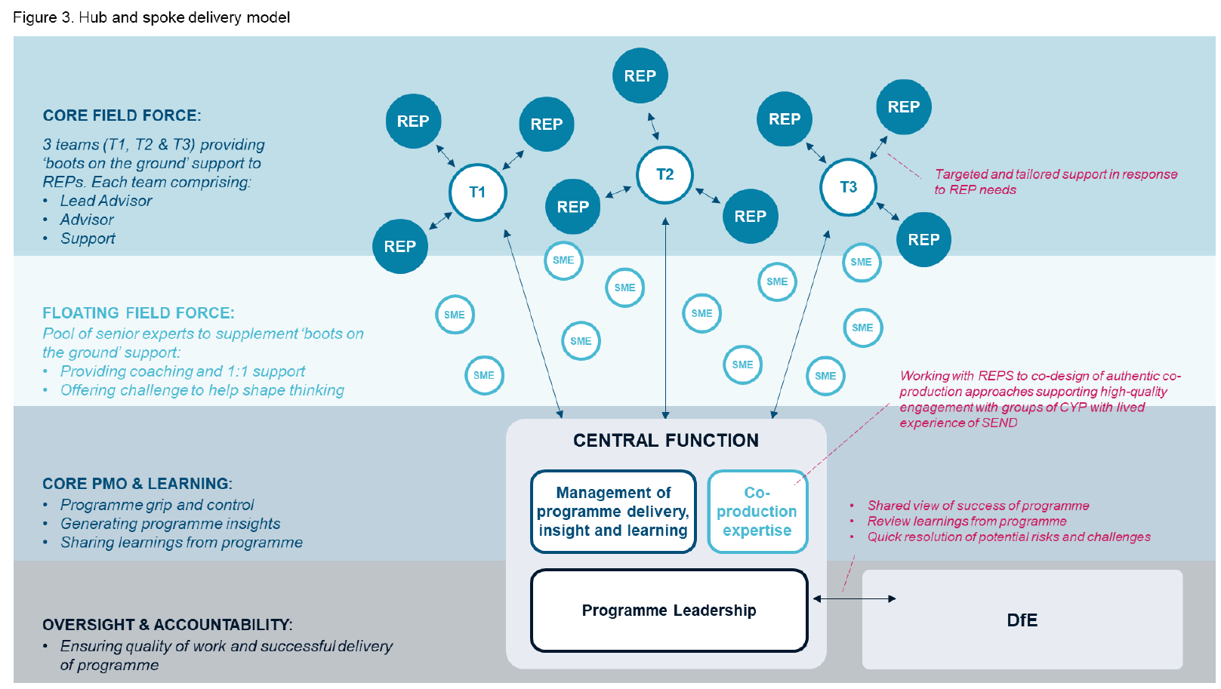
Response to Question 4.2: Qualifications and expertise
Confidential between PA, IMPOWER, Council for Disabled Children, Olive Academies and DfE © PA Knowledge Limited 4

We will provide additional added value to the REPs by providing targeted support to co-design authentic co-production approaches supporting high-quality engagement with groups of CYP with lived experience of SEND, as well as their parents/carers.
We will also create a paid internship role for a young person with lived experience of SEND. The role will be embedded in the Core PMO & Learning function and hosted by CDC who have a strong track record of supporting young people to progress at the beginning of their career. The post holder will receive structured wraparound employability and coaching support.
Managing multiple engagements to create a tailored field force
We will complete needs assessment for each REP in phase 1 based on the LIPs, using a template support needs assessment, signed off by DfE. These will be reviewed termly to ensure field force support is targeted and prioritised towards REP need. We will also agree appropriate governance, to ensure support can be quickly flexed as required.
Ways of working and engaging with DfE
This programme is about learning together. We bring significant expertise, but this programme will deliver better if we harness our collective expertise, including the sector and DfE to test and refine the reforms. Equally important, this programme to leave a legacy of sustainability. Our approach focusses on upskilling and training, challenging and supporting rather than simply ‘doing’ – leaving a system that is transformed and knows how to maintain and continue the process of improvement without the need for ongoing external support. Our programme plan sets out how we will do this in practice.

Response to Question 4.2: Qualifications and expertise
Confidential between PA, IMPOWER, Council for Disabled Children, Olive Academies and DfE © PA Knowledge Limited 5

As a starting point, we suggest spending a concentrated amount of time together in the first two weeks commencing 5 and 12 June. This will ensure we jointly have clarity about the aim and expectations for the programme and start to build trusted relationships.
We will agree a joint charter for working together based on a ‘no surprises’ approach. Colleagues from DfE will be invited to our informal weekly retrospective meetings where we will:
- • Review what went well
- • Discuss potential risks and challenges
- • Update forward work plans

Working in collaboration means issues are more likely to be raised and resolved quickly without needing to escalate.
Formal contract performance review meetings will take place monthly, focussing on progress against milestones and KPIs.
Training, development and managing performance
All members of the team working on the programme will be expected to maintain professional training as part of our commitment to CPD.
Specific programme related training will also be provided including:
- • Surgeries support on applying toolkits and templates to maintain consistently high-quality delivery
- • Quarterly learning circle for programme team to reflect on successes and challenges supporting knowledge transfer and upskilling of team
- • Project team online community of practice via the digital collaboration platform to transfer real time knowledge in between the learning circles

DfE and REP colleagues would be welcome to join training where relevant and would have access to best practice materials and 1:1 coaching with our experts.
We will ensure our core team members has a clear learning and development plan in place aligned to their programme role and personal goals. This will enable us to identify training needs and delivery approaches for the whole team.
Formal line management will be in place to manage individual performance of team members. We’ll also do informal check ins through weekly team meetings. The leadership team will undertake quarterly review cycles, seeking feedback from DfE colleagues and REPs to inform these reviews.
Our team profiles
See Attachment 3 for full CVs of our core team and details of our SMEs.
Response to Question 4.2: Qualifications and expertise
Confidential between PA, IMPOWER, Council for Disabled Children, Olive Academies and DfE © PA Knowledge Limited 6

Response to Question 4.2: Qualifications and expertise
Confidential between PA, IMPOWER, Council for Disabled Children, Olive Academies and DfE © PA Knowledge Limited 7

Delivery of programme
Award Question Criteria 4.3 Weighting 15%
Maximum wordcount is 1000 words. Any words in excess of this amount will be redacted and not scored. Words within requested attachments WILL NOT count towards the wordcount stated above.
Response to Question 4.3: Delivery of programme

We’ve tested our proposed approach with local areas and sector leaders (including parent carers). We will follow a three-phase approach after mobilisation: 1) setting up PMO and REPs for success; 2) deploying a field force and learning in real time; 3) building enduring capacity and capability in the REPS (see below).

Our detailed approach is provided in the accompanying attachments.
Phase 1: Set Up and Planning
Challenges: delivering at pace to meet key milestones; local areas not engaging due to competing pressures; running nine reform programmes in areas at different levels of maturity. We will address by:
1. Setting up the REPs for success

- • Diarise kick off sessions with REPs before contract start
- • Facilitate interactive workshops with REPs to maximise local ownership and ambition for the programme
- • Convene REP Steering and Core Groups to support REPs decision making

- • Assess baseline for REPs using a needs assessment framework – supporting allocation of ‘boots on the ground’ support in phase 2

2. Establishing strategic PMO/data insight function to provide rigour and visibility

- • Upskill local areas on PMO requirements, providing templates to drive consistency
- • Set up a single digital platform (Airtable, incorporating Power BI) to store and serve PMO reports, logs and impact analysis (LIDs and dashboards) allowing coordination and full visibility of programme performance data
- • Resource central PMO function to deliver across the two-year programme

- • Set up baseline and data dashboard ahead of Rapid Cycle Evaluation (RCE) in phase 2 (see attachment 6).

3. Designing and mobilising learning approach

- • Test shared learning design through kick off sessions with REPs and DfE
- • Develop initial Communities of Practice which will be used to drive sector learning and agree forward plan based on LIPs
- • Workshop with Implementation Unit (IU) team to stress test learning approach and confirm process for translating data into programme performance insight and policy decision-making.
Response to Question 4.3: Delivery of programme
Confidential between PA, IMPOWER, Council for Disabled Children, Olive Academies and DfE © PA Knowledge Limited 3

Key milestones achieved
Signed off LID/LIPs for all REPs by 31 August 2023.
Phase 2: Test and Refine
Challenge: maintaining similar pace of reform testing and refinement across the 9 REPs, whilst implementing a robust evaluation framework that gives DfE and the sector confidence that we know what works, why it works and how to scale. We will address this by:
1. Deploying a highly skilled field force

- • Tailor support to areas based on LIPs and support needs identified in phase 1. Our field force will:
- - Provide strategic and leadership challenge and coaching
- - Drive REP governance and reporting
- - Support co-production and facilitate co-design
- - Problem solve delivery risks
- - Collate, synthesise and codify learning for REPs and DfE
- • All team members will be trained in trained in EDGEWORK™ which is a tried and tested theory of change
- • Review support needs termly to ensure PMO, and field force support is continuously targeted and prioritised to achieve programme aims. Refine and agree with DfE the agile governance arrangements to support easy flex of field support in phase 1.

2. Establishing and maintaining the discipline of real time learning

- • Introduce RCE as part of real time learning approach through workshops with DfE and REPs so we can test and analyse rapidly, allowing reforms to be assessed, modified, and improved in real time.
- • Tailor the RCE approach to each reform, e.g., testing new AP models and practice will likely require joint local ambition setting and co-planning with commissioners, AP and school leaders as well as social care and health representatives.
- • Capture and analyse data centrally, allowing local reporting and central oversight of progress via dashboards (see Figure 2), allowing local & national leaders to make informed & insightful decisions
- • Start to build ‘reform delivery toolkits’ as a key repository and resource for REPs and LAs, in and beyond the programme
- • Stand up and support Expert Review Panels (ERPs) to present evidence, distil learning, and codify policy and practice recommendations
Response to Question 4.3: Delivery of programme

Confidential between PA, IMPOWER, Council for Disabled Children, Olive Academies and DfE © PA Knowledge Limited 4

- • Use the Effective Practice Framework and Signal Strength methodology (see Figure 3) to evaluate evidence presented to the ERPs. These will be tailored to this programme in conjunction with the IU team.
Response to Question 4.3: Delivery of programme

Confidential between PA, IMPOWER, Council for Disabled Children, Olive Academies and DfE © PA Knowledge Limited 5

- • Introduce ‘ThoughtExchange’, a survey and discussion management platform, to engage quickly with a wide range of stakeholders (see Figure 4) and provide qualitative insight to inform reform impact assessment

- • Capture key learning outcomes and products on the What Works in SEND (WWiS) Hub

3. Disseminating learning

- • Facilitate six ongoing Communities of Practice – incorporating strategic issues and reform specific topics
- • Provide easy access to learning and insight by publishing programme learning products on the WWiS site e.g., reform delivery toolkits, guidance and newsletters.

Kd 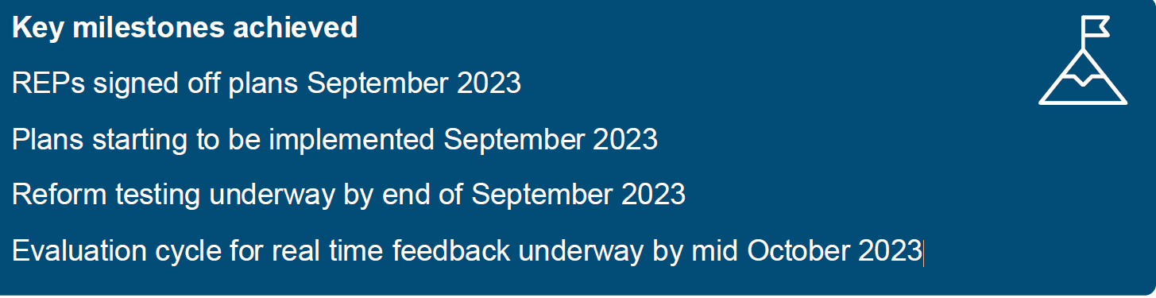
REPs signed off plans September 2023
Plans starting to be implemented September 2023
Reform testing underway by end of September 2023
Evaluation cycle for real time feedback underway by mid October 2023
Phase 3: Build Capacity & Capability Response to Question 4.3: Delivery of programme
Confidential between PA, IMPOWER, Council for Disabled Children, Olive Academies and DfE © PA Knowledge Limited 6

Challenge: ensuring REPs are confident and capable of delivering support to wider group of REPs. As we extend the areas, the rigour and evidence driven insight brought by the PMO could become diluted. We will address this by:
1. Adapting the PMO infrastructure

- • Prepare the PMO to receive new area progress and impact reports
- • Agree with you the ongoing reports and analysis ensuring we continue to provide proportionate yet sufficient assurance and oversight.

2. Use a target field force to ensure REP support readiness

- • Work with REPs to agree a menu of support options
- • Train REPs in how to support the new areas
- • Provide ongoing support and guidance to REPs in their support role

3. Facilitating and disseminating learning

- • Support REPS in forward planning and facilitation of CoPs targeting additional LAs to drive learning system-wide
- • WWiS fully launched in Phase 3 to drive learning system-wide, ensuring evidence is interpreted so SEND decision makers can use it
- • Use our well-established networks to disseminate insight and learning to build national SENDAP capacity, including:
- - 280,000 website users
- - 11,600 subscribers to newsletter/digest
- - 15,521 practitioners engaged across education, health, and care

KPIs
All proposed KPI percentage are accepted. We also propose KPI for establishing CoPs, 100% by 31/8/23.
Added value
We also offer significant added value by:

Client Engagement
The PA Assignment Manager (AM) will be the Consortium’s main point of contact with DfE and will be responsible for ensuring the objectives of the SEND & AP Change Programme are successfully delivered. The AM will ensure DfE is provided with visibility and clarity on the Programme’s evolution and progress, working closely with DfE counterparts to provide updates, feedback and promote a one team spirit.
The AM will act as the voice of consortia in supporting DfE on overall delivery matters and have close working relationship with the leads from each of Consortium partners, the Consortium’s Project Managers and rest of the delivery team.
We understand that the detailed definition of deliverables will be co-developed with DfE in the first three months. We will use our sector expertise to provide critical analysis and input to constantly refine and improve the Consortium’s approach in light of delivery. We will ensure the contract management regime will be fully suited to the SEND & AP environment and needs. Our reach back to this wider sector expertise will be utilised by the Programme through the AM.
The Contract Management Plan (CMP), and key documentation (such as Project/Programme, Risk Management, Governance, REP Engagement, etc), will be revised and validated with stakeholders in order to support the delivery for all three phases during this period.
The AM will work with DfE to establish the desired programme reporting, formats, frequency and mechanisms. We propose the following structure to initiate the first stage of engagement and adapt this as the programme evolves: Meeting | Frequency / Phase | Purpose
Kick-Off  Setup & Initiation | Daily / Weekly in mobilisation and phase 1 | Onboarding of programme delivery team, REPs, LAs, and other delivery stakeholders.  Confirm programme and project objectives, expectations, delivery options.  Set the programme initiation documentation, resourcing, outline plans, governance, risk management, reporting inc. KPIs and milestones, assurance, communications and reviews.
Performance Review Meetings/ Operations Board | Monthly | Review Delivery Partner performance and ensure that all parties are meeting their contractual obligations, KPIs review and reporting, milestone review and reporting. Review progress and value delivered against plan.  Review risks, issues, opportunities, threats, and resolution options.  Discuss preparations & planning for next stages/phases.
Change Control Meetings | As required | Review any changes to contract or scope of work, discuss impact of changes, negotiate terms (where necessary), and finalise any required documentation.
Dispute Resolution Meetings | As required | If any disputes arise, these ‘as-required’ meetings provide a forum to discuss, negotiate (where necessary), and agree a resolution.
Contract Closeout Meeting | Monthly starting from 3 months before the contract end date | Review end of programme final deliverables from all parties, ensure all contractual obligations and handover arrangements have been met, discuss any outstanding issues or concerns.
Counterpart Check-Ins | Daily / Weekly | DfE and programme delivery SMEs ensure close alignment, collaboration and ensure voice of DfE is always present.

Governance Structure
Through our experience of delivering many large and complex programmes we know that an effective governance model is key to the success of a programme. If programmes do not have effective governance, they can run out of control whilst those that are strangled by it often grind to a halt. We believe that the model described in this governance paper will give DfE the right amount of oversight and control whilst supporting the programme and REPs to deliver at pace.
An Overview of the Proposed Governance Structure
Effective decision-making boards provide assurance and are a point of escalation that help clear blockers out of the way of a programme. The diagram below shows the layers of boards and meetings and details the different governance meetings and cadence required to ensure effective delivery with clear communication between teams and early escalation as required. Our management information and reporting will provide a single source of truth to facilitate effective decision making across the Programme.

Based upon the governance requirements and structure set out in the ITT, we propose the following structure for non DfE led boards/meetings

Board/Meeting | Purpose | Chair | Frequency | Membership
Operations Board | To review the contract deliverables and contract performance including KPIs, milestones, identified opportunities, the invoicing schedule, risk and issues to performance | DfE contract manager | Quarterly | DfE and Deliver Partner (DP)
Change Programme External Working Group | To provide central team update, review progress of LAs (LIPs/LIDs/RCE dashboard), ensuring effective delivery of the programme plan milestones, identify areas of improvement and plans to address these, discuss top level risk/ issues/blockers and where required escalate to Delivery group. | Delivery director/  Programme director | Weekly | 9 x REP Leads and Delivery Partner
Delivery Group | To review programme level plan, unblock issues; review progress against key milestones; provide policy steers; share monthly reporting and preparation for Programme Board | Delivery director/  Programme director | Monthly | DfE policy and Delivery Partner
REP Senior Leadership Steering Group (SLSG) | To provide effective monitoring and reporting to DfE with robust challenge and support to both local areas and DfE teams to maintain delivery against agreed milestones and timelines | REP lead DP or local REP lead | Monthly | REP and relevant LAs, PCF Regional representative, DCO's
To provide additional value, we recommend including the following boards and meetings into the governance structure
Board/Meeting | Purpose | Chair | Frequency | Membership
Challenge panel | To provide check and challenge from RIIAs, LGA, health on our approach and update from DP on the progress of the programme | Delivery director/  Programme director | Monthly | REPs, LGA, RIIAs, LAs, ICB Exec Lead for CYP, NHS E Regional Lead for SEND, NNPCF Chair
Expert Review Panel | To present and discuss reform testing evidence and learning, and the implications / options for policy to be considered and where appropriate recommendations to be drafted in readiness for delivery group and Programme board | Learning Function Lead | Half Termly | Delivery Partner, DfE(Implementation unit and representatives from funding, policy, regional)
Delivery Core Group (one Core Group for each key reform focus) | To define plans, problem-solve delivery, capture progress and learning, and report to Steering Group, Issuance of updated delivery toolkits, including co-production learning / guidance / tools and templates | REP or LA representative | Every 3 weeks | Dependent on the reform, members could include PCF Regional representative, DCO's
RAID Review | To review risk, issues, blockers and agree on ratings (impact/probability) and which need to be flagged at Delivery board | Programme PMO  Or,  Regional PMO | Fortnightly | Programme level  DP Reps leads  Regional level  REP leads
Daily huddle | A regular progress check-in, enable collaboration and unblock issues | DP Rep lead  Or,  REP lead | Daily | Programme level  DP Reps leads, REP support, PMO, Learning function, programme leadership. Optional attendance DfE  Regional level  REP leads and as required by REPs. Optional attendance from agencies.
Forward Plan of Key Decisions
We want to work with you to foresee the decisions that need to be made.
Requiring DfE sign off at Programme Board | Sign off date
Robust management controls and management information are agreed e.g. a programme plan/implementation plan, risk management and reporting dashboards for REPs | Mid-June to enable the controls to be in place by 1st July 23
Sign off an exit plan | August 23
A mechanism or framework for sharing real time feedback across all the members in the Programme is agreed | 30th Sept 23 to ensure it is in place by 31st Oct 23
A mechanism for shared learning is agreed | 31st Dec 23 to ensure it is in place by 31st Jan 24
Sign off menu of support options | 31st Dec 23 to ensure it is in place by 31st Jan 24
Monthly forward look of national events is agreed | Monthly from Dec 23 to July 25
Monthly reports on programme progress to support the continuous feedback loop, providing the department with real time insight | Monthly from July 23 to Aug 25
Quarterly evidence-based reports on learning from REPs to support dissemination of learning to the sector | Monthly from Sept 23 to Aug 25
Milestone 1 sign off: All REP and LA LIPs have been signed off | 31st Aug 2023
Milestone 2 sign off: REPs will implement signed off plans and start to test policy reforms | 1st Sept 2023
Milestone 3 sign off: The delivery partner will create and commence a mechanism/forum for sharing real time feedback. | 1st Oct 2023
Milestone 4 sign off: The delivery partner will develop a menu of options with REP’s and identify where that support should be targeted | 1st Jan 2024
Milestone 5 sign off: The delivery partner will create and commence a mechanism/forum for sharing programme learning nationally and across all of the system, delivering regular events/webinars as agreed with the department | 1st Jan 2024

Our assessment of the key risks to the delivery of a successful change programme, and how we would mitigate or manage such risks. The table below lists what we consider to be the key risks and mitigations: There is a risk that… |  | Impact |  | Likelihood |  | Proposed mitigation/management
1. | Lead LAs might not have the bandwidth to test the programme successfully whilst managing their own success and capacity |  | Phase 2 testing on the Programme and/or current day to day performance of the LA will be compromised |  | High |  | Clear REP agreements implemented and supported by early grant issuance, including ringfenced grant for Parent Carer Forums.  Targeting of areas with fewer challenges and contingency planning for school holiday period.
2. | REPs are unable to mobilise in the required timeframes |  | Knock-on delays to the whole programme |  | High |  | Clear expectations and requirements set and agreed and signed in REP agreements.  Early provision of resources, templates and support to REPs to support rapid mobilisation
3. | The gaps in SEND support between high performing areas and low performing areas may initially increase |  | Parents/carers and other keys stakeholders may be less committed to providing support into the Programme |  | High |  | Through our insights hub we will have access to real time data to understand any differences, and this coupled with the skills and expertise within our REP support you can be confident that we will work to minimise the gaps.
4. | LA lead will not have the authority/levers to influence supporting LAs |  | Reduced commitment to testing the reforms and extended timeframes for delivery |  | High |  | We will ensure the REP leads and their LAs are part of developing wider messaging about the Programme’s motivation in delivering outcomes first for children and YP.
5. | Health may not engage despite REPs being in ICB regions |  | Reform testing and implementation will be less effective |  | Medium |  | Early engagement with health and inclusion on the REP steering groups and challenge panel. We will also ensure the ICS responsibilities are explicit with the “contract” and that it is signed by the relevant ICB.
6. | Inspections, critical incidents or other priorities ‘take areas out' |  | Knock-on delays to the whole programme |  | Medium |  | Contingency planning from the outset and identification of potential ‘Deputy’ REP Lead LA if required.
7. | We will not have enough time to set up the appropriate measures/testing plans because we will not have certainty on the reforms the REPs will be asked to test |  | Testing and implementation of reforms will be inconsistent |  | Medium |  | We will develop a template testing plan which can then be localised and tailored with the core groups once the reform guidance has been shared.
8. | There is local and national stakeholder confusion and resistance |  | Stakeholders do not buy into the Programme, reforms are not implemented consistently and the Programme is not perceived as a success |  | Medium |  | Clear and consistent key messages from the outset, including on programme alignment and practical connection.  REP C&E and Co-Production Plan as inputs to a co-productive approach e.g. to LIP development.
9. | Phase 3 reform implementation is not as successful once the REPs take the lead |  | Overall aims to consistently implement the reforms across England will not be realised |  | Low |  | We will retain oversight of the progress on implementation through regular reporting into the PMO& data and insights hub. This will allow us to 'red flag' any areas for concern which can then be escalated to DfE.
10. | Child harm and/or abuse occurs, directly or indirectly, through the interventions brought about by the programme |  | Personal suffering from person receiving abuse and their family/friends, and reputational damage for the programme and its partnership |  | Low |  | Safeguarding included in onboarding training; tailored input and sense checks from our team of leading safeguarding and child protection experts (team and sme); and a standing item at REP team, PMO and Leadership meetings
11. | Staff sickness / absence impacts on the ability of the Delivery Partner to deliver work |  | Delays to implementation and/or inconsistent implementation of reforms |  | Low |  | Our consortium spans four organisations, with access to over 4000 delivery staff, enabling us to flex and redeploy resources easily. Each organisation has a Business Continuity Plan and we have established a joint approach to Business Continuity to ensure that risks to project delivery in relation relating to his programme are identified and mitigated early on.
12. | The Delivery Partner cannot access sufficient in-depth SEND / AP skills and expertise to support effective delivery of the programme |  | Additional burdens are placed on REPs, resulting in delays to implementation and/or inconsistent implementation of reforms |  | Low |  | Our consortium brings together significant specialist SENDAP skills and expertise with a track record of working both with DfE and local partners. We have access to an unrivalled pool of expertise.
13. | There is a duplication of effort/ lack of consistency resulting from multiple REP Cluster Teams supporting multiple REPs |  | Testing and implementation of reforms will be inconsistent |  | Low |  | Our PMO approach will ensure resources are deployed effectively, and that there is consistency (and efficiency) in the tools and methodologies we develop and deploy.
14. | The programme is not aligned with other ongoing programmes such as SV, DBV, RISE, SLIPs, RIIAs, ADCS networks etc. |  | Critical data inputs to support testing may be missed |  | Low |  | We understand the various different in-flight programmes and stakeholders that will provide critical input into the SEND & AP change programme. We will utilise existing relationships to join up the dots between programmes through setting up structures which ensure alignment and knowledge flow. We will also develop “Page one” messaging on strategic alignment and synergy across programmes, and on practical connection
15. | There is insufficient focus on benefits and impact tracking |  | Limited learning to support wider roll-out of the reforms |  | Low |  | Our REP Cluster Teams will work quickly to establish baseline metrics and tracking approaches, and link in effectively with the wider evaluation of the programme.
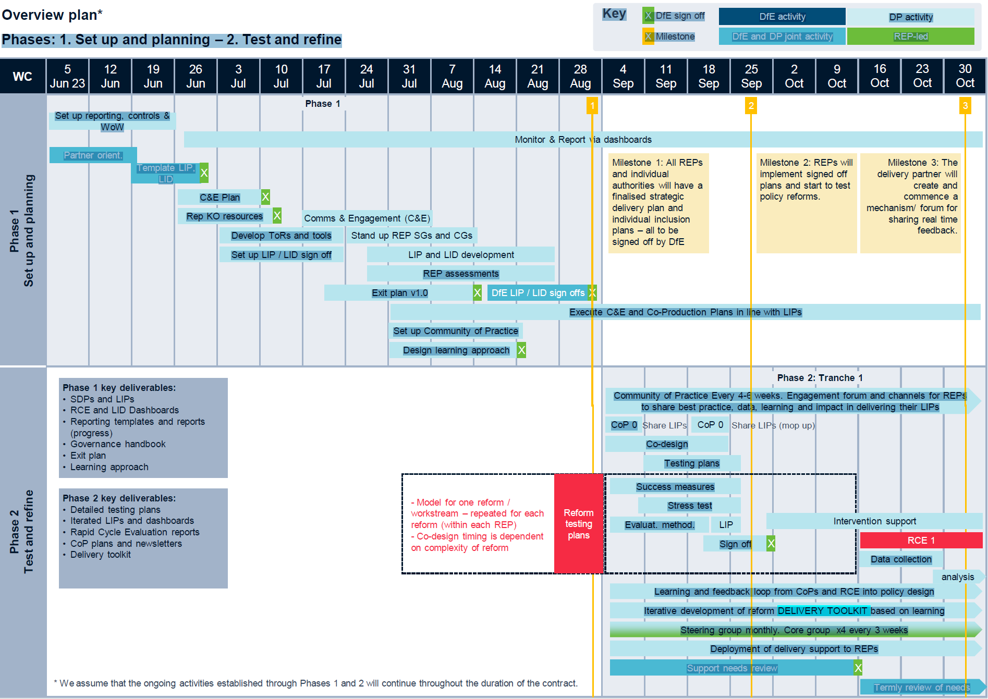
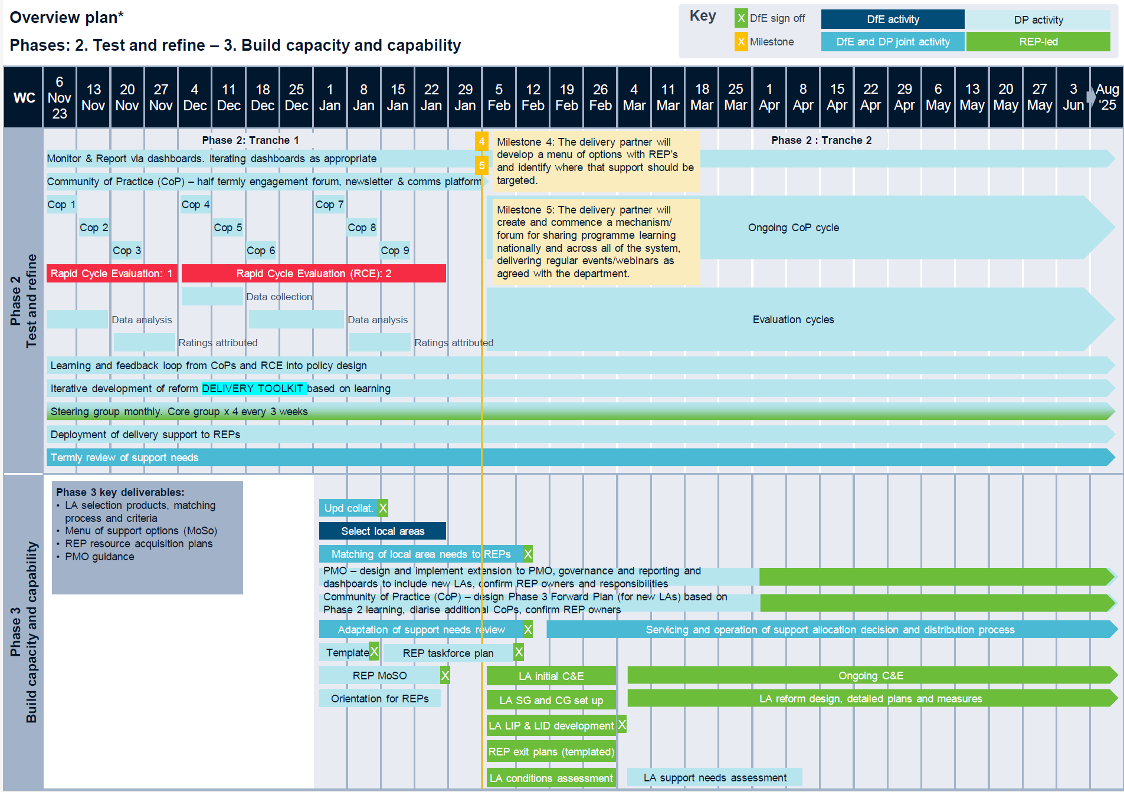

1 General principals
PA’s detailed Business Continuity Plan is attached for your reference, and we will enhance this specifically for this work.
The purpose of this document is to set out the BCDR policy and a framework of procedures and guidelines for effective business continuity management across all sites, recognising that it will not always be possible or practical to prescribe a response for every potential scenario, with the business continuity preparing for an incident and the disaster recovery the approach to resolving the incident and returning to business as usual (BaU). This document will be reviewed every 6 months, following the formal date of issue, or as frequently as required to respond to changes in the prevailing business environment.
Responsibility for reviewing and updating this document rests with the Delivery Partner. Responsibility for reviewing and updating Business Continuity Plans and Business Impact Analyses plans rests with the Delivery Partner and DfE. The Delivery Partner is responsible for ensuring plans are in place, that they meet the standards described in this document and that they are reviewed periodically. The validation process should take place in conjunction with a full review of this policy and any supplementary assignment/office Business Continuity Action Plans. The objective of the validation process is to: Identify elements of direction and guidance which require refinement or further clarification, consider and determine improvements, put each measure to the ‘what if’ test, and produce, as necessary, a revised version of the policy and/or a revised version of area-specific plans.
The 4 key components of the BCDR are:
Resilience: Core business functions and the supporting infrastructure are designed, engineered, and maintained in such a way that they remain materially unaffected by most business disruption events. Resilience is the capacity of an organisation to deter, remain unaffected or minimise the impact of a business disruption event which might undermine business continuity. Depending on the disruption scenario, business continuity planning may involve some of the following measures: Pandemic: Mass immunisation; pre-planned homeworking (with additional remote working capability). Severe weather: Access to alternative work premises or a period of remote working. Public utility failure: Sourcing of alternative power generators, water, and sanitary facilities. ICT network failure: Network defences, regularly updated; off-site backup; network access controls; controlled access to server rooms, firewall and intrusion detection. Damage to property: Physical barriers and access control; duplicate copies of key information or data held in a separate location.
Recovery: Arrangements are made to recover, restore or duplicate core business functions that have been affected by a business disruption event. The principal objective of the response to, and recovery from, a business disruption event is that it is timely and proportionate and that: the disruption is contained, and recovery of normal operational functionality is achieved as quickly as possible and at minimal cost to the business.
Contingency: Putting in place a dedicated ‘reserve’ capability, such as quick access to alternative office space and workshops, for activation in the event of a business disruption event. Contingency measures include maintaining liaison with providers of rented office space so that alternative office space can be acquired (and fitted out) at short notice and having access to specialist sub-contractors, in the event that people are out of action.
Communication: achieving a standardised and expected flow of communication throughout the event. Measures include under no circumstances must an incident be discussed on any social media platform unless you have the authority to do so, Communication will be managed by the (Incident Management Board (IMB), standardised contact practices.
2 Business Continuity
The objective of the business continuity planning is to establish and maintain a realistic level of ‘resilience’, put in place, or have timely access to ‘contingency’ resources and be able to respond and recover as effectively and efficiently as possible if a business disruption event occurs. A Business Continuity Plan is the documented procedures that guide the company to respond, recover, restore, and resume to a predefined level of operation following a disruption. A business disruption event is any event – natural, accidental, deliberate or otherwise – that has an adverse impact on the core business functions and/or key dependencies, and which may prevent business from being carried out as normal. Business Continuity Plans are typically enacted to achieve ‘business as usual’ at the direction of the Incident Management Board. It therefore follows that a disruption to normal business has occurred, and remedial action is required following an incident. The focus is to ensure core business functions continue when faced with a business disruption event. Core business functions are the operations and activities that are critical to the smooth running of the Programme. Suppliers are responsible for developing, maintaining and exercising functional Business Continuity Plans. Every staff member is responsible, at an individual and collective level, for remaining alert to the possible impact of a business disruption event or continuity issue and is required to report any concerns as soon as possible; in the first instance to their line manager and relevant organisation’s named member of the IMB, who would then escalate to the IMB as required, and ultimately to PA’s Head of Operational Risk.
At an organisational level, business continuity planning requires a holistic, bottom-up approach to be effective. This requires each group to have in place an up-to-date Business Impact Analysis and Business Continuity Plan that addresses the specific risks and threats that the teams and offices may be susceptible to. Business impact analysis is the process of determining the extent of the impact of a business disruption event upon core business functions and key dependencies. This analysis is a primary driver for business continuity preparation, planning and prioritisation. Specifically, each analysis requires consideration of the respective functional operation and its dependencies, the potential impact of business disruption events on activities and tasks, the need for proportionate contingency measures (e.g. alternative workplaces), how to remain aware and alert to possible disruption events and respond appropriately, the potential impact on other stakeholders (this includes external stakeholders such as clients and suppliers, as well as internal stakeholders such as Real Estate and Group Systems).

Response to Question 4.3: Business Continuity Disaster Recovery Plan

The principal roles in business continuity are set out in the table below, along with their responsibilities. While some activities may be delegated, the person in each role remains accountable for compliance with this policy.
Role | Key Responsibilities
All staff | Ensure all contact details are correct, including personal numbers and address. Ensure the incident is reported on discovery to the Head of Operational Risk as well as their line manager and IMB representative.
Staff working with young people | Should ensure that disaster recovery processes are recorded in offsite risk assessments and their whereabouts are known by at least two people within the business.
Line Managers | Ensure all team members understand their responsibilities and liaise with them if BCDR is enacted to account for whereabouts.
Incident Response Team | Assumes responsibility for managing the incident at the operational level. Determine appropriate actions and recommendations to the Incident Management Board.
Incident Management Board | Provides strategic direction and holds ultimate responsibility.
3 Disaster recovery
To invoke BCDR the Incident Management Board (IMB) would need to be convened. The IMB is made up of members of the management team (see table below). In the event of some members being unavailable their pre-defined deputies would be called to the board.
Company | Member Name and contact details | Member back up and contact details
PA | Partner - Amanda Kelly  Amanda.Kelly@paconsulting.com  07971 857 991 | Head of Operational Risk – Lawrence Ward  operationalrisk@paconsulting.com and lawrence.ward@paconsulting.com  07818 578 415
CDC | Head of People and Culture – Heather Devine. hdevine@ncb.org.uk 07432 739037 | Deputy Director – Dan Oaker doaker@ncb.org.uk  07950 688 722
IMPOWER | Delivery Director, Operations – Caroline Throssel  Cthrossel@impower.co.uk  07580 047692 | Chief Finance Officer – Vikki Mickel  Vmickel@impower.co.uk  07790 882 296
OLIVE ACADEMIES | Deputy CEO – Adam Tedesco  adam.tedesco@oliveacademies.org.uk  07990 040387 | CEO – Mark Vickers MBE  mark.vickers@oliveacademies.org.uk  07990 040390
Execution of a functional Business Continuity Plan is likely to follow an incident and there could be a direct request to enact it from the Incident Management Board. In the event of an incident that disrupts or is predicted to disrupt normal business as usual (BaU), the Incident Management Board would request the Business Continuity Plan is enacted or on standby respectively, and an appropriate person appointed to oversee its execution. In the event of invocation all staff members would be contacted as far as possible using e-mail land lines and mobile phones. If mobile and phone networks are unavailable staff should assume invocation of the BCDR plan until informed otherwise. If the offices are unusable, office-based staff would be advised to work from home. Staff are expected to carry on their duties as per normal operations. During this time communication with staff would be via mobile phones. Staff members distribute their mobile numbers to clients as a matter of course. Communication with staff during this time is critical and would be carried out through all the channels that are still available. The IMB will continue to meet until it is deemed that business function is sufficiently capable of acting as if in normal operations. There will be a time lag between the incident and the data being restored and available. During this time staff will be expected to use client e-mail addresses or internet accessible e-mail addresses such as hotmail or gmail.
Please see the risk register to understand the business continuity risks that might impact on successful delivery of the programme, and our plans to reduce the likelihood and mitigate the impact.
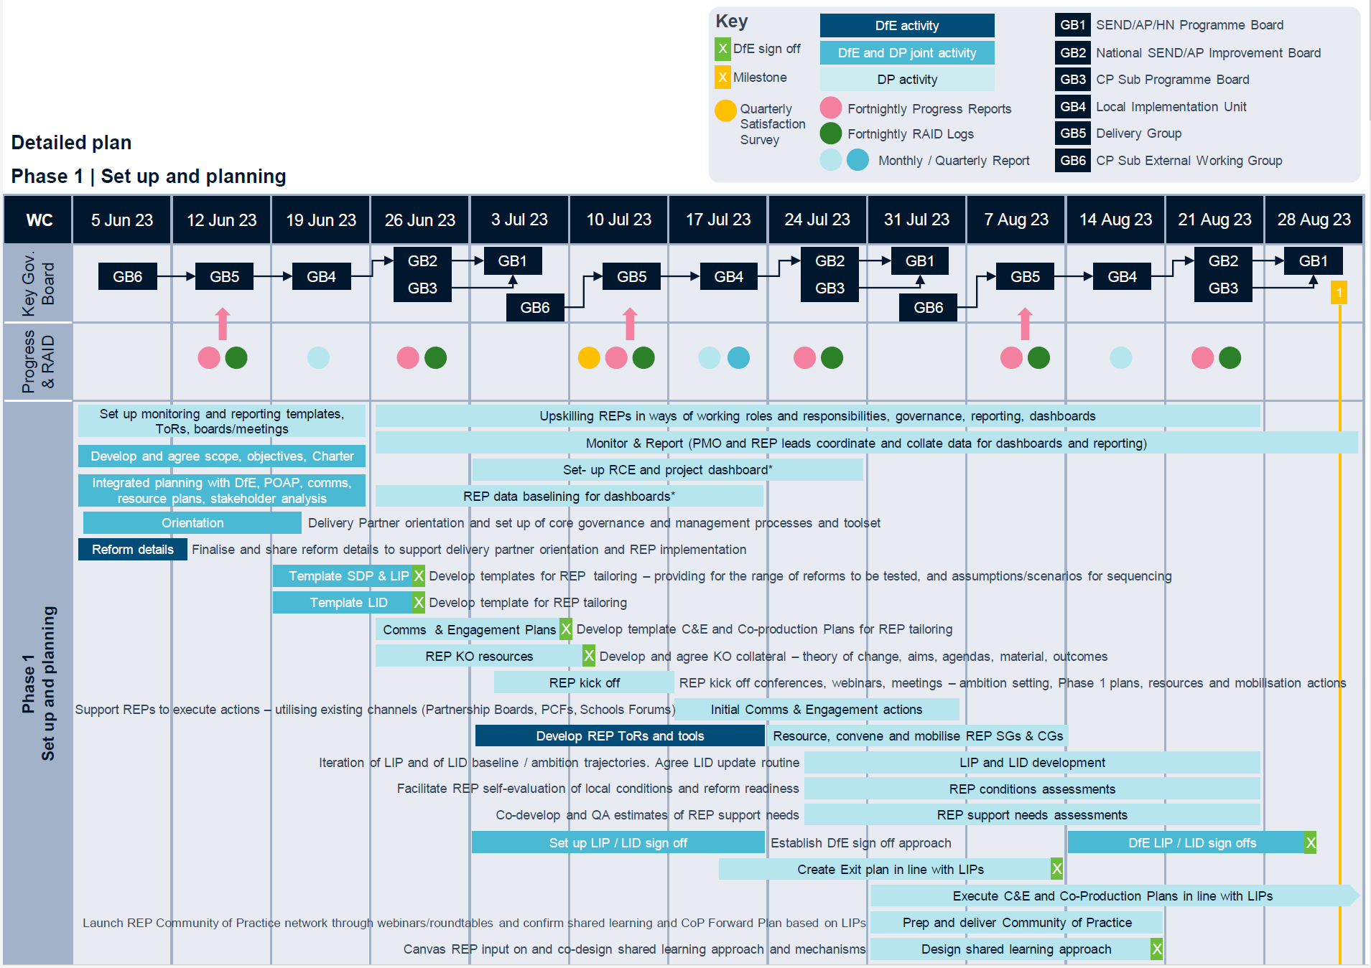
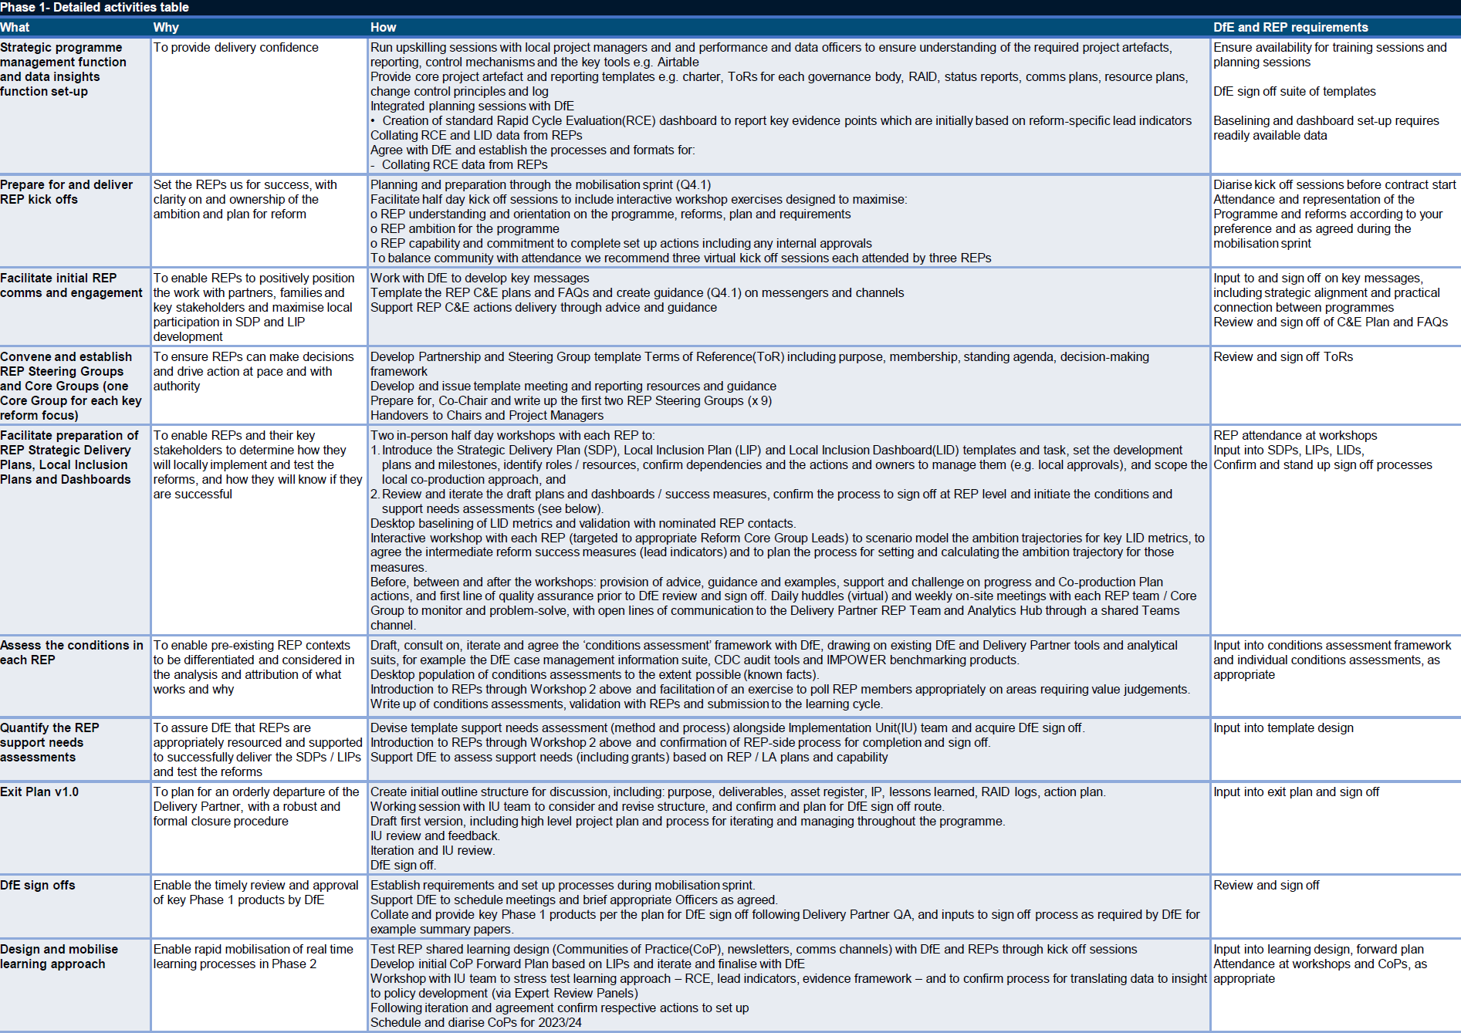
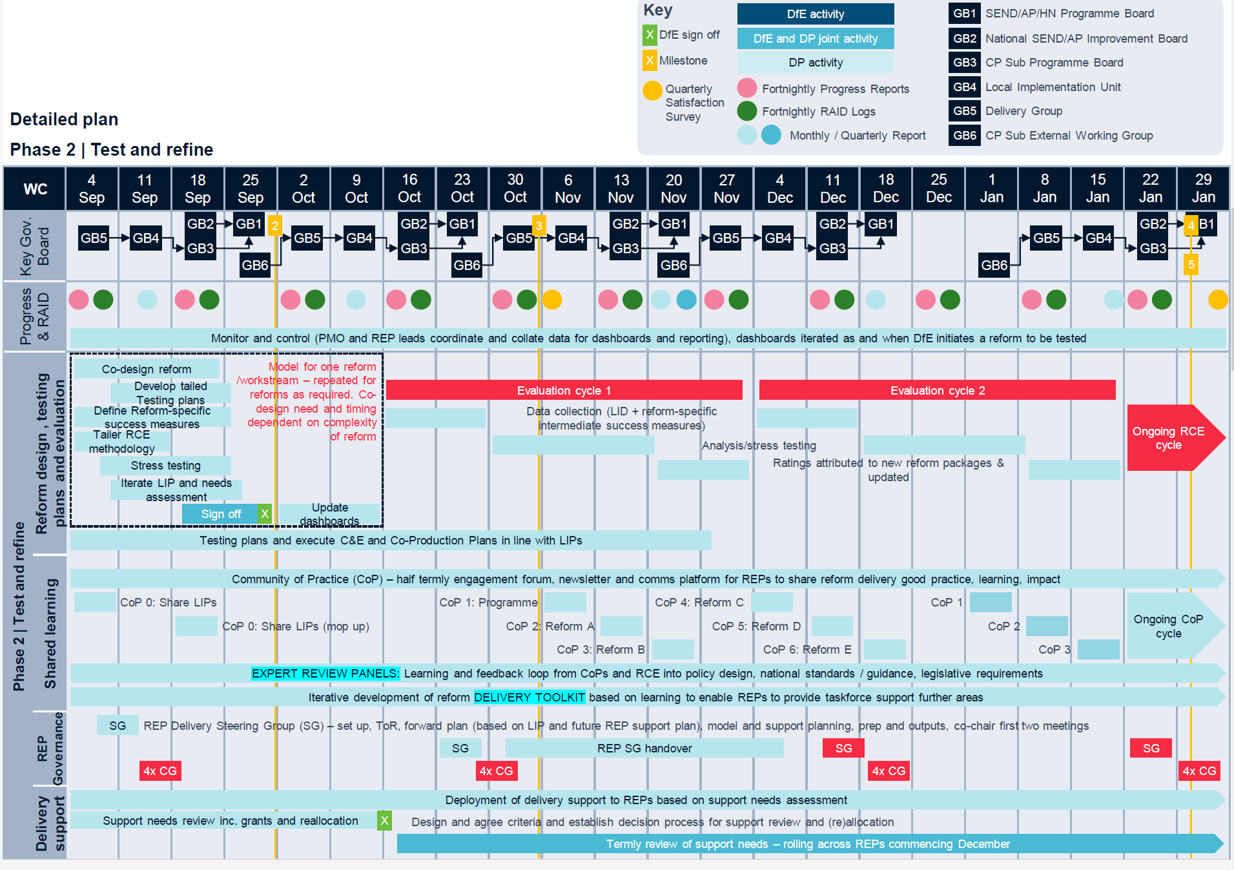
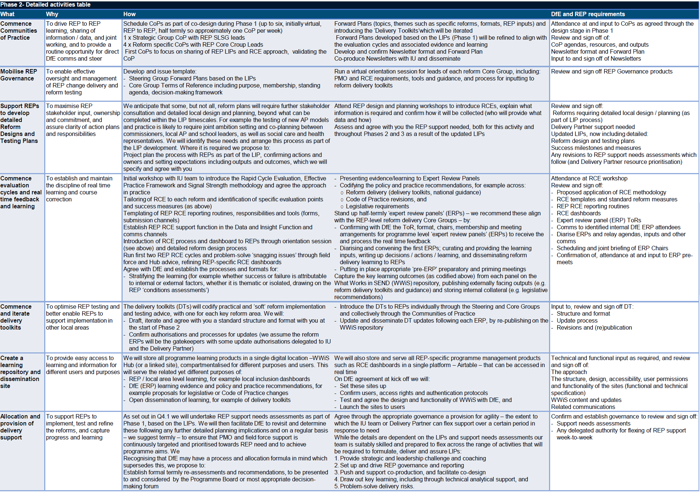
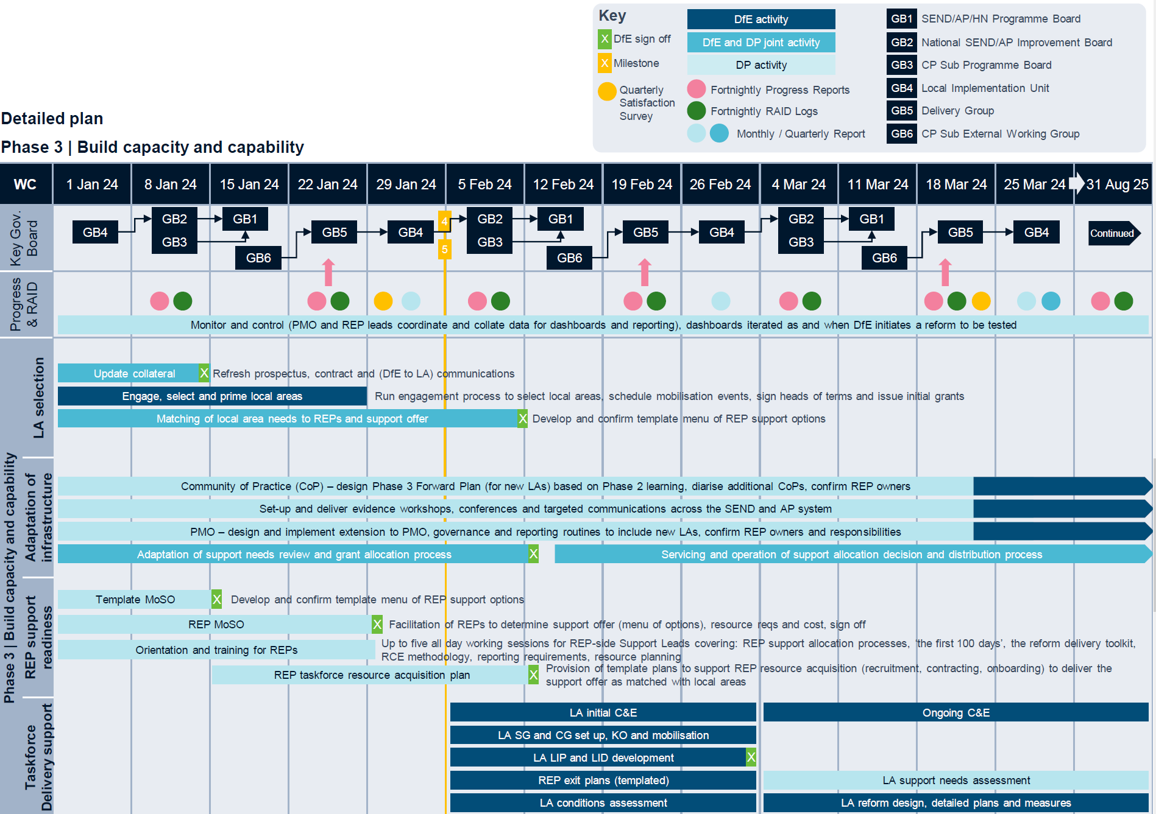
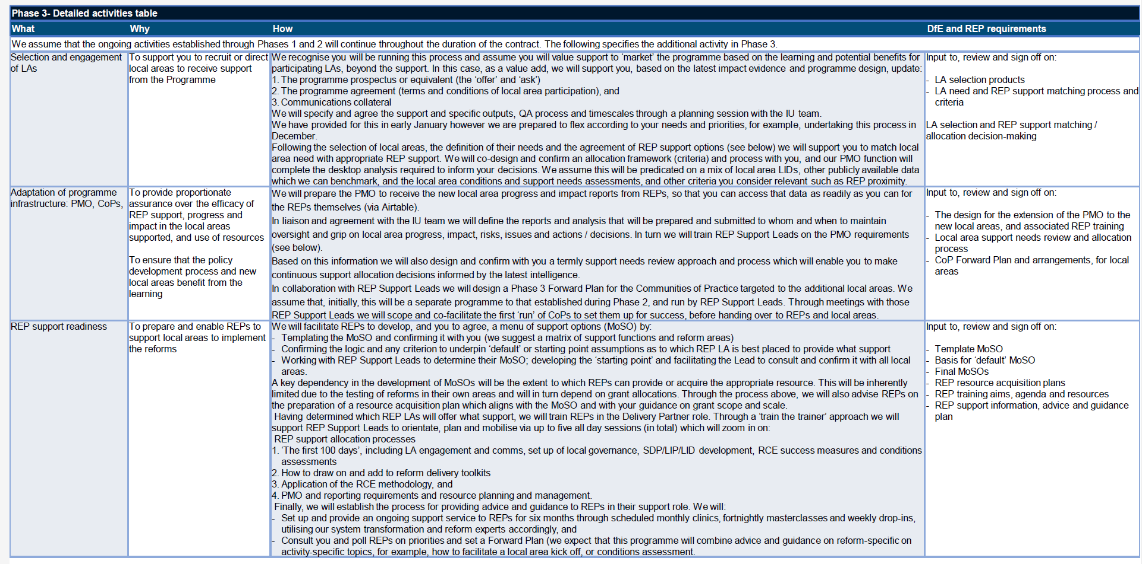

Response to Question 4.4: Quality Assurance

Confidential between PA, IMPOWER, Council for Disabled Children, Olive Academies and DfE © PA Knowledge Limited 1

Introduction
This response sets out how we will ensure that the service meets customer and stakeholder needs whilst maintaining consistent quality and meeting prescribed milestones.
To deliver we will:
- • Build on existing relationships with relevant stakeholders to accelerate engagement and ensure well-informed recommendations
- • Proactively manage issues to maintain quality through robust procedures and effective resolution
- • Ensure you have the right information at the right time using proven contract management and performance processes
- • Identify, record and recommend continuous improvements to the support offer
- • Anticipate and manage customer queries, ensuring a timely response
- • Deliver a mixed channels and methods communication model, recognising different stakeholders’ preferences and priorities
- • Maintain quality and satisfaction by formally and informally tracking customer feedback and taking forward recommendations

Accelerated stakeholder identification and on-going collaboration
Our wealth of stakeholder engagement expertise and experience of large-scale programme delivery means we know successful, impactful and results driven engagement is about more than the methodologies and tools. What really matters is actively engaging and listening, to develop trusted relationships and collaboration. It is why 70%+ of our effort will focus on better facilitating the ability to co-produce, test and refine key reforms through direct REP engagement.
Using our strong, well-developed networks, nationally and locally, into the three statutory agencies (education, health and social care), as well as schools and Parent Carer Forums and Groups will accelerate improvement planning through the programme. During mobilisation, we will run a programme wide stakeholder identification workshop to build out the mapping in Figure 1 and develop a customer universe baseline for different players in the system and their improvement factors.
These stakeholder universes will help ensure improvement planning has customers at its heart, with understanding of what impacts customers perspectives, decisions and behaviours. They will provide a clear framework for improvement plan focussed engagement.
Our relationships and understanding of the changing nature of these statutory systems, mean we can quickly build trusted engagement and communication around key messages that:
- • This programme will recognise the strengths and limitations of each agency and we will work decisively through these conditions to deliver change
- • We understand the health system and can cultivate a pathway that enables it to engage and fulfil its duties, including the statutory 4th objective for ICSs to promote broader social and economic development
- • We understand how key schools are to successful delivery and will embrace the potential of change
- • For parents, carers, and young people, we are committed to engagement and coproduction and will model that in how we behave, creating open communication platforms and being clear that the change we are trying to make has better outcomes for children and young people at its heart
- • Consistent outcomes may require tailored support so in each REP we will look at the best models for engagement and coproduction

Our approach to stakeholder collaboration shown in Figure 2 ranges from engaging diverse users and aligning on system change priorities.
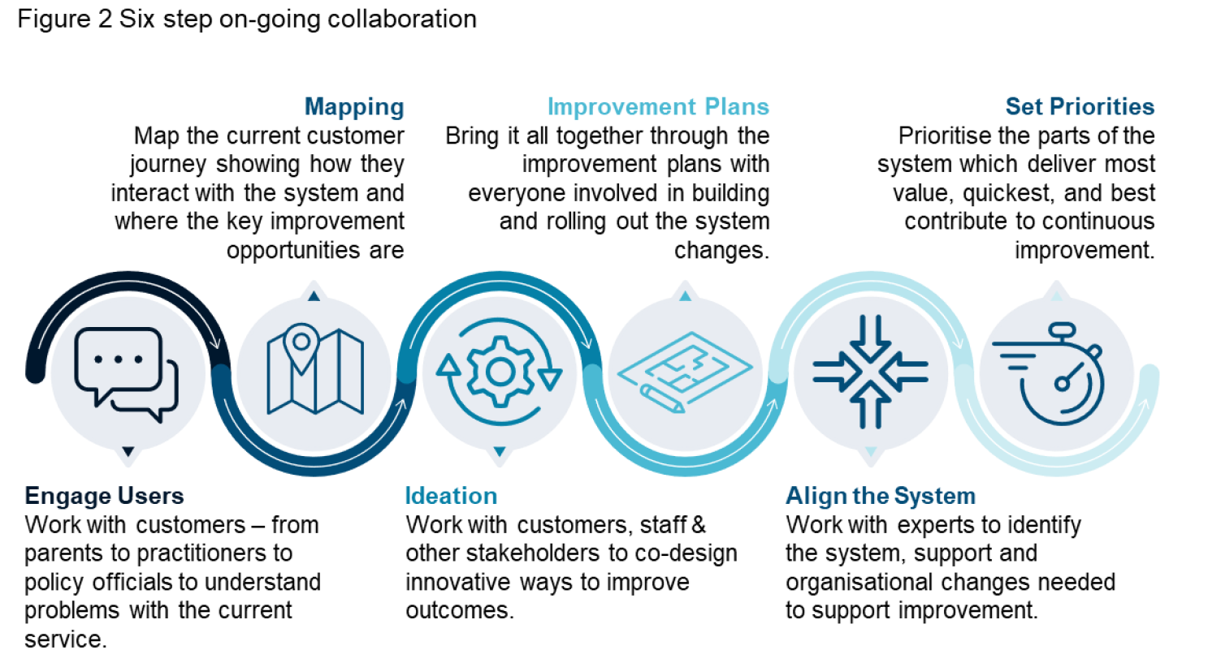
We bring:
- • Existing SEND and AP understanding, meaning we know who and how to engage
- • Existing relationships and contacts including parents, carers, children and young people groups, strategic leaders, frontline professionals, voluntary sector representatives, local authorities, and cross-government civil servants.
- • Expert networks and associates, including those involved in the 2014 changes and those developing National Standards today.
- • Extensive adjacent relationships, including with every Integrated Care Boards providing the opportunity to better align with NHS England on system change

We know stakeholder engagement is the responsibility of everyone. Our team onboarding and briefing will ensure everyone understands their role and supports meaningful engagement to build the change community.
Assuring quality through robust procedures
In addition to robust and proven assignment management processes and procedures developed and refined over thousands of projects for government, we will work with the DfE SEND and AP Implementation Unit to provide quality assurance and governance:
- • Programme oversight through a Delivery Group - Chaired by Amanda Kelly, PA’s Partner lead on children’s services, we will operate a Delivery Group (DG) involving the leads from iMPOWER (James Swaffield), CDC (Amanda Allard) and Olive Academies (Adam Tedesco) and our programme director, Tim Pope together with Alasdaire Duerden, Implementation Unit and other DfE colleagues as required. The DG will meet monthly and allow direct and clear discussion and resolution of any issues and hold our delivery teams to account for ensuring quality delivery and identifying improvements to offer. It will feed into the DfE-led CP Sub-Programme Board chaired by Fiona Nzegwu to support your strategic level governance and
Response to Question 4.4: Quality Assurance
Confidential between PA, IMPOWER, Council for Disabled Children, Olive Academies and DfE © PA Knowledge Limited 4

- decision making, including planning, reviewing and signing off deliverables. The delivery partner organisations will meet weekly to support and progress delivery, to which DfE would be welcome to attend.
- • Progress review through a Change Programme External Working Group - We also propose the Change Programme External Working Group (EWG) is chaired by Amanda Kelly and involves those above plus leads from each of the REPs, and our leads on insight and knowledge plus your evaluation partners. This provides an opportunity for sharing across the REPs and engagement with the central programme on key issues, opportunities and improvement areas. A weekly session would provide for immediate sharing of insight and issues between practitioners and policy leads, whilst also allowing for the efficient resolution of issues. It will feed directly into the weekly Steering Group with the Implementation Unit.
- • Delivery Teams and REP reviews– our delivery teams will manage day to day service delivery in line with the programme plan and performance requirements, running regular stand-ups to manage and measure service delivery performance in real time. There will be monthly REP Senior Leadership Steering Group in each of the nine areas as a step back, informing updates to the Delivery Group and your strategic governance.

Monitor, measure and manage contract performance and timely issue resolution
We recommend the Operations Board meets monthly, with a quarterly step back, to review progress against commercial and contractual requirements and agree invoicing. This will involve PA’s commercial leads, Amanda Kelly and Tim Pope, and your contract manager and commercial team.
In addition, PA will have monthly contract reviews with each partner to review performance and progress against agreed statements of work informing conversations on overall delivery.
On timely responses to issues, we will as part of the mobilisation agree performance standards. Our collaborative culture ensures timely responses, using both formal governance and informal channels - we don’t wait for a meeting if there is an issue that needs a resolution or discussion.
Identify, record and community to DfE continuous improvement opportunities
We will produce an initial quality improvement plan (QIP) as part of our initial mobilisation and then update quarterly based on experience from delivery. In each we will identify, record and recommend to you any continuous improvement opportunities.
Our initial plan will learn from both previous reform attempts ensuring lessons learnt and recommendations are used to inform improvement planning; and in-flight learning through a rapid cycle evaluation approach (RCE).
We will support reviews with feedback to DfE, REPs and individual systems on what is working, why and where, including mitigations for any problematic issues. This approach will enable us to flex at pace in response to on the ground feedback.
We anticipate:
- • Potential technology and automation opportunities to release capacity
Response to Question 4.4: Quality Assurance
Confidential between PA, IMPOWER, Council for Disabled Children, Olive Academies and DfE © PA Knowledge Limited 5

- • Identifying business process changes to provide cost savings and/or enhanced benefits
- • New or potential improvements to strengthen the quality and responsiveness of user engagement.

We will update our QIP after each phase, iterating drafts with the Implementation Unit before seeking agreement at Programme Board. The plan will set out issues, improvement rationale and it how can be done, including costs and benefits.
Manage customer queries, issues
We will be proactive in anticipating customer issues set out performance commitment measures and measures for managing customer queries and communication. We will ensure an initial response within one working day and because a key feature of our model being the fact 70%+ of total effort on the programme will be direct engagement with REPS and local places will use frequent and close engagement to minimise any delay.
This enquiry management approach was used with DHSC on charging reforms, helping deliver survey response rates of 90%+ and unprompted positive feedback from across the 152 local authorities.
It included:
- • A dedicated email mailbox for handling queries and communications, ensuring responses within one working day
- • Planning proactive webinars across the whole community
- • Standing-up ‘surgeries’ to provide assistance on unexpected issues within one week
- • Responsive technical assistance providing on the day support

We will proactively flag challenges and ensure practical steps are put in place early to prevent escalation through embedding RAID management within our support. Daily stand ups, weekly progress (including risk) reporting, planning sessions and governance meetings, will create formal and informal channels to raise and resolve risks and issues at the right time and in the right way. This will increase DfE’s visibility of potential challenges and allow early action and clear accountability, with our reporting integrated into existing DfE processes for the wider reform programme.
Communication approach
Using our strong, well-developed links, nationally and locally, into the three statutory agencies (education, health, and social care), as well as schools and Parent Carer Forums and Groups we will develop our two-way communications and engagement plan. Activities to supplement face to face contact could include.
- • A roadshow of face-to-face and virtual engagement sessions to meet colleagues where they are to explain reforms and gain feedback.
- • Dedicated leadership engagement materials for system leaders to engage with their teams.
- • Briefing for ‘fast followers’ outside of the change programme on how to learn to help readiness for change elsewhere.
- • Brief fortnightly updates, for senior leaders, to keep them informed on progress.
Response to Question 4.4: Quality Assurance
Confidential between PA, IMPOWER, Council for Disabled Children, Olive Academies and DfE © PA Knowledge Limited 6

- • Targeted external communications to keep your partners informed.

Track and respond to customer satisfaction and feedback
We will provide insight and evaluation to measure stakeholders’ views on our delivery of Change Support. We will build and test our customer satisfaction tools to maximise responses and actional insight through:
- • Pulse surveys and stakeholder feedback to track progress
- • Post engagement feedback in the moment to monitor stakeholders’ satisfaction with support and reforms
- • REP Lead led reviews on satisfaction from local areas every month

Our governance and contract management reporting will be underpinned by a ‘single source of truth’ with user-centred PowerBI dashboards providing stakeholders across DfE, REPS and LAs access to directly view, input and update qualitative, quantitative, timely and contextual reporting.
After each phase we will run a retrospective to reflect on progress, what’s worked well and identify change for the next period.
Examples of customer feedback
“This is an amazing opportunity to work across England and hear exemplars of good practice, share challenges and receive updates. As a DSCO this event gives me 'food for thought', research links and evidence of areas of change that must be implemented. It is a necessity to be able to come together at these events to be able to be strategic in own areas. Please more sessions.”
Feedback to CDC from a Designated Social Care Lead
“The feedback from systems on Phase 1 of the Place Development programme has been exceptionally positive. We are also excited by the prospect of creating System Learning Sites –who will test new approaches and create learning of lasting value for the whole system nationally.”
Feedback from Phil Walker, NHS Deputy Director System Support
“We have an effective relationship with them. They understood the pressure we were under but were relentless in challenging us. Without that external energy and focus from this work would have been delayed”
Adding value
Specific areas of added value include:
- • Leading sector figures in our networks sharing leading insight through ‘lighting talks’ and bite sized learning.
- • Access to Masterclasses on subjects of interest such as digital design, analytics, and quantifying benefits.
- • Tools like ThoughtExchange to amplify engagement and evidence reforms and National Standards. This crowd-sourcing tool allows us to pose a question (or series of questions) to seek input anonymously and rate others thoughts. This identifies trends,
- areas of disagreement and which ideas hold the most support to inform the change programme.

Social Value
Award Question Criteria 4.5 Weighting 10%
WORD COUNT: 2,000 excluding any words in graphs, tables or other illustrative diagrams. Any words in excess of this amount will be redacted and not scored. Words within requested attachments WILL NOT count towards the wordcount stated above. Response to Question 4.5: Social Value
Confidential between PA, IMPOWER, Council for Disabled Children, Olive Academies and DfE © PA Knowledge Limited 2

pay gap continues to rise in consulting, with the gap being at 13%, as reported by Consultancy.uk in 2023.
PA has increased the percentage of female partners by 5% (from 14% to 19%) from 2020-2022, with the target of having 30% female partners by year-end 2023. IMPOWER’s senior leadership team is now 44% women and with a new appointment will become 50%. CDC’s recent focus has been on improving their ethnic diversity and now 19% of staff are non-white, increasing from 17.5% in 2020. Furthermore, 78.5% of CDC staff are female and 10% of CDC staff identify as having a disability. Olive Academies has a 72% representation of females among its overall staff, with 78% of its Central Leadership Team being female. Additionally, 33% of this team comprises individuals from BAME backgrounds.
Our proposed measures to tackle workforce inequality in the contract workforce
MAC 6.1: Demonstrate action to identify and tackle inequality in employment, skills and pay in the contract workforce
We are committed to tackling inequality in the workforce. We select and engage employees on merit, seeking the best people for roles irrespective of their disability, gender, sex, marital or civil partner status, race, colour, ethnic or national origin, religion or belief, age, sexual orientation, or gender reassignment. All consortium partners pay at least the National Minimum Wage to all employees, and support applications from candidates with diverse backgrounds by showcasing jobs on platforms that specifically target a more diverse community, using ‘blind’ screening processes and a broad mix of interview panels to ensure inclusive recruitment.
Our existing commitment to actively tackling inequality in employment, skills and pay which will affect the contract workforce can be demonstrated in Table 1 below.
Table 1: Existing commitment to tackling inequality in employment, skills and pay

Our ‘Method Statement’ to deliver
MAC 6.2: Support in-work progression to help people, including those from disadvantaged or minority groups, to move into higher paid work by developing new skills relevant to the contract
Building on our existing commitments, we collectively commit to providing opportunities that deliver the Policy Outcome of tackling inequality. We also commit to including at least one person with special educational needs in our programme team. We will create a paid internship role for a young person with lived experience of SEND who will be embedded within the team and receive structured wraparound employability and coaching support.
The proposals below set out of the opportunities we will offer CYP, providing them with the right support and skills to prepare them for employment. These opportunities are available nationally and align with our ambition to get people with SEND or in AP workplace ready.
The Kick-Start Initiative
Building on the success of the award-winning Springboard Programme currently run by PA, we will implement The Kick-Start Initiative which will provide CYP with SEND with a chance to engage in the world of work through a targeted, bespoke, tailored and supported work experience initiative. Working in partnership with local schools, this will help demonstrate the value of practical and immersive work experience whilst engaging with the change programme.
School/ AP career sessions
Our team brings a wide range of different backgrounds. We will enable CYP with SEND to capitalise on this through career sessions which we will facilitate in schools and AP settings. These sessions will enable our people to share information and experience on their career history, their current role and the education, skills and strengths requirements that are required for success in their career. Skills masterclasses will also be offered as a supplement to these sessions (see below for more information).
CV guidance and support
In alignment with our ambition to get CYP workplace ready and enable them to be provided with the best opportunities, we will offer CV guidance and support. This opportunity will be delivered in a creative and interactive way to enable CYP to demonstrate their best selves and abilities.
Mock interview sessions
We will provide mock interview sessions, helping to improve presentation, confidence, and readiness. We will provide immediate and constructive feedback to support professional development.
Employer awaydays
We will offer CYP an opportunity to visit our offices nationally to gain insight into a workplace environment and a “day in the life”. This initiative will help optimise their CV, but uniquely, our range of experience in different markets across our consortium will help develop their knowledge of different industries.
To capture a broader audience, we will facilitate a range of further opportunities:
- • Lunch and learn sessions (remote and in-person) – informal teacher-to-peer or peer-to-peer training, development and learning opportunities
- • Remote skills masterclasses – building on the career sessions, providing a hands-on learning environment for CYP to develop and enhance essential employability skills
- • CDC’s FLARE Group – an opportunity for CYP to share their views and experiences to how they want to receive the support and services they need

Throughout these engagement sessions, mentors will be provided with appropriate training (i.e. cognitive bias training, gender bias training etc), and a regular cadence of engagement, feedback and impact plus surveys will be conducted to help us quickly understand where we need to focus our effort and where we are having a positive impact, to tailor, adapt and improve our approach quickly; as well as providing a psychologically safe environment to speak up. A member of the central PMO team will be appointed to oversee this work.
CDC will deliver cross-consortium training alongside CYP with SEND, to ensure that our organisations represent best practice in addressing equality diversity and inclusion. This training will be made available to the DfE and relevant system partners.
Our timed project plan and process
See Attachment 1 for section 4.5 for our timed project plan.
Monitoring, measuring and reporting progress
At contract initiation we will agree the value of social value contribution in points and the target social value points for the course of the contract with the DfE, enabling transparent and regular reporting. Below is an indicative illustration (Table 2).
Table 2: Measuring social value contribution
Our commitments |  | Metric per commitment |  |  | Tool/ process to gather data |  | Reporting cycle
The Kick-Start Initiative |  | 5,000 social value points per work experience placement |  |  | Observation and feedback questionnaire (quantitative and qualitative) after the experience |  | To inform transparency, all initiatives and opportunities we offer will be reported on monthly
School/ AP career sessions |  |  | 2,000 social value points per career session |  |  | Quantitative questionnaire after the session
CV guidance and support |  |  | 100 social value points per CV reviewed |  |  | Quantitative questionnaire once support has been provided
Mock interview sessions |  |  | 5,000 social value points per half day of mock interviews |  |  | Short qualitative interview/ feedback session post-mock interview
Employer awaydays |  |  | 300 social value points per CYP visiting employer offices |  |  | Observation and feedback questionnaire (quantitative and qualitative) after the experience
Target social value points: | 50,000
Feedback and improvement
Throughout the programme, we will collect qualitative and quantitative feedback from individuals which will inform continuous improvement. We will report monthly on progress to highlight performance against the agreed KPI. These will include:
- • Number of young people attending The Kick-Start Initiative, career sessions and employer awaydays
- • Results of impact and feedback from regular impulse survey’s, questionnaires, observations and feedback sessions
- • Consolidation of responses from young people assessing their ‘confidence’ and ‘readiness’ for work

Social value reporting will be incorporated into governance reports submitted to the Programme Sponsor and Steering Group.
How we will influence staff, suppliers, customers, and communities through the delivery of the contract to support SEND
Our values and practices shape how we will influence stakeholders through this contract. These include:

- Placing co-design/creation at the heart of our process
- • Building partnerships through effective collaboration
- • Authentic co-production
- • A passionate commitment to improving outcomes for CYP with SEND.
As part of this approach, we will consider aspects of equality, diversity and inclusion on a daily basis, reviewing accessibility of documentation, understanding legacy issues, considering methods for inclusive engagement and communications, and evaluating outcomes.
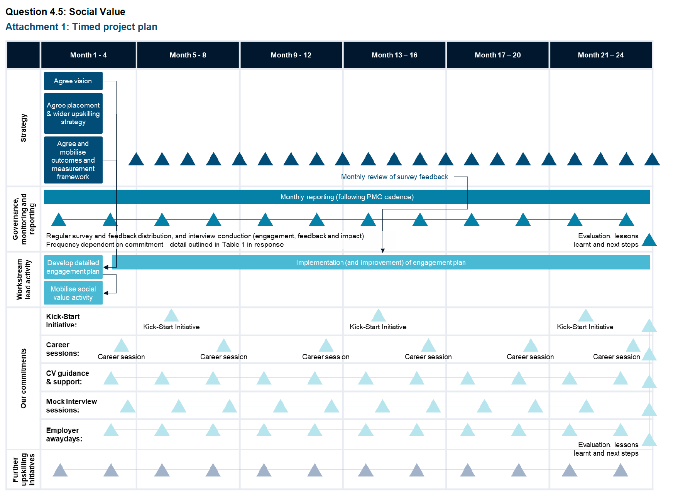

PA'S APPROACH TO BUSINESS CONTINUITY
POLICY -CLIENT VERSION
December2022
SIX CORE VALUES
Our success as an innovation and transformation consultancy is founded on a set of core values that drive the way we behave with clients and each other.
Inspired by client value:
We are committed to creating visible and sustained value for our clients. We are proud of our clients and what they think of us; we build long lasting relationships with our clients, responding to and anticipating their needs.
Passionate about people:
We are proud to be part of a team of brilliant people – our firm’s most prized asset. We are passionate about supporting each other in our continued growth to fulfil our ambitions.
Achieving success through shared endeavours:
We work collaboratively in diverse teams, shoulder-to-shoulder with our clients. We achieve more together than we could alone.
Prizing our ethical approach:
We are independent and prize our integrity and honesty. We strive to do ‘the right thing’ rather than ‘the easy thing’ which guides us through the responsibility of day-to-day activities, and through our most difficult challenges.
Seeking to excel:
We seek to excel in everything we do. We aspire to continually enhance our learning; we are ambitious to grow our innovation and insight.
Creating commercial success:
We are proud of what we are worth to our clients. We take personal responsibility for our commercial success, sharing and reinvesting our rewards.
DOCUMENT HISTORY
Issue no. | Date of release | Summary of changes
1.0 | December 2005 | First issue.
2.0 | 26 May 2006 | Reformatted in line with GOMs. No content change.
2.1 | 10 July 2006 | Chapter 5: Key players updated
2.2 | 2 November 2006 | Chapter 5: Key players updated
3.0 | 30 September 2007 | Full re-write  New front cover
3.1 | 31 January 2008 | Section 1.6: Roles and responsibilities updated  Section 3.1: PA strategy updated  Section 3.2: Relocation strategy updated  Section 4.2: The business continuity action plan updated throughout  New section 4.25: Physical security inserted  Chapter 6: Business continuity programme management deleted  Appendix A: Roles and responsibilities of crisis team members updated throughout  Appendix C: Business continuity action plan template updated throughout  Appendix G: Business continuity key contacts updated  New Appendix H: Physical security
3.2 | 03 August 2009 | Document review  New Appendix A, B, E and F  Removal of Appendix A – Roles  Roles and responsibilities of the crisis team members  Update business continuity decision flow chart
3.3 | 1 March 2015 | Document rewrite
3.4 | January 2016 | Change to job titles in relation to organisation changes
3.5 | October 2018 | New template  Document title change  Removal of reference to incident management as this is now standalone  Section 1: document properties removed  Section 5.2: Execution of business continuity planning rewritten  Approved by the COO
3.6 | December 2019 | No changes – Approved by COO
4.0 | September 2020 | Reformatted heading in Introduction  Change to 1.5 – document changed from two-year review to one year  Service/Sector Function replaced throughout with Go to Market teams and Capabilities  Added 1.6 PA’s response to Covid 19  2.2 Updated core business functions  Added 2.6 Business continuity plans  4.1 Core business functions updated

Document Properties Responsible Manager | Author name
Head of Operational Risk | Snr. Information Security Analyst

Responsible Oversight Committee
Incident Management Committee

Last reissue date | Review date
December 2022 | December 2023
Contents
PA’S SIX CORE VALUES 2
1 Introduction 7
1.1 The business priority is to maintain continuity and minimise disruption 7
1.2 Ownership and responsibility exist throughout the firm 7
1.3 This document covers both policy and procedures 8
1.4 The scope is global 8
1.5 Review of policy and procedures 8
1.6 PA’s response to covid 19 8
2 Key terms and definitions 9
2.1 Business continuity planning 9
2.2 Core business functions 9
2.3 Key dependencies 9
2.4 Business disruption event 9
2.5 Business impact analysis 9
2.6 Business continuity plan 9
3 Roles and responsibilities for business continuity 10
4 PA’s operational context 11
4.1 Core business functions 11
4.2 Key dependencies 11
4.2.1 Under PA Control 11
4.2.2 Limited or no PA Control 11
4.3 Other Considerations 11
5 Business continuity planning 13
5.1 Main components of PA’s business continuity planning 13
5.1.1 Resilience 13
5.1.2 Contingency measures 13
5.1.3 Communication Measures 13
5.1.4 Response and recovery 13
5.2 Execution of business continuity plans 13 PA’S APPROACH TO BUSINESS CONTINUITY
Confidential between PA and Client © PA Knowledge Limited 6

6 Testing, reviewing, and training 15
6.1 Types of validation 15
6.2 Validation process 15
6.3 Training and awareness 15
1 Introduction
This document sets out our approach to Business Continuity and its relationship with the corporate Incident Management Plan.
The approach provides appropriate mechanisms and plans to deal with a range of incidents that disrupt normal business activities whether they be a no notice or sort notice emergency requiring a quick PA-wide management response. The principles, definitions and roles are equally applicable to managing 'rising tide' incidents that unfold more slowly.
The aim of this document is to outline the general procedures that enable the business to recover from a disruptive challenge. It clarifies the agreed 'main effort' that will guide the response to an incident and defines the strategic objectives to be achieved.
Incidents that disrupt routine business happen all the time in any organisation. For most incidents within PA, normal problem solving will continue to provide successful resolution while, at the other end of the spectrum, a major incident may require the re-location of all or part of the work of a PA building to allow essential PA business to be conducted. Sitting between these two extremes is a wide range of disruptive challenges for which a coordinated and timely response is essential. Business Continuity Plans provide such a response capability.
1.1 The business priority is to maintain continuity and minimise disruption
Business Continuity Plans are typically enacted to achieve ‘business as usual’ at the direction of the Incident Management Team. It therefore follows that a disruption to normal business has occurred, and remedial action is required following an incident.
The focus is to ensure that PA is able to continue client-facing operations and business critical support
functions when faced with a business disruption event. This requires awareness of the principal business continuity risks that the business may be exposed to and their regular review by the Head of Operational Risk and senior business leaders. PA is sometimes required to provide clients with assurance that we have appropriate arrangements in place to minimise the impact and spread of disruption, so we are able to continue to deliver and honour our contractual obligations.
1.2 Ownership and responsibility exist throughout the firm
Go to Market team and capabilities are responsible for developing, maintaining and exercising functional Business Continuity Plans. The Head of Operational Risk is responsible for the policy, procedures and management of the Incident Management Plan.
Every member of PA is responsible, at an individual and collective level, for remaining alert to the possible impact of a business disruption event or continuity issue and is required to report any concerns as soon as possible; in the first instance to their line or assignment manager, and ultimately to the Head of Operational Risk.
At an organisational level, business continuity planning requires a holistic, bottom-up approach in order to be effective. This requires each Go to Market and capabilities team, Country and Office Head to have in place an up-to-date Business Impact Analysis and Business Continuity Plan that addresses the specific risks and threats that the Go to Market and capabilities teams, and offices may be susceptible to.
Specifically, each analysis requires consideration of:
- • the respective functional operation and its dependencies
- • the potential impact of business disruption events on activities and tasks
- • the need for proportionate contingency measures (e.g. alternative workplaces)
- • how to remain aware and alert to possible disruption events and respond appropriately
- • the potential impact on other stakeholders (this includes external stakeholders such as clients and suppliers, as well as internal stakeholders such as Real Estate and Group Systems).
- Operational Risk is responsible for verifying that appropriate plans exist throughout the firm and at an organisational level. It is also responsible for ensuring that the Business Impact Analyses and Business Continuity Plans are reviewed annually so they remain fit for purpose unless an incident supersedes the review date.
- 1.3 This document covers both policy and procedures
- The purpose of this document is to set out the PA policy and a framework of procedures and guidelines for effective business continuity management across all PA sites, recognising that it will not always be possible or practical to prescribe a response for every potential scenario.
- 1.4 The scope is global
- The scope of this document is global and concerns all PA Go to Market and capabilities teams, countries and offices, and is applicable to all PA employees and contractors.
- 1.5 Review of policy and procedures
- This document will be reviewed every year, following the formal date of issue, or as frequently as required to respond to changes in the prevailing business environment. Responsibility for reviewing and updating this document rests with the Head of Operational Risk. Responsibility for reviewing and updating Business Continuity Plans and Business Impact Analyses plans rests with respective Go to Market and capability teams/country/office Heads (and, where appropriate, Office Facility Co-ordinators). The Head of Operational Risk is responsible for ensuring plans are in place, that they meet the standards described in this document and that they are reviewed annually.
- 1.6 PA’s response to covid 19
- To protect our clients and colleagues we introduced measure in line with current government guidance, and also made sure the safety measure we introduced at the start of the pandemic remain in place. PA will continue to review its current measures until such a time that there is a consensus that things are back to a previous normal or a new normal.
- 2 Key terms and definitions
- 2.1 Business continuity planning
- 1. Resilience: Core business functions and the supporting infrastructure are designed, engineered and maintained in such a way that they remain materially unaffected by most business disruption events.
- 2. Recovery: Arrangements are made to recover, restore or duplicate core business functions that have been affected by a business disruption event.
- 3. Contingency: Putting in place a dedicated ‘reserve’ capability, such as quick access to alternative office space and workshops, for activation in the event of a business disruption event.

- 2.2 Core business functions
- Core business functions are the operations and activities that are critical to the smooth running of the business. PA has eight core business functions in its Go to Market Teams (GTM): the delivery of Defence and Security; the delivery of Financial Services; the delivery of Energy and Utilities; the delivery of Health and Life Sciences; the delivery of Public Services; the delivery of Transport Travel and Logistics and the provision of corporate business support.
- 2.3 Key dependencies
- Key dependencies are the assets and capabilities which must function effectively in order to maintain core business operations.
- 2.4 Business disruption event
- A business disruption event is any event – natural, accidental, deliberate or otherwise – that has an adverse impact on PA’s core business functions and/or key dependencies, and which may prevent business from being carried out as normal.
- 2.5 Business impact analysis
- Business impact analysis is the process of determining the extent of the impact of a business disruption event upon core business functions and key dependencies. This analysis is a primary driver for business continuity Preparation, planning and prioritisation.
- 2.6 Business continuity plan
- A Business continuity plan is the documented procedures that guide the company to respond, recover, restore and resume to a predefined level of operation following a disruption.
- 3 Roles and responsibilities for business continuity
- The principal roles in business continuity are set out in the table below, along with their responsibilities. While some activities may be delegated, the person in each role remains accountable for compliance with this policy.
- Roles and Responsibilities
Role | Key Responsibilities
PA person | Ensure the incident is reported on discovery to the Head of Operational Risk as well as their line manager, Partner in Charge (PiC) and Go to Market lead
Office Facilitator/  Go to Market/Capabilities Secretary/ Assignment Manager | Supports the Office or Country Head as needed under the direction of the Head of Operational Risk.
Office Head/Country Head/Go to Market and capabilities team leads/ Partner in Charge | Ensures their Business Impact Analysis documents are completed and tested. Provide local guidance and support to the Incident Response team, Head of Operational Risk and Executive Committee.
Incident Response Team | Assumes responsibility for managing the incident at the operational level. Determine appropriate actions and recommendations to the Executive Committee.
Head of Operational Risk | Ensures that PA’s approach to business continuity and the relevant Business Impact Analysis documents are maintained according to policy. Manage the incident and report findings and recommendations to the Executive Committee for decision where needed.
Executive Committee | Provides strategic direction and holds ultimate responsibility.

4 PA’s operational context
Business continuity planning must be relevant to the operational context of the business in order to be effective. This requires an understanding of the core functions of the business, its key dependencies and the likely impact of a business disruption event.
4.1 Core business functions
PA’s core business functions are as follows:
Consultancy services: The delivery of knowledge, skills, expertise or products to clients. This typically involves consultancy work taking place in PA offices and on client or third-party sites. There are seven Go to Market teams that operate in the following disciplines: Consumer and Manufacturing; Defence and Security; Financial Services; Energy and Utilities; Public Services; Transport and Logistics and Health and Life Sciences.
Technology research and development (R&D): Typically, this involves the research, development, design and manufacture of prototypes and other technology solutions on behalf of clients.
Corporate business support: This includes the corporate infrastructure and support provided by all corporate functions, specifically Finance, Group Systems, Company Secretariat (including Group Legal), Operations and Administration (including Real Estate), Human Resources (including Recruiting and Training and Development), Marketing, Operational Risk (Including Vetting) and Knowledge Services.
4.2 Key dependencies
The following assets and capabilities must function effectively if core business functions are to be maintained:
4.2.1 Under PA Control
- • People: Executive management; senior business leaders (Group Heads, Country Heads and Go to Market teams); consultancy staff; corporate business support, and suppliers
- • Information systems and assets: IT hardware and software; data storage media; internal and external communications networks. Information assets – PA and client-owned
- • Work premises: General work areas and access-controlled areas (including designated secure working environments; client access areas; R&D laboratories and workshops; training rooms; and logistic areas)
- • Business processes (except where outsourced): eg payment processing (in and out); accounting; recruitment; assignment management (CRM); performance reporting.

4.2.2 Limited or no PA Control
- • Public transport infrastructure, utilities and communication networks: Water, electricity, gas, mobile/cell phone, telephone, internet
- • Client: work premises
- • Legislative & Regulatory changes: National and international security advice and legislative and regulatory changes
- • Supply chains and subcontractors
- • Outsourced business processes and off-site backup of electronic data

4.3 Other Considerations
It is important that PA’s Business Continuity approach recognises that PA’s business activities are:

- diverse in nature – no single activity
- • conducted in various parts of the world, on PA premises or on client sites, or on other third-party sites.
With the exception of the Global Innovation and Technology Centre, PA premises are leased, not owned. consequently, a significant element of work premises risk requires the cooperation of third-party landlords. Where premises are rendered inoperable, third-party landlords (and their insurers) may be required to provide suitable alternative accommodation or compensate PA for sourcing alternative space. Similarly, client work premises may be subject to business disruption events that hinder our ability to provide consultancy services. Assignments with a large number of consultants working on client site should have contingency plans in place in the event that the client site becomes inaccessible.
5 Business continuity planning
The objective of PA’s business continuity planning is to:
- • establish and maintain a realistic level of ‘resilience’ – the ability of a consultancy assignment, business support function or office premises to withstand the impact of a business disruption event
- • put in place or have timely access to ‘contingency’ resources
- • be able to respond and recover as effectively and efficiently as possible if a business disruption event occurs.

5.1 Main components of PA’s business continuity planning
5.1.1 Resilience
Resilience is both the capacity of an organisation to deter, remain unaffected or minimise the impact of a business disruption event which might undermine business continuity. Depending on the particular disruption scenario, business continuity planning may involve some of the following measures:
- • Pandemic: Mass immunisation; pre-planned homeworking (with additional remote working capability)
- • Severe weather: Access to alternative work premises or a period of remote working
- • Public utility failure: Sourcing of alternative power generators, water and sanitary facilities
- • ICT network failure: Network defences, regularly updated; off-site backup; network access controls; controlled access to server rooms, firewall and intrusion detection
- • Damage to property: Physical barriers and access control; duplicate copies of key information or data held in a separate location.

5.1.2 Contingency measures
Contingency measures include:
- • maintaining liaison with providers of rented office space so that alternative office space can be acquired (and fitted out) at short notice
- • having access to specialist sub-contractors, in the event that PA people are out of action.

5.1.3 Communication Measures
- • Under no circumstances must an incident be discussed on any social media platform unless you have the authority to do so
- • Communication will be managed by the IMT and marketing team.

5.1.4 Response and recovery
The principal objective of PA’s response to, and recovery from, a business disruption event is that it is timely and proportionate and that:
- • the disruption is contained
- • recovery of normal operational functionality is achieved as quickly as possible and at minimal cost to the business.

5.2 Execution of business continuity plans
Execution of a functional Business Continuity Plan is likely to follow an incident and therefore be as a direct request to enact it from the Incident Management Team. In the event of an incident that disrupts normal Business as Usual (BaU), the Incident Management Duty Silver or Gold would request the Business
Continuity Plan is enacted, and an appropriate duty Bronze appointed to oversee its execution. It is likely that the duty Bronze would be the functional, country or Go to Market head.
6 Testing, reviewing, and training
Business Continuity Management for assignments, Go to Market and Capability teams and offices are subject to periodic validation in order to ensure that, so far as possible, the plan will minimise disruption caused by a business disruption event. In addition, there will be a periodic review to ensure the people responsible for the plan are fully aware of what is expected of them should the business disruption event occur.
6.1 Types of validation
Validation of plans are required by the following individuals:
- • Assignment – PiC and Assignment Manager
- • Go to Market and Capability teams
- • Business support functions
- • Office premises – Office and Country Head

6.2 Validation process
The validation process should take place in conjunction with a full review of this policy and any supplementary assignment/office Business Continuity Action Plans.
The objective of the validation process is to:
- • Identify elements of direction and guidance, which require refinement or further clarification
- • consider and determine improvements
- • put each measure to the ‘what if’ test
- • produce, as necessary, a revised version of the PA policy and/or a revised version of area-specific plans.

6.3 Training and awareness
The Head of Operational Risk is responsible for ensuring that relevant training and periodic awareness takes place on an annual basis.

