**Introduction**

Requests for quotation (RFQs) enable Durham University to gather relevant information from interested suppliers that is pertinent to the goods or services that is being tendered for. This allows the University to review each submission against the set criteria. RFQs can be scored, weighted or non-weighted. The evaluation methodology will be disclosed as part of the RFQ information at the time of publishing.

This guide is to assist you in navigating your way through oracle fusion to help you compile and respond to an RFQ.

The following sections will be covered in this guide:

1. Create RFQ Supplier Response
2. Response through spreadsheet
3. Response revision
4. **Create RFQ Supplier Response**

**Registered and Invited Supplier**

Suppliers who are already registered with Durham University can submit their responses by logging into the supplier portal.

Once the Negotiation is published and Active, the registered Supplier Contact will log in via supplier portal with their user credentials and create a response.

Note: Although more than one registered supplier contact can access the negotiation and respond, it is advisable that you coordinate who will complete which response sections to avoid confusion and overwrite when compiling your response.

Mention the User ID and Password and click on Sign In.

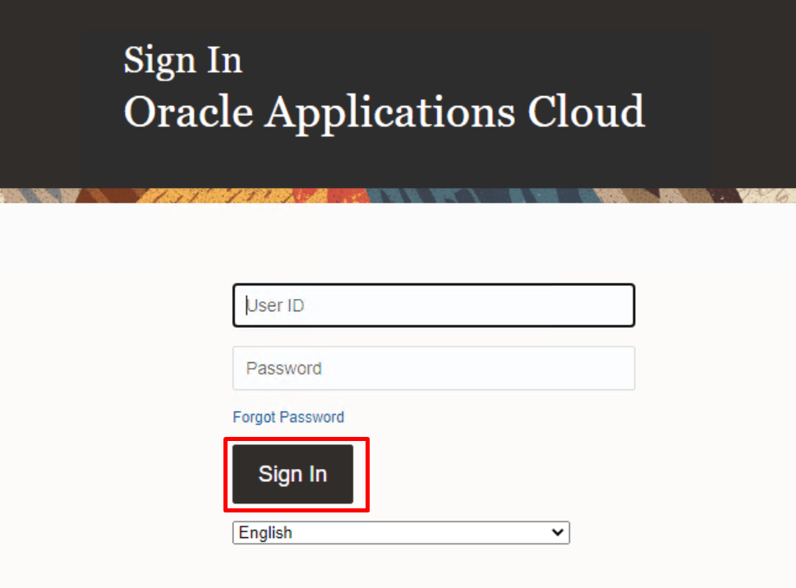

Go to Supplier Portal > Supplier Portal.

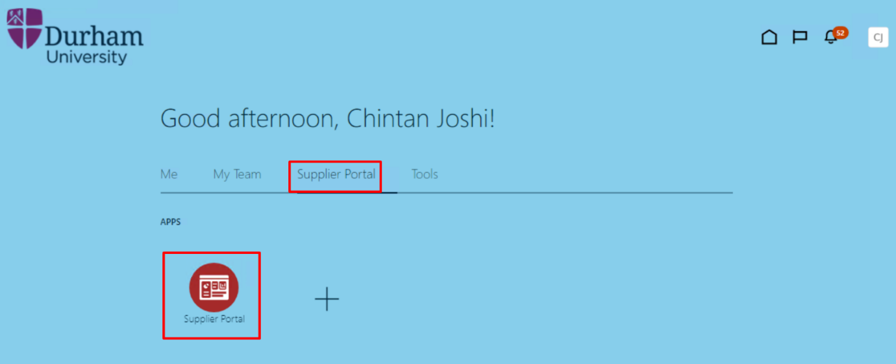

Registered supplier contact receives notification of invitation to the RFQ. Click on bell icon and navigate to notification to create response for RFQ.

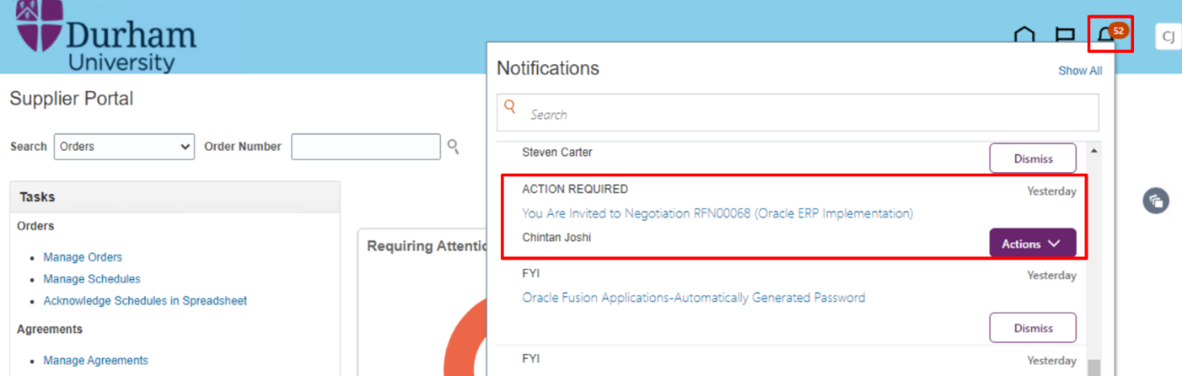

You can also create a response for the RFQ in another way.

Go to Negotiation > View Active Negotiations.

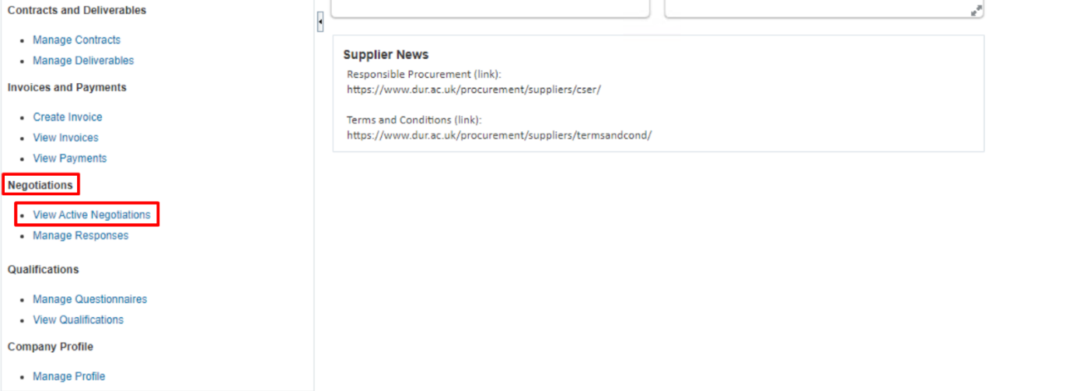

Different searching criteria is available. You can mention negotiation detail to search for RFQ or directly click on search without mentioning anything. This will show all active negotiations for which supplier is invited.

Click on “Search”.

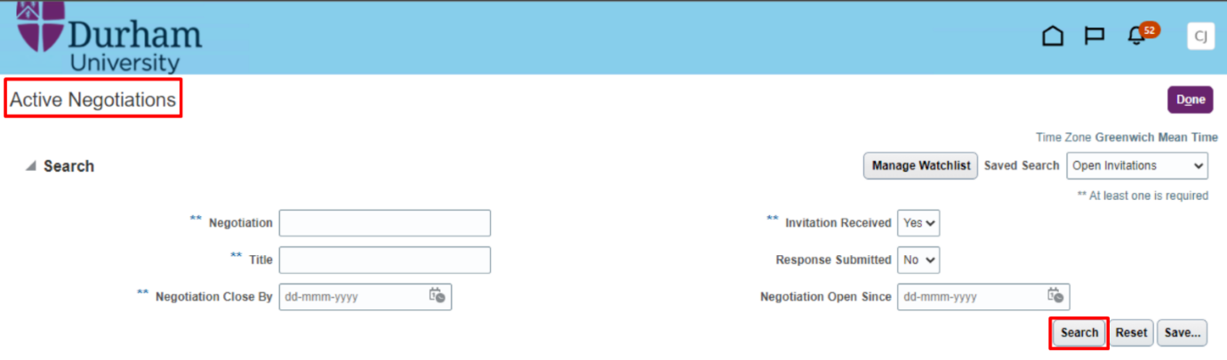

You will select Negotiation for which response needs to be created and click on “Create Response”. You can also view negotiation in PDF format by clicking on View PDF option. Fields marked ** require at least one search field populated.

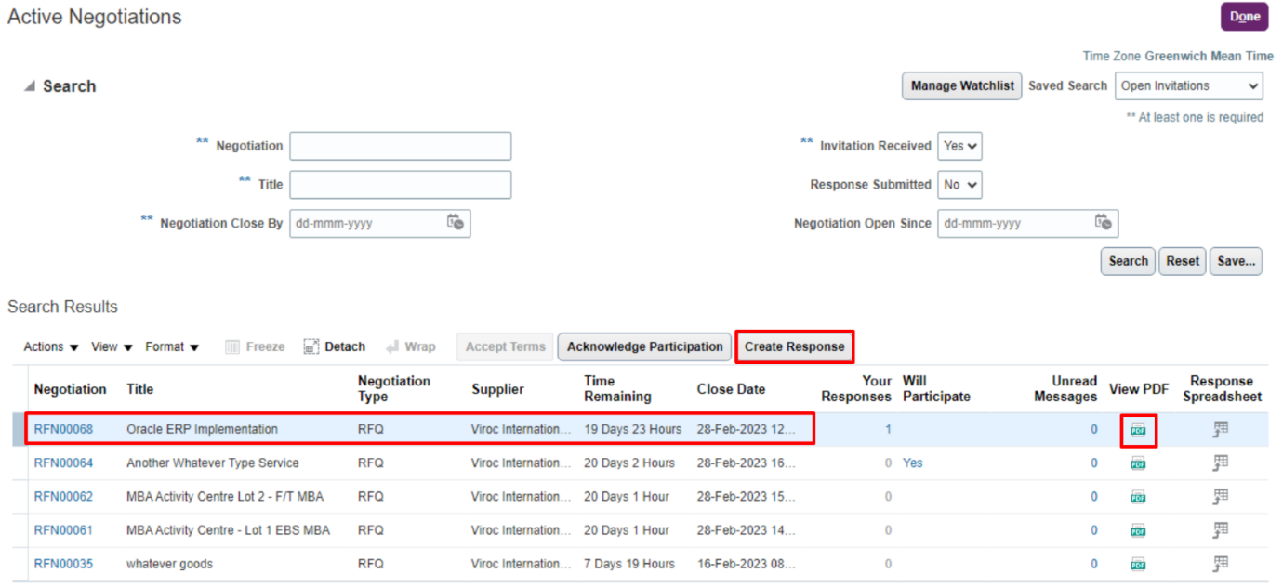

**Overview:** Enter the information like Response Valid Date, Reference Number, Note to buyer or any attachments. All fields marked with * are mandatory.

**Note:** The Buyer is the procurement contact overseeing the RFQ negotiation.

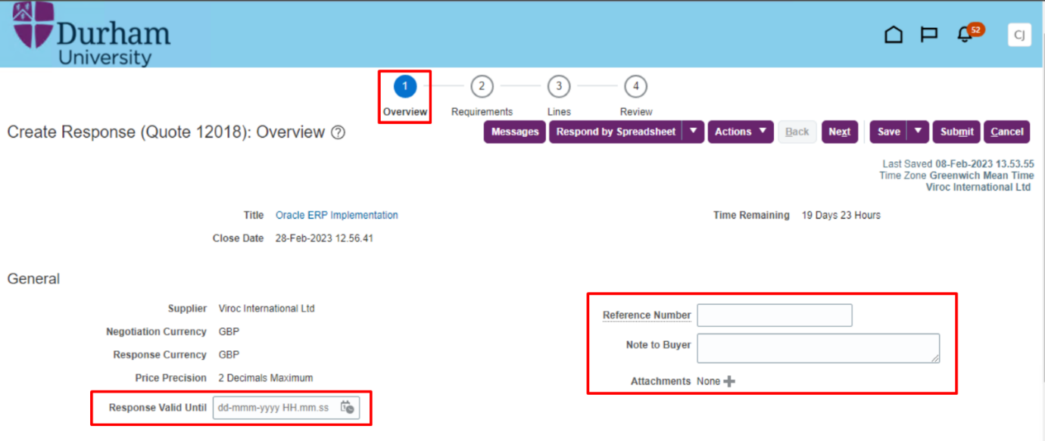

**Requirements:**

Enters your response against requirements in section 1.

Once all Requirements of Section 1 has been entered, select section 2 and complete Requirements. You can seek clarification or ask questions to buyer through the messaging service.

**Note:** Responses for any questions may populate automatically if you have already responded to the same questions for an earlier negotiation. It is your responsibility to ensure these responses are still valid. You can change these if they require updating.

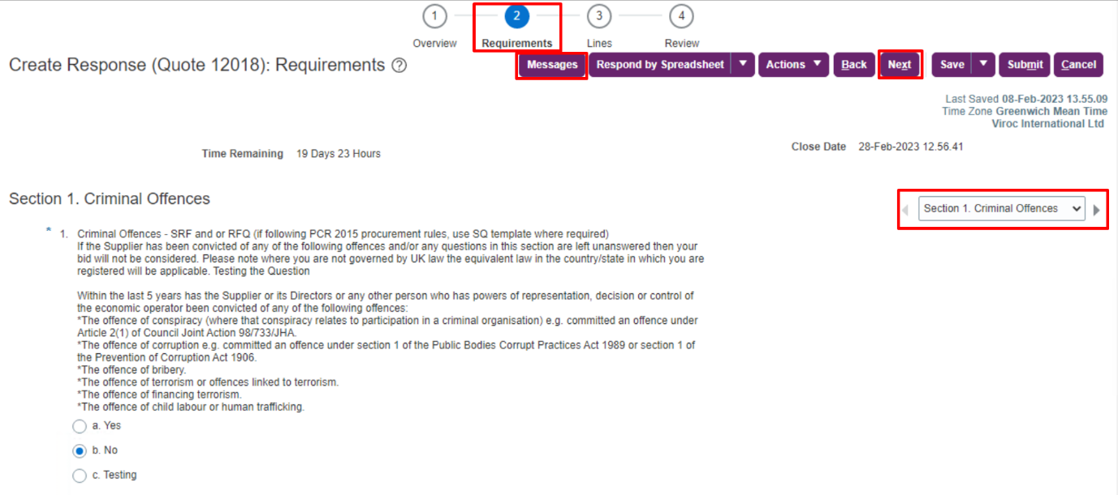

**Lines:**

Within the Lines section you will need to provide a response to price against the line(s) and click “Next”.

**Note:** At any point in the process, you can also click on Save and Close and can continue later with the response creation.

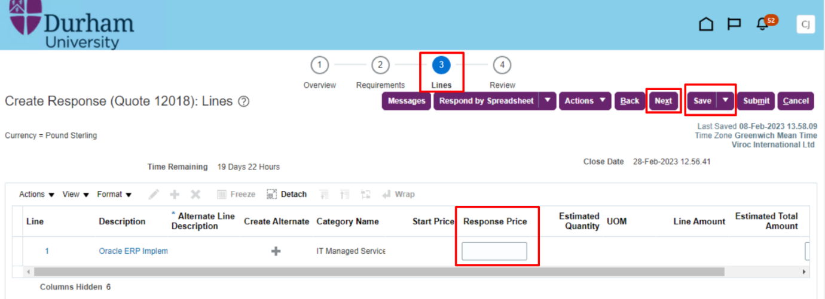

**Review:**

You can review the response you’ve created before submitting. Click on “Save” and “Submit” to submit response.

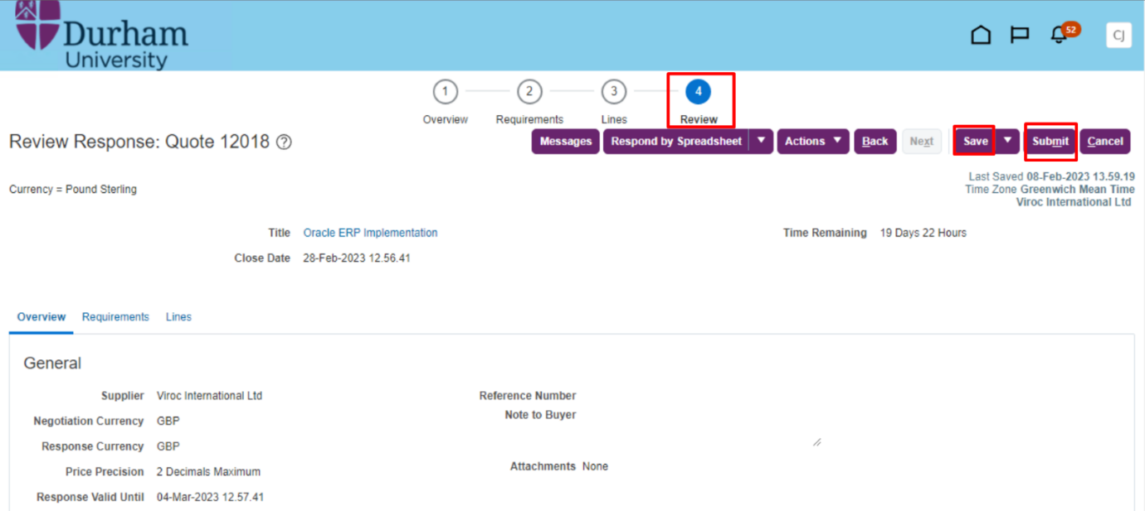

Confirmation message will pop up that the response was submitted.

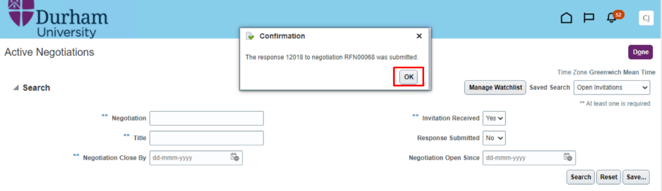

1. **Response through spreadsheet**

Spreadsheets facilitate easy and efficient response of negotiation requirements. Spreadsheets are useful when dealing with negotiations that have many requirements or requirements having complex criteria.

**Note:** When responding via spreadsheet, please ensure you upload any required attachments direct into oracle. You cannot include attachments in the upload spreadsheet.

Click on “Respond by Spreadsheet”.

Click on “Export” to export the requirements.

**Note:** Once you click on export a zip file will be downloaded. Supplier needs to extract the zip file and open the file within Excel. If it doesn’t allow you or you receive an error, open Excel, search for downloaded file and open within Excel.

Once export is clicked, the .zip file will get downloaded. Open the zip file and fill the spreadsheet with the response as below and save the file. Mention the responses for each requirement.

Once all requirements have been responded to, navigate to next tab titled ‘Lines’ and mention the response price.

Once all requirements are filled in the spreadsheet, navigate back to Supplier Portal and click on “Import” to import the spreadsheet.

Choose the relevant file and click on “OK”.

All responses and price will be populated within oracle. Go to Review to review all details of the response. Once reviewed click on “Submit” to submit the response.

**Note:** You can only respond to the requirement through spreadsheet. If any requirement requires attachment to be uploaded, then supplier has to upload through supplier portal. It will not be uploaded through spreadsheet.

A confirmation message will pop up stating response has been submitted successfully.

1. **Response Revision**

If you have made an error while creating the response or wish to revise a submission, you can do this by creating a response revision.

**Note:** You can revise and correct only if the negotiation is created having response revision enabled. This status will be confirmed as part of the RFQ introduction.

Go to Negotiations > Manage Responses.

There are different search criteria to search for the relevant response. Click on “Search”.

Select the relevant response and click on “Revise”.

Make required changes in the response and review before selecting “Submit”.

A confirmation message will pop up stating response is revised successfully.

