The ACC Liverpool Group

Cleaning Compliance Handbook

September 2017

Contents

Introduction Page 3
Core SOPs Page 4
Core Risk Assessments Page 5
ACC Liverpool Emergency Call Signs Page 6
Venue Standards Page 7
Venue Checks Page 21
Venue Check Form Page 22
Venue Check Schedule Page 23
Service Partner Induction Page 24

Introduction

The aim of the compliance handbook is to provide our service partners with instruction and guidance on the ACC Liverpool Group’s practices and principles that must be adhered to in order for us to operate a safe and efficient venue.

Core SOP’s
Listed below is a selection of the core ACC SOP’s that the Contractors team must familiarise themselves with:
- Accident & Incident Investigation Procedures SOP
- Accident & Near Miss Reporting and Recording SOP
- Adverse Weather SOP
- Code Orange SOP
- Departmental Risk Assessment SOP
- Environmental Waste Disposal SOP
- CDM Regulations
- Event Dilapidation SOP
- Event Safety File SOP
- First Aid (Events) SOP
- Loading Bay Plant Parking & Recharging SOP
- Personal Protective Equipment (PPE) SOP
- Pre-Use Inspection for ACCL MEWPS/FLT SOP
- Spill Response Emergency Procedures SOP
- Waste Management SOP

Core Risk Assessments
Listed below is a selection of the core ACC Risk assessments that the Cleaning team must familiarise themselves with:
- Noise at work Risk Assessment
- Working from a ladder or stepladder Risk Assessment
- PPE Assessment Risk Assessment
- COSHH Assessment Form Risk Assessment

ACC Liverpool Emergency Call Signs/Codes – To be shared upon award

Security can be contacted on Radio Channel x or by dialling x followed by xxxx

Code | What does it mean?

Venue Standards
The purpose of the venue standards principles are:
- To create a better awareness and understanding of the importance of standards across the ACC Liverpool Campus.
- To create consistency and understanding of what standards are deemed acceptable and not acceptable in all areas of our Venue.
- To encourage all teams across the site to be reporting defects and checking standards of our Venue.
- Provide teams with the necessary information needed to be able to drive standards forward and upwards
Standards are needed to ensure that our Front of House areas, store rooms and loading bays are all meeting the minimum criteria of presentation. This will ensure that as a company we are constantly portraying a professional and polished image.
Once an event has finished tenancy there should be no trace left of that event in the venue. This includes the following:
- Cleaning
- Furniture
- Signage
- AV
- FM power
- Event Related Materials
Whilst derigging areas should you note any damage that could have been caused by the event please let the Event Manager know as soon as possible.
Please report any of the above to service desk on xxxx

Arena Cleaning Standards
These are the standards that we need to maintain, to enable staff and users to enjoy a safe and hygienic environment, whilst maintaining the buildings furnishings, fittings and adhering to health and safety regulations at all times.

Arena floor
- Free from litter, debris, dust and loose foreign matter.
- Dry and free from spillages, removable stains, and superficial marks.
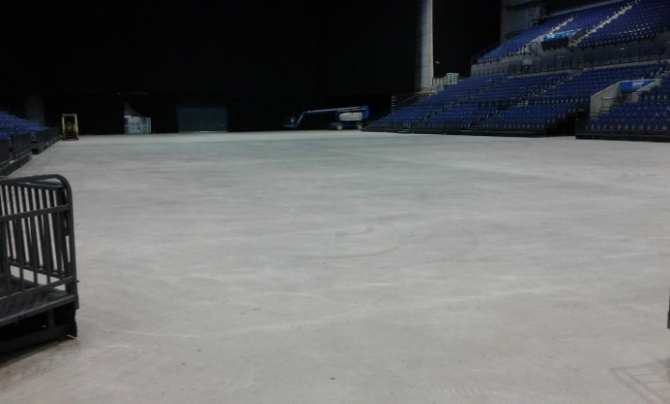

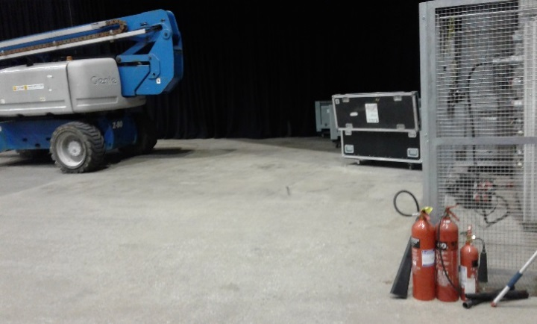

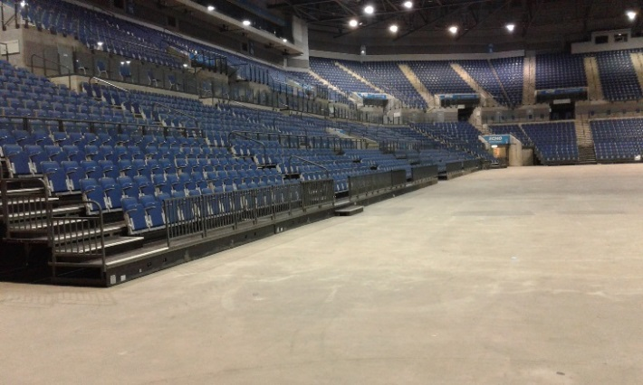

Arena Seating Area
- Free from litter, debris, dust and loose foreign matter.
- Dry and free from spillages, removable stains, and superficial marks.
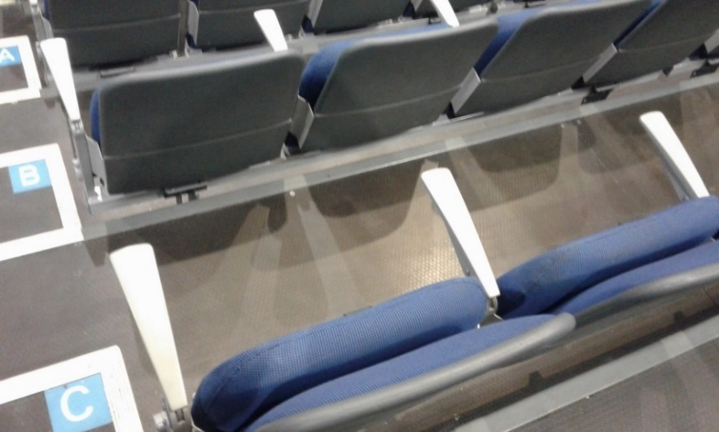
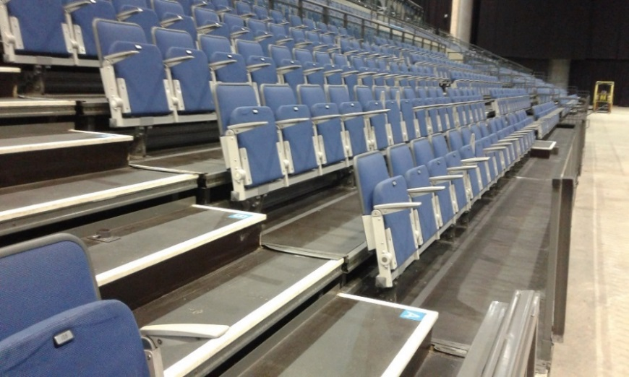
- Seats dry and free from removable stains.
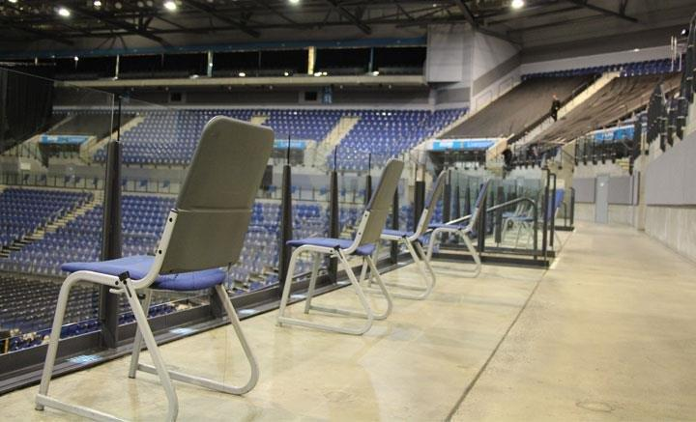

Arena Common Areas
- Free from litter, debris, dust and loose foreign matter.
- Dry and free from spillages, removable stains, and superficial marks.
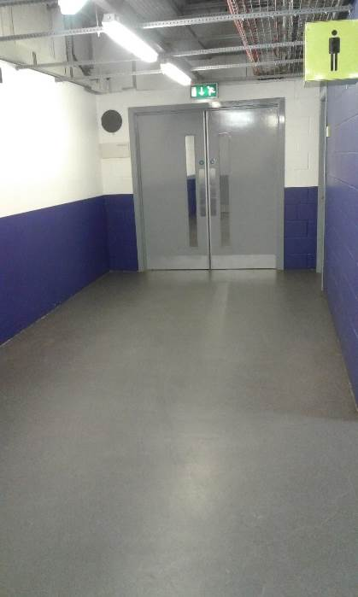
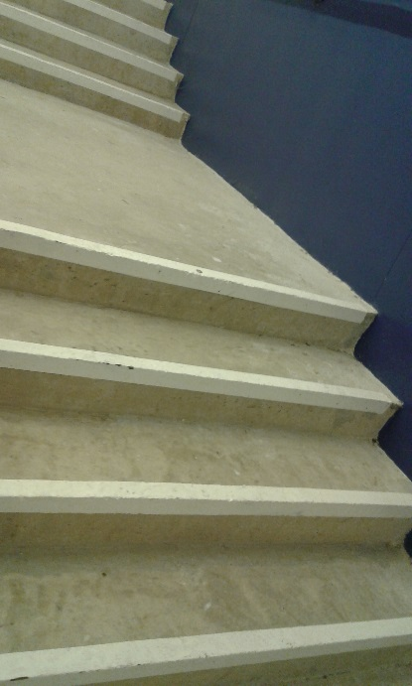
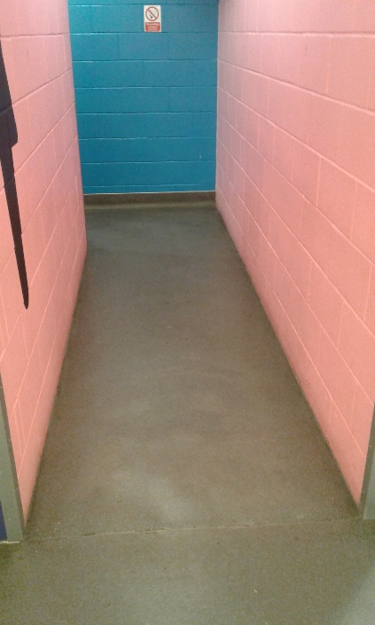

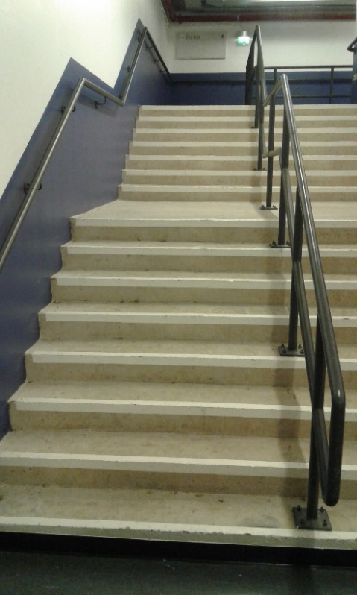
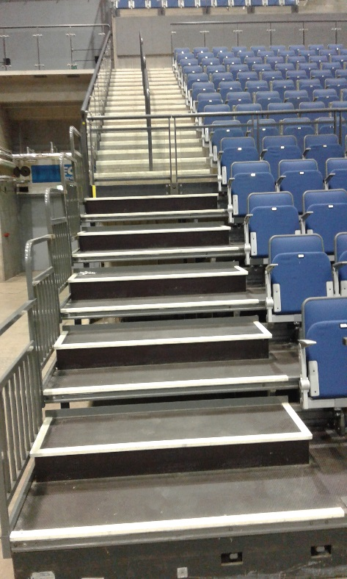

Arena Toilets
- Floors dry and free from spillages, removable stains, ingrained dirt, scuffmarks and impacted debris
- All vertical and high level surfaces are left free from impacted debris, dust, cobwebs and removable stains/graffiti.
- All sanitary fittings free from impacted debris, dust, removable stains and fluids.
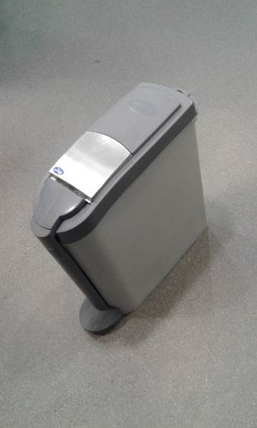
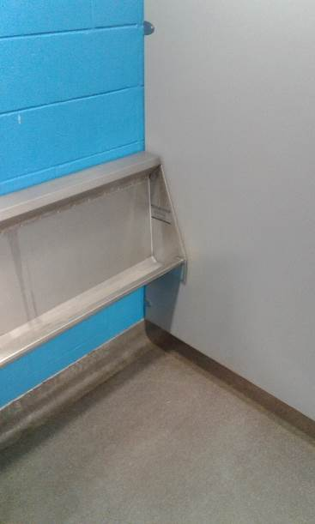
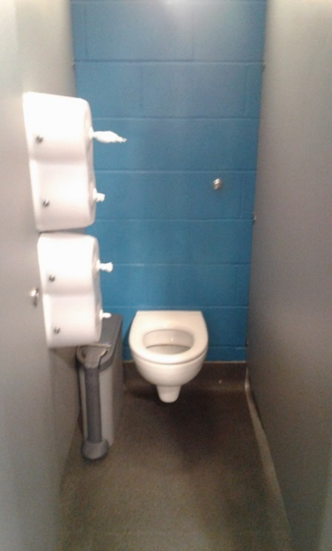
- Dry and odour free.

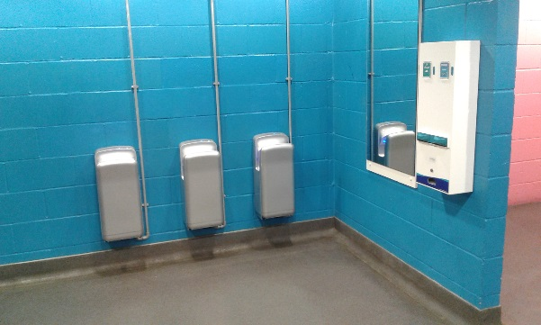

Duct Rooms
- Clear and free from foreign objects and debris
- Chemicals, Products and Equipment are prohibited from being stored in this area.
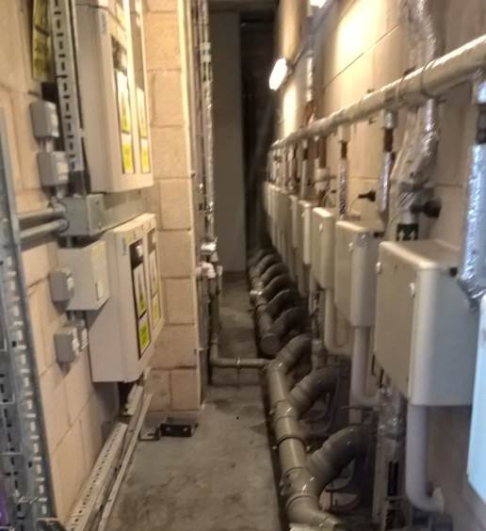

Artists Village Cleaning Standards

Dressing Rooms
- Soft & Hard Floors dry and free from spillages, removable stains, ingrained dirt, scuffmarks and impacted debris
- All vertical surfaces and high level free from impacted debris, dust, cobwebs and removable stains/graffiti
- All sanitary fittings free from impacted debris, dust, Dry and odour free.
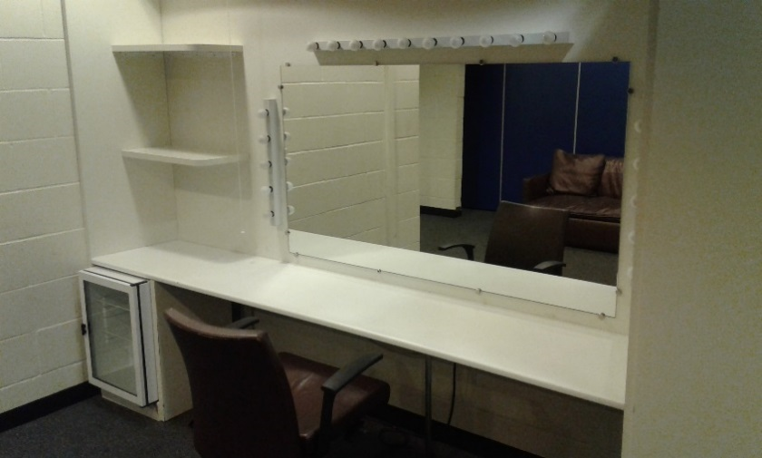

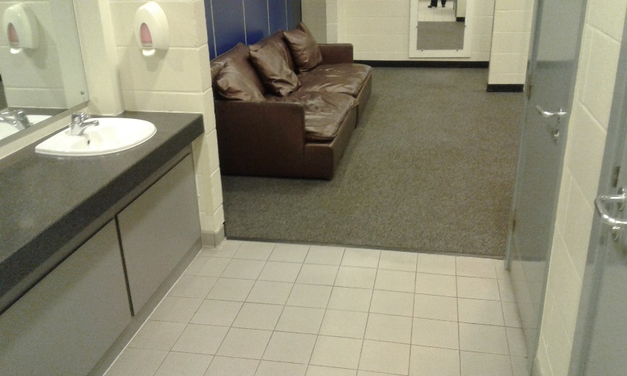

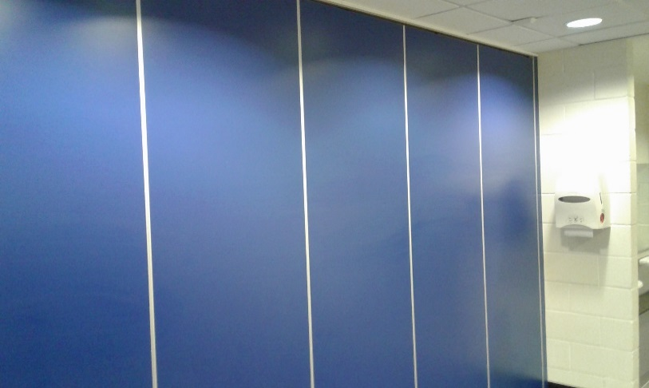

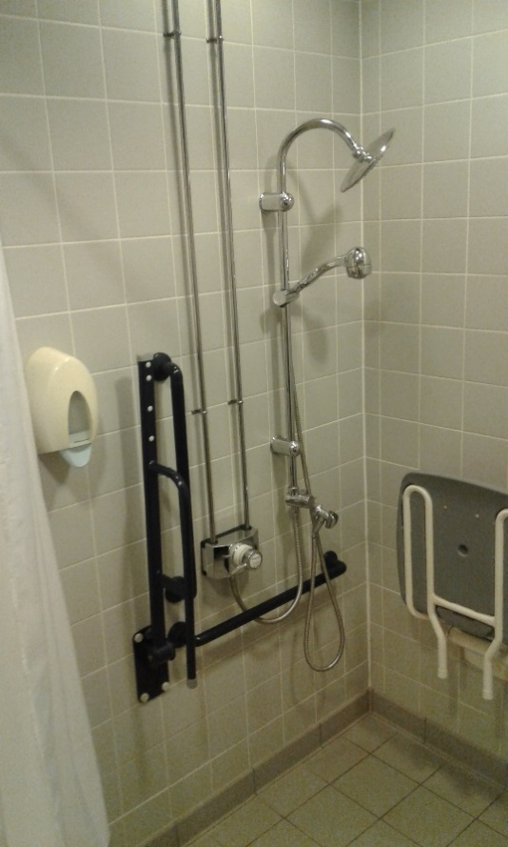
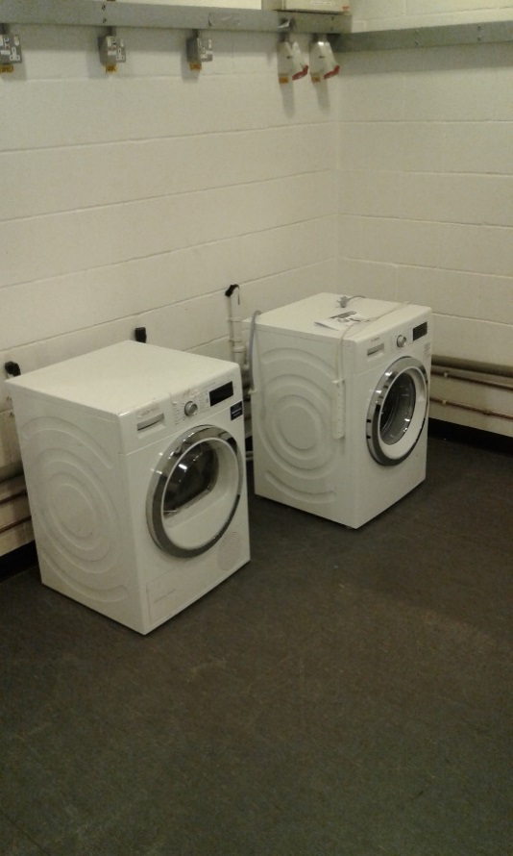

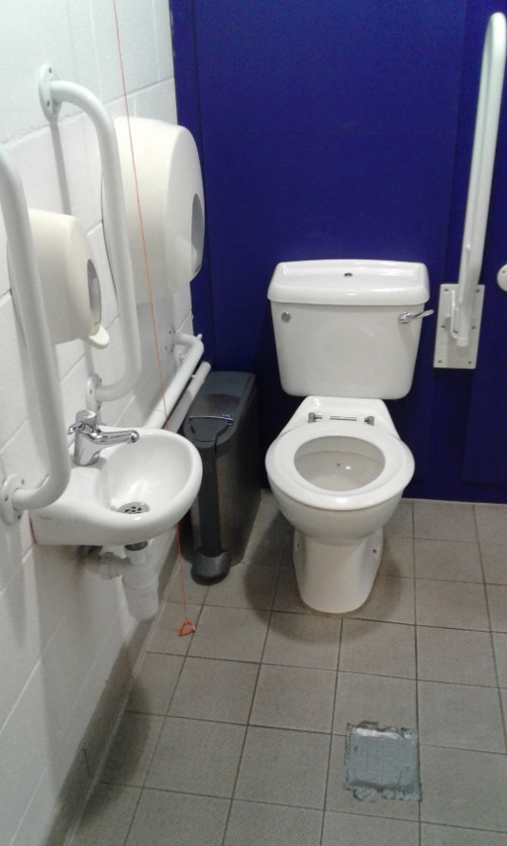
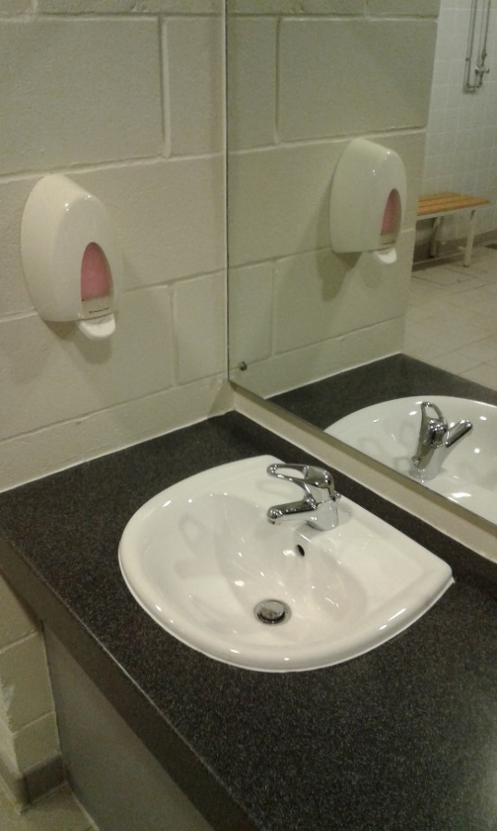

Artist Village Common Areas
- Free from litter, debris, dust and loose foreign matter.
- Dry and free from spillages, removable stains and superficial marks.
- All fixture & fittings free from impacted debris, dust, cobwebs and removable stains.
- Floors should be buffed/scrubber dried.
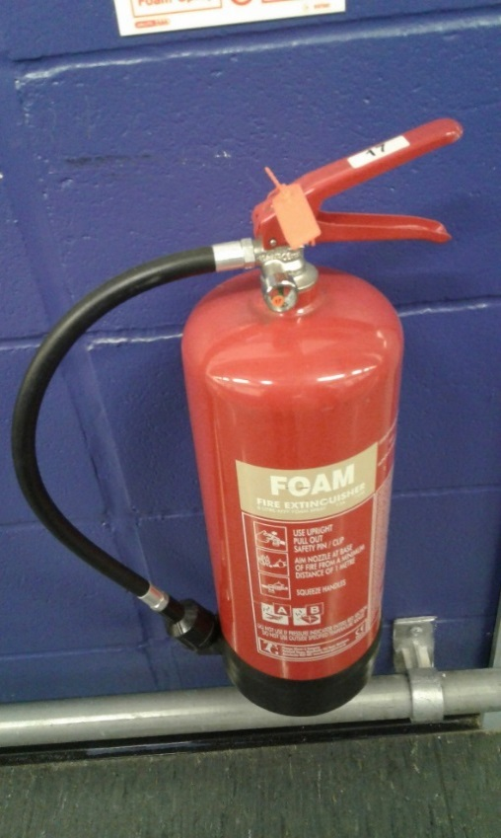
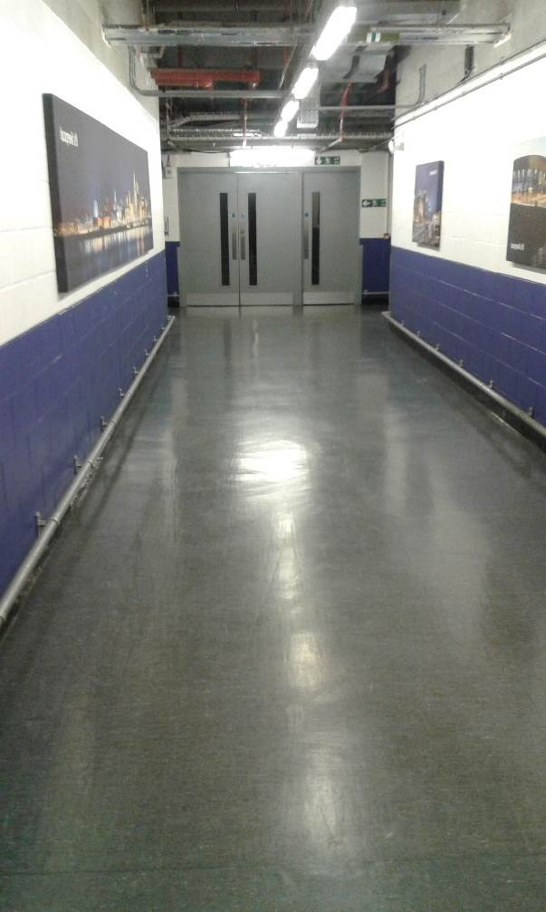

Artist Village Common Rooms
- Floors dry and free from spillages, removable stains, ingrained dirt, scuffmarks and impacted debris
- All vertical surfaces and high level free from impacted debris, dust, cobwebs and removable stains/graffiti
- All fixture & fittings free from impacted debris, dust, cobwebs and removable stains.
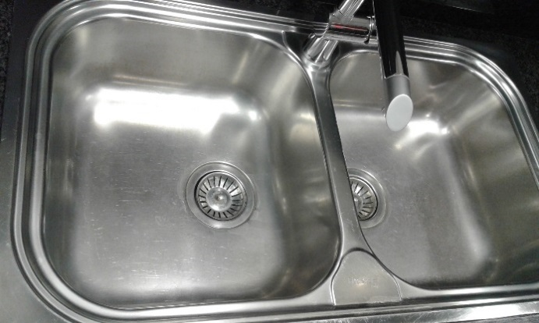
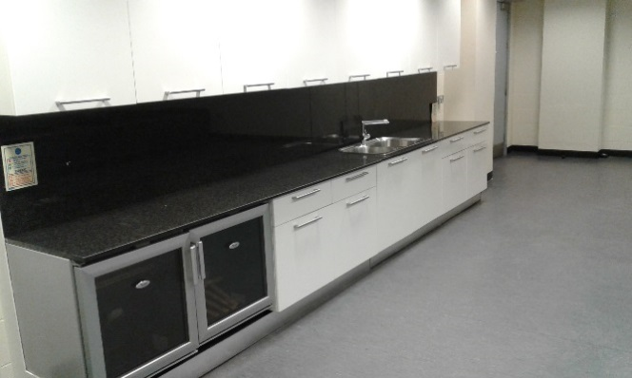

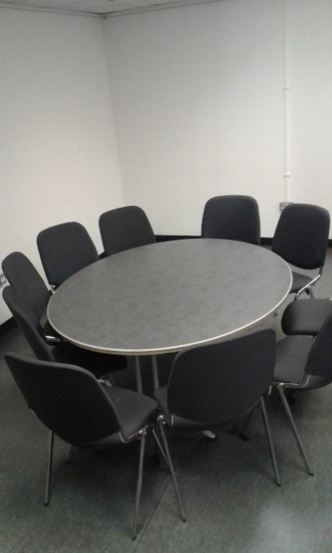
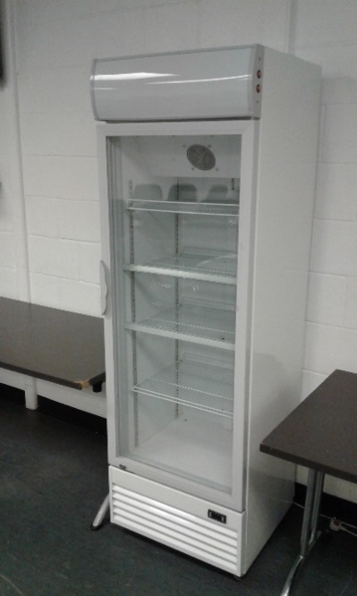

Artist Village Production Rooms
- Floors dry and free from spillages, removable stains, ingrained dirt, scuffmarks and impacted debris.
- All vertical surfaces and high level free from impacted debris, dust, cobwebs and removable stains/graffiti.
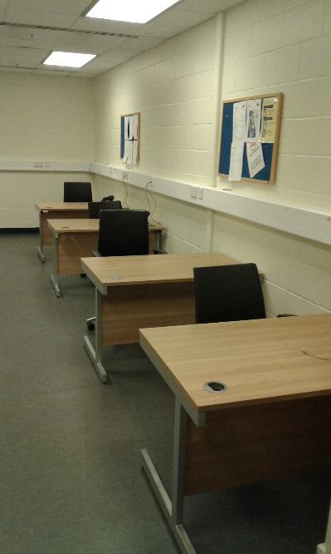
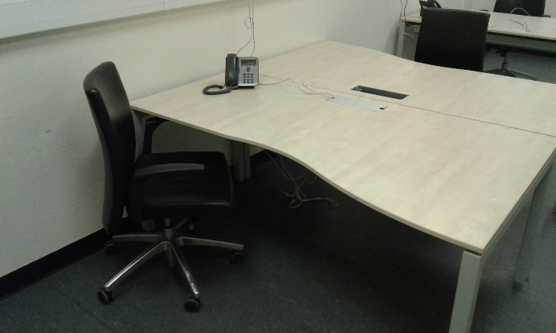
- All fixture & fittings free from impacted debris, dust, cobwebs, and removable stains.

Artist Village Kitchen
- Floors dry and free from spillages, removable stains, ingrained dirt, scuffmarks and impacted debris
- All vertical surfaces and high level free from impacted debris, dust, cobwebs and removable stains/graffiti
- All fixture & fittings free from impacted debris, dust, cobwebs, and removable stains.
- The Oven should be left clean and free from debris and surfaces to be wiped inside and out.
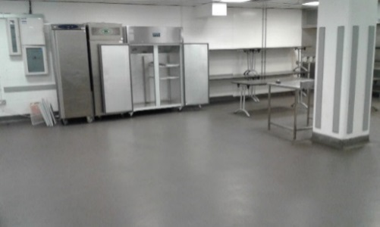
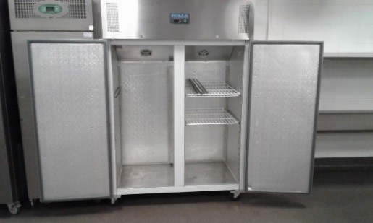

Loading Bay Cleaning Standards
- Floors free from spillages, removable stains, ingrained dirt, scuffmarks and impacted debris
- All vertical surfaces free from general debris, dust, cobwebs and removable stains/graffiti
- Machinery stored tidy, free from dust & dirt and placed on charge when required in the designated location.
- All bins to be stored tidy and free from general dirt & dust.

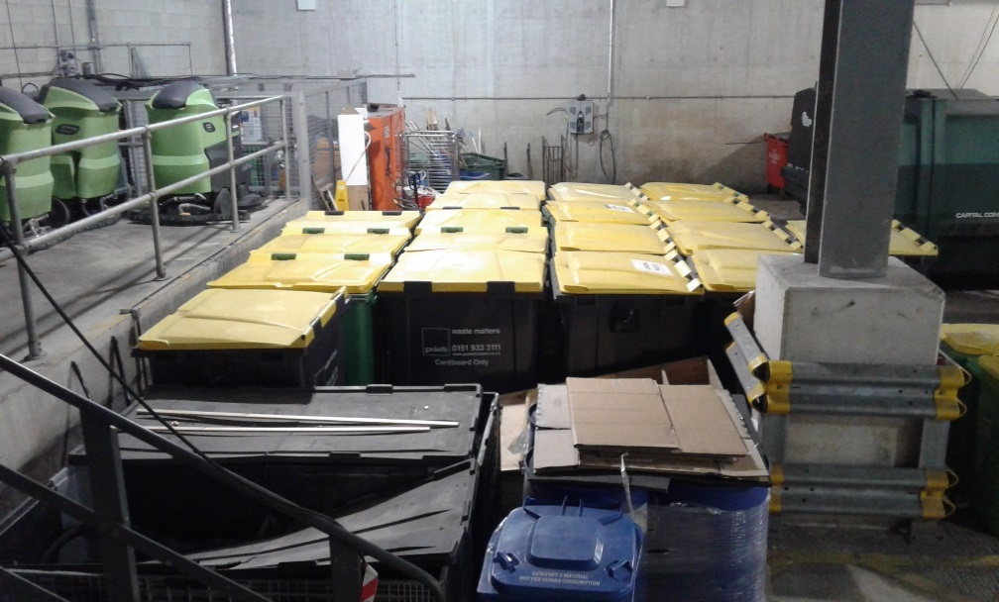

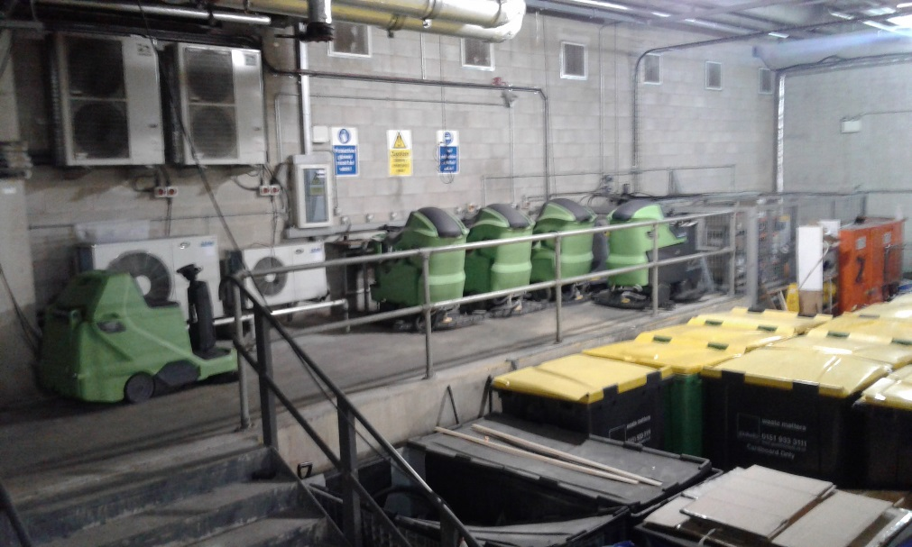

Uniform/PPE Cleaning Standards
These are the standards that we need to maintain, to enable staff and users to enjoy a safe environment, whilst maintaining Health and safety and visual awareness of who’s who.

Arena Uniform – Event
To be agreed upon award

Venue Checks
Venue checks are a valuable tool in maintaining the standards we require, to enable staff and users to enjoy a safe and hygienic environment, whilst maintaining the buildings furnishings, fittings and adhering to health and safety regulations at all times.
Checks must be diarised so that they happen without fail.
Whilst doing the checks of your areas please look out for the following:
- Defects and damage to the structure of the building
- Items left in areas that do not belong there
- Any damage to furniture
- Any damage to signage
- Wear and tear of carpets
- General cleaning standards

On each venue check please note any of the above that you come across regardless of whether this has been reported before.
Once completed please hand the form over to service desk who will the complete their relevant section and then upload the form the relevant folder so that this can then be accessed by all so we can all track checks and the progress of these.
If for any reason you are not able to complete your check due to annual leave etc. please ensure that you pass this check onto a colleague to complete in your absence.

Venue Check Form
Name: |  | Type of check:
Areas checked: |  | Date Completed:
Damage or defects found
(Please make note of area and type of defect – Please be as accurate as possible)

Service Desk
Jobs entered onto EBMS | Yes | ☒ | No | ☐
Jobs scanned to relevant folder | Yes | ☒ | No | ☐
Date completed | Yes | ☒ | No | ☐

Additional Information
Is there any more information to note?

Signed:
Venue Check Schedule
The Venue Checks Schedule incorporates all departments from across the business to ensure that all areas are maintained to the highest standards.
An example of a typical Venue Check Schedule is below. You should take the time to familiarise yourself with your areas of responsibility and diarise the checks accordingly so they are not missed.

Venue Check Due
Venue Check Not Due
Venue Check Complete

Service Partner Induction

Who Are We?
ACC Liverpool is part of The ACC Liverpool Group - a family of world-class venues, experiences and services for the local, national and international events market.
Currently our group includes Destination Venue ACC Liverpool, home to BT Convention Centre, Echo Arena and Exhibition Centre Liverpool and our ticketing agency TicketQuarter.
What we do?
We strive to be at the heart of Liverpool's cultural and economic success, and our passion for the city is matched only by the commitment we show to our customers.
Through the venues we operate and the services we provide, our focus is to attract business and visitors to Liverpool, contributing to the long-term growth and prosperity of our group, our city and its people.
How We Work
Ambitious - We always strive for better for our clients, our visitors and for us. We never settle for second best.
Straightforward - We say it how it is. We are transparent, honest and trustworthy. We are easy to work for and do business with.
Versatile - We are adaptable and dynamic, ready for anything and prepared to tackle every challenge head on.
Welcoming - We welcome people, cultures and ideas from all walks of life. We value all views and opinions.

ACC Liverpool Regeneration Effect

- Economic Contribution of £1.3billion
- 50% increase in footfall for Albert Dock
- Massive Profile for Liverpool (Opening Ceremony, MTV, SPOTY, Sea Odyssey, MOBO’s, Labour Party Conference, Davis Cup).

Our Brands


Looking After our Visitors
Our Customers are the reason you are here and quite rightly expect;
- To be treated fairly, with courtesy, with friendliness and good humour.
- To be given adequate directions, information and assistance.
- Not to be kept waiting too long.
- We must ensure that the customer leaves with those expectations exceeded.

Standards
- First Impressions are key
- It is essential for all staff to be in their correct uniform at all times including dark days.
- Be aware at all times of a customer approaching. Smile and say hello or say goodbye as they leave.
- Treat every customer with genuine friendliness. Unless you have a very good reason to suspect that a customer is a potential threat or danger to others, he or she must be treated with the maximum of respect and friendliness.
- Smile and show good humour whenever it is appropriate, which we hope will be most of the time. When handling incidents such as distraught parents whose child is lost or a customer who is otherwise distressed, smiles and good humour should be replaced with genuine concern and an obvious wish to help

Be Knowledgeable
Be efficient and confident in giving directions. Much of the contact you will have will be with customers seeking directions. Before taking up your position for the day, you should walk around your immediate area until you are confident you can direct people to the following:
- Entrance and Exit Points
- Box Office
- Toilets/Baby Changing
- Accessible Facilities
- Catering & Merchandise Units
- Smoking Areas
- Cash Points
- Seating & Meeting Areas
- First Aid
- Prayer Room

Smoking Areas:
There are three designated staff smoking areas:
- At the top of loading bay 2.
- On the riverside of the convention centre near the staff entrance.
- Loading Bay 3, adjacent to Hall A

Smoking is not permitted in any other areas

Policies
- Workplace Monitoring - CCTV
- Loan and Removal of Items from Site
- Reporting Accidents or Safety Concerns
- Contact with the Media
- Staff Searching
- Social Media
- Ticketing

The ACC Liverpool Group has CCTV across the business for security and monitoring purposes. The ACC Liverpool Group reserves the right to use CCTV surveillance including covert CCTV surveillance for the protection, benefit and safety of staff, and in particular for the detection and prevention of crime.
The ACC Liverpool Group may access this information if criminal activity or gross misconduct of employees is suspected.

Service Partner employees need to have approval from ACC Front of House Manager/Contracts Manager/ Head of Event Support for the loan of any equipment / items from site. If a Service Partner employee is in any doubt about the removal of an item from site, they should speak to their Manager. Failure to adhere to this policy may result in an allegation of theft or attempted theft, which is a gross misconduct offence.

Service Partner Employees are not permitted to disclose information or opinions to the media. Service Partner Employees who are approached directly by the media should report this immediately to their line Manager/ FOH manager.
An employee who discloses information or opinions directly to the media may be referred to the Company’s Disciplinary Policy.

Unauthorized contact with the media regarding the Company, other employees, stakeholders or customers may also constitute gross misconduct.
If a Service Partner employee has an accident on the premises, they must report it to their line manager as soon as possible. If in the course of their job a Service Partner employee witnesses an accident they must report this to their line manager/ FOH Manager.

If an employee identifies anything that could cause harm to themselves or others, they must report this to their line manager/ FOH Manager immediately. If an employee is unsure about how to carry out a work task safely, they must ask the line manager for clarity.

Eating & Drinking
Food and drink are only to be consumed in designated areas as specified by your supervisor.

Sweets, gum or other snacks are not to be consumed whist on duty in any public areas.

Mobile Phones

Please ensure your mobile phone is turned off and out of sight whilst in any public areas.



Radio Channels – to be shared upon award.

1 |  | 12
2 |  | 13
3 |  | 14
4 |  | 15
5 |  | 16
6 |  | 17
7 |  | 18
8 |  | 19
9 |  | 20
10 |  | 21
11 |  | 22

 | Duty Director | FOH | Cleaners | FM | Security | Venue Services | Catering
ECL – Channel 2
Arena – Channel 3
CC - Channel 4

Health & Safety Law
All workers have a right to work in places where risks to their health and safety are properly controlled. Health and safety is about stopping you getting hurt at work or ill through work. Your employer is responsible for health and safety but you must help.

Please ask your supervisor / manager for the location of your company’s policies, procedures and risk assessments.

First Aid
- Know your First Aiders
- How to contact them
- First Aid locations
- Defibrillator locations
- Accident Reporting Procedures

On hearing the alarm:
- Raise the alarm - Dial xxxx / Use hand held radio channel x / Activate the nearest manual call point / Alert the nearest person with a radio or telephone. Give location and nature of the incident. Remove persons in immediate danger to safety. Close doors behind you. Only tackle fire if exit is obstructed
- Leave the building - Immediately leave the building by the nearest exit. Do not use lifts. Do not stop to collect personal belongings
- Report to assembly point - Muster on the piazza. Locate your team to confirm your presence. Do not re-enter the building until instructed

Security Alert Procedure
What do I do if I discover a suspect package/item/vehicle or person acting suspiciously?

- Discretely clear the immediate area if possible and ring (do not use your radio) the control room on xxxx informing them that you believe you have discovered a suspect package/item/vehicle/person
- The police will want to interview you and it is therefore essential that you remain onsite
