**DCHS/WP7138 – Requirements Specification**

CAITT Audit Tracking System

**For Circulation**

**Document Control Sheet**

|  |  |
| --- | --- |
| **Document name** | Clinical Records Audit |
| **Document Reference** | DCHS/WP7138 |
| **Subject Area** | SharePoint |
| **Category** | Work Packages |
| **Status** | For Circulation |
| **Version** | v 1.1 |
| **Author** | Neil Wilson & Andrew Brewster |
| **Approved by** | James Chisholm & Tracy Bailey |
| **Department** | Information Systems Development |
| **Target Audience** | DCHS |
| **Date** | 10/01/2014 |

# Document History

Document Location

The source of the document will be found in the locations below.

Paper Copy -

Electronic Copy – Auto updated in the document footer

Revision HistoryDate of next revision:

|  |  |  |  |  |
| --- | --- | --- | --- | --- |
| **Revision** | **Revision Date** | **Summary Of Changes** | **Change Author** | **Changes Marked** |
| 1.0 | 02/01/2014 | Original Version | Neil Wilson & Andrew Brewster | n/a |
| 1.1 | 10/01/2014 | Section 8.1 – Minor changes to text  Section 8.2.1 – Admin Screen  Section 8.2.2 – Removal of ‘ongoing’ field from screenshots.  Additional fields for Audit Report attachments. This will reflect what the user as selected for ‘Frequency of Audit Reports’.  Section 8.2.3 – Removal of ‘Quarterly Progress Update’ field for data collection only.  Section 8.2.4 – New section explaining archive functionality.  Section 8.2.5 – Minor changes to text  Section 24 – Changes to ‘On-going- field and ‘Audit Report Attachment’ field. | Neil Wilson | No |
|  |  |  |  |  |
|  |  |  |  |  |

Approvals This document requires the following approvals.

|  |  |  |  |  |
| --- | --- | --- | --- | --- |
| **Name** | **Signature** | **Job Title** | **Date of Issue** | **Version** |
| James Chisholm |  | Information Manager | 10/01/2014 | 1.1 |
| Tracy Bailey |  | Clinical Audit Team Co-ordinator | 10/01/2014 | 1.1 |
|  |  |  |  |  |
|  |  |  |  |  |

Distribution This document has been distributed to:

|  |  |  |  |
| --- | --- | --- | --- |
| **Name** | **Job Title** | **Date of Issue** | **Version** |
| Julie Painter | Head of Systems, Standards and Governance |  | 1.1 |
| Andy Counsell | Data Acquisition and Processing Manager |  | 1.1 |
|  |  |  |  |
|  |  |  |  |

# Contents

1 Document History 2

2 Contents 4

3 DATE 4

4 TEAM OR PERSON AUTHORISED 4

5 PURPOSE 5

6 AUDIENCE 5

7 INTRODUCTION 5

8 REQUIREMENTS SPECIFICATION DELIVERABLES 5

8.1 Overview 5

8.2 Forms 6

8.2.1 New/Existing Audit Plans 6

8.2.2 Add a new Audit Plan 8

8.2.3 Data Collection Only 11

8.2.4 Archive of Audit Records 12

8.2.5 Notifications 12

8.3 Testing 12

8.4 Deployment 13

8.5 Training and support 13

9 TECHNIQUES/PROCESSES/PROCEDURES TO BE USED 13

10 INTERFACES TO BE SATISFIED BY THE WORK 13

11 INTERFACES TO BE MAINTAINED DURING THE WORK 13

12 QUALITY 14

13 CONFIGURATION MANAGEMENT REQUIREMENTS 14

14 SERVICE LEVEL AGREEMENT 14

15 BUSINESS CONTINUITY MANAGEMENT 14

16 TIMESCALES & COSTS 14

17 JOINT AGREEMENT 15

18 SIGN OFF REQUIREMENTS 15

19 WORK RETURN ARRANGEMENTS 15

20 COMPLETION 15

21 CONSTRAINTS 15

22 INDEPENDENT QUALITY-CHECKING ARRANGEMENTS 15

23 PROBLEMS 15

24 APPENDIX 1 16

# DATE

02/01/2014

# TEAM OR PERSON AUTHORISED

Information Systems Development Team

# PURPOSE

The purpose of the system designed is to allow users to submit on-line audit plans and routinely update these on progress made. This will allow progress to be monitored and reported on a regular basis.

# AUDIENCE

The proposed Audience will be the Information and Clinical Audit Teams at Derbyshire Community Health Services (DCHS).

# INTRODUCTION

A key Care Quality Commission (CQC) compliance indicator is for DCHS to evidence their current compliance to clinical audits undertaken across the Trust for mandatory audits. The audits are undertaken across a wide range of services and sites and a system is required to track these audits and report on progress and compliance routinely.

# REQUIREMENTS SPECIFICATION DELIVERABLES

## Overview

A SharePoint solution is required with data being stored on a SQL 2008 relational database, allowing the Provider Business Intelligence Team to design, develop and deploy reporting solutions.

The user will access the clinical audit and service plan information within SharePoint 2010. Below figure 1 demonstrates what the user might see.

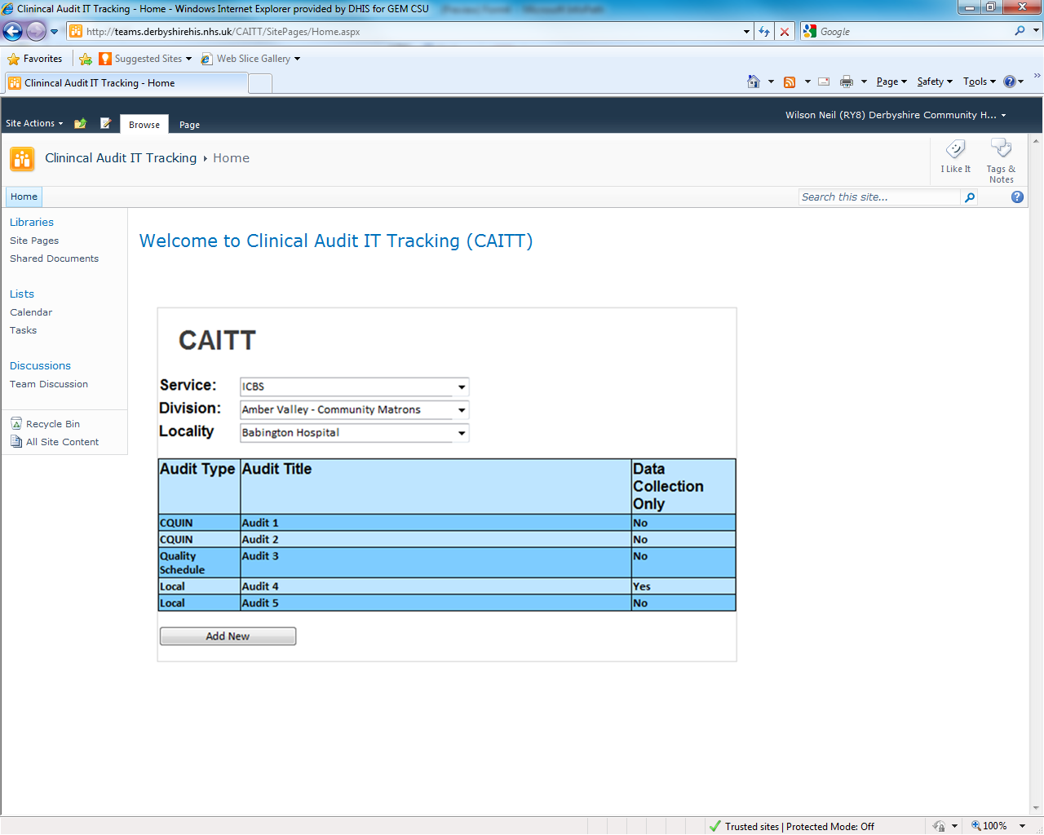

*Figure 1 - CAITT Solution integrated within SharePoint 2010*

## Forms

The forms in the next section will provide an example on how they might look within SharePoint 2010.

### New/Existing Audit Plans

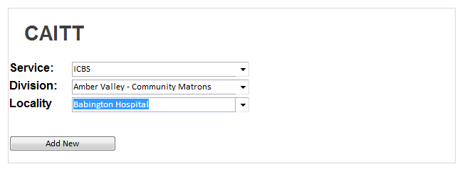

*Figure 2 – User can add new audit plan*

The user will be able to add new or amend existing audit plans. They will select the service, division and locality and this will then list audit plans if they exist (see figure 3). If the audit plans do not exist then the user can select ‘Add New’ to create a new one (see figure 2).

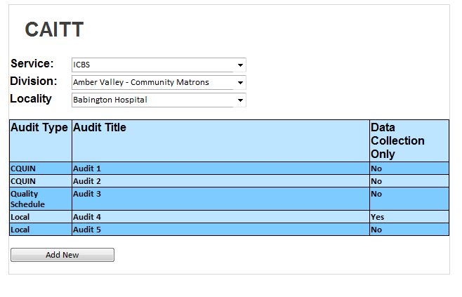

*Figure 3 – Existing Audit plans can be selected*

If the user has been assigned the role of an administrator then they will be able to see both live and archived audits. (See figure 3a)

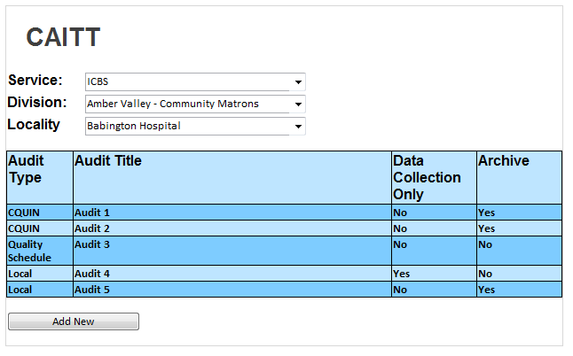

*Figure 3a – Administrator role will be able to view live and archived audits*

### Add a new Audit Plan

If the user clicks on ‘Add New’ a new CAITT template will be created. The user can then proceed to complete all the relevant information. See figure 4.

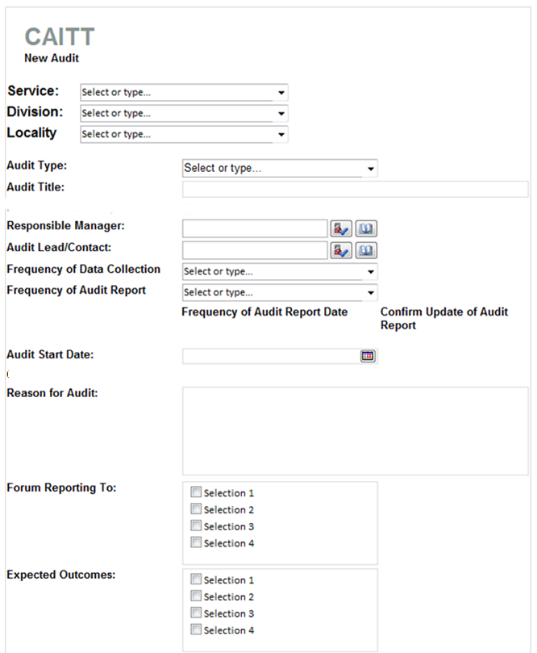

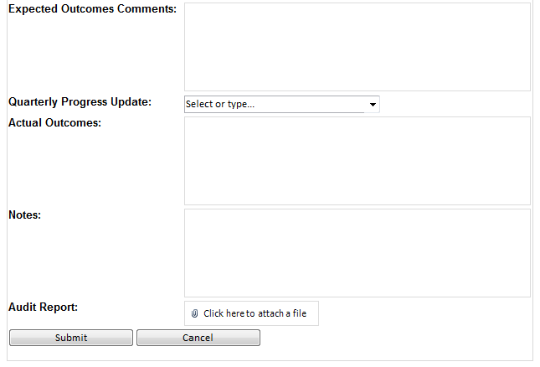

*Figure 4 – New CAITT Template*

The user will complete the form and add the audit plan to the CAITT template as shown in figure 5.

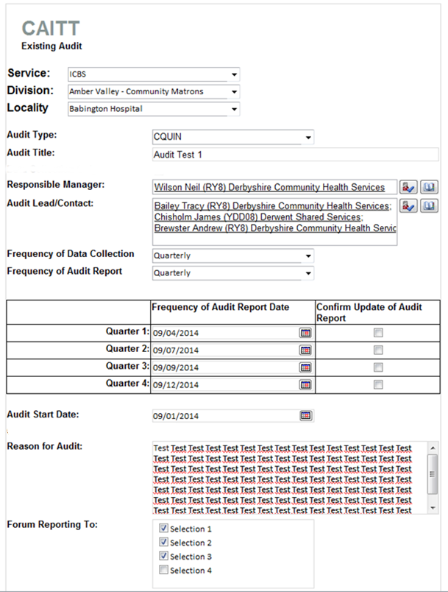

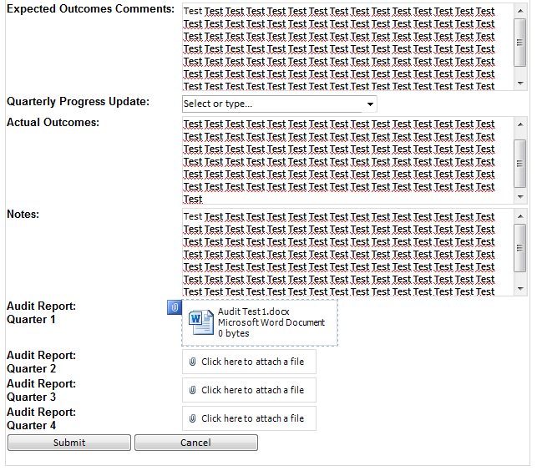

*Figure 5 – Completed Audit Plan*

Appendix 1 detail fields that are mandatory and non-mandatory giving further information on additional rules and logic that is required.

### Data Collection Only

If the user selects an audit type of ‘Data Collection Only’ only certain fields will be available for completion. Figure 6 demonstrates this and appendix 1 details these further.

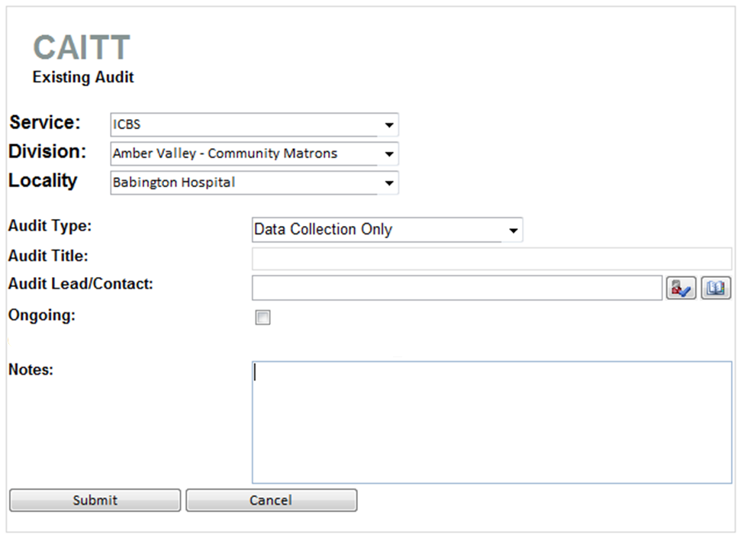

*Figure 6 – Data Collection Only View*

Once completed (see figure 7) the user can then submit the information.

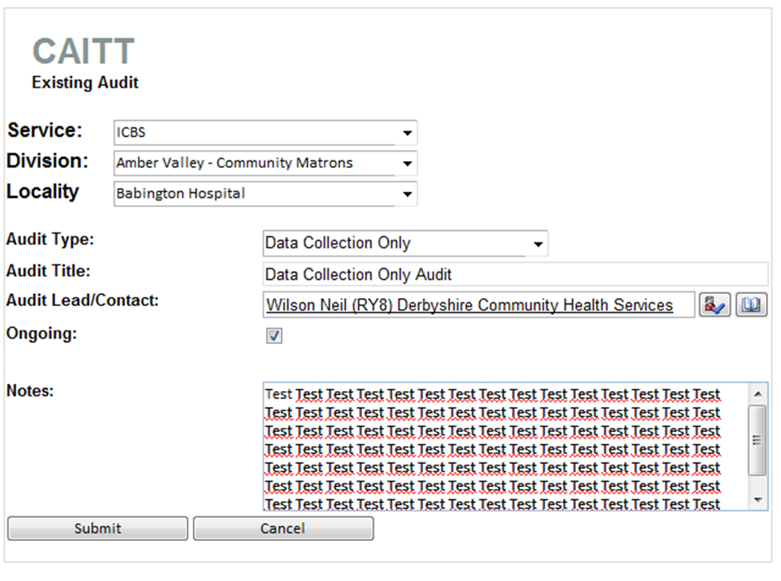

### Archive of Audit Records

Once the user has submitted the final report the records audit will be flagged as archived. Only the administrator will be able to then see archived audits (see figure 3a).

### Notifications

A key element of the application solution is the notification functionality. At certain stages of the audit report emails will be sent to both the responsible manager and clinical audit team. These will notify whether the audit report updates are overdue, please see appendix 1 for further information.

## Testing

This task includes the following:

* Review of site by the Information Systems Development Team
  + Review functionality of each feature
  + Review processes
* Review of site by the client
* Modifications to the site after reviews
* User verification period

## Deployment

This task includes the following:

* Deployment onto the Production Server
* Addition of all Web Parts and Solution files

## Training and support

The task includes the following:

* A training day will be included within the initial go-Live period with the administrators in order to cover all the aspects, features and design benefits of the system.
* A verification period will take affect once the site has gone live.
* Any additional training sessions may be required.

# TECHNIQUES/PROCESSES/PROCEDURES TO BE USED

A combination of the PRINCE2 project management methodology with an iterative and incremental software development process e.g. Unified Process. The focus of the system will be to provide a product which fits into the continued business justification of the Standards Investigation Register Members.

# INTERFACES TO BE SATISFIED BY THE WORK

n/a

# INTERFACES TO BE MAINTAINED DURING THE WORK

Any contact with the client will be initiated through the Information Systems Team Leader or Systems, Standards & Governance Manager.

# QUALITY

Reviewed by the Information Systems Development Team.

# CONFIGURATION MANAGEMENT REQUIREMENTS

All documents created will be attached to the Work Package on the DHIS Local document management system.

# SERVICE LEVEL AGREEMENT

N/A.

# BUSINESS CONTINUITY MANAGEMENT

The team site will be subject to a regular overnight backup and SQL backups will also be taken overnight. An off-site service as part of a business continuity plan, which provides for re-location of data and web applications in the event of a disaster, will be maintained. This is in accordance with the SLA agreement.

In the event of a disaster and loss of service the web site will be re-established in accordance with the DHIS disaster recovery procedures.

# TIMESCALES & COSTS

Below details the cost and timescales to design, build and deploy the site.

|  |  |  |  |  |
| --- | --- | --- | --- | --- |
| **Task** | **Task Name** | **Days (Est.)** | **Cost (Est.)** | **Comments** |
|  | Functional Specification and review |  |  |  |
|  | Set-up of development area |  |  |  |
|  | Development of CAITT |  |  |  |
|  | Integration Testing |  |  |  |
|  | Systems Testing |  |  |  |
|  | Acceptance Testing |  |  |  |
|  | Application re-work |  |  |  |
|  | Deployment |  |  |  |
|  | Verification Period |  |  |  |
|  | **Total** |  |  |  |

The actual start date and finish date will need to be agreed with the client, prior to the commencement of the development work.

# JOINT AGREEMENT

Timescales may slip if the following occurs:

* Client requests changes to the site during any phase of the project. If this affects the overall timescales and costs this would then be highlighted to the client.
* In the event that there is a problem with the DHIS resource assigned to the development of the site, the client will be notified within 1 working day. A meeting will then be arranged to discuss the impact and consequences of this.

# SIGN OFF REQUIREMENTS

Completion of the work needs to be signed off by:

* Client Representative
* Information Systems Development Team Leader or Systems Team Leader and Systems, Standards & Governance Manager

# WORK RETURN ARRANGEMENTS

n/a

# COMPLETION

The Team Member will inform the Information Systems Team Leader and Systems, Standards & Governance Manager once the work is completed.

# CONSTRAINTS

Only development outlined within this functional specification should be completed.

# INDEPENDENT QUALITY-CHECKING ARRANGEMENTS

Additional quality checks may be done by the client.

# PROBLEMS

The Team Member will ensure any problems, queries, issues and changes are logged with the Information Systems Development Team Leader as soon as they arise.

The Information Systems Development Team Leader will be responsible for ensuring that each Project Issue is examined by the appropriate people, update the risk log if necessary, and recommend a course of action.

Issues will be examined on at least a twice weekly basis.

Problems reported in the first instance to the Information Systems Development Team Leader. Where issues cannot be resolved at the level of the Information Systems Development Team Leader, they can be escalated to the Systems, Standards & Governance Manager.

# APPENDIX 1

|  |  |  |  |  |
| --- | --- | --- | --- | --- |
| **Field Name** | **Type** | **Mandatory**  **Field** | **Authorised to amend form** | **Rules/Notes** |
| Division | Drop-Down List | Yes | Admin |  |
| Service | Drop-Down List | Yes | Admin |  |
| Audit Type | Drop-Down List | Yes | Admin | CQUIN  Quality Schedule  Local  Data Collection Only  All fields apart from the following will be hidden if **Data Collection Only** selected:  **Audit Type**  **Audit Title**  **Audit Lead/Contact**  **Ongoing**  **Update**  **Notes** |
| Audit Title | Drop-Down List | Yes | Admin | If CQUIN or Quality Schedule then DROP-DOWN List ELSE  Free Text |
| Responsible Manager | People Picker | Yes | Admin | One person only |
| Audit Lead/Contact | People Picker | Yes | Admin | One person only |
| Frequency of Data Collection | Drop-Down List | Yes | Admin | Monthly  Quarterly  Bi-Annually  Annually |
| Frequency of Audit Report | Drop-Down List | Yes | Admin | Quarterly  Bi-Annually  Annually  Email generated and sent to Responsible Manager and CAITT Mailbox if Audit Report is not updated, based on the **Confirm Update of Audit Report** being flagged.  Based on **Audit Start Date** |
| Frequency of Audit Report Date | Date Picker | Yes | Admin | Quarterly – 4 Date picker fields  Bi-Annually – 2 date picker field  Annually – 1 date picker field |
| Confirm Update of Audit Report | Check Box |  | Admin/User | Linked to **Frequency of Audit Report**.  If this is ticked then this will confirm the Audit report has been submitted. |
| Audit Start Date | Date Picker | Yes | Admin |  |
| Ongoing | Check Box |  | Admin | Only visible for Data Collection Only |
| Reason for Audit | Free Text | Yes | Admin |  |
| Forum Reporting to | Choice (Multiple selection) | Yes | Admin |  |
| Expected Outcomes | Drop-Down List (Multiple Selection) | Yes | Admin | Pre-defined List |
| Expected Outcomes Comments | Free Text | No | Admin |  |
| Quarterly Progress Update | Pre-Defined List | Yes | Admin/User | If overdue then an email will be sent to the **Responsible Manager** |
| Actual Outcomes | Free Text | Yes | Admin | Linked to Frequency of Audit Report |
| Notes |  | No | Admin |  |
| Report | Attachment | Yes | Admin/User | Report attached – Linked to **Frequency of Audit Report**.  Quarterly – 4 attachment fields  Bi-Annually – 2 attachment fields  Annually – 1 attachment field |