Memorandum of Information:

Adult Substance Misuse Services

Appendix 1 - Briefing Paper on Problematic Substance Misuse in Medway

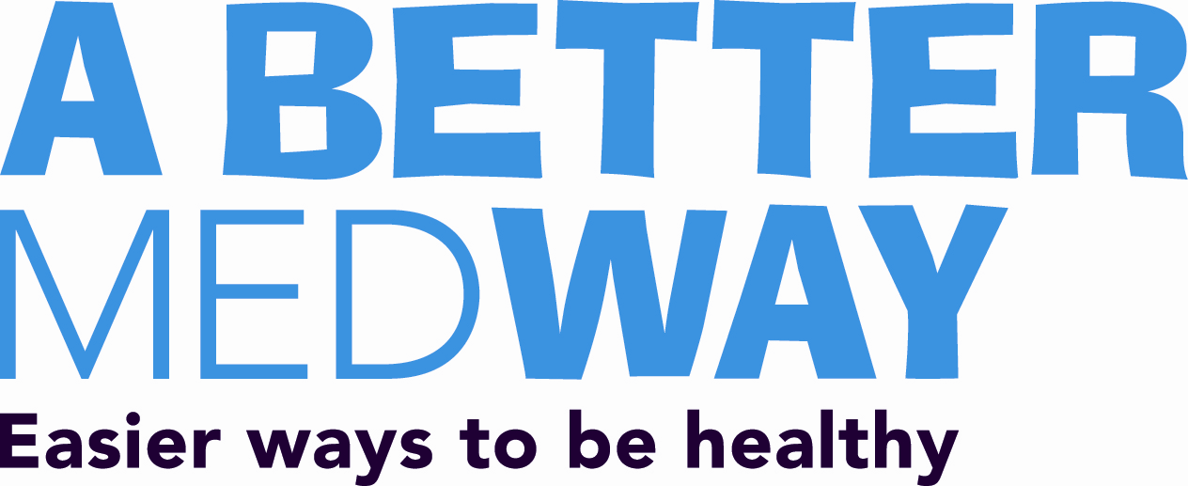

Briefing Paper
The population of Medway is estimated to be 268,218 people with an almost equal number of males and females. 89,278 people living in Medway are aged under 25 years and the population of those aged 25-49 is 92,282.
Medway is less ethnically diverse than the population of England as a whole; 89.6% of residents are from ‘White’ ethnic groups, 4.8% Asian and 2.5% Black.
Medway residents and communities experience a range of the issues linked with the problematic use of drugs and alcohol, including associated levels of offending, anti social behaviour, poor health and involvement of statutory (including social care provision) and non statutory services.
Whilst there are problems reported by users of non opiate drugs,( for example cocaine and cannabis) and use of alcohol at ‘risky’ levels, the primary focus for specialist treatment has been on provision for opiate users and dependent alcohol users. Current estimates project there are 1,291 Opiate and Crack Cocaine Users in Medway (1) alongside significant numbers of higher risk alcohol misusers (a projected 12,088 (2) ) and 2,808 (3) dependent alcohol misusers individuals in the area. At any one time there are approximately 650 opiate users and 250 alcohol users accessing current structured community based specialist provision (see NDTMS DOMES Quarter 2 2016-2017 Report attached).
Of the adults who started drug treatment in 2015-16:
• 61% were male & 39% female
• 26% were below 40, 60% were aged 40-59 and 14% were aged 60+ - with an older profile
than the national averages.
A recent Scoping Project completed in February 2017 for Medway Council Public Health Department offered insight in to the nature of the opiate using cohort in particular, revealing:
- The opiate using population have had contact with specialist treatment for significant periods, with over 25% in treatment continuously for 4 years or more and 43% accessing treatment on and off for over 10 years.
- Medway also has a higher than average rate of people using opiates for over 21 years
- There are higher than national average rates of people in treatment who have mental health and housing problems. Medway has more than half of its opiate treatment population assessed as having “high” or “very high” levels of complexity (higher than the Local Outcome Comparator).
In line with the wider national experience It is also noticeable that Medway has not experienced any recent growth in new users of opiates and the numbers in treatment have remained stable for over 5 years.
Medway has had an integrated drug and alcohol community based specialist treatment service with a single identity provider in place since 1st July 2014, replacing a previous model offering individual specialist services to alcohol users, opiate users and criminal justice referrals.
Whilst this change to a integrated model has been successful in improving performance – with rises in the rates of successful completions of treatment for opiate users (5% in 2015; 7.8% in last Quarter) and alcohol users. The Council want to build on this success by further developing the provision of a more client centred clinical service and promoting the growth of a recovery community in Medway.
We will be commissioning two distinct services during 2017-2018, for a contract start date of 1st April 2018:
- An Assessment, Engagement and Treatment Service (AET) that will offer access to a range of low and high threshold services including: Needle exchange provision; access to clinically safe substitute prescribing services for opiate dependent and alcohol dependent adults; group work options; a community rehabilitation programme; a community based detoxification provision.
- A recovery service delivered in the community and utilising the principles of peer mentoring models, enabling access to pre existing resources that promote recovery from dependent substance misuse.
The relationship between the two services must be robust, to actively promote and support the transition from treatment to recovery, enabling individuals to rebuild meaningful lives and relationships in the Medway area. We encourage current providers of recovery orientated services who have not previously delivered specialist provision for substance misusers to express an interest in the recovery service as we are aware of the significant amount of expertise and knowledge within the voluntary sector in developing and delivering innovative new resources that promote service user involvement.
Given the profile of opiate users in treatment – increasingly ageing and having spent significant periods in contact with specialist treatment - we are looking for a provider of clinical services that can demonstrate a record of applying principles such as segmentation (4) to inform approaches to planning and delivering specialist treatment for opiate users who require a prescribing intervention and individualised treatment and recovery planning.
Medway Council also seek to improve the joint working relationships between specialist treatment and children’s and adults social care services, to address the effects of problematic substance misuse on families and children. The new Assessment, Engagement and Treatment Service will be required to develop innovative new ways of offering service access to ‘hard to reach’ groups, including: street homeless population and members of emerging communities, building on current local initiatives such as the Medway Blue Light Operations Group.
Medway Council Public Health Department currently provide a range of successful interventions and services to support healthier lifestyles (including smoking cessation, more active lifestyles and healthier diets) and we require new services that embrace opportunities to embed public health interventions in treatment delivery alongside providing specialist advice and training to public health professionals.
Outcomes
Whilst a complete set of outcomes and key performance indicators will be developed for distribution alongside the Service Specifications, the service models will be required to evidence delivery against the following key Public Health Outcome Framework Indicators (PHOF) :
 | 2.15i Number of users of opiates that left drug treatment successfully (free of drug(s) of dependence) who do not then re-present to treatment again within 6 months as a proportion of the total number of opiate users in treatment
  2.15 Drug and alcohol treatment
  completion and drug deaths
 | 2.15ii Number of users of non-opiates that left drug treatment successfully (free of drug(s) of dependence) who do not then re-present to treatment again within 6 months as a proportion of the total number of non-opiate users in treatment
 | 2.15iii Number of alcohol only clients that left substance misuse treatment successfully who do not then re-present to treatment within 6 months as a proportion of the total number of alcohol only clients in treatment
 | 2.15iv The rate of drug misuse deaths per million population over a three year period
2.16 Adults with substance misuse treatment need who successfully engage in community-based structured treatment following release from prison | 2.16 Adults with a substance misuse treatment need who successfully engage in community-based structured treatment following release from prison

The provider of the AET will also be required to contribute to the delivery of a range of other PHOF indicators by Medway Public health and key partners (including smoking cessation); the provider of the Recovery Service will be supported with contributing to the delivery of other PHOF indicators. Relevant indicators will be agreed as part of the tendering and contracting arrangements.

Strategic Plans
There are a series of Medway overarching plans and strategies that the services will be expected to contribute to – including Medway Sustainable Community Strategy; Housing Strategy; Council plan 2016 - 17 to 2020 – 21; Medway Adult Social Care Strategy 2016‐2020; Community Safety Plan, and Action Plan; Health and Well Being Strategy.

(1) ‘Estimates of number of adults with opiate dependence’, University of Sheffield, March 2017
(2) ‘Older Adults and Alcohol: A Needs Audit’, Medway Council, 2016.
(3) ‘Estimates of alcohol dependence in England’, University of Sheffield, March 2017
(4) ‘Medications in Recovery: Re Orientating Drug Dependence Treatment’, National Treatment Agency, 2012

