

BUYER: The Secretary of State for the Home Department acting through Border Force

specification of requirements

HMC Valiant
Planned Maintenance and Safety Equipment Recertification period.

November 2024

Project_18154

Contents
Definitions 4
Part 1: General 7
1.0 Background 7
Part 2: Insurance 7
2.0 Insurance 7
Part 3: Objectives, Location and Constraints 8
3.0 Objectives 8
4.0 Location 8
5.0 Constraints 8
Part 4: Provision of Services 9
6.0 General Provision 9
7.0 Project Management 10
8.0 Warranty 12
Part 5: Emergent Work 13
9.0 Emergent Work 13
Part 6: Trials, Certification and Acceptance 14
10.0 Trials 14
11.0 Certification and Survey Reports 14
12.0 Project Completion 14
Part 7: Charges and Payment 15
13.0 Charges and Payment 15
Annex A: General Requirements of Work 16
Annex B: Inspection, Testing and Certification of Safety Equipment 17
Annex C: Vessel Maintenance Tasks 18
Annex D: Modifications and Defect Rectification 19
Annex D: Modifications and Defect Rectification (Reference Pictures) 23
Annex E: Docking Plan 24

Annex F: Vessel Details 25
Annex G: Emergent Work Individual Item Proforma 26
Annex H: Emergent Work Item Record Spreadsheet 27
Annex I: Project Completion Certificate 28
Annex J: Reimbursable Expenses 29
Annex K: Paint Specification 30
Annex L: Lubrication Specification 31
Annex M: Border Force SOP 08 32
Annex N: Survey reports 33
Annex O: PCM Meeting Agenda 34
Annex P: General Arrangements 36

For more information on how HM Government classifies its information to ensure it is appropriately protected and your role in that protection, please visit:
https://www.gov.uk/government/publications/government-security-classifications

Definitions
Phrase | Definition
Acceptance | The Buyer will formally complete Acceptance of the Vessel at the Project Completion Meeting by the issue of an Acceptance certificate to the Supplier, which will be duly signed by the BFOO on behalf of the Buyer, when all specified items of the requirement or authorised EW tasks have been completed satisfactorily.
After-Service | A single phone number of the Supplier giving access to a technical point of contact able to give user friendly assistance to Buyer staff experiencing technical complications with any part or operation of the Cutters.
Alongside Berth | A suitable quay/berth with at least year-round 1m depth below Low Water Spring Tides (LWS) complete with safe access by gangway.
Buyer | Border Force (BF)
BFOO | Border Force Overseeing Officer
Cardinal Date Plan (CDP) | A plan provided by the Supplier mapping out the significant dates for a project
Cutter | His Majesty’s Cutter (HMC) Valiant
Defect Rectification | Work undertaken to resolve any defect identified and listed in the work package at Annex D.
Emergent Work (EW) | Any additional work that emerges from the specified Planned Maintenance, which is notified to the Supplier in this Statement of Requirements.  Any repairs which are required as a direct result of defects/damage found during this package of works.
Lloyd’s Register | Lloyd’s Register’s Rules and Regulations set standards for the design, construction and lifetime maintenance of ships, offshore units, and land-based installations.
Major Defect | Any defect or fault which reduces the performance of the Cutter, so it is unable to safely perform its duties rendering the vessel inoperable or unseaworthy.
MCA | Maritime and Coastguard Agency
Minor Defect | Any defect or fault which reduces the performance of the Cutter while allowing it to safely perform its duties and remain seaworthy.
Original Equipment Manufacturer (OEM) | The original manufacturer of a piece of equipment.
Project Progress Meeting (PPM) | A formal Progress Meeting to be conducted between the BFOO and the PM weekly for the duration of the contract at a date and time to be agreed as part of contract mobilisation and following award.
Project Completion | Formal notification by the BFOO, on behalf of the Buyer, to the Supplier that the project is completed to a satisfactory standard. The Supplier will be issued a Project Completion confirmation.  Failure, by the Supplier, to complete all specified items and authorised EW tasks may result in a delay in the issuing of the Project Completion confirmation and a delay in payment for services rendered.
Project Conclusion Meeting (PCM) | The mandated project close-down meeting between Supplier and BFOO.
Project Initiation Meeting (PIM) | The mandated, initial, meeting between Supplier and BFOO.
Planned Maintenance | The package of works as detailed as detailed in the Specification of Requirements.
Project Manager (PM) | A member of the Supplier’s staff who is responsible for the overall planning and execution of a project. PM to be available via phone or email the lifetime during the Working Day.
Progress Report | A formal report that is emailed to the BFOO, either on request or as scheduled, giving details of progress against the agreed CDP
Rectification Plan | A plan to rectify a specified defect, giving dates and reasons for relevant actions to effect full rectification of the defect.
Safe Working Load (SWL) | The maximum load a piece of equipment can safely operate under.
Slipway/Dry Dock | A Slipway or Dry Dock of suitable size, complete with dock blocks in accordance with a MTLU supplied docking plan and to the satisfaction of the Border Force Overseeing Officer complete with safe permanent means of access to the Vessel.
SOP 08 | Standard Operating Procedure - Certification sheet of all safety equipment on board.
SQEP | Suitably Qualified and Experienced Personnel.  In order to be classified as SQEP you would need to the achieve the following baselines:  SQEP - Qualification  Qualifications that are current, in date, valid, appropriate to the requirements and issued by a recognised professional body, relevant to the work being undertaken. The minimum level we would expect to be obtained is UK NVQ Level 3, or equivalent.  SQEP - Experience  Having gained knowledge or skill in a particular field over time where we would expect appropriate experience over the last 3 years in the professional trade area concerned.  SQEP - Currency  Any appropriate qualification must be valid for at least 6 months from date of vessel acceptance
Vessel | His Majesty’s Cutter Valiant
Warranty | A guarantee, issued to the Buyer by the Supplier, promising to repair or replace an item or rectify a service level, if necessary, and within a specified period.
WHO | World Health Organisation
Working Location | The area in which the Cutter is operational
Work in Way | This is additional work that occurs before the repairs/maintenance works are started.
Work in Wake | This is additional work that occurs after the repairs/maintenance works are completed.

Part 1: General

1.0 Background
  - The Buyer currently operates a fleet of circa thirty (c.30) sea going patrol craft operating in both UK National and International waters. HMC Valiant is one (1) of four (4) Damen 4207 Class patrol craft that forms part of this fleet.

  - The four Damen 4207 patrol vessels, are built in accordance with Lloyds 100A+ and hold valid MCA International Load line certification.

  - The primary roles of the Cutters are:

    - To provide a mobile, flexible, seaborne force capable of maintaining an effective deterrent against illegal immigration, smuggling and other breaches of the law administered by Border Force both within and outside the territorial waters of the UK in support of the UK’s national security strategy.

    - To increase maritime intelligence, undertake surveillance and improve international liaison in combating illegal immigration, the smuggling of drugs and movement of instruments of terrorism by sea.

    - To intercept suspect vessels in territorial and international waters; and

    - To provide mutual assistance to EU countries, the Channel Isles, the Isle of Man and other partners on the UK border.

  - In addition to these primary responsibilities, Border Force also undertake tasks on behalf of the Ministry of Defence, Maritime and Coastguard Buyer, National Crime Agency, Police and UK Fisheries Agencies.

Part 2: Insurance

2.0 Insurance
2.1 The Supplier is to provide written confirmation and self-certify that they already have, or can commit to obtain, prior to the commencement of the contract, the levels of insurance cover indicated below:
2.1.1 minimum Employer’s (Compulsory) Liability Insurance = £10,000,000.00
2.1.2 Public Liability Insurance = £1,000,000.00
2.1.3 Professional Indemnity Insurance = £1,000,000.00

2.2 The limit of liability, as expressed in § 2.1, is to be for every accident or series of accidents arising from the same event.

2.3 The Supplier’s insurance policy is to cover all employees of the Supplier or any entities sub-contracted by the Supplier, or by the Buyer, during the life of this contract and in the undertaking of this requirement.

2.4 The insurance certificate is to be submitted to the Buyer in .pdf format after contract award.

Part 3: Objectives, Location and Constraints

3.0 Objectives
3.1 The objective of this specification is to provide the requirements for;

3.1.1 the maintenance of equipment and machinery;

3.1.2 the recertification of all safety equipment;

3.1.3 the rectification of specified defects; and, if applicable

3.1.4 conduct modifications to the fabric of the vessel as authorised by the BFOO.

Location
  - Due to the operational Working Location of the Cutter, this requirement is to be undertaken within the following geographical parameters.

4.1.1 The East and South coast of England from Portland to Great Yarmouth.

Constraints
5.1 All specified work must be completed by the Supplier.
5.2 All quotations are to be submitted in currency GBP. The Vessel is a qualifying ship under VAT Notice 744C and zero rated for VAT. Quotes and invoices should therefore not include VAT.
5.3 All work must be completed in accordance with this Specification of Requirements and must be compliant to all applicable industry standards or Flag State regulations and in accordance with all applicable laws.
5.4 All work must be completed in accordance with this Specification of Requirements and must be compliant to all applicable standards or Flag State regulations and in accordance with best industry standards.

5.5 All new parts and equipment fitted are to be supportable for a period of five years following installation. If applicable, these items are to be presented to the BFOO at the PCM.

5.6 All new equipment shall be provided with relevant operator & maintenance documentation, and any applicable certification.

5.7 For the purposes of this requirement, the working week is Monday to Friday and consists of five (5) working days.

5.8 For the purposes of this requirement, the Working Day is to be no less than any eight (8) hour period between 07:00am and 18:00pm.

5.9 The Buyer expects the duration of this requirement to be no longer than fourteen (14) consecutive Working Days.

5.10 The start date for this requirement is to be no later than: 11th November 2024.

5.11 The expiry date for this requirement is to be no later than: 29th November 2024.

5.12 The supplier needs to have the facility to accept the Vessel from Border Force, no later than the start date, and the supplier must provide suitable and secure storage of the Vessel until Maintenance and Safety Equipment Recertification work commences.

Part 4: Provision of Services

General Provision
6.1 The Buyer will appoint a BFOO for the duration of this requirement who shall be entitled to inspect any work, or to have it inspected by their duly authorised representative, at any point during the lifetime of this contract.
6.2 The Buyer may engage with OEM manufacturers under separate commercial arrangements. The Supplier must afford access, as required, and assist with various tasks as instructed by the BFOO under EW process to complete specific work as arranged by the Buyer under a separate arrangement with OEM to this MSER contract.
6.3 The Supplier shall submit a draft CDP (in days) covering the completion of all planned work as part of the formal quotation for this work package. Once agreed by the Buyer, this will form the final CDP to be followed during the lifetime of the contract (including dates for PIM, PCM and weekly meetings).
6.3.1 The CDP will be evaluated and contribute 5% to the total evaluation score.
6.3.2 The CDP shall, in addition to § 6.3:
6.3.2.1 Clearly show the Critical Path, with key milestones.
6.3.2.2 List all Major Headings in Annexes A, B, C and D of the Bidding. Tool
6.3.2.3 List all work in chronological order with relationships clearly shown and logically scheduled across all annexes.
6.3.2.4 Include start and finish dates for all work.
6.3.2.5 Be presented in a reasonable, understandable, and readily readable electronic format.
6.4 During the contract period and during normal working hours, the BFOO and Buyer appointed contractors will be afforded access to all premises of the yard or its supplier’s premises where any parts are being fitted, removed, manufactured, repaired, or serviced.
6.5 The Supplier is to ensure that all tasks are completed by suitably qualified and experienced personnel (SQEP) in relation to the equipment being worked upon. The Supplier may be asked to prove the qualifications of any employees or contractors by the BFOO at any time.
6.6 Where a higher level of qualification is expected, this will be communicated with the Statement of requirements as part of the Work Item.
6.7 If you have any doubts about your qualification, experience and currency meeting these requirements, please clarify with the Buyer as a clarification.
6.8 The Buyer reserves the right to evaluate the qualifications, experience and currency of bids at any point prior to contract award for technical compliance. Your bid may not be accepted if it is not deemed to meet the SQEP criteria.

7.0 Project Management
7.1 As part of the CDP the Supplier must schedule and attend a Project Initiation Meeting (PIM) with the BFOO prior to any works being undertaken on the vessel. The BFOO may request this meeting to be held up to one week before the contract start date and at the Supplier’s premises.
7.2 During the meeting, the BFOO and the Supplier will confirm the following;
7.2.1 the EW process;
7.2.2 berthing arrangements;
7.2.3 any Health and Safety arrangements pertinent to the Supplier’s premises including the Suppliers Covid health protection measures;
7.2.4 Border Force crew accommodation arrangements;
7.2.5 any OEM manufacturers that are expected to work on the vessel during the Supplier’s CDP period; and
7.2.6 The proposed date of the PCM.
7.3 During the course of the CDP, the Supplier is to provide a report to the BFOO within twenty-four hours of the identification of any deviation from the submitted CDP. Any cost implications are to be agreed in accordance with the EW process following authorisation from the BFOO.
7.4 The Supplier must schedule and attend a weekly Project Progress Meeting (PPM) with the BFOO. This meeting is required to be minuted and will be in addition to the brief daily meetings. The PPM agenda must include;
7.4.1 a briefing on project progress on a task-by-task level, as per the CDP;
7.4.2 all approved EW and costs;
7.4.3 all rejected EW and costs;
7.4.3 any sub-contractors’ issues, both from the Supplier and the Buyer; and
7.4.4 any technical issues.
7.5 As part of the CDP the Supplier must schedule and attend a Project Conclusion Meeting (PCM) and confirm the following.
7.5.1 all specified work items contained in Annex’s A, B, C and D , in addition to all authorised EW tasks, have been completed to the satisfaction of the BFOO.
7.5.2 any variations to the specified requirements, as agreed by the BFOO, during the Supplier’s CDP period, have been agreed in accordance with § 7.3.
7.5.3 all Emergent Work Individual Item Proformas have been signed and agreed by the BFOO and the Supplier in accordance with § 9.0;
7.5.4 the Supplier agrees to supply the BFOO with SOP 08 as per Annex B, § 2.0; and
7.5.5 the Supplier and the BFOO agree a project total cost.
7.5.6 The meeting minutes are to be recorded by the Supplier and emailed to the BFOO
7.6 Following the PCM and to the satisfaction of the BFOO, formal notification of completion will be given to the Supplier and a Project Completion Certificate issued in accordance with §12.0.

8.0 Warranty
8.1 The Supplier shall provide an After-Service for reporting faults and obtaining technical advice, during the hours of 08:00 and 16:30, Monday to Friday.

8.2 Response times for the service outlined in § 8.1 shall allow for all faults to be logged, given a reference number and Rectification Plan agreed between all parties within a maximum of two (2) working days of the fault being logged.

8.3 The Supplier shall provide warranty repairs in the event that any of the supplied or repaired parts develops a fault during the parts warranty period as detailed in § 8.6 and § 8.7.

8.4 All Work carried out by the Supplier during the period of this contract shall be covered by a one-year Warranty commencing from the date the Vessel is accepted back into the custody of the Buyer.

8.5 All new parts supplied or fitted during the period of this contract shall be covered by a one-year warranty or such other provided warranty if it is longer than the minimum one year commencing from the date the Vessel is accepted back into the custody of the Buyer.

8.6 In the event that a Warranty Major Defect is notified to the Supplier that will render the Cutter non-operational. The Supplier shall provide services to ensure the Cutter is restored to full working condition within two (2) working days, calculated from the date and time on which the Buyer agrees the Supplier personnel can gain access to the Cutter. In the event a Major Defect cannot be rectified within the assigned period, a Rectification Plan must be agreed with the Buyer within forty-eight hours of identification of the potential failure.

8.7 In the event that a Warranty Minor Defect is notified to the Supplier, other than those that will render the Cutter non-operational, the Supplier shall provide services to ensure the Cutter is restored to full working condition within a maximum of ten working days, calculated from the date and time on which the Buyer agrees the Supplier personnel can gain access to the Cutter. In the event a Minor Defect cannot be rectified within the assigned period, a Rectification Plan must be agreed with the Buyer within forty-eight hours of identification of the potential failure.

Part 5: Emergent Work

9.0 Emergent Work
9.1 The Supplier will not be renumerated for any EW that is not approved by way of a completed and signed Emergent Work Individual Item Proforma.

9.2 All identified EW proposals are to be submitted to the BFOO on the attached Emergent Work Individual Item Proforma (Annex G) prior to the commencement of any work for authorisation by the BFOO.

9.3 The PM for the Supplier is to inform the BFOO if any of the Suppliers employees or contractors have been approached by either; the Vessel commander, the Vessel’s crew or any member of the Buyer’s staff to undertake work not specified in this Specification of Requirements or as part of previously authorised EW task.

9.4 The Supplier is to confirm that they understand the Vessel Commander is unable to commission or authorise work tasks at the PIM.

9.5 The Supplier must ensure any costs or time delays that may impact on the overall project cost or timeline are articulated to the BFOO with the EW proposal.

9.6 If the work is deemed appropriate, the BFOO will authorise the EW on behalf of the Buyer and provide formal acknowledgement of acceptance of the proposal including costs and completion timeframe to the Supplier.

9.7 Any proposals or work that have been undertaken by the Supplier, or a sub-contractor of the Supplier, and that are found to have not been authorised by the BFOO in accordance with § 9.0, upon final invoice submission, will be strictly at the expense of the Supplier and will not be remunerated by the Buyer.

9.8 The Supplier are to record the cumulative EW costs on the attached spreadsheet (Annex H), or in a similar format, which will be cross checked and analysed at the Weekly progress meeting.

9.9 The Supplier will email all authorised Emergent Works Individual Item Proformas along with the overall Emergent Work Item Record Spreadsheet (Annex H), to the BFOO one working day prior to PCM.

9.10 The Supplier must, therefore, liaise with the BFOO for every item of EW that requires consideration before the Supplier commences work.

Part 6: Trials, Certification and Acceptance

10.0 Trials
10.1 On completion of all work and once the Supplier has satisfied themselves that the Cutter is seaworthy, the seaworthiness will be demonstrated to the Buyer who will provide a Project Completion Certificate (provided at Annex I) and confirm the hand back of the Cutter into the Buyer’s custody and responsibility. Where propulsion work has been undertaken, this shall include propulsion and manoeuvring trials measured against original trials data for comparison and include OEM service engineer alongside the Supplier’s own mechanical and electrical service engineers.

10.2 Any trials required shall be to prove that the executed work has been carried out satisfactorily and that the various systems can be checked and confirmed as fully and effectively re-commissioned. Other than fuel, all costs related to the operations of test and trials will be the responsibility of the Supplier.

10.3 Where the Buyer have engaged separate OEM(s), under $ 6.2, these service engineer costs for attendance at Basin Trials will be funded by the Buyer.

10.4 Because of the specialist nature of the Vessel, the Buyer will provide a minimum of five (5) crew members familiar with the navigational, controls and engineering systems of the Cutter during the Sea trials.

11.0 Certification and Survey Reports
11.1 All certification and survey reports (including the list of survey reports at Annex N) required for regulatory compliance, or requested by the Buyer, shall be supplied in hard copy enclosed in clear plastic envelopes within a four-ring ring binder, complete with index. An electronic copy of all certificates and survey reports shall also be forwarded by e-mail to the Buyer in an accessible Microsoft Office format.

12.0 Project Completion
12.1 Once approved by the BFOO, formal notification of Project Completion will be given to the Supplier by the Buyer through the issuing of a Project Completion Certificate (Annex I).

12.2 The Project Completion Certificate will only be issued to the Supplier after:

12.2.1 successful completion of all specified items as stated in this requirement.

12.2.2 the Supplier has formally presented all certificates to the BFOO during the PCM in accordance with § 11; and

12.2.3 upon successful completion of any applicable trials required in response to the work undertaken.

12.3 The issuing of a Project Completion Certificate to the Supplier by the Buyer, or a duly authorised representative of the Buyer, does in no way effect the warranty requirements as specified in this requirement nor the statutory rights of the Buyer.

Part 7: Charges and Payment

13.0 Charges and Payment
13.1 All invoices are to be submitted in GBP and exclusive of VAT.

13.2 All invoice correspondence is to be as per instructions on the Buyer-issued PO document only.

13.3 The Supplier will receive one (1) Purchase Order (PO) number for this requirement. It may be amended by the Buyer, from time to time.

13.4 Upon issue of a PO by the Buyer, and following approval from the BFOO, the Supplier can submit an invoice(s) to the email address provided in accordance with the line-items on the PO document ensuring that all mandatory data is on the Invoice.

13.5 The Supplier is to acknowledge that all travel and subsistence costs related to warranty defect repairs shall be recharged at the Home Office reimbursable travel and subsistence rates as stipulated in Annex J. Any additional costs outside those stated in Annex J are strictly at the expense of the Supplier.

13.7 The Supplier is to ensure that every item of specified work has been completed in line with this Specification of Requirements or they have a formal acknowledgement from the BFOO allowing for non-completion.

13.8 The Supplier is to ensure that all EW tasks are approved by the BFOO, serialised appropriately and signed off and recorded in the EW spreadsheet (Annex H).

13.9 Failure, by the Supplier, to include EW that is compliant with the instructions set out at § 9.0, will result in the Buyer being unable to accept those services for remuneration. If non-compliant tasks, either specified or emergent, are invoiced for payment, these costs will be rejected by the Buyer, and they will be at the expense of the Supplier.

13.10 The Buyer reserves the right to withhold payment from the Supplier, in part or in full, should any, specified or otherwise, condition as expressed in this Specification of requirements, not be successfully met by the Supplier and to the satisfaction of the BFOO.

Annex A: General Requirements of Work
Please see Project_18154 HMC Valiant - MSER - Bidding Tool – v1.0.

Annex B: Inspection, Testing and Certification of Safety Equipment
Please see Project_18154 HMC Valiant - MSER - Bidding Tool – v1.0.
Please see Annex K below for the Paint specification.

Annex C: Vessel Maintenance Tasks
Please see Project_18154 - HMC Valiant - MSER - Bidding Tool – v1.0.
Please see Annex L below for the Lubrication specification.

Annex D: Modifications and Defect Rectification
Please see Project_18154 – HMC Valiant - MSER - Bidding Tool – v1.0.
Defect 10/24 Wheelhouse Doors Fibre Glass blowing

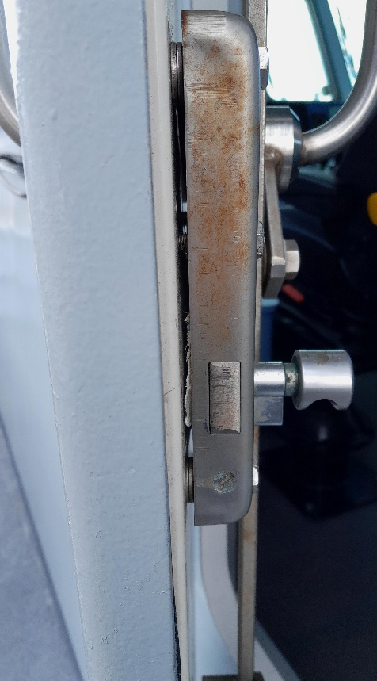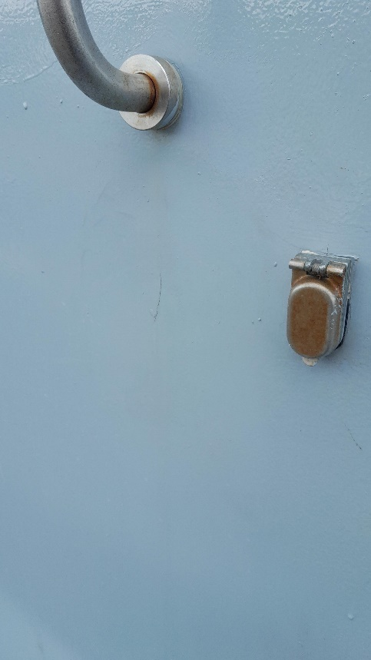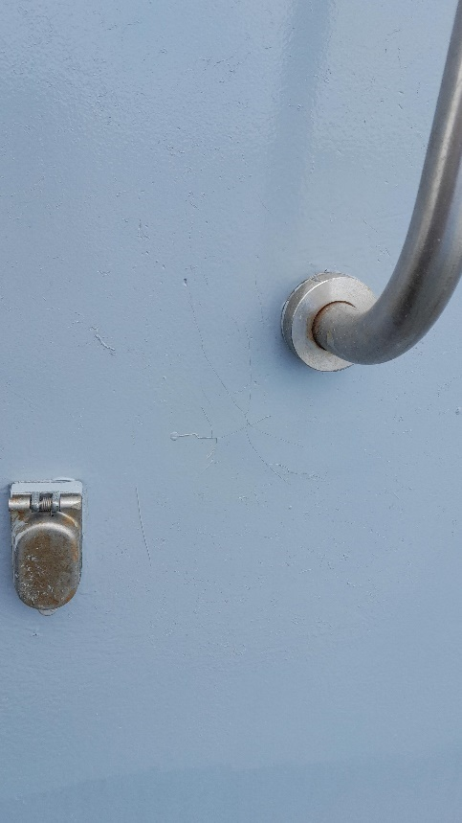

Defect 18/24 Starboard CPP valve block overhaul.
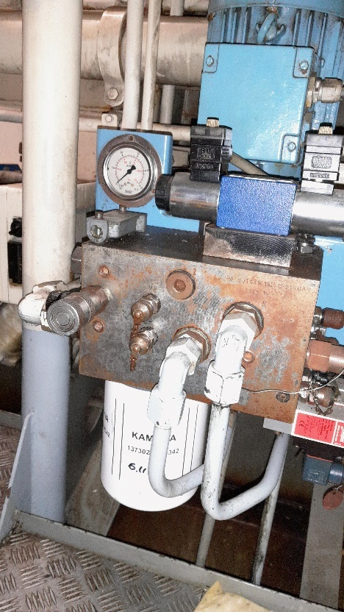

Defect 25/24 Flybridge gratings
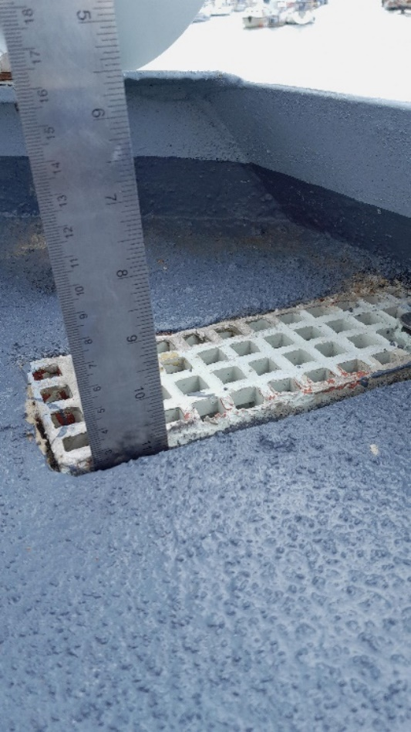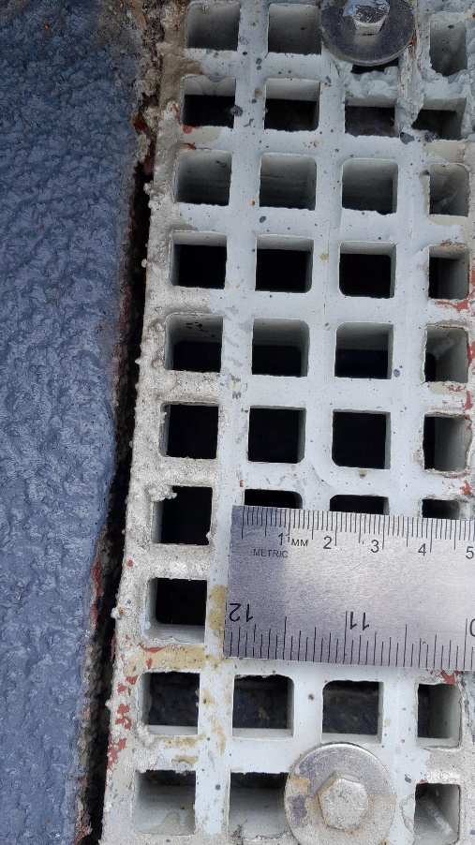
Defect 28/24 Forepeak Hatch spindle
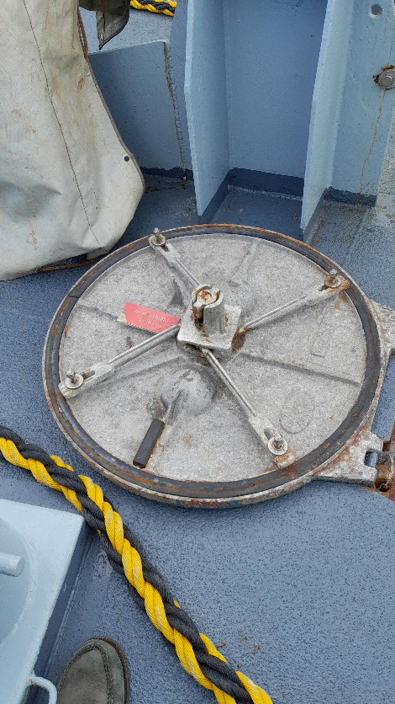

Tank Vents raised
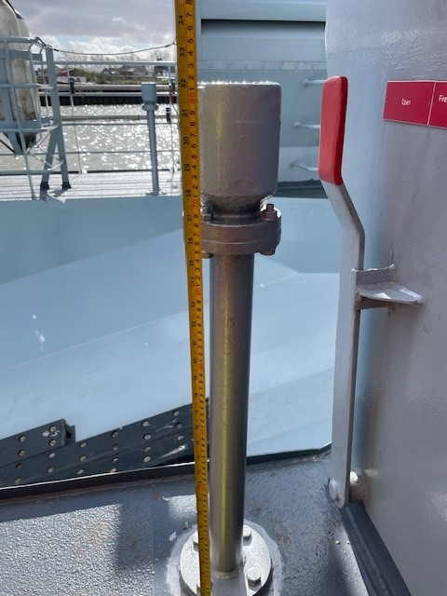 X 9
Forward Hatch Combing Raise
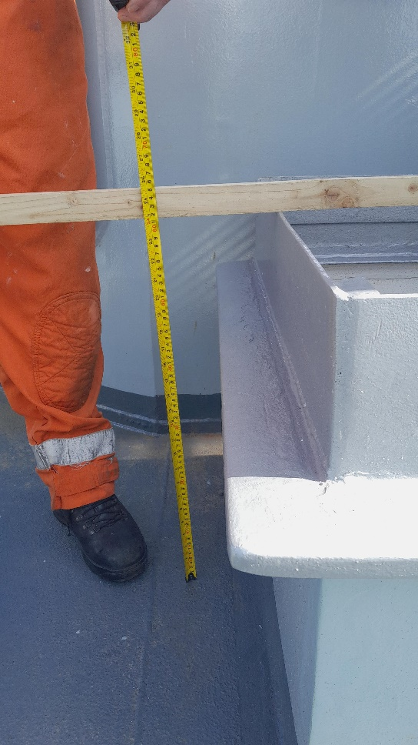 X 1

Annex D: Modifications and Defect Rectification (Reference Pictures)

This page is left blank

Annex E: Docking Plan

This Annex is not required in this project.

Annex F: Vessel Details
 | Name | MMSI | Callsign
 | HMC Valiant | 235745000 | MBLL8
Length overall (LOA) | 42.80 m
Length waterline (LWL) | 42.80 m
Beam Overall | 6.95 m
Draught aft full load | 2.5 m
Ht Overall USK to mast | 17.8 m
Displacement | 251.1 tons
Deadweight | 69.3 tons
Gross Tonnage | 235 tons
Construction | Steel Hull  Aluminium Superstructure
Main Engines | 2x Caterpillar 3156B
Gearbox | 2x Reintjes WLS
Propulsion | 2x Controllable Pitch Propellers
Speeds | 26.50 knots
Manoeuvrability | 2x Rudders
Range / Endurance | Up to 2150 nautical miles at 12 knots
Fuel | 23 cubic metres
Fuel Consumption | Variable
Fresh water | 6 cubic metres
Black Water | 2 cubic metres
Accommodation | 16 persons
Built to | Lloyd’s 100A1 SCC

Annex G: Emergent Work Individual Item Proforma
Emergent Work (EW) Individual Item Proforma |  |  |  | 
EMERGENT WORK ITEM No: Project_18154/001
Description
Signed, BFOO: |  | Date:
PART I: By Supplier
The above item is accepted as a genuine Emergent Work item.
Our Firm Price is*^{Δ}  Our Realistic Estimate is*^{Δ} | £
Signed: | Position:
Signed: | Dated:
TIME PENALTY (if any) ..................................................................... The completion date of the contract* will/will not be affected by this item.
PART II: By BFOO
It is agreed that this is a genuine emergent work item and Buyer is given for the work to be undertaken.
The Above Firm Price/Realistic Estimate* of £ |  |  | ACCEPTED |  | REJECTED
Signed: |  |  | Date:
Notes:
1 * Delete as required
2 ^{Δ} If the costing of an EW task, upon further examination, is projected to vary by ± 10%, the quote must be re-authorised by the BFOO
3 All interactions pertaining to Emergent Work are to be carried out strictly in accordance with Pt. 5, § 8.0.

Annex H: Emergent Work Item Record Spreadsheet
HMC Valiant |  | 
Supplier:
Contract Number: | Project_18154
BFOO:
EMERGENT WORK NUMBER | JOB DESCRIPTION |  | %  COMP
Project_18154/001

Annex I: Project Completion Certificate
Project Completion Certificate |  | 
PART I: to be completed by Supplier
HMC Valiant

HMC Valiant, having completed Project_18154 to the satisfaction of the Buyer and having successfully completed any applicable trials and provided all documentation required under this requirement, Contract Number Project_18154 is this day offered as completed to the Buyer.
Signed: | For and on Behalf of the Supplier:
Print Name: | Date:
PART II: to be completed by The Buyer
By Vessel Commander:
I attended the Project Completion Meeting of HMC Valiant and have satisfied myself that all systems, machinery, and equipment are working satisfactorily. I have inspected the vessel and consider she is in a condition suitable for return to operational service.
Signed: | Print Name / Post:
By BFOO:
HMC Valiant having completed Project_18154 to the satisfaction of the Buyer and having completed all appropriate trials and received all documentation required under the Contract is hereby accepted at.…......... hours.
Signed: | BFOO
Print Name: | Date:
PART III: Warranty
The issuing of a Project Completion Certificate to the Supplier by the Buyer, or a duly authorised representative of the Buyer, does in no way effect the warranty requirements as specified in this requirement nor the statutory rights of the Buyer
Distribution
Original - Retained by the Supplier
Copies to - BFOO

Annex J: Reimbursable Expenses

The Supplier may claim the following Reimbursable Expenses at the rates set out below:
1. Travel
Standard rate of allowance for private cars
Initial 10,000 miles |  | 45p per mile
Additional miles over the initial 10,000 |  | 25p per mile
2. Hotel rates
London |  | £150 per night
All other locations other than London |  | £100 per night

Annex K: Paint Specification

As referred to in Annex B above.

This Paint Specification is Generic to all Border Force Damen 4207 Class of Vessels.

Annex L: Lubrication Specification

As referred to in Annex C above.

Annex M: Border Force SOP 08
SOP 08 will be made available to the Supplier post contract award.

Annex N: Survey reports
- Portable Appliance Testing

- Electrical insulation test results

- Alternator insulation test results

- Reintjes Gearbox

- Intentionally Blank

- Hatches, water test

- Steering Gear inspection

- Bow thruster coupling

- Portable Fire pump service

- Emergency Fire pump

- Hydrophore

- Air Conditioning

- Electrical Starters

  - GS pumps x 2

  - Capstans x 2

  - Anchor Windlass

  - Davit

  - AC pump

13.6 Hydrophore pumps x 2

- Davit

Annex O: PCM Meeting Agenda

Agenda
Title of meeting |  | Project_18154 – HMC Valiant – Project Conclusion Meeting
Date |  | [INSERT AS REQUIRED]
Time
Venue
Attendees |  | (BFOO)  [INSERT AS REQUIRED] (Supplier PM)  [INSERT AS REQUIRED]
Meeting objectives |  | Finalise the period of works for Project_18154 – HMC Valiant – LSA - MSER
Agenda Item | Description |  |  | Lead | Complete
1 | Welcome |  |  | BFOO | Complete
2 | Project Summary |  |  | Supplier PM
3 | Outstanding Work Items
4 | Certificates and Survey Reports  - Delivered  - Outstanding |  |  | Supplier PM  Supplier PM
5 | EW  - Approved Forms  - Rejected Forms |  |  | Supplier PM  BFOO
6 | Spares  - Unused, return of |  |  | Supplier PM
7 | Return of all drawings and manuals |  |  | Supplier PM
8 | Finance  - Outstanding items reimbursement amount  - Final invoice amount |  |  | Supplier PM  BFOO
9 | AOB |  |  | BFOO
Issue Certificate | Project Completion Certificate |  |  | BFOO

NB: The meeting minutes are to be recorded by the Supplier and emailed to the BFOO.

Annex P: General Arrangements

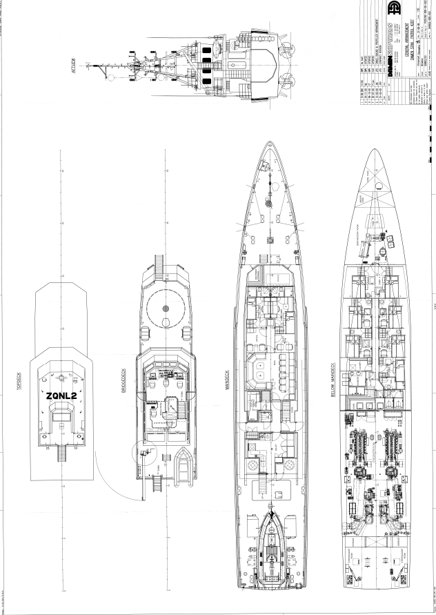

Check UK Qualifications or Check Overseas Qualifications
Ships, trains, aircraft and associated services (VAT Notice 744C) - GOV.UK (www.gov.uk)

