**CONTENTS**

WHATS INCLUDED

OVERVIEW

LOTTING STRUCTURE

TIMESCALES

KEY DELIVERY DATES

CURRENT ROLES AND RESPONSIBILITIES OF THE CUSTOMER

TEST & DEVELOPMENT REQUIREMENTS

REQUIRED CAPABILITIES AND OUTCOMES OF THE SUPPLIER

TERMS AND CONDITIONS

EVALUATION STAGES, MINIMUM PASS MARKS & PRICE EVALUATION

# WHATS INCLUDED

Customer Requirements (this document)

Appendix A – Award Questionnaire (template to be completed)

Appendix B – Supplier Pricing Matrix (template to be completed)

Appendix C – Call-Off Contract (Part A&B) (Customer specific terms)

– Call-Off Contract (Part C) (Standard Terms and Conditions)

Appendix D – Supplier List for Consortium Possibilities (if applicable)

**OVERVIEW**

|  |  |
| --- | --- |
| CCS Project Lead: | Amy Retallack |
| Customer: | Ministry of Justice (HMCTS) |
| Delivery Location: | Croydon |
| Phase(s): | Discovery, Alpha, Beta, Live |
| Project: | DS02- 028 |
| Required Capabilities: | Include, but are not limited to: (mark those that apply) Software engineering and On-going Support  Agile Product Design & Delivery  Front-End Design and Interaction design  Content Design, Editorial and Strategy  System Administrations and Web Operations  User Research (UX Design) |
| Subcontracting Permitted? | ☒ No |
| Supplier Partnering Permitted? | ☒ Yes |
| Contract Charging Mechanism (Discovery Phase): | Time and Materials |
| Contract Charging Mechanism (Alpha Phase): | Time and Materials |
| Contract Charging Mechanism (Beta Phase): | Time and Materials |
| Contract Charging Mechanism (Live Phase): | Time and Materials |
| Tender Publish Date: | 07/10/2015 |
| Tender Submission Deadline: | 23/10/2015 |
| Proposed length of phase: | Discovery: 4 weeksAlpha: 8 weeksBeta: 12 weeksLive: 50 weeks (enhance & deploy all prosecuting authorities) |
| Proposed Commencement Date of Project: | 16/11/2015 |

**LOTTING STRUCTURE**

## The Customer has structured this procurement as follows:

|  |  |
| --- | --- |
| **Lot 1** | Roles including (capabilities and outcomes from these roles are specified later in document):   * Delivery Manager (2) * Agile Business Analyst (2) * Performance analyst (1) |
| **Lot 2** | Roles including (capabilities and outcomes from these roles are specified later in document):   * Technical Architect (2) * Developer (Lead) (2) * Developer (Front End) (4); * Developer (Back End) (4); * Developer (Automated Testing) (2) |
| **Lot 3** | Roles including (capabilities and outcomes from these roles are specified later in document):   * Web Operations (4), |
| **Lot 4** | Roles including (capabilities and outcomes from these roles are specified later in document)   * Content Designer (2); * Designer (User Interaction) (1); |
| **Lot 5** | Roles including (capabilities and outcomes from these roles are specified later in document)   * User Researcher (3) |
| **Lot Notes** | (1) the actual team size required to be confirmed as an outcome of the discovery phase  (2) a number of additional project roles will be provided by the customer (see below)  (3) it is anticipated that input from the following roles will be required during the discovery phase: Delivery Manager (full time); Business Analyst (full time); Designer (User Interaction) (full time); User Researcher (full time); Technical Architect; Developer (Lead). |

**TIMESCALES**

The Customer or CCS may change this timetable at any time. The Potential Provider will be informed by email if there are any changes to this timetable.

## It is the Potential Provider’s responsibility to monitor the online messaging facility (e-Sourcing).

|  |  |  |
| --- | --- | --- |
| **DATE** | **WHO** | **ACTIVITY** |
| 07/10/2015 | CCS | **Publish requirements to Potential Providers**  Clarification period starts |
| |  |  |  | | --- | --- | --- | | 09/10/2015 | CCS, Customer & Potential Providers | **Clarification Webinar 16:15**  Invite to webinar will be issued via the CCS eSourcing Suite. All questions and responses will be published via eSourcing Suite. | | CCS, Customer & Potential Providers | **Clarification Webinar 15:00**  Invite to webinar will be issued via the CCS eSourcing Suite. All questions and responses will be published via eSourcing Suite. |
| 14/10/2015 | Potential Providers | **Clarification Question period closes**  Please submit all clarification questions by 23:59hrs  Please note that we aim to publish all response to Q&A within 24hrs |
| 23/10/2015 | Potential Providers | **Submission Deadline**  Potential Provider must upload submission to the eSourcing suite by 12:00noon |
| 02/11/2015 | Potential Providers & Customer | **Demonstration and Scrutiny** |
| 09/11/2015 |  | **Award Notification**  Publish Successful and un-successful Potential Providers. |
| 16/11/2015 |  | **Expected "Commencement Date" for Call-Off Contract/s** |

**KEY DELIVERY DATES**

|  |  |  |
| --- | --- | --- |
| PROJECT PHASES | START DATE | COMPLETION DATE |
| [Discovery](https://www.gov.uk/service-manual/phases/discovery.html) | 16/11/2015 | 14/12/2015 |
| [Alpha](https://www.gov.uk/service-manual/phases/alpha.html) | 15/12/2015 | 12/02/2016 |
| [Beta](https://www.gov.uk/service-manual/phases/Beta.html) | 15/02/2016 | 15/05/2016 |
| Live (Early Adopter)  Live (National Rollout) | 16/05/2016  15/08/2016 | 12/08/2016  14/04/2017 |

# 

**CURRENT SITUATION / BACKGROUND INFORMATION**

**Programme**

The CJS Common Platform Programme will deliver a unified way of working for HMCTS and CPS. It is a business change programme enabled by the introduction of a single jointly owned data base and IT system to replace existing legacy systems. It aims to transform the experience of staff and all those who participate in the criminal case management process, and supports the objective of a modern, efficient CJS. The Programme is a key work stream within HM Courts & Tribunals Service (HMCTS) Reform Programme.

The Programme will deliver a new unified Crime Business Process Model and supporting IT for CPS and HMCTS to enable criminal cases to be managed and progressed more efficiently and effectively, so that:

* Business is transacted at the lowest possible cost per case;
* The right information is available for decision makers to ensure better outcomes;
* There is an improvement in the experience of people across the system, particularly victims and witnesses;
* The independence of decision makers in the system is protected;
* The level of resources required from other Criminal Justice Organisations and partners is reduced;
* There is a consistent approach to information security and sharing across the CJS;
* There is flexibility to respond to policy and legislative changes.

The current state of the Criminal Justice System has been described as cumbersome, with too many complex procedures and paper based working practices, its use of technology lags behind other public services, and is still characterised by unacceptable delays, complexity which leads to blurred accountabilities, and huge amounts of time and effort unnecessarily going into straightforward cases.

The CJSCP Programme will have a profound impact on the whole Criminal Justice System for decades to come. It will transform the way the CJS works by putting in place a fully digital cross-agency operating system, facilitating digital working from the outset of investigations through to the sentencing and rehabilitation of offenders. Deploying the right technology in the right places has the potential to quickly transform criminal justice from a fragmented, paper-based system to a digital service that provides an efficient customer experience which meets the standards the public rightly expect from a modern public service.

The Programme has worked with users across the system to establish a new, unified Crime Business Process Model for the criminal justice process from pre-charge to disposal, making the most of the opportunities for data sharing, automation and standardisation that a new system would offer. Much of the process will be moved to a new digital channel, allowing defendants, victims, witnesses and professional users to interact with the process on-line. Only actions that absolutely must be conducted in the courtroom will be done there.

The common platform represents a huge step forward in the progression of criminal proceedings which, by itself, is a truly significant undertaking. It will act as a ‘central hub’ that will enable all users to share information and benefit from interacting with it. By doing so, they will adapt and use common standards, driving out inefficiency, delay and duplication, creating accessibility and transparency of information at the right time and place.

**Project**

The programme has a requirement to define and deliver a new end to end service for the handling of Regulatory cases (Summon Only, Non Imprisonable - 740k cases in 2014/15 – 394k Motoring & 346k Non Motoring) dealt with under the Single Justice Procedure (SJP) spanning:

* capture of cases from prosecuting authorities,
* obtaining pleas from defendants (online),
* capture of the court decisions for each case, notifying stakeholders (defendant, prosecutor, enforcement)
* production of orders and notices for distribution by post
* cases involving not-guilty pleas (<10%) or any complicating factors would be adjourned under the SJP process for forward progressing using existing court applications (e.g. Libra)

This process is illustrated below:

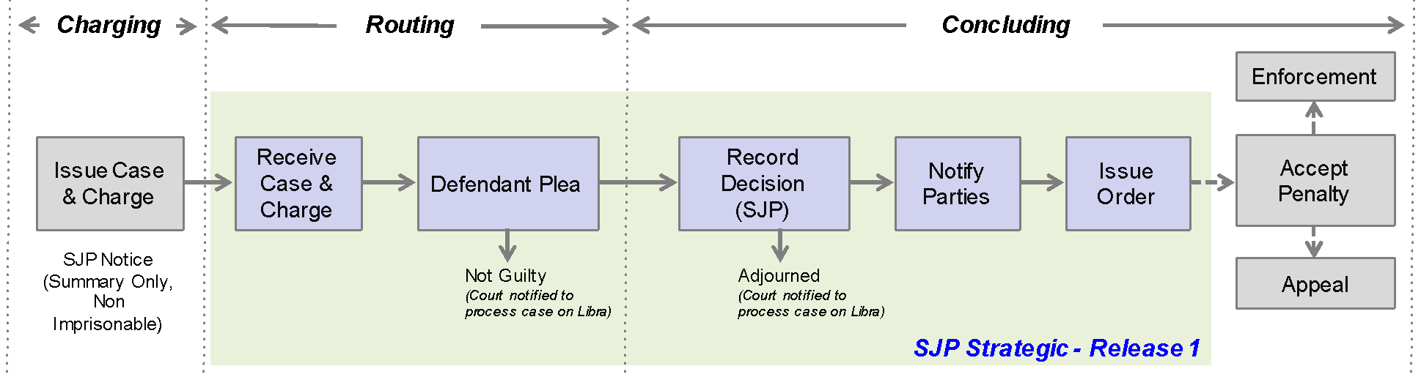

The delivery approach proposed is based on:

* Discovery: involving a sample set of prosecutors, magistrates’ courts and enforcement
* Alpha: focusing on delivery of a Minimal Viable Product, for a single prosecutor with simple cases, offences and court results (e.g. Transport for London (TfL), fare evasion)
* Beta: focusing on technically scaling product and extending to support additional prosecutor types e.g. DVLA, Police through additional mini discovery, alpha, beta iterations as appropriate
* Live: transition to live service and phased deployment across all SJP prosecutors and cases

The following principles have been defined to guide the implementation:

* pilot with thinnest strand of end-to-end business process, that adds value
* design with no dependency on legacy applications
* minimum impact on 3rd Parties (Prosecutors / Enforcement) through use of existing data standards
* convergence towards the programme Strategic Architecture (Business / Technology / Infrastructure)
* interface with the existing online Make a Plea (Defendant Plea) service
* reuse or build on learning from relevant existing delivery where practical (IdAM, DMU, Steel Thread)
* design and implement to readily enable roll out across all SJP prosecutors and court locations

In line with the first principle identified above, it is proposed to implement the initial pilot (alpha) solution for TfL cases:

* single defendant
* single, non-imprisonable offences
* relatively small case load (c. 10k p.a.)
* 99% of cases relate to 6 offence codes
* minimal case management needed (withdraw case)
* basic requirement for electronic notification (plea & decision)
* simple mechanism to receive cases (CSV file)
* simple requirement for production and distribution of court orders
* no involvement of CPS, Defence Solicitors, Victims, Witnesses (for cases with guilty or no plea)

Annex A contains further information on the requirement identified through an initial lightweight discovery.

**CURRENT ROLES AND RESPONSIBILITIES OF THE CUSTOMER**

|  |  |
| --- | --- |
| **Role** | **Responsibilities** |
| Programme Manager | Responsible for the development and leadership of the national business change function within an area of the CJSCP Programme |
| Business Product Owner | Responsible for the business aspects of the delivery, on-going success and continuous improvement of one or more digital products and/or platforms. |
| Project Manager | Responsible for leading and managing the implementation of a project within the CJS Common Platform Programme. |
| Agile Coach | Responsible for the implementation of agile working practices and adherence to GDS Digital by Default standards |
| Business Architect | Responsible for the definition and assurance of the business architecture of projects within the context of the overall CJSCP programme. Works closely with the project Business Product Owner, Business Analyst and lead developer across a cluster of projects. |
| Programme Technical Architect | Responsible for the definition and assurance of the technical architecture of projects within the context of the overall CJSCP programme. |
| Information Assurance | Responsible for the identification of the Information Assurance requirements of a project within the context of the programme and production of associated documents for acceptance of the delivered products by the Senior Information Risk Owner (SIRO). |
| Business Analyst (Reform) | Responsible for collaborating with the project Business Analyst to ensure alignment with related business changes being implemented under the Reform programme. |

**CURRENT TECHNOLOGIES AND LANGUAGES**

The figure below identifies the key technical products that form part of the programme technical architecture standards and are to be used for delivery of the solution.

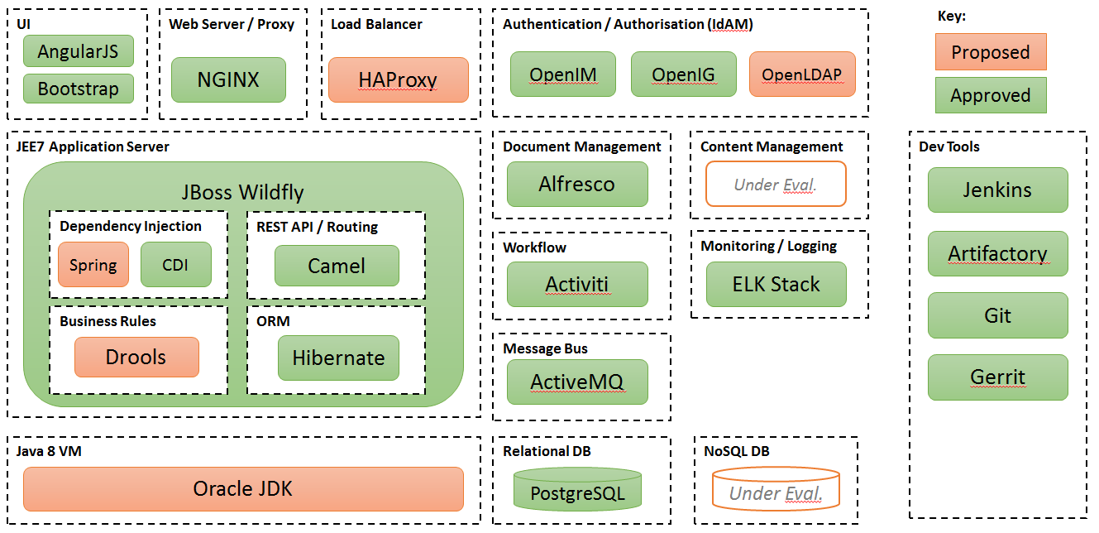

The figure below illustrates the logical development, test and build environments that will be provisioned by the for the supplier to use for the delivery.

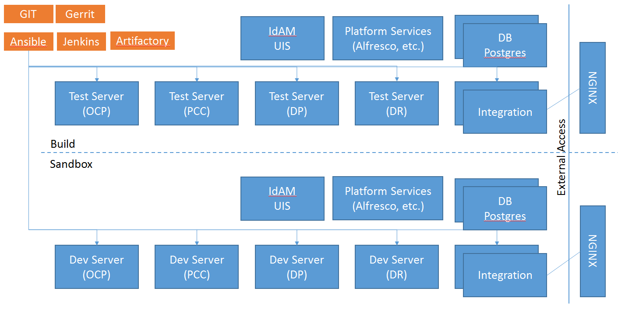

**REQUIRED OUTCOMES**

The following key outcomes required from the project include (but not limited to):

* Discovery Phase:
  + Undertake User Needs Research and Analysis,
  + Define Users Stories (including functional, non-functional, HMCTS Reform, Enforcement, Management Information, Transition, System of Record, Reference Data, aligned with Unified Business Process Model),
  + Define User Journey(s),
  + Prototype Screens (flow, layout, data),
  + Define High Level Solution and Technical Architecture (including integration with Online Plea Service, Enforcement Service, Reference Data, core case management services),
  + Develop Product Roadmap,
  + Define Sprint Plan for Alpha phase,
  + Undertake CJSCP Discovery gate assessment prior to commencing Alpha.
* Alpha Phase:
  + Deliver pilot service for use with TfL cases (including supporting production of information assurance case),
  + Update Product Roadmap,
  + Define Sprint plan for Beta phase,
  + Undertake GDS/CJSCP Alpha gate assessment.
* Beta Phase:
  + Scale application to meet GDS Beta Assessment criteria,
  + Extend product capability to supporting additional prosecutors (including DVLA & Police),
  + Sprint and delivery plan for Live
  + Undertake GDS/CJSCP Beta gate assessment prior to commencing Live phase;
* Live Phase:
  + Scale application to meet GDS Live Assessment criteria,
  + Extend use to additional early adopter prosecuting authorities (e.g. DVLA and a Police Force),
  + Define plans for National rollout,
  + Undertake GDS/CJSCP Live gate assessment.
* Post Live
  + National rollout across all SJP cases, prosecutors and relevant court locations.

**TEST & DEVELOPMENT REQUIREMENTS**

The development, test and production environments (server infrastructure and software e.g. operating system, frameworks, database, application server, web server,) will be made available for the supplier to undertake delivery.

|  |  |
| --- | --- |
| Required Capabilities, Outcomes and Experience of the Supplier | |
| **Capabilities and Roles** | **Outcomes** |
| **Delivery Manager** | The Delivery Manager is responsible for the day to day running of the agile software delivery team, in line with agile scrum principles. The role will have specific skills and experience, including:   * Qualified Scrum Master with 5 years experience in client facing (not internal development) teams * experience of working in a continuous integration environment * be willing to work within the constraints of a pre-defined SDLC * experience of BDD, TDD, MoSCoW, User Stories, Story Points and working in environments with multiple scrum teams. * a capable and confident facilitator * focused on removing blockers and delivering working software in line with business owners direction   They will:   * work with the Business Product Owner to establish and maintain a roadmap and sprint plans for the product to be delivered based on a backlog of prioritized user stories * lead the collaborative, dynamic planning process - prioritising the work that needs to be done against the capacity and capability of the team * ensure all products are built to an appropriate level of quality for the stage (alpha/beta/production) * actively participating in the Delivery Manager community, sharing and re-applying skills and knowledge and bringing in best practice. |
| **Agile Business Analyst** | The Business Analyst will be familiar with a range of digital / web services solutions and have skills and experience in agile development methodologies. They will be an excellent communicator and be able to rationalise complex information to make it understandable for others to work with. The ability to work independently, proactively and with versatility in responding to changing circumstances is essential. They will need an eye for detail, excellent communication skills and be able to interrogate reported information and challenge sources where inconsistencies are found. During this engagement they will work as part of the project team following direction, guidance and approach set by the programme Head of Business Architecture Practice. The Business Analyst will undertake activities to:   * **User Stories** - deliver and maintain a prioritized backlog of user stories in JIRA (covering functional and non-functional requirements), through stakeholder workshops, in sizes capable of being delivered in a single sprint * **Domain Modeling** – define business terms (dictionary) and narratives as part of a Domain Driven Design methodology * **Release Product Planning** - collaborate with the Business Product Owner and Delivery manager to size the user stories and inform sprint plans and product development cycles * **Product Development** - support the development teams through undertaking research and analysis to elaborate the user stories and business process * **Programme Alignment** – support the Business Architect to Align the detailed project user stories with the relevant programme epics * **Interaction Design** - collaborate with the User Researcher and Designer (User Interaction) to ensure quality and alignment with user stories. |
| **Designer (User Interaction)** | The Designer (User Interaction) will undertake activities to deliver the indicative list of items described below for the Automated Track Case management project. During this engagement they will work as part of the project team following direction, guidance and approach set by the programme Head of UX Practice. Specific deliverables to be sequenced according to need and build on existing programme work.   * **Wireframes / prototype** - Produce a detailed set of wireframes/prototype to illustrate the user journeys for target users. * **Permissions model** - In conjunction with the Business Architecture and User Experience practices, incorporate user account management into the user journeys and wireframes. * **Backlog** - Support the Business Analyst’s definition and iteration of user stories through the use of user research (personas, user journeys etc) and wire framing. * **User Journeys** - Collaborating with the User Researcher (Research) on user journeys that describe the product and the user interactions with it. * **Usability Testing** - Collaborating with the User Researcher (Research) on the user testing plan to identify the design elements that need to be tested and how they will be delivered to the user researcher for testing. |
| **User Researcher** | The User Researcher will undertake activities to deliver the indicative items described below for the Automated Track Case management project. During this engagement they will work as part of the project team following direction, guidance and approach set by the programme Head of UX Practice. Specific deliverables to be sequenced according to need and build on existing programme work.   * **User Segmentation & Personas** - Identify target audience and differentiation between their needs. Develop personas to illustrate how they will interface with the common platform functionality. Personas should be in line with the Programme-level user segmentation and be useable by the programme. * **User Journeys** - Generate and document user journeys that describe the product and the user interactions with it. Clearly identify the link between user research, user needs and the business decisions points throughout the user journey. * **Assisted Digital** - Identify any assisted digital requirements that may be required to be developed within the product. This should be articulated as a specific set of user stories and associated acceptance criteria that are then lodged onto the product backlog * **Usability Testing** - Document project’s plan for user testing in ALPHA (guerrilla) and BETA (remote/user groups/1-to-1). Work with the BPO and CP user researchers to profile target users and book usability testing sessions with users to take place in ALPHA. * **Permissions model** - In conjunction with the Business Architecture and User Experience practices, identify how the users’ journey will be impacted by what they should and shouldn’t see, the device they use and the accounts they have. To be developed in conjunction with ongoing work in the Programme in this area. * **Backlog** - Support the Business Analyst’s definition and iteration of user stories through the use of user research (personas, user journeys etc) and wire framing. * **Wireframes** – Support the Designer (User Interaction) to inform the production of wireframes which illustrate key user journeys through the product for target users. * **Customer Satisfaction & Performance Dashboard** - To identify in conjunction with the Product Owner and Subject Matter Experts (SMEs) the requirements and instrumentation required in order to implement a performance dashboard in line with the GDS Service Manual. This includes how customer satisfaction will be benchmarked and measured over time. Visualisation of initial data gathering to generate benchmark should be delivered in Discovery. |
| **Technical Architect** | The Technical Architect will provide hands-on technical leadership across an agile team of developers, in the development, operation and ongoing improvement the services to be delivered under the project. During this engagement they will work under the direction and guidance set by the Programme Technical Architect to ensure the technical architecture delivers aligns with wider programme standards and objectives. The role will:   * have a strong experience of Agile and SOA design and implementation * work across the software solution and specify the infrastructure required * have experience in a multi-tier Java / Open Source delivery and an understanding of micro-services, CQRS and Domain Driven Design methodology * have experience in the key technologies to be used for the delivery (as outlined earlier in this document) * where necessary be able to review developer code * produce good quality technical documentation * work with delivery teams and partners to break technical requirements down into appropriate pieces, and to identify key API requirements for integration with internal and external systems. |
| **Developer (Lead)** | The Developer (Lead) role will provide hands-on software development leadership across an agile team of developers. They will be responsible for working with their team to design, create and improve software products.  The main responsibilities of the role are:   * Building web products to serve a variety of user needs. * Implementing APIs for internal and external use. * Building up a useful, robust automated test suite to support a Continuous Deployment environment. * Being involved in the wider programme development community, identifying good practices we can adopt and sharing our experiences. * Sharing knowledge of tools and techniques with the wider team, both developers and non-developers * Taking part in 2nd-line support of applications and platforms * Can demonstrate insight, interest, experience and drive   The role will have experience in:   * building server-side web applications and detailed knowledge of the programming languages to be used in the project (see list of current technologies above) and understanding and experience of front-end web development (HTML/CSS/JS) * have experience in a multi-tier Java / Open Source delivery and an understanding of micro-services, CQRS and Domain Driven Design methodology * Java 8, 10+ years |
| **Developer (Front End)** | The Developer (Front End) as per Developer (Lead) with skills and experience focused on the front end development of web applications, including AngularJS 2+ years. Front end development will be undertaken using a standard UX framework provided. Agile development team experience is essential. |
| **Developer (Back End)** | The Developer (Back End) as per Developer (Lead) with skills and experience focused on the back end development and integration of web applications, including Java 8, 5+ years. Agile development team experience is essential. |
| **Developer (Automated Test)** | The Developer (Automated Test) as per Developer (Lead) with skills and experience focused on design, implementation and operation of automated testing for the developed applications. Skills and experience required:   * ability to work with users to set and manage quality levels for software * excellent knowledge of test automation design, strategy, planning, best practice, principles and reporting within a BDD delivery * use of the automation tools already in place: JUnit; Headless Selenium; Gerrit; Apache JMeter; Jenkins; SonarQube. * coding of automated test scripts using programme languages with recommended standards and best-practice, including Java 8, 5+ years experience * Agile development team experience is essential. |
| **Web Operations** | The Web Operations role must have demonstrable experience configuring web and application servers and possess a fundamental understanding of the technology stack specified for the project (see current technologies and languages section). An ideal candidate will have previous experience supporting a large production platform.  The duties and responsibilities will include:   * Operational management of servers, delivering a complex web application stack * Building and configuring new server platforms and the automated tooling to do so * Testing, debugging and troubleshooting of platform level problems * Supporting development teams with configuring applications for deployment * Working with developers to optimise existing applications and to design new ones * participate in stand-ups, planning sessions and retrospectives * design, build and run systems for application deployment, systems orchestration and configuration management * encourage everyone (developers, delivery managers, product owners) to think about how new applications will be run and maintained * contribute to designing internal processes needed in the running of a high performance development and operations organization * help everyone understand constraints around security, performance, cost and resulting tradeoffs   The Web Operations role will have specific skills, including:   * a deep understanding of the target operating system * experience of multiple programming languages * common deployment patterns * continuous integration * capacity planning * load and performance testing techniques * highly-available systems design * administration and tuning of production database systems * installation and usage of monitoring tools * knowledge of configuration, deployment and management of web application stacks * configuration management * an interest in or some experience with compliance, auditing and security |
| **Content Designer** | The Content Designer role will have specific skills including:   * extensive experience of writing for the web, with proven ability of creating content that is accessible and usable * exceptional skills in convincing people that user needs and a usable approach is the only way to present information * proven experience in using metrics and user feedback to define/refine content * proven experience of working within a web application development environment, proficient in writing Markdown, picture sourcing and editing * experience in choosing the best format for displaying information to the user * experience in working with content publishing systems   **Competencies required**    Leading and team working   * Building on the inter-dependencies and relationships between teams to create a common purpose * Clarifying and communicating team objectives, bringing a broader perspective to a team so that it can focus on different delivery approaches * Co-ordinating and monitoring team performance, utilising team diversity to maximise effectiveness   Analysing evidence and thinking strategically   * Identifying hidden or emerging issues and proposing decisive strategic action * Probing evidence to identify strategic trends and links * Analysing evidence from diverse sources to generate robust solutions and make timely decisions   Focusing on customers and stakeholders   * Investing time to understand customer and stakeholder expectations and priorities, developing services to meet those needs, including when they change * Anticipating and managing problems, bringing issues and conflict into the open and taking pre-emptive action * Identifying and introducing improved services to deliver customer and stakeholder requirements |
| **Digital Performance Analyst** | Digital Performance Analyst works to specify, collect and present the key performance data and analysis for their service. They will have skills including:   * familiarity with data analysis, web analytics and visualisation tools essential e.g. Google Analytics, Google Refine, Tableau etc * experience of providing performance analysis and recommendations on digital public services   Additionally the role will:   * support the [service manager](https://www.gov.uk/service-manual/the-team/service-manager.html) to make sure their service meets the performance requirements set out in the [Digital by Default Service Standard](https://www.gov.uk/service-manual/digital-by-default) * communicate service performance against key indicators to internal and external stakeholders * ensure high-quality analysis of departmental transaction data * support the procurement of the necessary digital platforms to support automated and real-time collection and presentation of data * share examples of best practice in digital performance management across government * identify delivery obstacles to improving transactional performance in departments and working with teams to overcome those obstacles |

## 

**THE METHODOLOGY**

The CJS Common Platform Programme has adopted the methodologies defined by the Government Digital Service as a basis for delivery. The document attached below is a summary of sections from the Government Service Design Manual <https://www.gov.uk/service-manual>. The work undertaken on the ATCM project is expected to follow the principles as defined within.

The resources provided must be highly collaborative as a team, experienced in modern development practices (e.g.: agile/XP/lean, CI/CD, config-as-code, DDD) that can solve business problems through software development, focusing on both user-need and the non-functional requirements.

They will engage with different facets of the business to discover what good enough quality software, and stable systems mean in context. They will work in parallel with other teams to provide an emerging digital platform.

They will integrate their code early and often, using tests, automation and staged pipelines to get early confidence of changes, to allow them to push code towards other teams without delay, and with confidence, to allow for fast feedback in use.

They will adopt and adapting existing patterns, practices and delivery framework, and use a Domain driven/JIT/emergent design methods to produce working systems incrementally that can be evaluated for fitness.

**GOVERNANCE**

The project delivery will be undertaken in line with the governance arrangements established for the CJSCP Programme. The governance arrangements include:

* Programme Board
* Design Authority
* Business Design Authority
* Design Board (Technical Architecture and Standards)
* CJSCPP/GDS Gate Review (the project governance step to move between discovery, alpha, beta, live)
* Information Assurance

**TERMS AND CONDITIONS**

Please note that Customer specific Terms and Conditions apply to this agreement. Please refer to the Call-Off Contract Part A, for further information. Please note that these terms will supersede the standard terms within Call-Off Contract Part C Call-Off Terms and Conditions

**EVALUATION STAGES, MINIMUM PASS MARKS & PRICE EVALUATION**

## Evaluation will follow the approach below:

## Technical & Cultural evaluation

* Demonstration, Testing and Scrutiny

## Pricing evaluation

**MINIMUM PASS MARKS:**

## In order for Potential Providers to progress they must achieve or exceed the Minimum Pass Mark, as defined in the Award Questionnaire.

|  |  |
| --- | --- |
| Stage 1: Technical & Cultural evaluation | All Potential Providers who achieve the required Minimum Pass Mark for a Lot will be added to the Short List, and will be eligible to continue in the Further Competition. |
| **Stage 2:** Practical Demonstration, and Scrutiny of the resources proposed by the supplier | Suppliers who meet the Minimum Pass Marks specified for Part A Supplier Confirmation, and Part B1 Written Submission; will be required to complete Part B2 Practical Demonstration of a particular skill through an ‘agile interview’ process (specified within the Award Questionnaire) in order to evidence capability.  Supplier resources will be required to respond to the Scrutiny questions stipulated within the Award Questionnaire. Each shortlisted Supplier must achieve the Minimum Pass Marks identified in the Award Questionnaire to continue in the Further Competition. |
| Stage 3: Pricing evaluation | For each Further Competition the Customer has a choice as to how they wish the pricing to be evaluated. In this instance the Customer has specified combined evaluation as their chosen price evaluation method. For more information please see the Evaluation Guidance document held on the e-Sourcing suite. Please note that pricing will only be evaluated for those shortlisted suppliers that have met the Minimum Pass Marks for the preceding evaluation stages |

**Annex A – Supplementary Information**

This annex contains supplementary information that aims to describe the nature of the service(s) to be delivered by the supplier. It is anticipated that the output from the discovery phase will supersede this information.

**Epics -** The figure below illustrates the epics associated with the high level process described earlier in this document.

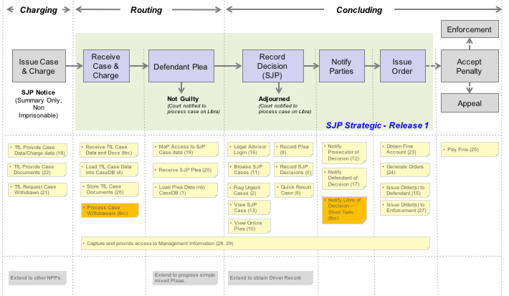

**Solution Components -** The figure below illustrates the potential components required within the solution.

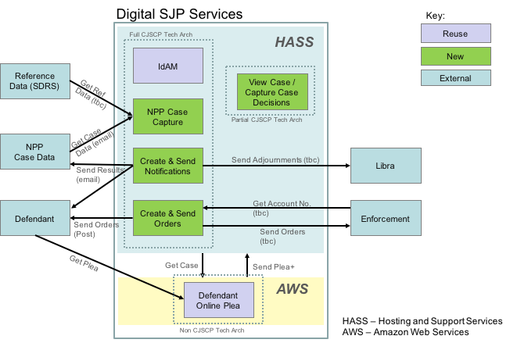

**Application Architecture** - The figure below illustrates the Command Query Responsibility Segregation (CQRS) pattern adopted as a standard by the programme.

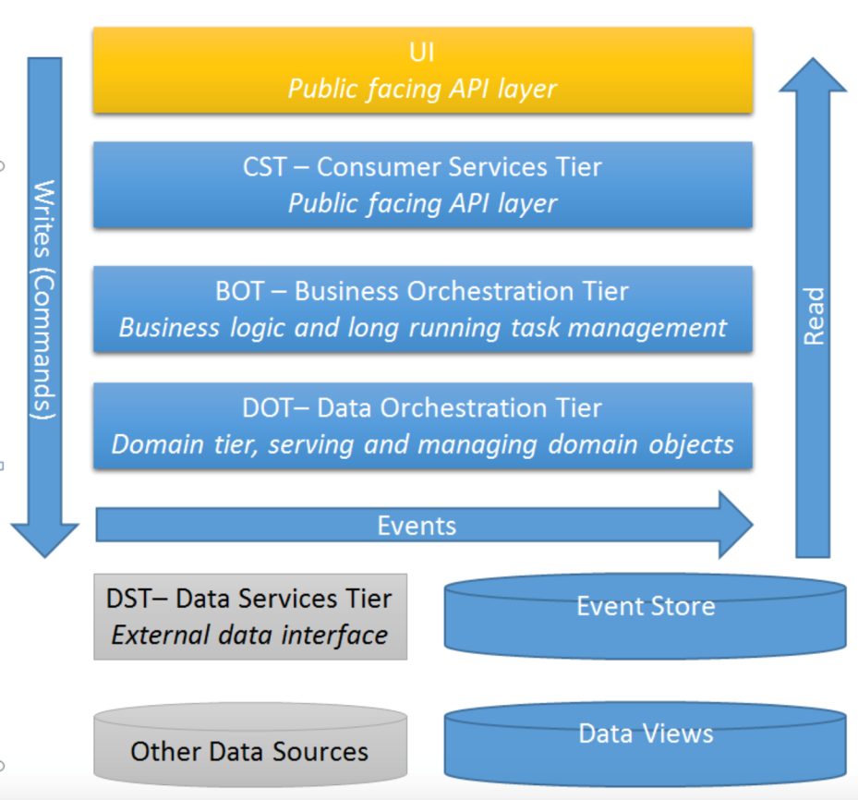

**Prototyping** - An early prototype has been developed for the courts to work through and record decisions on SJP cases. The figures below illustrate the functionality required for a Legal Advisor:

1. to select a group of cases to work on during the SJP Session

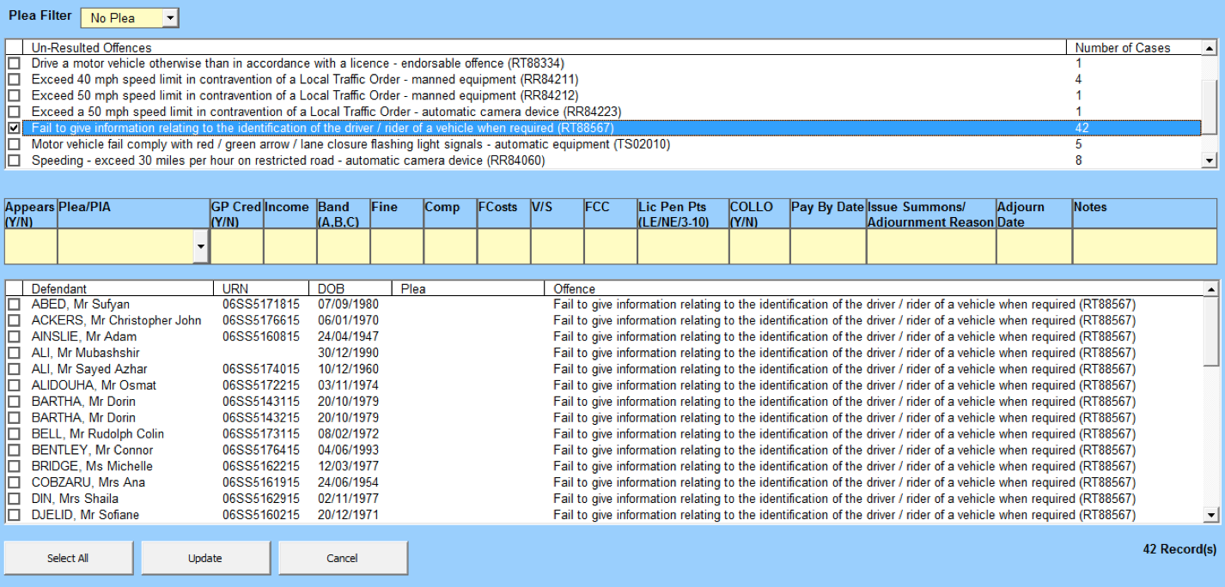

1. to record information for a court SJP Session and decisions on SJP cases during the Session

