CSW-JETS Registration

1.To access CSW-JETS type www.csw-jets.co.uk into your web browser.
2.When you get to the below screen click the highlighted button (Register Here).

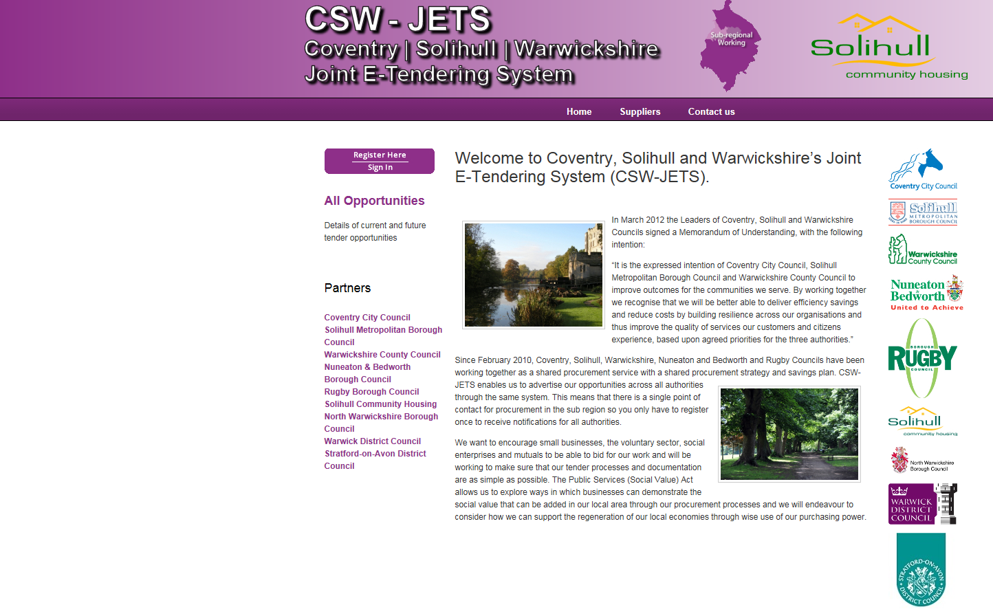
3.This will take you to the following page. When here click the button ‘Register’.
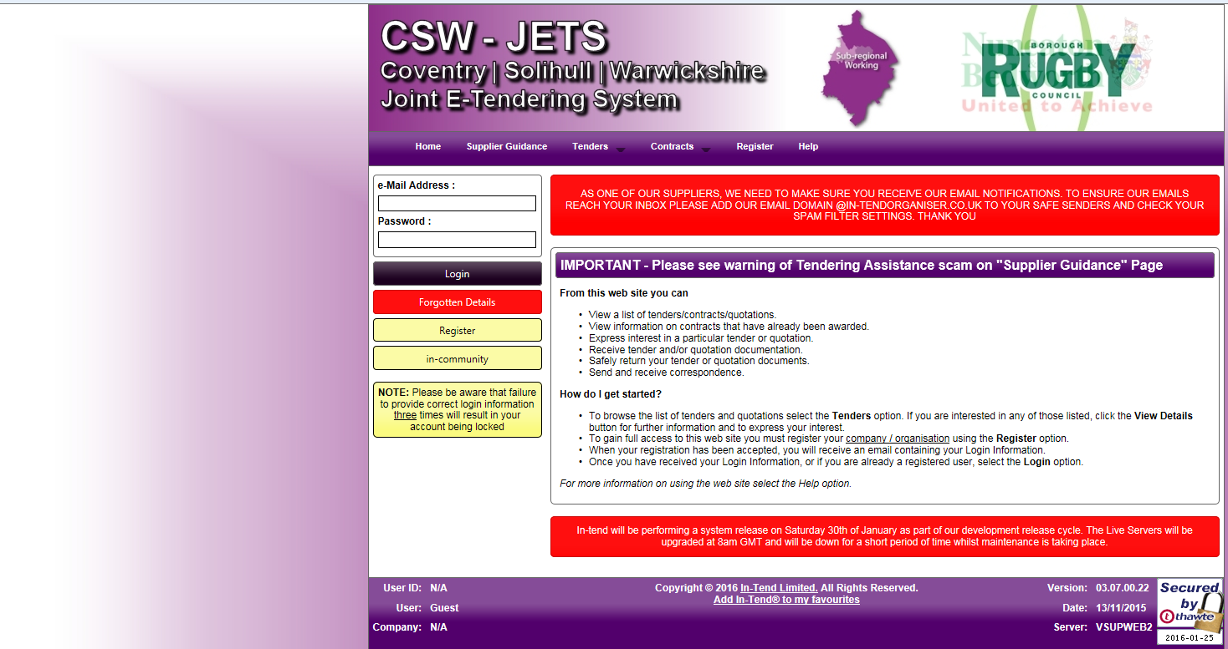

4.Fill in your company details on the following page. Yellow boxes are mandatory.
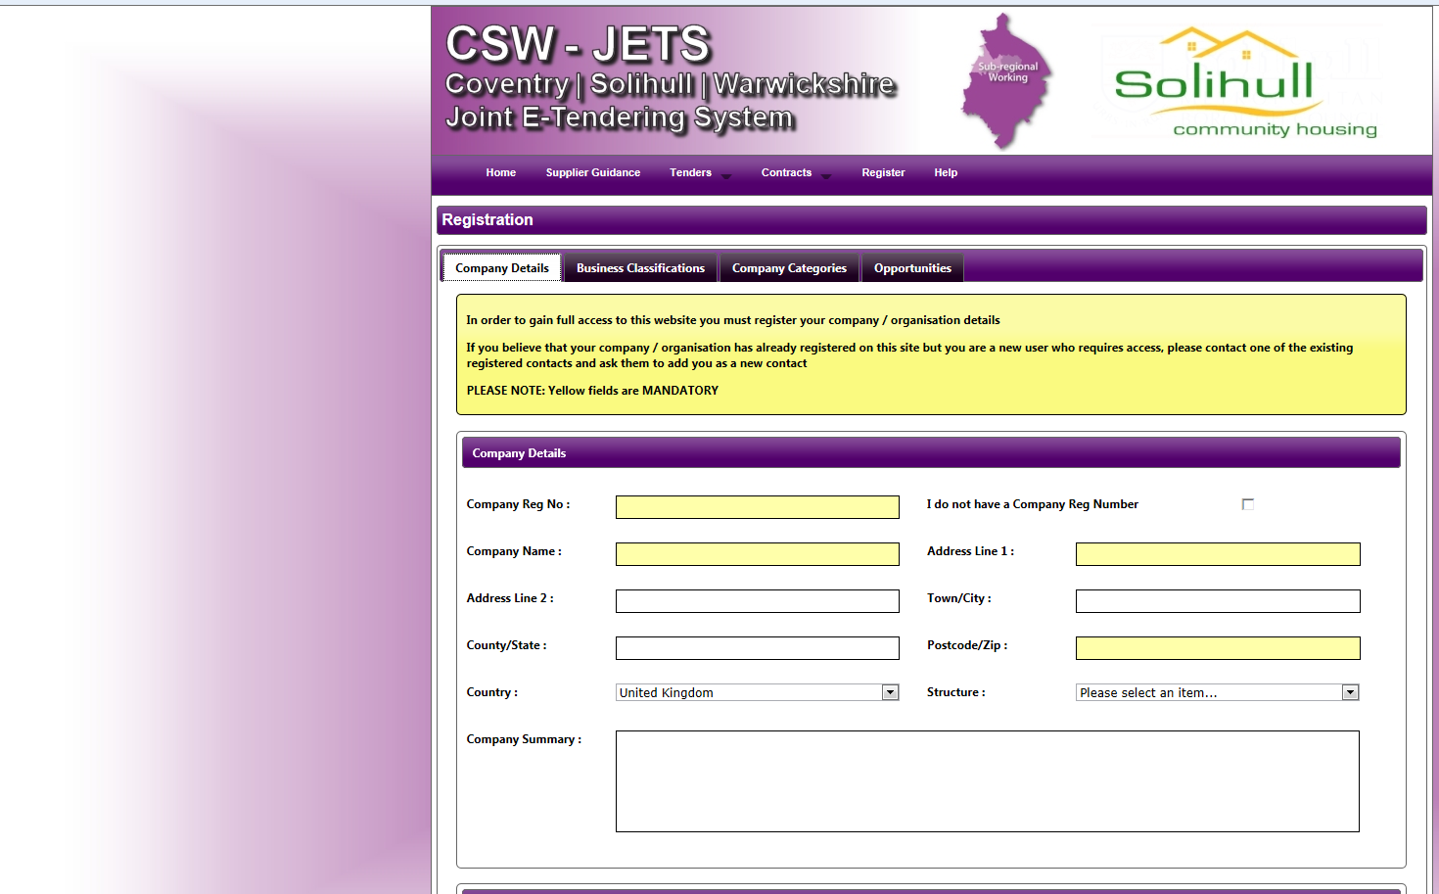
5. Select the tab ‘Business Classification’.
6. Once here type key words into the search bar and then select the applicable options. –You can have more than one business classification.
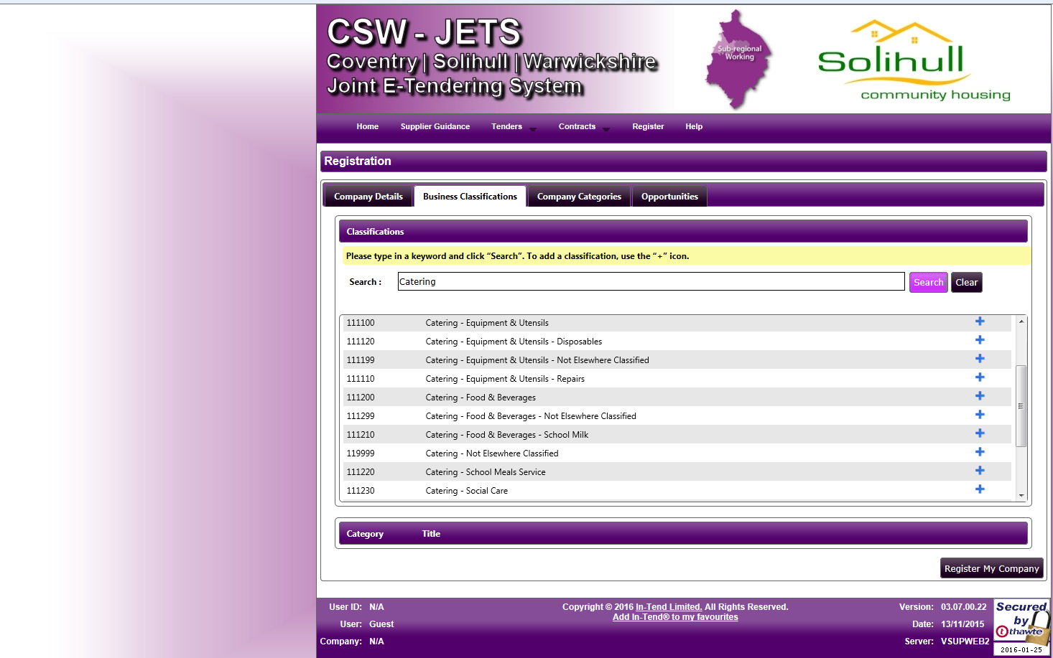
7. Then select ‘Register My Company’ to Complete the registration.

