

ESSEX COUNTY COUNCIL

Tackling Cycling Inequalities In Essex - Essex Pedal Power

SPECIFICATION

Issued 15th January 2021

Procurement Project CO0044

1. **Essex County Council**
   1. Essex County Council is dedicated to improving Essex and the lives of our residents. Our ambition is to deliver the best quality of life in Britain. We will achieve this by providing high-quality, targeted services that deliver real value for money.
2. **Our vision**
   1. The Essex Organisation Strategy sets out our aims and priorities for the period 2017-21. It articulates how we will achieve better outcomes for Essex and secure the ambitions set out in the Vision for Essex. Our ambition, at the end of this period, is for Essex to be the best local authority in the country.
   2. At ECC we are passionate about better lives for people in Essex. We believe prosperity is the best route to achieve that – so people can help each other, and themselves. We are also ready to step in – to protect vulnerable children, to help care for older people and to support our economy to flourish. As a public body it is important we spend taxpayers’ money wisely, on the issues that matter to our residents. To offset reductions in government funding, we must constantly manage demand, reshape and re-imagine services and look for opportunities to generate income. It is also important we work tirelessly to secure investment into the county that can help make Essex an even better place to live and work.

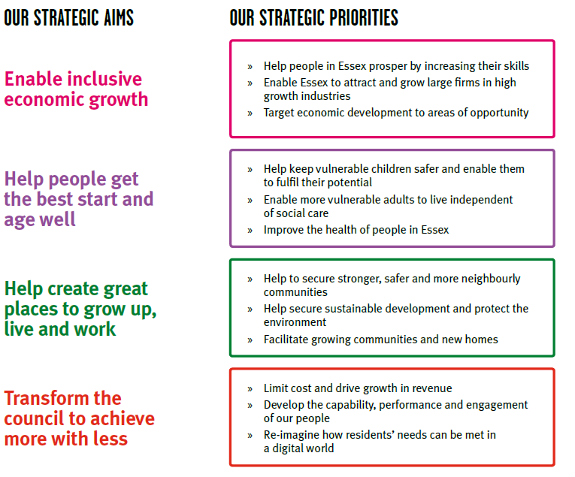

* 1. Further information can be found on the [ECC website.](http://www.essex.gov.uk/Your-Council/Strategies-Policies/Pages/EssexWorks-Pledges-2011_12.aspx)

1. **Delivering the vision**
   1. If we are to succeed through these testing times, we must maintain a focus on our core purpose. The challenge ahead strengthens our resolve to:

* increase educational achievement and enhance skills
* develop and maintain the infrastructure that enables our residents to travel and our businesses to grow
* support employment and entrepreneurship across our economy
* improve public health and wellbeing across Essex
* safeguard vulnerable people of all ages
* keep our communities safe and build community resilience
* respect Essex’s environment
  1. Our Corporate Outcomes Framework translates our Cabinet’s political ambitions – outlined in their Vision for Essex – into a set of outcomes and supporting indicators that can guide the work of commissioners across ECC. The consolidation of outcomes into a single, authoritative, framework for ECC is designed to:
* provide a clear foundation for the development of our commissioning strategy and plans;
* provide a clear framework for assessing progress – allowing ECC to understand its impact on residents and communities in Essex; and
* allow for the analysis of ECC resources, assets, contracts etc, against a consistent set of outcomes.
  1. The Corporate Outcomes Framework, shown in the table below, embeds the principles of Outcomes Based Accountability (OBA) within ECC. OBA is an established and effective approach for expressing, operationalising and ensuring accountability for outcomes. It provides a simple, common sense, low bureaucracy planning model supported by clear terminology.

|  |  |  |  |  |
| --- | --- | --- | --- | --- |
| |  | | --- | | **Essex: a**  **county where innovation brings prosperity** | | **Children in Essex get the best start in life** | **People in Essex enjoy good health and wellbeing** | **People have aspiration and achieve their ambitions through education, training and lifelong-learning** |
| * Percentage of children ready for school * Percentage of children achieving a good level of development by the age of five * Percentage of families living in temporary accommodation * Percentage of children living in non-working households | * People in Essex have a healthy life expectancy * Reduced differential in life expectancy across different areas of Essex * Percentage of children achieving at school [measured at foundation stage, KS2 and KS4] * Percentage of working age people in employment * Prevalence of healthy lifestyles * Prevalence of mental health disorders among children and adults * Percentage of Essex residents who consider themselves to be in good health * Percentage of families living in safe and suitable housing * Percentage of households living in fuel poverty * Teenage pregnancy rates * Life satisfaction rates (ONS condition of wellbeing) | * Rates of literacy and numeracy at all ages * Percentage of children achieving at school * Percentage of adults participating in lifelong learning * Percentage of working age people in employment * Percentage of people participating in further education/higher education/vocational learning * Percentage of young people aged 16-19 not in education, employment & training * Rates of volunteering * Percentage of children attending a good school |

|  |  |  |  |  |
| --- | --- | --- | --- | --- |
| |  | | --- | | **People in Essex live in safe communities and are protected from harm** | | **Sustainable economic growth for Essex communities and businesses** | **People in Essex experience a high quality and sustainable environment** | **People in Essex can live independently and exercise control over their lives** |
| * Level of crime in Essex * Number of children subject to protection plans * Number of children in care * Rate of anti-social behaviour in Essex * Number of people killed or seriously injured on Essex roads * Percentage of residents who feel that Essex roads are safe * Hospital admissions caused by injuries to children and young people * Hospital admissions caused by injuries to adults * Incidents of domestic abuse * Percentage of residents who feel safe * Rates of re-offending | * Job growth in key locations and key sectors * Housing growth in key locations * Supply of fit for purpose business premises * Increased connectivity and journey time reliability on priority route network (PR1) * Number of bus and/or community transport journeys * Median earnings * Coverage of superfast broadband services * Sustainable business start-up rates * Percentage of Essex businesses who think they can recruit suitable people * Percentage of working age people in employment * Business rates growth | * Residual waste volumes * Cost of energy to households * Preventable flooding incidents * Level of pollution * Condition of roads and footways * Access to valuable open spaces * Perception of the quality of the environment in Essex’s cities, towns and villages | * Proportion of people who live independently * Percentage of people who regain or increase their level of independence following hospital admissions * Access to end of life care in their preferred placement of choice * Number of children and adults who receive social care support * Number of people with personal budgets |

1. **Introduction**
   1. Essex Local Delivery Pilot (LDP) is a £12 million programme managed by Essex County Council and Active Essex to tackle population levels of physical inactivity in the county in the most disadvantaged communities. The LDP are working together with partners such as The Active Wellbeing Society (TAWS), Inclusion Ventures, Tendring District Council and many more organisations to deliver an ambitious £2.1m project to tackle cycling inequality across Essex. Evidence shows that the main barrier that prevents low-income communities from cycling is the expense of purchasing a bike.
   2. Essex Pedal Power scheme is focused on low-income communities where the need is highest, and the benefits of becoming regularly active through cycling are greatest. Our ambition is to address this through a large scale project. This scheme will be a priority for Essex County Council, as it links directly to the ECC Place and Public Health Business Plan, as well as plans for Business Recovery and Climate Change. Different approaches will be tested across Essex, including in Tendring replicating the successful Big Birmingham Bikes scheme delivered by TAWS which has been running for the past 7 years.
   3. COVID -19 has reinforced and amplified Government and Public Health England advocacy that daily exercise is a necessity, and Government encouragement to get people cycling through a multi-million pound funding of new protected cycle lanes and GPs prescribing cycling to their patients in more deprived areas.
   4. The national Better Health campaign launched at the end of July and amplified by Active Essex in September is another example of the urgent messaging that people need to exercise regularly to stay healthy and fight illness including Covid-19. Investment in cycling infrastructure is significantly increasing across Essex, with a desire to ensure that the cycling infrastructure is used by everyone, including inactive people in low-income communities.
   5. We have seen a major shift in opportunity to improve the conditions for cycling and active mobility not least the wide-reaching Emergency Transport Plans from the government as a response to trying to protect and build on the increase in cycling during lockdown.
2. **Background**
   1. The LDP ran a workshop in early March 2020 to showcase the successful cycling inequality work that has taken place in Birmingham and a number of key Essex stakeholders expressed their positive intention to back a similar approach in Essex
   2. The aspiration is to make this a county wide scheme to provide free bikes and support to up to 10% of the most deprived communities across the county. To begin with, the scheme would pilot in Jaywick and the 5 most deprived wards in Clacton (Alton Park, Bocking Elms, Pier, St Marys and Rush Green), with a plan to provide up to 3000 local people with new quality bikes in the pilot phase. These areas are some of the most deprived in Essex. This equates to approx 31,000 residents in total, with a plan to give away 3000 bikes in the pilot phase. (ratio of 1:10).
   3. The cost of a bike stops those who are deprived from being able to benefit from improvements to the cycling infrastructure. Not owning a bike also stops people being the agents of their own positive health and wellbeing improvement.
   4. To truly improve access to cycling for everyone, we need to address cost as a barrier to cycling in our society.
   5. The scheme would aim to create new cycling communities, building on interest from early adopters in places where the inequalities are greatest. The scheme would work with local communities to provide some initial infrastructure such as bikes, bike storage, bike parking, bike mechanics, as well as a new cohort of bike leaders and community cycling groups. The scheme would focus on the outcomes of increasing health, increasing volunteering and community cohesion, decreasing carbon emissions, and increasing access to employment and education.
   6. Local trusted organisations and co-creating the project with respected community leaders and local people will be the key to success in getting bikes to the right people and in building strong and sustainable community cycling clubs.
   7. The ambition of the Big Essex Cycles programme would be to create a large group of new cyclists that ‘look like me’ and create a tribe that a new and tentative cyclist can instantly belong to e.g. groups of mums in Clacton cycling together.
   8. The identified pilot area for the first phase of Big Essex Cycles is Tendring, with a specific focus on the geographical area of Jaywick and Clacton. This is a priority area for the LDP and for ECC. ECC have created a special project as part of its localities work called Jaywick Sands Social Infrastructure (JASSI).
   9. Qualifying criteria for the bikes would be based on a condition that applicants are currently inactive and low-income and could demonstrate they have cycled at least once a week for the first 6 months once given the bike – once successfully demonstrated, ownership of the bike would transfer to the recipient. The programme would retain a right to recall the bikes for improper usage within the rules of the scheme.
   10. Bike recipients would be able to access base level cycle training to enable them to be safe and confident independent cyclists. Alternatively, there is the option to sign a disclaimer if they feel they are already competent on-road cyclists with basic cycle repair skills.
   11. The impact on the market by COVID-19 has been significant and as such availability of bikes is a key issue. Early market engagement has shown that bike orders, dependant on specification, can be completed over a period of 1 to 6 months thus expectations would need to be tailored accordingly.
3. **Scope**
   1. The LDP is looking for a provider who is able to supply, potentially, up to 3000 bikes in phases from April 2021 to March 2024, acting as a large bike shop for the client (Essex County Council) with a catalogue of products available for supply.
   2. The range of bikes will vary depending on the need of the individuals, including adult hybrid bikes, and bikes suitable for children, disabled people, girls and women, older people, overweight and obese people, and couriers. Please see appendix C
   3. The core offer:
      1. High quality bikes that are centrally procured and distributed in a phased approach starting in Tendring in the specific low-income areas of Jaywick and top 5 most deprived wards in Clacton.
      2. District Councils and their area stakeholders will be able to shape the design of the programme and delivery model in line with their own strategic priorities and what the community need/wants are. Support would be given to develop clear insight based on the lived experience within the target communities.
      3. A proportion of the bikes (to be determined in conjunction with ECC) would be GPS tracked and their usage monitored.
   4. The total number of bikes procured would depend on a number of risk factors:
      1. The local demand for bikes and the emergence of different forms of transport – e.g., E Scooters
      2. Project may reduce in size if funding is withdrawn
      3. The pilot in Tendring is not successful and the scheme is scaled back or stopped
   5. The potential scale of this contract, (unit cost maximum £350) must include bike, helmet, lock. lights, pump and delivery (not final build cost), is the procurement of up to 3000 bikes and therefore a clear process needs to be established for the phased ordering and delivery of bikes over a three-year period.
   6. Future phases are planned for other LDP areas and will continue to focus on our disadvantaged areas of Essex including Basildon, Colchester with potential to scale to areas such as Harlow, and Castle Point, subject to funding.
   7. Unit pricing: 
      1. Supplier must be able to provide a range of bikes sizes from children’s 12” wheel up to adult 21” frame. We would also welcome prices for cargo/e-cargo bikes and adapted bikes if providers can supply these for information only – this will not be scored.
      2. Volume discounts – Bidders are given the opportunity to apply volume discounts given the volume of units that the Authority will be ordering. An example of ranges is provided below and an option will be available in the pricing matrix if a bidder so wishes to offer such discounts.

|  |  |
| --- | --- |
| **Number of bicycles** | **Volume discount** |
| 1 – 99 | *%* |
| 100- 249 | *%* |
| 249 - 499 | *%* |
| 500 + | *%* |

6.9. Initial Pilot Scheme

6.9.1. The first phase of this Essex-wide scheme would target Jaywick residents and the 5 most deprived wards in Clacton (Alton Park, Bocking Elms, Pier, St Marys and Rush Green).

6.9.2 The first batch of 500 bikes to be ready for batched of deliveries starting between June-Sept 2021.

1. **Key Dates** 
   1. Commencement date: 01/04/2021.
   2. Completion date: 31/03/2024.
   3. Duration: 36 months.
   4. Required delivery dates/milestones.

* 1st delivery of 500 units 1st June 2021
* 2nd delivery batches of 1000 units 1st September 2021 (TBC nearly the time for the number of units to be made)
* Other dates under review/ subject to funding levels

1. **Statement of Technical Requirements –** 
   1. The specification of the bikes is an important aspect of the programme. To create an enjoyable riding experience that is safe, robust and can last a lifetime you need to invest in a good quality bike that meets the needs of communities. The specification of each bike must ensure safety, security and comfort should not be compromised by price. This helps build the trust in citizens as they will be receiving bikes real value.
      1. Specification Details (please see appendix C for further information)
   * Lightweight Hybrid Bike adult and child bikes – suitable for roads and cycle paths
   * Metal, no plastic components, – easily maintainable and not prone to breakage
   * Puncture resistant hybrid tyres – far less likely to get a puncture than standard tyres
   * Straight and sloped cross bars – to suit all genders and those with mobility issues
   * Good range of mid spec gears
   * V brakes – easily and cheaply maintainable
   * Strong lightweight alloy wheels – less prone to buckling
   * High quality chain – longer life
   * Ergonomic saddle and handlebars – better riding comfort
   * Kick Stand – reduced damage from falling over
   * Quick release wheels/saddle – no tools required for adjustments
   * Mudguards – enabling riding in all weathers
   * Lights pre fitted – enabling night/early morning riding in all seasons
   * Hand pump fitted to frame – easy to use valves for inflation
   * Helmet – fitted with the correct size and shown safe adjustment and fitting
   * Gold standard (highest rating possible) D -Lock
     1. Delivery and packaging
   * Bikes are delivered from the manufacturer boxed in an 85% built state.
   1. The responsibility for securely transporting the bicycles to ensure they arrive in perfect condition remains with the provider and they must ensure that they have all relevant insurances to the point of the cycle retailer signing for the bicycles.
   2. The provider must ensure that bicycles transported have as a minimum the protective packaging detailed below:
   3. All packaging must be environmentally friendly and widely recyclable. Forks and Axels must have protective packaging
   4. Pricing - The following are indicative costs only and are to be used as a guideline by bidders.
      1. The specified standard bike as listed above for adults between £250 and £300 ex VAT and build. (Max unit cost for adult bikes £350)
      2. E-Bikes to start from £800 to £1000 (Max unit cost for E-bike £1000) and the budget needs to be flexible to meet the demand.
      3. Cargo Bikes – A 2 wheel box cargo bike from £2500 and a 3 wheel larger box cargo bikes from £4000 (max unit cost for E-Cargo bike/trike £4000).
      4. Package of accessories (All bikes unit cost must include the cost of a helmet, lock, light and pump as per the attached specification details) – max £50 .
   5. IS Information Handling and Security - Bidders will be required to adhere to the Data Protection Act (DPA) 2018 and General data Protection Regulations.
   6. Continuous / Expected improvement – Bidders should build on issues and lessons learned from the pilot to scheme to adapt any future roll-out of similar schemes.
   7. Performance, targets, and monitoring arrangements – These will be agreed as part of the implementation phase with the preferred bidder.
   8. Exit Plan– The preferred bidder shall complete an exit plan following award of contract, this may include (but is not limited to);
      1. Hand-over process, transition between providers
      2. Training and Knowledge transfer
      3. Support arrangements
      4. Decommissioning & Disposal
   9. Implementation/mobilisation – ECC and the preferred bidder will agree an implementation/mobilisation plan in line with section 6.9 and Appendix A.
   10. Business Continuity - Preferred bidders will be required to provide a copy of their high-level business continuity plan that covers the service(s) they are providing.
2. **Authority’s policies**
   1. Council’s Information Policy Requirements - <http://www.essex.gov.uk/Business-Partners/Supplying-Council/Documents/ECC_information_policy_requirements_for_contractors.pdf>.
   2. Any other policies e.g. Environmental
3. **Insurance and warranties** 
   1. Employer’s (Compulsory) liability insurance - £5 million.
   2. Public liability insurance - £10 million.
   3. Professional indemnity insurance - £5 million.
   4. Warranties – The preferred bidder shall ensure all warranties are obtained for any equipment that is provided to those taking part in the schemes as directed by ECC. Detail a warranty process and process for covering of costs incurred by build partners as a result of a warranty issue and bike returns- issue of faulty parts
4. **E-Procurement Requirements**

11.1. Overview

11.1.1. Essex County Council has implemented a fully automated Purchase to Pay system. Purchase to Pay enables the full purchasing and payment process to be carried out on-line, from order creation and authorisation to receipting and invoice matching. It is easier, faster and more efficient than conventional purchasing processes.

11.1.2. Marketplace is a Proactis Solution. It is a web-based system used by Essex County Council to submit purchase orders electronically and receive and process e-invoices and e-credits.

* + 1. The Marketplace supplier interface is both simple and secure. All the preferred bidders will need to access Marketplace using an Internet browser. Marketplace supports the latest release of web browser technologies, for example, Internet Explorer, Firefox, Safari etc.
  1. Electronic Ordering
     1. A record on Marketplace will be created for the preferred bidder and a user ID and password will be issued via e-mail.
     2. The user ID and password will allow the preferred bidder to:
* View their purchase orders online
* Update their status
* Notify delivery
* Submit and monitor the status of electronic invoices and credits, once they have been submitted
  + 1. Purchase orders will be sent electronically to the preferred bidder’s central e-mail address
  1. Emailed Purchase Orders
     1. Orders will be sent electronically, via Marketplace, to the preferred bidder’s preferred central e-mail address from the contract start date. To ensure continuity of service, the preferred bidder will be responsible for ensuring that orders are processed quickly and efficiently. It is therefore not advisable to provide individual e-mail addresses unless appropriate access is available, to ensure that orders are still processed if the main contact is unavailable. There is no transaction charge for e-mail orders which are sent to a preferred central e-mail address, via Marketplace.
  2. Electronic Invoicing
     1. The preferred bidder will be expected to submit electronic invoices and credit notes via Marketplace by utilising the PO Flip method from the contract start date. On approval of the electronic invoice an automatic payment will be made via BACS, direct to the preferred bidder’s bank account, in line with Essex County Council’s contracted payment terms. In addition to the above, the preferred bidder will be able to view the status of their invoices, via the Marketplace system.
  3. Purchase Order Flip (PO Flip)
     1. The preferred bidder will be able to gain access to the Marketplace system via a web browser, to view their Purchase Orders and turn any outstanding Purchase Orders into electronic invoices, by choosing the PO Flip method. There is no charge for this method.

Further information about all of the above can be found on ECC’s website: <http://www.essex.gov.uk/Business-Partners/Supplying-Council/Pages/IDeA-Marketplace.aspx>

* 1. Please be aware, the preferred bidder will also be registered onto ECC’s Finance system, Oracle. They will in turn receive a registration email to activate their iSupplier portal account. This account is used to:
* View the status of invoice payments
* Amend your supplier details e.g. address, contact details, bank details
* Create additional user accounts
  1. E-Procurement Terms of Trading
     1. A preferred central e-mail address, (where orders will be sent electronically via Marketplace) must be provided. It is the responsibility of the supplier/ preferred bidder to ensure that they can provide a central e-mail address for orders sent electronically via Marketplace from the contract start date. The Preferred bidder/ Supplier/ Contractor will be asked to submit this e-mail address. It is also the supplier’s/ preferred bidder’s responsibility to ensure that continuity of service is maintained at all times and that orders are processed promptly.
     2. All invoices and credit notes must be submitted electronically by the supplier/ preferred bidder to Essex County Council and as a minimum must be raised using the PO Flip method via Marketplace from the contract start date.
     3. Goods/Services should only be provided/carried out on receipt of an Official Purchase Order which has been issued via Marketplace by the Authority.
     4. The preferred bidder assumes full responsibility for ensuring that programs or other data downloaded uploaded or in any way transmitted electronically to the Authority are free from viruses, or any other items of a destructive nature whatsoever. The Authority makes every effort to virus check information made available for download from Marketplace. The Authority cannot accept any responsibility for any loss, disruption or damage to your data or your computer system which may occur whilst using material derived from Marketplace. The Authority recommends that users recheck all downloaded material with their own virus check software.

1. **Agreement term**
   1. The Agreement term for this agreement with be 36 months. The decision to extend the Agreement with is at the sole discretion of Essex County Council.
   2. With appropriate notice the Authority may terminate the Agreement on any of the following Authority Break Point Dates:
      1. Following competition after the initial pilot scheme.
      2. Any subsequent point at which time funding is not available to continue the scheme.
2. **Payment** 
   1. The Authority will pay any invoice issued by the Supplier within 30 days of receipt of a valid invoice following the delivery of the Good(s) and/or service(s). On the thirtieth day the payment will leave the account of the Authority
   2. The rates/prices stated on the invoice must be those specified under this Agreement.
3. **Commercial Response**
   1. The Tenderer is to complete the commercial response detailed within the E-sourcing portal.

Appendix A-Project Plan



Appendix B - Governance

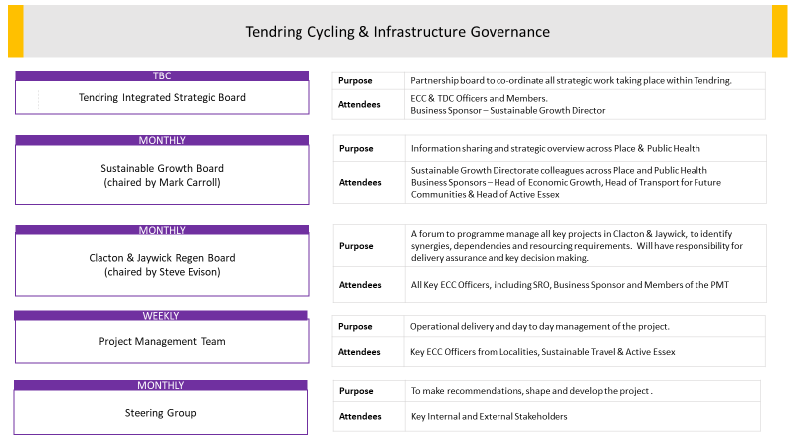

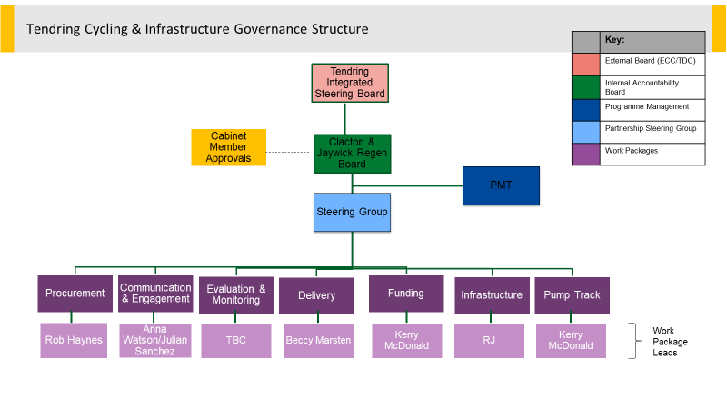

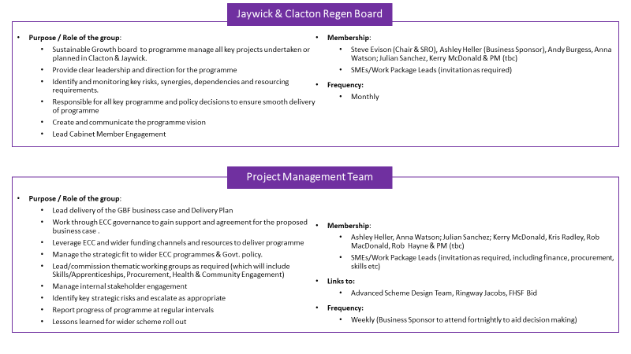

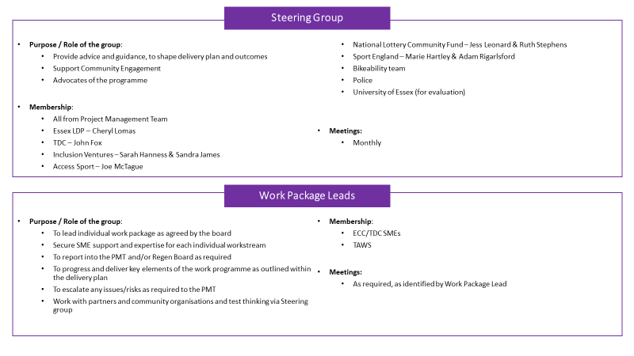

**Appendix C -Step-Through Bicycles specification**

**Mandatory C.1**

|  |  |  |
| --- | --- | --- |
| **BIKE TYPE** | ***700C Alloy Trekking Low-Step Unisex (Lady)*** |  |
| **SPEED** | ***21 Speed combined brake/gear shifter*** |  |
| **FRAME SIZE** | **15" & 18"** |  |
| **FRAME COLOUR** | **To be confirmed** |  |
| **FORK COLOUR** | **To be confirmed** |  |
| ***Item*** | ***Description*** | ***Colour*** |
| FRAME/FORK Assy. |  |  |
| Frame 15'' | 700Cx15 Alloy Trekking Type Low step Lady (unisex), with replacement dropout | TBC |
| Frame 18'' | 700Cx18 Alloy Trekking Type Low step Lady (unisex), with replacement dropout | TBC |
| Fork | 700C Steel Trekking Type Fork | TBC |
| Head Badge | As per supplier logo design |  |
| Headset | STEEL THREADED 1-1/8" STEEL BLACK W/WATER PROOF-NO LOGO | Black |
| BB Set | Sealed cartridge | Black |
| BB Axle | Included with BB Set |  |
| BB Cable Guide | Plastic with Bolt(M5) | Black |
| Bottle Screw & Wash. | Stainless steel x 2 |  |
| Decals | Decal under lacquer with tamper proof serial number HRST Type (Frame) + SKC Type (8 Pcs SKC Rim Sticker) | TBC |
| Seat Bolt/Pin/Clamp | 31.8mm Seat Clamp with Stainless Steel Bolt, Black with Side CNC | Black/CNC |
| Paint | TBC | TBC |
| BAR Assy. |  |  |
| Handle Bar | Steel Lo-Rise Bar, Raise: 30mm, 30 Degree Backswept, W: 620mm | SB Black |
| Stem 15''' | Alloy Adjustable Type, Ext: 90mmx180mm | SB Black |
| Stem 18'' | Alloy Adjustable Type, Ext: 110mmx180mm | SB Black |
| Grips | Trekking soft touch comfort type 125mm/125mm (Ergo Type) | Black/Grey |
| BRAKING SYSTEM |  |  |
| Brake Levers | Alloy 3 Finger Type (Equipped with gear shifter) | Black |
| Front Brake | Alloy V Brakes with linear springs & EN Conformed Shoes. With stainless bolts and brake pipe | Black |
| Rear Brake | Alloy V Brakes with linear springs & EN Conformed Shoes. With stainless bolts and brake pipe | Black |
| Brake Inner Cable(F) | Stainless steel | Silver |
| Brake Inner Cable(R) | Stainless steel | Silver |
| Brake Outer Casing | Standard Outer Casing. Full length rear cable outer | Black |
| TRANSMISSION |  |  |
| Shifter Right | SHIFT/BRAKE LEVER 7 speed index type with optical display with alloy lever. | Black |
| Shifter Left | SHIFT/BRAKE LEVER 3 speed index type with optical display with alloy lever. | Black |
| Front Derailleur | Index type TOP-SWING, DUAL-PULL FOR REAR 7-SPEED, BAND TYPE FOR 48-38-28T |  |
| Rear Derailleur | 7-SPEED, DIRECT ATTACHMENT INDEXED TYPE | Black |
| Chain | Rust resistant chain 1/2x3/32, For 7 Speed | Dark Silver/Brown |
| Freewheel | Cassette sprockets for index gears,12-28T, 7-SPEED BLACK | Black |
| Chainset | FRONT CHAINWHEEL, for index gears. 170MM crank 48X38X28T FOR REAR 7-SPEED. With integral chainguard | Black/Silver |
| Pedals | 9/16"Pvc Trekking Type With BS Reflectors (Dual Density) w/o Logo | Black/Gray |
| Derailleur Cables Outer Casing | SP Type Cable (4mmD) | Black |
| Outer Cable endcap | Steel | CP |
| Inner safety endcap | Alloy | Natural |
| ROAD WHEEL Assy. |  |  |
| Tyres Front | 700CX35C Trekking Pattern with Puncture Protection | Black |
| Tyres Rear | 700CX35C Trekking Pattern with Puncture Protection | Black |
| Tubes/Valve | 700C Schrader Valve + Tube | Black |
| Rim Tape | 700C Rubber | Black |
| Rims | 700C Alloy 36 Holes Double Wall with Side CNC Finish with 2 pc Rim Decal per wheel SV | Black |
| Front Hub | Alloy 14Gx3/8"x36Hx100x140mm, w/stainless nuts | Black |
| Rear Hub | Cassette Alloy 14Gx3/8"x36Hx135x180mm w/stainless nuts | Black |
| Spokes | UCP black coated | Black |
| Spokes | UCP black coated | Black |
| Spoke Disc | PVC 6 1/2" | Clear |
| Nipples | Standard | CP |
| SADDLE Assy. |  |  |
| Saddle | Comfort saddle. W/Gel, Bumper: F&R BK, w/o Clamp, Rail: Steel ED Black rail | Black |
| Seat Post | 27.2x350mm Alloy Micro Adjust Type Seat Post | Black |
| ACCESSORIES |  |  |
| Bell | Mini Bell; Alloy Black Top, PVC Bracket and Lever | Black |
| O-rings | CC170/CC171, 1.2mm*2+1.6mm*1, | Clear |
| REFLECTOR Assy. |  |  |
| Reflector Bracket(F) | Plastic; FORK Fitting; 22.2mm | Black |
| Reflectors(Front) | DIN/EN Standard with K Mark; Snap on Type | Clear |
| Reflectors(Rear) | DIN/EN Standard with K Mark; Mounted on rear fender | Red |
| Reflectors(Wheel) | DIN/EN Standard with K Mark | Clear |
| MANUAL PACK |  |  |
| Manual | User Manual |  |

**Optional**

|  |  |  |
| --- | --- | --- |
| ***Item*** | ***Description*** | ***Colour*** |
| Mudguards | Clip on. | Black |
| Lock | D type shackle lock and bracket medium size (approx 14mm bar x 200mm length x 150mm width). Combination lock. | Black |

C.2 Hybrid Bicycles

**Mandatory**

|  |  |  |
| --- | --- | --- |
| **BIKE TYPE** | ***700C Alloy Hybrid Gents*** |  |
| **SPEED** | ***21 Speed combined brake/gear shifter*** |  |
| **FRAME SIZE** | **14", 17", 19", 21"** |  |
| **FRAME COLOUR** | **To be confirmed** |  |
| **FORK COLOUR** | **To be confirmed** |  |
| ***Item*** | ***Description*** | ***Colour*** |
| FRAME/FORK Assy. | | |
| Frame 17'' | 700Cx 17 ALLOY HYBRID. REGULAR 1.1/8" HEAD TUBE: FORMED TOP & DOWN TUBE. With replacement drop out | TBC |
| Frame 19'' | 700Cx 19 ALLOY HYBRID. REGULAR 1.1/8" HEAD TUBE: FORMED TOP & DOWN TUBE. With replacement drop out | TBC |
| Frame 21'' | 700Cx 21 ALLOY HYBRID. REGULAR 1.1/8" HEAD TUBE: FORMED TOP & DOWN TUBE. With replacement drop out | TBC |
| Fork | 700C Straight blade rigid steel fork w/pivots, w/mudguard eye | TBC |
| Head Badge | As per supplier logo design |  |
| Headset | STEEL THREADED 1-1/8" STEEL BLACK W/WATER PROOF-NO LOGO | Black |
| BB Set | Sealed cartridge (EN14764) | Black |
| BB Axle | Included with BB Set |  |
| BB Cable Guide | Plastic with Bolt(M5) | Black |
| Bottle Screw & Wash. | Stainless steel x 4 |  |
| Decals | Decal under lacquer with tamper proof serial number HRST Type (Frame) + SKC Type (8 Pcs SKC Rim Sticker) | TBC |
| Seat Bolt/Pin/Clamp | 31.8mm Seat Clamp with Stainless Steel Bolt, Black with Side CNC | Black/CNC |
| Paint | Single Tone colour TBC | TBC |
| BAR Assy. | | |
| Handle Bar | Steel Lo-Rise Bar, Raise: 30mm, 6 Degree Backswept, W: 620mm | SB Black |
| Stem 17''' | Alloy Adjustable Type, Ext: 90mmx180mm | SB Black |
| Stem 19''/21" | Alloy Adjustable Type, Ext: 110mmx180m | SB Black |
| Grips | Trekking soft touch comfort type 125mm/125mm (Ergo Type) | Black/Grey |
| BRAKING SYSTEM | | |
| Brake Levers | Alloy 3 Finger Type (Equipped with gear shifter) | Black |
| Front Brake | Alloy V Brakes with linear springs & EN Conformed Shoes. With stainless bolts and brake pipe | Black |
| Rear Brake | Alloy V Brakes with linear springs & EN Conformed Shoes. With stainless bolts and brake pipe | Black |
| Brake Inner Cable(F) | Stainless steel | Silver |
| Brake Inner Cable(R) | Stainless steel | Silver |
| Brake Outer Casing | Standard Outer Casing. Full length rear cable outer | Black |
| TRANSMISSION | | |
| Shifter Right | SHIFT/BRAKE LEVER 7 speed index type with optical display with alloy lever. | Black |
| Shifter Left | SHIFT/BRAKE LEVER 3 speed index type with optical display with alloy lever. | Black |
| Front Derailleur | Index type TOP-SWING, DUAL-PULL FOR REAR 7-SPEED, BAND TYPE FOR 48-38-28T |  |
| Rear Derailleur | 7-SPEED, DIRECT ATTACHMENT INDEXED TYPE | Black |
| Chain | Rust resistant chain 1/2x3/32, For 7 Speed | Dark Silver/Brown |
| Freewheel | Cassette sprockets for index gears,12-28T, 7-SPEED BLACK | Black |
| Chainset | FRONT CHAINWHEEL, for index gears. 170MM crank, 48X38X28T FOR REAR 7-SPEED. With integral chainguard | Black/Silver |
| Pedals | 9/16"Pvc Trekking Type With BS Reflectors (Dual Density) w/o Logo | Black/Gray |
| Derailleur Cables Outer Casing | SP Type Cable (4mmD) | Black |
| Outer Cable endcap | Steel | CP |
| Inner safety endcap | Alloy | Natural |
| ROAD WHEEL Assy. | | |
| Tyres Front | 700CX35C Trekking Pattern with Puncture Protection | Black |
| Tyres Rear | 700CX35C Trekking Pattern with Puncture Protection | Black |
| Tubes/Valve | 700C Schrader Valve + Tube | Black |
| Rim Tape | 700C Rubber | Black |
| Rims | 700C Alloy 36 Holes Double Wall with Side CNC Finish with 2 pc Rim Decal per wheel SV | Black |
| Front Hub | Alloy 14Gx3/8"x36Hx100x140mm, w/stainless nuts | Black |
| Rear Hub | Cassette Alloy 14Gx3/8"x36Hx135x180mm w/stainless nuts | Black |
| Spokes | UCP black coated (mmL) | Black |
| Spokes | UCP black coated (mmL) | Black |
| Spoke Disc | PVC 6 1/2" | Clear |
| Nipples | Standard | CP |
| SADDLE Assy. | | |
| Saddle | Gents comfort hybrid. W/o Clamp, Rail: Steel ED Black, Artwork: Printed/Embossed logo on top | Black |
| Seat Post | 27.2x350mm Alloy Micro Adjust Type Seat Post | Black |
| ACCESSORIES | | |
| Bell | Mini Bell; Alloy Black Top, PVC Bracket and Lever | Black |
| O-ring | CC170/CC171, 1.2mm*2+1.6mm*1, | Clear |
| REFLECTOR Assy. | | |
| Reflector Bracket(F) | Plastic; FORK Fitting | Black |
| Reflector Bracket(R) | Plastic; Seat post mount 27.2mm bracket | Black |
| Reflectors(Front) | DIN/EN Standard with K Mark; Snap on Type | Clear |
| Reflectors(Rear) | DIN/EN Standard with K Mark; Snap on Type | Red |
| Reflectors(Wheel) | DIN/EN Standard with K Mark; w/14GA Rivet | Clear |
| MANUAL PACK | | |
| Manual | User Manual |  |
| **D.4 Optional** |  |  |
| ***Item*** | ***Description*** | ***Colour*** |
| Mudguards | Clip on. | Black |
| Lock | D type shackle lock and bracket medium size (approx 14mm bar x 200mm length x 150mm width). Combination lock. | Black |

1. C.3 Junior Bicycles

We want to procure three sizes of children’s bikes – please see table below:

|  |  |  |
| --- | --- | --- |
| **Essex Pedal Power Bikes** | | |
| **Bike Size** |  | **To Fit Height** |
| Sloped top tube -14 inch frame |  | Adult/Teen – 5’3 or 161cm and under |
| Sloped top tube -17 inch frame |  | Adult/Teen – 5’4-5’7 or 164-173cm |
| Straight top tube -18 inch frame |  | Adult – 5’5-5’9 or 167-180cm |
| Straight top tube -20 inch frame |  | Adult – 5’10 or 150cm and above |
| 20 inch wheel |  | Children – 3’11-4’3 or 120-130cm (5-8 yrs) |
| 24 inch wheel |  | Children 4’2-4’8 or 127-142cm (7-11 yrs) |
| 26 inch wheel |  | Children 4/7-5’2 or 140-158cm (10yrs +) |

**Mandatory**

|  |  |  |
| --- | --- | --- |
| **BIKE TYPE** | ***26" Whl Junior Alloy MTB*** |  |
| **SPEED** | ***21 Speed EZ fire*** |  |
| **FRAME SIZE** | **14"** |  |
| **FRAME COLOUR** | **To be confirmed** |  |
| **FORK COLOUR** | **To be confirmed** |  |
| ***Item*** | ***Description*** | ***Colour*** |
| FRAME/FORK Assy. | | |
| Frame 14'' | 26"x14" Alloy Men 6061 Frame with replacement dropout | TBC |
| Fork | 26" UNICROWN STEEL BLADE:28.6 BIG FORK CHISEL END W/PIVOT | TBC |
| Head Badge | As per supplier logo design |  |
| Headset | STEEL THREADED 1-1/8" STEEL BLACK W/WATER PROOF-NO LOGO | Black |
| BB Set | Sealed cartridge (EN14764) | Black |
| BB Axle | Included with BB Set | Black |
| BB Cable Guide | Plastic with Bolt(M5) | Black |
| Bottle Screw & Wash. | 1 set on down tube. Stainless bolts |  |
| Decals | Decal under lacquer with tamper proof serial number HRST Type (Frame) + SKC Type (8 Pcs SKC Rim Sticker) |  |
| Seat Bolt/Pin/Clamp | 31.8mm Seat Clamp with Bolts with Side CNC Finish with stainless steel bolt | Black/CNC |
| Paint | Single tone colour TBC | TBC |
| **BAR Assy.** | | |
| Handle Bar | Steel Lo-Rise Bar W: 620mmL, Raise: 30mm, 10 Degree Bend W/O Logo | ED/Black |
| Stem | Steel Front Loading Type Stem Clip ID: 28.6mm, Ext: 90mm,Q.L- 180mm Bar Bore: 25.4mm, Rise: 10 degree, w/o Logo | Black |
| Grips | D2 Type 130mm/130mm with Coloured End (Colour TBC) | TBC |
| **BRAKING SYSTEM** | | |
| Brake Levers | Alloy 2 Finger Type (Equipped with gear shifter) | Black |
| Front Brake | Alloy V Brakes | Black |
| Rear Brake | Alloy V Brakes | Black |
| Brake Inner Cable(F) | Stainless steel | Silver |
| Brake Inner Cable(R) | Stainless steel | Silver |
| Brake Outer Casing | Standard Outer Casing. Full length rear cable outer. | Black |
| **TRANSMISSION** | | |
| Shifter Right | SHIFT/BRAKE LEVER 7 speed index type with optical display with alloy lever. | Black |
| Shifter Left | SHIFT/BRAKE LEVER 3 speed index type with optical display with alloy lever. | Black |
| Front Derailleur | Index type TOP-SWING, DUAL-PULL FOR REAR 7-SPEED, BAND TYPE FOR 48-38-28T |  |
| Rear Derailleur | 7-SPEED, DIRECT ATTACHMENT INDEXED TYPE |  |
| Chain | Rust resistant chain 1/2x3/32, For 7 Speed | Dark Silver/Brown |
| Freewheel | Cassette sprockets for index gears,12-28T, 7-SPEED BLACK | Black |
| Chainset | FRONT CHAINWHEEL, for index gears. 170MM crank, 48X38X28T FOR REAR 7-SPEED. With integral chainguard | All black |
| Pedals | 9/16"Pvc BMX type with BS Reflectors (Dual Density) w/o Logo | Black |
| Derailleur Cables Outer Casing | SP Type Cable (4mmD) | Black |
| Outer Cable endcap | Steel | CP |
| Inner safety endcap | Alloy | Natural |
| **ROAD WHEEL Assy.** | | |
| Tyres Front | 26X2.125 MTB Pattern with puncture protection | Black |
| Tyres Rear | 26X2.125 MTB Pattern with puncture protection | Black |
| Tubes/Valve | 26" Schrader Valve + Tube | Black |
| Rim Tape | 26'' Rubber | Black |
| Rims | 26" Alloy 36 Holes Double Wall W/CNC | Black |
| Front Hub | Alloy 14Gx3/8"x36Hx100x140mm, w/stainless nuts | Black |
| Rear Hub | Cassette Alloy 14Gx3/8"x36Hx135x180mm w/stainless nuts | Black |
| Spokes | UCP black coated | Black |
| Spokes | UCP black coated | Black |
| Nipples | Standard | CP |
| **SADDLE Assy.** | | |
| Saddle | Gents comfort hybrid. W/o Clamp, Rail: Steel ED Black | Black |
| Seat Post | 27.2x350mm Alloy Micro Adjust Type Seat Post | Black |
| **ACCESSORIES** |  |  |
| Bell | Mini Bell; Alloy Black Top, PVC Bracket and Lever | Black |
| **REFLECTOR Assy.** | | |
| Reflector Bracket(F) | Plastic; FORK Fitting; 22.2mm | Black |
| Reflector Bracket(R) | Plastic | Black |
| Reflectors(Front) | DIN/EN Standard with K Mark; Snap on Type | Clear |
| Reflectors(Rear) | DIN/EN Standard with K Mark; Snap On Type | Red |
| Reflectors(Wheel) | DIN/EN Standard with K Mark; w/14GA Rivet | Clear |
| **MANUAL PACK** | | |
| Manual | User Manual |  |
| **Optional** |  |  |
| ***Item*** | ***Description*** | ***Colour*** |
| Mudguards | Clip on. | Black |
| Lock | D type shackle lock and bracket medium size (approx 14mm bar x 200mm length x 150mm width). Combination lock. | Black |

Appendix D -Branding

