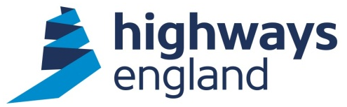  Our ref: HEITT1777  Your ref:  Ernst & Young LLP | Procurement Business Partner, Commercial & Procurement  4 South  Lateral  8 City Walk  Leeds LS11 9AT  Direct Line:  12th July 2018

COMMERCIAL - SENSITIVE

Dear*********,

SUPPLY OF SPECIALIST TECHNICAL FINANCIAL SUPPORT SERVICES TO HIGHWAYS ENGLAND

Thank you for submitting your proposal following the further competition process under the terms and conditions of the CCS Framework Agreement number RM3745 – Lot 2.

On behalf of Highways England I accept your offer (dated 23rd May 2018) to undertake the supply of Specialist Technical Financial Services under the CCS Framework Agreement number RM3745 – Lot 2 Terms of Agreement.

This Call off Agreement commenced 1st July 2018, for a period of three years, end date 30th June 2021, with an option to extend by a period of up to a further 12 months.

Please find the call off agreement document for your signature and return attached.

The following documents will form a binding contract between Highways England and Ernst & Young LLP:

- Your returned, completed CCS Framework Agreement number RM3745 Further Competition Response Template and Quality Questionnaire
- The signed Form of Tender and
- Call Off Order Form and Call Off Terms for the Management Consultancy Framework Agreement RM3745 – Lot 2.

In addition to:
- Highways England Anti-Collusion Certificate
- Highways England Fair Payment Charter
- Highways England Anti-Bribery Code of Conduct
- Highways Agency Anti-Fraud Code of Conduct

Invoices should be forwarded directly to Highways England, FS Payments, The Cube, 199 Wharfside Street, Birmingham B1 1RN quoting **********************name and the Purchase Order number that will be advised shortly.

Please acknowledge receipt of this letter.

Yours sincerely

Procurement Business Partner
Email: ********** @highwaysengland.co.uk

