Ham Street Woods National Nature Reserve Track Surfacing 2024
Ham Street Woods National Nature Reserve is located in Kent Near Ashford (Map 1 below). It is a Site of Special Scientific Interest (SSSI) due to its woodland flora, Invertebrate and breeding bird populations.
Location: Ham Street Woods NNR, Bourne Lane, Hamstreet, Nr Ashford, Kent TN26 2HH.
Map 1 – Hamstreet Village and NNR Location.

The main bridleway track in Ham Street Woods NNR is a well-used track by walkers, horse riders and bikers. In winter it becomes difficult to use due to the clay soil becoming waterlogged. It also means that any 4WD or forestry vehicles make the situation worse, causing deep ruts. As this is the arterial track in the woods, to help with public access and year-round forestry and conservation work, Natural England would like to surface this track (Map 2 – Number 1).

Map 2 – Bridleway and other surfaced areas

Key to map 2
Orange line = Existing surface tracks
Green line No. 1 = Track to be surfaced.
P = Car park.

Bridleway - Works Specification
All works are to be competed by the end of October at the latest. This is due to the tracks becoming waterlogged and the clay is very difficult to work. The best month would be September.
Bridleway track (feature 1 on the map)
This is a 1000m section to be surfaced at a width of 3m. The surfacing will need to be able to self drain and if required drainage channels / culverts to be included.

Preparation
Cut back overhanging vegetation, scrape back soil to level the ground and infill any hollows with Type 1. Lay down a semi-permeable membrane to stop any loss of stone in the clay over the winter months before covering with Type 1 aggregate.
Depth of Surfacing material
Lay an average of 150mm Type 1 at 3m width. This will vary throughout the site due to dips and hollows in the tracks. There are also areas near the stream that will need building up above the winter water level, to avoid potential flooding of the track. This will necessitate increasing the depth to 300mm in some locations.
Finish
Compact with vibrating roller to give a cambered surface before laying 15mm thick of 4mm to dust limestone fines. Compact again with vibrating roller to give tightly compacted surface.
Ditches and Culverts
Recontour ditches and include any new culverts to ease drainage.

Photos of Current tracks and entrances
- Main entrance and parking at Bourne Lane.

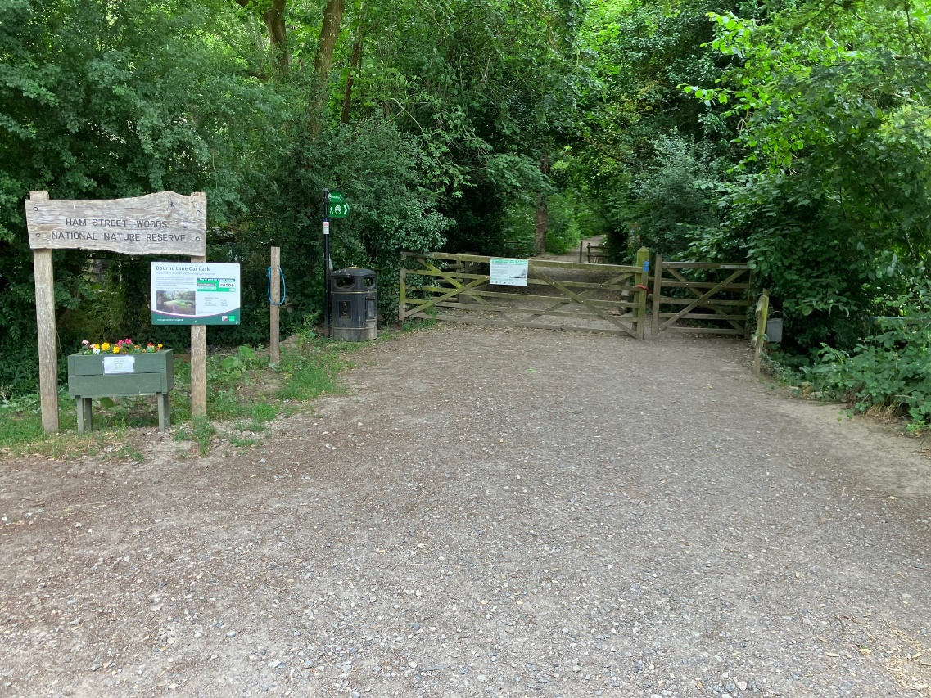
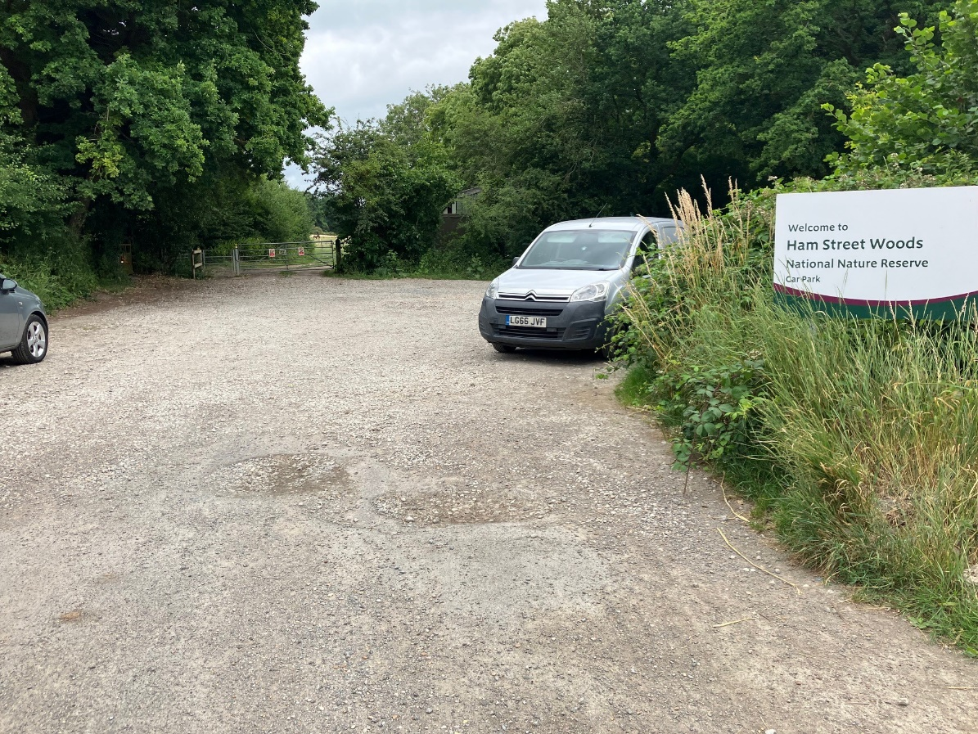

- Access to Gill Lane at Northern end of Woods

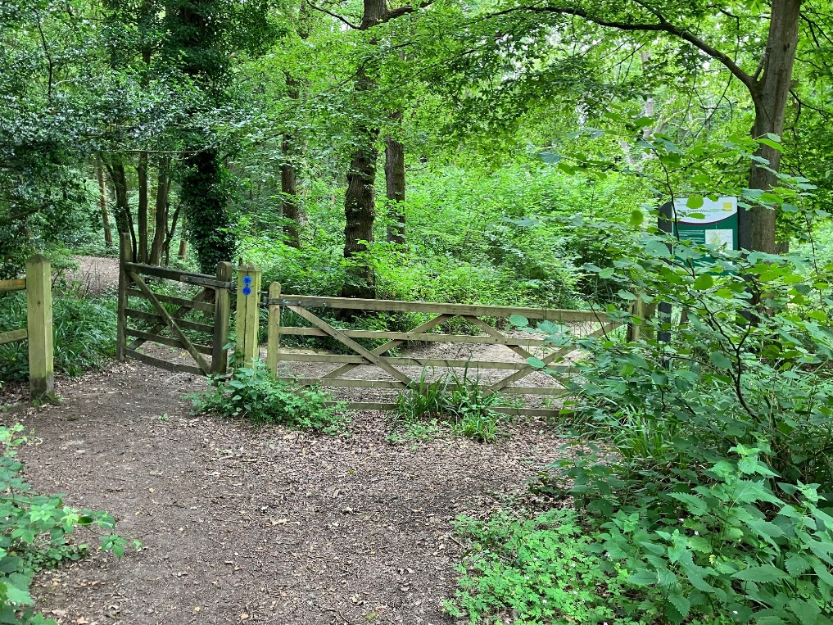

- Northern Access Point (Gill Lane)

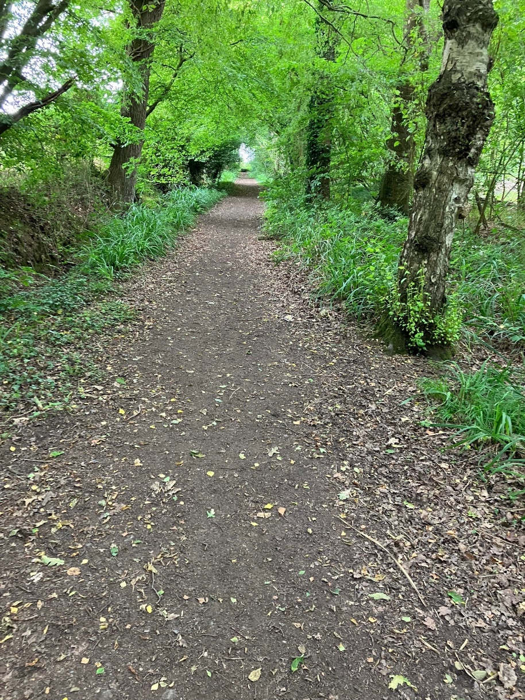

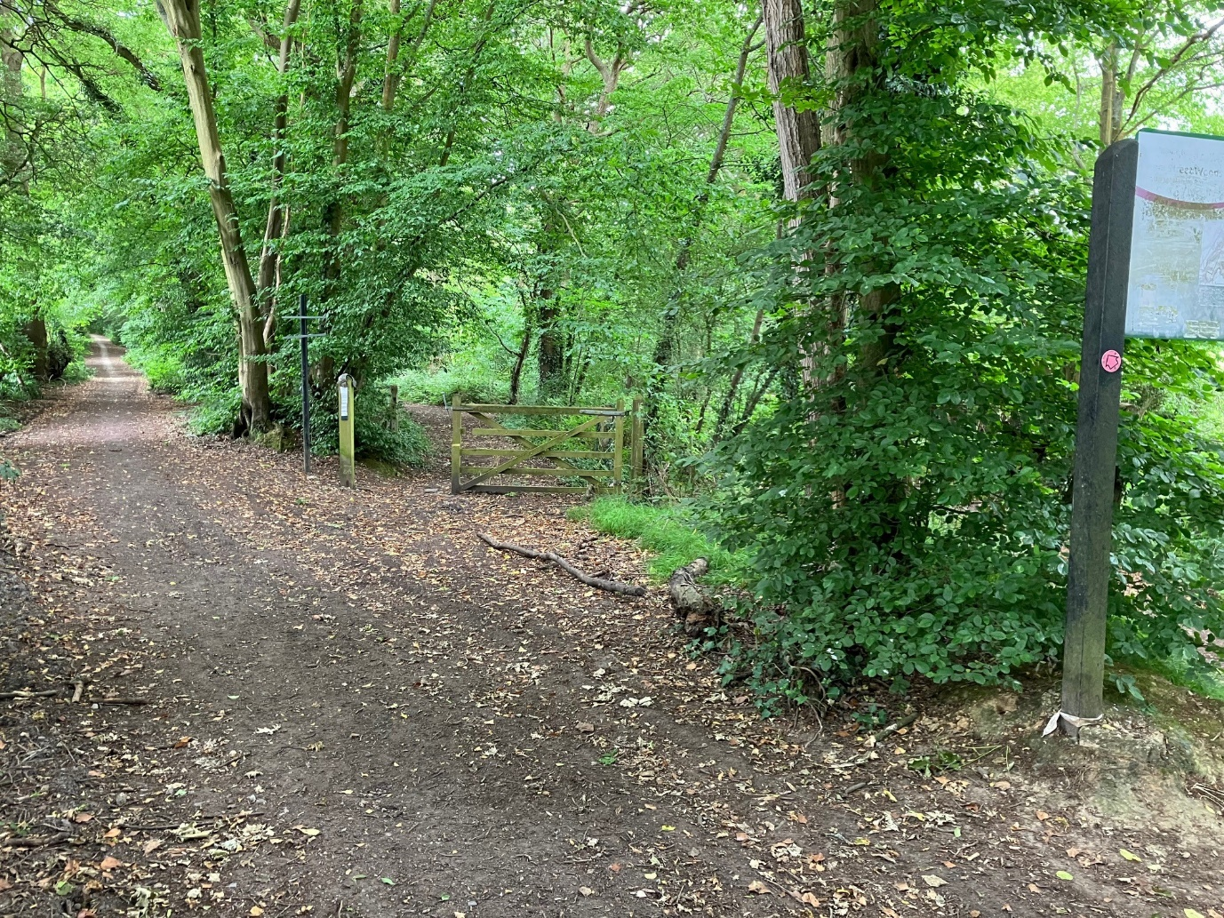
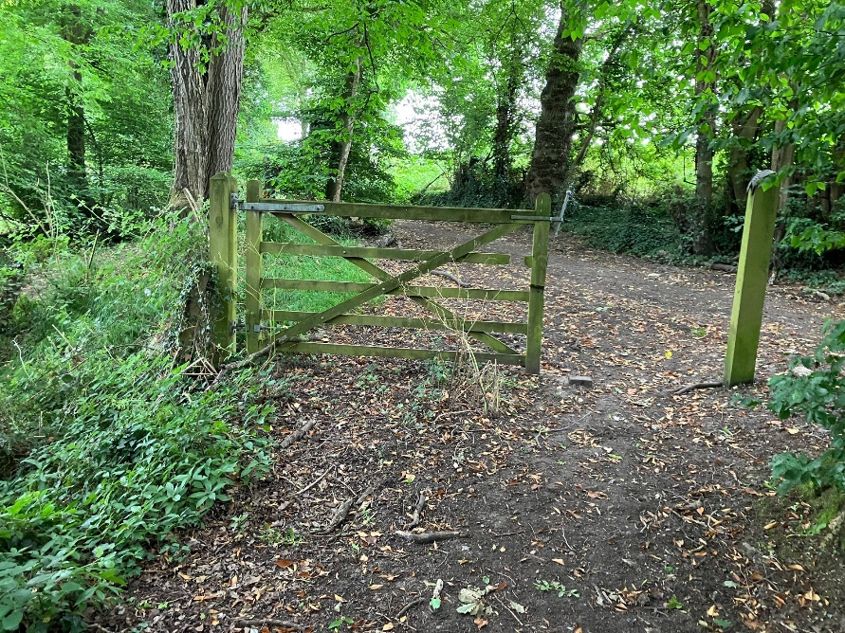

- General Bridleway Photos

