**Early Market Engagement**

**Special Educational Needs and Disabilities Information, Advice and Support Service (SENDIASS)**

**Introduction**

Shropshire Council would like to take the opportunity to engage with potential providers and/or partners in the future commissioning of the Special Educational Needs and Disabilities Information, Advice and Support Service (SENDIASS).

Please note that the purpose of this process is for the council to discuss with the market and inform our current understanding of key issues and themes relating to the provision of these services and also to discuss what the market has to offer to assist the Council to deliver the services from 1st September 2024.

Please note that this is not the commencement of any formal procurement process and the Council is not committed to carrying out such a process.

For the avoidance of doubt no information provided in response to this process will be used by the Council in assessing providers during any subsequent procurement process.

This early market engagement exercise is intended to allow providers to outline their views and to provide information to the Council decision making process.

The Council will consider the information received as a result of this exercise to help inform the Council’s options appraisal and subsequent Council decision making process.

**Background**

The Council currently commissions SENDIASS in accordance with its statutory duty under the [Children and Families Act 2014](https://www.legislation.gov.uk/ukpga/2014/6/contents/enacted?view=plain) and [Special education needs and disability code of practice: 0 to 25 years](https://assets.publishing.service.gov.uk/government/uploads/system/uploads/attachment_data/file/398815/SEND_Code_of_Practice_January_2015.pdf).

Further information about SENDIASS can be found [here](https://councilfordisabledchildren.org.uk/about-us-0/networks/information-advice-and-support-services-network/about).

The Council wishes to consider the options available to inform the approach to future commissioning of this service.

**Please reply by midday Friday 5th January 2024.**

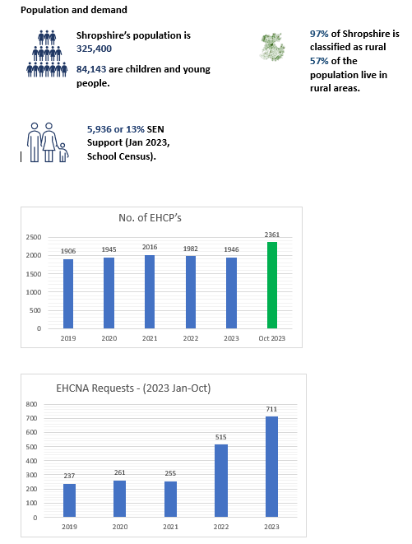

**Timetable**

|  |  |  |
| --- | --- | --- |
| **PROJECT STAGE** | **PURPOSE** | **SCHEDULED START** |
| Early Market Engagement | ***This is NOT a call for competition***.  This is intended to allow interested parties with relevant experience to outline their views and provide information with no commitment to themselves or the Council | 11/12/2023 |
| Responses Due By | The closing date and time for responses | 05/01/2024 |
| *Target date for issue of tender* | *Placing of tender notice \** | *10/04/2024 \** |
| *Target closing date of tender* | *Closing date for receipt of tenders \** | *08/05/2024 \** |
| Contract Start |  | 01/09/2024 |

*\* The target dates for issue and closing date of tenders are approximate and subject to change.*

**General Information**

Completed questionnaires (see Appendix 1) should be returned to Jane Dudley [Jane.dudley@shropshire.gov.uk](mailto:Jane.dudley@shropshire.gov.uk) by midday Friday 5th January 2024.

**If you have any questions about this early market engagement, such questions should be submitted to the Council through an email to** Jane Dudley [Jane.dudley@shropshire.gov.uk](mailto:Jane.dudley@shropshire.gov.uk)

***We encourage your participation in this early market engagement exercise but must emphasise that your involvement in this exercise will not carry any commercial advantage in any ensuing procurement process.***

***No information provided in response to this early market engagement exercise will be used in any evaluation of any subsequent response to a procurement exercise.***

**Appendix 1 – Questionnaire**

***Please complete the following questionnaire (questions 1 – 7) fully, highlighting any information that you consider to be commercially sensitive***.

|  |  |
| --- | --- |
| **Name of your organisation** |  |
| **Contact name**  **Email**  **Telephone** |  |
| **Do you currently**  **(or have you previously) delivered an IASS or similar service? Y/N** |  |
| **If Yes please give a brief description** | |

|  |  |
| --- | --- |
| **Question 1** | **Would you be interested in bidding for this contract?**   * **If Yes, why?** * **If No, why not?** |
|  | |

|  |  |
| --- | --- |
| **Question 2** | **Please share your thoughts and views around possible models of SENDIASS operation and delivery that will enable maximum reach and impact, particularly given the rurality of Shropshire.** |
|  | |

|  |  |
| --- | --- |
| **Question 3** | **If you ARE currently delivering a SENDIASS, please tell us briefly about:**   * **what works well?** * **what have you learnt from the experience?** * **where do / did you deliver the service?**   **OR:**  **If you are NOT currently delivering a SENDIASS, please tell us briefly about:**   * **any relevant experience your organisation has** * **what worked well** * **what you learnt from the experience** * **where do / did you deliver the service** |
|  | |

|  |  |
| --- | --- |
| **Question 4** | **Thinking about your experience in delivering this type of service, are there any emerging needs, themes, gaps in provision or priority areas of work that you would like commissioners to consider when specifying the new service? If so please set these out here.** |
|  | |

|  |  |
| --- | --- |
| **Question 5** | **What Social Value opportunities do you feel may be available through this contract? (see link –** [**Shropshire Council Social Value**](https://www.shropshire.gov.uk/social-value/commissioning-social-value-faqs/) |
|  | |

|  |  |
| --- | --- |
| **Question 6** | **We are keen to understand how best to ensure there is sufficient capacity to meet need and demand and to secure the financial sustainability of these services in a challenging financial climate for publicly funded services. Please share any thoughts and ideas around how this could be achieved (for example you may want to reference length of contract, price inflation, frequency of contract reviews, use of volunteers or anything else that would complement contract funding or support delivery)** |
|  | |

|  |  |
| --- | --- |
| **Question 7** | **Is there anything you would like to add that you would like the council to take in consideration?** |
|  | |

**Thank you for your interest and time in completing this questionnaire.**