Invitation to Quote for Stand Build
AHDB Exports Stand

FHA Food and Beverage
23 – 26 April 2024

Contact Name: David Phillips Email: david.phillips@ahdb.org.uk

Company Name: AHDB Website: www.ahdb.org.uk

Address: Middlemarch Business Park Tel: +44 (0) 2476 478604
Siskin Parkway East Mob: +44 (0) 7591 350360
Coventry
CV3 4PE

Show Name: FHA Food & Beverage Show Dates: 23 – 26 April 2024

Hall: 7 Stand Number: 7M4 - 05

Stand Size: 66m² Open Sides: 3

Budget: £40,000

Show Venue: Singapore Expo, 1 Expo Drive, Singapore 486150

Deadlines: Latest date for questions/clarifications – Friday 19th February 2024

Tender Submission Deadline: Wednesday 28th February 2024

Award notification date: Friday 1st March 2024

Contract Period: Monday 11th March 2024 – Saturday 27th April 2024

- Introduction

This document outlines the requirements for the AHDB Exports stand at FHA Food & Beverage, 23 – 26 April 2024.

AHDB Exports are part of AHDB (the Agriculture, Horticulture Development Board) and based in Warwickshire, England.

AHDB Exports are part of AHDB (the Agriculture, Horticulture Development Board) and based in England. We are a non-departmental Government public body working to promote (Beef, Lamb & Pork) both at home and abroad.

For more information about our work visit www.ahdb.org.uk or https://meattheukexporters.com/

2. Event Objectives

To provide a platform for meat producers to create new business relationships with international meat buyers and promote products in the market. AHDB will promote beef, lamb and pork through impactful graphics and cookery demonstrations. Exporters will utilise the stand for product displays, meetings and discussion opportunities. The overall stand design should maximise footfall in the exhibition hall, encouraging show visitors to engage with exporters.

3. Stand Build Requirements

The stand measures 11m x 6m, a total floor-space of 66 sqm with 3 open sides.

The look and feel of the stand are important and must portray the quality of British meat (Beef, Lamb and Pork) and be clearly British. The stand should be open and inviting, encouraging visitors to engage with us. The objective of the stand is to provide an impactful, visible platform promoting the high standard of British meat.

The stand will need to be seen from a distance and visually appealing - high level branding should reflect GREAT branding, guidance in Section 5 below illustrates.

Solutions incorporating sustainability and energy efficiency are encouraged in your response – note that all lighting should be low heat creating.

The stand will include the following elements:

- Reception counter
- 2 x A2 chiller counters with branded wraps (24 hour power)
- Area for seated meeting and networking space
- Cooking and butchery demo station
- 3 x company booths for co-exhibitors
- Plasma TV
- Storeroom with lockable door
- Small fridge in storeroom
- Electrical sockets for charging items
- Bin
- Literature rack
- Hospitality package (soft drinks, tea and coffee, water cooler)

Your stand design and quote should also include provision for:

- Down lighting above graphic walls
- Flooring to be wood effect padded vinyl
- Security
- WiFi

Cooking/Demonstration Area

The cooking and demonstration area should include:

- Cooking counter with low safety glass across the counter facing the visitors at a standard kitchen counter height
- An additional counter space for butchery demonstrations
- 1x Induction hob
- 3x Induction pans
- 1x undercounter fridge (24 hour power)
- Cooking utensils
- Surface/food hygiene cleaning equipment
- Red resin cutting board approx. 600x450mm – raw products
- Yellow resin cutting board approx. 600x450mm - cooked product
- Anti-slip matt for cutting boards
- 2x blue roll
- 300x cocktail sticks
- Tin foil
- X2 plates – standard white plates for resting meat
- Steamer
- Waste bin and bags (for waste product from cutting table)

The counter should have underneath lockable storage cupboards with shelves for cooking pans/ingredients and graphics on the front; and there should be electric power points for appliances in the kitchen/prep area, and cable extensions where needed.

Kitchen/Storeroom
The storeroom should include:

- Lockable door
- Preparation area containing 1 large sink with both hot and cold water for food prep and washing utensils
- 1 x induction hob
- Cooking utensils
- One small hand basin with hot and cold water for hand washing
- Countertop work services for food preparation, shelving for kitchen utensils
- 2 x H3A fridge underneath the counter (Lowe refrigeration or equivalent) for meat and drinks – 24 hour power
- Wall shelving for literature storage
- Additional double electrical socket
- Coat hooks / rack
- Coffee machine – to provide coffee and tea services
- Soft drinks package
- Space for storing luggage/valuables/laptops etc.
- Power for recharging mobile/cell phones (UK adaptors)
- Water dispenser with hot and cold water.
- Cleaning equipment e.g.
  - Cloths and tea towels for cleaning the surfaces
  - Cleaning fluids for washing equipment
  - Anti-bacterial spray
  - Waste bin and bags
  - Soap for handwashing
  - Black bin liners

Company Booths

Three equally sized spaces for co-exhibitors allowing for company branding to be displayed and provision for seating. Additional requirements are:

- Booth 1 – requires 1m wide counter
- Booth 2 – no additional requirements
- Booth 3 – Display chiller with branded wrap (24 hour power required), 1m wide counter and cooking hob

Maintenance of Stand

Maintenance, upkeep and cleaning of the stand shall be carried out daily by the successful supplier during the duration as well as prior to the start of the Exhibition. This is to include, but not limited to the following:

- The cleaning of floors throughout the stand
- The cleaning of furniture including tables, chairs and work surfaces
- Emptying of bins

Hospitality package

Please provide a price for supplying the following hospitality package for the entire show:

- Pods for coffee machine
- UHT milk
- Tea bags
- Sugar sachets
- Stirring sticks
- Water for cooler
- Cups for water, tea, coffee
- Soft drinks e.g. coke, sprite
- Refuge sacks – for bins

Stand Management

A member of the successful supplier’s team shall be nominated and must be available during the duration of the Exhibition covering construction and dismantling of the stand, and capable of dealing with any eventuality. A nominated deputy must be available during any absence of such person. AHDB would require names of who will be in attendance.

AHDB will nominate a “Stand Manager” who will be the key contact for the successful supplier for the full duration of this project.

Stand Location

Our stand in Hall 7 is indicated in red on the below floorplans:

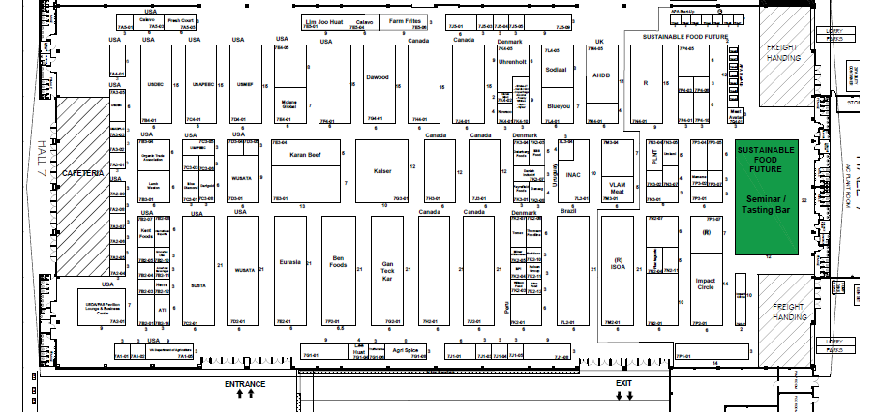

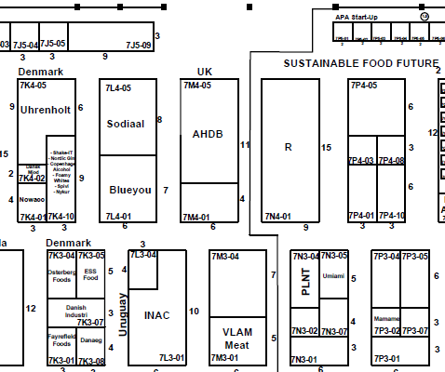

4. Graphics

AHDB will provide full and print ready artwork for all graphics. Top level branding needs to be seen from a distance in all directions and draw people to our stand. This should be co-branded with GREAT as per the below.

AHDB graphic panels

The theme will be based on Quality Meat from Britain using landscape images with livestock and/or food images. Our key message “Quality Meat from Britain” – will need to be shown in a prominent position.

Our unique selling point is based around a quality product and graphics design needs to reinforce this message.

5. GREAT Branding

AHDB have agreed the following overarching principles for use of the GREAT brand at international events.

- Where the stand design does not incorporate a lampshade, AHDB will design a column or back wall which mirrors the agreed logo and brand hierarchy with GREAT as the primary brand.

- In this instance the GREAT header fascia must be clearly separated from the AHDB panels. Ideally there should be a physical gap no less than the same dimension as the height of the header fascia.

- Where this is not achievable the GREAT header fascia must be a definite different colour. If the AHDB background colour is blue, then the GREAT header must be white (or vice versa).

Branding hierarchy:

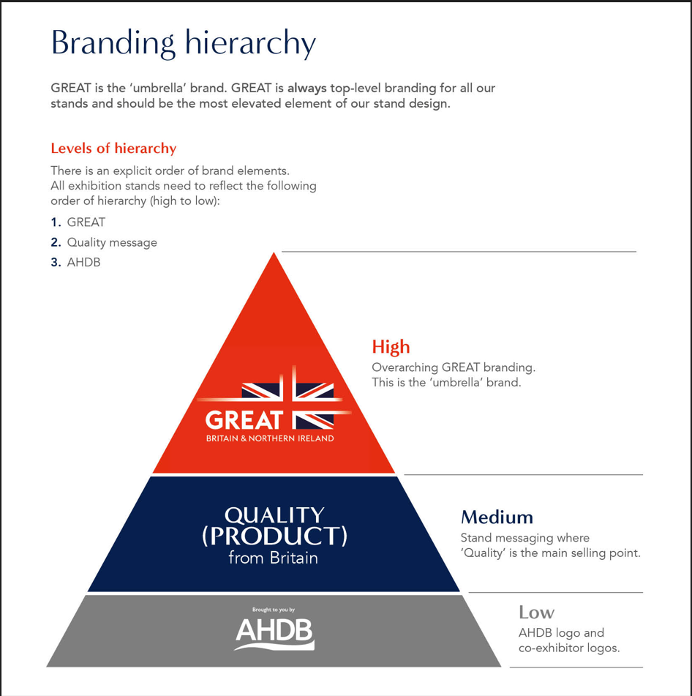

6. Stand Design

The image below illustrates the stand used at the previous edition of the show, FHA Food & Beverage 2022.

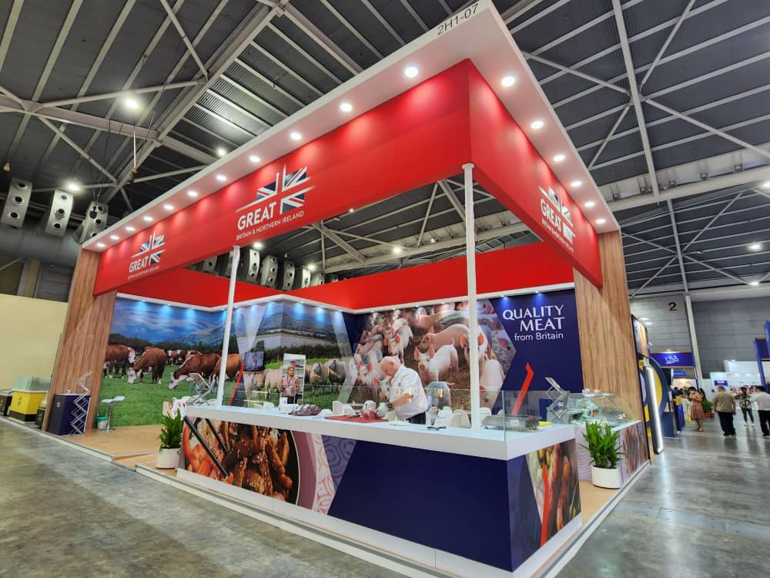

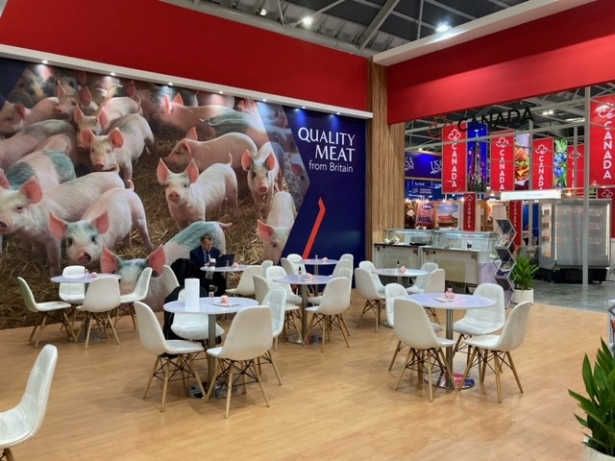

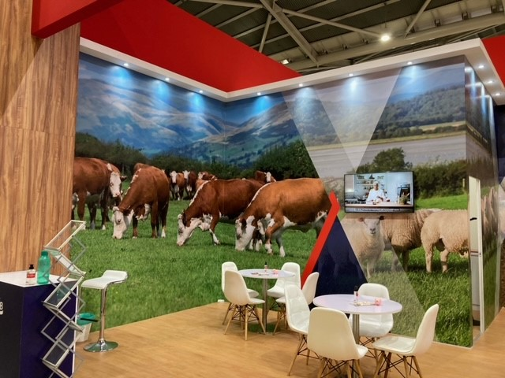

7. Useful information

All stands in the exhibition must have at least half of any frontage facing an aisle left open or fitted with transparent material. This area must be visibly free of obstruction.

- Maximum stand height allowed: 4m
- Floor loading capacity: 20KN/sqm (417 lbs/sq. ft) of concrete flooring.
- Materials for the construction of the exhibition booths shall have a minimum flame spread rating of Class 2.

Stand build dates

Build-up: | 20 – 21 April | 8.30am – 10.00pm
 | 22 April | 8.30am – 5.00pm
Show days: | 23 – 25 April | 10.00am – 6.00pm
 | 26 April | 10.00am – 4.00pm
Tear-down: | 26 April | 5.00pm – 10.00pm
 | 27 April | 8.30am – 5.00pm

The contractor will be responsible for completion and submission of organisers forms relating to the design and construction of the stand, including organiser design approval. A login for the exhibitor portal will be provided after the contract is awarded, which includes relevant exhibition build information, order forms and deadline dates.

8. Health and Safety

Risk assessments, method statements and proof of public liability insurance will need to be provided before a contract is awarded.

9. Tender Process

The contractor shall deliver the whole of the services, complete in all parts and furnished with every necessary detail, notwithstanding any omission or inconsistency in the specification.

The quote should include ‘to scale’ visuals of your design and be clearly itemised for all services and provision as stated in this document; where possible split by area (cooking area, storeroom, partner areas etc.) stating if any sub-contractors will be used; graphic dimensions and artwork deadline.

Except as otherwise stipulated in the specific conditions of service required, the contract shall remain at the fixed price and rates shall not be revised.

AHDB’s Event Manager can order reasonable additions to or reduce from the service specified. These amendments shall be requested in writing and agreed by both parties.

10. Evaluation of Tenders

Our award criteria are:

- Understanding of the brief 20%
- Price 25%
- Design, creative impression and equipment 40%
- Ability to meet H&S requirements and event timelines 15%

Please email your design proposals to David Phillips David.Phillips@ahdb.org.uk by 28 February 2024.

13. Payment Terms

Please note that all invoices submitted to AHDB require a purchase order number to enter onto our payment system. Our payment terms are 30 days from receipt of the invoice.

14. Appendix

