Order Form

CALL-OFF REFERENCE: CCSO21A29

THE BUYER: Cabinet Office

BUYER ADDRESS REDACTED

THE SUPPLIER: CISION GROUP LIMITED
SUPPLIER ADDRESS: REDACTED
REGISTRATION NUMBER: 00874637
DUNS NUMBER: 210089876
SID4GOV ID: N/A

This Order Form, when completed and executed by both Parties, forms a Call-Off Contract. A Call-Off Contract can be completed and executed using an equivalent document or electronic purchase order system.

If an electronic purchasing system is used instead of signing as a hard-copy, text below must be copied into the electronic order form starting from ‘APPLICABLE FRAMEWORK CONTRACT’ and up to, but not including, the Signature block

It is essential that if you, as the Buyer, add to or amend any aspect of any Call-Off Schedule, then you must send the updated Schedule with the Order Form to the Supplier]

APPLICABLE FRAMEWORK CONTRACT

This Order Form is for the provision of the Call-Off Deliverables and dated 5 November 2021. It’s issued under the Framework Contract with the reference number RM6134 for the provision of Media Monitoring and Associated Services.

CALL-OFF LOT(S):
Lot 1: Media Monitoring and Associated Services
CALL-OFF INCORPORATED TERMS
The following documents are incorporated into this Call-Off Contract. Where numbers are missing we are not using those schedules. If the documents conflict, the following order of precedence applies:
- This Order Form including the Call-Off Special Terms and Call-Off Special Schedules.
- Joint Schedule 1(Definitions and Interpretation) RM6134
- The following Schedules in equal order of precedence:

- Joint Schedules for RM6134
  - Joint Schedule 2 (Variation Form)
  - Joint Schedule 3 (Insurance Requirements)
  - Joint Schedule 4 (Commercially Sensitive Information)
  - Joint Schedule 10 (Rectification Plan)
  - Joint Schedule 11 (Processing Data)
- Call-Off Schedules for RM6134
  - Call-Off Schedule 1 (Transparency Reports)
  - Call-Off Schedule 2 (Staff Transfer)
  - Call-Off Schedule 3 (Continuous Improvement)
  - Call-Off Schedule 4 (Call Off Tender)
  - Call-Off Schedule 5 (Pricing Details)
  - Call-Off Schedule 6 (ICT Services)
  - Call-Off Schedule 7 (Key Supplier Staff)]
  - Call-Off Schedule 15 (Contract Management)
  - Call-Off schedule 20 (Specification)

- CCS Core Terms (version 3.0.7)
- Joint Schedule 5 (Corporate Social Responsibility) RM6134

No other Supplier terms are part of the Call-Off Contract. That includes any terms written on the back of, added to this Order Form, or presented at the time of delivery.

CALL-OFF SPECIAL TERMS
The following Special Terms are incorporated into this Call-Off Contract:
Social Listening Terms
The following terms have the following meanings:
“Applicable Law” means any legally binding obligation on a party, including statutes, rules, regulations, codes, court rulings, or any other binding requirement.
“Services” means the Services as set out in this Call-Off Contract.
“Supplier Data” means means any data in Supplier’s database that Supplier uses in providing the Services.
“User” means an individual that Buyer has authorised to use the Services.

1. Responsibility. Buyer will comply with the Twitter Terms of Service, usually at https://twitter.com/tos, and the Youtube Terms of Service, usually at https://www.youtube.com/t/terms;
2. User protection. Buyer will not: (a) knowingly display, distribute, or otherwise make Supplier Data available to any person or entity that it reasonably believes may use Supplier Data in a manner that would have the potential to be inconsistent with that individual’s reasonable expectations of privacy; (b) conduct any research or analysis that isolates a small group of individuals or any single individual for unlawful or discriminatory purposes; (c) use Supplier Data to target, segment, or profile any individual based on health, negative financial status or condition, political affiliation or beliefs, racial or ethnic origin, religious or philosophical affiliation or beliefs, sex life or sexual orientation, trade union membership, data relating to any alleged or actual commission of a crime, or any other sensitive categories of personal information prohibited by applicable law; or (d) without Supplier’s prior written consent, but subject to applicable law, display, distribute, or otherwise make Supplier Data available to any member of the US intelligence community or any other government or public-sector entity.
3. Removal of Supplier Data. A licensor or Applicable Law may require Supplier to remove personal data within any Supplier Data. In such cases, Supplier will notify Customer of the impacted Supplier Data that requires removal and Customer will promptly remove such data from its systems, whether during or after the Term.
4. SLA. The Service Level Agreement available at https://www.brandwatch.com/legal/brandwatchslas/ applies to the Services.
5. Supplier Data licence. Supplier grants to Buyer a worldwide, non-exclusive, non-transferable, royalty-free, licence to use, download, copy, or otherwise remove Content from Supplier’s systems, in accordance with this Agreement.
6. Pass-through terms: Buyer agrees to the following pass-through terms directly with Twitter:
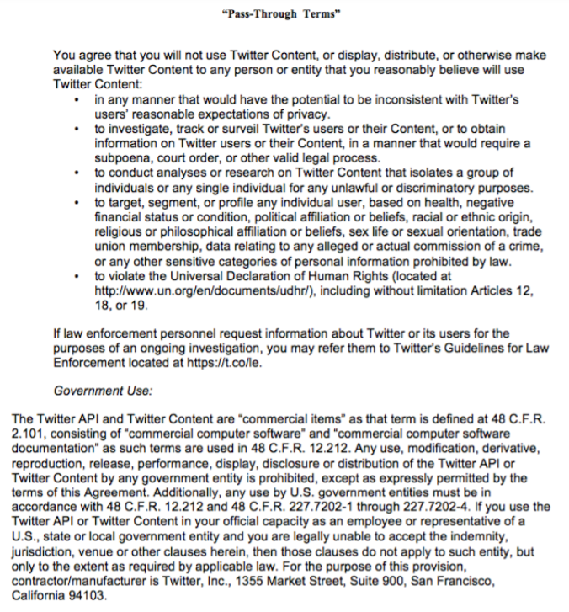

CALL-OFF START DATE: Friday 5th November 2021

CALL-OFF EXPIRY DATE: Friday 4th November 2022

CALL-OFF INITIAL PERIOD: [One (1) Year]

CALL-OFF DELIVERABLES

See Call-Off Schedule 20 (Specification)

MAXIMUM LIABILITY
The limitation of liability for this Call-Off Contract is stated in Clause 11.2 of the Core Terms.

The Estimated Year 1 Charges used to calculate liability in the first Contract Year is £75,600.00 (ex VAT)

CALL-OFF CHARGES
See details in Call-Off Schedule 5 (Pricing Details)]

REIMBURSABLE EXPENSES
None

PAYMENT METHOD
BACS

BUYER’S INVOICE ADDRESS:
REDACTED

BUYER’S AUTHORISED REPRESENTATIVE
REDACTED

BUYER’S ENVIRONMENTAL POLICY
Cabinet Office Environmental Policy Statement] [5 March 2015] available online at: https://www.gov.uk/government/publications/cabinet-office-environmental-policy-statement

BUYER’S SECURITY POLICY
Security policy framework: protecting government assets] [1 April 2013] available online at: https://www.gov.uk/government/publications/security-policy-framework

SUPPLIER’S AUTHORISED REPRESENTATIVE
REDACTED

SUPPLIER’S CONTRACT MANAGER
REDACTED

PROGRESS REPORT FREQUENCY
On the first second Wednesday of each calendar month

PROGRESS MEETING FREQUENCY
On the first second Wednesday of each calendar month

KEY STAFF
REDACTED

KEY SUBCONTRACTOR(S)
Runtime Collective Limited (trading name: Brandwatch)

COMMERCIALLY SENSITIVE INFORMATION
Supplier pricing and contract methodology

SERVICE CREDITS
Not applicable

ADDITIONAL INSURANCES
Not applicable

GUARANTEE
Not applicable

SOCIAL VALUE COMMITMENT
Not applicable

For and on behalf of the Supplier: |  | For and on behalf of the Buyer:
Signature: | REDACTED | Signature: | REDACTED
Name: | REDACTED | Name: | REDACTED
Role: | REDACTED | Role: | REDACTED
Date: | REDACTED | Date: | REDACTED

