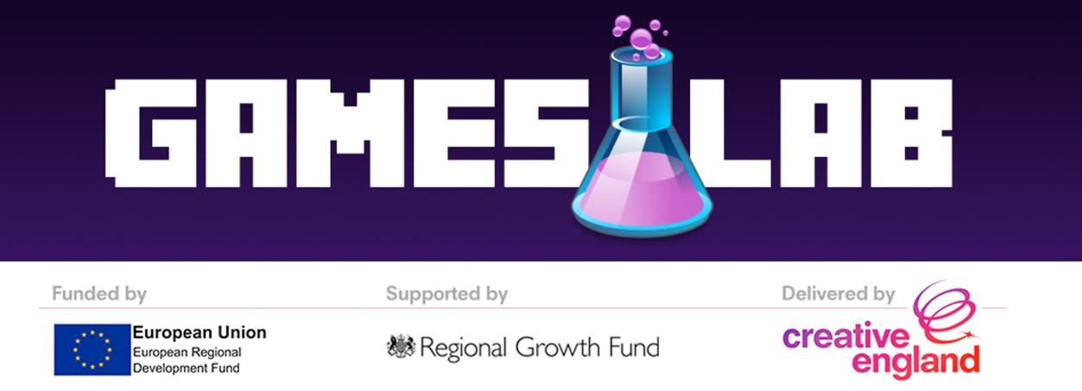

TENDER SPECIFICATION

TENDER TITLE: GamesLab Leeds - Programme Mentors

ERDF PROJECT: Creative England GamesLab Leeds

TENDER REF:GLL/2017/03

SUBJECT TO CONTRACT

January 2017

Please read the instructions carefully and answer all questions. If you have any queries regarding completing of the response please email ella.waving@creativeengland.co.uk. We reserve the right to distribute the response
provided to your question to other interested applicants via a public Questions and Answers Log.

B A C K G R O U N D

Creative England operates with the core purpose of supporting the sustainable growth of independent creative businesses, and the talent that feeds them, in every part of England outside of London.

Creative England’s GamesLab is a programme of investment and support, designed to aid and sustain the growth of the region’s burgeoning games industry, through the development of innovative games and IP. Working with emerging and established companies, the GamesLab programme aims to create the conditions necessary for the region’s most innovative and commercially astute games companies to flourish.

GamesLab Leeds is intended to stimulate the development and growth of the games industry in the Leeds City Region by supporting companies that demonstrate high-growth potential. By coupling investments with business support in the form of one-to-one mentoring and group workshops, we endeavour to offer our grant recipients the best possible chance of success.

The focus of the GamesLab programme is to foster Research, Development and Innovation in the sector

The support offered through the GamesLab programme will take two forms

Financial

Grants will be awarded between £10,000 - £30,000 for the development of a) beta prototyping and principle
R&D and b) sophisticated prototypes, leading to new IP generation

GamesLab will appoint a small panel of business / games industry experts to mentor the funded companies on a one-to-one basis

Non-financial

Of course not all problems need to be solved with money, often it’s advice and guidance that would be most beneficial. So businesses not receiving funding can still access the support of the GamesLab programme through a series of group workshops
R E Q U I R E M E N T S O F T H E B R I E F

As part of their support package, an individual from all businesses in receipt of a GamesLab grant will also receive a two days of mentoring from an experienced industry professional

Creative England now wishes to engage at least one highly experienced games industry professional to act as a mentor to the 18 developers selected to receive grant funding.

The requirements of the mentor role are as follows:

- Deliver two days of bespoke mentoring to the 18 businesses in receipt of grants before the end of 2017. A total of 36 days
- The mentoring sessions should identify the individual or organisation’s knowledge gaps and current challenges and then develop a realistic action plan, with specific deliverables, to help overcome these business challenges

GamesLab Leeds is intended to stimulate the development and growth of the games industry in the Leeds City Region by supporting companies that demonstrate high-growth potential. By coupling investments with business support in the form of one-to-one mentoring we endeavour to offer our grant recipients the best possible chance of success. A primary focus of the programme is facilitating, Research, Development and Innovation in the sector and with that in mind we are looking for mentors with expertise that includes (but is not limited to) the following

- Understanding, and developing for, new technologies (VR/AR/Wearable tech etc)
- Marketing: understanding customers, identifying routes to market and building marketing strategies
- Accessing further funding
- Developing commercial business models
- Pivoting a business from client work to development of original IP
- Production and resource management
- Legal and financial

Please note that it is not essential to have expertise in all of the above areas to apply, this is simply a range of skills and knowledge gaps we expect the grant beneficiaries may need support to fill

Creative England has secured a venue in central Leeds where all programme activity, including mentoring sessions will take place

As a guide we would expect the successful bidder to deliver approx nine days of mentoring in each of the following quarters

January-March 2017
April-June 2017
July-September 2017
October-December 2017

B U D G E T

In your application to tender, you should include your day rate inclusive of all VAT and expenses

We are looking for a fully costed solution and Creative England will expect this day rate to include all costs associated with delivering the workshop ( time, travel, subsistence etc) Once this rate has been agreed with the successful bidder Creative England will not be liable for any costs incurred above and beyond that amount

We would expect the successful bidder to submit one invoice per quarter of 2017 (as listed under ‘requirements of the brief’ ) . Ie: the total cost for delivering all the work should be split equally across four quarters

T I M E S C A L E S

The table below outlines the timescales for this tender and delivery of the project. This is an indicative timetable and, whilst Creative England does not intend to depart from the timetable, it reserves the right to do so at any stage.

Issue of Specification | 20th January 2017
Deadline for Submission of Questions | 30th January 2017
Deadline for Submission of Tenders | 6th February 2017
Tender Evaluation/Scoring & Shortlist Completion | w/c 6th February 2017
Interviews (if required for clarification) | w/c 6th February 2017
Preferred Bidder Identified & Notified | w/c 6th February 2017
Feedback to All Bidders | w/c 13th February 2017

E L I G I B I L I T Y C R I T E R I A

Please note that Creative England is only able to accept tenders from organisations or individuals who can meet the following eligibility criteria:

- able to commit up to 36 days of mentoring – with a minimum of 4 days of mentoring be delivered before the end of March 2017
- solid, demonstrable games industry experience
- expertise in two or more of the areas highlighted under ‘requirements of the brief’
- previous experience as a mentor in a similar capacity
- individuals tendering must be able to offer solutions for everything detailed in the brief – at a minimum. Please clearly outline in your application any additional services you are able to offer as ‘added value’

H O W T O A P P L Y

Proposals should include

- CV outlining the applicants games industry experience
- personal statement explaining the applicants suitability for the role and detailing any previous mentoring experience
- clear indication of the applicants specific area/s of games industry expertise Please refer to ‘requirements of the brief’ for more detail
- day rate. Please refer to ‘budget’ above

Please submit a full proposal to Ella Waving via post to the address below, clearly noting ‘TENDER REF:
GLL/2017/03 on the tender envelope. Creative England Ltd
1st Floor, College House

32-36 College Green

Bristol

BS1 5S

A W A R D C R I T E R I A

An evaluation team will consider all tenders correctly submitted by the tender deadline. The team will score bids with a view to shortlisting a maximum of 3 potential providers interview stage, if required. The evaluation team will take into consideration the following scoring criteria:

- Proposals fully meet the ‘Eligibility Criteria’ listed above (Pass/Fail)
- Proposals include the requested information as stated under ‘How to Apply’ (20% of Score – Max 20
- Points)
- Realistic budget that demonstrates value for money, and extent to which proposals offer a “whole fully costed solution” (20% of Score – Max 20 Points)
- Suitability of bidder in terms of industry experience and mentoring experience (20% of Score – Max 20 Points)
- Extent to which bidder offers an event solution against the brief requirements (20% of Score – Max 20 Points)
- Extend to which bidder offers additionality over and above the brief requirements (further value add to promote the creative industries) (20% of Score – Max 20 Points)

Creative England will evaluate all proposals on the basis of the “most economically advantageous proposal”. Creative England does not bind itself to accept the lowest tender or indeed any tender submitted and reserves the right to accept any tender in whole or in part. The overall evaluation process will be conducted in a fair and equitable manner, so that Creative England is able to consider the value for money of each proposal. This means that different clarification/information may be sought from different applicants.

TECHNICAL NOTES

N O C O N T R A C T

No information contained in this specification or in any communication made between Creative England, and the project partners and any supplier in connection with this specification shall be relied upon as constituting a contract, agreement or representation that any contract shall be offered in accordance with this specification. Creative England reserves the right, subject to the appropriate procurement regulations, to change without notice the basis of, or the procedures for, the competitive tendering process or to terminate the process at any
time. Under no circumstances shall Creative England incur any liability in respect of this specification or any supporting documentation.

You accept Creative England’s Terms and Conditions of Business and Requirements of ERDF Funding.

Q U E R I E S A B O U T T H E P R O C U R E M E N T

Creative England will not enter into detailed discussion of the requirements at this stage. Any questions about the procurement should be submitted by e-mail to the contact stated at the top of page 2. If Creative England considers any question or request for clarification to be of such significance that all potential suppliers who have responded should be made aware of it, both the query and the response will be communicated to them, in a suitably anonymous form. All responses received and any communication from service providers will be treated in confidence.

