RSPB Pulborough Brooks

Pollution Prevention Plan

Contents

Emergency procedures 2

RSPB Emergency contacts: 2

Identified risks 3

Controlling any spillages 4

Spill kits locations 5

Incidents/Accidents/near misses 5

# Emergency procedures

**Reserve Location**

RSPB Pulborough Brooks, Upperton's Barn, Wiggonholt, Pulborough, West Sussex RH20 2EL

Grid Reference: TQ05941642 (Visitor Centre Entrance)

///reading.cared.stag

**Nearest Telephone Locations**

Pulborough Brooks Office / work mobile

**Mobile Phone Coverage**

Good coverage across the reserve

**Access Points**

Car Park: TQ06271655, ///adjust.paddocks.view

Workshop: TQ06181714, ///respond.trifling.gearbox

Sewage Works: TQ06321805, ///speakers.caskets.typically

Will Ryden’s: TQ05361593, ///accordion.piles.questions

The Triangle: TQ06211604, ///planting.dentures.moves

Wiggonholt Heath: TQ06201605, ///remainder.natively.brew

**Emergency Service Response Times**

Circa 10 mins. Nearest fire station – Storrington RH20 4NB

# RSPB Emergency contacts:

|  |  |  |  |
| --- | --- | --- | --- |
|  | Name | Office phone no | Mobile |
| Senior Site Manager | Oriole Wagstaff | 01798 875851 | 07595 092346 |
| Warden | James McComiskey | 01798 875851 | 07594 083232 |
| H & S officer | Kerry McCoubrie | 01708 899847 |  |

# 

# Identified risks

|  |  |  |
| --- | --- | --- |
| **Potential Pollution Source** | **Risk area** | **Control measures** |
| Oil storage for heating and machinery re-fuelling | * leaks | * Keep records of usage to spot when it is unusually high, * Monitor levels in the tank and check pipes and ground for a leak every month * Visually check tanks and ancillary equipment regularly - at least annually - for signs of corrosion or perishing of hoses * Keep the area around the tank clear of tall vegetation |
|  | * Refuelling tractors at fuel store | * Where any refuelling it to take place, spill kits must also be available. |
|  | * Refuelling machinery on site | * All vehicles utilised to complete the works detailed in Annex 1 (see Management plan consent) to be refuelled more than 10m from a watercourse * Any machinery/vehicles requiring re-fuelling should be re-fuelled on a track or hardstanding, away from any water bodies/courses. * Spill kits to be taken out on site. |
|  | * Contractors doing work on site refuelling vehicles | * Explain procedures as part of exchange of information |
|  | * Delivery of fuel | * Check tank can hold amount ordered * Supervise deliveries of oil to tanks to ensure that the lorry doesn’t back into the tank, that the delivery person remembers to switch off the pump once the tank is full and that they remember to disconnect the pipe before they drive off – these all happen! |
|  |  |  |
| Waste oil from vehicles and machinery | * Oil changes in the tractor | * Appropriate receptacles & storage containers used with adequate capacity * Waste oil disposed of promptly by a licensed contractor or to a licensed waste site |
|  |  |  |
| Release of sediments into water bodies | * Working near water bodies | * In the design of excavation works, consider the use of sediment traps & ways of working to stop sediment reaching water courses * Monitor impact of work whilst working |
|  | * Run off from poached, churned areas and/or bare soil, * piles of aggregate, rotting vegetation etc. | * Identify through cross-compliance work * Site piles of aggregate, etc. under cover or on hard standing if possible |
|  |  |  |
| Pesticides | * See Code of Practice 24 | * Ensure storage facilities are well maintained * Ensure spill kits in vicinity of pesticide use and storage * Ensure waste pesticides are stored and disposed of appropriately, following on label instructions * Identify areas where any washings can be disposed of and apply for relevant permission from environment agency |
|  |  |  |
| Vehicle washing | * Run off of soapy water | * Wash vehicles off site in facilities designed for the purpose * If done on site, then use bio-degradable “eco” products |
|  |  |  |
| Oil/petrol from parked cars/other visiting vehicles | * Leaks from vehicles | * Spill kit to hand designed for biggest regular visiting vehicles i.e. staff cars up to coaches * Manholes/other drainage points are fitted with oil receptors at larger sites > 50 cars or covers available |
|  |  |  |
| Run-off from Fire Service hose pipes in event of a fire |  | * Consider how to protect water bodies and habitats from firewater |
|  |  |  |
| Flood | * Burst pipes * Flooding from rain/river | * Turn off water supply at stopcock * Stopcock marked on plan below * Follow advice of emergency services * Move perishables upstairs if time * Close off oil tank valves to heating system if time |
| Waste storage | * See COP D2 Waste management | * Make sure waste is contained and kept dry * Ensure regular collections * Keep compost heaps aerated to avoid leachate |

# Controlling any spillages

On discovery of a spill:

* Assess type and extent of spillage.
* Prevent access to the area and barrier off the affected area.
* Use PPE (gloves and safety glasses) in accordance with safety data sheet (SDS)
* Locate nearest spill control kit. Use contents to contain and clear the spill.
* **Do not allow spillage to enter drainage system**
* Label spill bag with contents including details of spill substance (found on SDS)
* Arrange disposal of spill contents and any contaminated clothing/ PPE via our Waste contractors (see below)
* The incident should be recorded on the RSPB Prime system
* Re-order any materials used
* Large Spills, greater than 15ltrs, contact HSEA for advice

# Spill kit locations

Pulborough Brooks Workshop

Large supply of fuel and oil mats

1 x chemical spill kit

# Spill response contractors

# Ideal response 0808 2399129

# Incidents/Accidents/near misses

The site manager (or designee) will report any incidents via the RSPB PRIME incident reporter.

# Stopcock / Burst pipes

Visitor centre – Disabled toilet - controls water for all toilets, the classroom and the office

- Under first sink on the right in kitchen – controls water for kitchen

Reserve – At back of visitor centre outside (by water meter)

Workshop – left of butler sink

Mains - At entrance from main road with the water meter on grass verge

# Site hydrology

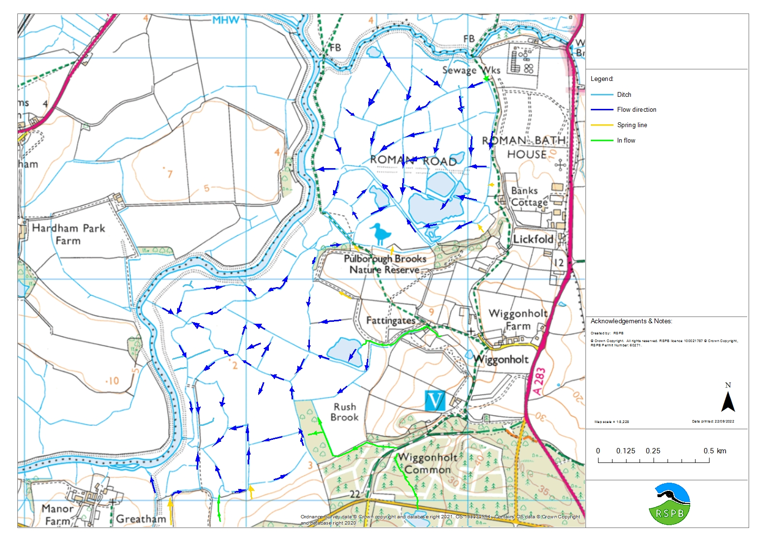

# Emergency Plan

|  |  |
| --- | --- |
| **Site name and address** | RSPB Pulborough Brooks  Upperton's Barn, Wiggonholt, Pulborough, West Sussex RH20 2EL |
| **Site/Office Manager**  **Name and number** | Oriole Wagstaff - 07595 092346 |

CONTACT DETAILS

|  |  |
| --- | --- |
| Main office number | 01798 875851 |

**Primary Contacts**

|  |  |  |  |  |
| --- | --- | --- | --- | --- |
| **RSPB staff** | **Contact number(s)** |  | **Home locations** | **Ist aider** |
| First-responders |  |  |  |  |
| Oriole Wagstaff | 07595 092346 |  | Hove | Yes |
| James McComiskey | 07594 083232 |  | Midhurst | Yes |
| Others able to respond |  |  |  |  |
| Pulborough Duty Manager | 01798 875851 |  | N/A | Some |
| Project Manager – Ruth Gillies | 07751 400077 |  | Chichester | Yes |

|  |  |
| --- | --- |
| **Emergency Services contact** | 999 |
| **Pollution hotline - England, Scotland & NI** | 0800 80 70 60 (24 hrs) |
| **Pollution hotline - Wales** | 0300 065 3000 (24 hrs) |
| **Floodline - England, Wales and Scotland** | 0345 988 1188 |
| **Flooding incident line - NI** | 0300 2000 100 |

**Secondary contacts**

**Local community**

|  |  |
| --- | --- |
| To notify if at risk or potential sources of help |  |
| Is there a school or other neighbour nearby who might be affected | Banks Cottage |
| Are any adjacent landowners affected | Will Rydon |
| Local rescue organisations that can assist |  |
| Organisations/People who may need to be notified – after the event |  |
| National Park Authority | SDNP |
| Other wildlife organisations | NE, EA |

Other RSPB contacts

|  |  |
| --- | --- |
| Others who may need to be informed | |
| Area Manager | Yianni Andrews |
| Health, Safety and Environment Adviser | Graham Figg |
| Regional Director | Deborah Fraser |
| Country Director | Michael Copleston |
| RSPB Communication and media officer | Harriet Brampton |
| Environmental Manager | Jane Sears (Ecology) |