**Document No. 02**

**Invitation to offer for NHS National Pharmaceuticals Transition 2020_2**

**Offer reference number: CM/PHG/20/5618**

**Period of framework agreement: The total maximum duration of the framework agreement to be no more than 38 months (19 months plus options to extend (at the Authority's sole discretion) for up to a further 19 months)**

**Potential periods of call-offs under the framework agreement**

**Transition Products: LSNE 01/12/2020 to 30/09/2021 (10 months)**

**NWLN 01/12/2020 to 31/01/2022 (14 months)**

**CESW 01/12/2020 to 30/06/2022 (19 months)**

**Hospital Only Products: All Regions 01/12/2020 to 31/01/2022 (14 months)**

**Terms of offer**

**1. The Commercial Medicines Unit**

1.1 The NHS Commissioning Board (operating under the name of NHS England), (‘Authority’) is conducting this procurement exercise as a central purchasing body to establish a framework agreement (the ‘Framework Agreement’) for and on behalf of the Participating Authorities with whom the suppliers appointed to the Framework Agreement (‘Successful Offerors) will ultimately enter into contracts under the Framework Agreement for the supply of the goods and/or services. The Participating Authorities are the organisations specified in Schedule 8 (*Participating Authorities*) of Document No. 03 Framework Agreement and Terms and Conditions.

1.2 The Authority will not be a party to any such subsequent contracts. In accordance with Regulation 37 of the Public Contracts Regulations 2015, each Participating Authority is and shall remain responsible for the conduct of its award of contracts under the framework agreement, including (but not limited to) fulfilling the requirements imposed by Regulation 33 of the Public Contracts Regulations 2015 when conducting an award of contract(s) under the framework agreement.

1.3 The Authority is not responsible or accountable for and shall have no liability whatsoever in relation to:

1.3.1 the conduct of Participating Authorities in relation to the framework agreement;

1.3.2 the acts or omissions of a Participating Authority in connection with a contract between the successful Offeror and the Participating Authority entered into pursuant to the framework agreement; or

1.3.3 the performance or non-performance of a contract between the successful Offeror and the Participating Authority entered into pursuant to the framework agreement.

1.4 Offerors taking part in this competition consent to the terms set out in this Invitation to Offer as part of the competition process.

**2. The framework agreement**

2.1 This procurement exercise concerns the establishment of a Framework Agreement under which one or more successful Offerors will be appointed to supply goods and/or services on the terms agreed to such of the Participating Authorities as may place orders for such goods and/or services from time to time.

2.2 The Authority cannot mandate the Participating Authorities to place any orders or any particular level of orders, nor can it require them to place orders with particular successful Offerors. It follows that the Authority can give no warranty that any successful Offeror will receive any business or any particular level of business under the framework agreement.

2.3 Any volume estimates provided to Offerors by Authority staff are statements of opinion, provided in good faith and based on past experience and market knowledge, but they should not be relied upon by Offerors in formulating their Offers.

2.4 By submitting an Offer, an Offeror is deemed to acknowledge and agree that:

2.4.1 the supply of goods and/or services under any framework agreement resulting from this procurement exercise is not an exclusive arrangement; and

2.4.2 notwithstanding the establishment of any framework agreement pursuant to this procurement exercise, the Authority and/or any of the Participating Authorities may at any time purchase goods and/or services from (and/or enter into other contracts and framework agreements with) any third party that are the same as, or similar to, the goods and/or services described in the Specification (Document No. 04).

**3. Information and confidentiality**

3.1 Information that is supplied to Offerors as part of the procurement exercise is supplied in good faith. However, Offerors must satisfy themselves as to the accuracy of such information and no responsibility is accepted for any loss or damage of whatever kind or howsoever caused arising from the use by the Offerors of such information, (including but not limited to any claim in tort (including negligence), contract or quasi-contract, restitution or other equitable claim, breach of statutory duty, misrepresentation, judicial review or other public law remedy, or any other type of claim whatsoever) unless such information has been supplied fraudulently by the Authority.

3.2 All information supplied to Offerors by the Authority in connection with this procurement exercise shall be regarded as confidential. By receiving information in any manner whatsoever in relation to this procurement exercise, Offerors agree to be bound by the obligation to preserve the confidentiality of all such information.

* 1. All Central Government Departments and their Executive Agencies and Non Departmental Public Bodies are subject to control and reporting within Government. In particular, they report to the Cabinet Office and HM Treasury for all expenditure. Further, the Cabinet Office has a cross-Government role delivering overall Government policy on public procurement - including ensuring value for money and related aspects of good procurement practice.
  2. For these purposes, the Authority may disclose within Government any of the Offerors documentation/information (including any that the Offeror considers to be confidential and/or commercially sensitive such as specific bid information) submitted by the Offeror to the Authority during this Procurement. The information will not be disclosed outside Government (other than as required by the Freedom of Information Act 2000 or other legal obligation).
  3. This invitation and its accompanying documents shall remain the property of the Authority and shall be returned to the Authority on demand.

**4. Freedom of Information Act 2000**

4.1 The Freedom of Information Act 2000 (FOIA) and the Environmental Information Regulations 2004 (referred to as ‘FOIA’) applies to the Authority.

## 4.2 Offerors should be aware of the Authority’s obligations and responsibilities under the FOIA to disclose, on request, recorded information held by the Authority. Information provided by Offerors in connection with this procurement exercise, or in connection with any framework agreement that may be concluded as a result of this exercise, may therefore have to be disclosed by the Authority in response to such a request, unless the Authority decides that one of the statutory exemptions under the FOIA applies. The Authority may also include certain information in the NHS England freedom of information publication scheme. Further information can be found at <https://www.england.nhs.uk/contract-us/pub-scheme>

4.3 In certain circumstances, and in accordance with the Code of Practice issued under section 45 of the FOIA and/or the Environmental Information Regulations 2004, the Authority may consider it appropriate to ask Offerors for their views as to the release of any information before a decision on how to respond to a request is made. In dealing with requests for information under the FOIA, the Authority must comply with a strict timetable and the Authority would, therefore, expect a timely response to any such consultation within five working days (a working day being any day of the week from Monday to Friday excluding Bank holidays in England).

4.4 If Offerors provide any information to the Authority in connection with this procurement exercise, or with any framework agreement that may be concluded as a result of this exercise, which is confidential in nature and which an Offeror wishes to be held in confidence, then Offerors must clearly identify in their offer documentation the information to which Offerors consider a duty of confidentiality applies. Offerors must give a clear indication which material is to be considered confidential and why it is considered to be so, along with the time period for which it will remain confidential in nature. Such indications by Offerors shall also include the section number in FOIA for the applicable exemption and where the proposed exemption is classified as a qualified exemption under FOIA, Offerors shall indicate clearly how they have determined that the result of the public interest test applicable under FOIA would be that the information is exempt. This information should be listed in Document No.8 (Confidential Information Schedule). The use of blanket protective markings such as “commercial in confidence” will no longer be appropriate. In addition, marking any material as “confidential” or equivalent should not be taken to mean that the Authority accepts any duty of confidentiality by virtue of such marking. Please note that even where an Offeror has indicated that information is confidential, the Authority may be required to disclose it under the FOIA if a request is received.

4.5 The Authority cannot accept that trivial information or information which by its very nature cannot be regarded as confidential should be subject to any obligation of confidence.

4.6 In certain circumstances where information has not been provided in confidence, the Authority may still wish to consult with Offerors about the application of any other exemption such as that relating to disclosure that will prejudice the commercial interests of any party.

4.7 The decision as to which information will be disclosed is reserved to the Authority, notwithstanding any consultation with Offerors.

**5. Right to publish – Transparency agenda**

5.1 By submitting an Offer, an Offeror is deemed to acknowledge and agree that, except for any information which is exempt from disclosure in accordance with the provisions of the FOIA, this Invitation to Offer and the content of any framework agreement resulting from this procurement exercise will be published in accordance with the Government's policies on transparency as expounded in the Guidance published by the Cabinet Office. Further information on transparency can be found at:

<https://www.gov.uk/government/policies/buying-and-managing-government-goods-and-services-more-efficiently-and-effectively>

5.2 The Authority shall be ultimately and solely responsible for determining whether any of the content of this Invitation to Offer and any framework agreement that is concluded as a result of this procurement exercise is exempt from disclosure in accordance with the provisions of the FOIA.

**6. Samples**

6.1 Offerors will be required to submit samples of each item offered. Such samples shall be provided free of charge.

6.2 Samples should be despatched under separate cover as and when required by the Authority.

6.3 Samples should be clearly marked with the name of the Offeror and the project code reference: **CM/PHG/20/5618.** Samples should be clearly labelled **‘NHS National Pharmaceuticals Transition 2020_2’**

**7. Prices**

7.1 Prices must be stated in the offer schedules, and must remain open for acceptance until ninety **(90)** days from the closing date for the receipt of offers.

7.2 Prices must be firm (i.e. not subject to variation) for the duration of any framework agreement that may result from this procurement exercise subject only to any variation provisions contained in the framework agreement and documents incorporated within it.

7.3 Prices must be quoted in sterling (GBP) and exclusive of Value Added Tax.

**8. Requirement and Lot Structure**

8.1 This procurement concerns the procurement of “Transition” and “Housekeeping” products (“Products”). The procurement is sub-divided into lots.

8.2 For the transition products (CM/PHG/20/5618/00) three Regions are being tendered (see Table 1 below):

**Table 1**

| **LOT** | **DESCRIPTION** |
| --- | --- |
| Lot 1 – Transition Products (CM/PHG/20/5618/00) | LSNE |
| Lot 2 – Transition Products (CM/PHG/20/5618/00) | NWLN |
| Lot 3 – Transition Products  (CM/PHG/20/5618/00) | CESW |

8.3 For the housekeeping products (CM/PHG/20/5618/02) four Regions are being tendered (see Table 2 below):

**Table 2**

| **LOT** | **DESCRIPTION** |
| --- | --- |
| Lot 1 – Housekeeping Products (CM/PHG/20/5618/02) | DLN  DLS  DNW  DNE |

8.4 The composition of each Region (and therefore the potential range of Participating Authorities in each Lot) is described in more detail in Schedule 8 (Participating Authorities)) of Document No. 03 (Framework Agreement and Terms and Conditions)

8.5 A detailed description of the goods and/or services that an Offeror will be required to supply for a Lot in which it has been successful is set out in the offer schedules and the Specification (Document No. 04).

8.8 Each National Product Code product description listed in the offer schedules, shall be a **Product** for the purposes of this Invitation to Offer.

8.7 The tender comprises the following offer schedules:

8.7.1 **CM/PHG/20/5618/00 (Document No. 05a(ii)) – NHS National Pharmaceuticals Transition 2020_2 – Transition Products:**

For each Product comprised in this offer schedule, Document No. 05a(i) specifies the Lot(s) being tendered in this competition.

**Please note that this reference to ‘Lot’ in the SELECTT tender tool does equate to a Lot as defined in Table 1 above.**

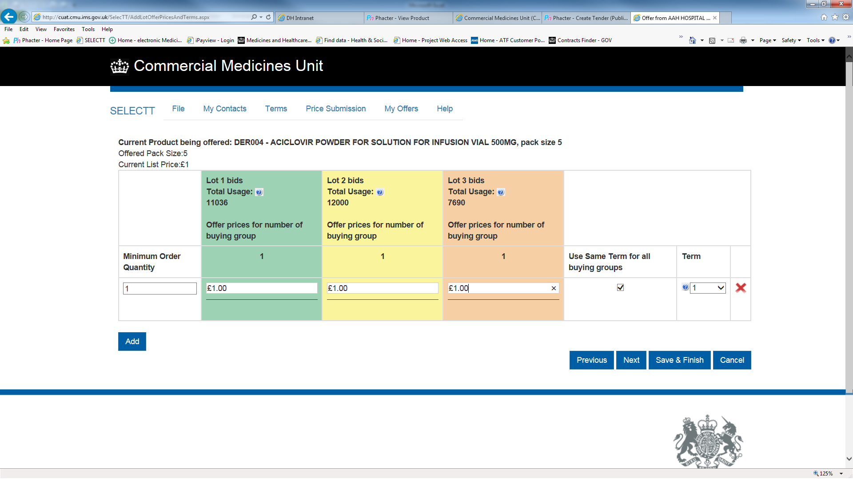

**In this example each Lot relates to the specific regional buying groups as defined in Table 1 above. Where offerors are offering for all tendered Lots they should insert the price in each of the Lots above. Should a supplier not wish to offer for all tendered Lots but to restrict their offer to a specific Lot(s) then they should insert the price against the specific Lot(s) only. Where a supplier wishes to offer for less than the total number of Lots available but does not wish to be specific about which Lots it wishes to offer for then the supplier should offer the price against all of the Lots on the Tender schedule and insert the comment “Not Lot specific” in the remarks field, such bids should additionally be supported by including an explanatory note when the supplier uploads their bid(s). For the avoidance of doubt any such Offers will be dealt with as per the Award Criteria and awarded on the basis of MEAT, where applicable. Please refer to Paragraph 8.8 regarding offer prices.**

8.7.2 **CM/PHG/20/5618/02 (Document No. 05a(iv)) – NHS National Pharmaceuticals Transition 2020_2 – Housekeeping Products:**

For each Product comprised in this Offer Schedule, Document No. 05(iii) specifies the Regions being tendered in this competition.

**Please note that this reference to "Lot" in the SELECTT tender tool DOES equate to a Lot, as identified in Table 2 above.**

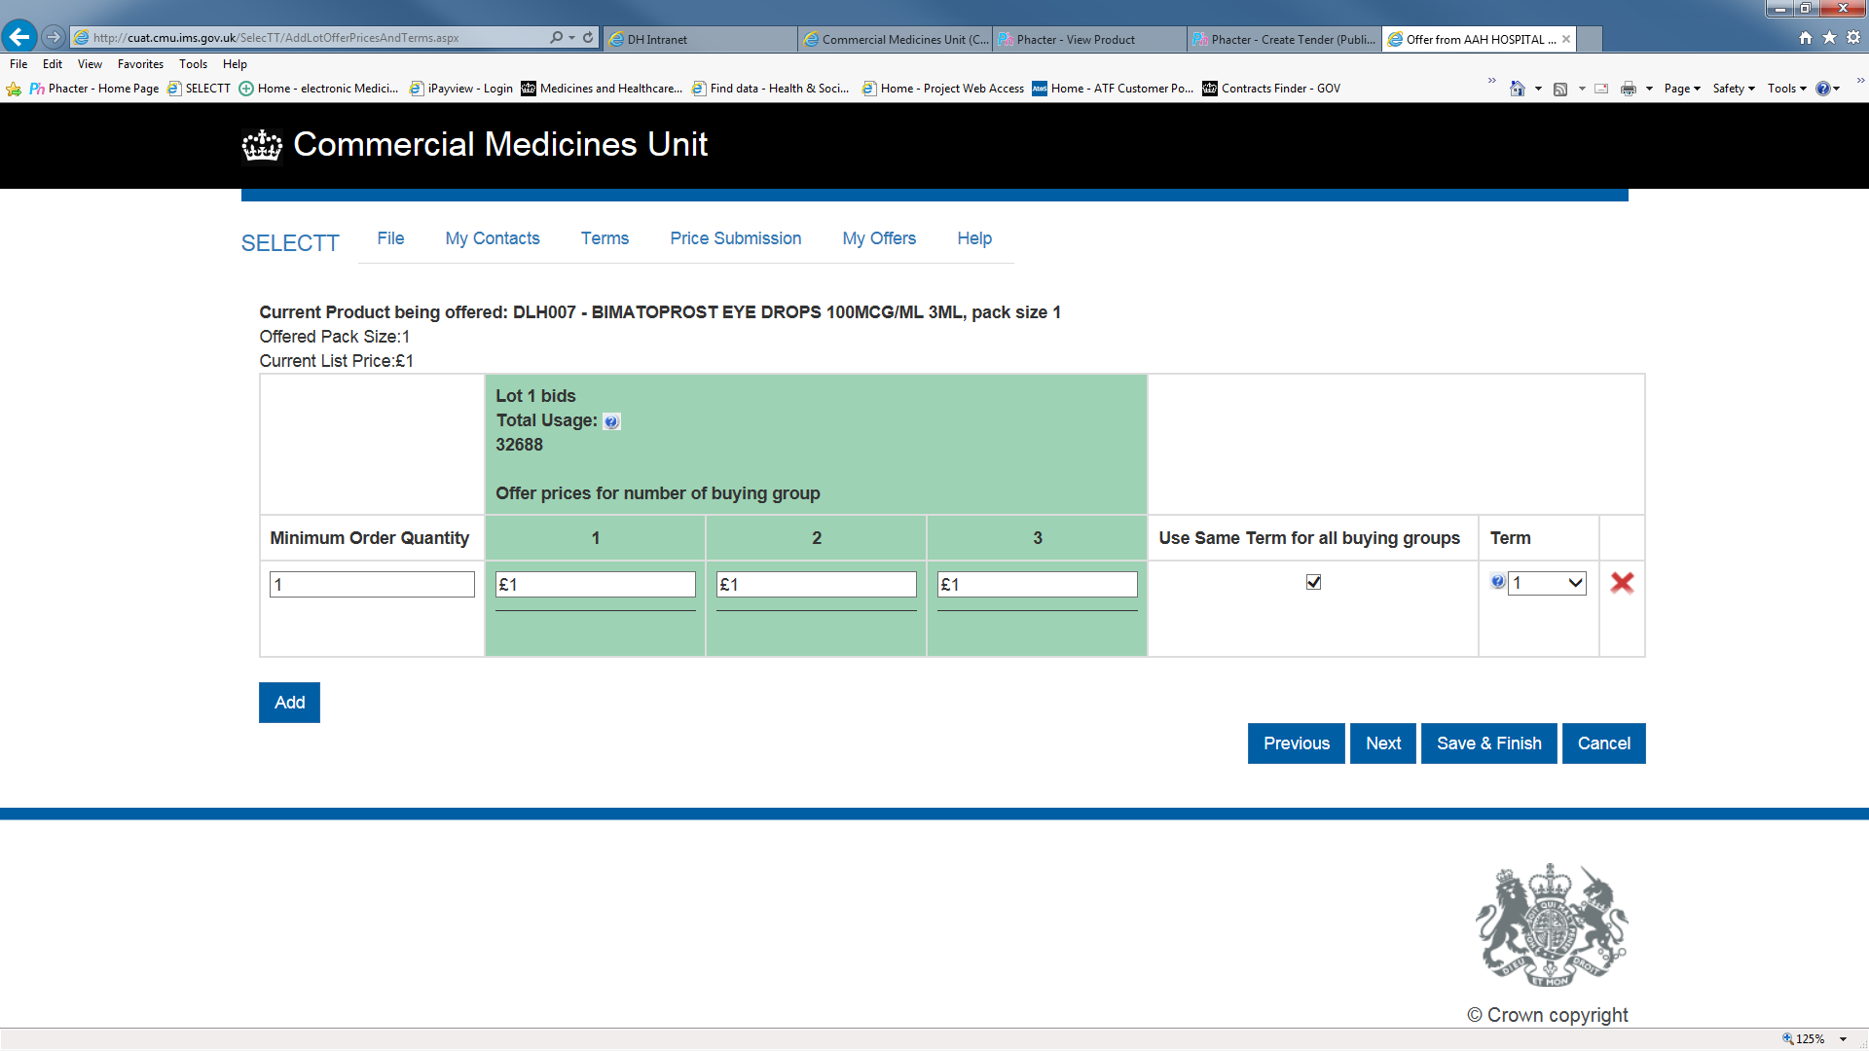

**In this example each buying group is a Region (total of 3 Regions in the example). The numbers 1-3 in the boxes above do not relate to specific Regions but to the number of Regions that an Offeror may tender for in respect of this product. Please refer to paragraph 8.8 regarding offer prices.**

8.8 Offerors have the opportunity to bid for all (or any) of the Lots or Regions specified in the offer schedules. **Offerors shall only submit one offer price per Product, irrespective of the number of Lots specified in the offer schedule.**

8.9 To ensure a diverse range of suppliers, the Authority may limit the number of Lots or Regions that may be awarded to one supplier as follows:

8.9.1 In respect of each Product listed in the CM/PHG/20/5618/00 **–** NHS National Pharmaceuticals Transition 2020_2 **–** Transition Products offer schedule:

(a) where Document No. 05a(i) specifies that all three Lots are being tendered, the following restrictions shall apply, subject to paragraph 12.2.3:

1. where three or more compliant offers that meet the qualitative criteria are received, a maximum of one Lot may be awarded to one supplier;
2. where only two compliant offers that meet the award criteria are received, a maximum of two Lots may be awarded to one supplier;
3. where only one compliant offer that meets the qualitative criteria is received, all three Lots may be awarded to one supplier.

8.9.2 In respect of each Product listed in the CM/PHG/20/5618/02 **–** NHS National Pharmaceuticals Transition 2020_2 **–** Housekeeping Productsoffer schedule:

(a)        where Document No. 05a(iii) specifies that two Regions are being tendered, the following restrictions shall apply, subject to paragraph 12.2.3:

1. where two or more compliant offers that meet the qualitative criteria are received, a maximum of one Region may be awarded to one supplier;
2. where only one compliant offer that meet the award criteria are received, both Regions may be awarded to one supplier.

8.10 In respect of each Product in each Lot or Region, unless otherwise notified, this procurement will establish a single supplier framework arrangement.

**9. Offer documentation and submission**

9.1 Offers may be submitted for all goods and/or services or for selected items.

9.2 The goods and/or services offered by Offerors shall be strictly in accordance with the Specification (Document No. 04). Goods and/or services of essential similarity may be offered but all differences between such items and the Specification must be indicated in detail in the offer schedule.

9.3 CMU’s Selectt programme shall be used by Offerors to create the Offer documents for this procurement exercise. Instructions on accessing and using this system can be found at the following web link:

<https://www.gov.uk/government/publications/drugs-and-pharmaceutical-supplier-tender-submission>

9.4 Offers must comprise:

9.4.1 the completed Response form on the BravoSolution website – found under “My Response”;

9.4.2 the offer schedule in .cmu format - Document No. 05a(ii) and Document No. 05a(iv) of the tender pack, Selectt bid file(s), with the title:

CM_PHG_20_5618_00_xxx.cmu

CM_PHG_20_5618_02_xxx.cmu

where xxx represents your organisations’ tendering supplier code;

9.4.3 the Form of Offer (Document No. 06) to be completed on the Bravo website;

9.4.4 the Quality control technical sheet (Document No. 07a) to be completed on the Bravo website;

9.4.5 the Commercially Sensitive Information Schedule, if any, types of information are considered to be confidential by the Offeror;

9.4.6 a statement of prompt settlement discounts, if available;

9.4.7 details of the Offeror’s ability, if any, to trade electronically; and

9.4.8 confirmation that any information previously supplied to the Authority in connection with the Offer is still accurate and is incorporated by reference into the Offer.

9.5 The Form of Offer must be approved via the Authority’s electronic tendering system by an officer authorised by the Offeror.

9.6 The Form of Offer and other documents referred to in paragraph 9.5 above must be completed in full. Any Offer may be rejected which:

9.6.1 contains gaps, omissions or obvious errors; or

9.6.2 is received after the closing time and date for the receipt of offers.

9.7 For clarification in completing the offer documentation / commercial and / or technical queries please send a message via the Bravosolution messaging portal: <https://nhsengland.bravosolution.co.uk/web/login.html> . Please note that any queries raised by Offerors and the responses to those queries by the Authority may be published anonymously to all Offerors in order to ensure transparency, fairness and equal treatment of Offerors throughout the procurement exercise. If you are concerned that your query and/or the response to it may disclose confidential information or information which is commercially damaging to you, then you may submit the query marked "Confidential" and setting out clearly the reasons why you believe that the query and/or the response are or will be confidential or commercially damaging. The Authority will consider your request and make its decision at its sole discretion. If the Authority determines that the query or response should not be disclosed to other Offerors, it will answer your query and not disclose it or the response (as appropriate) to the other Offerors. If the Authority determines that the query and/or the response should be disclosed to other Offerors, it will give you the chance either to withdraw your query or have it answered. If the latter, then the Authority will disclose the query and the response to all other Offerors.

9.8 Offers and all documents relating to the offers must be written in English and submitted to the Authority via the Authority’s electronic tendering system by **13:00 on 03/09/2020.**

# **10.** **Authority’s Rights**

10.1 The Authority reserves the right to:

10.1.1 waive or change the requirements of this Invitation to Offer from time to time without prior (or any) notice being given by the Authority;

* + 1. seek clarification or documents in respect of an Offeror's submission;

10.1.3 disqualify any Offeror that does not submit a compliant Offer in accordance with the instructions in this Invitation to Offer;

10.1.4 disqualify any Offeror that is guilty of serious misrepresentation in relation to its Offer or the procurement process;

10.1.5 withdraw this Invitation to Offer at any time, or re-invite Offers on the same or any alternative basis;

* + 1. accept an Offer either in whole or in part, each item being for this purpose treated as offered separately;
    2. choose not to award any framework agreement as a result of the procurement process for any reason;
    3. make whatever changes it sees fit to the timetable, structure or content of the procurement process, depending on approvals processes or for any other reason; and/or

10.1.9 at any time terminate the procurement process for any reason.

**11. Warnings and disclaimers**

11.1 While the information contained in this Invitation to Offer is believed to be correct at the time of issue, neither the Authority, its advisors, nor any other awarding authorities will accept any liability for its accuracy, adequacy or completeness, nor will any express or implied warranty be given. This exclusion extends to liability in relation to any statement, opinion or conclusion contained in or any omission from this Invitation to Offer and in respect of any other written or oral communication transmitted (or otherwise made available) to any Offeror. This exclusion does not extend to any fraudulent misrepresentation made by or on behalf of the Authority.

11.2 If an Offeror proposes to enter into a framework agreement with the Authority, it must rely on its own enquiries and on the terms and conditions set out in the framework agreement(s) (as and when finally executed), subject to the limitations and restrictions specified in it.

11.3 Neither the issue of this Invitation to Offer, nor any of the information presented in it, should be regarded as a commitment or representation on the part of the Authority (or any other person) to enter into a contractual arrangement.

**12. Contract award criteria and award methodology**

12.1**Award Criteria**

12.1.1 Any framework agreement(s) awarded as a result of this procurement shall be awarded on the basis of the offer that is the most economically advantageous to the Authority (MEAT) and which satisfies the Quality Criteria, each as set out in paragraph 12.1.3 and Table 1 below, in accordance with this Invitation to Offer. Where a framework agreement award is made, each Product within the Lot or Region shall be awarded separately; each Product within the Lot or Region will form a separate single supplier framework arrangement.

12.1.2 An award(s) shall be made in accordance with:

1. the award criteria described at paragraph 12.1.3 below;
2. the award methodology described at paragraph 12.2 below; and
3. the lotting strategy described at paragraph 8.9 above,

on the basis of the lowest cost solution for the Authority for all of the Lots being tendered (for the Product), where cost is calculated by multiplying the offer price tendered by the Offeror (for the Product) by the estimated volumes for the Lot(s) being tendered for the Product (anticipated for the duration of the agreement excluding any extension period) for the Product.

12.1.3 For each Product, the award criteria are as follows:

(a) **Price criteria of:**

(i) sub-criterion (1) - Cost of product;

(iii) sub-criterion (2) - Cost of change – **only to be used in the circumstances described in paragraphs 12.2.1 (d)(i) and 12.2.4**

(b) **Qualitative criteria of:**

1. sub-criterion (1) – QA assessment of risk to patient; and
2. sub-criterion (2) – QC assessment of risk to a patient across a range of products;
3. sub-criterion (3) – Supply route and associated cost – **only to be used in the circumstances described in paragraphs 12.2.1 (d)(ii) and 12.2.5;**

|  |  |  |
| --- | --- | --- |
| **Criteria** | **Sub-Criteria** | **Debrief Explanation** |
| **Price** | **Sub-criterion (1)**  Cost of product | The successful supplier’s offer was the lowest-priced compliant offer received. |
| **Sub-criterion (2)**  Cost of change  **Only to be used in the circumstances described in paragraphs 12.2.1 (d)(i) and 12.2.4** | The successful supplier’s product provides the most economically advantageous offer when the costs associated with change are taken into consideration.  Examples of indicators of costs of change may include (but shall not be limited to) the following:   * The costs associated with updating pharmacy ordering and stock-holding systems. * The costs associated with segregating products stocked to avoid co-dispensing where this might be problematic, e.g. two products to one patient. * The costs associated with changing any ancillary documentation that might be associated with a particular product, e.g. patient information cards, work cards etc. * The costs associated with assessing and promulgating information pertaining to any specific changes associated with a given product, e.g. storage, handling, differences in excipients or salts or differences in preparation or use of the product. * The costs associated with explaining any differences between products to the patient, e.g. changes in pack presentation, excipients etc. |
| **Quality** – to include QA assessment of risk to **patient** | **Sub-criterion (1)**  Assessed according to the approach documented in the ‘Guidance for performing a pharmaceutical quality assessment of licensed medicines for the NHS’. A copy of this document is available at Document No. 7b. Product QC assessments that are confirmed by the evaluation panel as “Low Risk” or “Medium Risk” will be deemed to be acceptable for award to the framework agreement (subject to satisfying all other award criteria). Any Product QC assessments that are confirmed by the evaluation panel as “High Risk” will only be awarded to the framework in the absence of any other qualifying offers (and subject to satisfying all other award criteria). | The successful supplier’s packaging is in accordance with the criteria detailed in the "Guidance for performing a pharmaceutical quality assessment of licensed medicines for the NHS” and therefore less likely to give rise to an increased risk of a medication error and the PQA assessment for their product reflects this. |
| **Sub-criterion (2)**  Assessed according to the approach documented in “Guidance for performing a pharmaceutical quality assessment of licensed medicines for the NHS”. A copy of this document is available at Document No.07b within the Invitation to Offer pack – [Range issue where the Authority is splitting an award across a range of products for differentiation reasons]. | The successful Offeror's packaging for the complete range of products under consideration is more distinctive and is, in accordance with the criteria detailed in the “Guidance for performing a pharmaceutical quality assessment of licensed medicines for the NHS”, less likely to give rise to an increased risk of a medication error. |
| **Sub-criterion (3)**  Supply route and associated cost  **Only to be used in the circumstances described in paragraphs 12.2.1 (d)(ii) and 12.2.5** | The successful supplier’s distribution routes allow greater flexibility for ordering across a range of products |

*Table 1. Further description of award criteria requirements and standards*

12.2 **Award Methodology**

* + 1. **Identification of Lowest Priced Compliant Offer**

In respect of **each Product**, **for each Lot**, the evaluation shall comprise the following:

1. all (compliant) offers (for the Product) for that Lot will initially be ranked on Price against the price criteria (being Price sub-criterion (1). Such highest ranking offer (for the Product) for that Lot and Region shall be the Lowest Priced Offer for the purposes of this paragraph 12.2.1.
2. the Lowest Priced Offer shall then be assessed against the quality criteria (being Quality sub-criterion (1) and (2)) according to the approach documented in the ‘Guidance for performing a pharmaceutical quality assessment of licensed medicines for the NHS’. A copy of this document is available at Document No. 07b.
3. where the Lowest Priced Offer:
4. fulfils the quality award criteria (being Quality sub-criterion (1) and (2)), such offer (for the Product) for the Lot shall be the **Lowest Priced Compliant Offer** for the purposes of this paragraph 12.2;
5. fails to fulfil the quality award criteria (being Quality sub-criterion (1) and (2)), such offer shall be deemed non-compliant and shall be rejected. In such event, the process set out in paragraph 12.2.1(a) and (b) above shall be repeated (starting with the offer ranked second on Price) until an offer that fulfils the quality criteria is identified. Such offer shall be the **Lowest Priced Compliant Offer** for the purposes of this paragraph 12.2.

(d) where two or more offers are received at the same price and all such offers fulfil the quality award criteria (being Quality sub-criterion (1) and (2)) the following additional sub-criterion may be applied to differentiate between the offers and to identify the **Lowest Priced Compliant Offer**:

(i) the cost of change sub-criterion described in Table 1 (Price sub-criterion (2)) at paragraph 12.1.5 above and paragraph 12.2.4 below shall be applied; and

(ii) if this does not differentiate between the offers, the supply route and associated cost sub-criterion described in Table 1 (Quality, sub-criterion (3)) at paragraph 12.1.5 above and paragraph 12.2.5 below shall be applied; and

* + 1. **In respect of each Product, the steps outlined in paragraph 12.2.1 (a) to (d) shall be repeated for each of the Lots being tendered (for the Product) in order to identify the Lowest Priced Compliant Offer for each such Lot.**
    2. **Awards**

For each Product, the Authority will identify the lowest cost solution for the Authority for all of the Lots being tendered. In respect of each Product, in furtherance of the lotting strategy described at paragraph 8.9, awards shall be made as follows:

1. **Where one Lot is being tendered (as specified in Document No. 05a(i) or one Region is being tendered (as specified in Document No. 05a(iii):**

The Lot or Region shall be awarded to the Lowest Priced Compliant Offer.

(b) **Where two Lots or two Regions are being tendered (as specified in Document No. 05a(i) and No. 05a(iii) respectively:**

1. the Lot or Region with the highest estimated volumes (anticipated for the duration of the agreement excluding any extension period) shall be awarded to the Lowest Priced Compliant Offer;
2. the Authority shall repeat the process described in paragraph 12.2.1 (a) to (d) to identify the offer ranked second. Such offer shall be the **Second Lowest Priced Compliant Offer** for the purposes of this paragraph 12.2.3;
3. where a Second Lowest Priced Compliant Offer is not identified, both of the Lots or Regions shall be awarded to the Lowest Priced Compliant Offer;
4. where a Second Lowest Priced Compliant Offer is identified, the Lot or Region with the lowest estimated volumes (anticipated for the duration of the agreement excluding any extension period) shall be awarded to the Second Lowest Priced Compliant Offer.

(c) **Where three Lots are being tendered (as specified in Document No. 05a(i)):**

1. the Lot with the highest estimated volumes (anticipated for the duration of the agreement excluding any extension period) shall be awarded to the Lowest Priced Compliant Offer;
2. the Authority shall repeat the process described in paragraph 12.2.1 (a) to (d) to identify the offer ranked second. Such offer shall be the **Second Lowest Priced Compliant Offer** for the purposes of this paragraph 12.2.3;
3. the Authority shall repeat the process described in paragraph 12.2.1 (a) to (d) to identify the offer ranked third. Such offer shall be the **Third Lowest Priced Compliant Offer** for the purposes of this paragraph 12.2.3;
4. where both a Second Lowest Priced Compliant Offer and a Third Lowest Priced Compliant are not identified, all three Lots shall be awarded to the Lowest Priced Compliant Offer;
5. where a Second Lowest Priced Compliant Offer is identified but a Third Lowest Priced Compliant Offer is not identified:
   1. the Lot with the second highest estimated volumes (anticipated for the duration of the agreement excluding any extension period) shall be awarded to the Lowest Priced Compliant Offer; and
   2. the Lot with the lowest estimated volumes (anticipated for the duration of the agreement excluding any extension period) shall be awarded to the Second Lowest Priced Compliant Offer;
6. where the Third Lowest Priced Compliant Offer is identified:
   1. the Lot with the second highest estimated volumes (anticipated for the duration of the agreement excluding any extension period) shall be awarded to the Second Lowest Priced Compliant Offer; and
   2. the Lot with the lowest estimated volumes (anticipated for the duration of the agreement excluding any extension period) shall be awarded to the Third Lowest Priced Compliant Offer.

The process described in paragraphs 12.2.1 to 12.2.3 above shall be repeated until at least one or more Offerors are successfully appointed to the framework agreement for each Product for all of the applicable Lots or Regions, or none of the offers are found to be acceptable against the award criteria.

* + 1. **Cost of change**

If the incumbent supplier (i.e. the supplier on the Framework Agreement immediately preceding that which is offered in this Invitation to Offer) and one or more other suppliers submit offers at exactly the same price, then subject to the award methodology and lotting strategy outlined at paragraph 12.2 and paragraph 8.9 above respectively the award shall be made to the incumbent supplier.

12.2.5 **Supply route and associated cost**

If the cost of change sub-criterion does not differentiate between the offers then supply routes shall be preferred in the following order and awards shall be made in this strict order of preference:

1. Combination of three or more wholesalers and direct distribution
2. Combination of two wholesalers and direct distribution

1. Combination of wholesaler and direct distribution
2. Three or more wholesalers

1. Two wholesalers
2. One wholesaler

1. Direct distribution only

12.2.6 For avoidance of doubt where all offers received are confirmed as “High Risk” by the evaluation panel, the award criteria shall be applied in the order of priority described in Table 1 above.

12.3**Evaluation Panel**

Offers shall be evaluated by an evaluation panel against the award criteria. The evaluation panel may comprise members of the NHS England and NHS Improvement Commercial Medicines Unit, the Pharmaceutical Market Support Group, NHS Trust pharmacy procurement group representatives, NHS England commissioners and clinical experts.

12.4 **Final Decision to Award**

12.4.1 Following evaluation of Offers in accordance with the evaluation process set out in this Invitation to Offer, the Offeror who offers the most economically advantageous Offer shall be awarded the framework agreement for each Product in the relevant Lot(s).

12.4.2 The most economically advantageous tender for a particular Product in the relevant Lot shall be the Offer satisfying the award criteria and evaluation process set out in this Invitation to Offer.

12.4.3 Once the Authority has decided to make an award of a framework agreement the Authority will inform the successful Offeror, along with all other tenderers via the bravosolutions eTendering Portal of its intention to award a framework agreement and will allow a 10-day standstill period in accordance with Regulations 86 and 87 of the Public Contracts Regulations 2015.

12.4.4 Should the successful Offeror for a particular Product within a Lot decline to accept a framework agreement then, subject to the award methodology and lotting strategy outlined at paragraph 12.2 and paragraph 8.6 above respectively, it may be offered to the next ranked Offeror for that Product within the relevant Lot, until it has been accepted.

12.4.5 At any time following a standstill period of ten days, subject always to paragraph 10 above (and subject to there being no substantive challenge to that intention), a framework agreement shall be formally awarded, subject to contract, to the successful Offeror(s).

**13. E-auctions**

This tender will not include an electronic reverse auction stage.

**14. Contract monitoring**

14.1The Authority is committed to helping improve the efficiency of contracted suppliers through sharing information on performance measurement. The criteria for measuring performance shall be agreed with the selected Offerors and formally documented. It is possible that measurement criteria will develop during the term of the framework agreement - this will also be documented following agreement with the Offerors.

**15.** **Costs and expenses**

15.1 The Authority will not be liable for any bid costs, expenditure, work or effort incurred by an Offeror in proceeding with or participating in this procurement, including if the procurement process is terminated or amended by the Authority.

**16. Amendments to Invitation to Offer**

16.1 At any time prior to the closing time and date for the return of offers, the Authority may modify the documents comprising the Invitation to Offer by notifying Offerors of the same in writing.

16.2 The Authority may extend the closing time and date for the return of offers to allow for significant amendments made by the Authority to be fully assessed and taken into account by Offerors.

**17. Procurement exercise timetable**

17.1 The following is the timetable for the procurement exercise and Offerors shall note that these dates are indicative and are subject to change upon notice from the Authority. Offerors should also note and observe the timetable for the receipt of clarification queries under this procurement exercise as shown on the Bravo website.

|  |  |
| --- | --- |
| **Tender Stage** | **Date** |
| Tender Documents Returned to CMU via Bravo | 03/09/2020 |
| Evaluation Period | 03/09/2020 to 30/09/2020 |
| Award notification issued to Offerors | Circa 01/10/2020 |
| Agreement Commences | 01/12/2020 |