The purpose of this Prior Information Notice (PIN) is to alert and potential suppliers to a future opportunity in relation to maintenance service for 12 sets of MBQ-707 Orthodrive Lite Modular Hand pieces and accessories, and to engage with the market before starting the formal procurement process.

King Facilities Management (KFM) are seeking to maximise value for money and improve the services that provides better outcomes.

Maintenance cover: Maintenance service contract preventative cover

Contract length – 4 years

Equipment: Please see the details below

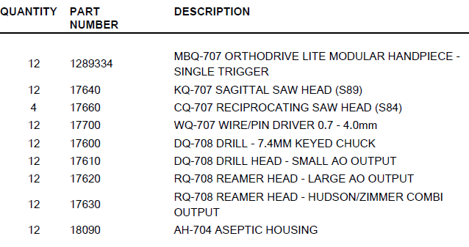

Location – King’s College Hospital NHS Foundation Trust, Theatres Dept, Denmark Hill, SE5 9RS

Could you please confirm the following:

Response times – please advise

Coverage times – please advise

Cancellation term – please advise

Payment terms – please advise

Call out charges – please advise

Service label – please advise

Loans - please advise

Repair cost – please advise

Travel cost- please advise

Labour cost – please advise