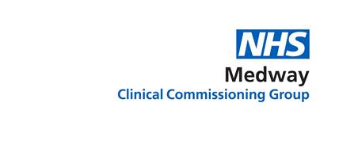

**Adult Community Services**

**Re-Procurement Programme**

**Case for Change and**

**Revised Model for**

**Adult Community Services**

**July 2018**

|  |  |  |  |
| --- | --- | --- | --- |
| **Version control** | | | |
| 0.1 | Part 1 – draft clinical and strategic case for change. | 23/11/2017 | Draft circulated to Community Services Re-Procurement Steering Group for comment and amendments. |
| 1.0 | Part 1 - clinical and strategic case for change. | 06/12/2017 | Presented to and signed off by Commissioning Committee (subject to minor amendments). |
| 2.0 | Addition of Part 2, revised model for community services. Revision of Part 1 in light of model development – including revised activity information. | 24/01/2018 | Initial draft circulated to Community Services Re-Procurement Steering Group and senior managers. |
| 3.0 | Amendments to Part 1 and Part 2, | 06/02/2018 | Amendments after comments from Public Engagement Agency. |
| 3.1 | Commissioning Committee comments considered | 12/02/2018 | Amendments after circulation to Commissioning Committee (virtual). |
| 3.2 | Additional Financial Viability information | 08/03/2018 | Amendments to section 14. |
| 3.3 | Amendments to Financial Viability | 15/03/2018 | Amendments to section 14. Agreed by Finance and COO. |
| 4.0 | Updated to reflect change in scope | 11/07/2018 | Circulated to Community Services Re-Procurement Steering Group and Commissioning Committee for approval alongside submission of outline business case. |
| 5.0 | Amendments to reflect Commissioning Committee and Community Services Re-procurement Steering Group feedback. Commissioning Committee approval on 18/7/18 | 18/7/18 | Circulated to the Governing Body alongside the submission of the Outline Business Case. Approved at Governing Body on 25/08/2018 with no amendments. |
| 5.0 | Submission to NHS England Stage 2 Service Reconfiguration Assurance Panel | 03/08/2018 |  |

**Contents**

|  |  |  |
| --- | --- | --- |
|  | Introduction | 3 |
|  | **Part 1 – the clinical and strategic case for change** | |
|  | Background and local context | 5 |
|  | Strategic context | 8 |
|  | Local challenges | 15 |
|  | Stakeholder engagement | 19 |
|  | Summary of the case for change | 24 |
|  | **Part 2 – the revised model for community services** | |
|  | Introducing the revised model | 29 |
|  | Services aligned to the Medway Model | 37 |
|  | Improved access to services | 43 |
|  | Focus on prevention and empowerment | 45 |
|  | Improved coordination of care | 48 |
|  | Realigned and upskilled workforce | 50 |
|  | Collaborative working | 52 |
|  | Summary of the revised model | 53 |

**Appendices**

Appendix 1: Stakeholder event summary feedback (October to December 2017)

Appendix 2: Whole-systems event summary feedback (January 2018)

1. **Introduction**

As part of its commitment to securing a sustainable and healthy future for the people of Medway, NHS Medway Clinical Commissioning Group (the CCG) has undertaken a review of adult community health services (community services) to determine how they can be strengthened and redesigned to ensure that patients remain well and cared for close to home. The Community Services Re-Procurement (CSR) Programme is underway with the aim of a new contract with provider(s) to be in place by April 2020.

The first part of this document outlines the case for change which is the foundation of the revised model for community services. It outlines the strategic and clinical context in which community services operate, highlights the local challenges and opportunities, and summarises the key areas of focus for the CSR Programme. It draws on findings of a recent due diligence stocktake review, best practice case studies, and the stakeholder feedback gathered to date.

The second part of the document presents the improved and redesigned model for community services, with as many services as possible delivered at the local level in six Healthy Living Centres (HLCs). It shows how the revised model is fundamental in making the Medway Model a reality, which is the local response to the Kent and Medway Sustainability and Transformation Plan for local care (KMSTP), which in turn is the regional response to the NHS Five Year Forward View.

The KM STP sets out the changes required to deliver the Medway Model including the required reduction in acute activity (outpatient appointments, non-elective admissions, elective admissions, and emergency attendances) to support this. It is important to note that the revised community services model will contribute to some, but not all, of the key changes required to deliver the Medway Model including the reduction in some of the acute activity. All other changes required will be delivered through the Medway Local Care programme, noting that the community service model is predicated on many of these changes being implemented through Local Care by 2020.

**Part 1**

**The clinical and strategic case for change**

1. **Background and local context**

**2.1 Historic and current arrangements**

The current arrangements for the provision of community services date back several years with Medway Community Healthcare (MCH) as the main provider. A small number of services are commissioned from Kent Community Health NHS Foundation Trust (KCHFT), through contract arrangements with the voluntary and community sector (VCS), and through an Any Qualified Provider contract. The CCG has worked with providers to develop and refine community service provision over several years.

Current contracts end on 31 March 2020 which provides the CCG with the opportunity to redesign services. As a Public Sector Contracting Authority the CCG is governed by the Public Contracts Regulations 2015/102 (PCR 2015) and the National Health Service (Procurement, Patient Choice and Competition) Regulations 2013/500. The PCR 2015 places legal requirements and procedures on the CCG for awarding new healthcare service contracts above a certain financial threshold. As the current value of the existing contracts is above that threshold, the programme is subject to a formal procurement process.

**2.2 Scope**

Community services are those that help people optimise and maintain their health either in their own home or other out-of-hospital settings. They provide a wide range of care, from supporting patients to manage long-term conditions, to treating those who are seriously ill with complex conditions. Teams of health care professionals, such as nurses and therapists, coordinate and deliver care, working with other professionals including GPs, social workers and the voluntary sector. Listed below are the services in scope of the CSR procurement programme:

|  |  |
| --- | --- |
| * Anti-Coagulation | * Learning Disabilities |
| * Cardiology and Arrhythmia | * Lymphoedema |
| * Cellulitis | * MSK Physiotherapy |
| * Clinical Assessment Service | * Neuro physiotherapy |
| * Community Nursing | * Nutrition & Dietetics |
| * Community rehabilitation | * Phlebotomy (not GP phlebotomy) |
| * Continence Care | * Podiatry |
| * COPD and Frailty pilots | * Respiratory |
| * Dementia Crisis Support Team | * Specialist Palliative Care |
| * Diabetes | * Speech and Language Therapy |
| * Epilepsy | * Stroke Services (community)* |
| * Hand Therapy | * Tissue Viability and Wound Therapy |
|  |  |

*There is an ongoing Kent-wide review of stroke services. The outcome of which will determine the future arrangements for services in Medway and whether this is included in this procurement.

The K&M STP involves realigning a proportion of the total health system funding from secondary care into primary and community services in order to reduce acute activity and to enable more proactive management of patients in a setting closer to home. The focus is on a range of services highlighted by the Right Care Programme, including, but not limited to, cardiology, respiratory, rheumatology, and services for frail and complex elderly people. While much of this shift in activity is outside the scope of the CSR Programme, there will be some lower acuity activity that moves into the community.

* 1. **Current expenditure and activity**

Community services contribute to a substantial proportion of CCG expenditure. In 2016-17, £44m was spent on community services for adults and children, equating to 12% of total expenditure. Figure 1 shows this breakdown.

|  |
| --- |
|  |
| *Figure 1: Medway CCG expenditure 2016-17* |

Community services have a wide reach with over 90,000 people receiving these services in 2016-17. This equates to approximately 1 in 3 people in Medway. There were approximately 632,647 contacts and the majority of these contacts were face-to-face (91%). Figure 2 shows the breakdown of contacts by service.

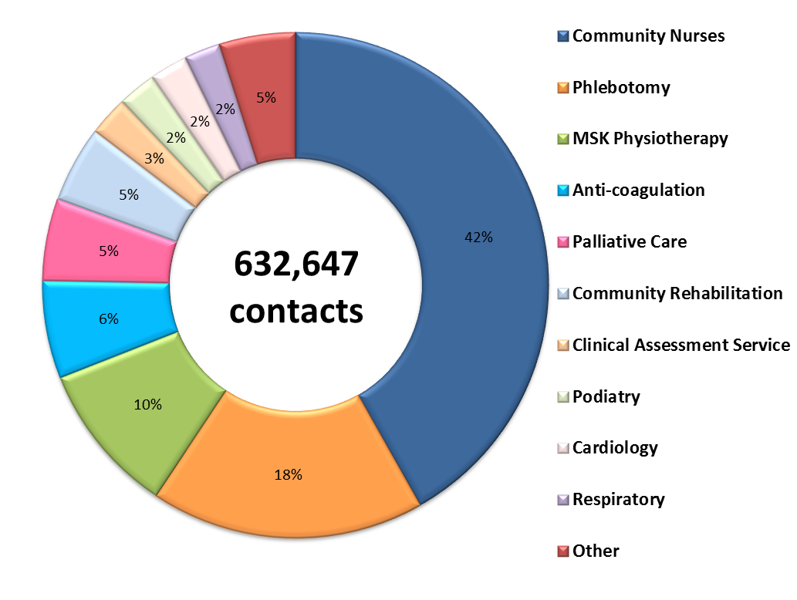

*Figure 2: Contacts by Service (figures are approximate and exclude some activity related to Cellulitis)*

As shown in Figure 2, the largest service is Community Nursing which accounted for 42% of contacts; this service interfaces with many other services. Community Phlebotomy accounted for approximately 18% and musculo-skeletal physiotherapy accounted for approximately 10%. The remaining 30% of contacts were for more specialist services, including those for people with long term conditions and people at the end of their lives.

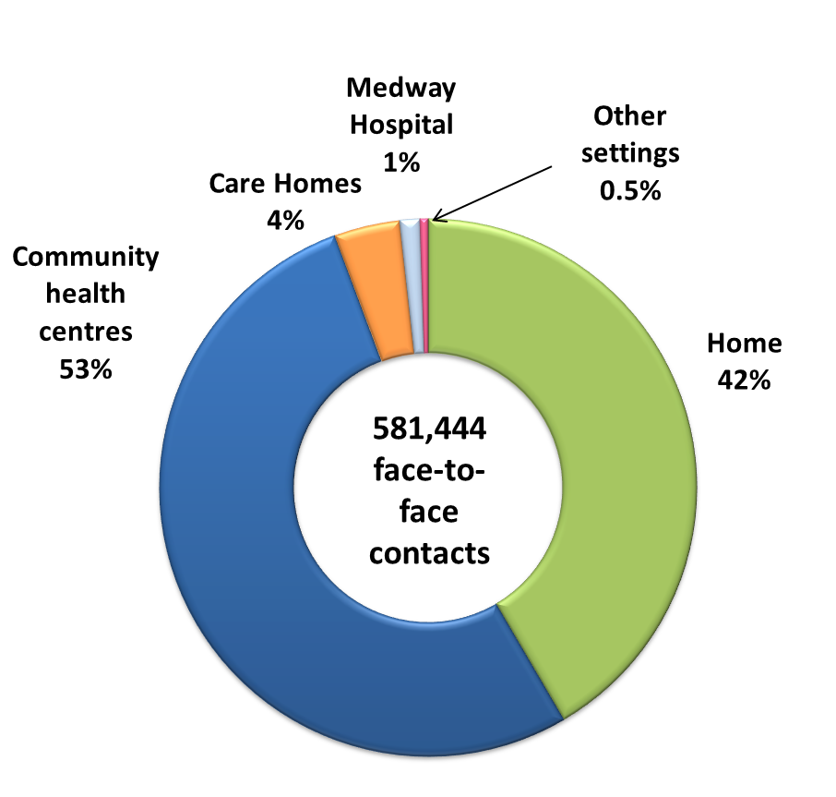

*Figure 3: Location of contacts*

Community services are provided in a variety of settings across Medway as shown in Figure 3. 46% of face-to-face contacts take place in peoples’ places of residence (including care homes). 53% take place in community health settings (i.e. not in people’s place of residence). This includes visits to clinics, exercise and rehabilitation groups and education sessions.

There are six localities within Medway and analysis highlights that currently, around 50% of these contacts are provided in a setting that is outside of the locality in which the patient lives. This means that a large proportion of patients must travel to another locality to receive treatment. This highlights that the location of some clinics in Medway are not always closer to home for some patients, resulting in some patients having to travel further than others for the same services.

Analysis on current community services highlights that approximately 25% of face to face contacts in the community (approximately 80,000) are provided in settings such as smaller clinics, GP practices, leisure centres and community centres, and are not in one of the four Health Living Centres.

Over half the contacts for community services are for people aged 65+ (estimate based on available data).

Within the clinical acceptance criteria for each service, community services are open to everyone regardless of race, gender, sexual orientation, religion or belief. This will not change in the revised model and no significant impact is expected on any of the protected characteristics (outlined in the Equality Act 2010). Work has commenced on a combined impact assessment and will be completed alongside the outline business case.

**3. Strategic context**

The redesign of community services must take into account the national policy of the NHS and local strategic direction. Below, the key policies and strategies are summarised with an explanation as to why they contribute to the case for change.

**3.1 The NHS Five Year Forward View**

The NHS Five Year Forward View (FYFV) was published in October 2014 by NHS England. The strategy recognises the dramatic improvements in the NHS since the turn of the century thanks to protected funding and commitment of NHS staff. However, it highlights the ongoing challenges and the pressures that the NHS is facing – including that the quality of care is variable, preventative illness is widespread, and health inequalities remain. The FYFV advocates the breaking down of barriers in how and where care is provided – between GPs and hospitals; physical and mental health; and health and social care. It highlights that the traditional divide between primary care, community services and hospitals is increasingly a barrier to the personalised and coordinated health services to meet patient need.

The FYFV explains that the revised model should focus on managing and designing whole systems of care – not just a focus on individual organisations that provide care; and that care should be delivered locally, organised to support people with multiple conditions rather than single diseases.

The FYFV is a vision for the future of health services based on new models of care, with local areas selecting models that best suit their local needs. Many of these new models of care have been trialed in vanguard projects across the country to develop blueprints for the NHS moving forward and capturing the learning to share with the rest of the health and care system.

**This tells us:** The revised model for community services in Medway must ensure that experiences from these vanguard projects is taken into account.

**3.2 Kent and Medway Sustainability and Transformation Plan**

To deliver the FYFV on a local basis, regional health and care systems in England were asked to come together to create a plan for accelerating its implementation. The result was Sustainability and Transformation Plans (STPs) which set out how NHS and local authority organisations will sustain services and transform the delivery of care. STPs are being developed in an atmosphere of financial and operational pressures. They must, therefore, balance the need to sustain current services and use existing resources in the most efficient way, whilst developing new models of care that focus on better integration, better health and wellbeing, and improving quality of care.

Locally, Medway is a partner in the KM STP. The list below identifies the local reasons for change:

* The local population is growing rapidly.
* Local people are living longer and older people tend to have additional health needs.
* Lots of people are living with long-term conditions with a higher level of acuity.
* Too many people are living unhealthy lifestyles and are at risk of developing conditions that are preventable.
* There are unacceptable differences in health across Kent and Medway.
* Many people (including children) have poor mental health, often alongside poor physical health.
* If we carry on working in the way we are, we cannot meet the current and future needs of local people with our existing budgets.

An overarching priority of the KM STP is local care which is focused on developing more and better services in people’s homes and in the community by bringing together services currently provided by GPs, with the range of existing community services and others, like urgent care, diagnostic tests, mental health support, and social care. The Medway Local Care Sustainability and Transformation Programme has been set up to better integrate primary, community, mental health and social care but also to realign some parts of traditional hospital care into the community. This will enable people to get joined-up care that considers them holistically – something patients have clearly and consistently told us they want.

Realignment of aspects of the traditional hospital system into the community will reduce the need for people to go to hospital for treatment and services that in the future could be provided more locally. Having high-quality local care with greater capacity will relieve some of the pressure on our hospitals. It will reduce the need for people to go to hospital for treatment and increase the services that, in the future, could be provided more locally.

A priority of the STP is to support re-orientation of hospital treatment into the community by avoiding preventable hospital admissions for people with long-term conditions and supporting their carers. There are over 40,000 adults in Medway with long term conditions. Evidence from elsewhere suggests that 25% to 40% of emergency admissions could be avoided if alternative care was available outside hospital. People who have a long-term health condition can be supported to reduce the risk of their condition becoming worse. There are opportunities for better management and control of long term health conditions in the community.

Many local people do not get enough support to manage their conditions and there are high levels of hospitalisation for these people.

Clinical evidence tells us that many patients, particularly the frail and complex (aged 75 and over) who are admitted to hospital, could be better cared for outside hospital. There are examples that relate to the change in setting of care which can be built on where this new approach is being delivered (such as the Encompass Vanguard in East Kent). Clinics are being rolled out across Medway to provide a multidisciplinary approach to care for frail older patients through a geriatrician-led MDT.

**This tells us:** Developing and implementing a revised model of care for adult community services that supports the realignment of resources is an important strand of the KMSTP.

**3.3 General Practice Forward View**

NHS England published the GP Forward View (GPFV) in April 2016 to support GP practices and invest additional funds in: developing the GP workforce; improving recruitment and retention, streamlining workload and reducing red tape, improving infrastructure, and supporting practices to redesign services to meet the needs of local people.

Medway CCG published a local GPFV in December 2016. It explains how GPs are fundamental in the co-design of the Medway Model and in setting out a vision for self-care, technology, and the wider workforce. It includes the implementation of ten high impact changes designed to give GPs ‘time to care’, listed in Figure 4.

|  |
| --- |
| ***Ten High Impact Changes***   1. *Active signposting* 2. *New consultation types* 3. *Reduce DNAs* 4. *Develop the team* 5. *Productive workflows* 6. *Personal productivity* 7. *Partnership working* 8. *Social prescribing* 9. *Support self-care* 10. *Develop quality improvement expertise* |
| ***Figure 4: GPFV 10 High Impact Changes*** |

**This tells us:** The work associated with realising the GPFV is outside the scope of the CSR Programme but as General practice is at the centre of Local Care, community services must align to it, including mirroring the ten high impact changes.

**3.4 The Medway Model**

The Medway Model outlines how Medway will address the FYFV, the GPFV and the KMSTP. The model is based on the provision of out-of-hospital services wrapped around six localities in natural geographical communities – Rainham, Gillingham, Chatham Central, Lordswood, Rochester and Strood

The Medway Model brings together GP practices within Primary Care Locality Teams (PCLT) that are responsible for the health of populations of around 30,000 to 50,000. Within each of the six localities, services will be provided either in peoples own homes or Healthy Living Centre (HLC). The HLCs are the physical buildings where clinics and services provided by health, social care, mental health, voluntary and third sector organisations will be co-located. Currently four HLCs are already established in Rainham, Gillingham, Rochester and Lordswood localities; another two are planned for the Strood and Central Chatham areas and will be operational by 2020-2021.

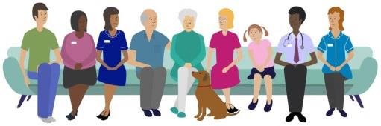

*Figure 5: Dorothy in the Medway Model*

**This tells us:** Wrapped around the LCTs, community services are a fundamental element the Medway Model. Services should to be co-located based on needs of the local population.

**3.5 Health and social care integration**

The Better Care Fund (BCF), implemented in 2015, encourages local health and social care organisations to work together in line with the vision outlined in the FYFV. The BCF requires organisations to pool budgets and agree a spending plan to integrate health and social care services and to improve the lives of the most vulnerable. In Medway, the BCF Plan focuses on: aligning resources with the Medway Model, building joint commissioning arrangements, working on the digital roadmap, and joint communications and engagement.

The BCF includes the following services that are outside of the scope of the CSR Programme, but are integral to the transformation of the local health and social care system:

* The Integrated Discharge Team, consisting of social care and staff from community and acute health services, supports the timely discharge of patients from the hospital into community settings.
* The Intermediate Care and Reablement Service works with people in need of short-term bed-based care and home-based reablement therapy to facilitate the recovery process and to keep people independent in their own homes.
* The commissioning of services to support informal and family carers, recognising the support they need to continue in their valuable role.

One of the key areas of focus for Medway Council Adult Social Care in 2017-18 is the development of a ‘Three Conversation’ approach which will deliver more person-centred care and support as well as help prevent, reduce and delay the development of longer term care needs.

Over the next few years, Medway Council will realign expenditure on traditional institutional style services, such as care homes and day centres into services delivered in people’s own homes and in local communities. The aim is to reduce the amount spent on residential care homes unless there is a specific, specialist need to provide care in those settings which cannot be accommodated at home. Figure 6 summarise NHS guidance in this area and this will be a focus of the Medway Care Home Steering Group.

|  |
| --- |
| ***Best Practice: Enhanced health in care homes***  *The FYFV includes a new model that aims to provide more support for frail older people living in care homes by NHS services working in partnership with local authorities and local care home providers to develop new ways of working to support older people. The Framework for Enhanced Health in Care Homes was developed based on the findings of six vanguard areas.*  *The framework has a focus on quality as the driving factor for change and the use of clinical evidence to support as well as drive change. It advocates putting the needs of the resident at the centre of any changes whilst supporting carers and families at the same time. It argues that strong leadership and a joint shared vision for better care and a whole-system approach is needed to break down organisational barriers between health, social care and the voluntary sector. The framework acknowledges the value of the care home sector in supporting the NHS and the significant level of healthcare that is delivered in care homes by social care staff.* |
| ***Figure 6: Enhanced health in care homes (NHSE, 2016)*** |

**This tells us:** Wherever possible, we must ensure that community services work alongside social care services to provide a coordinated service and a better patient experience. The revised model must work seamlessly with the Integrated Discharge Team and the Intermediate Care and Reablement Service and be designed to cope with the shift of social care out of traditional style care homes to other settings.

**3.6 Estates Strategy**

The Medway Local Estates Strategy is being updated to ensure that estates enable the building of resilience and growth into the local system and to deliver the new models of care outlined in the FYFV. As outlined above, the development of HLCs is fundamental to the Medway Model to ensure that the scale and configuration of space is suitable for clinical work and supporting activities. The existing HLCs will be developed and, working with the local authority through the One Public Estate Programme, there are plans to build new facilities in central Chatham and Strood.

**This tells us:** The Medway Local Estate Strategy is fundamental in the delivery of the revised model of care.

**3.7 Digital Strategy**

The Kent and Medway Digital Roadmap, supported by a large-scale scheme of national investment into technology, outlines how ICT and technology enabled care services will be utilised to support the delivery of a modern, integrated, paperless NHS which revolutionises the way patients access care from home and empowers people to take control of their healthcare needs. Areas of focus include: the standardisation of systems, consolidating ICT infrastructure, improving patient record sharing, introducing SMS text reminders, improving the ordering of diagnostic tests, patient online services, and telehealth opportunities to support patients in self-management of long term conditions.

**This tells us:** We must ensure that areas of focus in the digital strategy are incorporated into the revised model for community services so that they become a key enabler to providing more efficient services. In the revised model services should be designed to keep up with ever-developing technology.

**3.8 Urgent Care Redesign**

In November 2013, the Keogh Review outlined the case for change for improving urgent and emergency care services in England. It highlighted the following areas of focus:

* Provide better support for people to self-care.
* Help people with urgent care needs to get the right advice in the right place, first time.
* Provide responsive urgent care services outside of hospital so people no longer choose to queue in the Accident and Emergency (ED) department.
* Ensure that people with more serious or life threatening emergency care needs receive treatment in centres with the right facilities and expertise.
* Connect all urgent and emergency care services together so the overall system becomes more than just a sum of its parts.

The FYFV complements these findings and states that urgent and emergency care services should be redesigned to improve integration between emergency departments, GP out-of-hours services, urgent care centres, NHS 111 services and ambulance services. NHS 111 is central to this vision – acting as a single point of access for urgent care, supported by a clinical advice hub that will assess patient needs and advise on the most appropriate course of action. In Medway, the Urgent Care Redesign process is underway and is subject to a separate procurement process.

**This tells us:** The revised model for community services must consider and enhance the interface with urgent care and ensure that they complement the new model for urgent care.

**3.9 End of Life Strategy**

Medway’s End of Life Strategy for Adults was published in 2017. This is aligned to the national framework, Ambitions for Palliative and End of Life Care (2008). It includes the following priority areas to address gaps in the system:

* Ensuring professionals are supported and have the skills and knowledge to provide end of life care.
* Reviewing and developing a new model of care.
* Improving systems to support consistent, efficient and effective care.
* Ensuring that patients, carers and families feel supported.
* Promoting local awareness of death, dying and bereavement.

**This tells us:** The revised model for community services should support the delivery of the End of Life Strategy for Adults, raising the profile of end of life care and the resources to support it in the community.

**3.10 Health and Wellbeing Strategy**

Medway’s Joint Health and Wellbeing Strategy is being refreshed in 2018. The existing strategy (2012-2017) highlights the following five strategic themes for Medway:

* Give every child a good start
* Enable our older population to live independently and well
* Prevent early death and increase years of healthy life
* Improve physical and mental health and wellbeing
* Reduce health inequalities

**This tells us:** The revised model for community services should support the prevention agenda by supporting local people to live for longer in good health. This will include supporting delivery of the refreshed Health and Wellbeing strategy, raising the profile of prevention and the resources to support it in the community and community services having clear pathways/signposting arrangements to wider health promotion services and support.

**3.11 King’s Fund research on community services**

King’s Fund research (Community Services: How they can transform care, 2014) has formed the basis for similar redesign programmes – summarised in Figure 7. It is based on work with a range of community providers to determine the changes required to enable care to be provided closer to home, and to contain the growth in demand and the financial constraints that the NHS is facing.

|  |
| --- |
| ***Best Practice: Community Services: how they can transform care (King’s Fund, 2014)***  *The report outlines the following key areas of focus:*   * *Simplify services and remove unnecessary complexity which needs fundamental changes in the way primary care and hospitals are configured and commissioned.* * *Wrap MDTs around groups of practices, including mental health, social care, specialist nursing and community resources – based on natural geographies.* * *Use these services to build multidisciplinary care teams for patients with complex needs.* * *Ensure that services can respond quickly to speed up discharge and to reduce length of stay in hospital beds.* * *Working in new ways with specialist services to offer patients less fragmented services.* * *Develop teams and services to provide support to patients as an alternative to a hospital admission.* * *Improve the information infrastructure, workforce, and ways of working and commissioning that are required to support this.* * *Reach out into the wider community to improve prevention, reduce social isolation, and create healthy communities.* |
| ***Figure 7: Community Services; how they can transform care (King’s Fund, 2014)*** |

The King’s Fund continue to focus on the development of community services, building on the 2014 report, a vision for the future of community services was published at the end of January 2018. Analysis and findings from this report has been reviewed and will be incorporated into the Programme – a summary is shown in Figure 8.

|  |
| --- |
| ***Best Practice: Reimagining community services: Making the most of our assets (King’s Fund, 2018)***  *This report builds on the influential 2014 report, Community Services: how they can transform care, and provides an update on developments in community services. The report outlines ten design principles that should apply to community services:*   * *Organise and coordinate care around people’s needs – including better connected community services, reduced duplication and shared information and IT systems.* * *Understand and respond to people’s physical health, mental health and social needs in the round – a ‘whole person’ approach.* * *Make the best use of all community assets to plan and deliver care to meet local needs.* * *Enable professionals to work together across organisational and service boundaries – this may be through fully integrated teams, MDTs, and shared care plans.* * *Build in access to specialist advice and support – recognising the high levels of clinical complexity, acuity and risk and should be able to easily draw on specialist input when required.* * *Focus on improving population health – acting on the wider determinants of health and wellbeing.* * *Empower people to take control of their own health and care.* * *Design delivery models to support and strengthen relational aspects of care that are most closely linked to good patient experience.* * *Involve families, carers and communities in planning and delivering care – recognising the significant contribution they have in providing support and the role community services have in supporting carers.* * *Make community-based care the central focus of the health system.*   *The report makes recommendations for making the vision for community services a reality including: building capabilities for quality improvement among staff delivering care in the community; joining up information systems and shared electronic care records; doing more work to collect and make use of data about community services; and further investment community services.* |
| ***Figure 8: Reimagining community services (King’s Fund, 2018)*** |

The King’s Fund report includes examples of good practice from across the country which the CCG has considered. In addition, a review of other areas where similar redesign and re-procurement projects have taken place, for example, Bromley CCG’s recent procurement of community services, learning from Encompass in Whitstable (Vanguard site for new models of care), and from the Carnell Farrar STP local care research.

**This tells us:** Our model for community services should be based on best practice and evidence from other areas.

**3.11 Local tests for change**

Over recent months, the CCG has worked on several small tests for change. The findings from these have informed the revised model which builds on the pilot projects:

* Originally focusing on **Proactive Care for the Elderly** (PACE) and developing into complex patients with long term conditions, Integrated Locality Review (ILR) meetings are being trialled across Medway. The ILR meetings have built significantly on the learning gained from implementing the PACE clinics by continuing to be based in the community, ensuring that operational details are managed from the outset, continuous improvement methodology and sustainability measures to support the implementation, establishing more quickly the information governance around patient information sharing and having clearer SMART metrics to monitor impact. The implementation has also been informed by the nearby new care model Vanguard site, Encompass, a Multispecialty Community Provider on which the first Medway pilot ILR has been modelled but tailored accordingly to the specific locality GP and patient population needs.
* **Enhancing Health in Care Homes** – Taking the lead from the NHS England Enhanced Health in care homes framework 2016, and the Gateshead CCG enhanced service vanguard the CCG is implementing an enhanced GP service to care homes for older people. A mapping exercise of the current GP provision to care homes for older people in Medway identified that a number of care homes have residents registered with up to four GP practices and that some GP practices care for residents at six separate care homes. The enhanced GP service seeks to align practices to care homes ideally within their locality. Furthermore, the care home pharmacist and community nursing teams will work closely with the homes and the GP to ensure that there is no duplication of efforts and equally as important no gaps in provision. The service will seek to ensure that planning for end of life care is undertaken using “My Wishes” and that this information is recorded on the “My Wishes” register where consent has been given.
* **Primary Care Home Programme** – Following on from the experience of implementing the Proactive Care for the Elderly (PACE) service, the ILR meetings will be undertaking a multi-pronged approach to identifying patients for review. Combining knowledge of cases currently known to community health and social care professionals, local knowledge of GPs and other primary care workers and stratification reports such as use of the Electronic Frailty Index in conjunction with the Frailty Scale to refine those patients identified as moderately to severely frail. The ILRs will also be linked to wider services such as Kent Fire and Rescue Service, End of Life services and the community voluntary sector to identify service users who may not currently be known to health or social services in Medway.

The primary care programme is based on the Medway Model and has GPs within each of the six localities come together to identify and develop primary care initiatives that are aligned with the GP FYFV. Examples of current pilots include: a mental health pilot in Rainham where a mental health nurse is reviewing and supporting patients with dementia and mental health problems, a paramedic practitioner supporting GP practices by seeing patients in their own homes and reception staff within GP practices undergoing training to be able to sign post patients to services.

* **Care Navigation** - Currently there are two pilots running in Medway delivering Care Navigation. The term Care Navigator has been used in Medway to describe a link worker and refers to a non-clinically trained person who works in a social prescribing service and receives the person who has been referred to them. A fully procured service is planned to begin in October 2018. The focus of the service will be to work with those individuals whom are frequent users of primary and acute care, those patients with long term conditions and those people who are at risk of their health deteriorating due to social issues.

**This tells us:** We must learn from the tests for change and build this into the revised model at scale where appropriate.

**4. Local challenges**

**4.1 Demographics and population health – key facts**

*(Data taken from Medway Council Public Health team, the Medway JSNA -* [*http://www.medwayjsna.info*](http://www.medwayjsna.info) *, and the KMSTP Case for Change Technical Document, March 2017)*

***Growing population and people living for longer***

The resident population of Medway is approximately 278,000 and is estimated to grow to approximately 330,000 by 2035. While Medway has a relatively young population, the number of older people is set to increase - those aged over 70 will rise by 20% in the next 5 years. Older people have a higher usage of health and care services compared to other age groups, particularly hospital admissions and use of community services.

Medway has a lower than average life expectancy for both males and females. For males, the average life expectancy is 78.4 compared with an England average of 79.5. For females, the average life expectancy is 82 years compared with an England average of 83.1. Healthy life expectancy is also below average. For males, the average healthy life expectancy is 61.8 compared with an average of 63.4. For females, the average healthy life expectancy is 59.7 years, compared with an England average of 64.1.

**This tells us:** We must ensure that resources are realigned to cope with a growing and aging population and there is support for people to live healthier longer.

***Living with poor physical health***

In Medway, 16.4% of adults (all ages) have a long term condition or disability that limits their day-to-day activities. Whilst this is lower than the England average (17.6%), it equates to over 40,000 people. In some parts of Medway this percentage increases to almost 40%. This is based on adults of all ages, with the prevalence of long term conditions increasing in older population groups, with many people also having more than one long term condition.

For a number of long term conditions, including diabetes, obesity, hypertension and depression, the proportion of the Medway population registered with their GP as having these conditions is higher than the England average. This may place more demand on services relating to these conditions than average.

People are living longer with long term conditions, males are living for around 16 years in poor health and females over 20 years in poor health (22.3 years). Over these periods people are more likely to use services that support them with their health. On average, a person with a long-term condition requires six times more health and social care support as a generally healthy person (from Kent Integrated Dataset (KID) (2015-16); Carnall Farrar Analysis, reported in KM STP).

Locally, there are also around 12,500 adults in Medway who have three or more long term conditions such as respiratory, cardiology, diabetes, rheumatology where there are opportunities for better management and control of long term health conditions in the community. These patients equate to a relatively small percentage in population terms, approximately 4.5% of the Medway population, but account for approximately 10% of all adult A&E attendances, and 19% of all adult emergency admissions. Patients with three or more long term conditions are much more likely to use Acute Hospital services than those no long term conditions; likely to have 34% more A&E attendances and 24% more emergency admissions than those with no long term conditions*. (Source: Medway Public Health analysis – how often to people with long term conditions use secondary care, based on 2017/18 data. (* this is a control group with no long term conditions, controlling for underlying effects of age and sex).

**This tells us:** We must ensure that resources are realigned to better support people with long term conditions to stay healthier for longer reducing the demand on health and social services, recognising the demand that this cohort of patients has on the health system.

***Living with poor mental health (often alongside poor physical health)***

It is estimated that approximately 16% of people in Medway have a common mental health disorder – such as depression or anxiety. This is similar to the England average and equates to around 31,000 people in Medway. However, mental health problems disproportionately affect people living in the most deprived areas and often go hand-in-hand with physical health conditions.

**This tells us:** In order to ensure there is parity of esteem* between mental and physical health; The revised model will need to link community services for people with physical conditions to those that support people with mental health conditions.

*\*Parity of esteem is defined as 'valuing mental health equally with physical health', which would result in those with mental health problems benefitting from: equal access to the most effective and safest care and treatment, and equal efforts to improve the quality of care.*

***Wider determinants***

There are many wider factors that influence people’s health which, for Medway overall, we are not doing as well as England. These are areas where further work would be beneficial across the health and care system. We know that wider determinants of health such as homelessness and unemployment are important influences on people’s health. Community services need to have strong pathways and referral mechanisms to preventative services which will help people to stay well for longer, as well as incorporating secondary prevention and self-care within services.

Lifestyle behaviours such as smoking, alcohol consumption, physical inactivity, poor diet and being overweight cause poor health, worsening of disease, multiple illnesses and early death. These tend to be worse in the more deprived areas of Medway.

**This tells us:** We must ensure that preventative services are at the centre of the revised model for community services, building on what is already in place and ensuring that we strengthen links to other services that support people’s wider wellbeing.

**4.2 Pressures in Primary Care**

Primary care is often the first point of contact for people with a health problem and is crucial in health promotion, treating minor illness, signposting to other health and social care services and managing people with more complex needs. As outlined above, the Medway Model places GPs at the centre of our vision for an improved system.

There are areas in which the primary care sector in Medway is fragile. The KM STP explains that fragility within primary care is characterised by low numbers of GPs and practice nurses per head of population meaning that access to primary care services is difficult.

In addition, high vacancy rates and a dependency on the use of locums, which constitute 8% of the GP workforce in Kent and Medway, mean that GPs and practice nurses do not know the patients or the services available locally. In Medway, the percentage of GP practices, excluding branches, where the practice operates with a whole-time-equivalent of two or less is 48%. The situation is likely to get worse as over a third of GPs in Medway will retire in the next five years . In Medway, there are also challenges in recruiting practice nurses, with a low number of practice nurses compared to the national average. Workstreams have been identified to mitigate the identified risks to workforce in Kent and Medway; focussing on delivering the General Practice Nurse 10 Point Plan, supporting and developing new roles in Primary Care and recruitment and retention of GPs.

The KM STP identified the following issues associated with fragility in primary care:

* Later identification of disease when early indicators of disease such as obesity and smoking are not identified and addressed in primary care.
* More complications and worsening of disease if monitoring of people with long term conditions is not comprehensive.
* Increasing activity in hospitals if local people use the Emergency Department rather than their local GP practice for urgent care.
* Pressure on mental health services if poor mental health is not identified until it results in a crisis.

Some people in Medway are unhappy with existing GP services; on average 68% would recommend their GP practice to a friend, compared to 78% nationally. People find it difficult to contact their GP practice and there are long waits to be seen when they get there.

**This tells us:** Community services should take into account the fragilities that exist in primary care whilst recognising that GPs are fundamental in the Medway Model.

**4.3 Pressures in Secondary Care**

There are many pressures on secondary care, and relieving this pressure is a key aim of the strategies outlined above. Some illustrations gathered from locally collected data are:

* As many as four in ten emergency admissions to hospital could be avoided if the right care was available in the community.
* Since May 2015, the four-hour target for waiting in the Emergency Department has not met at Medway Maritime Hospital.
* Diagnostic test waiting targets have not been achieved since May 2015 at Medway Maritime Hospital.

The KM STP states that when people go to hospital they tend to stay in hospital for a long time and have difficulty getting out of hospital and back home. In addition a third of all people in acute hospitals who are medically fit for discharge have been so for over a week. When people are ready to leave hospital, local services are often not ready to look after them and so they must stay in hospital longer. It costs, on average, £220 per day to care for someone in an acute hospital bed and this money could be better used elsewhere. There have been improvements in this area over the last year but we need to ensure that community services are designed to sustain this improvement.

The KM STP found that the level of referrals from GPs to hospital specialists in Kent and Medway is higher than other places with a similar population. This may reflect different levels of patient need, or it may be due to differences in clinical practice between doctors and nurses at any point where care is given. The STP found that if the level of referrals were the same as top performing CCGs in similar areas, outpatient activity would reduce by 9%. If planned activity in hospitals were the same as top performing areas CCGs in similar areas it would reduce by 14%.

**This tells us:** In line with national and local strategy, a revised model for community services must help relieve pressure on secondary care and this will require a realignment of resources across the system if we are to meet the financial challenge facing the local economy. This cannot be done by one organisation, but needs to be done with everyone working together.

**4.4 In-depth service reviews**

***CSR Programme Due Diligence Stocktake***

Throughout summer 2017, a series of due diligence stocktake reviews took place for a range of community services. Service specifications reviewed to ensure that commissioners and providers a common understanding of current service provision. The findings are broadly in line with the evidence and rationale detailed in the various local and national strategies. There were many areas of good practice which will be continued in the revised model. However, there were also areas that could be improved, including:

* The way current services are designed does not always promote a holistic and patient-centred approach.
* The way in which professionals work together within and between organisations could be better to improve people’s experience of care.
* There is inconsistent use of the Medical Interoperability Gateway, Electronic Referral System and other digital developments across services. Sharing of information could be better.
* Improvements are needed to make sure that care is available in the right location and at the right time.
* There is variation in how quickly people get seen from services to service.
* The prescription of medication is not always done in the most timely and efficient way.
* Working with primary care, community services could be more proactive in identifying and treating those people who are most at risk.
* There needs to be stronger links to services that support wellbeing, such as talking therapies; and to wider support networks in the VCS, including peer support groups.
* Improvements have been identified in the way activity data is recorded and reported.

**This tells us:** The detailed findings of the due diligence stocktake reviews must be taken into account when designing new services to ensure that inefficiencies and gaps are addressed. We must also use also this to work with our current Providers to start addressing current inefficiencies and gaps now.

Historically, our community services have been commissioned and delivered by a large number of separate teams and groups of professionals. It is evident from the reviews we have undertaken that some services work in isolation with little integration or coordination across boundaries including between teams and with GP practices.

Detailed workforce information for each service was reviewed and findings were consistent with other areas in that the pressure on the local community workforce is increasing. Staff shortages are a recurring theme across community services. Recent data (Jul 2017) identifies that there are a number of local community services that are operating with a vacancy rate of over 5%.

This is a similar picture to the findings of the Kings Fund report on workforce planning in the NHS, published in 2015 which raised serious concerns about workforce pressures within community services, with staff shortages being a recurring theme.

It also highlights that the ambitions of delivering integrated community services wrapped around general practice requires a workforce that reflects the centrality of primary and community care and the need for more ‘generalism’, with the ability to deliver increased coordination across boundaries.

The CCG is working with community and secondary providers to look at improving the skill mix in the current workforce as an opportunity to deliver integrated and seamless system-wide care.

**This tells us:** We must ensure that the future workforce is adequate, resilient and competent and that we need to simplify our services and improve coordination of care across boundaries, reduce duplication and improve continuity of care to support the revised model for community services. We must also use also these findings to work with our current Providers to start addressing current inefficiencies and gaps now.

***Community Nursing Review***

This independent review took place at the end of 2017-18 and stemmed from the desire from the CCG and MCH to develop a shared understanding of the community nursing service, recognising its central role in the provision of community services. Findings of the review include:

* Community nursing can be seen as a catch-all service which increases demand and causes inefficiencies.
* There is inconsistency in the quality of referrals into the service which results in inappropriate referrals and a considerable amount of time establishing basic information about clients.
* Greater clarity is needed on the definition of ‘housebound’ which results in inappropriate referrals to the service.
* Data collection and data quality is poor which hinders the drive for continuous improvement.
* Technical difficulties make mobile working difficult.
* Some patients have an over reliance on services, placing expectations on them responding to their needs rather than accept personal responsibility for their own health care; which highlights the need to promote and encourage people to take more control over their care.
* Recording and reporting of cancellations and missed visits could be improved.
* Relationships with key partners, including Patient Transport Services, Medway Hospital and GPs need be improved

**This tells us:** Alongside the provider, we must continue to address current issues and challenges facing community nurses, recognising their key role in providing community services.

**5. Stakeholder engagement**

During autumn and winter 2017-2018, the CCG collated a wealth of patient, public and care professionals views relating to community services and the improvements people would like to see through various engagement activities. All of these activities have informed and shaped our revised model of care for adult community services and highlighted the benefits of changing. This has been supported by the Public Engagement Agency (PEA) that was commissioned to provide expert engagement advice throughout the redesign and procurement process. These events were attended by a wide range of stakeholders including patients and public, GPs, representatives from current providers, Medway NHS Foundation Trust, KCHFT, Kent and Medway NHS Social Care Partnership Trust, Medway Council, Patient Participation Groups, Healthwatch, and various community and voluntary sector organisations.

The findings from the stakeholder engagement activity carried out to date can be found below in Figures 9 and 10. A more detailed report is in Appendix 1.

The CCG Governing Body has been kept informed at various stages of progress including a workshop on the 29 November 2017 and fully supports the Community Services Re-Procurement Programme.

**5.1 Patient questionnaires**

***Existing provider patient experience information***

Friends and Family Test results and complaints and concerns have been reviewed. People tend to be positive about the care they or their families have received but the use of these feedback mechanisms is low.

***Questionnaire***

In the autumn of 2017 a questionnaire was launched to gain more information about current experiences of care from stakeholders (patients and clinicians). 150 people responded to the questionnaire.

**5.2 Focus groups and community health research**

The CCG has been working with the Involving Medway partnership to carry out a series of workshops and focus groups with patients and community groups. Involving Medway is helping the CCG ensure that a wide range of communities are reached and involved in shaping a revised community services model. The partnership has carried out 14 focus groups or drop-in sessions in local community settings and also trained 15 ‘community health researchers’. These are volunteers from local community groups who have interviewed 36 family carers and patients for the programme to gather their stories directly into the programme, some of which have been used as examples in the stakeholder events listed below.

**5.3 Community services stakeholder events**

***Launch and design events***

A series of stakeholder events have taken place. Findings and feedback from each session have been collated and used to develop subsequent events to ensure that stakeholders can see how their views have informed, and shaped the developing model:

* General Principles launch events (10 and 15 November 2017) – 100 attendees at the launch events to develop a set of high-level principles on which to build the revised model.
* Self-Care and Empowerment (30 November 2017) – 25 people helped us examine how to incorporate prevention into the model to empower people to take more control over their own care, and how to encourage stronger local communities in the model.
* Person-Centred and Coordinated Care (5 December 2017) – At this event, attended by 49 people, we asked a panel of patients to tell us their stories which were used as a focus for discussions.
* Clinical Priorities (12 December 2017) – This workshop focused specifically on developing the clinical model and involved a range of clinicians from across acute, primary and community services. The session tested the key elements of the revised model and was broadly supported by all participants including patients who recognised that the revised model represented an opportunity to improve patient experience and outcomes.
* GP Protected Learning Time (15 November 2017).
* STP Workshop (27 November 2017).
* Informal CCG Governing Body Workshop (29 November 2017).

***Whole-systems testing event***

An event on 10 January 2018 was held in order to present the revised model to stakeholders. There were 154 attendees representing organisations across health, social care and the voluntary sector as well as patient representatives, carers and members of the public. The feedback gathered at the event is consistent with previous findings. It helped to identify gaps and areas for further development and to validate the revised model. A draft report of the findings from this event is in Appendix 2.

|  |  |
| --- | --- |
| ***People told us what a good commissioning process looks like***   * *Ensure consistent and regular communications about ongoing changes to the systems and should reach out to more people.* * *Take into account the cost of services but base service specifications on patient outcomes.* * *Share more details about the current demographics and needs of the area.* * *Involve all organisations from start to finish.* * *Ensure that engagement is as inclusive as possible and that we use a range of methods.* * *Feedback frequently to let people know how we have used their input.* * *Design services based on detailed and accurate baseline information.* * *Consider quality in the tender evaluations.* * *Be open, honest and transparent about services, costs and financial constraints.* * *Be innovative and consider new models and best practice.* * *Ensure contracts are long enough for providers to make a difference.* * *Ensure that there are concrete timelines.* * *Keep engaging once contracts have gone live.*   ***People told us how to keep them informed*** | |
| * *Public events* * *Attending existing groups/meetings* * *Carers forums* * *Through care agencies* * *Through voluntary sector* * *Bus advert* * *Emails and text* * *Workshops* * *GP practices (noticeboards, leaflets)* * *Patient Participation Groups* | * *Healthwatch Medway* * *Online* * *Newsletter/magazine* * *Focus groups* * *Websites/webcasts* * *Local papers/radio* * *Leaflets/fliers* * *Videos* * *By post* * *Posters* |
| ***Figure 9: Feedback about the commissioning process*** | |

|  |
| --- |
| ***Stakeholder feedback from launch and design events***  *There were many key themes that re-occurred throughout the engagement activities ((from questionnaire, interviews, focus groups, launch events and planning events) that were considered in designing the revised model for community service. These include:*   * *Greater involvement, collaboration and integration between services and organisations, to move people through the system more seamlessly, avoid duplication, and build on one assessment.* * *One shared IT system, so that patient information is shared and easily accessed.* * *Person-centred services, with the patient at the centre of care, treated holistically, not just the presenting or health problem, building in resources – such as peer support and training programmes – to support self-care.* * *Continuity of care through a named point of contact.* * *Make more use of digital technology for appointments, health screening/monitoring, advice, and self-care – but to complement, rather than replace human interaction.* * *Inclusive engagement, taking into account the diverse needs of different groups and communities.* * *Be more proactive and focus on prevention, from an early age, through schools.* * *Patient information and communication with the patient, so they understand and have the confidence to manage their own care, can be involved in decisions about their care, understand their conditions and know about local services.* * *One person-centred care plan, shared across organisations and agencies, created with the patient where possible.* * *Involve and support family carers who know about the person and can support them and be involved in their care plan.* * *Educate from school onwards, to manage own care better and use services more effectively.* * *Address workforce shortages and create new ways of using the workforce – define new/shared roles/skill mixes; shared training; career progression; better use of unqualified staff – to ensure a sustainable future workforce.* * *Take into account the impact of travel and transport on access to services.* * *Adopt a ‘one stop shop’ approach, with a range of services, including community services and access to social prescribing, on one site, locally.* * *Move more services into the community.* * *Consistency and equality of care and services across locations.* * *Access improved through more flexible appointment times, better transport arrangements, and care navigation.* * *Strong community engagement, working with community services (e.g. fire, police, voluntary sector) and community groups.* * *Easier, quicker referral systems through different services/agencies.* * *Wider local, community involvement.* |
| ***Figure 10: Summary of stakeholder feedback*** |

***The Patient Panel***

A Patient Panel was formed and became a focal point for discussions at several events. It included three members of the public (past and present service users), Healthwatch Medway, and Involving Medway. The panel was independently supported by the Public Engagement Agency to participate in events and to challenge with confidence. The Patient Panel has ensured that communication is patient-centred and uses plain English and will be involved in subsequent stages of the procurement programme, including evaluation of bids.

**5.4 Next Steps**

The Medway Health and Adult Social Care Overview and Scrutiny Committee (HASC) has deemed the proposed changes to community services as a substantial variation to healthcare provision in Medway. As such, the CCG will consult with the HASC sharing the CCGs plans for public engagement on the revised model which will take place before procurement of the final service begins. This is expected to take place between September and October 2018.

**6. Summary of the case for change**

Drawing from the evidence outlined above, there are eight key reasons for redesigning community services. The first three are overriding principles and the subsequent five are specific areas where improvement is needed.

**6.1 To abide by procurement regulations**

The Public Contracts Regulations 2015/102 (PCR 2015), and the National Health Service (Procurement, Patient Choice and Competition) Regulations 2013/500 place legal requirements and procedures on the CCG for awarding new healthcare service contracts above a certain financial threshold. As the current value of the current contracts is above that threshold, the programme is subject to a formal procurement.

**6.2 To align with national, regional and local strategic direction**

Developing and implementing a revised model of care for adult community services is an important strand of the KM STP. Revised models of care in Medway need to ensure that experiences from the FYFV vanguard projects are taken into account. GPs should be at the centre of community services in the revised model ofwhich need to mirror the ten high impact changes. Wrapped around the Primary Care Locality Teams (PCLT), community services will be a fundamental part of the Medway Model.

Wherever possible, we must ensure that community services work alongside social care services to provide a coordinated service and a better patient experience.

The revised model for community services must consider the interface with other whole-system strategies. Firstly, we must ensure that the developments listed in the digital strategy are incorporated into the revised model of community services so that they become a key enabler to providing more efficient services. The model must allow for flexibility to harness the efficiencies brought by continual developments in this field. The model must ensure that that community services complement the new models for Urgent Care services, support the delivery of the End of Life Care for Adults Strategy, compliment the work of the Integrated Discharge Team and Intermediate Care and Reablement Service, and continue to develop the services for people in care homes.

**6.3 To realign resources where they have the most impact**

In line with national and local strategy, the revised model for community services must help relieve pressure on secondary care and support the realignment of resources across the system. This will create stronger links between community services and secondary care and will encourage proactive in-reach and out-reach.

The revised model must take into account the findings from the due diligence stocktake review and the community nursing review to ensure that future services address any inefficiencies and incorporates good practice.

Community services should take into account the fragilities that exist in primary care whilst recognising that GPs are fundamental in the Medway Model. The revised model must also ensure that community services make the best use of community pharmacies and opticians.

**6.4 To improve access to community services by ensuring services are provided in the right place and at the right time**

We must ensure that community services make the most efficient use of existing and planned estate to align with our local estates strategy, which underpins the Medway Model. In line with the FYFV, the STP and the Medway Model, we need to enable services to offer care in people’s home, or as close to home as possible. This includes within care homes – the NHS has published guidance in this area and this will be a focus of the Medway Care Home Programme. We must also ensure that community services operate to compliment the extended hours being developed in Primary Care.

**6.5 To realign and upskill the workforce to make it more resilient**

We must ensure that the future workforce is adequate, resilient and competent so that it can support the revised model for community services. Regular monitoring of workforce data and the service review process have shown that there are currently challenges relating to vacancy rates and competency levels that we need to overcome.

Figure 11 summarises research from the Kings Fund into developing specialists in community settings. There is evidence to suggest that realigning the workforce can help break down the traditional barriers between hospital settings, GPs and community services to provide more coordinated care.

|  |
| --- |
| ***Best Practice: Specialists in out-of-hospital settings***  *A Kings Fund report, Specialists in out-of-hospital settings (2014),*   * *This report looks at six case studies from areas in England where specialist consultants have been deployed in community services in different ways. It highlights the evidence that shows that specialist input into the delivery and coordination of out-of-hospital care can improve patient outcomes and reduce the pressure on hospitals. Benefits to patients include an improved management of complex conditions, more timely access to specialist treatment, and treatment closer to home. The following strategies are advocated:*   + *Enhancing the skills of GPs and other community professionals*     - *Jointly staffed outreach clinics.*     - *Consultant-run email and telephone helplines.*     - *Consultant participation in MDTs.*     - *Consultant-run education sessions.*     - *Consultants supporting staff to work extended roles.*   + *Redesigning the workforce (redistributing roles and responsibilities).*     - *Integrated consultant roles that span hospital and community settings.*     - *New roles for nurses and AHPs.*     - *GPs with Specialist Interests.*   + *Redesigning the work (to replace rather than supplement and avoiding duplication).*   + *Addressing patient needs based on population-based health approach (segmenting the population and active case finding).*   *The report argues that in order for these changes to happen the whole-system must adapt, including shifts in culture and embracing innovation and change. System infrastructure must also change, including improving information sharing, and establishing new contractual arrangements.* |
| *Figure 11: Specialists in out-of-hospital settings (King’s Fund, 2014)* |

**6.6 To improve coordination of care to treat the person, not the condition**

There is a wealth of evidence that shows that if a coordinated, holistic approach is taken to people’s needs and desires then outcomes are better – treating the person, not the condition. There are several ways to accomplish this:

* Asking ‘what matters to you’, rather than ‘what is the matter with you?’ – ensuring consistency with the approach in adult social care.
* Improving information sharing and having joint care plans – the service reviews suggests this could be better.
* Case management can improve coordination – this does not happen consistently across community services.
* Focusing on multiple long term conditions and recognising the impact of long term conditions on the local health system. Design services so that people with long term and complex conditions can stay healthy and in their own homes for as long as possible.
* Ensuring that there is parity of esteem between mental and physical health and recognising their interdependencies.

The Kings Fund has gathered evidence and made recommendations in this area that will be used to develop community services – this is summarised in Figure 12.

|  |
| --- |
| ***Best Practice: Coordinated care for people with complex conditions***  *A King’s Fund report, Coordinated care for people with complex conditions (2013), outlines the benefits of a more coordinated approach to treating people with complex health conditions. It is based on five UK case studies. It highlights the following:*   * *A holistic focus on an individual rather than treating medical symptoms helps people to become more resilient and to manage their own conditions.* * *Building resilience amongst carers is important in promoting home-based care.* * *Named co-ordinators of care and a single point of access can provide continuity, more timely care, and can facilitate access to MDTs.* * *MDTs that bring together a range of generalist and specialist staff and work toward a common set of objectives help support people to live well at home.* * *Improved sharing of information and fostering collaboration between professionals can break down silo working and enable meaningful conversations about the needs of the patient.* * *Proactive targeting of patients that uses intelligence to predict risk can be used to prioritise care.* * *A population management approach with specific communities is required to determine the priorities in geographical localities.* * *Community resources can be harnessed to support coordinated care and where appropriate can be formalised into the MDT.* * *Integration between health and social care and a holistic assessment can support person-centred care coordination.* * *Engagement of GPs and strengthening links with secondary care are important enablers to person-centred care.* * *Models of care coordination are likely to be more effective when they operate as fully integrated provider teams with some operational autonomy.* |
| ***Figure 12: Coordinated care for people with complex conditions (King’s Fund, 2013)*** |

* 1. **To ensure a greater focus on prevention and patient empowerment**

The review of community nursing highlighted that a culture of expectation, entitlement and self-neglect is prevalent in Medway, highlighting the need to promote and encourage people to take control over their care.

The revised model for community services should support the prevention agenda by supporting local people to live for longer in good health, raising the profile of prevention and the resources to support it in the community and community services having clear pathways/signposting arrangements to wider health promotion services and support.

We need to make better use of community assets. There should be strong links to the VCS, recognising its value in supporting people’s health and wellbeing. Support to informal and family carers could be better, recognising that many people with long term health conditions are looked after by carers.

The NHS is years behind in digital services that could better enable care – in terms of access to services, sharing information, and supporting people to care for themselves at home. We must ensure that areas of focus in the digital strategy are incorporated into the revised model of community services so that they become a key enabler to providing more efficient services. The revised model should ensure that services are designed to keep up with ever-developing technology.

**6.8 To make better use of intelligence to constantly develop the system**

The revised model and contract monitoring arrangements must ensure that service provision is based on robust activity and finance data. Better use of intelligence, risk stratification, and proactive identification of those most in need will allow resources to be aligned more flexibly and efficiently.

We must continue to learn from the stakeholder engagement activity carried out as part of the CSR Programme and use this to inform the revised model. We must continue to keep people informed throughout the Programme.

Services must be better at collecting and analysing patient outcome information to gauge ongoing success and develop services.

**Part 2:**

**The revised model for community services**

**7. Introducing the revised model**

The first part of this document presented the strategic and clinical case for change and highlighted the overarching principles for redesigning services and areas that need to be improved:

* To abide by procurement regulations
* To align with national, regional and local strategic direction
* To realign resources where they have the most impact
* To improve access to community services by ensuring services are provided in the right place and at the right time
* To realign and upskill the workforce to make it more resilient
* To improve coordination of care to treat the person, not the condition
* To ensure a greater focus on prevention and patient empowerment
* To make better use of intelligence to constantly develop the system

This, the second half of the document, outlines the key elements of the revised model and shows how they address the case for change.

**7.1 Revised community services model within system-wide developments**

It is important to consider the revised model in the context of the wider developments in the health and social care system in Medway. The first part of this document detailed some of these in the Strategic context section. In short, improved and redesigned community services are a fundamental element to making the Medway Model a reality and delivering the required changes for the Local Care agenda of the KMSTP, which in turn is the regional response to the NHS FYFV.

This means that alongside the revised model for community services, there are other key elements of work that are fundamental in making the Medway Model a reality, some of which are listed below:

* Patient Transport Services and better links to community and volunteer transport
* Extended hours in primary care
* Minor illness clinics will be realigned with primary care extended access
* Care Navigation
* Whole-system mutli-agency approach
* A whole-systems directory of service
* Consistency of GP systems
* Reorganisation and relocation of adult social care workforce
* Development of GPSIs
* Medicines Optimisation Agenda
* Ensuring that community pharmacies and opticians are used to their full potential
* Improved links and more collaborative working with the voluntary sector

These are either being developed or procured through alternative routes and sit within an overarching plan to implement the Medway Model. It is therefore important to note when reviewing the revised model for community services that these elements are out of scope of the re-procurement. The redesign and re-procurement of community services do include a shift of some activity from secondary care into the community, and is a significant contributor to the system-wide developments to implement the Medway Model.

Therefore, when describing the revised model the document highlights the elements listed above to demonstrate how they are fundamental to supporting the delivery of this model but are not part of the community services re-procurement. These are highlighted in blue text (and are labelled **‘Supported by’**).

***Kent and Medway Stroke Review***

In addition to the developments listed above stroke services in Kent and Medway are undergoing a review, the outcome of which will determine the services required to support the whole stroke pathway. This includes hyper acute, acute and community stroke services. Until the outcome of the review is known, stroke services will remain out of scope and the organisation(s) responsible for delivering the revised model will work closely to ensure seamless transition of care between stroke services and other community services.

***Urgent care redesign***

The new integrated urgent care model (NHS 111 and in and out-of-hours face-to-face urgent care services) will establish better working relationships and processes to ensure timely access to the relevant community services. The 24-7 healthcare professional line will also provide clinical support to healthcare professionals in the community. Although this is out of scope of the community services re-procurement there is an expectation that the organisation(s) responsible for delivering the revised model will work proactively with the urgent and emergency care services to establish robust links.

***Integrated Discharge Team and Intermediate Care and Reablement Service***

Patients that are medically fit for discharge go to the most appropriate setting for their assessment, including in their own home, if it is safe to do so. Although this is out of scope of the community services re-procurement there is an expectation that robust links will be established with the organisation responsible for delivering the revised model to ensure that plans are in place for patients to facilitate a timely and safe discharge and the intensive therapy needed to improve the chances of people staying independent at home for as long as possible.

Figure 13 depicts an overarching view of the benefits of the Medway Model at the Healthy Living Centre level, centred on the ‘one stop shop’ approach of which community services is a key element. The Healthy Living Centres within each locality are key enablers for the Medway Model.

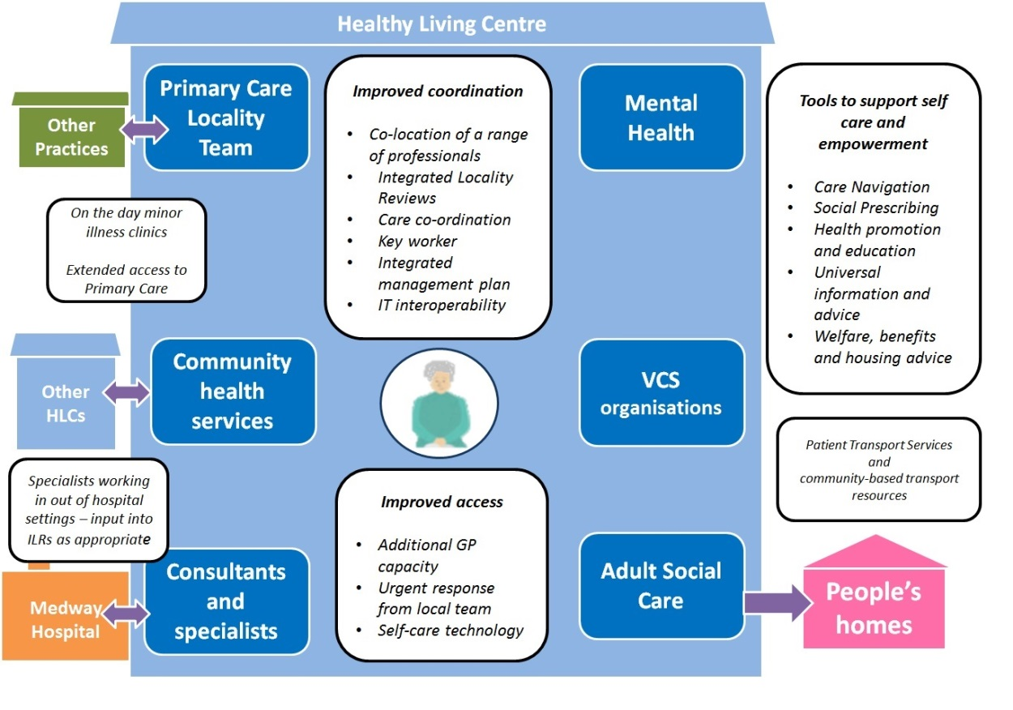

*Figure 13: The ‘one stop shop’*

**7.2 Key changes in the revised model for community services**

Our proposal is to reconfigure adult community health services in Medway so that they are less fragmented and more joined up, so that more services take place within local communities closer to people’s homes with longer access times. We are proposing moving to a system of multidisciplinary teams – where multi skilled community nurses provide the majority of care for people with long term care conditions backed up by a small number of specialist teams. Patients will also see a change in the way that they receive their care – with most people being seen in a location nearer to where they live.

We propose introducing Senior Community Clinicians so that people with multiple long term and complex conditions are provided with integrated care in the community to keep them clinically safe and well at home, away from unnecessary admission to hospital and we will instigate a single point of contact – email and telephone for those affected. Built into the new system will be a rapid response mechanism so that the service responds quickly to patients with urgent needs and there will be more use of technology for people to manage their own conditions.

There are seven key changes to adult community health services and these are summarised below:

**Change 1: The most common services will be provided locally in each Medway Town, with specialist support provided centrally.**

Wherever possible, care will provided closer to home by moving clinics so that the most common services (such as Wound Therapy, Respiratory, Cardiology, Phlebotomy, Community rehabilitation) will be provided in each of the six localities except where specialist equipment or specialist expertise is required. The revised model for community services means some clinic locations will move but this does mean that the travelling distance to community clinics will reduce for some patients.

Around 54% of our current community activity takes place in a clinic setting. Of these clinic appointments around a half are NOT provided in the same locality in which the patient lives resulting in patients travelling much further than necessary.

Going forwards more services will be provided within each of the existing purpose built Healthy Living Centres in Balmoral Gardens, Rainham, Rochester and Lordswood. Subject to the usual approval process the expectation is that the two new facilities in Chatham and Strood will be completed during 2020-21 with existing sites being used in the interim.

**Change 2: More multi skilled community nurses and therapists supported by specialist teams.**

Patients have told us they are often being seen by a number of different practitioners to manage their conditions and that they attend multiple appointments when a single one would be better.

In response we will reconfigure fewer but larger teams with more generalist multiskilled nurses and therapists in each locality to treat and provide support and basic education on a range of conditions, reducing unnecessary contacts and improving coordination of people’s care. Smaller highly specialist teams will support the multi skilled community nurses and therapists and will continue to provide some services in patients own home or in a clinic. The revised model does not mean that there will be a reduction in the level of services currently provided; it does mean that services will look different as there will be fewer but larger teams at a local level.

**Change 3: Extended hours and days of operation**

Currently, most community services operate on an historic 9am to 5pm basis such that patients who work conventional hours have limited choice of appointment slots.

Whilst the final operating hours of services will be agreed as part of the procurement the intention is that hours of operation will be extended where possible to align with Primary Care i.e. 8am to 8pm Monday to Friday, Saturday from 9am to 4pm, and where demand exists on Sunday.

This is likely to apply to all the larger services provided in each of the six localities, for example such as a core nursing and therapist services although it is recognised that it may not be possible or necessary to extend hours for smaller specialist services.

**Change 4: A new central co-ordination function**

To support extended hours and a two hour response time for patients with the most complex conditions, a central co-ordination function will ensure that the booking of appointments and access in times of crisis is easier.

The revised model will mean that patients will have access to a 24/7 phone number to arrange and manage their own appointments. For patients who have a named Senior Community Clinician they will be able to access support through this central point including accessing an urgent response.

For housebound patients, the central co-ordination function will arrange appointments based on set time slots to ensure that patients know when professionals are coming to visit, including where possible combining multiple appointments from different professionals.

The central coordination function will be linked to/supported by a patient portal which will allow patients to see their integrated management plan, test results, letters from health professionals, notes and appointment details providing the opportunity to manage and take more control over their own care.

**Change 5: Senior Community Clinicians will case manage the care of all patients with complex or multiple long term conditions**

All patients with three or more long term or complex conditions will have their care managed and co-ordinated by a Senior Community Clinician. This will be made possible by an additional investment of approximately £1.5m in the workforce to recruit additional staff to carry out these roles.

There are approximately 12,500 patients with more complex conditions including people who are frail and elderly and people living with three or more long term conditions (LTC3+). These patients are likely to disproportionately attend or be admitted to hospital and that their care could be much better managed in the community than is currently the case. Although these patients represent around 4.5% of the population they account for approximately 10% of all adult A&E attendances and 19% of all adult emergency admissions.

**Change 6: Speedier response within two hours for people with complex or multiple long term conditions who are in crisis or when they need urgent treatment or support.**

For the 12,500 LTC3+ people when they start to experience exacerbations in their condition or in crisis, require an urgent response within two hours. Analysis identified that a large majority of current community services are not able to respond urgently to patients in crisis which often means that patients will either attend A&E or are admitted to hospital.

The revised model will mean that patients who have a named key professional (Senior Community Clinician) will have access to a much quicker response. Patients will access help through a single telephone number – where needs will be assessed and support provided within two hours, where it is necessary.

**Change 7: More opportunities and support for people who use community health services to lead healthier lifestyles and to manage their own conditions.**

In the future there will be greater emphasis on education and activities that support people to follow healthier lifestyles. Staff will be trained to talk to people about how they can make healthy lifestyle changes and will signpost them to where they can get further support (e.g. health improvement services).

People, particularly those with long term conditions, are often the experts in managing their own conditions but are not always heard or involved in care plans and actions. Staff will work with the patient to understand their individual level of knowledge, skills and confidence in managing their own conditions, so the most appropriate options can be offered to them.

There is a greater focus on prevention and supporting local people to live for longer and in good health. In the revised model, there will be routine assessments to find out what tools people are able and prepared to use to self-manage their conditions. Patients will be routinely assessed to gauge their propensity and capability in using tools to help them to self-care

The range of technology offered to patients is seen as a key enabler, making better use of the latest self-support apps and to provide training and support for patients in doing this. Staff will be trained to ensure that they are confident in assessing patient and carer’s needs, and are also capable of providing the relevant guidance to patients, and are able to competently use the technology used.

There will be a greater focus on increasing patient’s education and activities that promote healthy life styles alongside the self-management of conditions. Community services will create stronger links with a range of organisations, including Public Health, Care Navigation and Voluntary Community Services recognising their value in support people’s health and wellbeing.

Throughout the following sections further detail is provided on the changes, the areas where patients and professionals will see the most significant changes are highlighted (labelled **‘Key change’**).

**7.3 What benefits will the revised model for community services provide?**

The benefits for the model were developed with stakeholders during our engagement events that took place during November 2017 and January 2018. The benefits of a revised model are explained in detail in Sections 8-12. In summary, this includes:

Services aligned to the Medway Model

Care closer to home

Improved access to services

Focus on prevention and empowerment

Improved coordination and integration of care

Realigned and upskilled workforce

In addition, the revised model will see an improvement in collaboration between organisations, more flexibility within and between organisations to allow for constant improvements in services, and an improved use of intelligence on which to develop services.

**7.2 Illustrative case studies**

The following fictionalised case studies, in Figures 14 to 16 draw on the experiences of real people. They show how the revised model will improve care and patient experiences.

|  |  |
| --- | --- |
| **Laura**  **Laura is 72 years old and lives alone in a bungalow in Rochester. She has a history of heart attacks, heart failure and chronic obstructive pulmonary disease (COPD) and she now suffers from swollen legs and cellulitis. Laura recently tripped on the step at her front door. With the help of her neighbour she managed to stand but she cut her leg and knocked her side which resulted in hip pain. Her neighbour called an ambulance and contacted her daughter who lives in London. Once in A+E she was treated for a urine infection and the wound on her leg. Laura was discharged home with a temporary care package, home care in the mornings and in the evenings, to help her get in and out of bed.** | |
| ***Current community services*** | ***Community services in the revised model*** |
| * Whilst housebound, the community nurses looked after her wound. The wound does not improve. * She was referred to the wound clinic as soon as she is able to leave the house and had regained her confidence. * Services were not always well designed for patients with co-morbidities. * Laura had to juggle several appointments – to visit the wound clinic, to see the respiratory team for the COPD, and the cardiology team for the heart failure. Often these were in different settings and on different days. | * Laura will be pro-actively identified through risk stratification and clinical assessment as someone with long term conditions that is at risk of falling and may be socially isolated. * Laura will be seen by the Rochester area Community Locality Team (CLT), receiving a holistic assessment taking into account her health needs alongside a range of other issues that are important to her (like remaining independent in her home for as long as possible). The team will receive input from a heart failure specialist which helps with the treatment of her swollen legs, reducing the risk of Laura developing cellulitis. * Laura will receive a copy of her integrated management plan which continues to be updated by all the professionals she comes into contact with. Laura will get to know her named Senior Community Clinician who will coordinate her care, supported by a central co-ordination function, where she would access to support and clinical advice (urgent and non-urgent) for all community service functions including booking appointments and general enquiries. * In the event of a fall where Laura calls an ambulance, the ambulance service will be able to see her integrated management plan. If clinically appropriate, the central coordination function will arrange for an urgent response from her Community Locality Team instead of a conveyance to hospital, and will alert the named Senior Community Clinician. * The central coordination function will manage Laura’s subsequent appointments to ensure that, wherever possible she receives the minimum number of contacts (home visits or clinic appointments) necessary, reducing her anxiety and giving her more control over her care. In most cases, these will be in the Rochester Healthy Living Centre. * All the health professionals with whom she is in contact will have a greater understanding of the services available in the community that help reduce social isolation. They will either advise Laura of these or refer her to a care navigator who will help her to access services to support her wellbeing. |

*Figure 14: Case study 1 – Laura*

|  |  |
| --- | --- |
| **Susan**  **Susan is 57 years old and lives on the borders of Medway in Walderslade. She has Type 2 diabetes (diet-controlled) and Rheumatoid Arthritis (RA), which was diagnosed six years ago. Her GP manages the RA and she has a monthly blood test which is carried out at MCH House in Gillingham. She visits her GP occasionally to get painkillers. Recently, Susan had a health check and one of the recommendations was that she loses some weight as her BMI was high at 26.7. Following the health professional’s advice Susan decided, despite the poor weather, to get back into cycling. Whilst out of her bike she lost her balance and fell. She broke her leg in two places and cut her elbow. After surgery and a brief spell in hospital she was discharged home.** | |
| ***Current community services*** | ***Community services in the revised model*** |
| * Whilst housebound, community nurses visited to dress her wounds. She knew the day that they were due to visit but not the time. * When fit to commence physiotherapy, Susan had to rely on her sister to take her to her appointment. The physiotherapy clinics offered locally were not available at a time that suited her sister so she had to travel to a clinic in another part of Medway. * Susan has become increasingly anxious and depressed due to the fragmented nature and lack of integration between some services. | * Susan will be offered a range of self-management tools for her diabetes and RA, these will include self-care apps for her phone, healthy eating advice, exercise classes – such as those run by Public Health. Susan will be empowered to take control of her care in the way that suits her best. * Improved interoperability of various healthcare ICT systems will help professionals, and Susan, access her integrated management plan, records, blood forms, and test results - as well as communicating electronically any changes on her prescription made in the event of a hospital admission. * The central co-ordination function will manage Susan’s community nurse appointments, offering time slots for visits helping to reduce her anxiety. * When it comes to visiting the physiotherapy clinics, Susan will have more choice because of the extended hours. Her appointment will be either within the Lordswood Healthy Living Centre or in the Chatham Healthy Living Centre. * Susan will receive community services that work around her, facilitating her rehabilitation and promoting a fast recovery and supporting her to feel more in control of her long term conditions. |

*Figure 15: Case study 2 - Susan*

|  |  |
| --- | --- |
| **Bill**  **Bill is 66 years old and lives in Rainham with his daughter Barbara, and two dogs. They moved from Glasgow 18 months ago into a two-storey semi-detached house with two bedrooms and a family bathroom. Barbara doesn’t drive and so they both rely on public transport to get around. Bill has early stages of dementia and is waiting for further tests at the Memory Clinic. Since Bill was diagnosed, he has attended a day centre once a week. This allows Barbara time to get things done that she can’t when looking after her father. Two months ago Bill suffered a stroke and is currently receiving rehabilitation at home. Since the stroke, Bill’s dementia has deteriorated. He has lost strength on his right side and bladder control. He now has a catheter but the nurses have said that it might be possible, one day, to recover the function in his bladder and he might not need it any more.** | |
| ***Current community services*** | ***Community services in the revised model*** |
| * Barbara finds it difficult to look after Bill’s catheter. * Barbara has needed to call the ambulance several times when Bill get disorientated and aggressive. Every time Barbara calls, she needs to go through everything again which is very stressful. * The stroke rehab workers struggle with Bill’s behaviour and Barbara fears they might discharge him from the service. * The Dementia Crisis Support Team has been supportive but can’t help with all of Bob’s needs which means other teams have to visit too. * All the workers are caring and professional but Barbara feels that nobody understands the whole picture and all the different faces make Bill very confused. | * As Bill has developed several long term and complex conditions his GP (or any health or social care professional) will refer him to the Rainham Integrated Locality Review (ILR) where nurses and therapists work with Bill’s GP and are supported by mental health and social care workers to provide him holistic support under one integrated management plan. * Specialist input to the IRLs from a geriatrician, a dementia nurse, and the specialist stroke team will be easily accessible – recognising the level of acuity and risk in this case. * Bill will have a named Senior Community Clinician who will be responsible for making sure that he and Barbara know what is going on with his care and is a friendly face to go to with concerns. * The health professionals with whom Barbara and Bill are in contact will have a greater understanding of the services available in the community that may help improve wellbeing, both for Bill and Barbara as his carer. They will either advise of these or refer to a care navigator who will help her to access services to support their wellbeing – such as carer information and advice. If she is willing, Barbara will also be referred to Adult Social Care for a formal carer assessment to see if she is entitled to support. * Anyone who visits Bill will understand and feel confident in dealing with his dementia and will also be able to sort out his catheter. * If Barbara feels she cannot deal with Bill, instead of calling the ambulance, she uses the central co-ordination function, and if appropriate, they will provide an urgent response. If an ambulance is called, the ambulance service will be able to see Bill’s integrated management plan and Barbara will not need to explain the situation all over again. |

*Figure 16: Case study 3 - Bill*

**8. Services aligned to the Medway Model**

There is no intention to reduce the community services offered and the revised model will continue to provide the same services as it does currently. The Kent and Medway Referral and Treatment Criteria will continue to be used as a guideline for treatment options. However, as the case for change has highlighted, services need to be realigned and refocused in order to make better use of resources.

**8.1. Simplifying service configuration**

Our case for change identified that, historically, community services have been delivered by a large number of separate teams and groups of professionals, and some services work in isolation with little integration or coordination across boundaries including between teams and other organisations. It refers to King’s Fund research which highlights that fundamental changes are required in the way community services are commissioned to simplify services and remove unnecessary complexity. It advocates simplifying services, creating larger community teams with a shared set of skills supported by specialist teams.

These specialists are still required in areas such as tissue viability, continence and palliative care but will focus more on education support and providing clinical advice and support in the most difficult cases.

**Key change:** In the revised model there will be fewer and larger teams, in order to facilitate a reduction in unnecessary contacts and to improve coordination of people’s care.

**8.2 Arranging services into tiers**

As part of the procurement process, commissioners will work with potential providers to fully determine the final configuration of services based on the demand for each area and will continue to respond to changes in demand at a local level. This will allow providers to be innovative in their approach to delivering the revised model. However, the tiers outlined below based on learning from NHS New Models Vanguard sites, will form the basis for this configuration.

***Tier 1***

As the case for change has shown, the location and accessibility for community services is not currently equitable across Medway. To address this, the revised community service model will provide the most common services that support the highest number of patients in each of the six localities: Rainham, Gillingham, Chatham Central, Lordswood, Rochester and Strood – each of these areas serve populations of between 30,000 and 50,000.

Each locality will have a Community Locality Team (CLT) that comprises of multi-skilled generic nurses and therapists who can take a more holistic approach to people’s care, reducing duplication and transfers of patients between teams. Examples of support provided at this tier, either within an HLC or in the home, includes, day to day management of long term conditions (including respiratory, cardiology and diabetes), wound therapy, phlebotomy, medication administration, non-bed-based end of life care, physiotherapy and occupational therapy.

***Tier 2***

There are some services that are not be feasible to be provided frequently at every HLC due to the level of demand or where specialist staff, equipment or clinic space is required. These services will be provided to populations of between 80,000 and 100,000 across two adjacent localities (Gillingham and Rainham, Chatham Central and Lordswood, and Rochester and Strood). For people who need these services, this will either result in less frequent clinics in each HLC than tier 1 services, or the expectation that people will travel to the adjacent HLC. Examples include, gym-based exercise and rehabilitation and group education (including for diabetes).

To illustrate this, currently pulmonary rehabilitation sessions only take place in Chatham and Rainham. For a patient who lives in Strood, for example, there is no provision within their locality or the adjacent locality, Rochester. The revised model will address this inequitable access and ensure that pulmonary rehabilitation is also available in Strood or Rochester.

Another illustration relates to the X-PERT diabetes education course. Currently, courses take place in all localities except for Chatham Central and Lordswood. For a patient who lives in either of these localities, there is no provision within their locality or the adjacent locality. The revised model will address this inequitable access and ensure that diabetes education is also available in Chatham Central or Lordswood.

***Tier 3***

These include the most specialist community functions where staff will hold smaller caseloads and focus on providing support, education and specialist consultation to CLTs and primary care. For people who use these services this will result in clinics running less frequently than tier 1 and tier 2 services which reflects the lower level of demand. Currently, it is not feasible to provide these services in all localities and this is not expected to change. However, in the revised model, the provider will ensure that the location of clinics is based on local demand, and will follow the principle that, wherever possible, staff will travel to the relevant HLC, or be available through better use of technology, and will input into the ILRs.

Examples of services at this level include specialist nursing (including continence care, tissue viability and epilepsy), hand therapy, and musculo-skeletal assessment and triage. This tier also includes the specialist palliative inpatient care provided at the Wisdom Hospice which will not change in the revised model.

Figure 17 depicts the arrangement of services in the revised model and is described in more detail below.

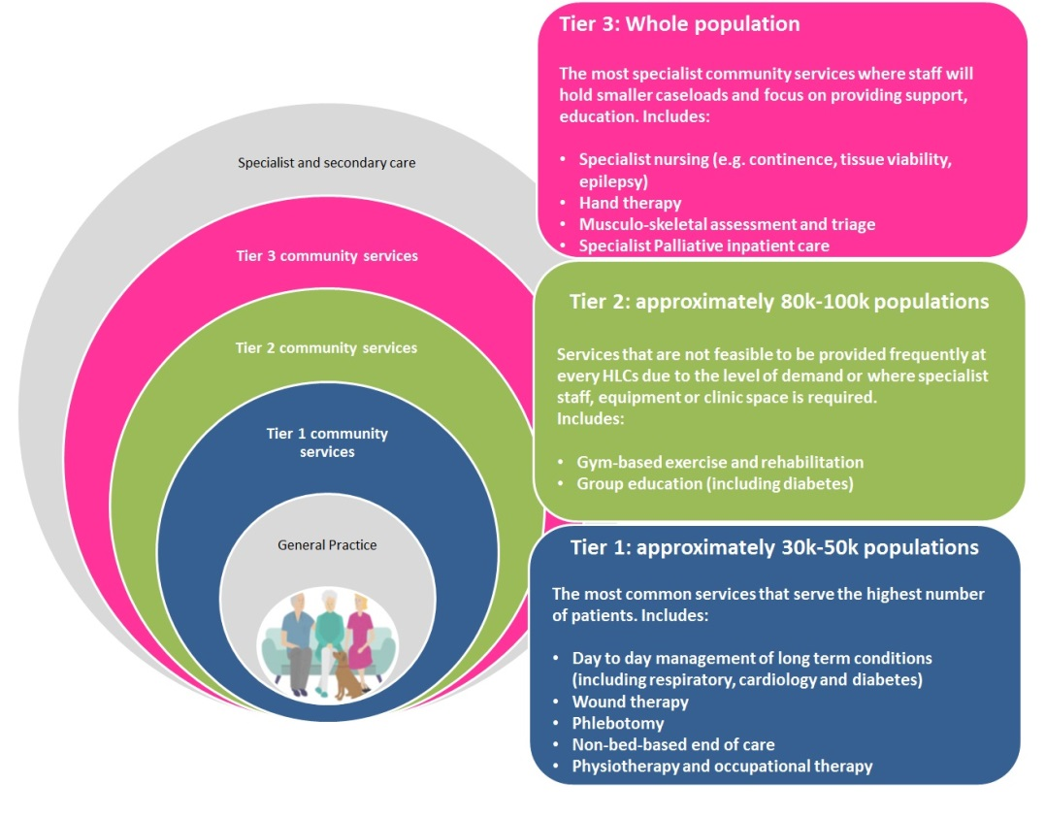

*Figure 17: The three tiers of service*

**Key change:** Services will be arranged around natural geographies and the feasibility of delivering certain services based on population size. Services will only be centralised if it is not clinically or financially viable to provide them at locality level.

**8.3 Changing the setting for community services**

***Home visits***

Around 46% (approximately 265,000) of all face-to-face contacts currently take place in people’s homes (including in care homes). The revised model will continue to recognise the importance of home visits and they will continue to be provided where necessary. However, the review of services established that in many cases patients could have visited a clinic and the home visit was not necessary. The community nursing review highlighted that an estimated 40% of home visit contacts for community nursing could have been provided in a clinic setting.

**Key change:** Housebound patients will be clearly defined and a more coordinated model of care will ensure that visits are planned and timely, and multiple visits from different professionals are avoided where possible.

***Contacts in the community***

The remaining 54% (approximately 317,000) of face-to-face contacts are provided in community settings (i.e. not in people’s place of residence). As outlined in the case for change, around 50% of contacts are provided in a setting that is outside of the locality in which the patient lives. This means that a large proportion of patients must travel to another locality to receive treatment as access is not equitable across each of the six localities.

Based on current community contacts and using the six HLC locations as a proxy for residence, analysis of contacts demonstrates that:

* Approximately a quarter of community contacts take place in the locality in which patients live but not within an HLC.
* Approximately a quarter of community contacts already take place in a HLC within a locality in which people live. This will mean no change in the revised model.
* Approximately half of all community contacts take place in a setting that is outside the locality in which they live. This means that there is likely to be a reduction in travel times for this cohort.

The revised model will enhance equality of service provision across localities whilst maintaining patient choice. As highlighted in the description of the tiers above, wherever possible, staff will travel to the relevant HLC, or be available through better use of technology. If it is more convenient for a patient to be seen outside of their locality, for example, due to work commitments, patient choice of preferred location will preside and choice will not be limited, for example for phlebotomy and wound clinics.

The next section (8.4) describes how the revised model for community services will support the alignment of hospital activity into the community. There will be a positive impact for the majority of these patients who will be able to access these services from a local setting instead of travelling to the acute hospital.

**Key change:** Wherever possible, care will provided closer to home by moving clinic contacts to the appropriate locality.

The Public Health England [Strategic Health Asset Planning and Evaluation](https://shape.phe.org.uk/) tool (SHAPE) can be used to show the travel times across Medway to the HLCs which are the basis for the revised model (based on the resident population and not limited to those people who use services) – shown in Figure 18.



*Figure 18: Travel times to the Healthy Living Centres*

In summary, analysis of the revised model demonstrates that a significant proportion of the population is able to access the HLCs within 15 minutes –56% of people using public transport and 94% and 98% using a car in rush hour and off peak respectively. Over half of the population (53%) will be able to walk to an appointment at an HLC within 25 minutes.

**Key change:** The revised model will significantly reduce the distance travelled and represents a positive impact for the patient and also a positive environmental impact due to fewer and shorter trips.

Public Health analysis completed in May 2018 using ‘Map Modeller’ based on 2016/17 current community contacts highlights that the average driving distance for patients to current community clinic locations is on average 5.8 miles compared to a distance of 3.6 miles where all services are provided at each of the six HLC.

For those patients that currently attend the Acute Hospital and in the revised model will be seen in a community setting the average distance for patients to travel is on average 6.7 miles compared to travelling to the nearest HLC is on average 3.4 miles.

Two real patient examples are summarised in Figure 19. This shows current against future travel arrangements and demonstrates the difference in the time it takes to travel to the community setting.

|  |  |
| --- | --- |
| ***Travel time illustrations*** | |
| ***Example 1***  *A Rainham resident had 75 contacts last year at the Walter Brice day rehabilitation centre for therapy.*  *The travel time from their residence in Rainham to Walter Brice is 28 minutes by car each (off peak) and 1 hour 45 minutes by bus (including walking to and from bus stops).*  *In the revised model, the same treatment will be available at the local Healthy Living Centre (Rainham) or the adjacent one in Gillingham.*  *The Rainham Healthy Living Centre is 9 minutes away by car (off peak) which represents a journey that is shorter by 19 minutes; and 17 minutes by bus which represents a journey that is shorter by 1 hour 28 minutes.*  *Alternatively (as a tier 2 service, provided across two localities, explained below) Gillingham Healthy Living Centre (Balmoral Gardens) is 14 minutes away by car (off peak) which represents a journey that is shorter by 14 minutes; and 46 minutes by bus which represents a journey that is 1 hour 18 minutes shorter.* | ***Example 2***  *A Gillingham resident had 59 contacts last year at Rochester Healthy Living Centre and only one at Gillingham Healthy Living Centre (Balmoral Gardens) for the treatment of a wound(s).*  *The travel time from their residence in Gillingham to the Rochester Healthy Living Centre is 14 minutes away by car (off peak) and 41 minutes by bus.*  *In the revised model, the same treatment will be available at the local Healthy Living Centre.*  *Gillingham Healthy Living Centre (Balmoral Gardens) is 7 minutes away by car which represents a journey that is shorter by 7 minutes; and 27 minutes by bus which represents a journey that is 19 minutes shorter.* |
| *Figures based on 2016-17 data.*  *Calculations from Google Maps and Arriva, using GP practice location as a proxy for patient residence* | |
| *Figure 19: Travel time illustrations* | |

**Supported by: Patient Transport Services and better links to community and volunteer transport**

Patient Transport Services are co-commissioned across North Kent and this service is outside the scope of this service. Commissioners will work with the provider to ensure that the revised model for community services is well served by the Patient Transport Services. In addition, people have told us that there needs to be better links between community services and volunteer-delivered transport services that currently operate in Medway. Commissioners will ensure that these links are strengthened in the revised model.

**8.4 Supporting the realignment of hospital activity into the community**

The revised model, involves defragmenting and simplifying the way current community services are configured. These improvements will support the KMSTP Local Care agenda and the gradual shift of activity across the local system from the hospital in to primary and community services.

The case for change highlights that many local people do not get enough support to manage their long term conditions which means that there are high levels of hospitalisation. It also highlights that when people do go to hospital they tend to stay in hospital for a long time and have difficulty getting out of hospital and back home, and the levels of referrals to hospital specialists is higher in Medway than other places with a similar population.

Greater support is required in the community to enable some realignment of lower acuity hospital activity into the community. Work is underway to realign resources from the hospital into the community and whilst much of the shift in activity is outside the scope of the CSR Programme, the revised model is predicated on many of these changes being delivered in the local system by 2020 and is fundamental in supporting the realignment.

**8.5 Making the most of our estates**

The case for change has shown that the Medway Local Estate Strategy is fundamental in delivering the revised model. The revised model is aligned to the Medway Model which is underpinned by the Medway Local Estates Strategy (which is currently being updated) and the development of the six HLCs in Medway.

There are currently only four HLCs, one in each of the four localities in Lordswood, Gillingham, Rainham and Rochester; all are undergoing infrastructure upgrades to ensure that they are fit for future purpose including enabling future ICT requirements. The CCG with Medway Council, through the One Public Estate programme, are working to identify equivalent high calibre estate in the Strood and Chatham locations to provide an HLC in each of these localities. The expectation, subject to approval through the appropriate governance process, is that the new buildings will be completed during 2020-21.

The development of the HLCs in each of the six localities is therefore a key enabler to ensuring that the scale and configuration of space is suitable to support more integrated and collaborative working within teams and across organisational boundaries. As part of our engagement on a revised model, people have told us that they would like to be able to access a ‘one stop shop’. Providing more services within the HLC and making better use of our current estate as part of the revised model will help to facilitate this and help to provide greater equity of provision across Medway. Recognising that there will be a delay in all the estate being ready, existing sites within the relevant locations will be used in the interim.

**Key change*:*** In order to support the co-location of health, social care, mental health, voluntary and third sector organisations, the majority of the services currently provided in alternative community settings would move into a local Healthy Living Centre.

**9. Improved access to services**

It is anticipated that the relocation of services as outlined above will improve access to services by ensuring that they can be delivered as close to home as possible. In addition, there are a range of other improvements included in the revised model that are explained below.

**9.1 Extended hours and urgent response function**

Currently, most community services currently operate on a traditional 9am to 5pm basis and, therefore, patients, particularly those who work conventional hours have limited choice of appointment slots.

**Key change:** The revised model will extend access to community services, where demand exists, by ensuring that they are available from 8am to 8pm and at the weekend.

**Supported by: Extended hours in primary care**

The [General Practice Forward View](https://www.england.nhs.uk/gp/gpfv/) published in April 2016 sets out plans to enable clinical commissioning groups (CCGs) to commission and fund additional capacity across England to ensure that, by 2020 everyone has improved access to GP services including sufficient routine appointments at evenings and weekends to meet locally determined demand, alongside effective access to out of hours and urgent care services. In Medway, discussions are underway with GPs and Patient Participation Groups and a specification is being developed, overseen by the Primary Care Operational Group and Commissioning Committee. The CCG must facilitate extended access across Medway by March 2019. Community services will be designed to complement the developments in Primary Care.

**Supported by: Minor illness clinics**

The CCG has established a Minor Illness Clinic pilot (MIC) in Rochester Healthy Living Centre. This is a GP/nurse-led clinic that provides additional on-the-day minor illness capacity to build resilience, educate the public on minor illness and self-care, increase capacity for long term condition management, and reduce pressure on urgent and emergency care. Rochester GP practices have developed a model that that allows them to work collaboratively in managing the clinic. The MIC model is being used as a foundation to develop extended access within primary care.

The case for change has shown that we need to address the pressure on acute hospital services, in particular, the emergency department where it is estimated that as many as four in ten emergency admissions to hospital could be avoided if the right care was available in the community.

**Key change:** The revised model will see an improved urgent response (within two hours) to deal with the most complex patients and those who are in crisis, in and out of hours, to avoid conveyances to hospital and attendances at the emergency department.

The urgent response function will include access to the relevant specialists to access and treat early onset exacerbations of long term conditions within each locality. In addition, links to specialist support from acute consultants will be strengthened so that high risk patients have robust integrated management plans and access to standby medications to support home treatment during exacerbations

* 1. **Central co-ordination function**

Stakeholders have stated that appointments could be better managed and that in many cases a single point of access to community services would improve their experience of care.

**Key change:** The revised model will include a central co-ordination function which will operate through a range of channels to improve access to services.

The central co-ordination function will be linked to/supported by a patient portal which will allow patients will be able to see their integrated management plan, test results, letters from health professionals, notes and appointment details – ultimately giving them more control over their care.

For housebound patients, the central co-ordination function will arrange appointments based on set time slots to ensure that patients know when professionals are coming to visit.

* 1. **Improved knowledge of wider community assets**

People have told us that there is much confusion regarding the services available in the community that can support and improve – both with patients and their carers, and with professionals. We want to support the workforce to have a greater knowledge of assets in the community that can be referred to that enhance people’s wellbeing.

**Key change:** The revised model will include/ facilitate access to a comprehensive directory of services to enable a proactive approach to sign posting to services for both professionals and patients.

**Supported by: Care Navigation**

Many health and social care professionals are unaware of the breadth and depth of services in the community that patients can access in order to improve their general wellbeing - they often lack the time to maintain their knowledge of local services or to focus on patient’s psychosocial issues. In order to address this issue, Medway CCG and Medway Council have been working with VCS organisations through pilot projects to develop care navigation. Health and social care professionals can refer to care navigators (an element of social prescribing) who support people to locate and access appropriate non-clinical services. As care navigation becomes completely embedded in the community it will act as a source of good quality information for patients and professionals, who currently are confused and lost by a myriad of information systems and places, and overstretched public health and social care services. Medway CCG and Medway Council, funded through the Better Care Fund, intend to procure comprehensive care navigation with a service expected to commence in October 2018. Building on learning from the current pilot projects, the new service will focus on frequent users of health services, those with long term conditions and those discharged from hospital. The care navigation service will not be seen in isolation and is part of a larger social prescribing project led by Medway Public Health but covering the whole health and social care system. Therefore, as this service develops, links to community services will be made.

**Supported by: Receptionist Signposting.**

Reception staff in all Medway GP Practices have been trained so patients are appropriately and safely signposted to the appropriate community service they need.

**10. Focus on prevention and empowerment**

We want to support people to be as independent as possible for as long as possible. The revised model will ensure that, in line with clinical guidelines, people are offered informed consent and choice of treatment options where appropriate. This will include a range of options that promote self-care and enhance general wellbeing, including accessing assets in the community (supported by better access to community assets as mentioned above) and to take advantage of technology enabled care, including telehealth, teleconferencing and self-care apps, which will improve accessibility for those patients who are able to take advantage of these tools, while recognising that they will not be appropriate for everybody.

**10.1 Person-centred approach**

Community services professionals will take a holistic approach when assessing and care planning, seeking input from social care and mental health colleagues whenever necessary. People will be asked, ‘what matters to you’, instead of ‘what is the matter with you’, so treating the person and not just their condition and recognising that people will often have more than one long term condition. This will be supported by colocation of professionals.

**Key change:** Wherever possible, people will have an integrated management plan that will be accessible by all professionals who can update it whenever they need to. The patient will be able to access this via the patient portal.

Physical health and mental health often go hand-in-hand and long term conditions and mental health services and staff will be more integrated to promote people’s emotional wellbeing and help prevent possible crisis. In addition the revised model will ensure that staff ensure people are aware of and are encouraged to access talking therapy services where appropriate.

Assessments and management plans will recognise the importance of family and informal carers. The community services workforce will provide education and advice regarding the cared-for person but will, furthermore, direct carers to services in the community that can support their own wellbeing and will refer to adult social care for a formal carer assessment where appropriate.

**10.2 Patient activation – understanding how best to support people to self-care**

People who recognise that they have a key role in self-managing their condition and have the skills and confidence to do so experience better health outcomes. Figure 20 is the self-care continuum which shows the different levels of self-care linked to patient’s different situations. The organisation(s) responsible for delivering the revised model will ensure that staff have an understanding of a patient’s level of knowledge, skills and confidence (or activation level) so that the most appropriate options are offered to help them manage their condition.

**Key change:** Patients will be routinely assessed to gauge their propensity and capability in using tools to help them self-care to allow appropriate interventions to be put in place.

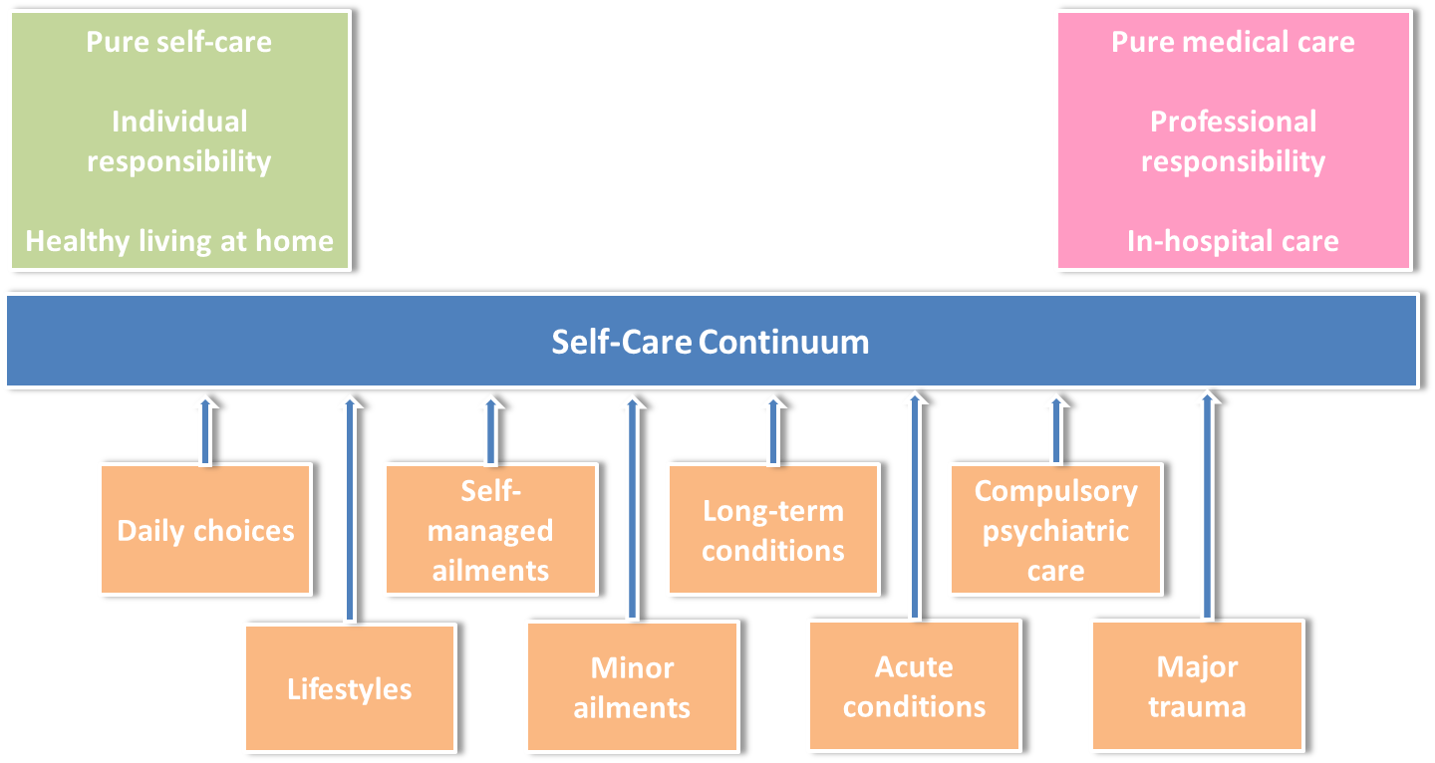

*Figure 20: The Self-Care Continuum*

**10.3 Education and health promotion**

Service reviews have highlighted that some patients have an over reliance on services, placing expectations on them responding to their needs rather than accept personal responsibility for their own health care; which highlights the need to promote and encourage people to take more control over their care. In addition, there should be stronger links with a range of organisations, including public health to ensure that opportunities to prevent ill health are embedded across the local community. This will include stronger links to schools to share information to educate people from a young age.

**Key change:** The revised model will expand the offer of patient education and activities that promote healthy lifestyles alongside secondary prevention and the self-management of conditions, for example increasing the provision of pulmonary rehabilitation.

**10.4 Improved offer of Technology Enabled Care Services**

Improving the offer of technology enabled care services (TECS) is seen as a key enabler in making the revised model a success. TECS come in many forms, as detailed in Figure 21, and improve access to services and communication for patients and professionals.

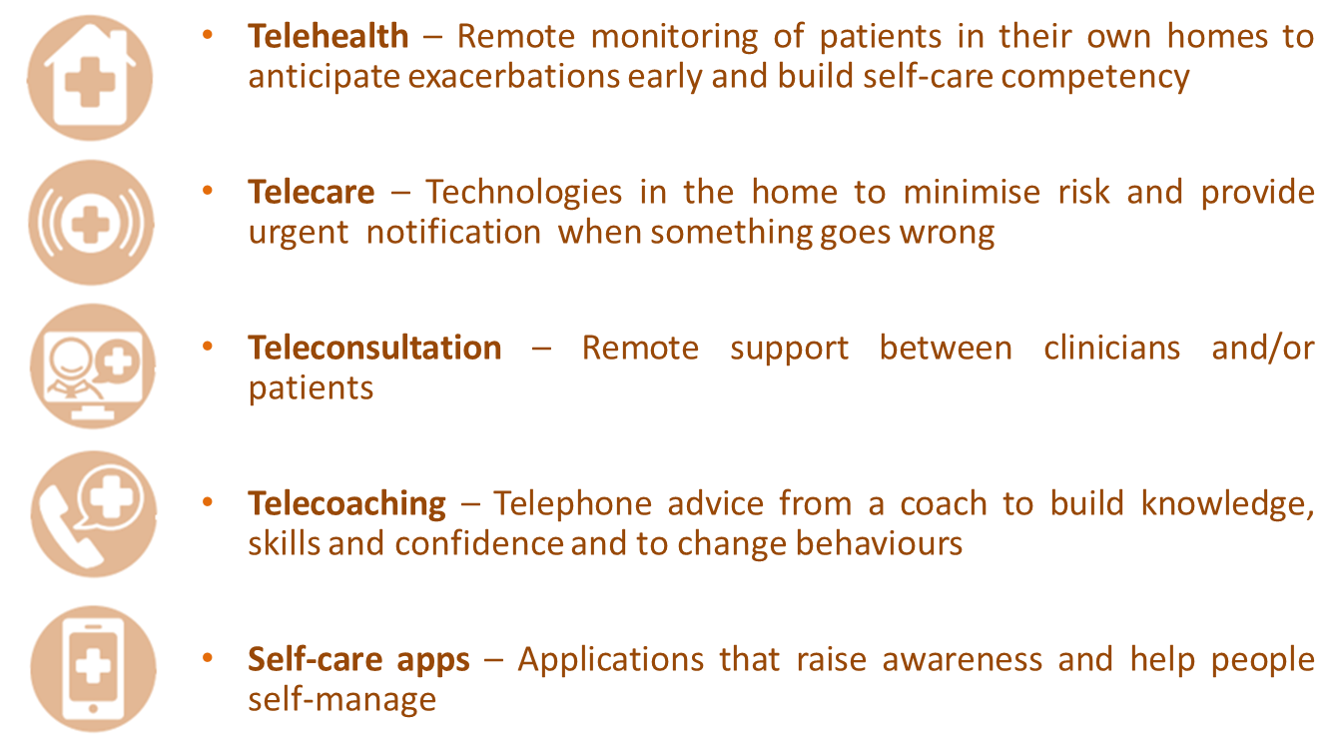

***Figure 21: Technology Enabled Care Services***

The organisation(s) responsible for delivering the revised model will offer TECS that support the whole population across all health conditions. Consideration needs to be given to people’s capability to and propensity to access these services whilst recognising that alternative options must also be available, as one size does not fit all. Figure 22 shows the digital inclusion scale and the types of support that can be offered (indicative and not exhaustive) to different cohorts of patients based on their use of TECS. This shows, for example, that for people who have never used digital technology and never will, phone support will be needed. However, for people who are confident or expert in using digital technology, self-care apps will be an option.

**Key change:** The revised model will expand the use of TECS to improve access to services, give people more control of their care and to make service delivery more efficient.

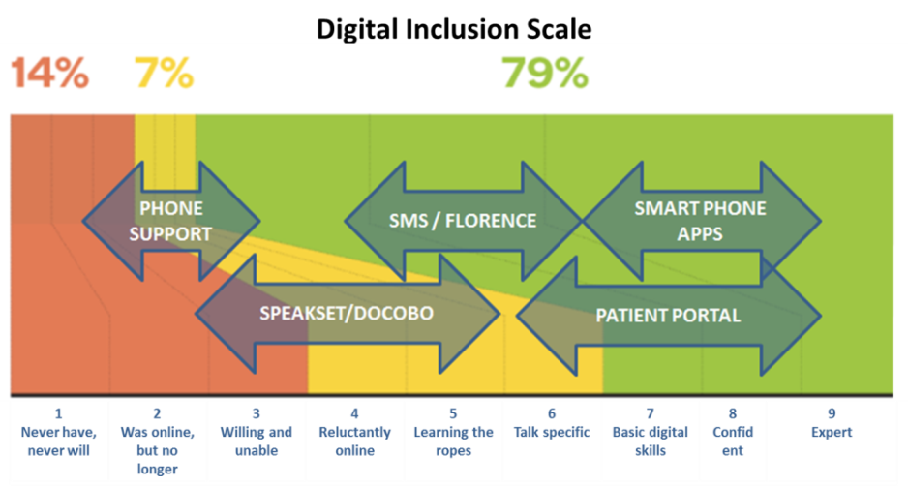

***Figure 22: The digital inclusion scale and examples of tools to support***

**11. Improved coordination of care**

**11.1 Improved sharing of patient information**

Patients and clinicians have told us that a major obstacle in improving the coordination of care is the lack of shared patient information that is hindered by systems that are not integrated. In addition, the due diligence stocktake review highlighted that there is currently inconsistent use of the Medical Interoperability Gateway, Electronic Referral System and other digital developments across services.

It is vital, therefore, that there is an interface between the systems used by community services and those that used by GPs to improve communication and information flow between Primary Care and community services, reducing the need for non-electronic correspondence.

**Key change:** Community services will ensure systems are fully interoperable with those use by GPs to enable improved flow of information.

**Supported by: Consistency of GP systems**

The CCG has worked with GPs to encourage the implementation of consistent systems. The majority of GP practices now use the same system.

**11.2 Community Locality Team working**

As Section 8 has shown, the revised model will reduce fragmentation of services by creating larger core teams at the local level. This will reduce patient transfers between teams and duplication, and will break down professional silos to facilitate professionals working more closely together.

Although outside the scope of the revised model, closer working with social care, mental health and the VCS is essential. Within each locality closer relationships will be builtbetween health, social care, mental health and VCS professionals.

**Supported by: Whole-systems multi-agency approach**

The CCG is working with health and social care partners across the system to develop Integrated Locality Reviews (ILR) where professionals can come together to discuss the needs of patients in a much more proactive way. The expectation is that IRLs will include representation from appropriate teams, including from community services.

**Supported by: Reorganisation and relocation of adult social care workforce**

Medway Council’s Adult Social Care division has recently undergone a restructure with staff now arranged in local teams. Work is continuing to further align adult social care staff with health colleagues in line with the Medway Model.

**11.3 Proactive identification of people with complex conditions**

It has been established that health and social care services need to be much more proactive in identifying and treating people, particularly those with long term and complex conditions, to ensure that they receive appropriate treatment to keep them well and at home.

**Key change:** In the revised model, community services will more proactively identify people who would benefit from intervention, using a combination of risk stratification and clinical judgement and working with GP practices where necessary.

**11.4 Integrated case management for people with multiple long term and complex conditions**

Data shows that that there are around 12,500 people in Medway who have three or more long term conditions. We want to use integrated case management to support these people and others where clinicians deem in beneficial to have from a more joined-up approach to their care. Figure 23 illustrates the main features of integrated case management.

Continuity of care and the relational aspects of care will be improved as those people identified for integrated case management will have access to a named key professional through which they kept up to date about their care.

These people will be also be managed and reviewed at local Integrated Locality Reviews with a set of interventions agreed and as outlined in a single integrated management plan. Input from specialists will support the process as– including specialist nurses, consultants and GPSIs in community settings.

These people will receive 24 hour, 7 days a week support from the central co-ordination and urgent response functions to support home treatment during exacerbations in their conditions helping to avoid conveyances and attendances at hospital.

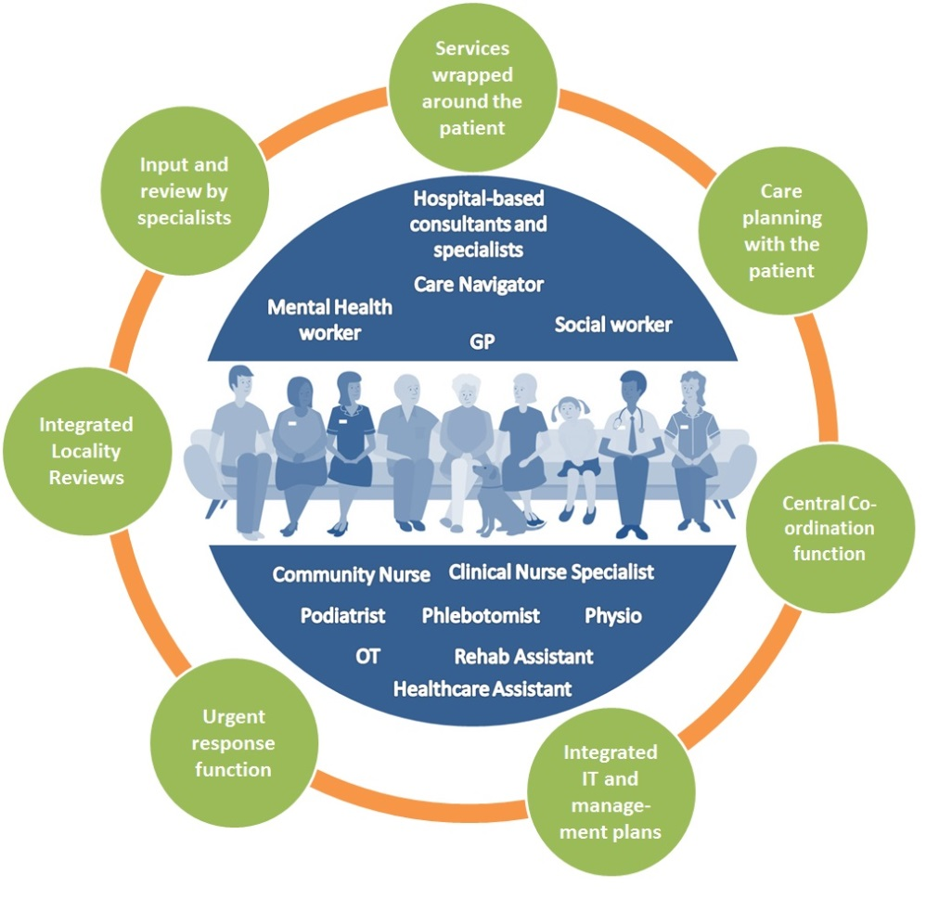

*Figure 23: Integrated case management*

**Key change:** In the revised model, those people identified as having multiple long term or complex conditions will be subject to integrated case management at the locality level.

**12. Realigned and upskilled workforce**

**12.1 Access to specialist advice and support**

The case for change has shown that realigning health professionals can help break down the traditional barriers between hospital and community settings and that if the level of referrals from GPs to hospital-based consultants in Medway were the same as top performing CCGs in similar areas, outpatient activity would reduce by 9%. The case for change also highlighted that 25% to 40% of emergency admissions could be avoided if alternative care was available outside hospital and many local people do not get enough support to manage their conditions.

Although the provision of specialist intervention, i.e. consultants and GPSIs is outside the scope of the CSR Programme, the organisation(s) responsible for delivering services will need to work closely in partnership with secondary care to access their expertise in the community.

The revised model will make better use of technology to provide access to specialist advice and support, for example by the use of teleconsulting.

**Supported by: Development of GPSIs in Primary Care**

GPSIs are GPs with additional training and experience in a specific clinical area who take referrals for patients who may otherwise have been sent directly to a secondary care consultant, or one who provides an enhanced service for particular conditions or patient groups. In Medway, there are currently GPSIs who specialise in dermatology.

**Supported by:** Ensuring that community pharmacies and opticians are used to their full potential

**12.2 Core function of generalist nurses and therapists**

The review of current community services established that there are challenges relating to vacancy rates and the core competencies of the workforce. This is consistent with findings from best practice research. In the revised model, services will be arranged so that there is a more resilient workforce.

As described in Section 8, for the revised model there will be a larger team of generalist nurses and therapists working in the six localities. The revised model will ensure that this group of staff have a shared set of skills to allow a reduction in duplication and transfers of patients between teams. The review of community services highlighted that a larger proportion of the current workforce should be able to carry out interventions relating to the most prevalent health conditions. This includes auscultation, catheterisation, compression bandaging, carrying out 12 lead ECG, and using syringe pumps.

The Community Locality Teams of generalist nurses and therapists will work alongside specialist teams that will have a greater focus on advice and education.

**Key change:** Community services will be supported by a larger team of generalist nurses and therapists with a larger proportion of the workforce able to carry out more interventions to support people with long term conditions.

Across the whole system, in line with the KMSTP Local Care agenda, the workforce will gradually be deployed differently to support the realignment of resources from the hospital into primary and community services. . Recognising that the workforce of 2020 is largely the workforce of today, the organisation responsible for delivering the revised model will continue to work with the CCG and the wider system meet the changes and challenges ahead.

**Supported by: System-wide workforce development**

* The CCG is currently working with providers in order to upskill the workforce in relation to diabetes management. The aim of this two-year training project is to expand and develop the expertise in diabetes management in the community and to provide a robust and sustainable strategy to the delivery of high quality care for people with diabetes and those at risk of developing diabetes.
* The project involves upskilling the primary care and community services workforce to reduce variations in care, improve patient access to receive the eight care processes, improve uptake to structured patient education and lifestyle services; and encourage proactive, appropriate management to improve patient outcomes.
* This model will be reflected in other areas in order to ensure that all community staff are generalists which will reduce the need for intervention from specialist teams and allow for patients with co-morbidities to have their health needs supported more succinctly providing a structured, consistent, high-quality service.
* The CCG is currently working with the community to start improving the skill mix in the current workforce. This is an opportunity to start developing the workforce requirements for the revised model, as the current workforce will also to a large extent, be the workforce of the revised model.
* The CCG is already working closely with local universities and well as Health Education England (Kent, Surrey and Sussex) to ensure that there are appropriate courses to support the development of our local workforce. We have already established a variety of programmes to start developing the workforce in Medway.
* All organisations have a workforce strategy and primary care also has a workforce strategy. The CCG will be working with relevant organisations to ensure alignment of strategies to meet the requirements for the future workforce.

**12.3 Optimised use of medicines**

The revised model will ensure that people are prescribed medicines in a manner that is safe, evidence-based, cost and clinically effective and consistent across all interfaces. This will prevent delay in patients starting treatment and will ensure prescribing responsibilities across the interface are clear. In order to meet this requirement, there will need to be an increase in the number of prescribers (including non-medical prescribers) in community services and there will need to be processes in place to ensure and monitor that all prescribers are adhering to local and national guidelines.

**Key change:** The revised model will ensure that people are provided with a supply of medicines following appointments with community services in a timelier manner in line with local and national arrangements. This will be supported by a greater number of prescribers.

**Supported by: Medicines Optimisation Agenda**

Local and national prescribing guidelines, agreements and formularies will ensure timely, consistent and safe supply of medicines to patients and transparent prescribing responsibilities across the interface. Multidisciplinary decisions on the use of medicines, joint medicines formularies will ensure patients are treated consistently across the interface and in a safe, evidence-based, cost and clinically effective manner.

**13. Collaborative working**

**13.1 Improved system-wide collaboration**

It is recognised that health system is undergoing constant and gradual change. Therefore, it is essential that whichever organisation(s) is responsible for delivering the revised model works alongside commissioners to develop and improve services.

The revised model involves realignment of resources between secondary care and community services that relate to the treatment of patients with long term conditions. There will be the potential for an increasing number of services to shift between settings. To this end, the organisation(s) who becomes responsible for delivering the revised model will work with the commissioner and the acute provider to build in flexibility into service provision to allow this to happen.

**13.2 Better use of intelligence to develop services**

Historically, the intelligence (qualitative and quantitative information) relating to community services is poor. The CCG is working with current providers to address data quality issues identified as part of the review of services. The revised model relies on improved collection, collation, analysis and evaluation of finance and activity data and will ensure that the organisation(s) responsible for delivering the revised model develops services based on a sound and reliable evidence base. This is consistent with the King’s Fund (2018) which found that further developments are needed in the way data about the activity in community services is used.

People have told us that they want to be involved in the ongoing monitoring of services. The revised model will ensure that the collation and analysis of patient experience information is expanded, including the improvement of survey return rates, learning from patient peer groups, and formalising patient panels in the monitoring of services.

Given the transformative nature of the revised model, the expectation is that organisations will operate in a collaborative fashion, improving transparency and information sharing.

**Key change:** The monitoring and development of services will be improved and evidence-based through better collection, reporting and analysis of activity data.

**13.3 Quality**

Current services have not always evolved alongside NICE guideline. The revised model will ensure that any service gaps are covered in the revised service specifications so that all services will be working to the latest quality standards and monitored by the Quality and Safety team at the CCG.

Commissioners are aware that the transition of services and mobilisation has the potential to impact patient safety. The Community Services Re-Procurement Programme Steering Group will ensure that an appropriate transition and mobilisation plan is in place to mitigate against any impact on patient safety and continuity of services. Commissioners will work with providers to ensure that any potential impacts on interdependent services are managed and mitigating actions are put in place.

**14. Summary of the revised model**

|  |  |  |  |
| --- | --- | --- | --- |
| **Key elements of the revised model** | | **Key changes** | **Benefits** |
| **Services aligned to the Medway Model** | * Simplifying service configuration | * Fewer and larger teams * Services grouped to take into account natural geographies and the feasibility of delivering certain services based on population size. * Housebound patients will be more clearly defined. * Contacts in clinics will be provided from the right locality based on local need. * Reduced distance travelled to clinics. * Services mainly provided from the HLCs | * More resilient local teams with less duplication and fragmentation. * More care provided out of hospital and closer to where people live. * Reduced travel times. * Fully utilised public estate. |
| * Arranging services into three tiers |
| * Changing the setting for community services |
| * Supporting the realignment of hospital activity into the community |
| * Making the most of our estates |
| **Improved access to services** | * Extended hours and urgent response function | * Improved urgent response, within two hours, to deal with the most complex patients and those who are in crisis. * Central co-ordination function which will operate through a range of channels to improve access to services. * Better access to a comprehensive directory of services. | * People can access services through a single point of access. * People can access more services in the evenings and weekends. * There is a more responsive community service for people in crisis - reducing ambulance conveyances and attendances and admissions to hospital. * The scheduling of appointments is more consistent and housebound patients know when health professionals are going to visit. * Professionals are better equipped to help people access not clinical services in the community. |
| * Central co-ordination function |
| * Improved knowledge of wider community assets |
| **Focus on prevention and empowerment** | * Person-centred approach | * An integrated management plan. * Routine assessments of people’s capability to use tools to help them self-care. * Expansion of patient education and activities that promote healthy lifestyles, and secondary prevention and the self-management of conditions. * Expanded use of TECS. | * People have a greater understanding and control over their care. * Professionals tailor self-care advice and services to patients to help them stay well and independent in their own homes. * Patients are able to remain well through a greater focus of prevention and self-help within community services, and feel supported to access a range of non-clinical support from VCS and local community groups. * Services take full advantage of TECS, making service delivery more efficient and more convenient to those people who can take advantage of them. |
| * Patient activation – understanding how best to support people to self-care |
| * Education and health promotion |
| * Improved offer of Technology Enabled Care Services |
| **Improved coordination of care** | * Improved sharing of patient information | * Community services systems that are interoperable with GP systems. * More proactive identification and treatment using risk stratification. * People identified as having multiple long term or complex conditions will be subject to Integrated Locality Reviews at the local level. | * Care is more patient-centred and people are treated in a holistic way, taking into account all aspects of health and wellbeing. * Better information sharing improves integration and reduces duplication and improves patient experience. * People received timely intervention which prevents their conditions getting worse. |
| * Proactive identification of people with complex conditions |
| * Integrated case management for people with long term and complex conditions |
| **Realigned and upskilled workforce** | * Access to specialist advice and support | * Larger teams of generalist nurses and therapists with skills to carry out more interventions to support people with long term conditions. * Provision of medicines in a timelier manner supported by a greater number of prescribers. | * Making the most efficient use of our workforce to reduce duplication. * Reduction in the number of contacts needed for patients. * People received the medicine they need more quickly. |
| * Core team of generalist nurses and therapists |
| * Increasing prescribing capacity |
| **Collaborative Working** | * Improved system-wide collaboration | * Better collection, reporting and analysis of activity data. | * Organisations will operate in a collaborative fashion, improving transparency and information sharing. * Ongoing developments in the system will be supported by more robust and accurate qualitative and quantitative information. |
| * Better use of intelligence to develop services |

***Figure 24: Summary of key elements and benefits of the revised model***