Part 2: Specification
Contract Reference: RBGKEW986
Wakehurst Mowers 2021
(This document is for information)

- Summary

RBG Kew is looking to purchase two different mowers, and you may submit a tender to supply one or both items:
- Lot 1 – Front Mower with Flail Deck
- Lot 2 – Mower Direct Discharge
- Lot 3 – Pricing only for any discounts offered to supply both items
This document details the requirements for both mowers and trade in vehicles on offer.
- Background
Royal Botanic Gardens, Kew (‘RBG Kew’) is a world-famous centre for botanical and mycological knowledge. With our two inspiring gardens at Kew in west London and Wakehurst in Sussex, we enchant our visitors with the wonder of plant diversity. This requirement is for Wakehurst only.

- Lot 1 - Front mower with Flail deck

  - Machine Specification
This is a unit that will primarily be for Bracken and long thick grass needs to be able to cope with this producing a good finish first time. The site is a combination of steep banks, narrow paths and a large number of trees. Ability to manoeuvre around the site and cope with the varied terrain is essential.
37.4hp 2800 rpm and above
Tier 5 engine compliance latest
fuel tank 55l or more
4 wheel drive
2 speed hydrostat
1.4m deck flail deck hammer flail or reversible flail
Optimal cutting height for flail deck 3” – 4”

  - Daily Maintenance
The following features are desirable to aid regular maintenance routines:
- Easy access hood providing good, easy access for daily checks and access for regular servicing.
- Low maintenance direct drives to decks to reduce greasing needs and eliminate belt adjustments.

  - Servicing
Dealership for servicing requirements within a reasonable distance (e.g. 50 miles) from RBG Kew, Wakehurst, RH17 6TN.
Optional services – 50 hours and 250 hours
  - Warranty
All machinery must be provided with a minimum 2 years manufacturer’s warranty
  - Delivery
Delivery to the RBG Kew, Wakehurst, Selsfield Road, Ardingly, RH17 6TN by 31/03/2022.
  - Part exchange with New Holland 6020 super with 2257 hrs

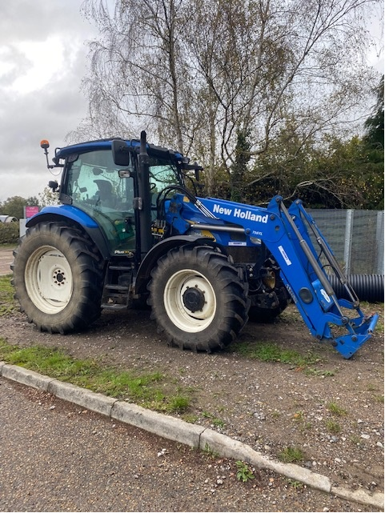

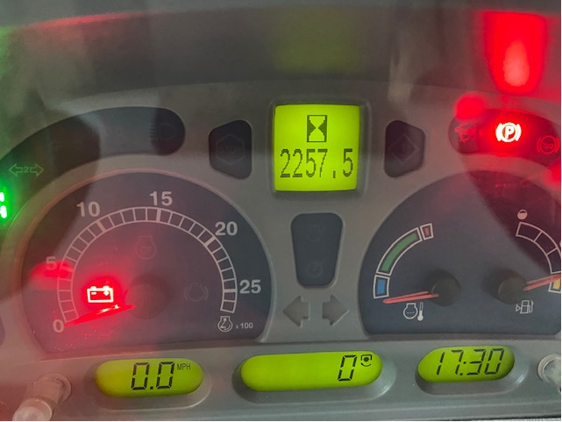

Contact details to arrange a viewing of this trade in machine
Russell Croft
01444 894062
r.croft@kew.org

- Lot 2 - Mower Direct discharge

  - Machine Specification
Minimum 22hp
long wet grass blade - this can be additional blade to the standard
20l fuel capacity
2 speed hydrostat
Tier 5 engine compliance latest
Direct centre chute collect – essential (pass/fail)
Hydraulic low or high dump 500l capacity
48-52 inch Cutting width
1-4 inch cut height
15cm clearance for deck in transport mode
Shear bolt on blade to protect gearbox ease of change - desirable
  - Daily Maintenance
The following features are desirable to aid regular maintenance routines:
- Easy access hood providing good, easy access for daily checks and access for regular servicing.
- Low maintenance direct drives to decks to reduce greasing needs and eliminate belt adjustments.

  - Servicing
Dealership for servicing requirements within a reasonable distance (e.g. 50 miles) from RBG Kew, Wakehurst, RH17 6TN.
Optional services – 50 hours and 250 hours
  - Warranty
All machinery must be provided with a minimum 2 years manufacturer’s warranty
  - Delivery
Delivery to the RBG Kew, Wakehurst, Selsfield Road, Ardingly, RH17 6TN by 31/03/2022.
  - Part exchange with Kubota BX231 with 163 hrs
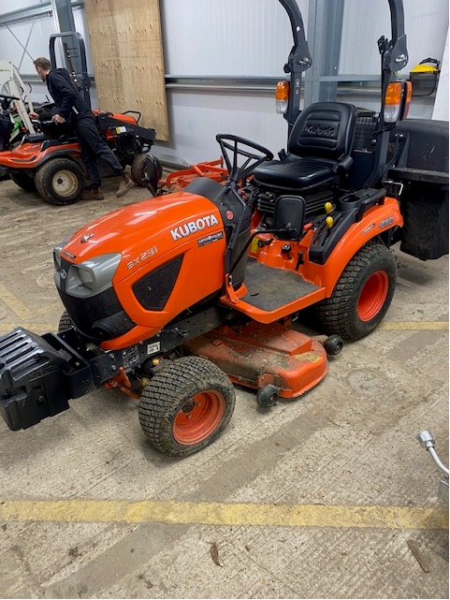

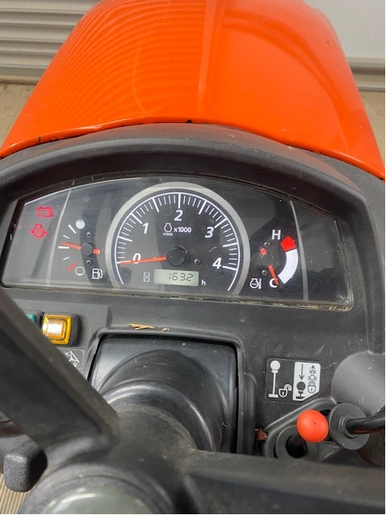

Contact details to arrange a viewing of this trade in machine
Russell Croft
01444 894062
r.croft@kew.org

