REQUEST FOR QUOTATION FOR heritage impact assessments

CONTENTS
SECTION 1: INTRODUCTION 3
PART A: GENERAL REQUIREMENTS 3
PART B: BACKGROUND 3
PART C: CLARIFICATION QUESTIONS 4
PART D: QUOTATION RESPONSES 4
PART E: EVALUATION OF QUOTATIONS 4
SECTION 2: SPECIFICATION 7
SECTION 3: SUPPORTING INFORMATION 10
PART A: Organisation and Contact Details 10
PART B: Questions 12
SECTION 4: PRICING SHEET 16
Pricing and Costs 16
SECTION 5: FREEDOM OF INFORMATION & SIGNATURE AND DATE 17
APPENDIX 1: CONDITIONS OF CONTRACT 18

INTRODUCTION

GENERAL REQUIREMENTS
Northampton Borough Council (The Authority) invites quotations for the provision of Heritage Impact Assessments.
The Authority’s detailed requirements are defined in Part 2 - Specification.
Please take care in reading this document in particular the Specification; In the event of any questions or queries in relation to this Request for Quotation (RFQ), please contact the buyer via the method stated below.
The Authority reserves the right to:
- carry out due diligence checks on the awarded provider;
- amend the conditions of Contract attached in Appendix 1;
- abandon the procurement process at any stage without any liability to the Authority; and or
- require the Potential Provider to clarify its quotation in writing and if the Potential Provider fails to respond satisfactorily, this may result in the Potential Provider not being selected.

BACKGROUND
Northampton is located approximately 60 miles north of London and 50 miles
southeast of Birmingham. The borough of Northampton is a predominately urban
area, with a population of around 220 000 and an area of 8082 hectares.
Northampton Borough Council is the Authority responsible for functions including
Waste Collection, Housing, Planning, and Environmental Health in the town and
Northampton and the immediately surrounding area. Our Corporate Plan is
Available here.

PROCUREMENT TIMETABLE
Request for Quotation Issued | Tuesday 27th August 2019
Deadline for Clarification Questions | 12pm Wednesday 11th September 2019
Deadline for Quotation Responses | 12pm, Monday 16th September 2019
Quotation Evaluation | Estimate Wednesday 18th September 2019
Contract Awarded / Start Date | Estimate Thursday 26th September 2019
Deadline for Delivery of Task 1 | Friday 1st November 2019
Contract End Date | Thursday 7th November 2019

CLARIFICATION QUESTIONS
Any queries about this document, the procurement process, or the proposed contract itself, should be referred to:
Name | Paul Everard
Job Title | Planning Policy and Heritage Manager
Telephone | 01604 837279
Email | planningpolicy@northampton.gov.uk
Deadline for questions (date & time) | 12pm Wednesday 11th September 2019

QUOTATION RESPONSES
Should you wish to take part in the selection process please complete this RFQ and return via email to:
Name | Paul Everard
Job Title | Planning Policy and Heritage Manager
Telephone | 01604 837279
Email | planningpolicy@northampton.gov.uk
Respond by Date & Time | 12pm Wednesday 16th September 2019

EVALUATION OF QUOTATIONS
Any bids not compliant or completed fully will be discarded. Based on the information provided by organisations, each compliant submission will be evaluated based on the following criteria:
Each Quotation will be scored by the evaluation team against each of the evaluation areas in Table 1 and Table 2 below.

Table 1
Overall Pricing Criteria 40% | Weighting
Total cost for Task 1 | 100%

The quality aspect of the quotation will take into account the criteria below in Table 2:

Table 2
Area | Overall Quality Criteria 60% | Sub-section weighting | Question weighting
 | Functional and Technical Compliance with the Specification | 70%
 | - Please provide details of your organisation’s experience and expertise in carrying out and delivering against the tasks described in the Specification and how it will be applied in this project. |  | 100%
 | Measuring Quality | 15%
 | - Please provide details of the arrangements your organisation has in place for ensuring the quality of all of the elements set out in the Specification and in Q1 above, including details of any relevant accredited or non-accredited performance of quality management systems in place in your organisation. |  | 100%
 | Relevant Experience / References | 15%
 | 3.1 Please provide details of the qualifications of the persons who will work on the project and who will be doing which element (These persons shall not be removed from the project without approval from the client). |  | For information
 | 3.2 Please provide two references from organisations for which your company has carried out a similar project. |  | Pass / fail

In respect of each quality criteria in Table 2 a score will be awarded on a system of 0-3 in accordance with the scoring scale in Table 3 (below):

Table 3
No. of Points | Definition
0 | Response does not meet requirements or no response is provided.
1 | Response partially meets requirements but contains significant weaknesses, issues or omissions.
2 | Response meets requirements to an acceptable standard but contains some weaknesses, issues or omissions.
3 | Response meets requirements to a high standard. Robust and detailed in all respects.

Responses may score any whole number between 0 and 3. The scoring system is set such that an acceptable standard would gain a score of at least 2. This would be awarded for a response which shows that the Tenderer’s solution demonstrated performance of the service to an acceptable standard in accordance with the Specification. Where the response is lacking in appropriate detail, only partially complete or inadequately justified, the overall score will be adjusted accordingly.

The score for each of the evaluation criteria will be multiplied by the weighted factor as follows to give an overall initial score:
Actual score / maximum score x weighting from Table 2

Evaluation of the Quotation Price payable by the Authority:
Price Evaluation (costs payable by the Authority) will be evaluated in accordance with Table 4 below using 40% price as an example:

Table 4
 | Cost of Proposal (£) | Calculation | Points
Quotation 1 | 10,000 |  | 40
Quotation 2 | 15,000 | 10,000/15,000 x 40 | 26.7
Quotation 3 | 20,000 | 10,000/20,000 x 40 | 20.0
Quotation 4 | 25,000 | 10,000/25,000 x 40 | 16.0

The scores achieved for the quotation price and the quality criteria elements will be added together and the tenderer achieving the highest score will be successful.
Note: failure to provide the required information requested may lead to your quotation being rejected.

SPECIFICATION
1.0 Background

  - Northampton Borough Council has recently undertaken public consultation on the Proposed Submission version of the Northampton Local Plan Part 2. The emerging draft Plan contains heritage policies and a number of proposed allocations close to important heritage assets including:
- the site of the Battle of Northampton 1460, which is a Registered Battlefield;
- the Scheduled Ancient Monuments of Northampton Castle, Saxon Palace Complex and Medieval Deposits (Central Northampton);
- various listed buildings; and
- locally listed buildings.

  - The recent consultation has attracted representations to the heritage policies and allocations. This includes representations from Historic England regarding the proposed allocation of sites in Tanner Street (0167), Ransome Road (1139), Ransome Road Gateway (0174), Railway Station Car Park (0288), Railway Station Car Park (0333), St Peter’s Way (0818), Green Street (0931), land in St Peter’s Way / Court Way / Freeschool Street (1010) and Greyfriars (1113). Also in the vicinity of those sites are Southbridge Site 1 (0932), Southbridge Site 2 (0933), and Car Park, Victoria Street (0598).

  - Following advice from Historic England, the Authority now requires heritage advice to undertake heritage impact assessments, on a proportionate basis, in line with guidance including Historic England Advice Note 3, in three areas of Northampton:
- Area 1 – to cover the area including sites 0167, 0288, 0333, 0818, 0931 and 1010;
- Area 2 – to cover the area including sites 0174, 0932, 0933 and 1139; and
- Area 3 - to cover the area including sites 0598 and 1113.

  - The two tasks are set out in section 2 below.

1.4 The outputs will support the evidence base for further consultation on the Northampton Local Plan Part 2 prior to submission to the Secretary of State.

2.0 Tasks

2.1 The tasks are set out below:

Task 1: Full Heritage Impact Assessment for Areas 1, 2 and 3

2.2 A map showing the extents of Areas 1, 2 and 3 and the locations of the proposed allocations is attached at Appendix 2. A full heritage impact assessment (HIA) is required for each of the three areas. Each HIA will need to assess designated and non-designated heritage assets, their significance and their setting, including archaeology. Features should be considered not only in terms of their likely date of construction but holistically in terms of their siting, use, reuse, disuse and interrelation. It is important that the HIA is undertaken as an integrated landscape approach. Important considerations include the impact of the proposed allocations on the Scheduled Monuments listed above and the Battlefield.

2.3 Where potential for harm is identified, each HIA should explain the nature of the harm and make recommendations for how harm can be minimised, whether there is the potential for mitigation and if development could provide the opportunity to enhance heritage assets to better reveal their significance. If appropriate, consideration could be given to producing a map showing levels of sensitivity across the site.

2.5 The methodology used for the HIA must be clearly set out and compliant with the National Planning Policy Framework, in particular, proximity should not be used as a gauge of harm or impact. The methodology must also be undertaken in accordance with the guidance set out in the following Historic England publications:

- Historic Environment Good Practice Advice Note 1: The Historic Environment in Local Plans
- Historic Environment Good Practice Advice Note 2: Managing Significance in Decision-taking in the Historic Environment
- Historic Environment Good Practice Advice Note 3: The Setting of Heritage Assets
- Historic England Advice Note 3: The Historic Environment and Site Allocations in Local Plans
- Historic England guidance on preservation in situ
- Conservation Principles, Policies and Guidance

2.6 Although much of the HIA will be undertaken as a desk top study, it should also involve a site visit to each of the three areas. It will also be necessary to consult with the relevant Battlefield Trust in relation to the methodology for the assessment of the site of the Battle of Northampton 1460.

Task 2: Representation at Local Plan examination

2.9 Appearance at the Local Plan Examination to support the Authority in explaining and defending the advice given for Task 1. Due to the unknown amount of work involved in this element of the project, consultants are to provide hourly rates and approximate expenses for preparation and appearance at the examination.

3.0 Resources

3.1 The following documents are available and should be referred to:

- Northampton Local Plan Part 2 Proposed Submission
- Policies Map
These can be downloaded from the following webpage:
https://www.northampton.gov.uk/info/200205/planning_for_the_future/1746/

- Responses to the Local Plan Part 2 consultation from Historic England, attached at Appendix B.

- National Heritage List for England
This can be accessed from the following webpage:
https://www.historicengland.org.uk/listing/the-list

- Historic Environment Record for Northamptonshire
This can be accessed from the following webpage:
http://www.northamptonshireheritage.co.uk/enjoy-being-an-expert/historic-environment-record/Pages/default.aspx

- Conservation Area and Management Plans and related documents
These can be accessed from the following webpage:
https://www.northampton.gov.uk/info/200207/building_conservation_and_trees/1446/conservation-home

- Details of Scheduled Ancient Monuments in Northampton are listed on the following webpage:
https://www.northampton.gov.uk/info/200207/building_conservation_and_trees/1497/list_of_scheduled_ancient_monuments_in_northampton

- Details of locally listed buildings will be made available to the successful contractor.

3.2 Detailed use should be made of Historic Environment Record data and consultation with County archaeological advisors, a visit to the HER may therefore also be required.

4.0 Requirements
4.1 Consultants should be members of the Institute of Historic Building Conservation or equivalent and possess appropriate qualifications with skills and experience. Membership of the Chartered Institute of Archaeologists is desirable.
4.2 Consultants should set out their past experience of producing heritage impact assessments.

SUPPORTING INFORMATION
Please complete section 3 and 4 below.

Organisation and Contact Details
A-1 Name of your organisation
A-2 Registered office (if applicable)
A-3 Trading address (if different from registered
office)
A-4 Organisation Registration Number
(if applicable)
A-5 Is your organisation a:
- Sole Trader
- Partnership
- Public Limited Company
- Private Ltd Company
- Charity
- Other
If you selected other, please specify
A-6 What, if any, local connections do you have with the County
A-7 If the Company is a
member of a group of companies,
please give the name and
address of the ultimate holding
company
A-8 Name of person to whom
any queries relating to this quote
should be addressed
A-9 Telephone
A-10 Email
A-11 Address
(if different to the Address above)

Questions
Please see Section 1, Part F (Evaluation of Quotations) for details on the weighting and scoring criteria.

Question  Number | Question | Sub-Section Weighting (%) | Question Weighting (%)
Functional and Technical Compliance with the Specification |  | 70%
1 | Please provide details of your organisation’s experience and expertise in carrying out and delivering against the tasks described in the Specification and how it will be applied in this project. |  | 100%
Potential Provider’s Response | This can form part of a separate project proposal document
Measuring Quality |  | 15%
2 | Please provide details of the arrangements your organisation has in place for ensuring the quality of all of the elements set out in the Specification and in Q1 above, including details of any relevant accredited or non-accredited performance of quality management systems in place in your organisation. |  | 100%
Potential Provider’s Response | This can form part of a separate project proposal document
Relevant Experience / References |  | 15%
3.1 | Please provide details of the qualifications of the persons who will work on the project and who will be doing which element (These persons shall not be removed from the project without approval from the client). |  | For information
Potential Provider’s Response | This can form part of a separate project proposal document
3.2 | Please provide two references from organisations for which your company has carried out a similar project within the last five years. |  | Pass / fail
Potential Provider’s Response | This can form part of a separate project proposal document
5 | Task 1 needs to be completed by 1st November 2019. Consultants should confirm that they are able to meet this. | Pass / fail
Potential Provider’s Response | This can form part of a separate project proposal document
4 | The level of insurance required is as follows:  - Employers Liability Insurance £5,000,000  - Public Liability Insurance £5,000,000  - Professional Indemnity Insurance £1,000,000  Can you confirm that your organisation has the required level of cover or is prepared to obtain the level of cover prior to award? | PASS/FAIL question. Potential Providers who answer ‘No - have not got cover and won't provide Authority’s level of cover’ will fail the RFQ process.
Potential Provider’s Response | Yes - have levels of cover already and will continue to for this contract  No - but will provide the Authority‘s level of cover requested if awarded contract  No - have not got cover and won't provide Authority’s level of cover
5 | The Authority wishes to ensure that within your business or in its supply chain there is no servitude or forced labour, slavery human trafficking, arranging or facilitating the travel of another person with a view that a person is being exploited or conducting any activities that contain violation of human rights. Please confirm that your supply chain with regards to this quotation response complies with the Modern Slavery Act 2015. | PASS/FAIL question. Potential Providers who answer ‘No’ - will fail the RFQ process.
Potential Provider’s Response | Yes–in response to this quotation our supply chain complies with the Modern Slavery Act 2015  No–in response to this quotation our supply chain does not comply with the Modern Slavery Act 2015
6 | The Authority wishes to ensure that within your business or in its supply chain that the processing of personal data and processes in relation to this contract are compliant with the requirements of the General Data Protection Regulations (GDPR) and Data Protection Act 1988.  Please confirm that you and your supply chain with regards to this quotation response comply with all applicable data protection legislation including but not limited to the General Data Protection Regulations (GDPR) and Data Protection Act 1988. | PASS/FAIL question. Potential Providers who answer ‘No’ - will fail the RFQ process.
Potential Provider’s Response | Yes–in response to this quotation ourselves and / or our supply chain comply with all applicable data protection legislation including but not limited to with the General Data Protection Regulations (GDPR) and Data Protection Act 1988.  No–in response to this quotation ourselves and/or our supply chain does not comply with all applicable data protection legislation including but not limited to with the General Data Protection Regulations (GDPR) and Data Protection Act 1988.

PRICING SHEET

Pricing and Costs
Please insert your costs in the table below. The costs should be broken down into components with a full description of each component and its associated time and costs.

[Component] | [Component description] | [Delivery by] | [Costs (£)]
 | Total Costs (£):

FREEDOM OF INFORMATION & SIGNATURE AND DATE
Information in relation to this RFQ may be made available on demand in accordance with the requirements of the Freedom of Information Act 2000 (“The Act”) and your organisation details will be disclosed where the expenditure is over £250 as per the Government Transparency agenda. Details of contracts will also be published on the Authority’s website.
Organisations should state if any of the information supplied by them is confidential and commercially sensitive or should not be disclosed in response for the Information under the Act. Organisations should state why they consider the information to be confidential or commercially sensitive.
Please state here any specific information in this RFQ that you do not wish to be disclosed under Freedom of information Act. This will not guarantee that the information will not be disclosed but will be examined in the light of the exemptions provided in the Act.

Request for Quotation for Heritage Impact Assessments
I the undersigned hereby declare by marking an X in the box:

that the information provided is complete and accurate;

- that the price in Section 4 is our best offer;
- that no collusion with other organisations has taken place in order to fix the price;
- to be subjected to the terms and conditions set out in Conditions of Contract identified in Appendix 1;
- that no works/goods/supplies/services will be delivered or undertaken until both parties have executed the formal contract documentation as identified in Appendix 1 and an instruction to proceed has been given by the Authority in writing.
Name
Position Held
Date

- CONDITIONS OF CONTRACT

NORTHAMPTON BOROUGH COUNCIL

and

? LIMITED

AGREEMENT
FOR
HERITAGE IMPACT ASSESSMENT SERVICES

this AGREEMENT is made on 20

BETWEEN

(1) NORTHAMPTON BOROUGH COUNCIL of The Guildhall, St Giles Square, Northampton, Northamptonshire NN1 1DE (the “Council”); and

(2) ? LIMITED Company Number ? whose registered office is ?? (the “Consultant”)

IT IS AGREED AS FOLLOWS:

1. BACKGROUND

  - In response to the Specification provided by the Council in Schedule 1(Section 2 of RFQ), the Consultant shall carry out the Services for the Price in accordance with the terms and conditions of this Agreement.

  - In reliance upon the skill, knowledge and experience of the Consultant, the Council wishes to appoint the Consultant to provide the Services and the Consultant agrees to accept the appointment in accordance with the terms and conditions in this Agreement.

  - The Consultant shall fully co-operate and assist the Council and or its representatives during the delivery of the Services.

2. DEFINITIONS

2.1 In this Agreement unless the context otherwise requires the definitions set out below shall apply.

“Agreement”  “Bribery Act” | this agreement, its terms and conditions, the Specification, the Consultant’s Quotation submitted by the Consultant, and any other document incorporated by reference herein;  the Bribery Act 2010 and any subordinate legislation made under the Act from time to time together with any guidance or codes of practice issued by the relevant government department concerning the legislation.
“Council’s Representative” | Namely the Planning Policy and Heritage Manager of the Council the officer responsible for the management of the Agreement, unless otherwise advised in writing by the Council;
“Commencement Date” | the commencement date of the Agreement is 26 September 2019 ;
“Force Majeure Event” | any cause materially affecting the performance of the Services under the Agreement arising from any act, events, omissions, happenings or non-happenings beyond the parties reasonable control including, without limitation, acts of God, war, riot, fire, flood or any disaster affecting either of the parties but will not mean any labour dispute between the Consultant and the Consultant’s employees, agents or sub-Agencies;
“Good Industry Practice” | standards, practices, methods and procedures conforming to the Law and with all due skill and care, diligence, prudence and foresight which would be expected from a skilled and appropriately experienced, qualified and trained person or body engaged in a similar type of undertaking under the same or similar circumstances;
“Laws” | any applicable Act of Parliament, subordinate legislation within the meaning of section 21(1) of the Interpretation Act 1978, exercise of the royal prerogative, enforceable community right within the meaning of section 2 of the European Communities Act 1972, regulatory policy, guidance or industry code, judgment of a relevant court of law, or directives or requirements of any Regulatory Body of which the Consultant is bound to comply;
“Price” | the price identified within clause 6, payable to the Consultant by Council under the Agreement for the full and proper performance by the Consultant of their obligations;
“Prohibited Act” | (a) | offering, promising or agreeing to give to any servant of the Council any gift or consideration of any kind as an inducement or reward:
 |  | (i) | for doing or not doing (or for having done or not having done) any act in relation to the obtaining or performance of this Agreement or any other agreement with the Council; or
 |  | (ii) | for showing favour or disfavour to any person in relation to this Agreement or any other agreement with the Council;
 | (b) | committing any offence:
 |  | (i) | the Local Government Act 1972 and or the Bribery Act ;
 |  | (ii) | under legislation creating offences in respect of fraudulent acts; or
 |  | (iii) | at common law in respect of fraudulent acts in relation to this Agreement or any other agreement with the Council; or
 |  | (iv) | defrauding or attempting to defraud or conspiring to defraud the Council;
 |  | (v) | any action that may reasonably be considered to be to the detriment of the Council and or its end user’s welfare, either by positive action or by omission. Such action shall include but is not limited to; breach of the law, related to health, safety and or care, safeguarding, abuse, sexual allegations and or misconduct; financial malpractice or business continuity failure.
“Quotation” |  | the | information and Price supplied by the Consultant to the Council for undertaking the Services.
“Safety Legislation” |  | the Health and Safety at Work Act 1974 and the Consumer Protection Act 1987 together with all regulations made under them including, but not limited to, the General Product Safety Regulations 2002, the Control of Substances Hazardous to Health Regulations 2004 and all other legislation, codes of practice and guidance from time to time amended (including subordinate legislation and European Community legislation to the effect that it has direct effect on member states) imposing legal requirements with respect to health and safety at work and/or the safety of any goods and equipment used in the performance of the Services and the health and safety of the users of such goods and equipment;
“Services” |  | the services, duties and responsibilities to be provided, performed and observed by the Consultant pursuant to this Agreement and as specified in the Specification and the Consultant’s Quotation referred to in Schedule 2 of the Agreement;
“Specification” |  | the document so entitled which describes the Services to be provided by the Consultant in accordance with Schedule 1 (Section 2of the RFQ) of the Agreement;
“Term” |  | the period from the Commencement Date to the 7th November 2019
“Working Day” |  | a day (other than Saturday, Sunday or an official public bank holiday)

2.2 The interpretation and construction of the Agreement shall be subject to the following provisions:

(a) words importing the singular meaning include where the context so admits the plural meaning and vice versa;

(b) words importing the masculine include the feminine and neuter;

(c) reference to a clause is a reference to the whole of that clause unless stated otherwise;

(d) references to any statute, enactment, order, regulation or other similar instrument shall be construed as a reference to the statute, enactment, order, regulation or instrument as amended by any subsequent enactment, modification, order, regulation or instrument as subsequently amended or re-enacted;

(e) references to any party shall include natural persons and partnerships, firms and other incorporated bodies and all other legal persons of whatever kind and however constituted and their successors and permitted assigns or transferees;

(f) the words “include”, “included”, “includes” and “including” are to be construed as if they were immediately followed by the words “without limitation”; and

(g) headings are included in the Agreement for ease of reference only and shall not affect the interpretation or construction of the Agreement.

3. duration

3.1 The Agreement and the rights and obligations of the parties shall take effect on the Commencement Date and shall continue until the expiry of the Term or earlier termination of the Agreement pursuant to Clause 18.

4. NOTICES

4.1 Any notice, request, demand, consent or approval given under or in connection with this Agreement must be given in writing. Any such notice, request, demand, consent or approval shall be sent to the registered office or principal business address of either party and, if sent by post, shall be deemed to have been received on the second Working Day following the date of posting.

5. The Service standard

In the performance of the Services throughout the Term of this Agreement the Consultant shall :

comply with the terms of this Agreement the Specification or requirements included or referred to in the Agreement;

operate in accordance with Good Industry Practice and in compliance and conformance with all applicable Laws;

carry out all reasonable directions of the Council’s Representative;

use its reasonable endeavours to secure and achieve continuous improvement in the delivery of the Services during the Term;

understand fully the risk potential of performing the Services. The Consultant must perform a thorough risk assessment exercise, and ensure that all of its staff (if any) are particularly diligent and safety conscious; and

if given access to, or occupation of, any offices or premises which may be granted to the Consultant from time to time shall be on a non-exclusive licence basis free of charge. The Consultant shall use the offices or premises solely for the purpose of performing its obligations under the Agreement. The Consultant shall co-operate with such other persons working concurrently at the offices or premises as the Council may reasonably request;

The Consultant is deemed to have made appropriate enquiries so as to be satisfied in relation to all matters connected with the performance of its obligations under the Agreement and accordingly no claim by the Consultant for additional payment or extension of time will be allowed on this basis;

5.2 For the avoidance of doubt nothing in this Agreement shall render the Consultant an employee, worker, agent or partner of the Council and the Consultant shall not hold themselves out as such.
5.3 This Agreement constitutes a contract for the provision of services and not a contract of employment and accordingly the Consultant shall be fully responsible for and shall indemnify the Council for and in respect of:
- any income tax, National Insurance and social security contributions and any other liability, deduction, contribution, assessment or claim arising from or made in connection with the performance of the Services, where the recovery is not prohibited by law. The Consultant shall further indemnify the Council against all reasonable costs, expenses and any penalty, fine or interest incurred or payable by the Council in connection with or in consequence of any such liability, deduction, contribution, assessment or claim;
- any liability arising from any employment-related claim or any claim based on worker status (including reasonable costs and expenses) brought by the Consultant against the Council arising out of or in connection with the provision of the Services.
5.4 No variation of this Agreement shall be valid unless it is in writing and signed by or on behalf of each of the parties.

6. Price and Payment

6.1 In consideration of the performance of the Consultant’s obligations under the Agreement, the Council shall pay the Price in accordance with the Agreement; for the avoidance of doubt the Price shall include all costs of providing the Services howsoever incurred whether primary or support functions including specifically but without limitation the costs of all labour, equipment, information technology, accommodation, heating, lighting, materials, purchasing and maintaining vehicles and equipment, all normal office costs (including but not limited to costs of telephone calls, letters, typing, photocopying time, filing time, postage) general training and personnel costs, holiday entitlements, professional subscriptions, library costs, travelling time, waiting time, disbursements (subject to any detailed provisions listed in the Agreement), all accounting and banking systems and services, production of reports and copy documents, attendance at meetings, anything incidental or ancillary to the foregoing and all costs, charges, expenses and outgoings of whatever nature incurred by the Consultant in performing its obligations under the Agreement other than specifically provided therein;

6.2 The Council in consideration of the Services provided by the Consultant as an independent Consultant and not the servant of the Council shall pay the Consultant £? ( ?? Pounds) plus Value Added Tax for providing the Services during the Term. For the avoidance of doubt there is no obligation on the Council to make payment when the Services are not in fact provided.

6.3 The Consultant shall render an itemised invoice in arrears to the Council in respect of the payments due under Clause 6.2. Such Payments will be invoiced on the basis of the payment schedule detailed in the Quotation.

6.4 Subject to the proper provision by the Consultant of the Services, the Council shall make due payment within thirty (30) days of receipt of the invoice by the Council.

6.5 Notwithstanding Clause 6.4 above, the Council reserves the right to withhold payment against any invoice which is not in accordance with the Contract or which covers or purports to cover the Services which have not been provided in accordance with the Contract and shall notify the reasons to the Consultant in writing forthwith.

6.6 The Consultant shall pay all taxation including National Insurance contributions in connection with any payments pursuant to this Contract and shall indemnify and compensate the Council in full on demand for any liability which is suffers in connection with the same.

6.7 Payment by the Council shall be without prejudice to any claims or rights which the Council may have against the Consultant and shall not constitute any admission by the Council as to the performance by the Consultant of its obligation hereunder;

6.8 If either party owes the other money under the Agreement, then the party who is owed the money may set off any such sum against any money it subsequently owes to the other under the Agreement.

7. Statutory rights

  - Nothing in these conditions shall affect in any way the statutory rights of the Council under the Sale of Goods Act 1979, the Supply of Goods and Services Act 1982 or any subsequent amending or consolidating legislation.

  - A party who is not a party to this Agreement is not entitled to enforce any of its terms under the Contracts (Rights of Third Parties) Act 1999 except where this Agreement expressly provides otherwise.

  - The Consultant shall comply in all respects with the law and all applicable rules and regulations in all matters arising in the performance of or in connection with the Agreement.

8. BRIBERY, Corrupt Gifts and Fraud
8.1 The Consultant represents and warrants that neither it, nor to the best of its knowledge any of its staff (if any), have at any time prior to the Commencement Date:
(a) committed a Prohibited Act or been formally notified that it is subject to an investigation or prosecution which relates to an alleged Prohibited Act; and/or
(b) been listed by any government department or agency as being debarred, suspended, proposed for suspension or debarment, or otherwise ineligible for participation in government procurement programmes or contracts on the grounds of a Prohibited Act.
8.2 The Consultant shall not during the term of this Agreement:
(a) commit a Prohibited Act; and/or
(b) do or suffer anything to be done which would cause the Council or any of the Council's employees, consultants, contractors, sub-contractors or agents to contravene the Bribery Act or otherwise incur any liability in relation to the Bribery Act.
8.3 The Consultant shall during the term of this Agreement:
(a) establish, maintain and enforce policies and procedures which are adequate to ensure compliance with the Bribery Act and prevent the occurrence of a Prohibited Act; and
(b) keep appropriate records of its compliance with its obligations under Clause 8.3(a) and make such records available to the Council on request.
8.4 The Consultant shall immediately notify the Council in writing if it becomes aware of any breach of Clause 8.1 and/or 8.2, or has reason to believe that it has:
(a) been subject to an investigation or prosecution which relates to an alleged Prohibited Act;
(b) been listed by any government department or agency as being debarred, suspended, proposed for suspension or debarment, or otherwise ineligible for participation in government procurement programmes or contracts on the grounds of a Prohibited Act; and/or
(c) received a request or demand for any undue financial or other advantage of any kind in connection with the performance of this Agreement or otherwise suspects that any person or party directly or indirectly connected with this Agreement has committed or attempted to commit a Prohibited Act.
8.5 If the Consultant makes a notification to the Council pursuant to Clause 8.4, the Consultant shall respond promptly to the Council’s enquiries, co-operate with any investigation, and allow the Council to audit any books, records and/or any other relevant documentation.

9. ANTI-DISCRIMINATION AND HUMAN RIGHTS

9.1 The Consultant shall not unlawfully discriminate within the meaning and scope of any law, enactment, order, or regulation relating to discrimination (whether in age, race, gender, religion, disability, sexual orientation or otherwise) in employment or otherwise.

9.2 The Consultant shall take all reasonable steps to secure the observance of Condition 9.1 by all servants, employees or agents of the Consultant and

all suppliers and sub-contractors employed in performance of this Agreement

9.3 The Consultant shall (and shall use its reasonable endeavours to procure that its staff shall) at all times comply with the provisions of the Human Rights Act 1998 in the performance of this Agreement.

9.4 The Consultant shall undertake, or refrain from undertaking, such acts as the Council requests so as to enable the Council to comply with its obligations under the Human Rights Act 1998.

10. ASSIGNMENT and SUB-CONTRACTING

10.1 The Consultant shall not assign, transfer, novate, sub-contract or deal in any other manner with all or any of its rights or obligations under the Agreement without the prior written consent of the Council.

11. HEALTH AND SAFETY

11.1 The Consultant (or persons, officer, agent, representative, or sub-contractor) employed by it will throughout the Term fully comply with the requirements of Safety Legislation;

11.2 The Consultant shall promptly notify the Council of any health and safety hazards which may arise in connection with the performance of its obligations under the Agreement.

11.3 The Consultant shall comply with any health and safety measures implemented by the Council in respect of its premises.

11.4 The Consultant shall notify the Council immediately in the event of any incident occurring in the performance of its obligations under the Agreement on the premises of the Council where that incident causes any personal injury or damage to property which could give rise to personal injury.

11.5 The Consultant shall comply with the requirements of Safety Legislation and any other acts, orders, regulations and codes of practice relating to health and safety, which may apply to its staff and other persons working on the premises of the Council in the performance of its obligations under the Agreement.

12. Not Used

13. FREEDOM OF INFORMATION

13.1 The Consultant recognises the Council's obligations under the Freedom of Information Act 2000 (FOIA) the Environmental Information Regulations 2004 (EIR) and any codes of practice issued by the Information Commissioner. The Consultant will comply with this legislation in so far as it places obligations upon the Council in the performance of its obligations under any contractual arrangement entered into. The Consultant will provide such assistance and support which may be requested from time to time by the Council for the purposes of enabling or assisting the Council in requests for information.

13.2 In the event of a request made on the Council for access to information under the FOIA and/or EIR or any notice, recommendation or complaint made to the Council in relation to the FOIA and/or EIR, the Consultant will provide to the Council in relation to an access request, any details in respect of the information as the Council may request and a copy of the relevant information where the Council requests such copy; and in relation to any notice, recommendation or complaint, any background details, supporting documentation and copy information which the Council may request in order to deal with such notice, recommendation or complaint within five (5) Working Days of the date of the request from the Council.

13.3 The Consultant acknowledges that the Council is obliged under the FOIA and/or EIR to disclose information, including information relating to its appointment under this Agreement subject to certain exemptions. The Consultant further accepts and acknowledges that the decision to disclose information and the application of any such exemptions under the FOIA and/or EIR will be at the Council’s sole discretion PROVIDED THAT the Council shall act reasonably and proportionately in exercising its obligations under the FOIA and/or EIR as to whether any exemptions under may apply to protect the Consultant’s legitimate commercial interests and trade secrets.

13.4 The Council shall take reasonable steps, where appropriate to give the Consultant advance notice to draw any disclosure to the Consultant’s attention. Notwithstanding the Council shall be responsible for determining at its absolute discretion whether any information relating to the Consultant is exempt from disclosure in accordance with the FOIA and/or EIR.

14. CONFIDENTIALITY

14.1 Subject to Clause 13 (Freedom of Information) the Consultant shall not, without the prior written consent of the Council, during or after the termination or expiry of this Agreement disclose, directly or indirectly, to any person any information relating to the Agreement or the Council any information of whatever nature which is not in the public domain Save in respect where disclosure of having undertaking the Services for the Council is for the purpose of securing future employment

The Consultant’s obligations under this condition shall survive the expiry or termination of the Agreement.

15. INTELLECTUAL PROPERTY RIGHTS

15.1 Unless otherwise agreed in writing between the parties, all copyright, design rights and other intellectual property rights in any work which is developed in the course of the provision of the Services shall be vested in the Council and the Consultant shall do all things and render all such assistance as may be reasonably required by the Council in order to vest such rights in the Council.

15.2 Any database, program, plans, drawings, documents, handbooks, codes of practice or other information in whatever form (the "IPR Documents") provided by the Council pursuant to the Agreement shall at all times remain its property and the Consultant shall not use, reproduce, disseminate, adapt, transmit in any form or by any means the IPR Documents or any part thereof or permit the same to be so used, reproduced, disseminated, adapted or transmitted as aforesaid or published other than for the purposes of carrying out its obligations under the Agreement.

15.3 The Consultant hereby grants to the Council an irrevocable, non-exclusive, royalty-free licence to use for any purpose in connection with the Services all the Consultant’s intellectual property which the Consultant has used or supplied in connection with the Services, provided that the Consultant shall have no liability for any use of such intellectual property other than for the purposes for which it is intended. The Council may grant sub-licences out of the said licence.

15.4 The Consultant shall indemnify the Council against all loss, damage, costs and expenses for which the Council is or becomes liable as a result of any infringement or alleged infringement by the Consultant of any third party’s intellectual property rights.

16. Indemnity

16.1 The Consultant will indemnify the Council in full in respect of all damage or injury to any person or to any property and against all actions, suits, claims, demands, costs, charges or expenses awarded against or incurred by the Council, whether criminal or civil, (including the costs of transport, labour, administration and legal costs on an indemnity basis to the Council) arising from:

any act, neglect or default on the part of the Consultant, its employees or agents;

breaches in respect of any matter arising from the provision of the Services resulting in any successful claim by any third party.

16.2 Without prejudice to any other provision of this Agreement, the Consultant will fully indemnify the Council against any claims made against it as a result of any failure by the Consultant to comply with any statutory provision to be observed or performed in connection with the provision of the Services.

17. Insurance

17.1 The Consultant will throughout the Term maintain with a reputable insurance Consultant within the UK such policies of insurance (provided that such insurance is available in the market at commercially reasonable rates) as are necessary to cover any liability of the Consultant in respect of loss of or damage to property and personal injury to, or death of, any person arising out of or in the course of or caused by the Consultant’s carrying out or failing to carry out its obligations under the Agreement or for which it may become liable to the Council under clause 17. all statutory required insurance(s) including:

employers liability insurance cover shall be in the minimum sum of £5,000,000.00 in respect of any one incident and the number of incidents covered shall be unlimited and should be adequate to cover all risks in the performance of the Services

public liability insurance cover shall be in the minimum sum of £5,000,000.00 in respect of any one incident and the number of incidents covered shall be unlimited and should be adequate to cover all risks in the performance of the Services;

professional indemnity or similar as appropriate to the Consultant’s circumstances shall be in the minimum sum of £1,000,000.00 in respect of any one incident or series of incidents.

17.2 Upon request, the Consultant will provide the Council with details of the policies of insurance (by way of insurer’s certificate) effected in accordance with Clause 17.1, so as to demonstrate that Clause 17.1 is being complied with.

17.3 The Consultant will immediately inform the Council of any failure or inability to maintain insurance in accordance with Clause 17.1 and of any circumstances likely to render such insurance void or voidable in order that the Consultant and Council can discuss the means of best protecting their respective positions in the absence of such insurance.

17.4 Any increased or additional premiums required by insurers by reason of the Consultant’s own claims records or other acts or omissions particular to the Consultant will be deemed to be within commercially reasonable rates.

18. Termination of Agreement

18.1 The Agreement shall terminate automatically on the expiry of the Term.

18.2 In the event of:

- the passing by the Consultant of a resolution for its winding-up or the making by a court of competent jurisdiction of an order for the winding-up of the Consultant or the dissolution of the Consultant; or

- the making of an administration order in relation to the Consultant or the appointment of a receiver over, or the taking possession or sale by an encumbrancer of, any of the Consultant’s assets; or

- the Consultant making an arrangement or composition with its creditors generally or making an application to a court of competent jurisdiction for protection from its creditors generally;

- the Council may, without prejudice to any other power of termination or to any rights or remedies it may have, terminate the Agreement forthwith by notice.

18.3 Without prejudice to the Council’s other rights and remedies, the Council may forthwith terminate the Agreement by notice if the Consultant:

- commits any breach of the Agreement and fails to remedy such breach within fourteen (14) days of being given written notice to do so by the Council ;

- fails to perform its obligation under the Agreement with due diligence;

- fails to comply with Good Industry Practice and or the Laws; or

- commits or attempts a Prohibited Act.

18.4 Notwithstanding the generality of clause 18 the Council and the Consultant shall have the right to terminate the Agreement, or to terminate the provision of any part of the Agreement at any time by giving 1 (one) weeks written notice to the other party.

19. Disputes

19.1 If the Council believes that the Services are deficient, the Consultant shall be formally notified in writing by the , inviting the Consultant at the earliest possible opportunity to discuss the matter and giving clear indications as to how the Services have not been satisfactory.

19.2 After such discussions, the Consultant shall remedy any agreed faults within an agreed, reasonable timescale.

19.3 If the Consultant is unable or unwilling to remedy the above faults, the Council may terminate this Agreement forthwith; if the Consultant feels that the Services are not at fault or that the Council is unfair in its judgment of the quality of the Services, and the parties are unable to agree the matter amicably between them, the matter may be resolved by reference to an independent mediator who is acceptable to both parties, and whose decision both parties agree shall be final. Both parties shall share the cost of mediation.

20. NO WAIVER

20.1 No delay, neglect or forbearance on the part of either party in enforcing against the other party any term or condition of the Agreement shall either be or be deemed to be a waiver or in any way prejudice any right of that party under this Agreement.

21. FORCE MAJEURE

21.1 Neither party shall be liable for delay in performing or failing to perform its obligations under this Agreement if the delay or failure results from events of circumstances beyond its reasonable control. Such delay or failure shall not constitute a breach of this Agreement and the time for performance shall be extended by a period equivalent to that during which performance is prevented provided that if such delay or failure persists for more than one month nothing in this clause shall be taken to limit or prevent the exercise of the right to terminate under clause 18.

22. ACCRUED RIGHTS AND REMEDIES

22.1 The termination of the Agreement will not prejudice or affect any claim, right, action or remedy that will have accrued or will thereafter accrue to either party.

23. RIGHTS AND DUTIES RESERVED

23.1 All rights, duties and powers which the Council has as a local authority or which the Council’s officers have as local authority officers are expressly reserved.

24. SURVIVAL OF TERMS

24.1 The terms of the Agreement will (except in respect of any obligations fully performed prior to or at the completion of the Services) continue in force and effect after the completion of the Services by the Consultant.

25. CONFLICT OF INTEREST

25.1 The Consultant shall use all reasonable endeavours to ensure that no conflicts of interest arise in connection with this Agreement and shall make available to the Council any information of which it is aware concerning assignments being undertaken by personnel concurrently with this Agreement which may give rise to such a conflict of interest.

25.2 If, in the reasonable opinion of the Council, a conflict of interest arises during the Term then the Consultant shall take all necessary measures as are required by the Council to resolve the conflict of interest or alleviate its effect.

25.3 If a resolution of the conflict of interest is not possible, then the Council shall have the right to terminate the Agreement.

26. AUTHORITY TO ENTER INTO THE AGREEMENT

26.1 Each of the parties warrants its power to enter into this Agreement and that it has obtained the necessary approvals to do so.

27. ENTIRE AGREEMENT

27.1 This Agreement contains the whole agreement between the parties and neither party has relied upon any oral or written representations made to it by the other or the others employees, representatives or agents and this Agreement supersedes any prior agreement between the parties.

28. Governing Law

28.1 This Agreement shall be governed by and construed in accordance with English law and the parties submit to the exclusive jurisdiction of the courts of England and Wales.

SCHEDULE 1 (see Section 2 of the RFQ)

SPECIFICATION

SCHEDULE 2

Consultants Quotation

IN WITNESS of which this Agreement has been duly executed by the
Parties

SIGNED by the COUNCIL ----------------------------------------------------

In the presence of: ____________________________________

Signature, name, address ________________________________

SIGNED by the Consultant ______________________________________

In the presence of: ______________________________________

Signature, name, address ______________________________________

Appendix 2: Maps of the three study areas
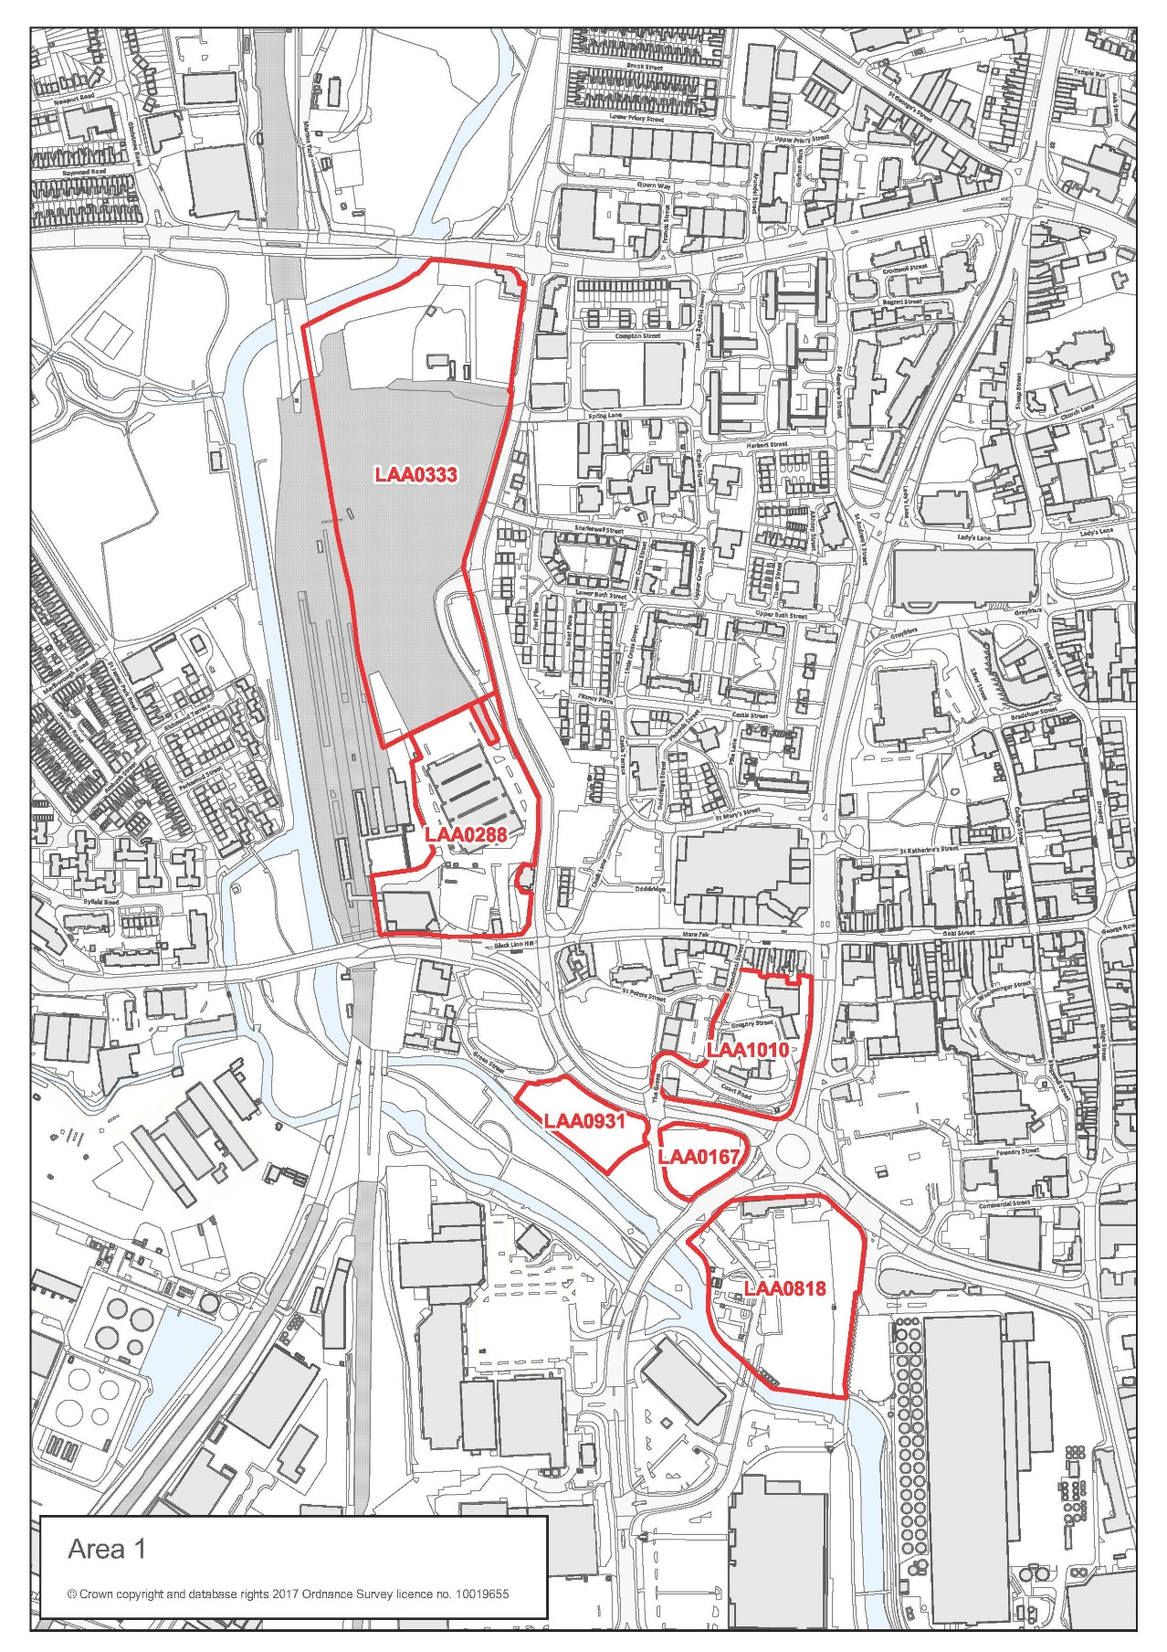

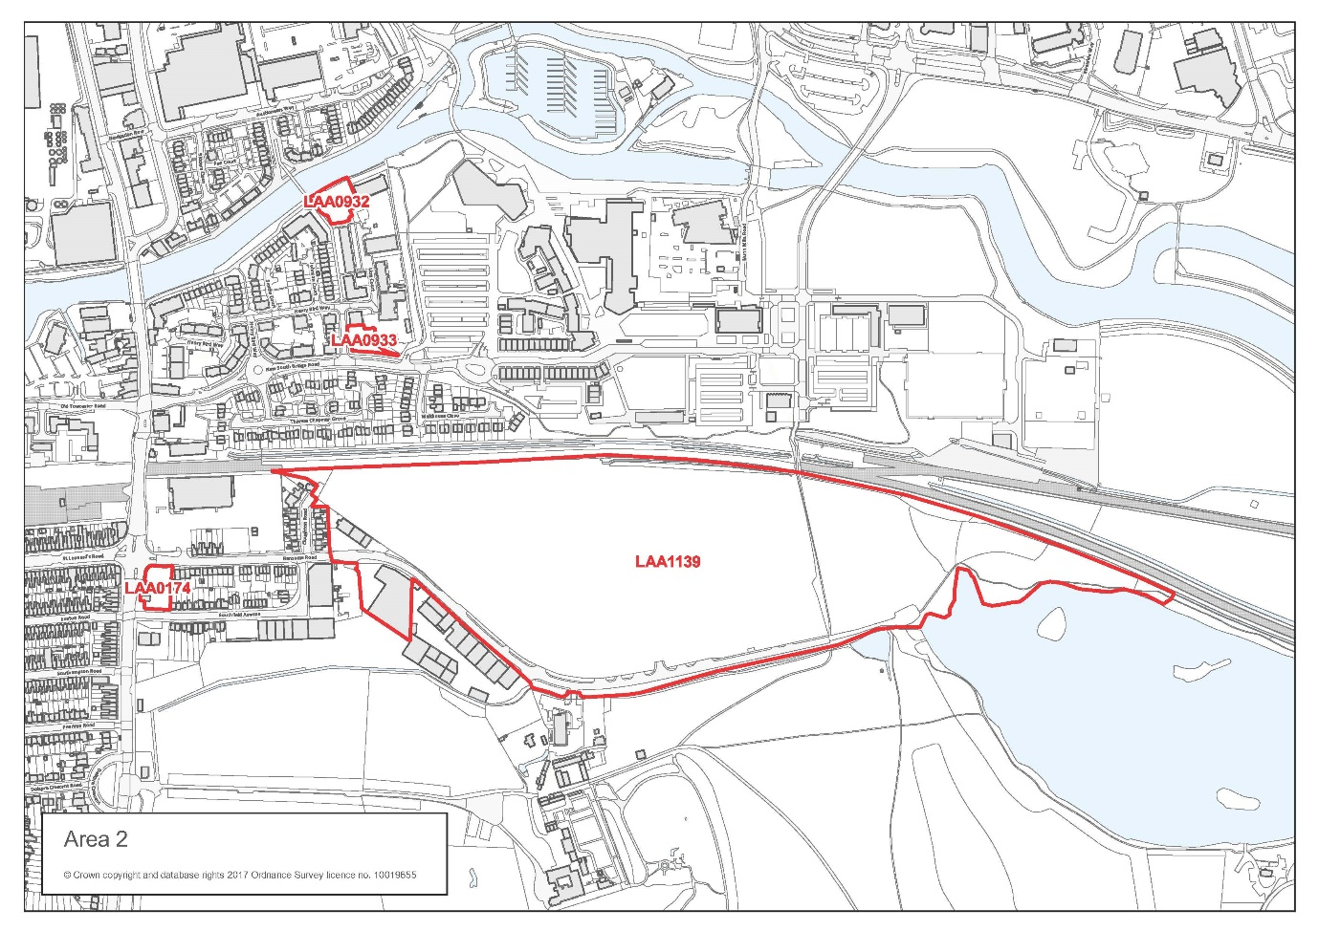

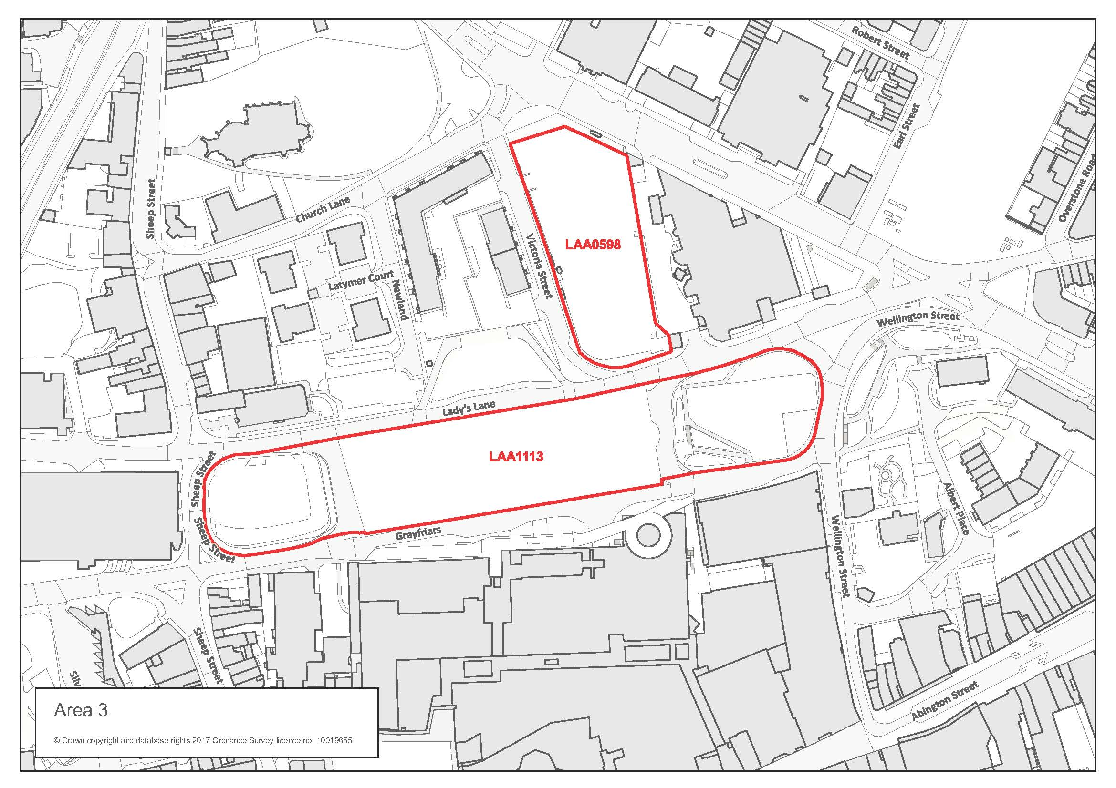

These documents can be accessed from the Historic England website: https://www.historicengland.org.uk/advice/planning/planning-system/
https://historicengland.org.uk/advice/technical-advice/archaeological-science/preservation-in-situ/
https://content.historicengland.org.uk/images-books/publications/conservation-principles-sustainable-management-historic-environment/conservationprinciplespoliciesguidanceapr08web.pdf/

